WEEK 5 · PREDICTIVE MODELLING & ALGORITHM SELECTION
Decoding the Skincare Shopper
Selecting, validating and interpreting models that predict whether a shopper will recommend a skincare product — before they buy it
PREPARED BY Aayush Gautam
PROGRAMME Data Science with Python Internship — YuvaIntern (Henry Harvin)
DOMAIN Beauty & Wellness — Skincare e-commerce
BUILDS ON Week 1 problem & H5 · Week 2 metrics plan · Week 3 pipeline · Week 4 features
CODE github.com/weebaayush/beauty-wellness (src/modeling)
DATE November 2026

Contents
1. Executive Summary
2. From Business Problem to Predictive Tasks
3. Data Characteristics That Shape Model Choice
4. Candidate Models
5. Evaluation Metrics & Performance Predictions
6. Validation Design
7. Results & Model Selection
8. Overfitting & Underfitting
9. Robustness Checks & Pitfalls
10. Interpreting the Model for Business
11. Secondary Tasks: Rating Regression & Segmentation
12. Deployment & Monitoring Plan
13. Limitations & Next Steps
Appendix — Code & Outputs
References

1. Executive Summary
This week I turned the Week 1 business problem into three predictive tasks, compared four classification algorithms against two baselines, and validated them with a time-ordered design that mimics real deployment. Every number below comes from running the code in the repository on the simulated, Sephora-format data built in Week 3 (see the caveat in Section 3).
Decision | Result
Main task | Binary classification: will a shopper recommend a product? Predicted from information available before the purchase review is written
Models compared | Logistic regression, decision tree, random forest, gradient boosting (scikit-learn) + two baselines
Validation | Train 2016–Aug 2020 (33,561) · validation to Oct 2021 (8,391) · untouched test to Mar 2023 (10,488); tuning with 4-fold time-series CV
Selected model | Logistic regression (L2, C = 0.01) — best validation AUC (0.728); test AUC 0.739 (95% CI 0.728–0.751)
Why not the "best" test score? | Gradient boosting scored 0.740 on test — a 0.001 difference, well inside the confidence interval. Logistic regression is simpler, explainable as odds ratios, faster and more stable
Versus baselines | Beats "product's past recommendation rate" (0.727) and catches 66% of unhappy shoppers at threshold 0.5 versus 4% for the baseline
Overfitting | Train vs test AUC gap ≈ 0.01 for the selected model; deep trees (train 0.95, validation 0.56) show what was avoided
Business value (assumed costs) | Flagging likely-unhappy shoppers costs ₹38,600 per 1,000 shoppers, versus ₹48,800 (flag everyone) or ₹74,700 (flag no one)
Risk found | Fairness gap across skin tones = 0.104 AUC (target ≤ 0.03); "tan" segment AUC 0.653 — must be fixed before deployment

Table 1. Summary of the modelling strategy and outcome.

2. From Business Problem to Predictive Tasks
Week 1 asked which product, ingredient, price and reviewer-profile factors determine whether a skincare customer recommends a product, and whether these can personalise suggestions by skin type. That translates into three complementary predictive tasks:
Business question | ML task | Target | Main users | Primary metric
Will this shopper be happy with this product? (personalised ranking, "not for your skin" warnings) | Binary classification | is_recommended (1/0) | E-commerce personalisation, CX | ROC-AUC; PR-AUC & recall for "not recommended"; business cost
How many stars will it get from this shopper? (product-page forecasts, launch planning) | Regression | rating (1–5) | Category managers, brands | RMSE, MAE
Which products are formulated and positioned alike? (assortment, "dupes") | Clustering (unsupervised) | none | Merchandising, R&D | Silhouette + interpretability

Table 2. Business questions mapped to predictive tasks.

2.1 Why classification is the main task
- It matches the decision. A retailer decides whether to show, warn about or replace a product for a shopper — a yes/no action.
- It is the more reliable target. is_recommended is binary and less noisy than the 1–5 scale, where people use stars differently.
- It tests H5 from Week 1 (how predictable is recommendation, and which features add value).

2.2 A deliberate restriction: pre-purchase prediction
The model may only use information available before the shopper writes the review: profile, product attributes, ingredients, claims, price, and the product's history up to that moment. Review text and helpfulness votes are excluded. Week 4 showed text makes prediction look almost perfect, but text does not exist at the moment a shopper is browsing, so including it would answer the wrong question. (A separate text-sentiment model for analysing existing reviews is planned for Week 6.)

3. Data Characteristics That Shape Model Choice
Caveat — simulated data. As in Weeks 3–4, the data is a Sephora-format simulation with known built-in effects (skin-type fit, a fragrance penalty for dry skin). The modelling workflow, validation and code are real and will run unchanged on the Kaggle data; the numbers show how the methods behave, not facts about real shoppers.
Characteristic (from EDA) | Value | Implication for modelling
Class imbalance | 81% recommend / 19% not | Accuracy is misleading (81% by always saying "yes"); use AUC, PR-AUC, recall; class weights
Time-ordered data | Reviews 2016–2023 | Random K-fold leaks the future; use time-based splits and TimeSeriesSplit
Strong product effect | Top 10% of products = 64% of reviews | Product history features matter; check performance on new/young products
Mixed feature types | 42 numeric/binary + 4 categorical | Pipelines with imputation, scaling and one-hot encoding
Interaction effects | Skin type × fragrance, skin match | Linear models need explicit interaction features (built in Week 4); trees find them automatically
Low multicollinearity | No |ρ| > 0.6 | Logistic regression coefficients are stable and interpretable
Moderate size | 52,440 labelled reviews | All candidate models train in seconds to minutes on a laptop
Stakeholders need explanations | Merchandisers, R&D, brands | Favour interpretable models unless a complex model is clearly better

Table 3. How the data shapes algorithm choice.

4. Candidate Models
Four supervised algorithms of increasing flexibility were compared, plus baselines that any useful model must beat. All are implemented with scikit-learn Pipelines so that imputation, scaling and encoding are fitted on training data only.

4.1 Baselines
- Always "recommend" (DummyClassifier, prior): AUC 0.5 by definition; accuracy 81%. Shows why accuracy is useless here.
- Product's past recommendation rate: score each review by the product's smoothed historical rate. A strong, realistic business rule — "bestsellers are safe" — that a model must beat to justify its complexity.

4.2 Logistic regression
How it works: models the log-odds of recommending as a weighted sum of features: log(p / (1 − p)) = β₀ + β₁x₁ + … + βₖxₖ. L2 regularisation (penalty strength 1/C) shrinks coefficients to avoid overfitting.
Strengths in this context | Weaknesses in this context
Coefficients become odds ratios that managers understand ("a product made for the opposite skin type lowers the odds by 7%") | Cannot discover interactions or non-linear effects by itself — relies on engineered features (skin_match, dry_x_fragrance)
Stable with correlated features thanks to L2; fast; small model | Assumes a linear relationship on the log-odds scale
Well-behaved probabilities that are easy to calibrate | Sensitive to feature scaling (handled by StandardScaler)

Tuned: C ∈ {0.01, 0.1, 1, 10}; class_weight = "balanced". scikit-learn: LogisticRegression.

4.3 Decision tree
How it works: splits the data with yes/no questions ("Is the product's past rating > 4.1?", "Is skin type dry?") until leaves are pure or a size limit is reached.
Strengths | Weaknesses
Readable rules that can be printed as a flowchart for merchandisers | High variance: small data changes produce a different tree
Finds interactions and thresholds automatically; no scaling needed | Overfits easily when deep (Section 8)
Handles mixed feature types | Step-shaped, poorly calibrated probabilities

Tuned: max_depth ∈ {3, 5, 8, 12}; min_samples_leaf ∈ {20, 100}. scikit-learn: DecisionTreeClassifier.

4.4 Random forest
How it works: averages hundreds of decision trees, each trained on a bootstrap sample and a random subset of features (bagging), which cancels out individual trees' errors.
Strengths | Weaknesses
Much lower variance than one tree; robust to outliers and noise | Less interpretable; needs permutation importance or SHAP
Captures non-linearities and interactions; little tuning needed | Larger and slower; probabilities compressed towards the middle

Tuned: max_depth ∈ {8, 16}; min_samples_leaf ∈ {5, 25}; 200 trees; max_features = √p. scikit-learn: RandomForestClassifier.

4.5 Gradient boosting (histogram-based)
How it works: builds small trees sequentially, each correcting the errors of the previous ones, with a learning rate that shrinks each step. scikit-learn's HistGradientBoostingClassifier bins features into histograms (the LightGBM approach), making it fast on tens of thousands of rows, and handles missing values natively.
Strengths | Weaknesses
Usually the most accurate method on tabular data | More hyperparameters; easy to overfit without early stopping
Learns interactions; built-in early stopping and L2 regularisation | Needs explanation tools; harder to communicate

Tuned: learning_rate ∈ {0.03, 0.1}; max_leaf_nodes ∈ {15, 31}; l2_regularization = 1; early stopping after 25 rounds without improvement.

4.6 Comparison matrix
Criterion | Logistic reg. | Decision tree | Random forest | Gradient boosting
Expected accuracy | Medium–high (with engineered features) | Low–medium | High | High
Interpretability | ★★★ odds ratios | ★★★ rules (if shallow) | ★ needs tools | ★ needs tools
Finds interactions itself | No | Yes | Yes | Yes
Overfitting risk | Low | High | Low–medium | Medium
Probability calibration | Good (after reweighting fix) | Poor | Fair | Good
Training cost (this data) | Very fast | Very fast | Slowest (200 trees) | Fast (histogram bins)
Scaling needed | Yes | No | No | No

Table 4. Strengths and weaknesses side by side.
Other models considered and not used now: support vector machines (slow on 50k rows, no native probabilities), k-nearest neighbours (poor with many mixed features), neural networks (no advantage on small tabular data; kept for text in Week 6), XGBoost/LightGBM (equivalent to HistGradientBoosting here; can be swapped in on the real data).

5. Evaluation Metrics & Performance Predictions

5.1 Metrics and why
Metric | What it measures | Why it suits this problem
ROC-AUC (primary) | Probability that a random happy shopper is scored above a random unhappy one | Threshold-free; unaffected by the 81/19 imbalance; used for ranking products per shopper
PR-AUC for "not recommended" | Precision–recall trade-off for the minority class | Focuses on finding unhappy shoppers; random baseline = 0.19
Precision / recall / F1 ("not recommended") | Of flagged shoppers, how many are truly unhappy / how many unhappy shoppers are caught | Directly describes an intervention campaign
Brier score, log-loss | Accuracy of the probabilities | Probabilities feed cost calculations and ranking, so they must be calibrated
Expected business cost (₹) | Cost of missed unhappy shoppers + unnecessary interventions | Chooses the threshold in business terms
AUC gap across skin tones | Max − min AUC by group | Fairness requirement from Week 2 (≤ 0.03)
RMSE, MAE (regression) | Average error in stars; RMSE penalises large errors more | Both reported: MAE is easy to explain ("off by 0.7 stars")
Silhouette (clustering) | How well separated segments are (−1 to 1) | Guides the choice of k, alongside interpretability

Table 5. Evaluation metrics.
Why not accuracy? A model that always predicts "recommend" is 81% accurate and useless. Why not RMSE for the main task? The target is binary; RMSE is used only for the rating-regression task.

5.2 Performance predictions (stated before the final test run)
Prediction | Reasoning | Observed on test | Correct?
AUC between 0.72 and 0.76 for the best model | Week 4 ablation gave 0.738 on a similar split; simulated satisfaction includes a large random component | 0.739–0.740 | ✔
Gradient boosting ≥ logistic regression by 0.01–0.02 | Boosting usually wins on tabular data | Tied (0.740 vs 0.739) | ✘ — engineered interactions already gave LR the non-linear signal
Single decision tree is the weakest model | High variance, coarse probabilities | 0.724 (lowest) | ✔
All models beat the product-history baseline, but by a small margin | Product history is the strongest single feature | +0.010 to +0.013 AUC for the top models | ✔
Rating regression RMSE ≈ 0.85–0.90 vs ≈ 0.97 for a mean baseline | Same signal as classification on a noisier target | 0.859 vs 0.974 | ✔

Table 6. Predictions versus results.

6. Validation Design

6.1 Time-ordered split
Set | Period | Reviews | Recommend rate | Used for
Train | 1 Jan 2016 – 3 Aug 2020 | 33,561 | 81.3% | Fitting models; time-series CV for tuning
Validation | 3 Aug 2020 – 3 Oct 2021 | 8,391 | 81.8% | Choosing the algorithm, calibration, threshold
Test | 4 Oct 2021 – 14 Mar 2023 | 10,488 | 81.3% | One final, untouched evaluation

Table 7. Data split. The test set was used once, after all choices were made.

6.2 Procedure
- Hyperparameter tuning with GridSearchCV and TimeSeriesSplit(4) on the training period: each fold trains on earlier data and validates on the following block, so no fold sees the future.
- Algorithm selection on the validation period (highest validation AUC). The test set plays no part in any choice.
- Refit the selected configuration of each algorithm on train + validation, then evaluate once on test.
- Uncertainty: 500-sample bootstrap 95% confidence intervals for test AUC; model differences inside the intervals are treated as ties.
- Robustness: performance on unseen products (GroupKFold by product), on young products, across skin tones, and calibration (Section 9).

6.3 Leakage controls
- Target-dependent and distribution-dependent features — brand target encoding, category price medians and price tiers — are re-learned from the training period only (completing the fix promised in Week 4).
- Product-history features use only reviews written earlier (Week 4).
- Review text and helpfulness votes are excluded (they arrive after the purchase).
- All preprocessing lives inside scikit-learn Pipelines, so cross-validation never leaks scaling or imputation statistics.
tscv = TimeSeriesSplit(n_splits=4)
pipe = Pipeline([("pre", ColumnTransformer([("num", num_pipe, NUM), ("cat", cat_pipe, CAT)])),
("m", LogisticRegression(class_weight="balanced", max_iter=4000))])
gs = GridSearchCV(pipe, {"m__C": [0.01, 0.1, 1, 10]}, scoring="roc_auc", cv=tscv).fit(X_train, y_train)
best = max(candidates, key=lambda m: validation_auc[m]) # chosen on VALIDATION, never on test
final = clone(tuned[best].best_estimator_).fit(X_train_val, y_train_val)
test_auc = roc_auc_score(y_test, final.predict_proba(X_test)[:, 1]) # reported once

7. Results & Model Selection

7.1 Tuning results (training period CV and validation)
Model | Best hyperparameters | CV AUC (train) | Validation AUC
Logistic regression | C = 0.01 (strong regularisation) | 0.729 | 0.728
Decision tree | max_depth = 3, min_samples_leaf = 100 | 0.710 | 0.711
Random forest | max_depth = 8, min_samples_leaf = 25 | 0.722 | 0.721
Gradient boosting | learning_rate = 0.03, max_leaf_nodes = 15 | 0.722 | 0.724

Table 8. Tuning. Every model preferred its simplest, most regularised setting — a sign that the signal is real but modest.

7.2 Test-set performance
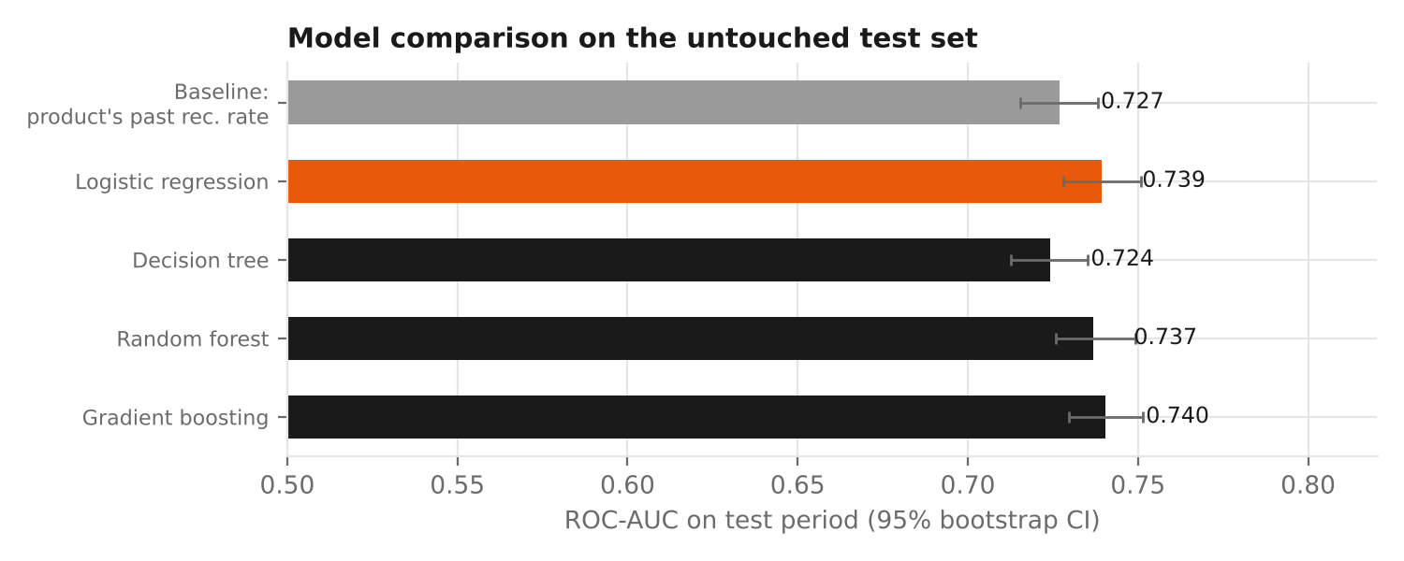
Figure 1. Test ROC-AUC with 95% bootstrap intervals. Orange = selected model.
Model | ROC-AUC (95% CI) | PR-AUC "not rec." | Precision* | Recall* | F1* | Brier
Always "recommend" | 0.500 | 0.187 | — | 0.00 | — | —
Product's past rec. rate | 0.727 (0.715–0.738) | 0.376 | 0.61 | 0.04 | 0.08 | 0.136
Logistic regression | 0.739 (0.728–0.751) | 0.402 | 0.33 | 0.66 | 0.44 | 0.207†
Decision tree | 0.724 (0.713–0.735) | 0.343 | 0.30 | 0.75 | 0.43 | 0.213
Random forest | 0.737 (0.726–0.749) | 0.394 | 0.32 | 0.69 | 0.43 | 0.206
Gradient boosting | 0.740 (0.730–0.751) | 0.400 | 0.32 | 0.70 | 0.44 | 0.210

Table 9. Test results. *For the "not recommended" class at threshold 0.5. †Before calibration; 0.134 after (Section 9.1).
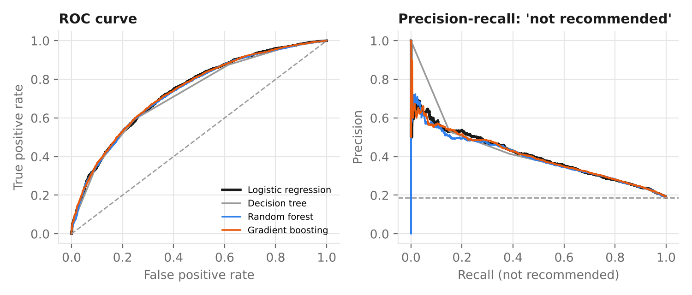
Figure 2. ROC and precision–recall curves on the test period.

7.3 Why logistic regression was selected
- Best on validation (0.728), which is the pre-agreed selection rule.
- Statistically tied with gradient boosting on test (0.739 vs 0.740; intervals overlap almost completely) and with the best PR-AUC (0.402).
- Occam's razor: with equal accuracy, the simpler model generalises more predictably and is easier to maintain.
- Explainability: each effect is an odds ratio that merchandisers and brand teams can read (Section 10).
- Good probabilities after calibration, needed for the cost-based threshold.
Gradient boosting is kept as a challenger model: if it beats logistic regression by more than the confidence interval on the real Sephora data — likely, since real data has more non-linear structure — it will replace it.
Value over the baseline: the AUC gain over "product's past recommendation rate" is modest (+0.012), but the practical difference is large. The baseline almost never predicts an unhappy shopper (recall 4%), because it only knows about the product. The model also knows about the shopper, through skin type, skin match and the dry × fragrance interaction, and catches 66% of unhappy shoppers at the default threshold.

8. Overfitting & Underfitting
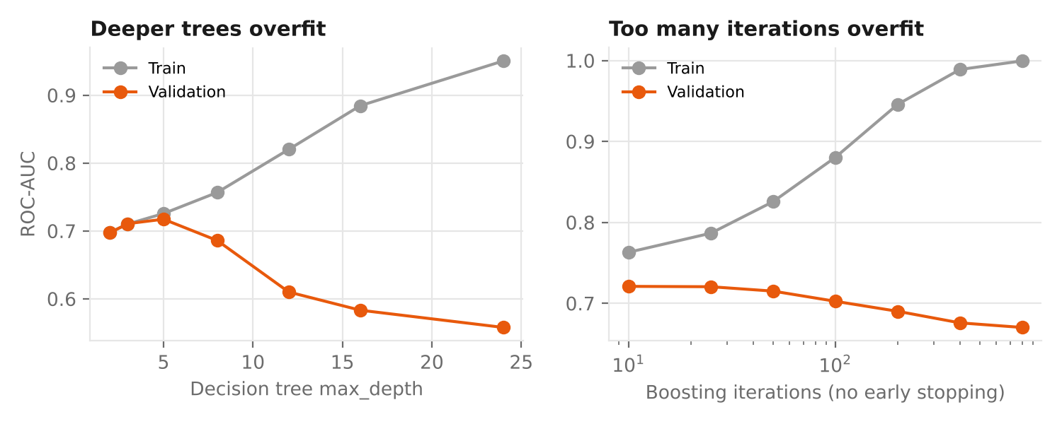
Figure 3. Validation curves: training AUC keeps rising while validation AUC falls — classic overfitting.
Decision tree: at depth 24 the tree scores 0.95 on training data but only 0.56 on validation. It memorises individual products and shoppers. Validation AUC peaks at depth 5 (0.717). Gradient boosting without early stopping: after 800 rounds training AUC reaches 0.9995 while validation falls from 0.721 to 0.670. Both curves justify the regularised settings chosen by cross-validation.
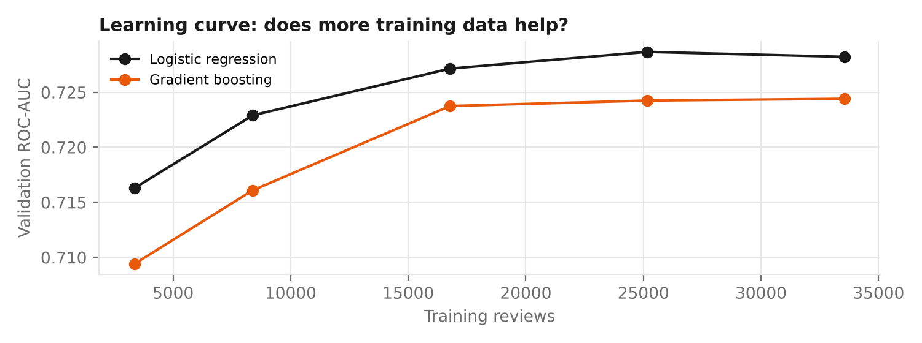
Figure 4. Learning curves: validation AUC as the training set grows (most recent reviews kept).
Validation AUC rises from 0.716 to 0.727 between 3,400 and 17,000 training reviews, then flattens (0.728 at 33,600). More data of the same kind would help little: the remaining error is noise in individual satisfaction, not too little data. Further gains must come from new information (real text, reviewer history), not more rows.
Model | Train AUC | Test AUC | Gap | Diagnosis
Logistic regression | 0.727 | 0.739 | −0.012 | No overfitting (test period slightly easier)
Decision tree (depth 3) | 0.709 | 0.724 | −0.015 | Slight underfitting — too simple
Random forest | 0.746 | 0.737 | +0.009 | Well controlled
Gradient boosting | 0.742 | 0.740 | +0.002 | Well controlled

Table 10. Train–test gaps for the final models.

8.1 Mitigation toolbox
Problem | Symptom | Mitigation used
Overfitting | Train ≫ validation score | L2 regularisation (C = 0.01); max_depth and min_samples_leaf limits; early stopping; learning rate 0.03; bagging (random forest); feature families validated by ablation in Week 4
Underfitting | Both scores low | Engineered interaction features; comparing non-linear models; adding information rather than complexity
Tuning overfit | Optimistic CV scores | Small grids; selection on a separate validation period; test used once
Temporal overfit | Model fits past behaviour that changes | Time-based CV; planned monthly retraining and drift monitoring (Section 12)

Table 11. Overfitting and underfitting controls.

9. Robustness Checks & Pitfalls

9.1 Calibration
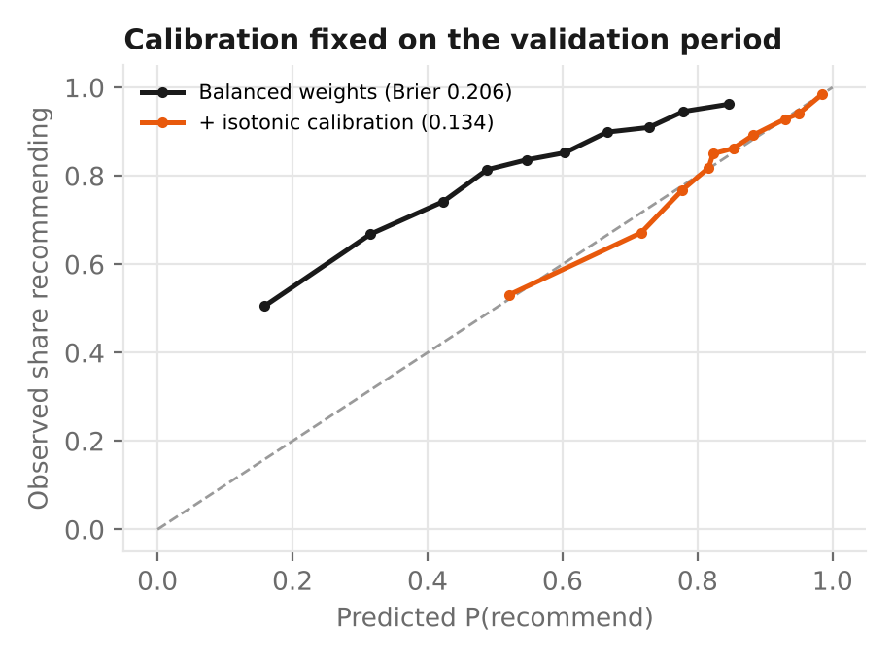
Figure 5. Reliability diagram before and after isotonic calibration.
class_weight = "balanced" improves recall but distorts probabilities: the model predicted an average 55.5% chance of recommending when the true rate was 81.3%. Isotonic calibration fitted on the validation period fixes this (average prediction 81.5%; Brier 0.206 → 0.134) without changing the ranking (AUC 0.739 → 0.738). Calibrated probabilities are used for all cost calculations.

9.2 Fairness across skin tones
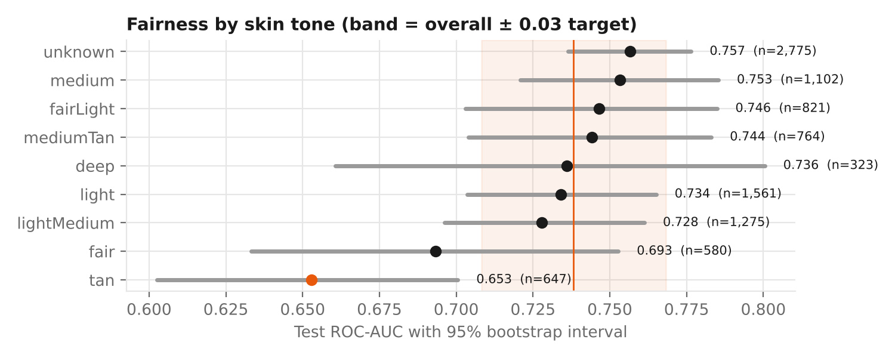
Figure 6. Test AUC by skin tone with 95% bootstrap intervals; the band shows the ±0.03 target around the overall AUC.
Seven of the nine skin-tone groups fall within or near the target band (AUC 0.728–0.757), but "tan" (0.653, n = 647, CI 0.603–0.701) and "fair" (0.693, n = 580) are lower. The largest gap is 0.104 (95% CI 0.072–0.180), so the Week 2 requirement (≤ 0.03) is not met.
Two cautions apply. First, a max–min gap across nine small groups is inflated by chance: with about 600 reviews, a single group's AUC has a standard error of roughly 0.025. Second, skin tone has no built-in effect in the simulation, so this gap reflects sampling and product mix. The process still worked: the check caught a problem that would block deployment. Mitigation plan: (1) test each group against the rest with a confidence interval rather than max–min; (2) investigate the products those groups review; (3) re-weight under-represented groups or set group-specific thresholds; (4) do not show personalised "not for you" warnings to a group until its AUC is within the band.

9.3 New and young products (cold start)
Only 23 test reviews are for products never seen in training, too few to measure directly. Two proxies were used instead. GroupKFold by product (models never see the validated products) gives a mean AUC of 0.717 (range 0.670–0.745), only slightly below 0.739. Products with fewer than 20 earlier reviews reach 0.688, versus 0.744 for established ones (n = 1,095). Implication: for new launches the model should lean on formulation and skin-match features, with a "limited data" label shown to users.

9.4 Pitfalls and mitigations
Pitfall | Why it matters here | Mitigation
Using accuracy | 81% for a useless model | AUC, PR-AUC, recall, cost
Random K-fold on time-ordered data | Leaks future product ratings into training | Time-based splits, TimeSeriesSplit
Target leakage | Text, helpfulness and full-history product ratings reveal the answer | Pre-purchase feature set; train-only encodings
Selecting on the test set | Optimistic, unrepeatable results | Validation-based selection; test used once
Uncalibrated probabilities | Wrong costs and thresholds | Isotonic calibration on validation
Ignoring subgroups | Unfair or harmful advice for some skin tones | Per-group AUC with CIs, deployment gate
Concept drift | Trends, reformulations, new launches change behaviour | Monthly retraining, drift alerts
Simulated-data optimism | Built-in effects are cleaner than reality | Re-run full pipeline on real Kaggle data before any decision

Table 12. Pitfalls and mitigations.

10. Interpreting the Model for Business

10.1 What drives recommendation — odds ratios
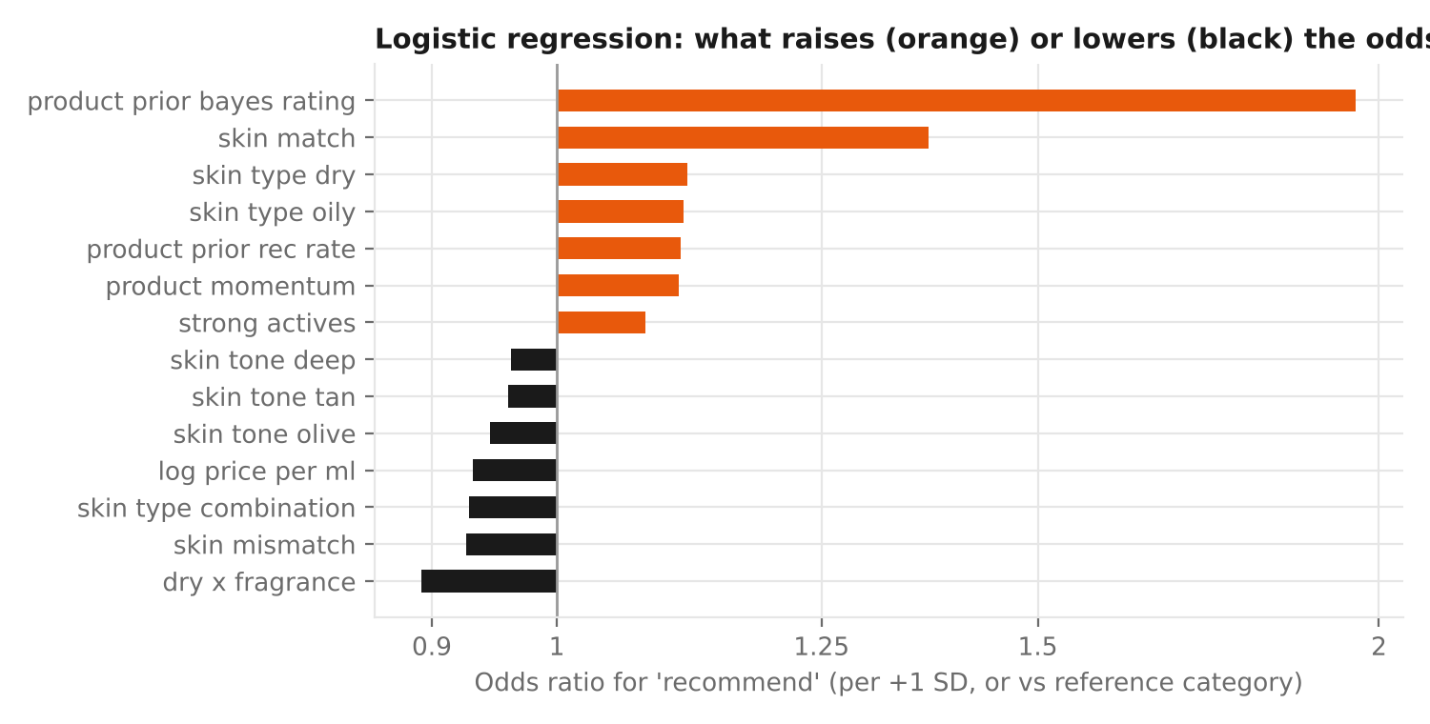
Figure 7. Largest odds ratios in the logistic regression (numeric features per +1 standard deviation).
Model result | Plain-language meaning | Business action
Product's past rating: OR 1.96 per SD | A product rated about 0.33★ higher by earlier buyers doubles the odds that the next buyer recommends it | Use Bayesian ratings in default sorting; investigate products whose rating is trending down
skin_match: OR 1.37 | When the product's "Good for" claim matches the shopper's skin, odds rise by 37% | Show "Best for your skin type" badges; ask shoppers for skin type at sign-up
dry_x_fragrance: OR 0.89 | Dry-skin shoppers are 11% less likely to recommend fragranced products | Recommend fragrance-free alternatives to dry-skin shoppers; brief R&D
skin_mismatch: OR 0.93 | Products made for the opposite skin type lower the odds | Warning: "This product is formulated for oily skin"
log price per mL: OR 0.93 | Higher unit price slightly lowers the odds once other factors are held fixed | Premium pricing must be backed by experience; consistent with H2
product_momentum: OR 1.11 | Products improving recently are rated better | Early-warning dashboard for products with negative momentum

Table 13. Translating coefficients into decisions.

10.2 How predictions change with one feature
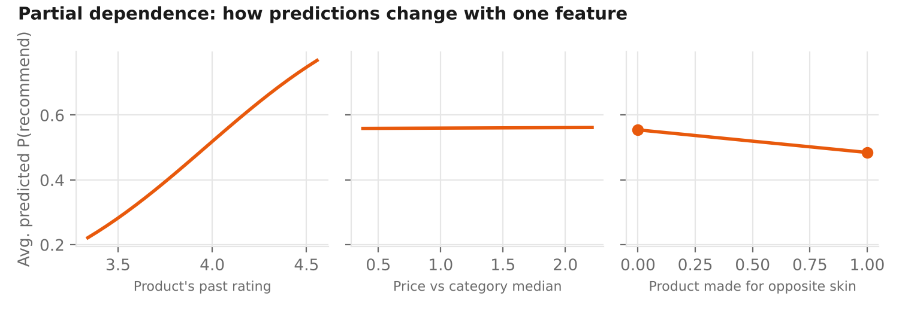
Figure 8. Partial dependence (gradient boosting challenger model).
The probability of recommending rises steeply with a product's past rating, is flat across relative price (price does not buy satisfaction), and drops when a product is made for the opposite skin type. The two model families agree on these patterns, which increases confidence in them.

10.3 From probabilities to decisions: the cost-based threshold
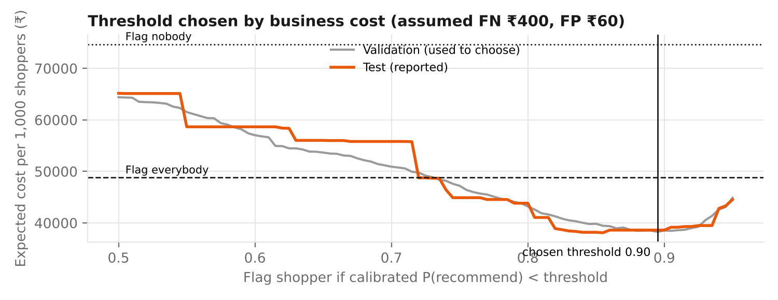
Figure 9. Expected cost per 1,000 shoppers by threshold (threshold chosen on validation, reported on test).
Hypothetical intervention: when the model predicts a shopper is likely to be unhappy with a product in their cart, the site shows a better-matched alternative or offers a free sample. Assumed costs: a missed unhappy shopper (return, churn, bad review) costs ₹400; an unnecessary intervention costs ₹60. The cost-minimising threshold on the validation period was a calibrated P(recommend) of 0.895. On the test period this:
- flags 65% of shopper–product pairs, catches 88% of unhappy shoppers (recall), with 25% precision;
- costs ₹38,600 per 1,000 shoppers, versus ₹48,800 for intervening with everyone and ₹74,700 for doing nothing — a saving of about ₹10,200 per 1,000 shoppers against the best simple rule.
The high flag rate follows from the assumed 6.7 : 1 cost ratio. With a cheaper missed-customer cost or a costlier intervention, the threshold falls and fewer shoppers are flagged. Because the code takes the costs as inputs, the business can plug in its real numbers.

10.4 Who uses what
Stakeholder | Model output they receive | Decision supported
E-commerce / personalisation | Calibrated P(recommend) per shopper–product pair | Ranking, "best for your skin" shelf, cart warnings
Category managers | Products whose predicted satisfaction is falling | Investigate reformulations, batch issues, supplier changes
Brand marketing | Odds ratios for claims and skin-match | Which claims and segments to target
R&D | Segment-specific penalties (e.g. dry × fragrance) | Fragrance-free or skin-type-specific variants
CX / returns team | Flagged high-risk orders | Proactive guidance, samples, easier exchanges

Table 14. Using the model across the business.

11. Secondary Tasks: Rating Regression & Segmentation

11.1 Predicting the star rating
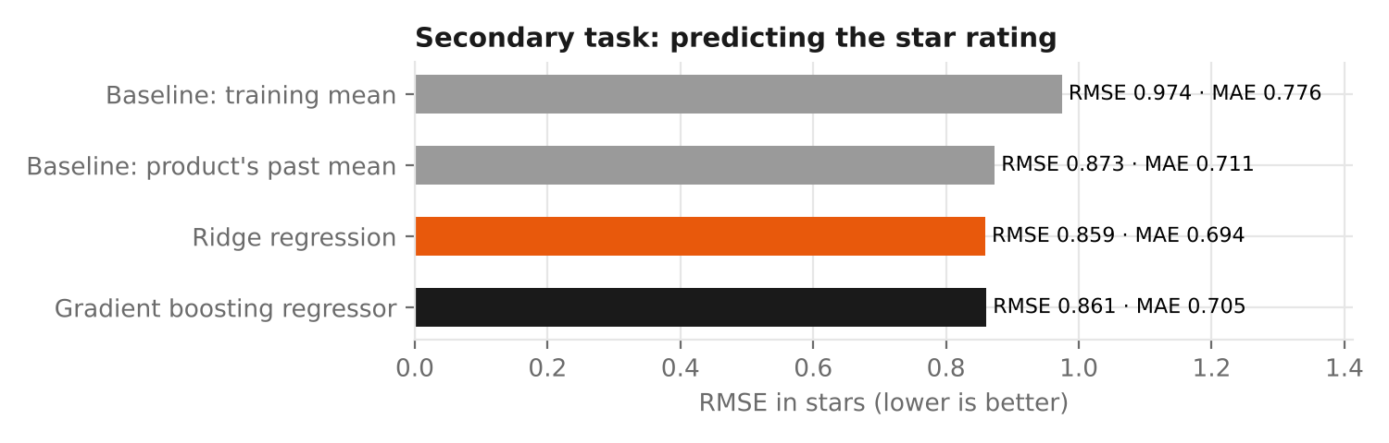
Figure 10. Test RMSE and MAE for the rating-regression task.
Ridge regression (L2-regularised linear regression) achieves RMSE 0.859 stars and MAE 0.694, beating the training-mean baseline (0.974 / 0.776) and the product-history baseline (0.873 / 0.711). The gradient-boosting regressor is equivalent (0.861). As in classification, the simpler model is chosen. A typical prediction is within about 0.7 stars, useful for forecasting a launch's likely rating range, not an individual review.

11.2 Product segmentation (k-means)
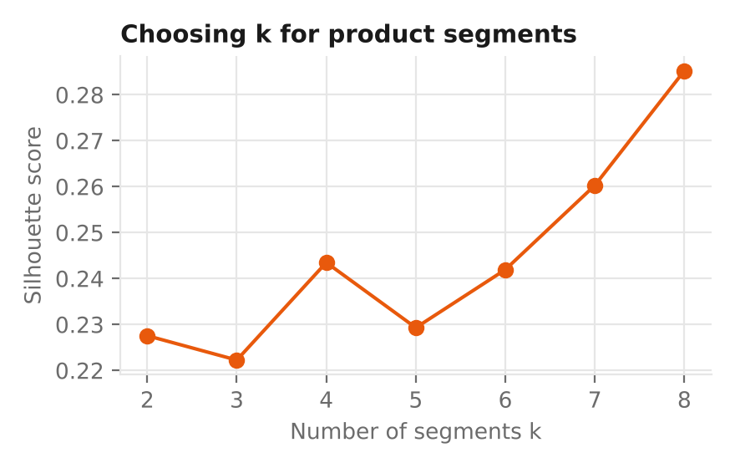
Figure 11. Silhouette score by number of product segments.
Silhouette scores are low for all k (0.22–0.29), meaning products form a continuum rather than sharply separated groups. k = 4 is a local peak (0.243) and gives the four interpretable segments described in Week 4 (basic fragranced, vegan, active-heavy fragranced, fragrance-free claimers). Higher k raises the score slightly but produces segments too small to act on. Segments are therefore used as merchandising labels and model features, not as hard boundaries.

12. Deployment & Monitoring Plan
Area | Plan
Packaging | Single scikit-learn Pipeline + calibrator saved as models/best_classifier.pkl; same code path for training and scoring
Retraining | Monthly, on a rolling window; challenger (gradient boosting) re-evaluated each time
Performance monitoring | Weekly AUC and recall on newly labelled reviews; alert if AUC falls more than 0.03 below the last release
Data drift | Population Stability Index on key features (skin-type mix, price, product history); alert if PSI > 0.2
Fairness gate | Per-skin-tone AUC with CIs at every release; personalised warnings disabled for any group outside the band
Business check | A/B test of the "best for your skin" ranking: recommendation rate, return rate, revenue per visitor

Table 15. From prototype to production.

13. Limitations & Next Steps
- Simulated data: performance and coefficients will change on real data; the method, not the numbers, is the deliverable.
- Modest ceiling: with pre-purchase information only, AUC around 0.74 means the model ranks well but individual predictions remain uncertain; actions should be low-cost nudges, not hard blocks.
- Assumed costs in Section 10.3 are illustrative and must be replaced with real return and retention figures.
- Fairness target not yet met; deployment is blocked until it is.

Week 6 plan
- Run Weeks 3–5 end to end on the real Sephora data and compare with these simulated results.
- Build the skin-type-aware recommender and a Streamlit dashboard for stakeholders.
- Add a text-sentiment model (transformer) for analysing existing reviews (H3).
- Present final insights and recommendations.

Appendix — Code & Outputs
python -m src.modeling.train_models # tune 4 models, select, test, curves, interpretation, regression, clustering (~5 min)
python -m src.modeling.robustness # calibration, fairness CIs, unseen/young products, cost-based threshold

src/modeling/train_models.py reports/model_results.json models/best_classifier.pkl docs/week5/figures/f01-f11
src/modeling/robustness.py reports/robustness.json

References
Bergmeir, C., & Benítez, J. M. (2012). On the use of cross-validation for time series predictor evaluation. Information Sciences, 191, 192–213.
Breiman, L. (2001). Random forests. Machine Learning, 45(1), 5–32.
Elkan, C. (2001). The foundations of cost-sensitive learning. Proceedings of IJCAI 2001, 973–978.
Friedman, J. H. (2001). Greedy function approximation: A gradient boosting machine. Annals of Statistics, 29(5), 1189–1232.
Hardt, M., Price, E., & Srebro, N. (2016). Equality of opportunity in supervised learning. Advances in Neural Information Processing Systems 29.
Hastie, T., Tibshirani, R., & Friedman, J. (2009). The Elements of Statistical Learning (2nd ed.). Springer.
Kaufman, S., Rosset, S., Perlich, C., & Stitelman, O. (2012). Leakage in data mining. ACM TKDD, 6(4).
Ke, G., et al. (2017). LightGBM: A highly efficient gradient boosting decision tree. Advances in Neural Information Processing Systems 30.
Niculescu-Mizil, A., & Caruana, R. (2005). Predicting good probabilities with supervised learning. Proceedings of ICML 2005, 625–632.
Pedregosa, F., et al. (2011). Scikit-learn: Machine learning in Python. JMLR, 12, 2825–2830.
Rousseeuw, P. J. (1987). Silhouettes: A graphical aid to the interpretation and validation of cluster analysis. Journal of Computational and Applied Mathematics, 20, 53–65.
Saito, T., & Rehmsmeier, M. (2015). The precision-recall plot is more informative than the ROC plot when evaluating binary classifiers on imbalanced datasets. PLOS ONE, 10(3), e0118432.

