WEEK 6 · MODEL EVALUATION, REPORTING & BUSINESS IMPACT
Decoding the Skincare Shopper
Final report — how well the model predicts skincare satisfaction, what it means for the business, and what to do next
PREPARED BY Aayush Gautam
PROGRAMME Data Science with Python Internship — YuvaIntern (Henry Harvin)
AUDIENCE Brand, marketing, e-commerce and product leaders; technical reviewers (appendices)
BUILDS ON Weeks 1–5: problem, data strategy, cleaning pipeline, EDA & features, model selection
CODE github.com/weebaayush/beauty-wellness (src/evaluation)
DATE November 2026

Contents
1. Executive Summary for Decision-Makers
2. The Project in One Page
3. Evaluation Strategy
4. Results: How Well Does the Model Work?
5. Business Impact
6. Communicating the Results
7. Actionable Recommendations
8. Risks, Limitations & Ethics
9. Final Summary
Appendix A — Glossary for Non-Technical Readers
Appendix B — Metric Definitions
Appendix C — Reproducibility
References

1. Executive Summary for Decision-Makers
The question. Online skincare shoppers cannot test products, so many buy something that does not suit their skin, then return it, leave a bad review or stop buying. Can we predict, before purchase, whether a shopper will be happy with a product — and use that to guide shoppers, brands and marketing?
The answer. Yes, usefully but not perfectly. The model ranks a happy shopper above an unhappy one about 74 times out of 100 (AUC 0.74). That is not good enough to block purchases, but good enough to re-rank products, add "best for your skin" guidance and target help where it matters most. The model was tested on 18 months of reviews it had never seen.
Important: all results come from a realistic simulated version of the public Sephora skincare dataset, built to test the full method end to end. The method and code are ready; the numbers must be confirmed on the real data before any business decision (Recommendation R0).
What we found | What it means for the business
Whether a product suits the shopper's skin type is the strongest shopper-side signal: 90% recommend when it matches, 73% when it is made for the opposite skin type | Personalise by fit, not just by skin-type segments
Price does not predict satisfaction (correlation −0.06) | Premium prices need other justification; value brands can win on satisfaction
Fragrance lowers satisfaction only for dry skin (82.6% → 78.5%) | Fragrance-free variants and targeted messaging for dry-skin shoppers
The 10% of shoppers the model rates riskiest are 2.6× more likely to be unhappy | Help (samples, alternatives, advice) can be focused where it pays
Under assumed costs, acting on the model saves about ₹10,200 per 1,000 shoppers versus the best simple rule | ≈ ₹10 lakh a month for a retailer with 100,000 such shopping decisions (illustrative)
Accuracy is lower for one skin-tone group ("tan") | Must be fixed before launch — a fairness and trust issue

Table 1. Key findings at a glance.
Top recommendations: (1) confirm on real data; (2) launch a "best for your skin" ranking as an A/B test; (3) ask every shopper for their skin type; (4) give category managers an early-warning list of products losing satisfaction; (5) brief R&D on fragrance-free options for dry skin; (6) close the fairness gap before any personalised warnings go live. Details, owners and timelines are in Section 7.

2. The Project in One Page
Week | Step | Key output
1 | Problem definition | Business problem, 5 research questions, 6 hypotheses (H1–H6)
2 | Data sourcing | 14 public sources evaluated; Sephora reviews chosen; decision rules fixed in advance
3 | Cleaning pipeline | 9-stage tested pipeline; 41 data problems fixed; privacy protection
4 | EDA & features | Hypotheses tested; 35 new features; skin-fit identified as the key signal
5 | Modelling | 4 algorithms compared on a time-based split; logistic regression selected (AUC 0.739)
6 | Evaluation & communication | This report: 6-stage validation framework, business impact, recommendations

Table 2. Project journey.
What the model does: for a shopper (skin type, skin tone, profile) looking at a product (ingredients, claims, price, category, how earlier buyers rated it), it estimates the probability that the shopper will recommend the product after using it. It uses only information available before purchase.

3. Evaluation Strategy

3.1 What "good" means — success criteria
Success was defined before the final test, partly in Week 1 and refined in Weeks 2 and 5. The scorecard is in Section 4.10.
Criterion | Why it matters | Target
Ranking quality (ROC-AUC) | Can the model put suitable products first? | ≥ 0.72 for pre-purchase prediction (Week 1 target of 0.85 assumed review text, see 4.10)
Beats simple business rules | Otherwise a simple rule is cheaper | Better than "product's past rating" and better cost than "flag all / flag none"
Catches unhappy shoppers (recall) | Missed unhappy shoppers drive returns and churn | ≥ 80% at the chosen threshold
Trustworthy probabilities (calibration) | Costs and thresholds use probabilities | Average prediction within 2 points of reality
Stable over time | Will it keep working after launch? | Every quarter within ±0.03 AUC of overall
Fair across skin tones | Equal service quality for all customers | No group significantly more than 0.03 AUC below the rest
Business value | The point of the project | Positive saving under realistic cost assumptions

Table 3. Success criteria.

3.2 Metrics chosen, explained in plain language
Metric | Plain-language meaning | Why chosen
ROC-AUC | Pick one happy and one unhappy shopper at random: how often does the model give the happy one the higher score? 0.5 = coin toss, 1.0 = perfect. | Measures ranking, which is what product sorting needs; not fooled by the 81/19 split
Recall (unhappy shoppers) | Of all shoppers who end up unhappy, what share did we spot in advance? | Missed unhappy shoppers are the most expensive error
Precision (unhappy shoppers) | Of the shoppers we flagged, what share really were unhappy? | Controls wasted interventions
F1-score | A single balance of precision and recall | Common summary; reported, but not used to decide (it ignores costs)
PR-AUC | Precision–recall quality across all thresholds | Better than ROC-AUC at showing performance on the rare "unhappy" group
Calibration / Brier score | When the model says 80%, do about 80% of such shoppers recommend? | Needed for cost calculations and customer-facing percentages
Lift | How many times more unhappy shoppers we find in the top-risk group than at random | The language of marketing targeting
Expected cost (₹ per 1,000 shoppers) | Money lost to missed unhappy shoppers plus unnecessary interventions | Turns model quality into business value; sets the threshold

Table 4. Metrics and rationale.
Why not accuracy? At the chosen operating point the model's accuracy is only 49% — yet it is the most profitable option. It deliberately flags many happy shoppers (a cheap gentle nudge) to catch 88% of unhappy ones (an expensive problem). A model that never flags anyone is 81% "accurate" and the most expensive option of all. Accuracy hides exactly the trade-off the business cares about.

3.3 Six-stage validation plan
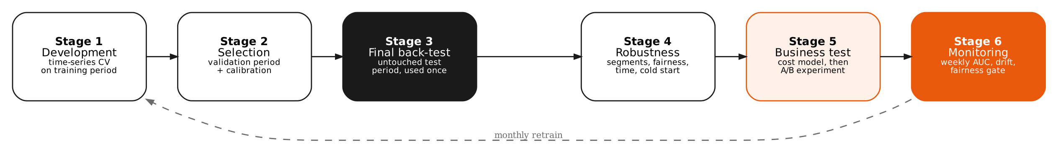
Figure 1. Validation framework, from development to monitoring.
Stage | Question answered | Method | Pass criterion | Status
1. Development | Which settings work best? | Time-series cross-validation (4 folds) on 2016–2020 reviews | Stable CV scores | ✔ Done (Wk 5)
2. Selection | Which algorithm? | Compare on Aug 2020–Oct 2021 reviews; calibrate | Highest validation AUC; calibrated | ✔ Logistic regression
3. Final back-test | How good on unseen future data? | One evaluation on Oct 2021–Mar 2023 (10,488 reviews) | AUC ≥ 0.72, beats baselines | ✔ AUC 0.738
4. Robustness | Does it hold everywhere? | By quarter, category, skin type, skin tone; new products; error analysis | Within ±0.03; no significant fairness gap | ⚠ Fairness gap (tan)
5. Business test | Does it make money and help customers? | Cost model now; live A/B test next | Positive saving; A/B uplift | ◐ Modelled; A/B pending
6. Monitoring | Does it keep working? | Weekly AUC, drift (PSI), fairness gate, monthly retraining | Alerts within thresholds | ○ Designed

Table 5. Validation stages and status.

4. Results: How Well Does the Model Work?

4.1 Model comparison
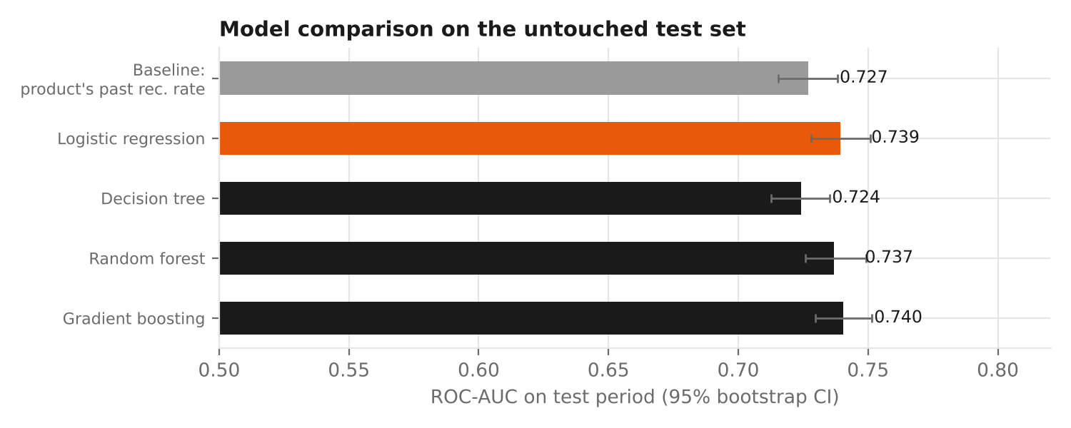
Figure 2. Test ROC-AUC of each algorithm with 95% confidence intervals (from Week 5).
All four algorithms reach similar quality (0.724–0.740). Logistic regression was chosen because it was best on the validation period, is statistically tied with the most complex model, and can be explained to managers as simple "odds" effects. The deployed version is calibrated, giving AUC 0.738 on the test period.

4.2 What happens to 1,000 shoppers
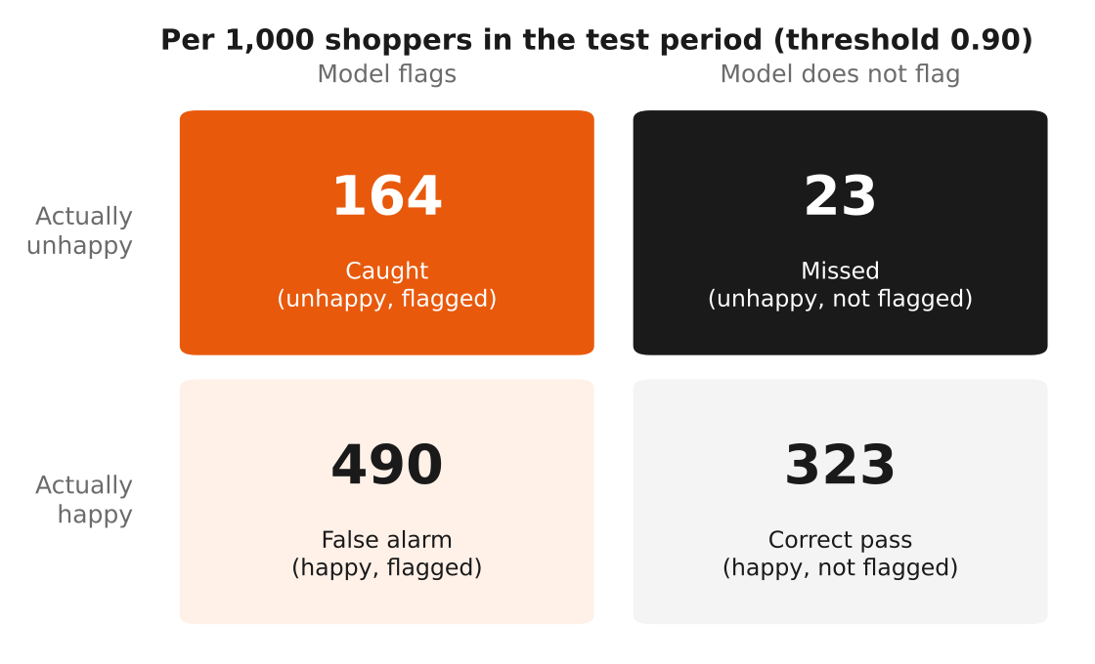
Figure 3. Outcomes per 1,000 shoppers at the cost-optimal threshold.
Out of 1,000 shopper–product decisions, 187 end up unhappy. The model catches 164 of them (88%) and misses 23. To do so it also flags 490 shoppers who would have been happy — acceptable only because the planned action is cheap and helpful (showing a better-matched alternative or a sample), never a block. Precision is 25%: one in four flagged shoppers really was heading for disappointment, compared with about one in five at random.

4.3 Targeting: gains and lift
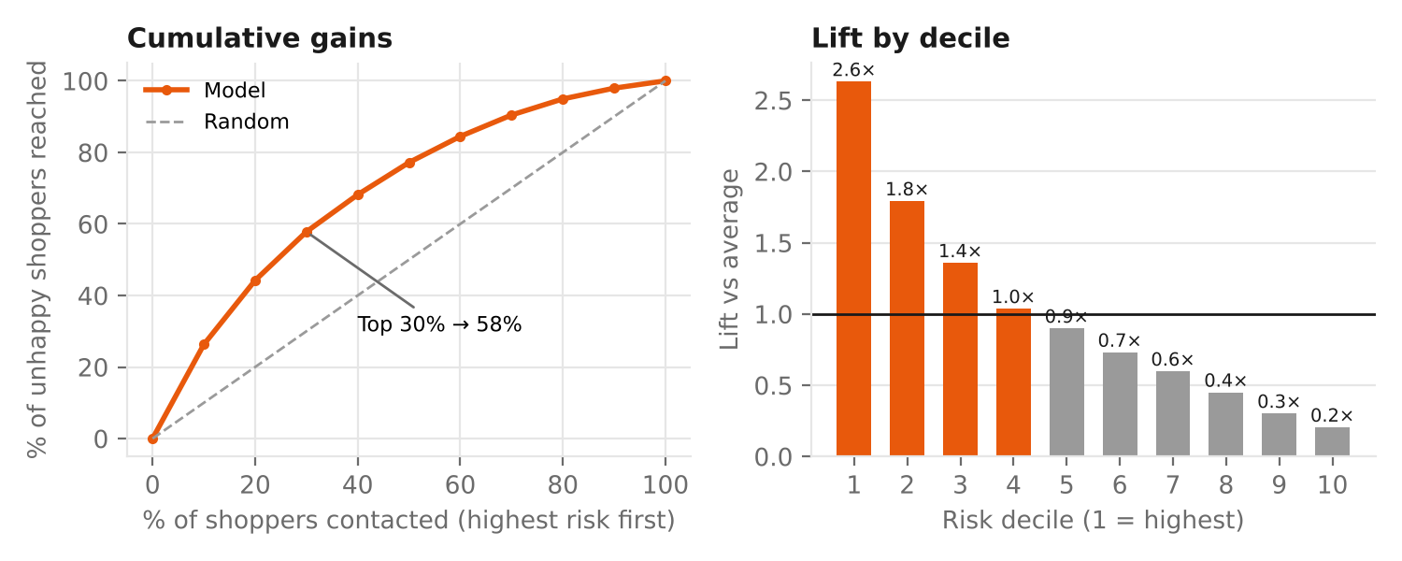
Figure 4. Cumulative gains and lift by risk decile.
If the team can only contact a limited number of shoppers, the model says whom to prioritise. The riskiest 10% of shoppers contain 26% of all unhappy shoppers (lift 2.6×; 49% of them are unhappy versus 4% in the safest 10%). Contacting the riskiest 30% reaches 58% of unhappy shoppers. This is the basis for budget-limited campaigns such as free samples or skin consultations.

4.4 Can we trust the percentages?
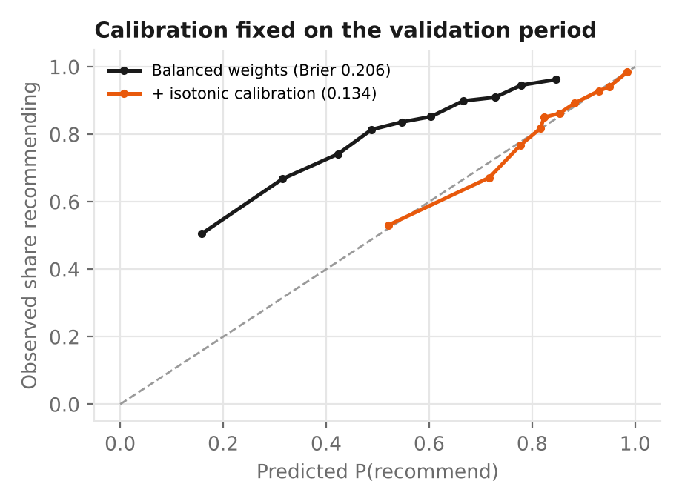
Figure 5. Calibration before and after correction (from Week 5).
After calibration, the average predicted chance of recommending (81.5%) matches the real rate (81.3%). When the model says "80% of shoppers like you recommend this", that statement is reliable enough to show customers, as long as it is labelled as an estimate.

4.5 Stability over time
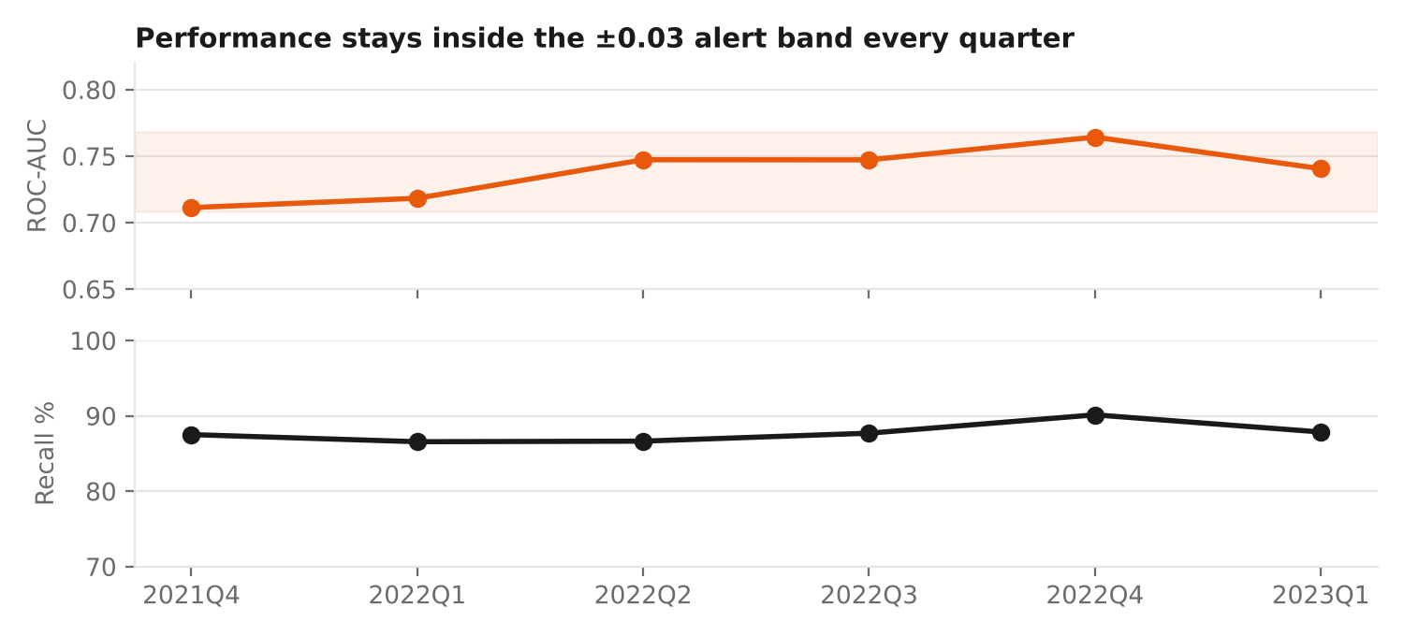
Figure 6. Quarterly AUC and recall over the 18-month test period (band = overall ± 0.03).
Performance did not decay over 18 months: quarterly AUC ranged from 0.711 to 0.764, inside the alert band, and recall stayed between 87% and 90%. Monthly retraining is still planned, because real markets change faster than this simulation (new launches, trends, reformulations).

4.6 Where the model works best and worst
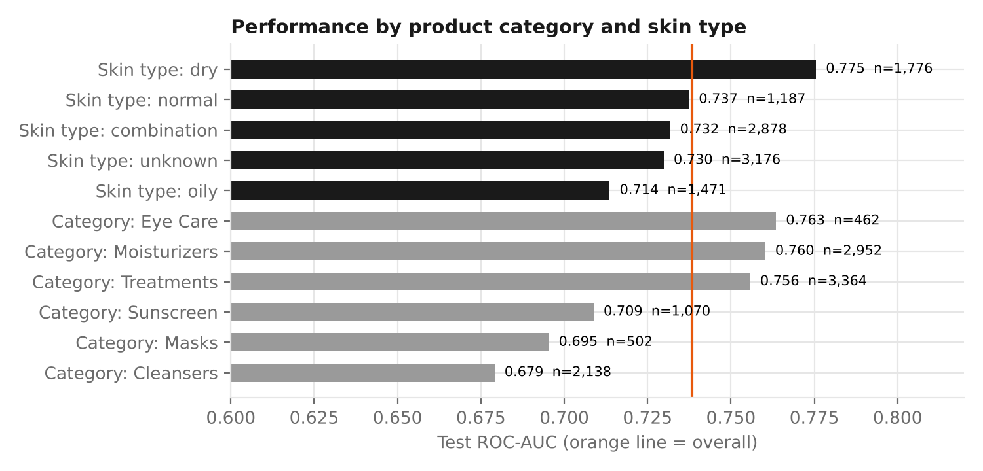
Figure 7. Test AUC by product category and skin type.
Segment | AUC | Interpretation
Eye care, moisturisers, treatments | 0.76 | Strongest — satisfaction depends on skin fit and formulation, which the model sees
Sunscreen, masks | 0.70–0.71 | Moderate — texture, white cast and scent matter more and are not in the data
Cleansers | 0.68 | Weakest — cleansers are judged on feel, which is hard to predict before use
Dry skin | 0.78 | Best skin type — the fragrance effect is a clear signal
Oily skin | 0.71 | Lowest skin type — needs texture information (e.g. "oil-free", "gel")

Table 6. Segment performance in plain language.
Implication: launch personalised features first in moisturisers and treatments, where the model is strongest, and add texture information before relying on it for cleansers.

4.7 Fairness across skin tones
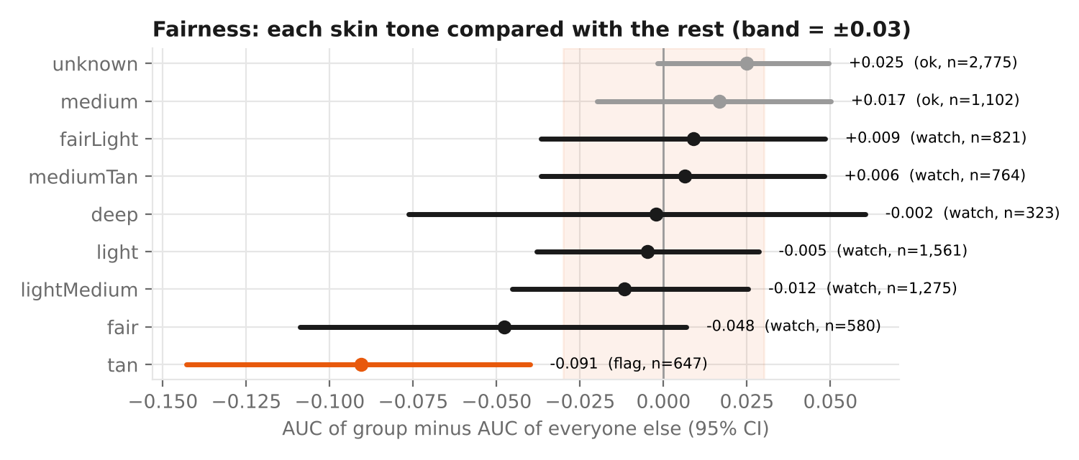
Figure 8. Each skin tone compared with all other shoppers (difference in AUC, 95% interval).
Week 5 measured fairness as the gap between the best and worst group, which exaggerates differences when there are many small groups. This report uses a stricter and fairer test: each group versus everyone else, with a confidence interval. Results:
- Flag — "tan" (n = 647): AUC 0.09 lower than the rest, and the whole interval (−0.143 to −0.040) is worse than the −0.03 limit. A real gap.
- Watch — "fair" and five other groups: no proven gap, but the intervals are too wide (small groups) to rule one out. More data is needed.
- OK — "medium" and "unknown": confidently within the limit.
Decision: personalised "not for your skin" warnings stay switched off for the flagged group until the gap is closed (Recommendation R8). The first step is to check whether those shoppers review different products, before re-weighting or collecting more data.

4.8 Who does the model miss?
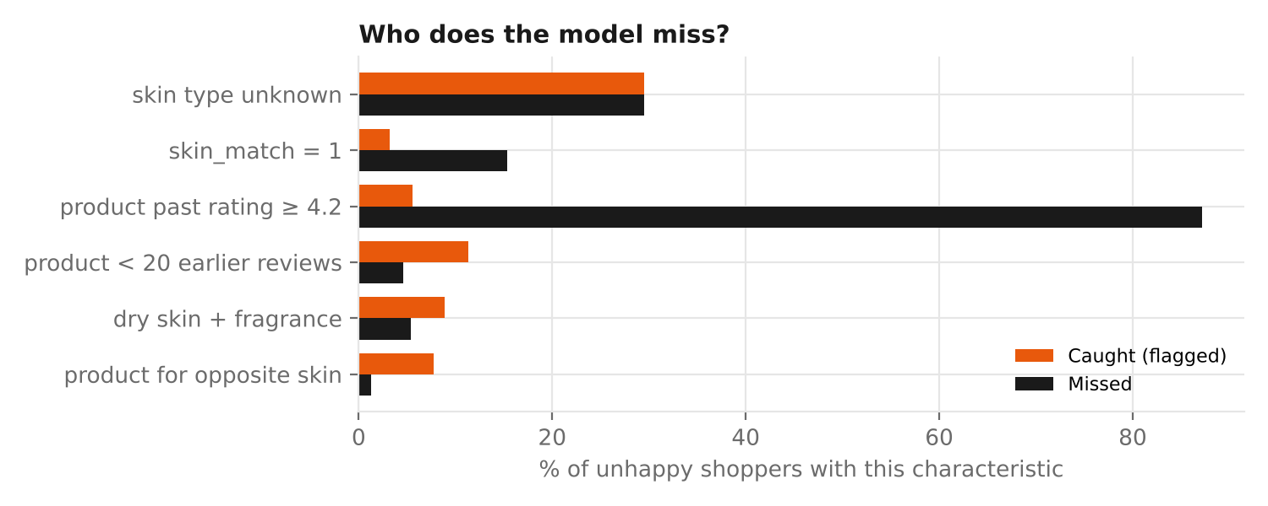
Figure 9. Characteristics of unhappy shoppers the model caught versus missed.
Only 241 of 1,958 unhappy test shoppers were missed, and they share one pattern: 87% bought a product that earlier buyers rated highly (≥ 4.2★), versus 6% of those caught; 15% even bought a product matched to their skin type. These are "surprise disappointments" — good products that did not work for one person. No pre-purchase model can predict these well. They are better handled after purchase: an easy-exchange offer, and analysing their review text (planned text model).

4.9 What drives the predictions
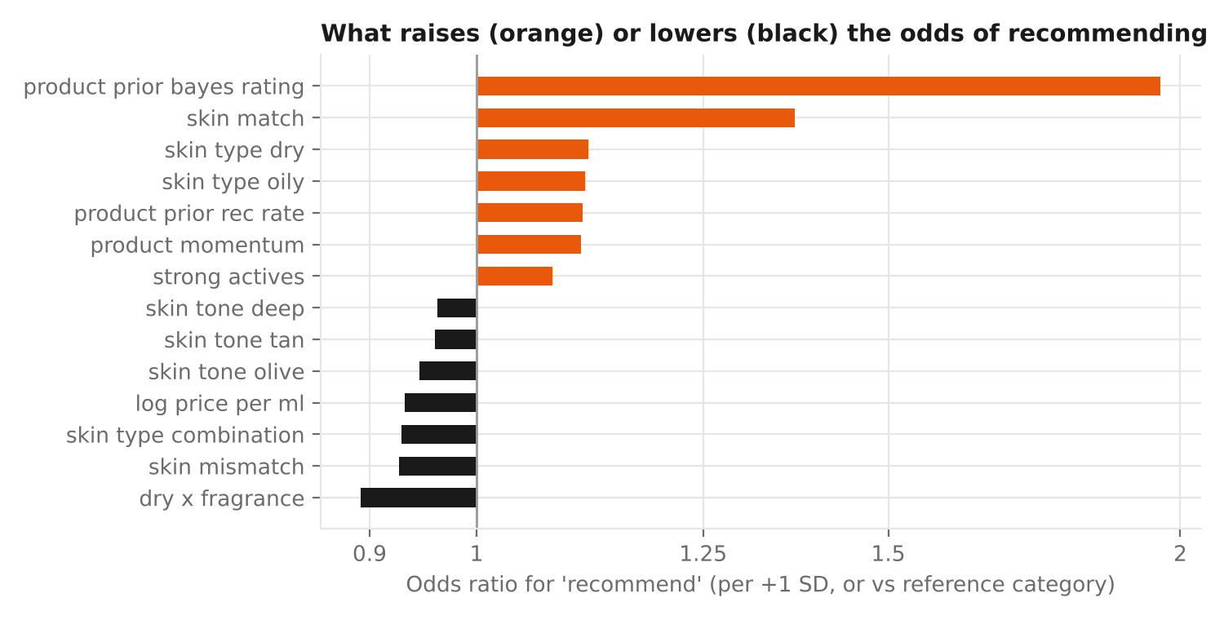
Figure 10. Factors that raise (orange) or lower (black) the odds of recommending (from Week 5).
Driver | Effect in plain words
How earlier buyers rated the product | The biggest factor: about 0.3★ higher past rating ≈ double the odds of a happy buyer
Product made for the shopper's skin type | +37% odds
Dry skin and the product contains fragrance | −11% odds
Product made for the opposite skin type | −7% odds
Higher price per mL | Slightly lower odds once other factors are equal — price does not buy happiness

Table 7. Main drivers.

4.10 Evaluation scorecard
Criterion | Target | Result | Status
Ranking quality | ≥ 0.72 (pre-purchase) | 0.738 (95% CI 0.728–0.751) | ✔ Met
Week 1 ambition | ≥ 0.85 | 0.74 pre-purchase; 0.97 with review text (simulated, post-purchase) | ✘ Not met pre-purchase (see note)
Beats simple rules | Better than baselines | AUC 0.738 vs 0.727; cost ₹38.6k vs ₹48.8k per 1,000 | ✔ Met
Recall of unhappy shoppers | ≥ 80% | 88% | ✔ Met
Calibration | Within 2 points | 81.5% predicted vs 81.3% actual | ✔ Met
Stability | Each quarter ± 0.03 | 0.711–0.764 (all inside) | ✔ Met
Fairness | No group significantly < −0.03 | "tan" −0.091 (CI −0.143 to −0.040) | ✘ Not met — blocking
Business value | Positive saving | ₹10,200 per 1,000 shoppers (assumed costs) | ✔ Met (assumption-dependent)

Table 8. Scorecard.
Note on the Week 1 target: the 0.85 target was set before deciding that the model must work before purchase. Week 4 showed that review text pushes AUC well above 0.85, but text only exists after purchase. For pre-purchase prediction, 0.74 is a realistic ceiling given how personal skincare reactions are. The target has been revised rather than the problem redefined to hit it.

5. Business Impact

5.1 Customer engagement: guiding shoppers to products that suit them
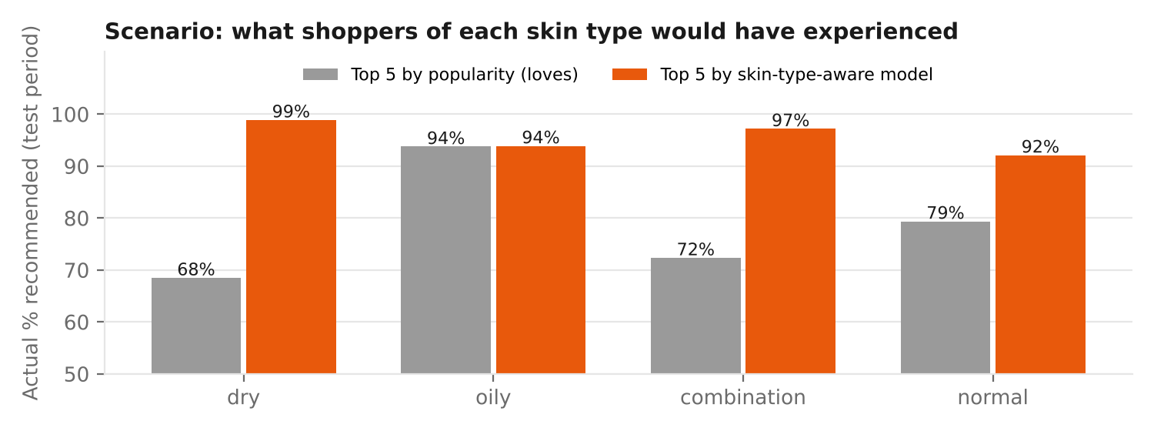
Figure 11. Back-test: actual satisfaction with the top-5 products chosen by popularity versus by the skin-aware model (from Week 4).
Showing each skin type the five products the model rates highest, instead of the five bestsellers, would have meant 95.5% instead of 78.5% of those shoppers recommending their purchase in the back-test. For dry skin the bestsellers performed below the category average (68.5% vs 81.7%) — popular is not the same as suitable. Because these samples are small, this is the strongest case for an A/B test rather than an immediate rollout.

5.2 Financial impact of a "better match" nudge
Option (per 1,000 shoppers) | Expected cost | Notes
Do nothing | ₹74,700 | Every unhappy shopper becomes a return, churn or bad review (₹400 each, assumed)
Nudge everybody | ₹48,800 | Cheap (₹60 each, assumed) but wasteful
Nudge shoppers the model flags | ₹38,600 | Catches 88% of unhappy shoppers; saves ₹10,200 vs the best simple rule

Table 9. Cost comparison (test period, calibrated model, threshold 0.895 chosen on validation data).
At 100,000 shopping decisions a month, the saving would be about ₹10.2 lakh per month, before counting the longer-term value of customers who stay loyal because their first purchase worked. These cost figures are assumptions for illustration; the code accepts the company's real figures.
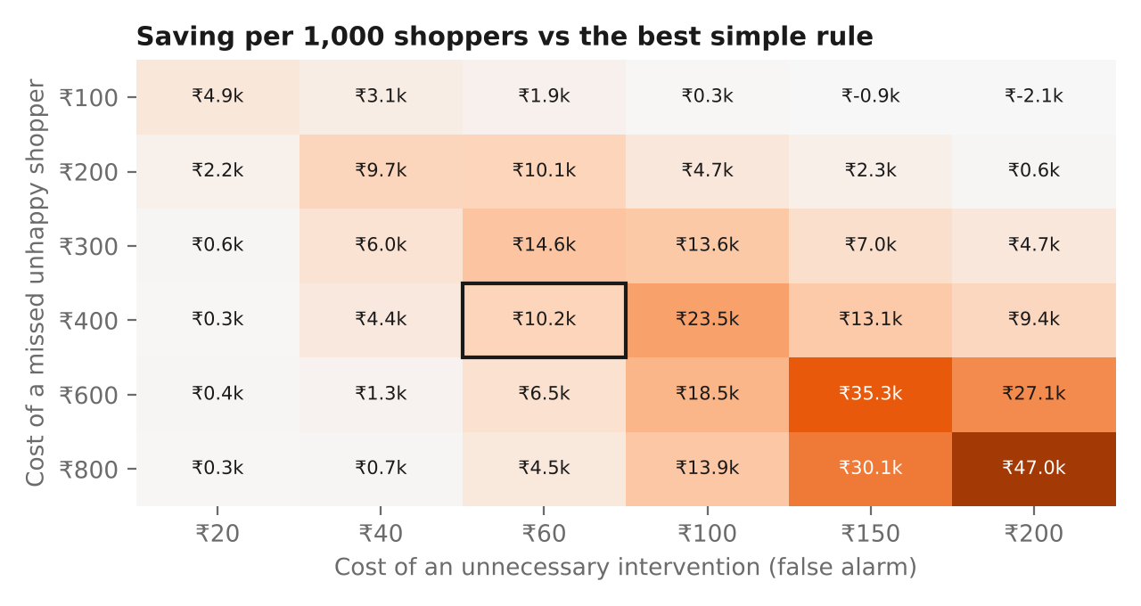
Figure 12. Saving per 1,000 shoppers for different cost assumptions (box = assumption used).
When does it pay? The saving is largest when a missed unhappy customer is expensive relative to an intervention (bottom-right of the grid: up to ₹47,000 per 1,000). When misses are cheap (₹100) and interventions costly (≥ ₹150), the programme does not pay and should not run. Finance should supply real return-processing and customer-lifetime-value figures before launch.

5.3 Brand decisions
- Formulation: dry-skin shoppers are 4 points less likely to recommend fragranced products, while other skin types show no penalty. A fragrance-free variant of best-selling moisturisers, marketed to dry skin, is a targeted opportunity rather than a range-wide reformulation.
- Claims: "Good for: [skin type]" claims are among the strongest drivers when they match the buyer. Brands should make these claims precise and visible, and back them with testing.
- Pricing and positioning: price does not predict satisfaction. Premium brands must justify price through experience, sensoriality or brand story; value brands can credibly compete on "loved by people with your skin type".
- Claim accuracy: the pipeline found products labelled "Fragrance Free" that list fragrance ingredients — a compliance and trust risk to fix with suppliers.

5.4 Marketing strategy
- Segment by fit, not demographics: messaging such as "for oily skin" outperforms generic messaging only when the product truly fits.
- Budget targeting: use risk deciles to focus samples, consultations or tutorial content on the 30% of shoppers who account for 58% of disappointments.
- Social proof done right: show ratings from "shoppers with your skin type" next to overall ratings.
- Review strategy: critical reviews are voted most helpful (Week 4). Surfacing balanced reviews builds trust and reduces mismatched purchases.

5.5 Product quality and category management
The momentum feature (recent ratings compared with long-run ratings) can power a watch list of products whose satisfaction is falling — often the first sign of a reformulation complaint, a bad batch or a counterfeit wave — weeks before it shows up in returns.

6. Communicating the Results

6.1 Stakeholder dashboard (mock-up)
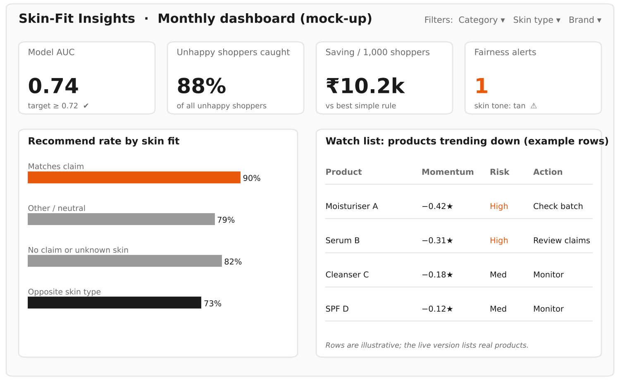
Figure 13. Mock-up of a monthly "Skin-Fit Insights" dashboard for business users.
The dashboard puts four health indicators at the top (model quality, unhappy shoppers caught, saving, fairness alerts), the key insight in the middle (satisfaction by skin fit), and an action list at the bottom (products trending down). It would be built in Streamlit or Power BI, with filters for category, skin type and brand.

6.2 One message per audience
Audience | What they need to hear | Format
Leadership | "Matching products to skin type can lift satisfaction and save ≈ ₹10 per shopper; we will prove it with an A/B test." | One-page summary (Section 1)
E-commerce / product | Ranking and nudge design, thresholds, A/B test plan | Workshop + dashboard
Brand & marketing | Fit-based segments, fragrance insight, price-satisfaction finding | Insight cards (below) + deck
R&D | Dry skin × fragrance effect; complaint themes | Short brief with evidence
Category managers | Weekly watch list of products losing satisfaction | Dashboard table + email alert
Data / tech team | Validation, metrics, code, monitoring | Appendices + GitHub repository

Table 10. Tailored communication.

6.3 Insight cards
Card 1 — Fit beats popularity
Finding: Shoppers are far happier with products made for their skin type.
Evidence: 90% recommend when the product matches their skin type vs 73% when it targets the opposite type (n = 7,487). Top-5 by fit: 95.5% vs 78.5% for top-5 bestsellers (back-test).
Action: A/B test a "Best for your skin" sort order in moisturisers and treatments. KPI: recommendation and return rate.
Card 2 — Fragrance is a dry-skin problem
Finding: Fragrance lowers satisfaction for dry skin only.
Evidence: 82.6% vs 78.5% recommendation among dry-skin shoppers (p < 0.001); no penalty for other skin types.
Action: R&D to scope fragrance-free variants of top moisturisers; marketing to target them to dry-skin shoppers.
Card 3 — Focus help where it counts
Finding: A third of shoppers account for most disappointments.
Evidence: The riskiest 30% of shoppers include 58% of all unhappy shoppers; the riskiest 10% are 2.6× more likely to be unhappy than average.
Action: Pilot free samples or a skin quiz for the top-risk 30% in one category; compare returns against a control group.

7. Actionable Recommendations
# | Recommendation | Evidence | Owner | Success KPI | When
R0 | Re-run the full pipeline on the real Sephora data and confirm key findings | All results so far are from simulated data | Data team | Findings replicated (or revised) | Month 1
R1 | Launch a "Best for your skin" ranking and badges (A/B test) | 90% vs 73% by fit; 95.5% vs 78.5% back-test | E-commerce | +3 pts recommendation rate; −10% returns | Months 2–5
R2 | Pilot a "better match" nudge in the cart | 88% of unhappy shoppers caught; ₹10.2k saving per 1,000 | E-commerce, CX | Saving vs control; no fall in conversion | Months 3–5
R3 | Ask every shopper for skin type (sign-up, quiz) | 30% of reviewers give no skin type; fit is the key signal | Marketing, CRM | > 85% of profiles with skin type | Months 1–3
R4 | Brief R&D on fragrance-free variants for dry-skin lines | Dry × fragrance penalty (−4.1 pts) | R&D, brand | Variant recommendation rate among dry skin | Months 3–8
R5 | Weekly early-warning list of products losing satisfaction | Momentum is a top driver | Category managers | Issues found before return spikes | Months 1–3
R6 | Display balanced reviews and "rated by people with your skin type" | Critical reviews most helpful; fit matters | E-commerce, content | Review engagement; fewer mismatched buys | Months 2–4
R7 | Position on value and fit, not price as a quality signal | Price–satisfaction correlation ≈ 0 | Brand, pricing | Campaign response by price tier | Ongoing
R8 | Close the skin-tone fairness gap before personalised warnings | "tan" group −0.09 AUC | Data team, legal/ethics | All groups within ±0.03 | Months 1–2 (blocking)

Table 11. Recommendations with owners, KPIs and timing.
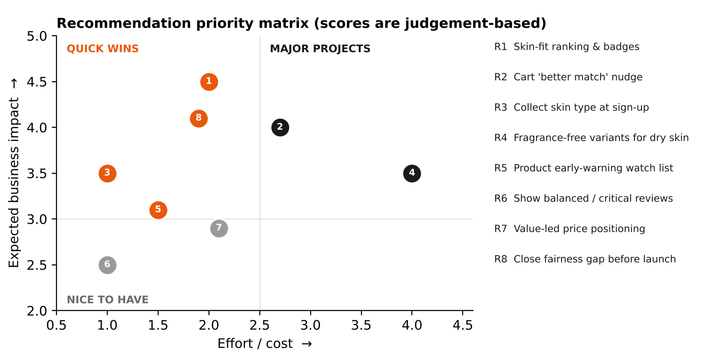
Figure 14. Priority matrix: impact versus effort.
Quick wins (high impact, low effort): skin-fit ranking (R1), fairness fix (R8), collecting skin type (R3) and the watch list (R5). Major project: fragrance-free product development (R4), which takes longer but creates lasting differentiation.
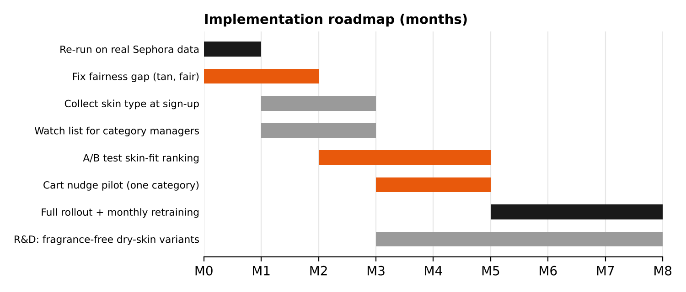
Figure 15. Eight-month implementation roadmap.

8. Risks, Limitations & Ethics
Risk / limitation | Impact | Mitigation
Results are from simulated data | Real effects may be smaller, larger or different | R0: replicate on real Sephora data before decisions
Modest predictive ceiling (AUC 0.74) | Individual predictions are uncertain | Use only for gentle nudges and ranking, never to block purchases
Assumed costs | Saving could be over- or under-stated | Sensitivity analysis (Figure 12); replace with finance data
Fairness gap for one skin tone | Unequal service; reputational risk | Blocking gate; investigate, re-weight, collect data
Correlation, not causation | E.g. fragrance effect might reflect formula type | Confirm with A/B tests and product trials
Reviewer bias | Reviewers are not all buyers; incentivised reviews | Flags from Week 3; describe results as "among reviewers"
Privacy | Skin profile is personal data | Hashed IDs, aggregation ≥ 30, opt-in skin quiz, DPDP Act 2023 principles
Model drift | Trends and launches change behaviour | Monthly retraining, weekly monitoring, drift alerts

Table 12. Risks and mitigations.

9. Final Summary
Over six weeks this project turned an industry question — why do skincare shoppers end up disappointed, and can we prevent it? — into a complete, tested data-science solution. The approach covered public-data sourcing, a reproducible cleaning pipeline, hypothesis-driven exploration, 35 engineered features, careful model selection and a six-stage evaluation framework.
Technically, a calibrated logistic regression predicts pre-purchase satisfaction with AUC 0.74, stable over 18 months, well calibrated, and better than the business rules it would replace. It falls short of the original 0.85 ambition (achievable only with post-purchase text) and has one unresolved fairness gap, which blocks deployment until fixed. Commercially, the findings point the same way: satisfaction in skincare is about fit — the right formula for the right skin — not price or popularity. Acting on that, through skin-aware ranking, targeted help, fragrance-free options for dry skin and an early-warning watch list, can make shoppers happier and save money.
If you remember three things: (1) Fit beats popularity and price — match products to skin type. (2) The model is a good guide, not a gatekeeper — use it to rank and nudge, and prove value with an A/B test. (3) Validate on real data and fix fairness first — then scale.

Appendix A — Glossary for Non-Technical Readers
Term | Meaning
Model | A formula learned from past data that estimates something for new cases
Training / validation / test data | Data used to learn / to choose between options / to check the final choice fairly, once
AUC (ROC-AUC) | How often the model ranks a happy shopper above an unhappy one (0.5 = guessing, 1 = perfect)
Recall | Share of real problems the model finds
Precision | Share of the model's alarms that are real problems
Threshold | The cut-off probability above or below which we act
Calibration | Whether predicted percentages match what actually happens
Lift | How much better than random a targeted group is
Overfitting | When a model memorises past data and fails on new data
A/B test | Showing a new feature to a random half of customers and comparing results with the other half
Confidence interval | The range in which the true value probably lies
Simulated data | Realistic artificial data used to test methods before using real data

Table 13. Glossary.

Appendix B — Metric Definitions
TP = unhappy & flagged FN = unhappy & not flagged FP = happy & flagged TN = happy & not flagged
Recall = TP / (TP + FN) = 164 / 187 = 0.88
Precision = TP / (TP + FP) = 164 / 654 = 0.25
F1 = 2·TP / (2·TP + FP + FN) = 0.39
Accuracy = (TP + TN) / total = 0.49 (why accuracy misleads: see Section 3.2)
ROC-AUC = P(score(happy) > score(unhappy)) for a random pair = 0.738
Brier = mean((p − y)²) = 0.134 after calibration
Lift(d) = unhappy rate in risk decile d / overall unhappy rate = 2.6 in decile 1
Cost = FP × ₹60 + FN × ₹400 (assumed), threshold chosen on validation data = 0.895
Fairness = AUC(group) − AUC(rest), 95% bootstrap CI; flag if the whole CI < −0.03

Appendix C — Reproducibility
python src/simulate_raw_data.py --seed 42 # Week 3: raw data (or download real Sephora data)
python -m src.cleaning.pipeline # Week 3: cleaning
python -m src.features.build_features # Week 4: features
python -m src.modeling.train_models # Week 5: model selection
python -m src.modeling.robustness # Week 5: calibration, threshold
python -m src.evaluation.evaluate # Week 6: evaluation framework -> reports/evaluation.json
python -m src.evaluation.communication_figures # Week 6: dashboard mock-up, priority matrix, roadmap

References
Elkan, C. (2001). The foundations of cost-sensitive learning. Proceedings of IJCAI 2001, 973–978.
Fawcett, T. (2006). An introduction to ROC analysis. Pattern Recognition Letters, 27(8), 861–874.
Hardt, M., Price, E., & Srebro, N. (2016). Equality of opportunity in supervised learning. Advances in Neural Information Processing Systems 29.
Kohavi, R., Tang, D., & Xu, Y. (2020). Trustworthy Online Controlled Experiments: A Practical Guide to A/B Testing. Cambridge University Press.
McKinsey & Company. (2026). State of Beauty. https://www.mckinsey.com/industries/consumer-packaged-goods/our-insights/state-of-beauty
Niculescu-Mizil, A., & Caruana, R. (2005). Predicting good probabilities with supervised learning. Proceedings of ICML 2005.
Provost, F., & Fawcett, T. (2013). Data Science for Business. O'Reilly Media. (Lift and profit curves.)
Saito, T., & Rehmsmeier, M. (2015). The precision-recall plot is more informative than the ROC plot when evaluating binary classifiers on imbalanced datasets. PLOS ONE, 10(3), e0118432.
Sculley, D., et al. (2015). Hidden technical debt in machine learning systems. Advances in Neural Information Processing Systems 28.
Government of India. (2023). The Digital Personal Data Protection Act, 2023.
Inky, N. (2023). Sephora Products and Skincare Reviews [Data set]. Kaggle.

