WEEK 3 · DATA CLEANING & PRE-PROCESSING PIPELINE DEVELOPMENT
Decoding the Skincare Shopper
A tested, configuration-driven pipeline that turns messy beauty & wellness review data into analysis- and model-ready tables
PREPARED BY Aayush Gautam
PROGRAMME Data Science with Python Internship — YuvaIntern (Henry Harvin)
DOMAIN Beauty & Wellness — Skincare e-commerce
BUILDS ON Week 1 problem (H1–H6) and Week 2 sourcing plan (Sephora primary dataset)
CODE github.com/weebaayush/beauty-wellness (src/cleaning, configs, tests)
DATE October 2026

Contents
1. Executive Summary
2. Context, Objectives & Approach
3. Data Quality Issues in Public Beauty & Wellness Data
4. Pipeline Overview & Flowchart
5. Simulating the Raw Data
6. Step-by-Step Cleaning & Pre-processing Methods
7. Results: Before vs After
8. Python Tools & Why They Fit
9. Documentation & Reproducibility
10. How Clean Data Improves Analysis & Modelling
11. Communicating Data Quality to Stakeholders
12. Limitations, Ethics & Next Steps
Appendix A — Repository Structure & Commands
Appendix B — Clean Data Dictionary (key fields)
References

1. Executive Summary
This week I designed, built and tested a data cleaning and pre-processing pipeline for the skincare review data selected in Week 2. Because the task asks to simulate the cleaning of raw data, I wrote a generator that produces a raw dataset with the same schema as the Sephora Products & Skincare Reviews dataset — 1,212 product rows and 61,500 review rows — and deliberately injected 41 types of data-quality problems that are typical of public beauty & wellness data, at known rates. Knowing exactly what was injected lets me measure whether the pipeline fixes it.
The pipeline runs in nine stages (Figure 1), is fully configured from one YAML file, records every action in an audit log, passes nine automated unit tests, and finishes in about 16 seconds. The same code runs unchanged on the real Kaggle files by switching one path.
Headline result (simulated data) | Raw | Clean
Distinct brand spellings | 79 | 30
Distinct skin-type labels | 15 | 4
Distinct category labels | 19 | 6
Invalid ratings (text or outside 1–5) | 282 | 0
Products with missing / impossible price | 6.0% | 0%
Mean product price (distorted by $9,999 and −$15 entries) | $98.35 | $55.60
Reviews with HTML markup | 3.0% | 0%
Reviews containing e-mail addresses (PII) | 126 | 0
Duplicate / syndicated / orphan reviews | 1,757 | 0
Model-ready feature matrix | — | 90 features · 41,952 train / 10,488 test rows

Table 1. Key before-and-after numbers from running the pipeline.
Why it matters: without cleaning, the average product price would be overstated by 77% ($98.35 vs $55.60), skin-type analysis (hypothesis H1) would compare 15 groups instead of 4, and 126 reviews would expose personal e-mail addresses. After cleaning, every Week 1 hypothesis can be tested on consistent, documented data.

2. Context, Objectives & Approach

2.1 Where this fits
Week 1 defined the problem — predicting whether a customer recommends a skincare product from product attributes, ingredients, reviewer skin profile and review text — and six hypotheses (H1–H6). Week 2 selected the Sephora dataset as the primary source and listed the quality risks. Week 3 turns that plan into working code.

2.2 Objectives
- Identify the data-quality issues likely in public beauty & wellness data and design a fix for each.
- Build a reproducible pipeline that handles missing values, outliers, inconsistencies, duplicates, text noise and formats.
- Normalise and encode the data for modelling without data leakage.
- Document every decision so that anyone can re-run the pipeline and get the same result.
- Show, with numbers, how cleaning improves the analysis planned for Weeks 4–6.

2.3 Approach: "simulate, inject, measure"
Testing a cleaner on data whose problems are unknown only shows that the code runs, not that it is correct. I therefore followed a three-step approach used in software testing:
- Simulate a realistic clean dataset with the Sephora column names and realistic distributions (prices log-normal, popularity Pareto-distributed, ratings skewed positive).
- Inject 41 problem types at documented rates with a fixed random seed (42), saving a ground-truth log (injection_log.json).
- Measure what the pipeline detects and fixes, and compare with the ground truth (Section 7.3).

3. Data Quality Issues in Public Beauty & Wellness Data
The table lists the problems I expect in public beauty data (Sephora, Amazon, Open Beauty Facts), with a domain-specific example, the damage each would cause if ignored, and the fix used. Issues marked ★ are specific to the beauty domain and need domain knowledge, not just generic cleaning.
# | Issue | Beauty & wellness example | Impact if ignored | Fix in pipeline
1 | Inconsistent categorical labels | Skin type stored as "combo", "Combination", "comb.", " DRY" | H1 compares 15 groups instead of 4; group sizes split | Mapping tables in config (Section 6.2)
2 | Brand name variants | "Petal & Pine", "PETAL AND PINE", "Petal & Pine." | Brand statistics fragmented; wrong brand encoding | Canonical brand key
3 | Prices stored as text / impossible values | "$42.00", "USD 62", $0, −$15, $9,999 | Mean price +77%; H2 correlation distorted | Parser + $1–$1,000 validity rule
4 ★ | Mixed size units | "1.7 oz/ 50 mL", "50ml", "1.7 oz" | Price comparisons ignore pack size | Parse to mL; price per mL
5 | Mixed date formats & impossible dates | "03/14/2022", "14-Mar-2022", "2031-01-01" | Wrong time trends; time split fails | Multi-format parser + snapshot rule
6 | Out-of-range / text ratings | "5 stars", 0, 6, 10 | Biased averages; model target corrupted | Extract number; enforce 1–5
7 | Mixed boolean encodings | is_recommended = "Yes", 1.0, "No" | Target split into extra classes | Unified 1/0 mapping
8 | Logical inconsistencies | 1★ review marked "recommended"; feedback totals ≠ pos + neg | Noisy labels; wrong helpfulness | Recompute totals; flag conflicts
9 ★ | Syndicated reviews | The same reviewer text copied to several products of one brand | Over-counts opinions; leaks between train and test | Author + text de-duplication across products
10 | Exact duplicates & orphans | Repeated rows from multi-file scraping; review for a product not in catalogue | Inflated counts; failed joins | De-duplicate; referential integrity
11 | Text noise | HTML tags, "&amp;", URLs, mojibake "itâ€™s" | NLP tokens polluted; sentiment errors | Text cleaner (Section 6.5)
12 | Personal data in text | "contact me at jane.doe@…" | Privacy breach when quoting reviews | E-mail/URL scrubbing; ID hashing
13 ★ | Incentivised reviews | "I received this product for free…", Influenster | Inflated ratings bias H1–H5 | Regex flag; sensitivity analysis
14 | Non-English and trivial reviews | Spanish/French reviews; "ok", "." | NLP models mis-score them | Flags; excluded from NLP only
15 ★ | Unstructured ingredient lists | Marketing prefix "-Niacinamide: Minimizes pores." and a legal disclaimer inside the INCI text | Ingredient features wrong | INCI parser (Section 6.6)
16 ★ | Ingredient synonyms | "Aqua", "Water/Aqua/Eau", "Parfum", "Fragrance (Parfum)" | Fragrance flag (H4) misses products | INCI synonym dictionary
17 ★ | Claim vs formula conflicts | "Fragrance Free" claim, but INCI lists Parfum or Linalool | Misleading claim features | Cross-check flag
18 | Missing optional profile fields | skin_type 30% missing, eye_color 34% | Dropping rows biases the sample | "unknown" category + indicator
19 | Structurally missing values | helpfulness empty when nobody voted | Dropping removes 53% of reviews | Laplace-smoothed helpfulness
20 | Skewed numeric variables & outliers | loves_count from 10 to 1,000,000+; luxury creams at 15× category median price | Models dominated by a few products | Robust z, IQR, winsorising, log scaling

Table 2. Catalogue of data-quality issues (★ = beauty-domain-specific).

4. Pipeline Overview & Flowchart
Figure 1 shows the nine stages. Each stage is a separate, tested Python function that takes a DataFrame and returns a new one, so any stage can be inspected or re-run on its own. Every stage writes to a shared cleaning log.
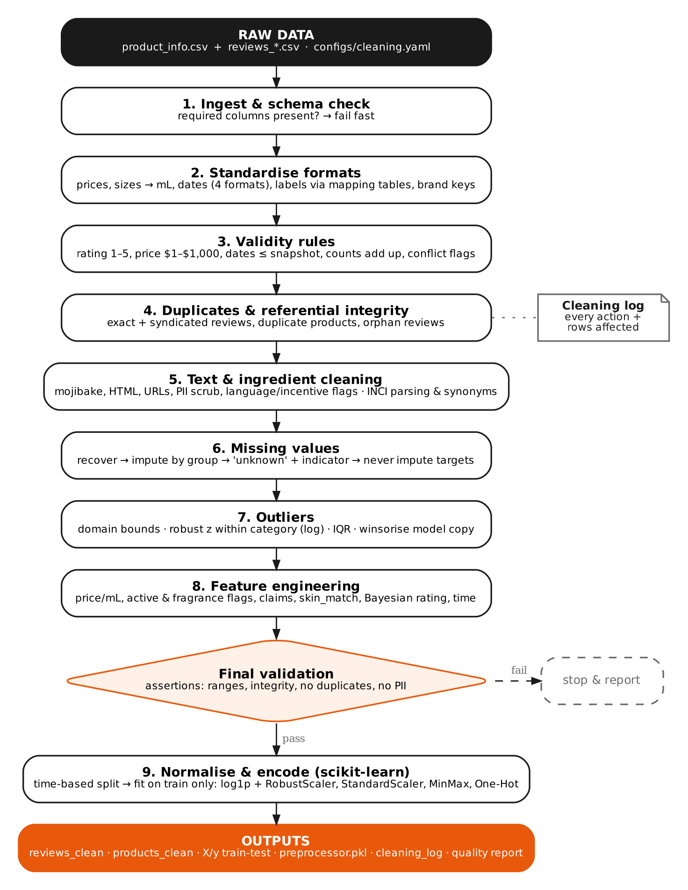
Figure 1. Data cleaning and pre-processing pipeline (source: docs/week3/pipeline_flowchart.dot).

4.1 Rationale for each stage and its position
Stage | What it does | Why here (order rationale)
1. Ingest & schema | Loads all CSV parts; checks required columns | Fail fast: nothing else is meaningful if a column is missing
2. Standardise | Parses prices, sizes, dates; maps label variants | Must come before validity and de-duplication — "Dry" and " DRY" only match after standardising
3. Validity rules | Enforces ranges and logical consistency | Turns impossible values into missing before imputation, so they are imputed rather than averaged in
4. Duplicates & integrity | Removes exact/syndicated duplicates and orphan reviews | After standardisation (so variants match) and before statistics (so nothing is double-counted)
5. Text & ingredients | Cleans review text, scrubs PII, parses INCI lists | Needs de-duplicated rows; produces fields used by imputation and features
6. Missing values | Recovers, imputes or flags each field by its own rule | Needs valid, de-duplicated data so group medians are not biased
7. Outliers | Flags with domain rules, robust z and IQR; winsorises model copies | After imputation so every product has a price; before features that use price
8. Feature engineering | Price per mL, ingredient/claim flags, skin match, Bayesian rating | Uses fully cleaned inputs
Validation | Hard assertions on ranges, integrity, duplicates, PII | Stops the pipeline instead of saving bad data
9. Normalise & encode | Time-based split, then scaling and encoding fitted on training data only | Last, to avoid leaking test-set information into the scalers

Table 3. Stage rationale.

5. Simulating the Raw Data
The generator (src/simulate_raw_data.py) first creates clean data with built-in, realistic relationships — for example, ratings are higher when a reviewer's skin type matches the product's "Good for" claim, and slightly lower for fragranced products used on dry skin. It uses 30 fictional brand names so that no real brand is misrepresented. It then corrupts the data. The table shows the main injected problems and their counts.
Injected problem | Rate | Count | Injected problem | Rate | Count
skin_type missing | 30% | 17,987 | Dates in other formats | 15% | 8,946
skin_tone missing | 25% | 14,890 | Future / unparseable dates | 0.1% each | 70 / 62
is_recommended missing | 12% | 7,227 | HTML in review text | 3% | 1,845
skin_type spelling variants | 10% | 4,221 | Mojibake characters | 2% | 1,207
skin_tone variants / "notSureST" | 8% / 2% | 1,336 / 1,223 | Incentivised reviews | 5% | 3,041
Rating out of range / as text | 0.3% / 0.2% | 161 / 113 | E-mail addresses (PII) | 0.2% | 125
is_recommended as "Yes"/"No" | 1% | 515 | Non-English reviews | 1% | 592
Helpfulness on 0–100 scale | 0.3% | 91 | Empty / trivial text | 1% | 634
Feedback totals inconsistent | 1% | 276 | Orphan product IDs | 0.5% | 303
Product price as text | 5% | 59 | Exact duplicate reviews | 1.5% | 900
Price missing / invalid / ×8 | 2% / 0.6% / 0.6% | 26 / 9 / 17 | Syndicated review copies | 1% | 600
Brand spelling variants | 8% | 85 | Size text missing | 15% | 207
Category spelling variants | 10% | 110 | Ingredients missing | 6% | 73

Table 4. Selected injected problems (seed = 42; full list in data/raw/simulated/injection_log.json).
A sample raw row shows several problems at once:
author_id=7645052798, rating=3, is_recommended=(empty), skin_type="OILY",
submission_time="2019-06-14",
review_text="Itâ€™s my 2nd tube â€“ It is okay, noticeably brighter skin after two weeks,
broke me out within a week."

6. Step-by-Step Cleaning & Pre-processing Methods
Each subsection gives the problem, the method, a simplified code example taken from the repository, and the measured result. All thresholds come from configs/cleaning.yaml.

6.1 Ingestion and schema validation
All review files (Sephora ships reviews in several CSV parts) are concatenated. author_id is read as text so long IDs are not converted to floats. A schema check confirms the 8 required product columns and 12 required review columns exist; if not, the pipeline stops with a clear error.
prod = pd.read_csv(raw_dir / "product_info.csv")
rev = pd.concat((pd.read_csv(p, dtype={"author_id": str}) for p in sorted(raw_dir.glob("reviews_*.csv"))),
ignore_index=True)
missing = [c for c in REQUIRED_REVIEW_COLS if c not in rev.columns]
if missing:
raise ValueError(f"reviews: missing required columns {missing}")

6.2 Standardising formats and labels

Prices, sizes and dates
Regular expressions extract numbers from strings such as "$42.00" or "USD 62". Sizes are converted to millilitres, preferring the mL figure when both units are present (1 fl oz = 29.5735 mL). Dates are parsed by trying four explicit formats in turn; explicit formats are faster and safer than letting pandas guess (it could read 03/04 as 3 April or 4 March).
def parse_size_ml(x):
if pd.isna(x): return np.nan
m = re.search(r"(\d+(?:\.\d+)?)\s*ml", x, re.I) # "1.7 oz/ 50 mL" -> 50
if m: return float(m.group(1))
m = re.search(r"(\d+(?:\.\d+)?)\s*(?:fl\.?\s*)?oz", x, re.I)
return round(float(m.group(1)) * 29.5735, 1) if m else np.nan

for fmt in ["%Y-%m-%d", "%m/%d/%Y", "%d-%b-%Y", "%Y-%m-%dT%H:%M:%S"]:
todo = parsed.isna()
parsed[todo] = pd.to_datetime(raw[todo], format=fmt, errors="coerce")
Result: 58 text prices parsed; 1,002 sizes converted to mL; 9,231 non-standard dates unified.

Categorical labels — mapping tables, not ad-hoc code
Every allowed value and its known variants are listed in the YAML config. Values are trimmed and lower-cased, then looked up. An unknown variant becomes missing instead of creating a new category, so new spelling errors show up in the log instead of silently becoming new groups.
# configs/cleaning.yaml
skin_type:
dry: [dry, "dry skin"]
combination: [combination, combo, "comb.", "comb"]

lut = {normalise(v): canon for canon, variants in mapping.items() for v in [canon, *variants]}
rev["skin_type"] = rev["skin_type"].map(lambda v: lut.get(normalise(v), np.nan))
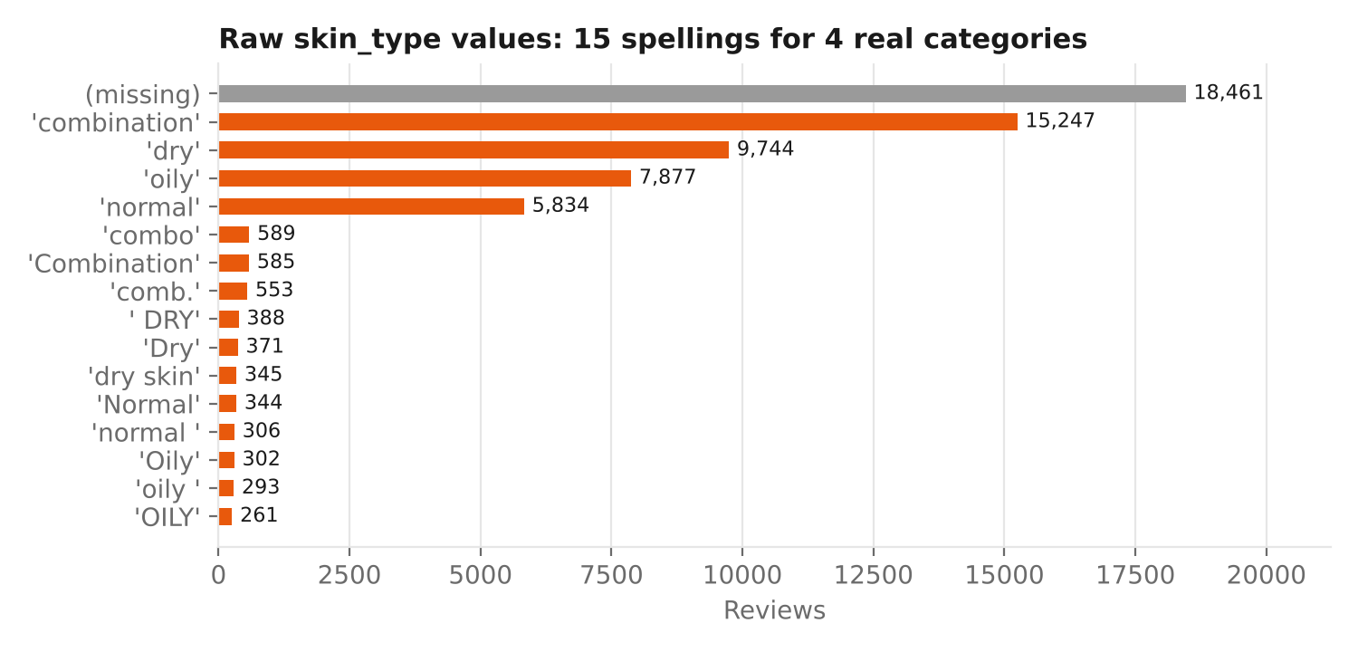
Figure 2. Raw skin_type values — 15 spellings for 4 real categories, plus 30% missing.
Brand names: a canonical key (lower-case, trimmed, trailing "." removed, "and" → "&") groups variants, and the most frequent original spelling is kept for display. This reduced 79 brand spellings to the 30 real brands.
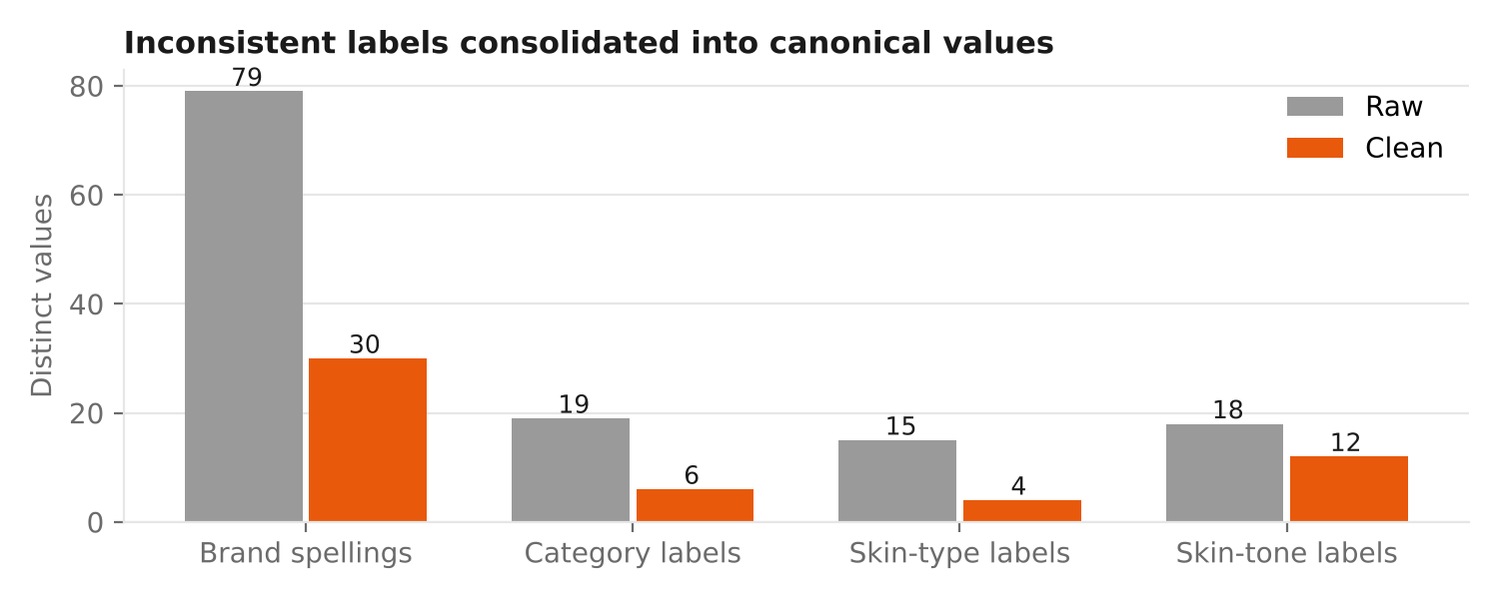
Figure 3. Distinct values before and after standardisation.

6.3 Validity rules and inconsistencies
Rule | Action | Rows affected
Rating must be 1–5 | Out-of-range set to missing (after "5 stars" → 5) | 166 (+117 text converted)
Price must be $1–$1,000 | Impossible prices set to missing (then recovered, Section 6.7) | 10
loves_count ≥ 0 | Negative counts are sign errors → absolute value | 14
Helpfulness in 0–1 | Values > 1 are percentages → divided by 100 | 78
total = positive + negative feedback | Total recomputed from its parts | 282
Date ≤ snapshot (31 Mar 2023) and ≥ 2008 | Set to missing | 70 (+63 unparseable)
1★ review cannot normally be "recommended" | Kept but flagged (flag_rating_rec_conflict) for review | 3

Table 5. Validity rules.
A conflict is flagged rather than "corrected", because I cannot know which of the two fields is wrong. The flag lets the modelling step exclude or down-weight these rows.

6.4 Duplicates, syndicated reviews and referential integrity
Three kinds of duplicate are handled. Exact duplicates (same author, product and normalised text) come from overlapping scraped files. Syndicated reviews are a beauty-specific problem: brands syndicate one review to several sibling products (e.g. a cleanser and its travel size), so one opinion is counted many times and can leak between training and test sets. These are detected as the same author posting the same text (at least 5 words) on different products; only the first is kept. Short texts such as "Love it, absorbs quickly." are not treated as syndicated, because different people genuinely write them. Finally, reviews whose product_id is not in the product table are removed.
rev["text_key"] = rev["review_text"].str.lower().str.replace(r"\W+", " ", regex=True).str.strip()
rev = rev.drop_duplicates(["author_id", "product_id", "text_key"]) # exact
long = rev["text_key"].str.split().str.len() >= 5
rev = rev[~(long & rev.duplicated(["author_id", "text_key"], keep="first"))] # syndicated
rev = rev[rev["product_id"].isin(prod["product_id"])] # integrity
Result: 12 duplicate products, 902 exact duplicate reviews, 553 syndicated copies and 302 orphan reviews removed.

6.5 Review text cleaning
Problem | Method | Reason
Mojibake ("itâ€™s") | Replacement map for common UTF-8/Windows-1252 errors | Restores words so tokenisers and sentiment lexicons recognise them
HTML tags and entities | html.unescape() then strip <tags> | "&amp;" and "<br/>" are not words
URLs and e-mail addresses | Replaced with [URL] and [EMAIL] tokens | Privacy (PII) and noise removal while keeping the signal that a link existed
Emojis | Kept | 😍 and 👎 carry strong sentiment; transformer models understand them
Negations | Kept (no stop-word removal at this stage) | "not greasy" must not become "greasy"
Non-English text | Flag when < 90% of letters are ASCII or ≥ 2 Spanish/French function words | English NLP models would mis-score them; rows stay for non-text analysis
Very short text | Flag if < 3 words | Too little text for aspect sentiment
Incentivised reviews | Regex for "received … for free", "honest review", "Influenster", "gifted" | Allows sensitivity analysis with and without them
Reviewer identity | author_id replaced by salted SHA-256 hash | Can still group by reviewer; raw ID never stored

Table 6. Text cleaning methods.
def clean_text(t):
for bad, good in MOJIBAKE.items(): t = t.replace(bad, good)
t = html.unescape(t)
t = re.sub(r"<[^>]+>", " ", t)
t = re.sub(r"https?://\S+|www\.\S+", " [URL] ", t)
t = re.sub(r"[\w.+-]+@[\w-]+\.[\w.]+", " [EMAIL] ", t)
return re.sub(r"\s+", " ", t).strip()

# "<p>Itâ€™s great &amp; cheap</p> mail me a.b@x.com 😍" -> "It's great & cheap mail me [EMAIL] 😍"
Result: 1,805 HTML, 1,164 mojibake, 576 URL and 123 e-mail cases cleaned; 2,958 incentivised, 585 non-English and 637 very short reviews flagged.

6.6 Ingredient (INCI) normalisation — a domain-specific solution
Sephora's ingredient field is free text. It often starts with marketing descriptions ("-Niacinamide: Minimizes the look of pores.") and ends with a legal disclaimer, and the same ingredient appears under several names. The parser removes both, splits on commas that are not inside parentheses (so "Aqua (Water, Eau)" stays one ingredient), and maps synonyms to one canonical INCI name. Order is preserved because INCI lists are in descending order of concentration.
def parse_ingredients(raw):
s = re.sub(r"please be aware that ingredient lists may change.*$", "", raw, flags=re.I | re.S)
s = re.sub(r"-[^:]{2,40}:[^.]*\.\s*", "", s) # marketing prefix
names = [normalise(p).strip(" .;") for p in split_outside_parentheses(s, ",")]
return list(dict.fromkeys(SYNONYMS.get(n, n) for n in names if n))

parse_ingredients("-Niacinamide: Minimizes pores. AQUA, Glycerin, Parfum. Please be aware ...")
# -> ["water", "glycerin", "fragrance"]
Result: 580 disclaimers and 398 marketing prefixes removed, 1,135 synonym occurrences unified. The cleaned lists also allow a claim-versus-formula check: 8 products claim "Fragrance Free" while listing fragrance ingredients — a labelling inconsistency worth reporting to the merchandising team.

6.7 Missing values
Missing values are handled field by field, according to why they are missing (Rubin, 1976): MCAR (missing completely at random), MAR (missing at random, explained by other fields) or MNAR (missing not at random — the missingness itself carries information). Dropping every incomplete row would have removed 79.6% of reviews.
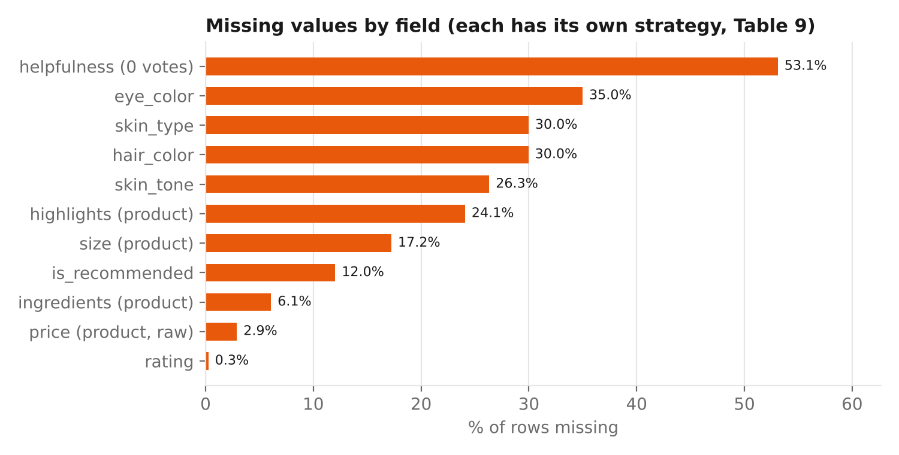
Figure 4. Share of missing values per field after validity checks.
Field | Missing | Likely mechanism | Strategy | Why
skin_type / skin_tone | 30% / 26% | MNAR — optional profile fields; some shoppers choose not to share | "unknown" category + missing indicator | Keeps 100% of rows; lets models learn whether non-disclosers behave differently
eye / hair colour | 35% / 30% | MNAR, low relevance | "unknown" + indicator | Used only for fairness checks
helpfulness | 53% | Structural — no votes cast | Laplace-smoothed score (pos + 1) / (total + 2) | 0 votes → 0.50 (neutral); 1/1 → 0.67; 30/30 → 0.97, so a few votes cannot look "perfect"
is_recommended (target) | 12% | MCAR/MAR | Never imputed; kept for EDA, excluded from training | Imputing a label invents the answer the model must learn
rating | 0.3% (after validity) | Data errors | Kept; excluded from rating statistics | Too few to matter; imputing would hide errors
product price | 2.9% (missing or invalid) | MCAR — entry errors | 1) recover from review-level price snapshot 2) brand × category median 3) category median; flag price_imputed | Uses the most specific reliable information first; all 35 recovered at step 1
size | 17% | MAR (some product types) | Left missing + size_missing flag | No reliable way to guess pack size; price per mL left missing
ingredients / highlights | 6% / 24% | MAR | Empty list + indicator; has_fragrance = unknown (not "false") | Missing ingredient list ≠ "no fragrance"

Table 7. Missing-value strategy per field.
# Hierarchical, flagged imputation for price
prod["price_imputed"] = prod["price_usd"].isna()
prod["price_usd"] = prod["price_usd"].fillna(prod["product_id"].map(rev.groupby("product_id")["price_usd"].median()))
for keys in (["brand_name", "secondary_category"], ["secondary_category"]):
grp = prod.groupby(keys)["price_usd"]
prod["price_usd"] = prod["price_usd"].fillna(grp.transform("median").where(grp.transform("count") >= 5))

# Laplace-smoothed helpfulness
rev["helpfulness_smoothed"] = (rev["total_pos_feedback_count"] + 1) / (rev["total_feedback_count"] + 2)

6.8 Outlier detection and treatment
Not every extreme value is an error. A $864 luxury cream is real; a $9,999 cleanser is not. The pipeline therefore separates three questions:
Question | Method | Treatment | Result
Is the value impossible? | Domain rules (price $1–$1,000; rating 1–5; dates ≤ snapshot) | Set to missing → imputed or excluded | 10 prices, 166 ratings, 70 dates
Is the value unusual for its group? | Modified (robust) z-score on log price per mL within each category: z = 0.6745 (x − median) / MAD; flag |z| > 3.5 (Iglewicz & Hoaglin) | Flag only — kept for analysis | 4 products flagged
Is a heavy tail dominating a model? | IQR rule on log scale (reported); 1st/99th percentile winsorising | Winsorised copy (*_w columns) for modelling; raw kept for EDA | 20 price/mL and 24 loves_count values clipped; 578 review lengths capped

Table 8. Three-level outlier strategy.
Why robust z and not the ordinary z-score? The mean and standard deviation are themselves pulled by outliers, so extreme values can hide themselves. The median and MAD are not affected. Why within category? A $1.50/mL serum is normal, but the same price for a body sunscreen is unusual — comparing across all skincare would flag every serum.
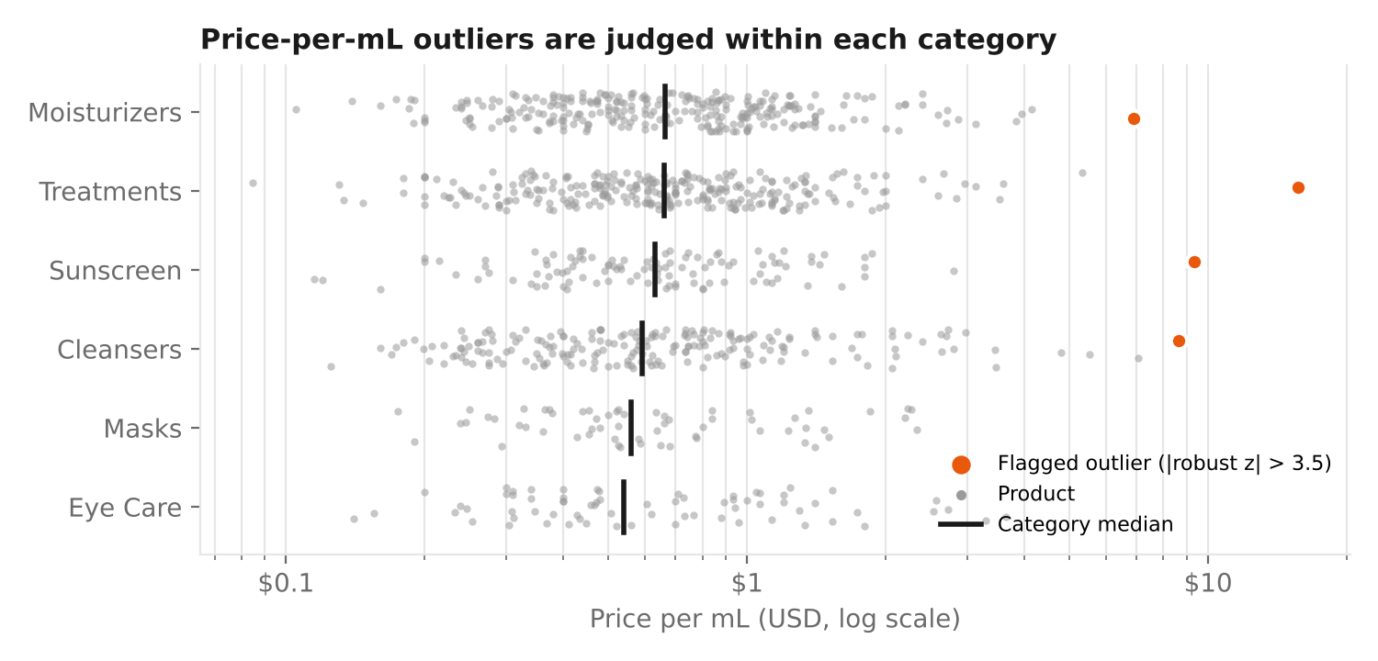
Figure 5. Price per mL by category (log scale). Orange points exceed |robust z| > 3.5 within their category.

6.9 Feature engineering
Feature | Definition | Supports
price_per_ml | price_usd / size_ml | H2 (fair price comparison)
has_<active> (10 flags), n_key_actives | Presence of niacinamide, retinol, ceramide NP, etc. in the cleaned INCI list | RQ4
has_fragrance | Fragrance, linalool, limonene or citronellol present; unknown if list missing | H4
claim_* (6 flags), good_for | Parsed from highlights | H4, recommender
skin_match | 1 if reviewer skin type equals the product's "Good for" claim | H1, recommender
product_bayes_rating | (C·m + Σ ratings) / (m + n) with m = 20, C = global mean 4.07 | Fair ranking of products with few reviews
helpfulness_smoothed | Laplace-smoothed helpfulness | H6
review_word_count, flags | Length, incentivised, non-English, short text, rating/recommend conflict | H3, H6, filtering
review_year, months_since_first_review | Time features | Trend analysis, time split

Table 9. Engineered features.

6.10 Normalisation, encoding and leakage prevention
Different variables need different scaling. scikit-learn's ColumnTransformer applies the right transformation to each group of columns, and is fitted on the training data only — the test set is transformed with the training parameters. The split is time-based (oldest 80% for training, newest 20% for testing), which mimics predicting future reviews and prevents information from the future leaking into the model (Kaufman et al., 2012).
Column group | Examples | Transformation | Why
Heavily skewed counts / prices | price_per_ml_w, loves_count_w, review_word_count_w | Median impute → log1p → RobustScaler | Log compresses long tails; RobustScaler uses median/IQR so remaining extremes do not dominate
Roughly symmetric | n_ingredients, n_key_actives | Median impute → StandardScaler | Mean 0, SD 1 suits linear models and regularisation
Bounded scores | helpfulness_smoothed, product_bayes_rating | MinMaxScaler to [0, 1] | Natural bounds; keeps interpretability
Categorical | skin_type, skin_tone, category, brand | One-hot; categories with < 50 rows grouped as "infrequent"; unknown categories ignored at prediction time | No false ordering; protects against rare/new brands
Binary flags | has_, claim_, missing indicators, skin_match | Most-frequent impute; kept 0/1 | Already on a comparable scale

Table 10. Normalisation and encoding plan.
pre = ColumnTransformer([
("skewed", Pipeline([("imp", SimpleImputer(strategy="median")),
("log", FunctionTransformer(np.log1p)), ("sc", RobustScaler())]), SKEWED),
("symmetric", Pipeline([("imp", SimpleImputer(strategy="median")), ("sc", StandardScaler())]), SYMMETRIC),
("bounded", Pipeline([("imp", SimpleImputer(strategy="median")), ("sc", MinMaxScaler())]), BOUNDED),
("categorical", OneHotEncoder(handle_unknown="infrequent_if_exist", min_frequency=50), CATEGORICAL),
])
train, test = time_split(df, test_frac=0.2) # oldest 80% / newest 20%
X_train = pre.fit_transform(train) # learn medians, IQRs, categories from TRAIN only
X_test = pre.transform(test) # re-use them -> no leakage
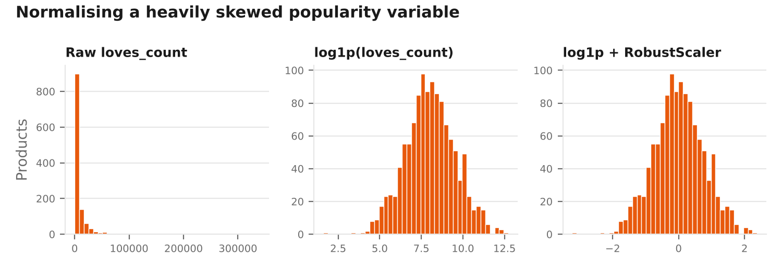
Figure 6. loves_count before and after log transformation and robust scaling.
Result: a 90-feature matrix with 41,952 training and 10,488 test rows. The fitted pre-processor is saved (preprocessor.pkl) so the identical transformation can be applied to new data later. Class balance in the target is 81.4% recommended / 18.6% not recommended, which will be handled with class weights in Week 5.

7. Results: Before vs After

7.1 Row flow through the pipeline
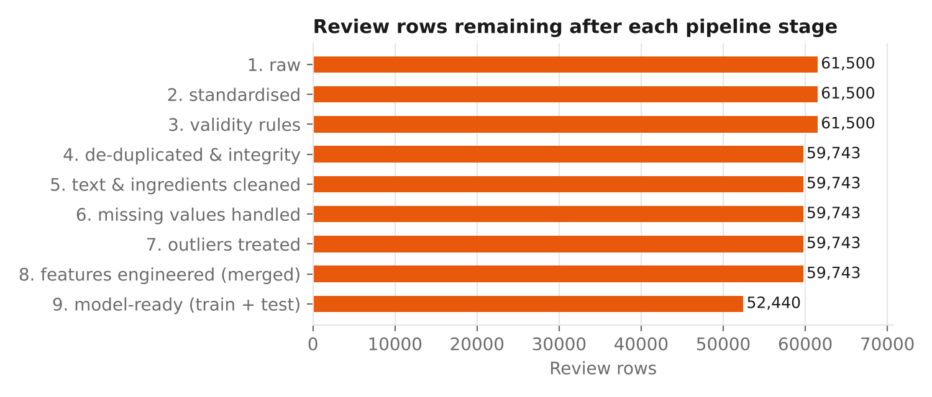
Figure 7. Review rows remaining after each stage (61,500 raw → 59,743 clean → 52,440 with a usable target and date).
Only 2.9% of review rows were removed, and only for good reasons (duplicates and orphans). Rows with missing profile fields or flags were kept; they are excluded only from the specific analyses they would harm. The drop at stage 9 is the 7,192 reviews without a recommendation label, plus 111 reviews with no valid date, which cannot be placed in the time-based split.

7.2 Data-quality scorecard
Metric | Raw | Clean | Change
Products / reviews | 1,212 / 61,500 | 1,200 / 59,743 | −12 / −1,757 (duplicates, orphans)
Duplicate product IDs | 12 | 0 | Removed
Products with missing or impossible price | 6.02% | 0% | Recovered from review snapshot
Brand / category / skin-type / skin-tone labels | 79 / 19 / 15 / 18 | 30 / 6 / 4 / 12 | Canonical values
skin_type missing | 30.0% | 30.0% (now "unknown" + flag) | Kept honestly, not guessed
Invalid ratings | 282 | 0 (161 now missing) | Out-of-range values not trusted
Reviews with HTML | 3.02% | 0% | Cleaned
Reviews containing e-mail PII | 126 | 0 | Scrubbed
Orphan reviews | 310 | 0 | Removed

Table 11. Data-quality scorecard (generated automatically in reports/data_quality_before_after.md).

7.3 Did the pipeline catch what was injected?
Issue | Injected | Handled | Explanation of any difference
Duplicate product rows | 12 | 12 | Exact match
Exact duplicate reviews | 900 | 902 | 2 natural repeats (same author wrote an identical short review twice)
Syndicated copies | 600 | 553 | 46 copies were very short texts (< 5 words), deliberately not treated as syndicated; the remaining 1 overlapped with other removals
Future dates | 70 | 70 | Exact match
Unparseable dates | 62 | 63 | Includes a duplicated copy of a corrupted row, counted before de-duplication
Ratings out of range | 161 | 166 | Includes duplicated copies of corrupted rows, counted before de-duplication
Missing / invalid prices | 35 | 35 recovered | All recovered from the review-level price snapshot
E-mail PII | 125 | 123 cleaned, 0 remaining | 2 were in rows later overwritten by other injections
Incentivised reviews | 3,041 | 2,958 flagged | Some injected rows were removed as duplicates or overwritten by later text injections
Non-English reviews | 592 | 585 flagged | 7 removed as duplicates or orphans

Table 12. Detection check against the injection log.
Every difference has an explanation, and the final assertions confirm that no out-of-range rating, orphan, duplicate or e-mail address remains.

8. Python Tools & Why They Fit
Library | Used for | Why it is suitable | Alternative considered
pandas | Loading CSVs, joins, groupby medians, string methods (.str), datetime parsing | Vectorised operations on ~60k–1M rows; rich string and date support; industry standard | Polars (faster, but less familiar and less teaching material)
NumPy | Log transforms, conditional logic (np.where), random generation for simulation | Fast numeric arrays; reproducible random generator (default_rng(seed)) | —
re (regex) | Prices, sizes, dates, PII, incentive phrases, INCI marketing prefixes | Precise pattern matching; built in | Hand-written string splitting (fragile)
html (std. lib.) | Decoding &amp;, &#39; etc. | Correct handling of all HTML entities | BeautifulSoup (heavier than needed)
hashlib | Salted SHA-256 hashing of reviewer IDs | One-way, standard, no extra install | —
scikit-learn | ColumnTransformer, imputers, scalers, OneHotEncoder | Fit/transform design prevents leakage; same object re-used on new data; integrates with models in Week 5 | Manual scaling in pandas (easy to leak test data)
SciPy / statsmodels | Statistical checks in EDA (Week 4) | Standard tests used for H1–H6 | —
PyYAML | Reading configs/cleaning.yaml | Human-readable configuration; rules change without code changes | JSON (no comments)
matplotlib + Graphviz | Report figures and the flowchart | Figures generated from code, so they update when data changes | Manual drawing (not reproducible)
unittest | 9 unit tests for parsers and rules | Built into Python; runs anywhere | pytest (nicer syntax, extra dependency)
Production options | pandera / Great Expectations (schema & data contracts); ftfy (encoding repair); langdetect / fastText (language ID); pyarrow (Parquet) | Recommended when running on the full 1M-review dataset | Implemented lighter equivalents here to keep dependencies minimal

Table 13. Tools and justification.

9. Documentation & Reproducibility
Following "good enough practices in scientific computing" (Wilson et al., 2017), the pipeline is built so that anyone can reproduce every number in this report with three commands:
python src/simulate_raw_data.py --seed 42 # 1. create raw data (or download real Sephora data)
python -m src.cleaning.pipeline # 2. clean + pre-process (16 s)
python -m unittest discover -s tests -t . -v # 3. run the 9 tests
Practice | How it is implemented | Benefit
Configuration, not hard-coding | All thresholds, mappings and paths in configs/cleaning.yaml | Rules are visible, reviewable and versioned; changing a rule does not touch code
Audit log | Every action writes {step, action, rows_affected} to reports/cleaning_log.json and .md (60 entries) | Exactly what happened to the data can be traced
Provenance metadata | Log stores config path, config SHA-256 hash, raw folder and pandas version | Detects if results came from a different configuration
Fixed random seeds | Seed 42 for simulation and sampling | Identical output on every run
Raw data is read-only | data/raw is never modified; outputs go to data/processed | Can always restart from the original
Automated tests | 9 unit tests (parsers, text, INCI, validity, duplicates, robust z) | Catches regressions when code changes
Fail-fast assertions | Final validation stops the pipeline on any violation | Bad data is never silently saved
Version control | Code, config, tests and reports on GitHub; raw data ignored | History of every change; data reproducible via scripts
Data dictionary | Appendix B and data/DATA_REGISTER.md | Readers understand each field and its origin
Generated figures | src/reporting/make_figures.py; flowchart from a .dot file | Figures always match the data

Table 14. Reproducibility practices.
A short extract of the automatically generated cleaning log:
| standardise | skin_type variants mapped to 4 canonical labels | 4,337 |
| validity | ratings outside 1-5 set to missing | 166 |
| duplicates | syndicated copies removed (same author + text on another…) | 553 |
| text | e-mail addresses (PII) cleaned | 123 |
| missing | helpfulness missing (0 votes) -> Laplace-smoothed score | 31,733 |
| validation | final assertions passed (ranges, integrity, duplicates, PII) | 59,743 |

10. How Clean Data Improves Analysis & Modelling
Hypothesis / task | Without cleaning | With cleaning
H1 — rating by skin type | 15 skin-type "groups"; "combo" and "Combination" compared as different segments | 4 groups + explicit "unknown"; group sizes large enough for the planned Kruskal–Wallis test
H2 — price vs satisfaction | Mean price $98.35, inflated by $9,999 and −$15 errors; no pack-size adjustment | Mean $55.60, median $42; price per mL available for 993 products
H3 — aspect sentiment | HTML, mojibake and URLs pollute tokens; PII in quotes | Clean text with emojis and negations preserved; short and non-English texts flagged
H4 — fragrance × skin type | "Parfum" and "Fragrance (Parfum)" missed; missing lists treated as fragrance-free | Synonyms unified; missing ≠ fragrance-free; 8 false "Fragrance Free" claims flagged
H5 — prediction | Targets with "Yes"/"No"/1.0 mixed; duplicates leak between train and test | Clean binary target; time-based split; 90 scaled features fitted on training data only
H6 — helpful reviews | 53% of helpfulness missing; 1/1 vote looks "100% helpful" | Smoothed helpfulness for every review

Table 15. Impact on each Week 1 hypothesis.
A first look at the cleaned (simulated) data shows why this matters: reviews where the reviewer's skin type matches the product's "Good for" claim have a 89.9% recommendation rate, compared with 78.0% when it does not. This 12-point gap is only measurable after skin-type labels are standardised and the "Good for" claim is parsed from the highlights. The relationship was built into the simulation, so it is not a real-world finding, but it shows the pipeline recovers a signal that raw data would hide. Week 4 will check whether the same pattern appears in the real Sephora data.

11. Communicating Data Quality to Stakeholders
Building on the Week 2 communication plan, data quality is reported in a form each audience can use:
Audience | What they receive | Example message
Internship mentor / leadership | One-page data-quality scorecard (Table 11) with three headline numbers | "After cleaning, 97% of reviews are usable; the average-price error from bad entries (+77%) is removed."
Merchandising team | List of catalogue issues found: claim conflicts, impossible prices, brand-name variants | "8 products claim Fragrance Free but list fragrance — please review the product pages."
Analysts / data scientists | GitHub repo, cleaning log, data dictionary, tests | Full traceability of every transformation
Brand / marketing | Caveats attached to every insight | "30% of reviewers do not state skin type; results by skin type describe the 70% who do."

Table 16. Data-quality communication.

12. Limitations, Ethics & Next Steps

12.1 Limitations
- Simulated data: the injected problems are realistic but chosen by me; the real Sephora data may contain problems I did not anticipate. The mapping tables log unknown values, so new variants will be visible.
- Language detection heuristic: an ASCII-ratio + function-word rule is simple; a trained language-ID model (fastText or langdetect) should replace it on real data.
- Syndication rule: requires identical text; reviews lightly edited between products would need fuzzy matching (e.g. MinHash).
- Imputation: price imputation uses medians; it does not capture premium positioning within a brand.
- Scale: on 1 million real reviews, Parquet and column selection (planned) will be needed for memory.

12.2 Ethical safeguards built into the pipeline
- Reviewer IDs hashed with a salt and the raw ID dropped (59,743 rows); e-mail addresses and URLs scrubbed from all text (0 remaining).
- Missing skin profile kept as "unknown" rather than inferred — the pipeline never guesses a person's skin tone.
- Fairness: skin tone retained (not dropped) so that model performance can be checked per tone in Week 5, as committed in Week 2 (maximum 0.03 AUC gap).
- Fictional brand names in the simulated data, so no real company is misrepresented.

12.3 Next steps (Week 4)
- Download the real Sephora data and run the same pipeline with --raw data/raw/sephora; compare its cleaning log with the simulated one.
- Add any new label variants found to the configuration and re-run the tests.
- Start exploratory data analysis and the first hypothesis tests (H1, H2, H4, H6) on the cleaned real data.

Appendix A — Repository Structure & Commands
beauty-wellness/
├── configs/cleaning.yaml all thresholds, mappings, paths
├── src/
│ ├── simulate_raw_data.py raw data generator with injected issues
│ ├── cleaning/
│ │ ├── steps.py schema, standardise, validity, duplicates, text, INCI
│ │ ├── impute_outliers.py missing values, outliers, feature engineering
│ │ ├── preprocess.py scaling / encoding (scikit-learn), time split
│ │ ├── log.py audit log
│ │ └── pipeline.py orchestrates all stages, writes outputs
│ └── reporting/make_figures.py report figures
├── tests/test_cleaning.py 9 unit tests
├── reports/ cleaning_log.md/json, data_quality_before_after.md
└── docs/week3/ this report, flowchart (.dot) and figures

Appendix B — Clean Data Dictionary (key fields)
Field | Type | Description
product_id | string | Product key; every review has a matching product
author_hash | string (12 hex) | Salted SHA-256 of the reviewer ID
rating | float 1–5 | Star rating; missing if the raw value was invalid
is_recommended | 0/1 (nullable) | Primary target; target_available = False when missing
skin_type | category | dry, oily, combination, normal, unknown (+ skin_type_missing flag)
skin_tone | category | 12 tones + unknown (+ skin_tone_missing flag)
submission_time | datetime | Review date (≤ 31 Mar 2023)
review_text_clean | string | Cleaned text; [URL] and [EMAIL] placeholders; emojis kept
review_word_count / _w | int | Words in cleaned text; _w capped at 99th percentile
flag_incentivised / flag_non_english / flag_short_text / flag_rating_rec_conflict | bool | Quality flags used to filter analyses
helpfulness_smoothed | float 0–1 | (positive votes + 1) / (total votes + 2)
price_usd, price_imputed | float, bool | Clean product price and whether it was recovered/imputed
size_ml, price_per_ml, price_per_ml_w | float | Pack size in mL, unit price, winsorised unit price
has_fragrance, has_<active>, n_key_actives | float/bool, int | Ingredient features from the cleaned INCI list
claim_*, good_for, flag_claim_conflict | bool, string | Claims parsed from highlights; claim-formula conflict
skin_match | 0/1/NaN | Reviewer skin type matches the product's "Good for" claim
product_bayes_rating, product_review_count | float, int | Bayesian-adjusted product rating (m = 20) and review count
review_year, months_since_first_review | int, float | Time features

Table 17. Data dictionary (72 columns in total in reviews_clean.csv.gz).

References
Harris, C. R., Millman, K. J., van der Walt, S. J., et al. (2020). Array programming with NumPy. Nature, 585, 357–362.
Iglewicz, B., & Hoaglin, D. C. (1993). How to Detect and Handle Outliers. ASQC Quality Press.
Kaufman, S., Rosset, S., Perlich, C., & Stitelman, O. (2012). Leakage in data mining: Formulation, detection, and avoidance. ACM Transactions on Knowledge Discovery from Data, 6(4), 1–21.
McKinney, W. (2010). Data structures for statistical computing in Python. Proceedings of the 9th Python in Science Conference, 56–61.
Pedregosa, F., et al. (2011). Scikit-learn: Machine learning in Python. Journal of Machine Learning Research, 12, 2825–2830.
Rubin, D. B. (1976). Inference and missing data. Biometrika, 63(3), 581–592.
Wickham, H. (2014). Tidy data. Journal of Statistical Software, 59(10), 1–23.
Wilson, G., Bryan, J., Cranston, K., Kitzes, J., Nederbragt, L., & Teal, T. K. (2017). Good enough practices in scientific computing. PLOS Computational Biology, 13(6), e1005510.
Inky, N. (2023). Sephora Products and Skincare Reviews [Data set]. Kaggle. https://www.kaggle.com/datasets/nadyinky/sephora-products-and-skincare-reviews
European Commission. CosIng — Cosmetic ingredient database. https://ec.europa.eu/growth/tools-databases/cosing/

