

**Mobile Application Development Project Report**

**IRC Client**

**Group 6**

Nguyễn Cao Nguyên – BI10-130

Nguyễn Đức Thắng - BI10-160

Đỗ Chí Nghĩa – BI10-125

Nguyễn Đăng Phi Long – BI10-108

Trần Dũng - BI9-074

**Table of contents**

**1. Introduction** **3**

Foreword 3

About our project 3

Project summary 3

About our program 3

**2. Requirements** **4**

Database 4

Data 4

Project Lifecycle 4

**3. GUI** **5**

**4. FUTURE UPDATE** **10**

**5. References and conclusions** **11**

# **1. Introduction**

## Foreword

- Mostly when it comes to work, people don’t use social networks such as Facebook or Twitter or Instagram. In fact, they prefer doing it by sending emails, and Gmail is the overall best email service.

- Email is the formal way to make a discussion from a long distance but, in some cases, it took quite the amount of time to complete the communication (or the letter was too long, for example, Johan didn’t read all the rules carefully). This is the reason why we used IRC.

## About our project

- We used Firebase - a platform developed by Google - for creating [mobile](https://en.wikipedia.org/wiki/Mobile_phone_application) and [web](https://en.wikipedia.org/wiki/Web_application) applications. Firebase was originally an independent company founded in 2011. In 2014, Google acquired the platform, and it is now their flagship offering for app development.

- Realtime Database is a service of Firebase. It can store and sync data with our NoSQL cloud database. Data is synced across all clients in real time and remains available when your app goes offline.

- We made this report to specify the details of our program about IRC Client.

## Project summary

- Project title: Internet Relay Chat Client

- Contributors:

* Nguyễn Cao Nguyên: 20%
* Nguyễn Đức Thắng: 20%
* Đỗ Chí Nghĩa: 20%
* Nguyễn Đăng Phi Long: 20%
* Trần Dũng: 20%

- Users: Everyone that can connect to the internet can use this.

- Functions: Provides a communication platform to help people to easily connect with others.

## About our program

Internet Relay Chat Client is fast and convenient.

* You don’t have to worry about forgetting your email’s password or signing in with your email account, you just need to create your own nickname and we will go straight to the chat room.
* The app doesn’t take up any space at all.

# **2. Requirements**

## Database

The database should be able to:

1. Provide a space to store and manage the data about the official server, chat room and chat log.
2. Track the details of the users: Number of users, user’s information.

## Data

The following data are required:

1. Servers.
2. Users.
3. Messages.
4. Administrator accounts.

## Project Lifecycle

Our database was mainly designed for group communication in discussion forums, called channels, but also allows one-on-one communication via private messages as well as chat and data transfer, including file sharing (which will be available in the future).

# 

# **3. GUI**

- Here is the app’s waiting screen:

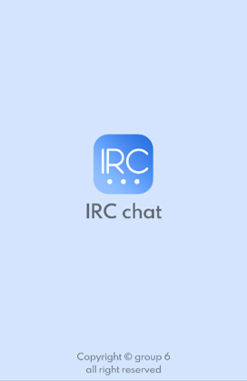

- This is the main screen interface of the app:

You will receive a welcome message, and the app will ask you to type in your nickname.

- After choosing your name, you will be moved to a new screen that show available servers:

Administrators can add a new server for the app by using the small plus icon on the top right:

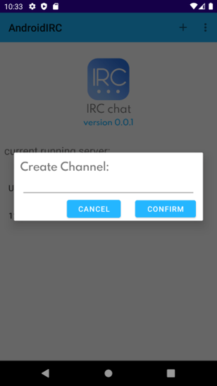

- This is what the chat room looks like:

You can see everyone’s messages and send your message by using “SEND”.

- All the data are all real-time taken straight from our database:

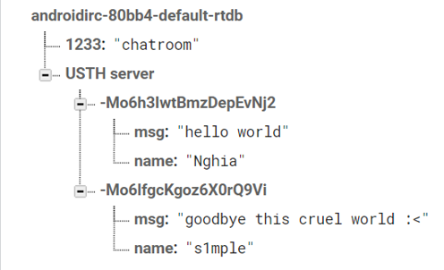

# **4. FUTURE UPDATE**

We - the app development team, have set a specific roadmap to continue developing this application:

- We still work hard to update the security system for the server as well as the software, because everyone's privacy is very important.

- Add referral code feature: some chat servers will be managed by admins, members can only join if they have a referral code created by admin.

- Add login system: some servers will need to login with a gmail account or via facebook, zalo,...

- Upgrade the app to be able to send not only text messages, but also audio, picture or video messages

- Upgrade the database in response to new functions.

- Add secret chat mode: All conversation information will be completely deleted both on the device and on the server when the conversation ends.

- Add emojis, GIFs to make the conversation more interesting.

- Add bot to play music, share screen,...

# **5. References and conclusions**

We used a lot of references from open-source sources on the net to complete this project (e.g., stackoverflow, YouTube, bootstrap...).

Although IRC chat is an old idea, it still has practical value and great potential for development in the future. If it is fully anonymous and supports open servers, it can completely attract a large number of users. In addition, if it is developed with features to maximize user experience, IRCchat can be widely used for community chat as well as personal chat between users.