DataPresent.r

Zack

Tue Aug 26 12:11:29 2014

# Presented are two major data tables in the orchard scaling project (2012-2013) conducted at Kaysville Research Farm, USU.  
# Five 24 year old tart cherry (Prunus cerasus Montmorency, P. mahaleb) from one block and   
# 19 8 year old apples (Malus domestica "Golden Delicious") from one block with various rootstocks were sampled.  
  
  
## BranchSegments.csv ("branch_size") contains the size and orientation data for all trees sampled at a "branch"-level.  
  
branch_size <- read.csv("BranchSegments.csv", sep = ',', header = T)  
   
# Terminal compenents of the tree (i.e., "twigs") were colected as twig counts and bulk mass. Fields are:  
# # # species - species common name [apple, cherry]  
# # # tree - individual tree ID; for apple [1-15,17-20], for cherry [1,7,10,13,15]  
# # # branch - branch-level ID per individual tree [integer]  
# # # date - date of collection in Julian days [integer]  
# # # parent - branch ID of predecessing branch [integer]  
# # # order - describes successing branch as "continuing" in relative diameter (order stays constant)   
# # # # # or as "daughter" stepwise diminishing in relative diameter (parent order + 1) [integer]  
# # # bearing - compass direction of branch at basipetal node [0 - 359]  
# # # opp_length_cm - length of horizontal traverse of branch as if branch is hypotenuse to calculate declination [float]  
# # # declination - angle from horizontal of branch [0 (horizontal) - 90 (vertical)]  
# # # length_cm - length of branch in centimeters [float]  
# # # path_length - total length of branch and longest continuous length of succeding branches [float]  
# # # diameter_mm - diameter at midpoint of branch in millimeters [float]  
# # # root_dia - daimeter at rootstock juncture for trunk segments in millimeters [float]  
# # # no_twigs - number of twig segments on branch (i.e., branching unit with multiple spurs attached) [integer]  
# # # no_spurs - number of spur segments on branch (i.e., branching unit with entirely apical growth) [integer]  
# # # no_scars - number of pruning scars on branch (i.e., locations of removed branching segments) [integer]  
# # # stem_m - mass of stem in grams [float]  
# # # tot_stem_m - total mass of succeding branches in grams [float]  
# # # twig_m - bulk mass of twigs in grams [float]  
# # # leaf_m - bulk mass of leaves in grams [float]  
# # # flower_m - bulk mass of flowers in grams [float]  
# # # length_ratio - ratio of daughter / parent branch lengths [float]  
# # # path_ratio - ratio of daughter / parent branch path lengths [float]  
# # # diameter_ratio - ratio of daughter / parent branch diameter [float]  
# # # mass_ratio - ratio of daughter / parent branch stem mass [float]  
# # # summass_ratio - ratio of daughter / parent branch total mass of succeding branches [float]  
  
  
## TreeSummary.csv ("tree_sum") contains the size and orientation data for all trees sampled at a "tree"-level.  
  
treesum <- read.csv("TreeSummary.csv", sep = ",", head=T)  
  
# Fields are:  
# # # X - Numerical ID of tree ***sorted by species, rootstock, and trunk diameter NOT YET***.  
# # # species - species common name [apple, cherry]  
# # # tree - individual tree ID; for apple [1-15,17-20], for cherry [1,7,10,13,15]  
# # # rootstock - individual rootstock name [Bud.9, CG.3041, CG.6210, M.26, JM.8, PiAu.5683]  
# # # trunk_diam - diameter at 15cm above graft union of trunck in millimeters [float]  
# # # height - height of individual [float]  
# # # canopy_volume - volume of the canopy as calculated by average radius in VolumeEstimates.py [float]  
# # # tot_stem_m - total mass of stems [float]  
# # # tot_twig_m - total mass of twigs [float]  
# # # tot_leaf_m - total mass of leaves [float]  
# # # tot_no_branch - total number of branch segments [float]  
# # # tot_no_twigs - total number of twig segments [float]  
# # # tot_no_spurs - total number of spurs [float]  
# # # tot_no_scars - total number of scars [float]  
# # # avg_length_ratio - average branch-level ratio of daughter / parent branch lengths [float]  
# # # avg_diameter_ratio - average branch-level ratio of daughter / parent branch diameter [float]  
# # # avg_mass_ratio - average branch-level ratio of daughter / parent branch mass [float]  
  
#Data is analysed using Standardized Major Axis (SMA; aka reduced major axis) with R-package 'smatr'  
  
library('smatr')

## Loading required package: plyr

#graph generation set-up  
  
tree_graph <- function(x, y, test, pred_b, pred_m, labx, laby, position, R2){  
 plot(log10(x[1:19]), log10(y[1:19]),   
 xlim = c((log10(min(x))-0.2),(log10(max(x))+0.2)), ylim = c((log10(min(y))-0.2),(log10(max(y))+0.2)),  
 xlab = labx, ylab = laby, cex.lab = 1.5, cex = 2.5, pch = 19, col = "black")  
 points(log10(x[20:24]), log10(y[20:24]), cex = 2.5, pch = 19, col = "red", bg = "red")  
 abline(sma(test)$coef[[1]][1,1], sma(test)$coef[[1]][2,1], lwd = 3, lty = 2)  
 abline(sma(test)$coef[[1]][1,2], sma(test)$coef[[1]][2,2], lwd = 3, lty = 3)  
 abline(sma(test)$coef[[1]][1,3], sma(test)$coef[[1]][2,3], lwd = 3, lty = 3)  
 abline(pred_b, pred_m, lwd = 3, lty = 1)  
 legend(position, legend=R2, bty='n', cex=3)   
} #tree-level figures  
branch_graph <- function(x, y, test, pred_b, pred_m, labx, laby, position, R2){  
 group_data_x <- list()  
 group_data_x[[1]] <- x[x$species=="cherry",]  
  
 apple <- x[x$species=="apple",]  
 group_data_x[[2]] <- subset(apple, tree==20 | tree==19 | tree==14)  
 group_data_x[[3]] <- subset(apple, tree==17 | tree==15 | tree==18)  
 group_data_x[[4]] <- subset(apple, tree==13)  
 group_data_x[[5]] <- subset(apple, tree==10 | tree==1 | tree==4 | tree ==9)  
 group_data_x[[6]] <- subset(apple, tree==5 | tree==11 | tree==6 | tree ==8)  
 group_data_x[[7]] <- subset(apple, tree==2 | tree==7 | tree==12 | tree ==3)  
   
 group_data_y <- list()  
 group_data_y[[1]] <- y[y$species=="cherry",]  
   
 apple <- y[y$species=="apple",]  
 group_data_y[[2]] <- subset(apple, tree==20 | tree==19 | tree==14)  
 group_data_y[[3]] <- subset(apple, tree==17 | tree==15 | tree==18)  
 group_data_y[[4]] <- subset(apple, tree==13)  
 group_data_y[[5]] <- subset(apple, tree==10 | tree==1 | tree==4 | tree ==9)  
 group_data_y[[6]] <- subset(apple, tree==5 | tree==11 | tree==6 | tree ==8)  
 group_data_y[[7]] <- subset(apple, tree==2 | tree==7 | tree==12 | tree ==3)  
   
 plot(log10(group_data_x[[1]][,3]), log10(group_data_y[[1]][,3]),   
 xlim = c((log10(min(x[,3], na.rm=T))-0.2),(log10(max(x[,3], na.rm=T))+0.2)),   
 ylim = c((log10(min(y[,3], na.rm=T))-0.2),(log10(max(y[,3], na.rm=T))+0.2)),  
 xlab = labx, ylab = laby, cex.lab = 1.5, cex = 1.5, pch = 21, col = "red", bg = "red")  
 points(log10(group_data_x[[2]][,3]), log10(group_data_y[[2]][,3]), cex = 1.5, pch = 21, col = "black", bg = "orange")  
 points(log10(group_data_x[[3]][,3]), log10(group_data_y[[3]][,3]), cex = 1.5, pch = 21, col = "black", bg = 'yellow')  
 points(log10(group_data_x[[4]][,3]), log10(group_data_y[[4]][,3]), cex = 1.5, pch = 21, col = "black", bg = 'green')  
 points(log10(group_data_x[[5]][,3]), log10(group_data_y[[5]][,3]), cex = 1.5, pch = 21, col = "black", bg = 'cyan')  
 points(log10(group_data_x[[6]][,3]), log10(group_data_y[[6]][,3]), cex = 1.5, pch = 21, col = "black", bg = 'blue')  
 points(log10(group_data_x[[7]][,3]), log10(group_data_y[[7]][,3]), cex = 1.5, pch = 21, col = "black", bg = 'purple')  
 abline(sma(test)$coef[[1]][1,1], sma(test)$coef[[1]][2,1], lwd = 3, lty = 2)  
 abline(sma(test)$coef[[1]][1,2], sma(test)$coef[[1]][2,2], lwd = 3, lty = 3)  
 abline(sma(test)$coef[[1]][1,3], sma(test)$coef[[1]][2,3], lwd = 3, lty = 3)  
 abline(pred_b, pred_m, lwd = 3, lty = 1)  
 legend(position, legend=R2, bty='n', cex=3)   
} #branch-level log10-trans  
branch_graph2 <- function(x, y, test, pred_b, pred_m, labx, laby, position, R2){  
 group_data_x <- list()  
 group_data_x[[1]] <- x[x$species=="cherry",]  
   
 apple <- x[x$species=="apple",]  
 group_data_x[[2]] <- subset(apple, tree==20 | tree==19 | tree==14)  
 group_data_x[[3]] <- subset(apple, tree==17 | tree==15 | tree==18)  
 group_data_x[[4]] <- subset(apple, tree==13)  
 group_data_x[[5]] <- subset(apple, tree==10 | tree==1 | tree==4 | tree ==9)  
 group_data_x[[6]] <- subset(apple, tree==5 | tree==11 | tree==6 | tree ==8)  
 group_data_x[[7]] <- subset(apple, tree==2 | tree==7 | tree==12 | tree ==3)  
   
 group_data_y <- list()  
 group_data_y[[1]] <- y[y$species=="cherry",]  
   
 apple <- y[y$species=="apple",]  
 group_data_y[[2]] <- subset(apple, tree==20 | tree==19 | tree==14)  
 group_data_y[[3]] <- subset(apple, tree==17 | tree==15 | tree==18)  
 group_data_y[[4]] <- subset(apple, tree==13)  
 group_data_y[[5]] <- subset(apple, tree==10 | tree==1 | tree==4 | tree ==9)  
 group_data_y[[6]] <- subset(apple, tree==5 | tree==11 | tree==6 | tree ==8)  
 group_data_y[[7]] <- subset(apple, tree==2 | tree==7 | tree==12 | tree ==3)  
   
 plot(group_data_x[[1]][,3], group_data_y[[1]][,3],   
 xlim = c((min(x[,3], na.rm=T)-0.2),(max(x[,3], na.rm=T)+0.2)),   
 ylim = c((min(y[,3], na.rm=T)-0.2),(max(y[,3], na.rm=T)+0.2)),  
 xlab = labx, ylab = laby, cex.lab = 1.5, cex = 1.5, pch = 21, col = "red", bg = "red")  
 points(group_data_x[[2]][,3], group_data_y[[2]][,3], cex = 1.5, pch = 21, col = "black", bg = "orange")  
 points(group_data_x[[3]][,3], group_data_y[[3]][,3], cex = 1.5, pch = 21, col = "black", bg = 'yellow')  
 points(group_data_x[[4]][,3], group_data_y[[4]][,3], cex = 1.5, pch = 21, col = "black", bg = 'green')  
 points(group_data_x[[5]][,3], group_data_y[[5]][,3], cex = 1.5, pch = 21, col = "black", bg = 'cyan')  
 points(group_data_x[[6]][,3], group_data_y[[6]][,3], cex = 1.5, pch = 21, col = "black", bg = 'blue')  
 points(group_data_x[[7]][,3], group_data_y[[7]][,3], cex = 1.5, pch = 21, col = "black", bg = 'purple')  
 abline(sma(test)$coef[[1]][1,1], sma(test)$coef[[1]][2,1], lwd = 3, lty = 2)  
 abline(sma(test)$coef[[1]][1,2], sma(test)$coef[[1]][2,2], lwd = 3, lty = 3)  
 abline(sma(test)$coef[[1]][1,3], sma(test)$coef[[1]][2,3], lwd = 3, lty = 3)  
 abline(pred_b, pred_m, lwd = 3, lty = 1)  
 legend(position, legend=R2, bty='n', cex=3)   
} #branch-level no log-trans  
  
  
  
### Predicted Relationships  
  
  
## Mass vs. Diameter [Predicted: M ~ D^8/3; Niklas & Spatz, 2004]  
  
# Tree Level [Estimated: 2.49 +/- 0.18, R2 = 0.974]  
# I would consider this spot on!!! It's just a little shy of the 8/3 buckling, which is within the statistical limits.  
  
Diameter_Mass <- sma(log10(treesum$tot_stem_m)~log10(treesum$trunk_diam), slope.test = 2.67)  
tree_graph(treesum$trunk_diam, treesum$tot_stem_m, Diameter_Mass, 0, 2.67,  
 "log ( Trunk Diameter )", "log ( Total Stem Mass )", 'bottomright', expression(R^2 == 0.974))

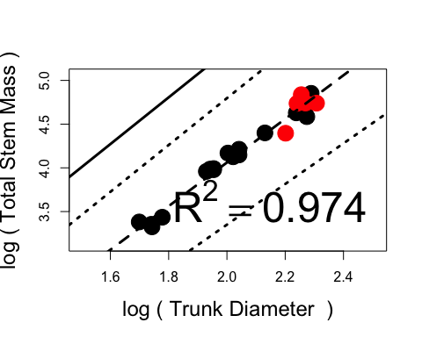

# Branch Level [Estimated 2.48 +/- 0.05, R2 = 0.905]  
# Again, this is just shallaw of the prediction, and begins to show a signal of pruning (i.e., mass removal)!  
  
diameter_mass <- sma(log10(branch_size$tot_stem_m)~log10(branch_size$diameter_mm))  
branch_graph(subset(branch_size, select = c(species, tree, diameter_mm)),  
 subset(branch_size, select = c(species, tree, tot_stem_m)),  
 diameter_mass, 0, 2.67, "log ( Diameter )", "log ( Total Stem Mass )",  
 'bottomright', expression(R^2 == 0.905))

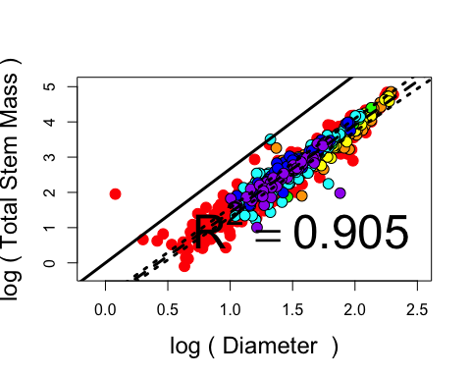

## Length vs. Diameter [Predicted: L ~ (D/2)^2/3; Price, Enquist & Savage, 2007]  
  
# Tree Level [Estimated: 0.74 +/- 0.12, R2 = 0.849]   
# The statistical result again includes the 2/3 expectation, but suggests closer to a 3/4. I don't have an explanation just yet.  
  
Diameter_Height <- sma(log10(treesum$height)~log10((treesum$trunk_diam/2)))  
tree_graph((treesum$trunk_diam/2), treesum$height, Diameter_Height, sma(Diameter_Height)$coef[[1]][2,1], 0.67,  
 "log ( Trunk Diameter )", "log ( Height )", 'bottomright', expression(R^2 == 0.849))

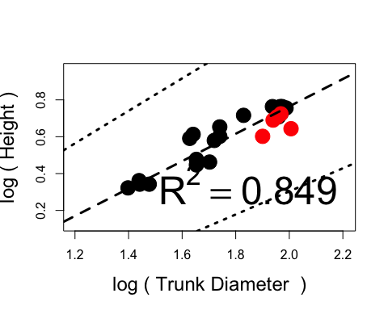

# Branch Level [Estimated: 0.86 +/- 0.04, R2 = 0.448]  
# This is even more beyond the 2/3 expectaiton, with more length per diameter.   
# Might be an artifact of vigorous shoots or a deviation in methods where I measured diameter at the midpoint   
# instead of at the node.  
  
diameter_path <- sma(log10(branch_size$path_length)~log10(branch_size$diameter_mm))  
branch_graph(subset(branch_size, select = c(species, tree, diameter_mm)),  
 subset(branch_size, select = c(species, tree, path_length)),  
 diameter_path, sma(diameter_path)$coef[[1]][2,1], 0.67, "log ( Diameter )", "log ( Path Length )",  
 'bottomright', expression(R^2 == 0.442))

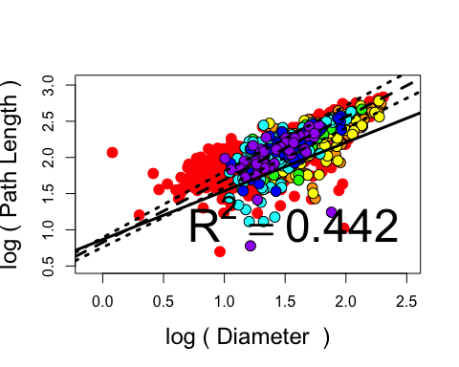

## Length vs. Mass [Predicted: L~M^1/4; Niklas & Enquist, 2001]  
  
# Tree Level [Estimated: 0.30 +/- 0.05, R2 = 0.849]  
# Again, the statistics include both reasonable options of 1/4 and 1/3. Hmm.  
  
Height_Mass <- sma(log10(treesum$height)~log10(treesum$tot_stem_m))  
tree_graph(treesum$tot_stem_m, treesum$height, Height_Mass, sma(Height_Mass)$coef[[1]][2,1], 0.25,  
 "log ( Total Stem Mass )", "log ( Height )", 'bottomright', expression(R^2 == 0.849))

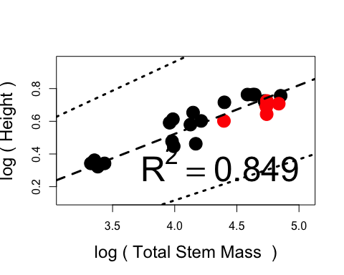

# Branch Level [Estimated: 0.35 +/- 0.1, R2 = 0.632]  
# And, again the branch level pushes beyong the upper limit of the expectation. Apple and cherry are not low density.  
  
  
length_mass <- sma(log10(branch_size$path_length)~log10(branch_size$tot_stem_m))  
branch_graph(subset(branch_size, select = c(species, tree, tot_stem_m)),  
 subset(branch_size, select = c(species, tree, path_length)),  
 length_mass, sma(length_mass)$coef[[1]][2,1], 0.25, "log ( Total Stem Mass )", "log ( Path Length )",  
 'bottomright', expression(R^2 == 0.632))

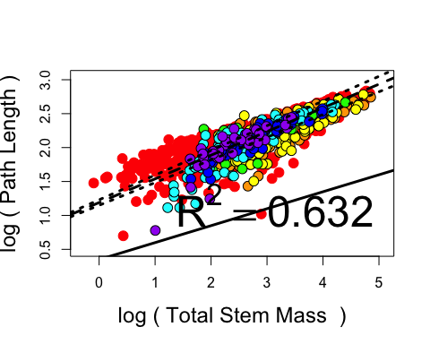

## daVinci's Rule of Area Preservation [Predicted: D(k+1)/D(k) = 0.5, McCulloh & Sperry, 2005; Price, Enquist & Savage, 2007]  
  
# Area Decreasing Result [Estimate: 0.68 +/- 0.03, R2 = 0.569, extreme end of reasonalbe values]  
# Major pruning signal! Stems are fatter at the bottom than expected due to removal of end shoots.  
  
dratio_temp_na <- subset(branch_size, select = c(species, tree, diameter_mm, diameter_ratio))  
dratio_temp <- na.omit(dratio_temp_na)  
parent_diam <- data.frame(species = dratio_temp$species, tree = dratio_temp$tree,  
 ratio = dratio_temp$diameter_mm/dratio_temp$diameter_ratio)  
  
diameter_ratio <- sma(dratio_temp$diameter_mm~parent_diam$ratio)  
branch_graph2(parent_diam, dratio_temp, diameter_ratio, 0, 0.5, "Parent Diameter", "Daughter Diameter",  
 'topleft', expression(R^2 == 0.632))

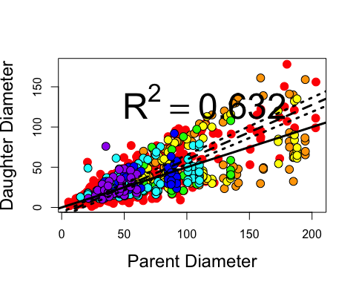

## Length Ratio [Predicted: L(k+1)/L(k) = 0.5; Price, Enquist & Savage, 2007]  
  
# Segment Length [Estimate: 1.41 +/- 0.1, R2 = 0.038, data incompatible]  
# My data is not detailed enought to get at this accurately. I ingnored small twig branching events.  
  
sratio_temp_na <- subset(branch_size, select = c(species, tree, length_cm, length_ratio))  
sratio_temp <- na.omit(sratio_temp_na)  
parent_length <- data.frame(species = sratio_temp$species, tree = sratio_temp$tree,  
 ratio = sratio_temp$length_cm/sratio_temp$length_ratio)  
  
  
length_ratio <- sma(sratio_temp$length_cm~parent_length$ratio)  
branch_graph2(parent_length, sratio_temp, length_ratio, 0, 0.5, "Parent Stem Length",   
 "Daughter Stem Length",'bottomright', expression(R^2 == 0.038))

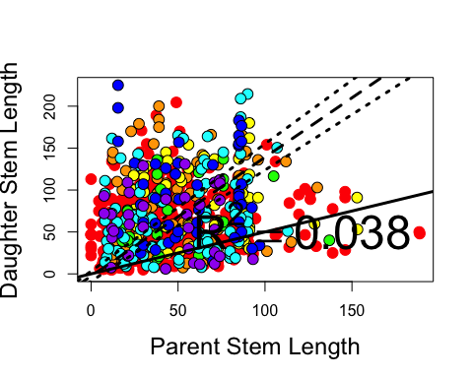

# Path Length [Estimate: 0.80 +/- 0.03, R2 = 0.545, still extreme end of reasonalbe values]  
# This is closer, but I'm still not sure it hits the mark.  
  
lratio_temp_na <- subset(branch_size, select = c(species, tree, path_length, path_ratio))  
lratio_temp <- na.omit(lratio_temp_na)  
parent_path <- data.frame(species = lratio_temp$species, tree = lratio_temp$tree,  
 ratio = lratio_temp$path_length/lratio_temp$path_ratio)  
  
  
  
path_ratio <- sma(lratio_temp$path_length~parent_path$ratio)  
branch_graph2(parent_path, lratio_temp, path_ratio, 0, 0.5, "Parent Path Length",   
 "Daughter Path Length",'topleft', expression(R^2 == 0.545))

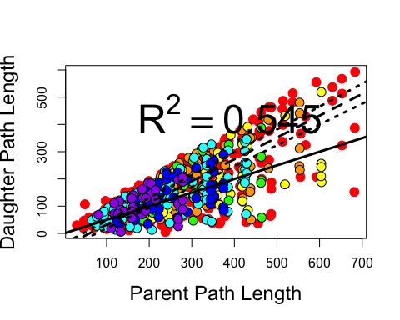

### Additional Relationships  
  
# trunk diameter vs. canopy volume [Estimate: 1.04 +/- 0.2, R2 = 0.7162]   
# This might be indicative of the D ~ M(leaves).  
  
Diameter_Volume <- sma(log10(treesum$canopy_volume)~log10(treesum$trunk_diam))  
tree_graph(treesum$trunk_diam, treesum$canopy_volume, Diameter_Volume, sma(Diameter_Volume)$coef[[1]][2,1], 1,  
 "log ( Trunk Diameter )", "log ( Canopy Volume )", 'bottomright', expression(R^2 == 0.716))

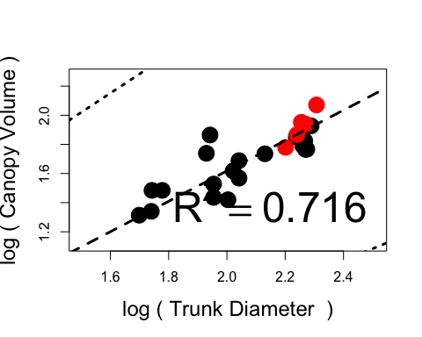

# trunk diameter vs. rank [Estimate: 2.04 +/- 0.5, R2 = 0.698]   
# This might be indicative of the furcation ratio = 2.  
  
Diameter_Rank <- sma(log10(treesum$tot_no_branch + treesum$tot_no_twigs + treesum$tot_no_spurs)~log10(treesum$trunk_diam))  
tree_graph(treesum$trunk_diam, (treesum$tot_no_branch + treesum$tot_no_twigs + treesum$tot_no_spurs),   
 Diameter_Rank, 0, 0,  
 "log ( Trunk Diameter )", "log ( Rank )", 'bottomright', expression(R^2 == 0.698))

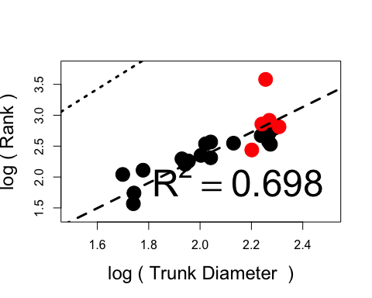

# rank vs. tot stem mass [Estimate: 1.22 +/- 0.25, R2 = 0.782]   
# Rank can be a good approximation for mass.  
  
Rank_Mass <- sma(log10(treesum$tot_stem_m)~log10(treesum$tot_no_branch + treesum$tot_no_twigs + treesum$tot_no_spurs))  
tree_graph((treesum$tot_no_branch + treesum$tot_no_twigs + treesum$tot_no_spurs), treesum$tot_stem_m,   
 Rank_Mass, 0, 0,  
 "log ( Rank )", "log ( Total Stem Mass )", 'bottomright', expression(R^2 == 0.782))

