Body size shifts mitigate effects of increasing temperatures on ectotherm metabolism
(question/answer or main message of MS, stay away from definitive results in title – the importance of body size in predicting metabolic rate increase from climate change...)

Kristina Riemer
kristina.riemer@weecology.org
Department of Wildlife, Ecology, & Conservation
University of Florida
Gainesville, FL, 32611

Morgan Ernest (2nd or last)
skmorgane@ufl.edu
Department of Wildlife, Ecology, & Conservation
University of Florida
Gainesville, FL, 32611

Kristina Anderson-Teixeira
teixeirak@si.edu
Smithsonian Conservation Biology Institute
1500 Remount Rd.
Front Royal, VA 22630 USA

Felisa Smith
fasmith@unm.edu
Department of Biology
167 Castetter Hall
University of New Mexico
Albuquerque, NM

David J. Harris
[email]
Department of Wildlife, Ecology, & Conservation
University of Florida
Gainesville, FL, 32611

Key words [6-10, these are just some possibilities]
Metabolic rate, temperature, changes in body size, ectotherms, metabolic theory of ecology, species response, phenotypic plasticity

Number of words (abstract):

Number of words (main body):

Number of references:

ABSTRACT
INTRODUCTION

The environmental shifts caused by climate change will be substantial across the globe: increasing and more variable temperatures, decreasing precipitation in some regions, and acidification of the ocean (IPCC, 2014). As the abiotic environment is an important determinant of species abundances and distributions, ecological systems will consequently be altered by climate change. Predicting what the resulting ecological systems will be is challenging because they are complex systems that are composed of many species with innumerable direct and indirect interactions amongst them. Species can be impacted directly by climate change, such as when extreme temperatures exceed physiological tolerances, or indirectly, such as via decreasing resource quality from more frequent droughts. Most current research focuses primarily on predicting either how species distributions will shift or shrink as species move to follow tolerable environmental ranges (e.g., Buckley et al., 2010) or how the phenology of species life history and development will change (e.g., Wolkovich et al., 2012). Other aspects of ecological systems are assumed to be fixed or omitted in these studies; simplifying assumptions are necessary because it is too difficult to determine the impacts that climate change will have on all aspects of complicated ecosystems simultaneously. Species traits are often assumed to be fixed in climate change studies and have been studied infrequently. While there are exceptions (e.g., Caruso et al., 2014), we are not able to generally predict how species traits will respond to climate change.
Traits encompass many morphological, physiological, and behavioral phenotypic expressions, such as appendage length and hormonal levels. Traits, of both individuals and species, have cascading effects on all levels of ecological organization. For example, traits have influence at the individual (e.g., body size modifies metabolic rate; Brown et al., 2004), community (e.g., predator gape size determines possible prey species; Shine 1991), and ecosystem levels (e.g., plant functional traits affect carbon cycles; Reichstein et al., 2014). While many studies examining impacts of climate change on species assume the traits of species will not change, the environment does influence species traits; a well-known example of this is Bergmann's rule, in which most species exhibit smaller body sizes at higher temperatures (Bergmann 1847, Ashton 2002). Trait changes occur due to either phenotypic plasticity, which occurs quickly and does not require genetic change, or adaptive evolution, which can happen on ecologically relevant time scales (Ghalambor et al., 2007/Carroll et al., 2007?). Because traits can be influenced by the environment and may change rapidly, the extent of the impact of trait changes on the predicted responses of species to climate change needs to be determined.
Metabolic rate, a species trait that will be influenced by climate change, is a measure of the energy used for maintenance, growth, and reproduction of organisms. Because metabolic rates increase exponentially with temperature due to greater kinetic energy (Gillooly et al., 2001; Brown et al., 2004), the metabolic rates of animals are expected to increase due to increasing global temperatures from climate change (Fig. za; Dillon et al., 2010; Seebacher et al., 2015). Ectothermic species in particular are expected to have greater metabolic rates due to increasing temperatures because they lack physiological mechanisms for regulating body temperature. Like most species traits, changes in metabolic rates will greatly influence many aspects of ecological systems. Metabolic rates affect individual behavior, population dynamics, and interspecific interactions (Sibley et al., 2012, refs), and could even affect climate change itself via impacts on ecosystem processes such as respiration rate and nutrient cycling (Enquist et al., 2003, McIntyre et al., 2008). Thus, increases in metabolic rate due to climate change would have cascading impacts on the ecology of populations and ecosystems.
While studies have begun to determine the direct impacts of increasing temperature on metabolic rate, there are also possible indirect, and potentially counterbalancing, effects on metabolic rate. Many ectothermic species exhibit a smaller adult size when raised at higher temperatures (Fig. zb; Forster et al., 2011; Angilleta et al., 2004; Atkinson 1994), which is referred to as the Size Temperature Rule (STR). The STR occurs quickly, with body size responding to temperature change after a single generation (Partridge et al., 1994). Ectotherms that are smaller as a result of increased temperatures will then have a decreased metabolic rate due to the quarter-scaling allometric relationship between body size and metabolic rate (Kleiber 1932; West et al., 1997; Brown et al., 2004). Therefore, while increased temperature will directly result in higher metabolic rates because of kinetic effects of temperature on chemical reactions, this increase may be offset by a decrease in metabolic rate that accompanies smaller body size (Fig. z).
Because previous studies on the effects of temperature on metabolic rates have not incorporated the indirect impact of the STR, we currently do not know if increasing temperatures will affect metabolic rates when the influence of the STR is included. For this study, we compiled data on the adult body sizes of ectotherm species grown experimentally at various temperatures. These data were first used to determine, given predicted temperature increases due to climate change, how ectothermic metabolic rates change with and without the effect of the STR. Second, we determined the magnitude of body size change that would be needed for the metabolic rates of these species to remain constant given temperature increases.

METHODS

Compilation of size-temperature experiment data
In order to address the impact of increasing temperatures on metabolic rates while including the STR, we collected data on adult mass from studies in which ectotherm species, that were lab-bred or collected at an early life stage, had been raised at various constant temperatures. Each study reported the average adult size reached by individuals in a constant temperature trial. We used data compiled and published by Forster et al. (2011), which required studies that reared individuals at a minimum of two temperatures and provided sufficient food supply. Some studies had multiple trials to compare responses of individuals from different latitudes or elevations. We searched the literature for additional studies that included size-temperature experiments which fulfilled the criteria used by Forster et al. (2011). If length was the only size metric provided, we converted it to mass using allometric relationships (see supplement).

For each study (and trial, if applicable), we retained pairs of average masses with a 3°C temperature difference (Fig. a); this temperature difference simulates the average temperature increase predicted due to climate change. The final dataset contained 191 pairs of average adult masses for 45 species across 40 studies. This dataset is representative of ectotherm diversity; it includes terrestrial species from every continent except Antarctica and aquatic species from every ocean and many large bodies of water, species from seven taxonomic classes, and mass values that vary by five orders of magnitude. The only limit of the dataset is that most species were very small (<100 mg) invertebrates, and the results would have been more generally applicable if there had been more data for other ectotherm types, including larger invertebrates and reptiles.

Calculation of metabolic rates
Because no studies examining body size responses to temperature also directly measured metabolic rates, we calculated metabolic rates from the size-temperature experimental data, which has been done in previous studies (e.g., Dillon et al., 2010). For the metabolic rate calculation, we used an equation that is central to the metabolic theory of ecology (MTE) (Brown et al., 2004), which combines both mass and temperature effects on metabolic rate:

R = r₀M^{b}e^{-E/kT}

where R = metabolic rate, r₀ = scaling constant, M = mass (g), b = unitless scaling exponent, E = activation energy of respiration (eV), k = Boltzmann's constant (8.617 x 10⁻⁵ eV/K), and T = temperature (K). Though the mechanism underlying the MTE equation has been questioned (O'Connor et al., 2007), it has generally performed well in accurately calculating metabolic rates. Values for b and E were estimated by class. For classes with data on size, temperature, and metabolic rate for a sufficient number of species (Branchiopoda, Amphibia, Malacostraca, and Maxillopoda), values were calculated using multiple regression (White et al., 2012). Values for Actinoperygii were estimated using fish species from several classes (Gillooly et al., 2001) and values for Insecta were acquired from literature sources (Chown refs), while the average values of b = 0.75 and E = 0.63 eV (Gillooly et al., 2001??) were used for Entognatha, the most data-limited class.

We used the data collected from size-temperature experiments and the metabolic theory of ecology equation to calculate metabolic rates in order to assess how the observed body size response to a 3°C increase in temperature might impact metabolic rate estimates. We calculated three metabolic rates for each 3°C pair of size-temperature data points using the relevant temperature and mass values (Fig. a).
- “Starting metabolic rate” was the metabolic rate for prior to a 3°C temperature increase, and was calculated using size and temperature data from the lower temperature experiment of each size-temperature pair.
- “Non-STR metabolic rate” was the hypothetical metabolic rate for after a 3°C temperature increase assuming size does not change. It was calculated with the size from the lower temperature experiment of the pair and the temperature from the higher temperature experiment.
- “STR metabolic rate” was the metabolic rate for after a 3°C temperature increase assuming size does change, and was calculated using size and temperature from the higher temperature experiment.

Metabolic rates comparison
We compared the three metabolic rates to understand how each species' metabolic rate changed after a 3°C increase in temperature when size change was and was not included. The starting, non-STR, and STR metabolic rates of all pairs for each species were averaged to provide one of each value per species (Fig. a), and then we used these species' metabolic rates to calculate two percent differences. The “non-STR metabolic rate change” was the percent difference between starting and non-STR metabolic rates, and represents the metabolic rate change that would be used in studies that do not take into consideration the effect of changing size on metabolic rate. The “STR metabolic rate change” does include this size change and was the percent difference between starting and STR metabolic rates. Positive percent differences showed an increase in metabolic rate from the starting metabolic rate for each species. To assess the difference between metabolic rate with and without the effect of the STR, each species' non-STR and STR metabolic rates were log-transformed and compared with a paired t-test.

Linear mixed model
To determine what could be driving the differences between non-STR and STR metabolic rates, we used a linear mixed model to assess the impact of several factors that seemed likely to be relevant to metabolic rates. We ran the linear mixed model using the R package lme4 version 1.1.9 (Bates et al., 2015; Winter 2013), and the response variable for the model was the log of the ratio between each pair's non-STR and STR metabolic rates, where a positive log-ratio indicated that the pair's STR metabolic rate was smaller than its non-STR metabolic rate. In addition to the model results, likelihood ratio tests were used to determine each effect's influence on the log-ratio. We included absolute temperature, as represented by the lower temperature for each pair, as a fixed effect because metabolic rate increases exponentially (i.e., nonlinearly) with increasing temperature. The random effects in the model were the taxonomic classifications of species and class, as metabolic rate varies amongst these groupings due to biology and ecology. We initially included study and trial as random effects, to take into account differences in experimental setups, but these effects were not included in the final model because their maximum likelihood estimates for variance were near zero. Similarly, because metabolic rate depends on the relative size of organisms, we tried size as a fixed effect but it did not have a substantial effect on the metabolic rate log-ratio (χ² = 0.7015; df = 1; p = 0.4).

Determination of compensation mass
We used three mass values to compare how much each species' size empirically changed due to a 3°C increase in temperature with how much their size would hypothetically need to change for metabolic rate to remain the same. Initial mass, the first mass value, was the empirical mass from the lower temperature experiment of each pair, while the second mass value was actual mass, the mass value from the higher temperature experiment. The third mass was the hypothetical needed mass, which was calculated by inserting starting metabolic rate and the higher temperature of each pair into the following equation:

M = (R / e^{-E/kT})^{1/b}

This equation is the MTE equation with mass solved for. Initial, actual, and needed masses were then averaged by species.

We then calculated two percentages to summarize the three mass values. “Observed mass change” represented how much each species' size actually changed with increased temperature, and was the percentage actual mass was of initial mass. “Compensation mass change” was theoretically how much size needed to change to maintain metabolic rate with increased temperature, and was the percentage of initial mass that needed mass was. Observed mass changes or compensation mass changes of less than 100% indicated that the mass of a species either did or needed to decrease, relatively. A paired t-test was used to compare log-normalized actual and needed mass values. All analyses were completed using R version 3.2.2 (R Core Team, 2015).

RESULTS

Metabolic rates comparison
With a 3°C increase in temperature, most species' metabolic rates did not increase as much when size change was included, as shown by smaller STR metabolic rate changes than non-STR metabolic rate changes (Fig. x). All STR and non-STR metabolic rate changes were positive (average percent differences = 23%, 28%; Fig. x), indicating that metabolic rate will increase with increasing temperature for all species regardless of size change, but there was a statistically significant difference between STR and non-STR metabolic rate changes, with STR metabolic rate change being consistently smaller (t(44) = 3.34; p = 0.002; 95% CI = 0.017 – 0.070). While the majority of species had a relatively smaller STR metabolic rate change, 9 of the 45 species in the study actually had a greater STR metabolic rate change and, therefore, a greater increase in metabolic rate when size change was included.

Linear mixed model
Similar to the metabolic rate comparison results, most pairs in this study had a smaller STR metabolic rate than non-STR metabolic rate (i.e., positive log-ratio); 82% of the 191 pairs had positive log-ratios, while the remainder had log-ratios that were negative or zero. These log-ratios, which represent the difference between STR and non-STR metabolic rates, were not explained by the three factors of interest we included in the model though. While absolute temperature (χ² = 9.27; df = 1; p = 0.002), taxonomic class (χ² = 3.90; df = 1; p = 0.048), and taxonomic species (χ² = 5.48; df = 1; p = 0.019) did affect the differences between metabolic rates, they did not sufficiently account for the variation in these differences. With an increase in absolute temperature, the STR metabolic rate of the pairs tended to get increasingly smaller than the non-STR metabolic rate, as shown by a slightly positive slope in the relationship between absolute temperature and log-ratio (slope = 0.004 ± 0.001), but this increasing difference had minimal biological relevance because it was between one and two orders of magnitude smaller than the actual difference between metabolic rates. Similarly, the taxonomic species designation of the pairs explained only 17% of the variability in random effects, while taxonomic class explained a more substantial 43% of random effects variability (Fig. x).

Compensation mass
The mass of each species would need to decrease in order for their metabolic rates to stay constant with a 3°C increase in temperature, as shown by all compensation mass changes being less than 100% (Fig. y), but all compensation mass changes were smaller than their respective observed mass changes, meaning that no species had an actual mass as small as the hypothetical needed mass. Actual and needed masses were statistically significantly different, with needed masses smaller than actual masses (t(44) = 17.707; p < 2.2x10⁻¹⁶; CI = 0.25 – 0.32). While most species decreased in size with an increase in temperature (i.e., observed mass change less than 100%), 20% of the species in this study actually increased in size (95% ± 11%). These were the same species that had greater STR metabolic rates changes than non-STR changes and therefore a greater increase in metabolic rate when size change was included (Fig. x).

DISCUSSION
Though all species' metabolic rates increased regardless of whether change in body size was included, metabolic rates for the majority of species did not increase as much with a 3°C rise in temperature when size change was included (i.e., STR metabolic rate change in Fig. 3) because of decreased body size (Fig. 4). Many studies state or assume that metabolic rates will increase due to temperature increases from climate change because of the direct effect of temperature on the chemical reactions that form the basis of animal metabolism (e.g. Dillon et al., 2010). Previous work neglected the potentially important and opposing effect of size change on metabolic rates via the size-temperature rule (STR), where increased temperatures cause smaller body sizes in ectotherms, which then results in decreased metabolic rates. The results from this study, the first to explicitly incorporate the STR, show smaller increases in metabolic rates in response to increased temperature than predicted because of size reduction in accordance with the STR, indicating the importance of body size change in accurately predicting the magnitude of ectotherm metabolic response to climate change.
When the STR was included, 20% of species unexpectedly increased in size with a 3°C increase in temperature instead of getting smaller (Fig. 4), resulting in increased metabolic rates (Fig. 3). The proportion of species exhibiting this opposing size change is consistent with previous research. For example, 12% of the studies in the meta-analysis by Atkinson (1994) had a response opposite that of the STR; these species were primarily insects, with one crustacean and one diatom. The taxonomic representation of species in our study was similar: four crustacean species from two classes (Artemia salina, Farfantepenaeus californiensis, Hyas coarctus, Pandalus borealis) and insect species including two butterfly species (Aglais urticae, Polygonia c-album), two out of 11 fruit fly species (Drosophila equinoxialis, Drosophila subobscura), and one crop pest (Ptero alternus) had size responses opposing the STR. Other explanations for an opposing size response to temperature change result from the most common hypothesis for the STR: growth rates are relatively faster than differentiation rates at higher temperatures, resulting in adult ectotherms of smaller size (von Bertalanffy, 1960). Consequently, conditions that slow growth rates at higher temperatures can instead increase adult ectotherm size, including decreased oxygen concentration for aquatic species and increased desiccation for terrestrial species (Atkinson, 1994; Atkinson, 1995). Other such conditions are insufficient resources to support higher growth rates (Atkinson, 1994) and temperatures exceeding biological limits (Atkinson, 1994; Kingsolver & Huey, 2008), which we avoided in this study by selecting experiments that provided adequate food and had a maximum temperature of 33°C. It may be that the assumptions about growth and differentiation rates that underly the STR hypothesis do not hold for certain species (Angiletta & Dunham, 2003; Walters & Hassall, 2006). Lastly, an opposing response to the STR has been observed in species that are univoltine, high-temperature stenothermal (Walters & Hassall, 2006), or large sun-baskers (Forster et al., 2012). Why a substantial minority of ectotherm species exhibited an opposing size response to that expected from the STR is unknown, but nevertheless those species had a greater increase in metabolic rate when size change was included.
While inclusion of the STR affected the magnitude of metabolic rate change in response to a 3°C increase in temperature, with decreased size in the majority of species somewhat mitigating the increase in their metabolic rates, none decreased in size enough for metabolic rates to remain constant and therefore all species had an increased metabolic rate regardless of size change. While all species would have needed to decrease to 65 – 85% of their original size for metabolic rate to remain constant with increased temperature, those species that decreased in size only did so by 80 – 100% (Fig. 4). Though the STR does not have an accepted quantitative description (Forster et al., 2011), the magnitude of size decrease in these species was similar to that of previous studies. For example, a worm species raised at a temperature that was 5°C higher was 97% the size that it was at the lower temperature (Voorhies, 1996), while two mayfly species Ameletus ludens and Ephemerella subvaria were 94% and 74% of their size, respectively, at a 3.1°C warmer temperature (Sweeney & Vannote, 1978). While it is possible that ectotherm species may get smaller than predicted due to climate change if there are inadequate resources in their ecological systems to support their increased metabolic demands (Sheridan & Bickford, 2011), we cannot determine this from our experimental data because species were provided with sufficient food. Consequently, we predict that ectotherm species will have increased metabolic rates, even including body size changes, due to the temperature increase that will accompany climate change.
This expected overall increase in ectotherm metabolic rates from climate change temperature shifts will have far-reaching consequences for every aspect of the ecological systems that the ectotherms are part of, from population-level and on up (Schmidt-Nielsen, 1984). Higher metabolic rates result in each individual of that species requiring more energy to maintain normal maintenance, growth, and reproductive function. Assuming that available resources remain constant, each ectothermic individual will use a greater proportion of those resources, increasing intraspecific competition and resulting in fewer individuals of that species, thereby increasing the probability of species extinction (MacArthur & Wilson, 1963; Hurlbert & Stegen, 2014). These changes in species abundances or persistence will result in shifting community composition, in addition to changes in the dominant species, trophic structure, and interspecific interactions. Increasing metabolic rates of species will ultimately affect energy fluxes at the ecosystem level (Allen et al., 2005; Yvon-Durocher & Allen, 2012) in an unknown manner. Determining the magnitude of species metabolic rate increases, as we have done in this study, is crucial because increasingly larger metabolic rates have a disproportionately greater impact on ecological systems (needref1). We can use these metabolic rate predictions to estimate how they will affect ecological systems, of which little is currently known (needref2). Such work has been done on the ecological impacts of changes in another species trait, body size, (Woodward et al., 2005; Ohlberger, 2013), including an extensive study by O'Gorman et al. (2012) which showed significant effects of body size on individuals, populations, communities, and ecosystem processes in Icelandic streams with a temperature gradient.
We need to understand how climate change will affect the processes underlying ecological systems in order to predict how these systems will change. Though some of these processes are being thoroughly investigated, species traits, besides body size, have been neglected (Bellard et al., 2012). This study provides one way to do this, by determining how an environmental shift due to climate change (e.g., increasing temperatures) will affect a species trait, metabolic rate. This is complicated by traits not changing independently of one another (e.g., clutch size & body size in Boyer et al., 2009; beak traits in Grant & Grant, 2006), which has been shown here by the impact of body size, an additional species trait, on the magnitude of change in metabolic rate. Though the indirect effects of temperature on body size did not affect the direction of metabolic rate change, this may not be true for other interacting traits. For example, LeRoy Poff et al. (2006) found high co-occurrence of many traits in stream insects, which is relevant for predicting community composition response to environmental conditions. We need to test commonly-held assumptions about how traits respond to climate change by addressing other environmental shifts such as more variable temperatures and higher occurrence of drought (IPCC, 2014) along with increasing temperatures and including additional species traits that have possible influential interactions. Only once we determine how species traits will respond to climate change conditions, including interactions of such traits, can we begin to determine the overall impact of climate change on ecological systems.

ACKNOWLEDGEMENTS
Anyone else who helped with data collection

REFERENCES

BIOSKETCH [short description of author research interest—do weecology lab as research team?]

TABLES

FIGURE LEGENDS

FIGURES

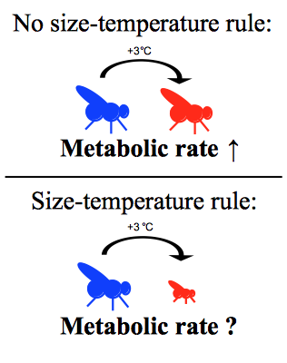
Figure 1. Diagram showing effect of increased temperature on metabolic rate of ectothermic species when body size does not change and when body size does change according to the size-temperature rule.

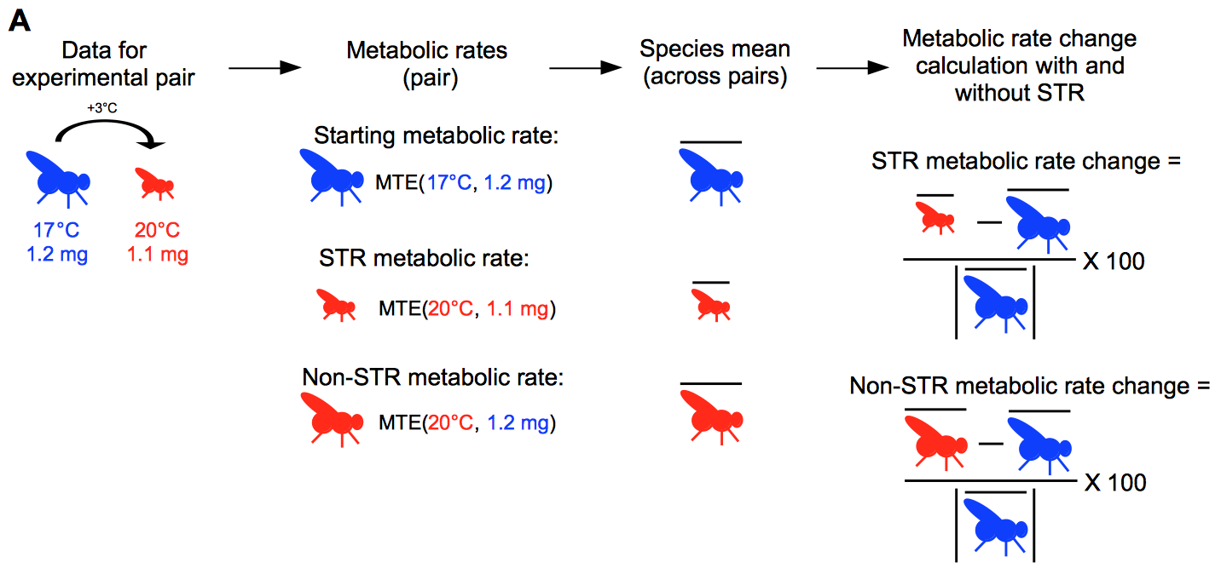
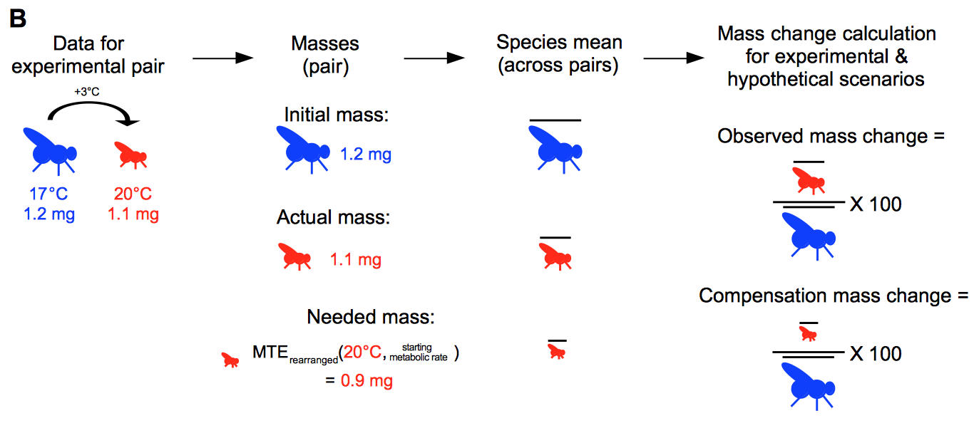
Figure 2. Diagrams showing how the experimental data from the pairs were used to calculate STR and non-STR metabolic rate changes for each species (A), and how the data were used to calculate observed and compensation mass change for each species (B). The example data is from the species Aedes aegypti.

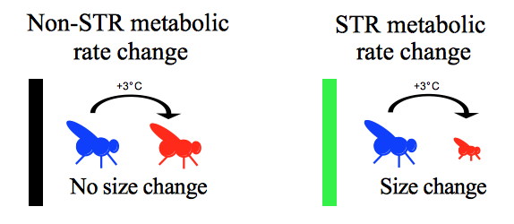
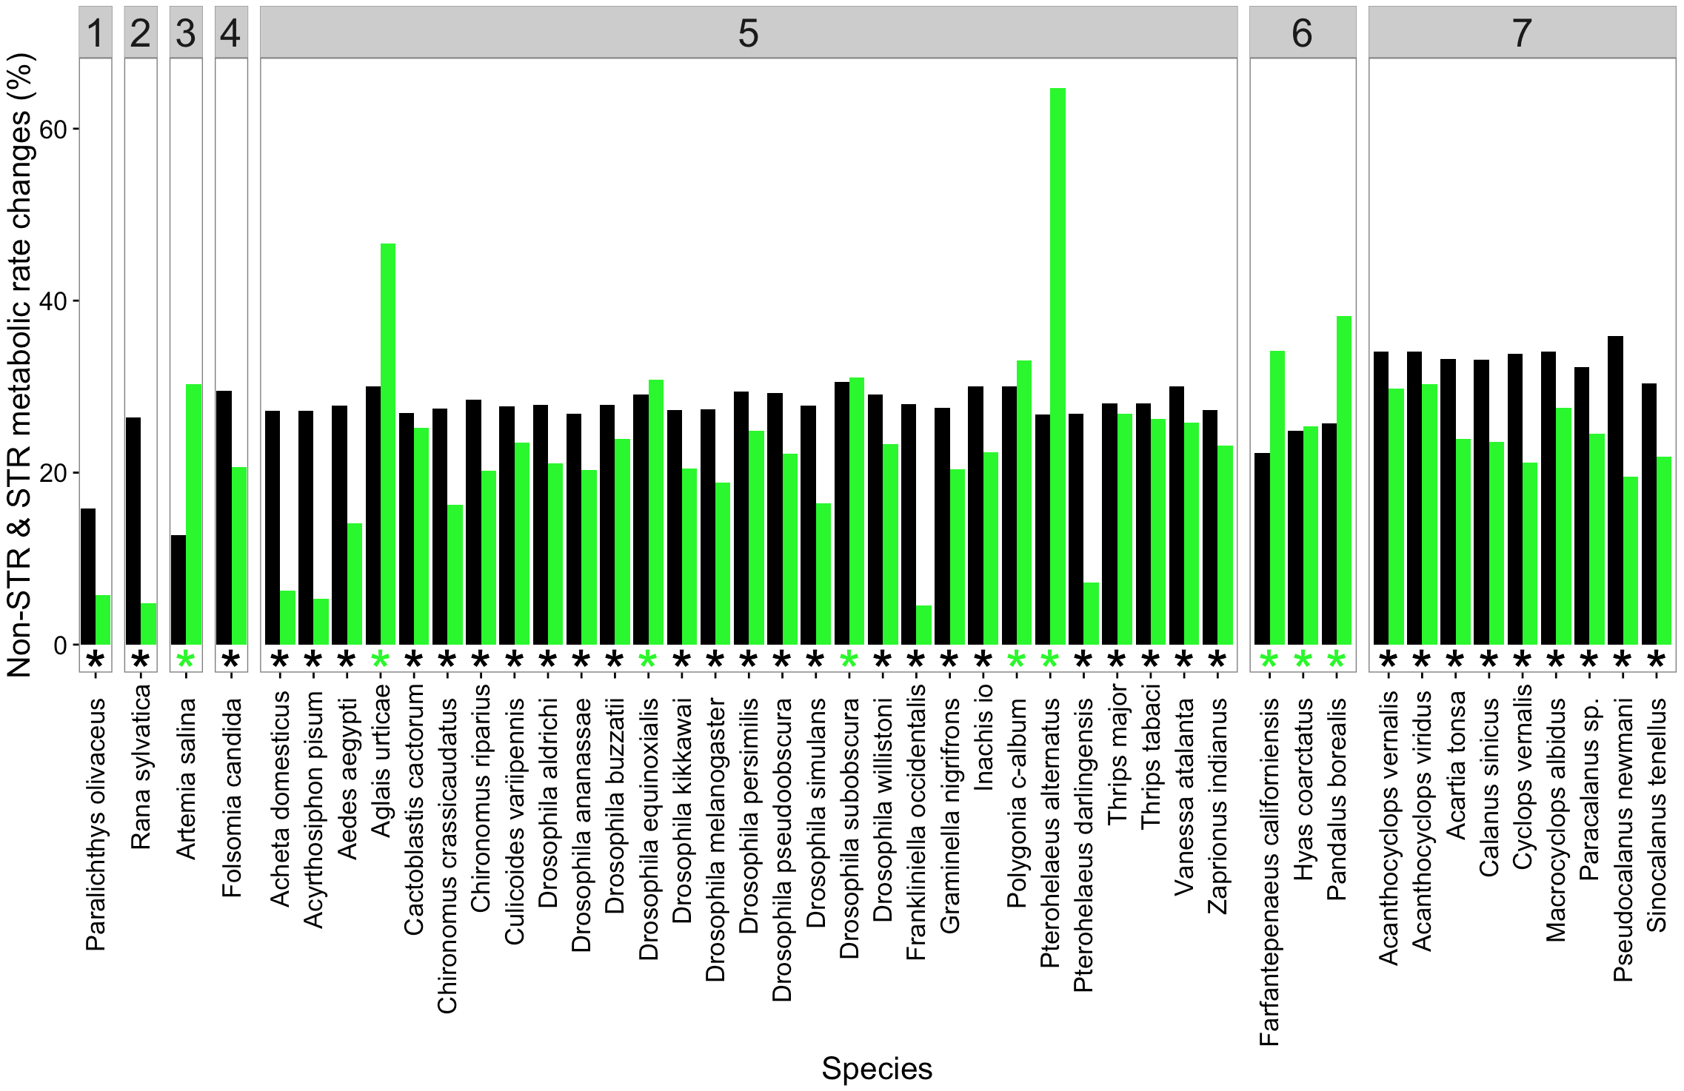

Figure 3. Non-STR metabolic rate change (black bar) and STR metabolic rate (green bar) change for all species, represented as percent difference from starting metabolic rate to metabolic rate without the STR and metabolic rate with the STR, respectively. A positive percent difference indicates an increase from starting metabolic rate. Asterisks are colored according to whether non-STR metabolic rate (black asterisk) or STR metabolic rate (green asterisk) is larger for each species. Species are grouped by class, with classes labelled at the top of the figure as follows: 1 = Actinoperygii, 2 = Amphibia, 3 = Branchiopoda, 4 = Entognatha, 5 = Insecta, 6 = Malacostraca, 7 = Maxillopoda.

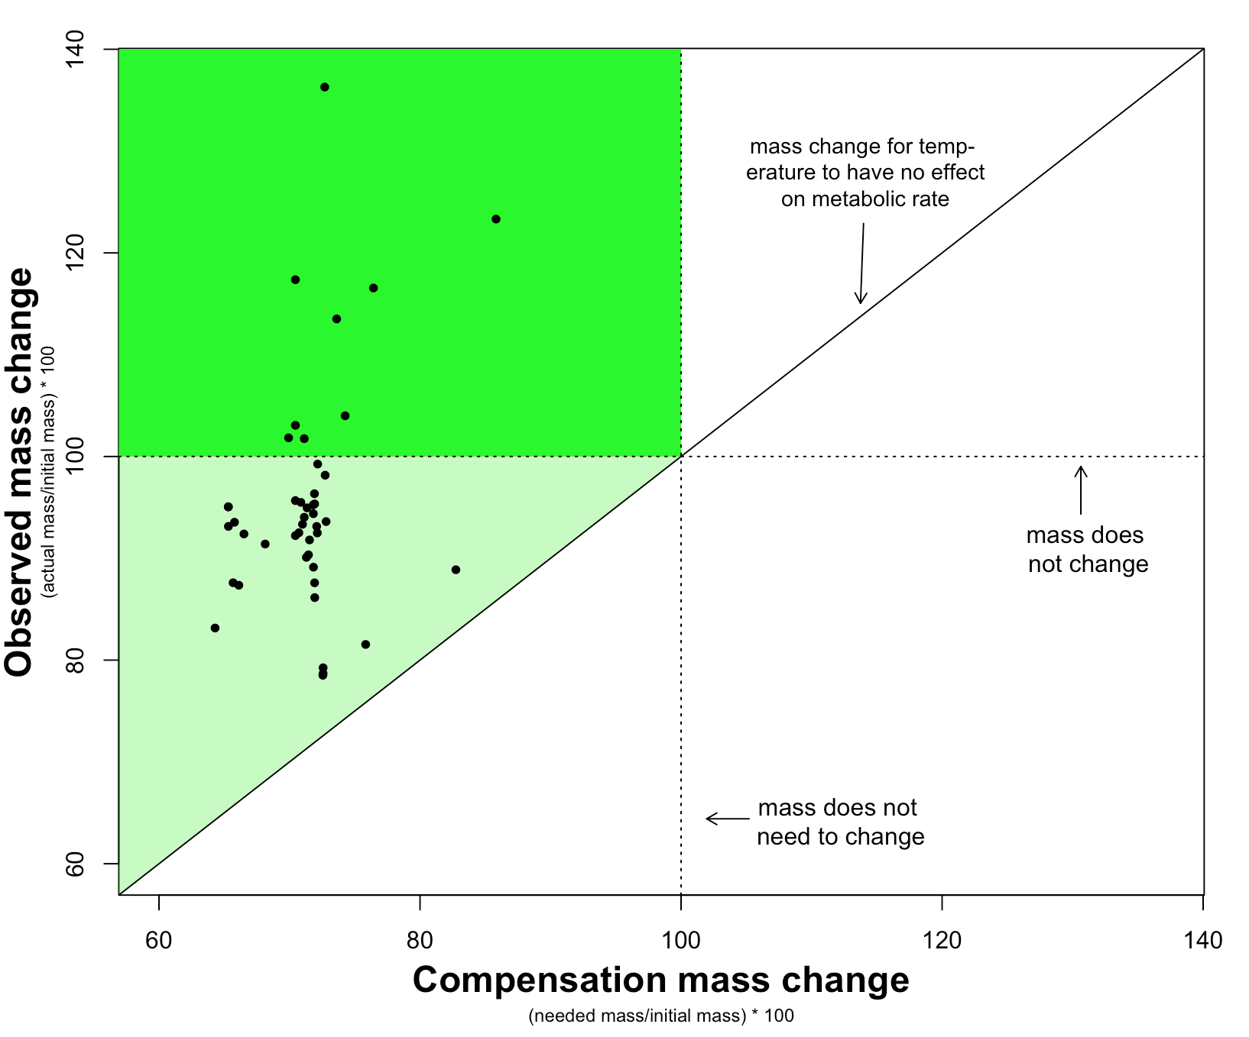
Figure 4. Comparison between compensation mass change and observed mass change for each species. Compensation mass change is the mass required to maintain metabolic rate with increased temperature (i.e., needed mass) as the percent of initial mass, while observed mass change is the mass of individuals of each species raised experimentally at the increased temperature (i.e., actual mass) as the percent of initial mass. Values over 100% indicate an increased mass from the initial mass and values less than 100% indicate decreased mass. No change in mass and no change needed in mass are indicated by dotted lines (i.e., 100%). Equivalence between needed mass and actual mass shown by continuous line. The darker green section of the plot indicates the mass of species increased experimentally but needed to decrease in order for metabolic rate to remain constant, while the light green section is where species mass decreased, but did not decrease enough for metabolic rate to remain constant.

SUPPORTING INFORMATION

