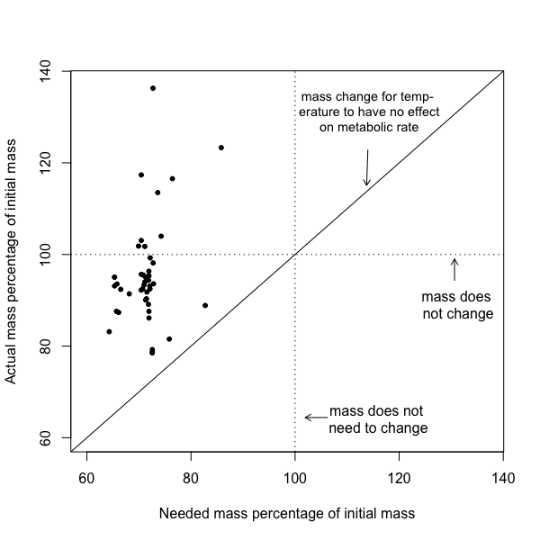
Figure y. Comparison between needed mass and actual mass for each species, where both masses are presented as the percentage of initial mass. Needed mass is the calculated mass required to maintain metabolic rate with increased temperature and actual mass is from species raised experimentally at the increased temperature. Values over 100% indicate an increased mass from the initial mass and values less than 100% indicate decreased mass. No change in mass and no change needed in mass are indicated by dotted lines (i.e., 100%). Equivalence between needed mass and actual mass shown by continuous line.

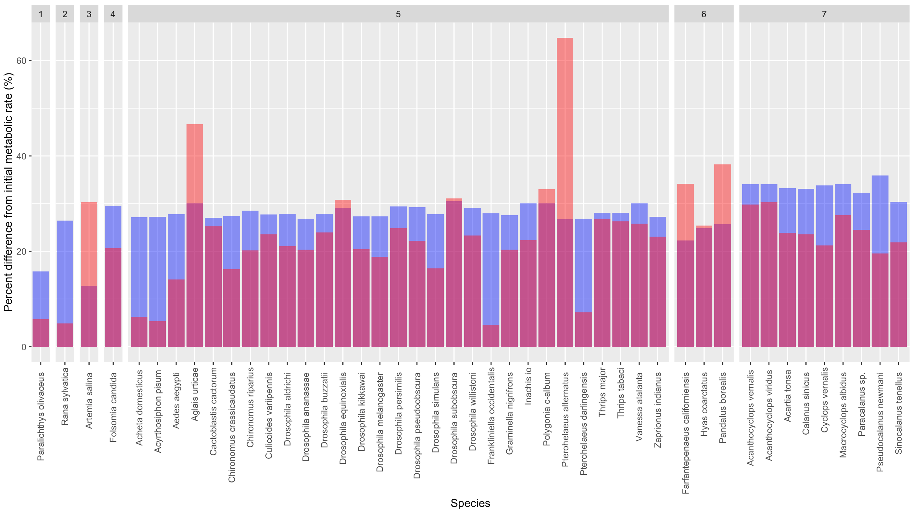
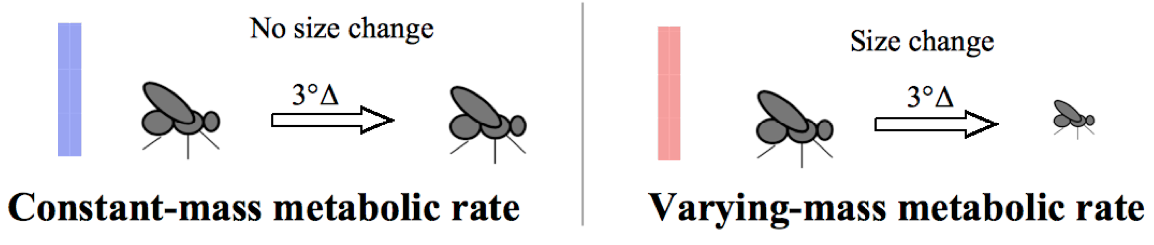
Figure x. Change from initial metabolic rate to constant-mass metabolic rate (blue bars), to represent metabolic rates without the STR, and change from initial metabolic rate to varying-mass metabolic rate (pink bars), to represent metabolic rates with the STR, for all species. Positive percent differences are increases in metabolic rate from initial. Species are shown by class (1 = Actinoperygii, 2 = Amphibia, 3 = Branchiopoda, 4 = Entognatha, 5 = Insecta, 6 = Malacostraca, 7 = Maxillopoda).

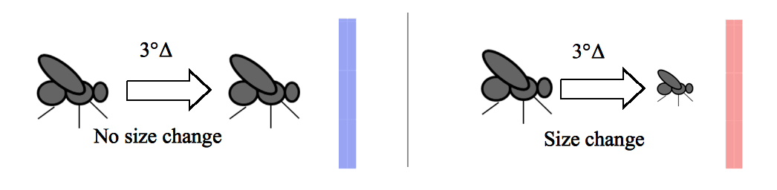

No size change
Size change
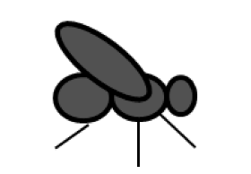
3°Δ
3°Δ
Constant-mass metabolic rate
Varying-mass metabolic rate


