Assessment Task 3: Team website
31265 Communication for IT Professionals

Edbert Wisely (14722262) • Fatih Putranda Lesmana (14724429)
Glenny Veneesha (14728594) • Hangyeon Cho (14730283)
Karell Yusdygo(14730295) • Yiming Bian (14735120)

Weed Management in Lama Lama Country: A Design Proposal

Link of website : weedranger.github.io
Tutorial Number and Zone : Tutorial 1 – Carina
Group Name : Power Ranger
Design Area : Augmenting the Ranger Program
Project Opportunity : Weed management innovation

Team member contributions to Assessment Task 3 Website
Group Member Name | Project Contributions
Edbert Wisely | Developed the implementation plan, costings, anticipated considerations, and recommendations. Led the website design and contributed to integrating and presenting the report content on the website.
Fatih Putranda Lesmana | Developed the prototyping and testing section, including prototype functionality, testing results, and other considerations. Merged the members' report sections into one file and contributed to reviewing the final report and website.
Glenny Veneesha | Developed the problem definition, scope, and project management sections. Contributed ideas for the website body and participated in reviewing the report and website content.
Hangyeon Cho | Developed the proposed solution section based on the team's design process. Checked citations and references and contributed to reviewing the report's consistency and accuracy.
Karell Yusdygo | Developed the design process and decision-making section, including the alternative solutions, evaluation criteria, and weighted decision matrix. Reviewed the members' sections and helped coordinate team meetings.
Yiming Bian | Developed the introduction to Lama Lama Country and background research. Contributed ideas for the website interface and body and participated in reviewing the final report and website.

Team Acknowledgement
We acknowledge and pay respect to the Traditional Owners of the land on which we meet; the Gadigal people of the Eora Nation. It is upon their ancestral lands that UTS stands.
We also acknowledge the Lama Lama people, Traditional Owners of Lama Lama Country in Cape York, and pay our respects to their Elders past and present. This project was developed to support the work of the Lama Lama Rangers in caring for Country.
Executive Summary/Landing page: Power Ranger – Offline Ranger Prioritisation & Support App
Design Area(s): Augmenting the Ranger Program (Project Opportunity 4.1 – Weed management innovation)

Background

The Lama Lama Ranger Program, supported by the Yintjingga Aboriginal Corporation (YAC), manages the natural and cultural resources across Lama Lama Country's vast and remote landscape. However, seasonal wet conditions cause impassable roads and river crossings, severely restricting ranger mobility and communication. Because invasive weeds threaten native vegetation, biodiversity, and cultural access, rangers currently utilize manual logging, GPS tagging, and tools like I-Tracker and drones, yet struggle with remote monitoring and limited connectivity. To address these challenges, there is a critical need for an offline-capable solution that respects Indigenous data sovereignty, operates locally with minimal complexity, and seamlessly integrates with existing ranger workflows and the regional Weed Action Plan.

Proposal Summary
The project aims to address the difficulty Lama Lama Rangers have in reliably detecting, monitoring and prioritising weed infestations across large, remote and seasonally inaccessible Country through an offline-first mobile application. The app saves each infestation’s photo, GPS location, species and treatment on the Ranger’s phone and synchronises it when a connection returns. It flags sites due for follow-up and ranks them by urgency, so Rangers can decide where to work next while their existing practices and knowledge stay at the centre.

Overview of Design
- The Offline Ranger Prioritisation & Support App achieves reliable weed record-keeping and prioritisation without internet access by saving every record on the phone first and uploading it to a central database when connectivity returns.
- The implementation is supported through a cross-platform Flutter application, a Supabase database, Ranger training, field testing and documentation.
- The design includes the following components: a mobile app with local storage, photo and GPS capture using the phone, a fixed list of the six priority species from the Weed Action Plan, a prioritisation dashboard with follow-up reminders, a Supabase database with role-based access, and public weed reports that are checked before they are listed.
- Lama Lama Rangers use the app in the field to record sites, track treatments and plan return visits. Yintjingga Aboriginal Corporation administrators manage access and review reports, so the Rangers and the corporation stay in control of their information.

Key Considerations
- Sourcing: The design needs no specialist hardware and is intended to run on smartphones Rangers already use. The database is an external subscription service (Supabase), so it is sourced externally rather than locally.
- Maintenance: The database subscription must be renewed, the app updated, user accounts managed and a support contact named. Phones are easy to replace and the app can be updated remotely.
- Implementation: GPS and photo capture must be tested on the Rangers’ own devices, secure authentication and access controls configured, and synchronisation tested for failures and conflicting updates. Android devices use APK files, which avoids a Google Play registration fee. Apple Developer Program enrolment is needed only if iOS devices are used.
- Prototype results: Initial prototype tests of offline logging, synchronisation, staying signed in, priority order and ease of use were reported as successful.
- Assumptions and risks: Rangers have compatible smartphones, and the six-species Weed Action Plan remains the priority list. Development is assumed to take 180 hours at A$100 per hour, so paying a developer for later changes could be costly.

Proposed Materials and Cost Summary

The estimated total cost is about A$18,630, which covers a one-off A$18,000 for outsourcing app development (180 hours at 100 per hour). Supabase database subscription is A$40 per month and A$150 per year for app distribution, along with existing smartphones and ranger training time.

Project Details
- Design Area: 4 - Augmenting the Ranger Program
Project Opportunity: 4.1 - Weed management innovation
- Why is this important?
The Lama Lama Ranger Program is supported by Yintjingga Aboriginal Corporation (YAC), which plays an important role in managing Country and connecting to environmental, economic and cultural values. However, seasonal conditions can create challenges for Ranger activities. During the wet season, roads and tracks may become difficult or impossible to use, limiting Rangers’ access to weed infestation sites. It highlights the need for more efficient and reliable approaches to weed mapping, monitoring and treatment.

Background
- Context
The Lama Lama Ranger Program is jointly managed by the Queensland Government and the Indigenous community. Rangers are responsible for managing the natural and cultural resources across Lama Lama Country, including a wide range of land and sea management activities.
Lama Lama Country is large and remote, with diverse terrain and ecosystems. That means the application should be tailored to local conditions, including offline capacity, easy of operation and maintenance, and require minimal training.

- Significance
Weed management is an important part of managing Lama Lama Country because invasive weeds impact environmental, economic and cultural values (Yintjingga Aboriginal Corporation, n.d.-b). Invasive weeds can threaten native vegetation, reduce biodiversity and affect access to important areas of Lama Lama Country.

- Current Solution
The current practice involves photographing, logging GPS location, applying herbicide, and returning after approximately one month to assess treatment effectiveness (Engineers Without Borders Australia, 2026b).
1. Locate Area: Identify and scout active weed infestation sites manually across Country.
2. Photo Log: Photograph and identify weed species for treatment.
3. GPS Tagging: Record and track the locations of weed infestations.
4. Weed Treatment: Apply herbicides appropriate to weed species.
5. Reassessment: Return to infestation sites approximately one month later to assess treatment effectiveness.
Besides, Rangers have integrated digital technologies such as Fulcrum, I-Tracker and drones with the knowledge passed by the Elders during this process (Engineers Without Borders Australia, 2026b).

- Objectives
Establishing an application that can improve efficiency and reliability of weed management work across Lama Lama Country. It should support large-scale weed monitoring and help rangers track the effectiveness of treatment. It is also important to keep costs low and respect Indigenous community priorities and cultural requirements.

Problem Description
While physical removal is important, the true challenge of weed management on Lama Lama Country lies in reliably detecting, monitoring, and managing infestations across such vast, remote areas. Weeds Australia (n.d.) states that "an important part of any weed control program is monitoring the response of weeds and desirable vegetation" to evaluate whether management goals and control actions have actually worked.
Four factors remain as key challenges:
- Access: During the wet season, roads and river crossings may be impassable (Engineers Without Borders Australia, 2026a). As a result, rangers’ mobility is highly restricted, therefore offline capability is crucial to sustain field operations when connectivity is unavailable.

- Monitoring: Infestations on Lama Lama Country are spread across an extensive landscape. Tracking their precise locations, treatment history, and subsequent regrowth remains a significant operational challenge. Monitoring is required to determine whether applied treatments are effective and to identify where further control actions are necessary (Weeds Australia, n.d.).

- Decision-making: As the ranger program is seasonal (Engineers Without Borders Australia, 2026b), this creates rangers with varying levels of field expertise. Some of the rangers may need help in identifying priority infestations and selecting appropriate actions. So, a decision-support system is important to improve consistency while complementing ranger knowledge.

- Operations: As stated in Engineers Without Borders Australia (2026c), any proposed solution must rely on standard spare parts instead of specialized components. This ensures local self-reliance, avoiding maintenance requirements from technicians from Cairns.

Given these challenges, an infestation record with offline capability is the ideal solution, as it could greatly benefit the Rangers even in the wet season, when access and connectivity are limited. Features such as a location tracker, photos and treatment history could help Rangers return to the treated site on time rather than relying on memory, complemented by a feature that could allow Rangers to see which sites need prioritisation. Moreover, a tool that can be maintained locally, with Rangers and YAC having control of their information, should also be part of the solution.

Therefore, one user statement is developed:
“Lama Lama Rangers need to reliably detect, monitor, and prioritise weed infestations across large, remote and seasonally inaccessible areas while integrating with their existing practices.”

Evaluation Criteria

Five criteria were selected to compare potential solutions:

- Effectiveness (35%): The usefulness of the proposed design to enhance the weed management process.
- Remote field operability (20%): The suitability of the solution for remote terrain and seasonal access constraints.
- Offline usability (20%): The ability to record and access information without internet connectivity.
- Maintainability (15%): Ease of maintenance, affordability, and long-term operation.
- Minimal training (10%): The simplicity and accessibility of the design to ensure rangers with varying levels of experience can operate it effectively.

Criteria Weightings:
Effectiveness (35) carries the most weight because it is how the solution can meet the user need. Offline usability (20) and remote field operability (20) share the same weight of 20 because most of Lama Lama Country has little signal and infestations are spread over large, remote areas (Engineers Without Borders Australia, 2026b). Maintainability (15) follows because long supply chains make repairs slow, and minimal training (10) has the smallest weighting score because training can be planned during implementation. These criteria and weightings were partially derived from the operational priorities and constraints outlined by Engineers Without Borders Australia (2026b).

Design Process & Decision-Making
The focus is on finding a solution that could operate within the practical conditions of Lama Lama Country. Particular attention for the proposed solution was given to offline capability, ease of use, field conditions, maintainability, and the ability to improve weed-management system.

We used the user need and project constraints to guide ideation, screening and final selection.

Design Solutions Options
- Portable Spot-Spray Device
A portable field device designed to apply herbicide directly to identified weed infestations. It supports targeted treatment while Rangers are working to check identified infestations.
- Offline Ranger Prioritisation & Support App
An offline application that records weed locations, photos, treatment details, and follow-up information. It also organises infestation records to help Rangers monitor and prioritise sites.
- AI Photo-Based Weed Identification
An image-recognition tool that analyses photographs of weeds to assist with species identification. The identified weed information can then be used to support field recording and management.
- Drone + Machine-Learning Aerial Survey
A drone-based system that captures aerial imagery across larger areas of Country. Machine-learning analysis is used to identify and map possible weed infestations from the collected imagery.

Figures Used:
Figure 1
[Lama Lama Ranger using a portable spot-spray device]
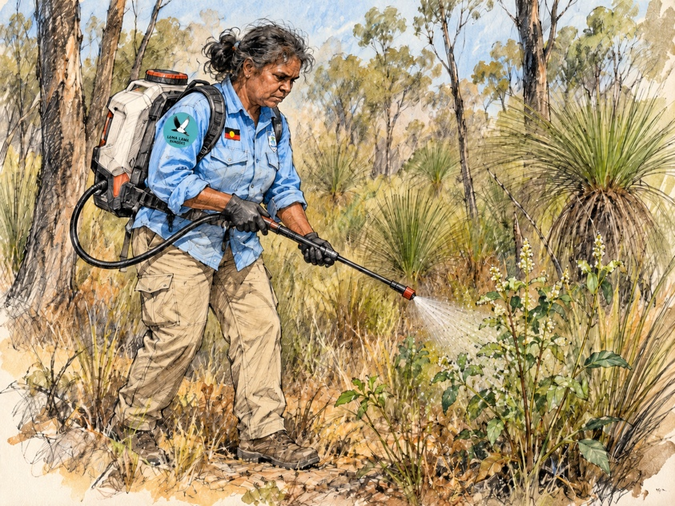
(Source: OpenAI, 2026)

Figure 2
[Lama Lama Ranger using an offline weed management application]
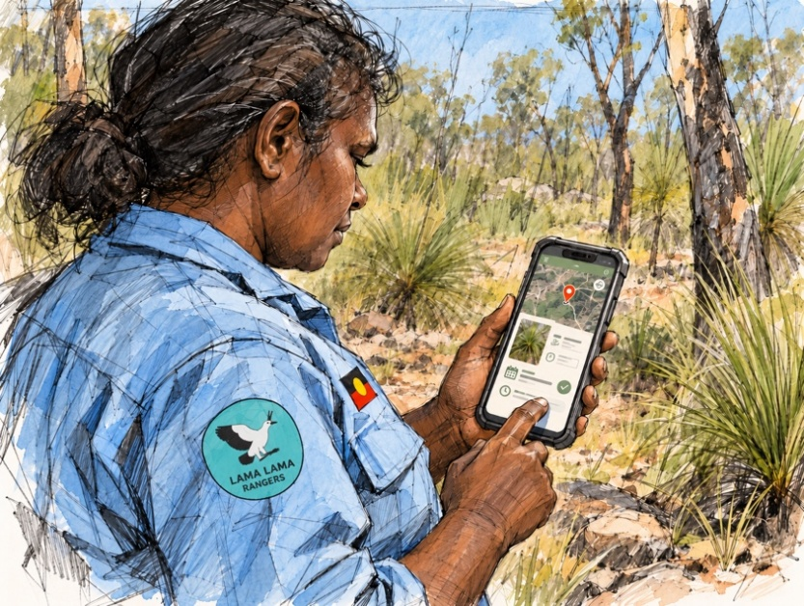
(Source: OpenAI, 2026)

Figure 3
[Lama Lama Ranger using AI photo-based weed identification]
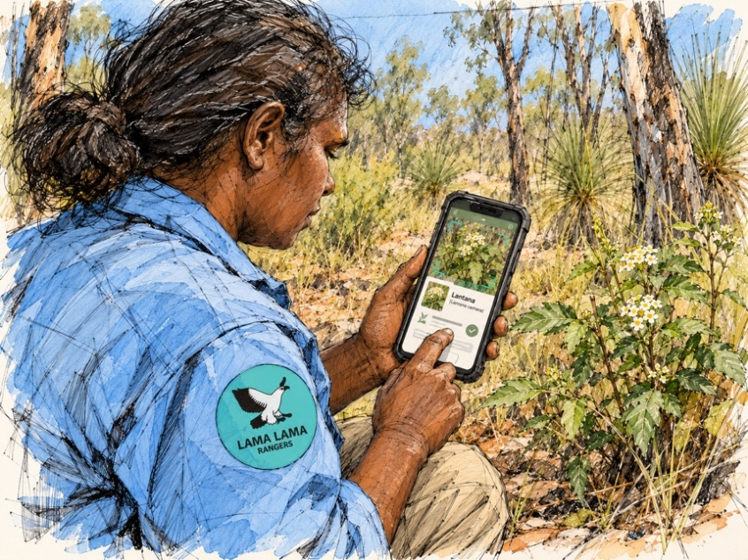
(Source: OpenAI, 2026)

Figure 4
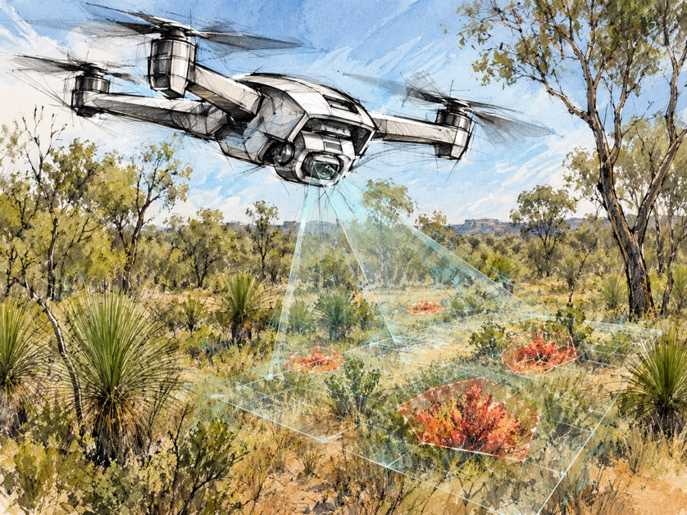
[Drone detecting weed infestations]
(Source: OpenAI, 2026)

Weighted Decision Matrix

Table 1
Weighted Decision Matrix
Solution | Offline usability (20) | Minimal training (10) | Remote field operability (20) | Maintainability (15) | Effectiveness (35) | Total (100)
Portable spot-spray device | 18 | 8 | 8 | 12 | 15 | 61
Offline Ranger Prioritization & Support App | 19 | 9 | 18 | 14 | 30 | 90
AI photo-based weed-ID system | 10 | 8 | 18 | 8 | 24 | 68
Drone + ML aerial survey system | 14 | 5 | 16 | 6 | 28 | 69
Note. Criteria partly adapted from EWB (2026b). All scores are the team’s own.

Rating scale:
- Fully meets: 90–100%: works fully with Lama Lama Country conditions
- Mostly meets: 70–89%: works well with small limits
- Partly meets: 50–69%: works, but with clear limits
- Weak: Below 50%: big barriers to use on Lama Lama Country

Effectiveness · 35 of 100 points
.
- Option 1: Drone + ML aerial survey system (Mostly meets 28 / 35).
Very good at finding and mapping weeds, but does not keep treatment history, remind Rangers to go back, or help decide what comes first.
- Option 2: Offline App (Mostly meets 30 / 35).
Covers the whole need: finding, keeping track and deciding what comes first. It loses a few points only because Rangers still have to reach a site to spot weeds
- Option 3: AI photo-based weed identification (Partly meets 24 / 35).
Helps name weeds, but does not keep treatment history, remind Rangers to go back, or help decide what comes first.
- Option 4: Portable spot-spray device (Weak, 15 / 35.)
Only helps with spraying. It does not help Rangers find weeds, keep track of sites or decide what comes first.

Offline usability · 20 of 100 points
- Option 1: Drone + ML aerial survey system (Mostly meets 14 / 20)
The drone flies without internet, but the computer program and photo uploads need strong internet.
- Option 2: Offline App (Fully meets 19 / 20)
Built to work offline first; every record is saved on the phone and uploads later.
- Option 3: AI photo-based weed identification (Partly meets 10 / 20)
The weed-guessing program usually needs internet or frequent updates.
- Option 4: Portable spot-spray device (Fully meets, 18 / 20)
A hand sprayer needs no signal or internet at all.

Remote field operability · 20 of 100 points
- Option 1: Drone + ML aerial survey system (Mostly meets, 16 / 20)
Limited by battery life, weather and thick plants, although it can reach places a vehicle cannot.
- Option 2: Offline App (Fully meets, 18 / 20)
Runs on a phone that can be carried anywhere.
- Option 3: AI photo-based weed identification (Fully meets, 18 / 20)
Runs on a phone that can be carried anywhere.
- Option 4: Portable spot-spray device (Weak, 8 / 20)
Heavy to carry on foot over long distances, and needs refilling with water and chemical, which limits how far Rangers can take it.

Maintainability · 15 of 100 points
- Option 1: Drone + ML aerial survey system (Weak, 6 / 15)
Drones need repairs and special parts, often from Cairns.
- Option 2: Offline App (Fully meets, 14 / 15)
Phones are easy to replace, and the app can be updated remotely.
- Option 3: AI photo-based weed identification (Partly meets, 8 / 15)
The weed-guessing ML model needs ongoing re-training.
- Option 4: Portable spot-spray device (Mostly meets, 12 / 15)
Simple parts such as nozzles and seals are easy to replace, but chemicals need safe storage.

Minimal training · 10 of 100 points
- Option 1: Drone + ML aerial survey system (Partly meets, 5 / 10)
Needs drone-flying training and skills to check the photos.
- Option 2: Offline App (Fully meets, 9 / 10)
Uses normal phone steps: take a photo, choose the weed, save.
- Option 3: AI photo-based weed identification: Mostly meets, 8 / 10.
Uses normal phone steps, like Option 1.
- Option 4: Portable spot-spray device (Mostly meets, 8 / 10)
Simple to use, but safe chemical handling still needs training.

The Selected Solution is … #2 Offline Ranger Prioritisation & Support App (90/100)

Alignment with user Need Criteria

Detect: Find and record weeds, even with no signal
- Works offline (Sites list screen): Saves records with no signal and uploads them later. Tag: Offline usability 19/20
- Six priority weeds (Report a weed screen): A fixed list of the six weeds keeps everyone’s records the same. Tag: Minimal training 9/10
- GPS without internet (Report a weed screen): The phone’s GPS works with no signal. Tag: Offline usability 19/20

Monitor: Keep track of treated sites and go back in time
- Overdue re-checks first (Sites list screen): Warns when a treated site is late for its check, so it is not forgotten. Tag: Effectiveness 30/35
- Photo evidence (Report a weed screen): Photos are kept to compare later visits. Tag: Effectiveness 30/35

Prioritise: Decide which site needs attention first
- Sorted by urgency (Sites list screen): Puts the most urgent sites first, to plan short field days. Tag: Effectiveness 30/35
- Navigate to the site (Sites list screen): Gives directions to the saved location. Tag: Remote field operability 18/20

Ranger control: Keep Rangers and YAC in control of their information
- Checked before listing (Report a weed screen): Reports are checked first, so Rangers and YAC stay in control. Tag: Must-have rule

Proposed solution

Overview
The proposed solution is an Offline Ranger Prioritization & Support App designed to support the weed management and environmental monitoring activities carried out by Lama Lama Rangers (Yintjingga Aboriginal Corporation, n.d.-a). The app is not intended to replace their knowledge or create a separate weed management process. Instead, it brings infestation records, treatment information and follow-up activities into one workflow. The main goal is to make field records easier to access and help Rangers decide which locations need attention next, particularly when working across remote areas with unreliable internet access.

How the app works
The process begins when a Ranger identifies a weed infestation during fieldwork. Using the app, the Ranger would create a site record containing a photograph, GPS location and weed species. The species could be selected from a fixed list based on the existing six-species Weed Action Plan (Yintjingga Aboriginal Corporation, n.d.-b). The Ranger could also enter the treatment date and describe the action taken. Keeping these details together means that the same record can be updated during later visits, rather than treating each observation as a separate entry.

This table summarises the main steps of the proposed application, from recording weed infestations to follow-up monitoring.
Table 2
Proposed Application Workflow
Step | Function | Description
1 | Weed Recording | Record photographs, GPS locations and weed species.
2 | Offline Storage | Save field records locally without internet access.
3 | Data synchronisation | Synchronise saved records when connectivity becomes available.
4 | Prioritisation | Identify sites requiring attention through the dashboard.
5 | Follow-up Monitoring | Schedule reassessments and update treatment records.

After a new site is recorded, its information would appear in a prioritisation dashboard. The dashboard is proposed to show infestation locations, treatment status and sites requiring follow-up. However, the app should support Ranger judgement, not make final treatment decisions automatically. Priority rules would need to be agreed with the Ranger team before implementation.
The next stage is follow-up monitoring. When a treatment is entered, the app would keep its date and use it to generate a reminder for reassessment. During a return visit, the Ranger could add new photographs, update the site's condition and record whether further treatment is needed.

How it is built: This application is built using Flutter, which means that it can be run across multiple devices, such as mobile, web, and desktop services using only a single codebase (Google, n.d.-a). This application integrates Supabase as the backend and database provider for storing infestation records, treatment histories, and photographs. Supabase’s Pro plan starts from A$40/month (around A$480 annually), liable to exchange rates and additional usage charges (Supabase, n.d.). The application stores the field records locally, so rangers could still record the eradication or infestation process without internet connectivity. When internet connection is available, the application will synchronise the changes that are stored in the local storage with the central database. However, it is crucial to note that Flutter does not provide a dedicated local storage and synchronisation method, which is needed for offline functionality (Google, n.d.-b).

Compatibility
The proposed application aims to complement existing field data practices, including the I-Tracker tools previously used by Lama Lama Rangers (NESP Resilient Landscapes Hub, 2014). However, direct integration with I-Tracker has not yet been confirmed and would require further investigation.

Prototyping and Testing

Prototyping allows designers to evaluate proposed solutions, identify potential design problems, and refine their ideas before committing to full implementation (Camburn et al., 2017). For the Offline Ranger Prioritisation & Support App, that idea is simple. A ranger can record and prioritise weeds on Country with no phone signal, and the information is still there when the phone reconnects.

What was built
- A working cross-platform prototype that can be opened in a browser or on a phone, built by the team using a hosted database (Supabase) and OpenStreetMap maps.
- Four parts were prototyped, because they carry the most risk and the most value:
  - sign-in that keeps the session, so a lost connection does not lock a ranger out
  - offline logging of a weed with its species, photo and GPS location
  - a site list ranked by urgency, with "Critical" and "Pending treatment" groups
  - a public report form, where any report is reviewed by an administrator before it is listed
- The prototype uses the six priority species from the existing Weed Action Plan, so the screens match how rangers already work.

How it was tested
Each test below targets one of the needs in the user needs statement: working without coverage, keeping reliable records, and showing what to do first.
Table 3. Prototype tests
Test | Method | Result
Offline logging | Put the phone in flight mode, log a weed with a photo and location, then check it is saved on the device | Successful
Sync | Turn the connection back on and check the record reaches the database once, with nothing lost or duplicated | Successful
Stay signed in | Sign in, lose the connection, close and reopen the app | Successful
Priority order | Add overdue and untreated sites and check the most urgent appear first | Successful
Ease of use | Ask a new user to log a weed without help, and note the steps taken and any errors | Achieved

Testing limitations
All tests were carried out locally by the team, simulating no coverage with flight mode, rather than by Rangers working on Country. The prototype has therefore not yet been tested in real field conditions, such as remote terrain, heat, long days without signal or the wet season.

Implementation
Deployment: As the application works fully across different platforms, Rangers can simply install the application on their devices. Moreover, Lama Lama Rangers already record field data digitally with Fulcrum and I-Tracker (Engineers Without Borders Australia, 2026b; NESP Resilient Landscapes Hub, 2014), this means Ranger can easily adapt to this proposed technology. Training can therefore be short.
However, several testing such as GPS recording and photo capture capability on their devices must be tested, allowing the application to work reliably. The rollout follows three phase approach:
- Phase 1 – Build and internal testing
GPS, photos and sync must be tested on any device that will be used in-field.
- Phase 2 – Ranger pilot trials in no-coverage zones
A small group of Rangers uses this design during the dry season, which then their feedback will be consider for the next changes.
- Phase 3 – Full wet season operational deployment
All Rangers use the app, and it is reviewed at the end of the first wet season.

Application distribution: This application will be distributed as APK files for Android devices to avoid Google Play registration fee. As for Apple devices, Apple Developer Program enrolment may be required for distribution, which costs A$150, liable to exchange rates and taxes. The final distribution method depends on the devices used by the Rangers and Apple’s applicable distribution requirement (Apple, n.d.).

Costing Analysis
Table 4. Estimated Development Time
Development Task | Estimated Hours
Requirement and architecture | 8-12
Flutter setup and UI | 15-25
Local database | 15-25
GPS and photo capture | 18-28
Offline synchronization | 25-40
Supabase backend and security | 18-28
Reminders and prioritization | 12-20
Testing and deployment | 20-30
Documentation and training | 6-10
Integration and contingency | 8-12
Total | 145-230 hours
Note: Estimated hours were generated with ChatGPT (OpenAI, 2026).

The hourly rate for a full stack developer is A$82 - A$131 (Second Talent, 2026). Given those data, this project is assumed to have taken 180 hours development time with A$100 hourly rate.
Table 5. Estimated Costs
Cost item | Cost basis | Estimated Cost
App development | A$100/hour x 180 hours | A$18,000
Supabase subscription | A$40/month x 12 months | A$480
App distribution | A$150/year x 1 year | A$150
Total Cost |  | A$18,630
Note. Development hours estimated with ChatGPT (OpenAI, 2026). Hourly rate from Second Talent (2026); database pricing from Supabase (n.d.), US$25 a month converted to about A$40; app distribution fee from Apple (n.d.).

Other considerations

The Lama Lama Rangers play an important role in protecting Country through weed management, wildlife conservation, and environmental monitoring (Yintjingga Aboriginal Corporation, n.d.-a). The team expects the community to welcome the app because it supports the Rangers' existing work, uses their own priority species list, and does not change how they care for Country.

Social considerations
- Risk: Rangers may feel the app replaces their knowledge, or that it monitors them, because each record carries the ranger's name.
- Response:
- Rangers make every decision. The app records and organises what they find, and the species list comes from their own Weed Action Plan.
- Yintjingga and the rangers agree, and write down, how records will and will not be used.
- Training is ranger-led and done in the field, so the skills stay in the community.

Cultural considerations
- Risk: GPS records show exactly where rangers have been, which could expose culturally sensitive or restricted places. Information about Country could also end up outside community control.
- Response:
- Yintjingga holds the database account and decides who can see, use and share the data, in line with Indigenous data sovereignty principles.
- Role-based access limits who can view and edit records.
- Elders and Traditional Owners are consulted, and give consent, before any data is stored.
- Restricted areas can be left unrecorded, and the public report form never publishes locations.
- Only Rangers approves any images, names or language used in the app.

Environmental considerations
- Risk: Inaccurate GPS location or outdated week records could lead rangers to wrong sites or overlook new infestation
- Response:
- Allow Rangers to verify and update weed locations during field visits
- Include the date of each observation and reminders to recheck treated sites
- Keep Rangers responsible for confirming infestation locations and deciding treatment priorities.

Maintenance considerations
- Risk: Supabase subscription must be renewed over a certain period, without a clear delegation application may not work.
Response:
- Assign someone internally to manage subscription.

Budget considerations
- Risk: Future changes are costly as development was valued at A$18,000, so paying a developer later for new features could be expensive.
Response:
- The source code and documentation are handed over, so any developer can pick it up.
- The client builds one new feature at a time, in priority order, rather than commissioning everything at once.
- Extra work is funded through grants or volunteer support.

Recommendations

The current design works well, however, it can be improved by integrating some extensive technologies.
- AI Integration: An on-device image-recognition model could identify weed species from photos without internet access, addressing the connectivity limits of the stand-alone AI option (Option 3). Model updates could be delivered with regular app updates.

Figure 5
[Artificial intelligence concept image]

(Adobe, n.d.)

- Connectivity & Sync: Advanced conflict resolution algorithms and Bluetooth P2P mesh sharing for deep remote camps.

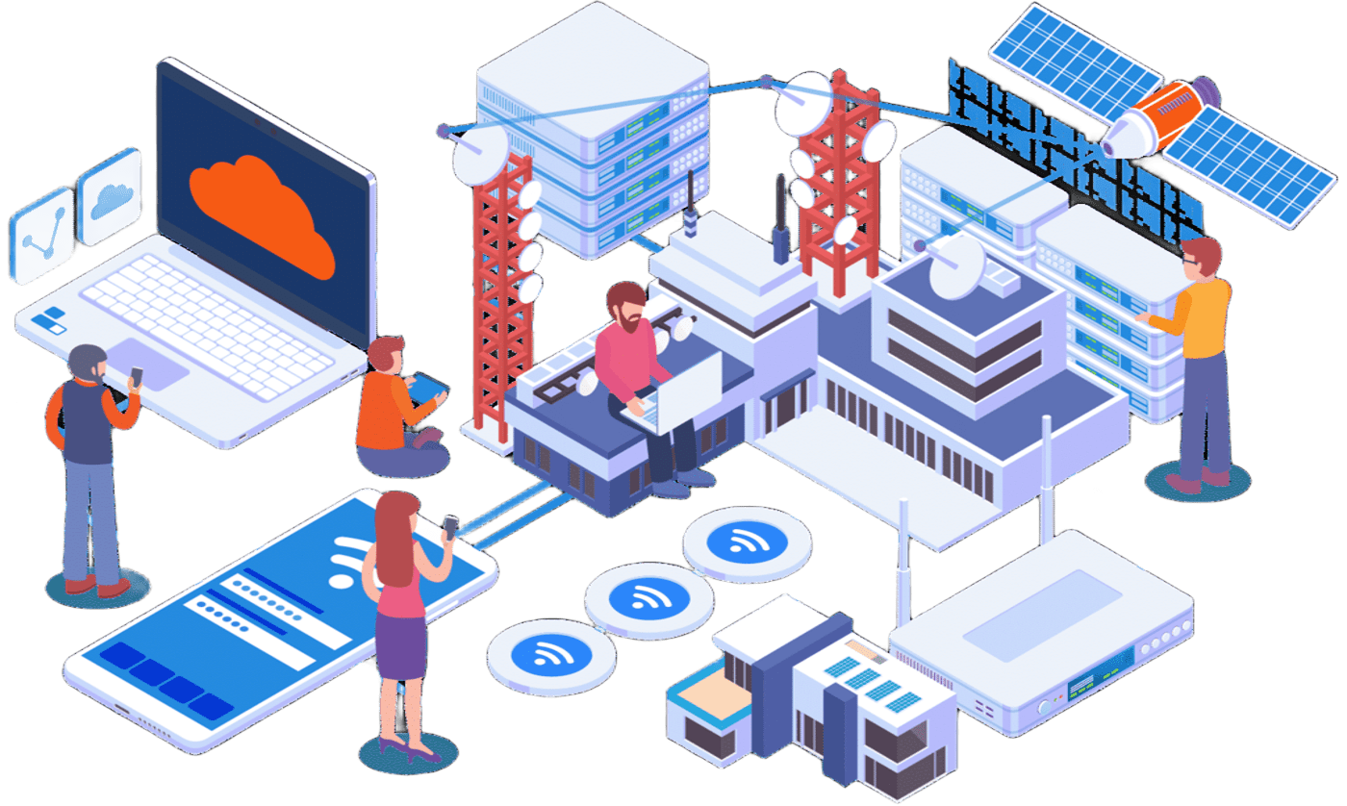
Figure 6
[Network Illustration]
(Coeo Solutions, n.d.)

- Plug-ins: High-resolution aerial drone integrated to the application to perform large area scanning and possibly treatment for specific weeds.
Figure 7
[DJI Air 3 drone]

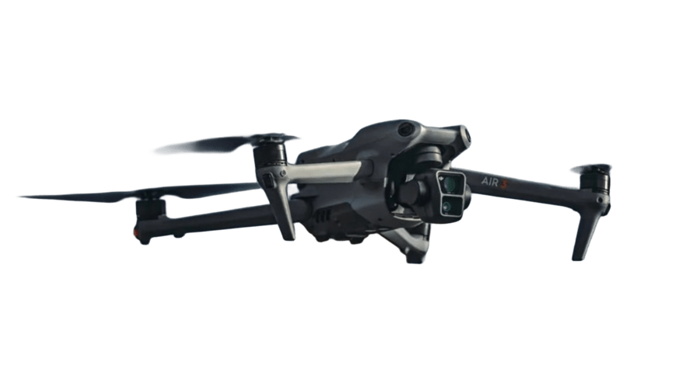
(DJI, 2023)

- Executive Dashboard: Centralized web analytics for Yintjingga Aboriginal Corporation grant tracking and environmental reporting.

Figure 8
[Executive Dashboard Illustration]

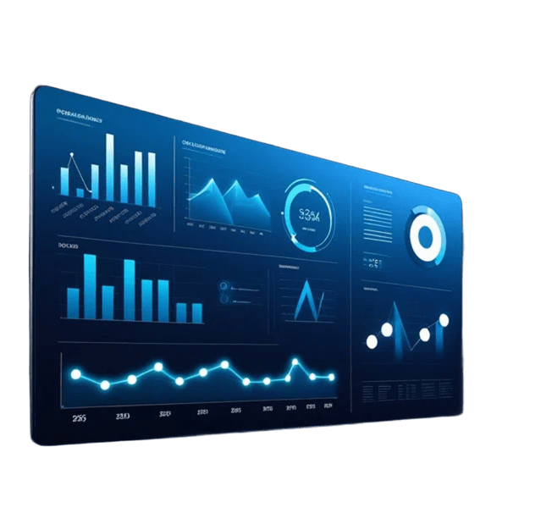
(Augmented Tech Labs, 2025)

References

Adobe. (n.d.). [Artificial intelligence concept image] [Image]. Psychology Today. https://www.psychologytoday.com/us/blog/finding-purpose/202510/can-ai-really-think
Apple. (n.d.). Apple Developer Program. Apple Developer. https://developer.apple.com/programs/
Augmented Tech Labs. (2025). [Executive dashboard examples for C-suite decision making] [Image]. https://www.augmentedtechlabs.com/blog/9-executive-dashboard-examples
Camburn, B., Viswanathan, V., Linsey, J., Anderson, D., Jensen, D., Crawford, R., Otto, K., & Wood, K. (2017). Design prototyping methods: State of the art in strategies, techniques, and guidelines. Design Science, 3, Article e13. https://doi.org/10.1017/dsj.2017.10
Coeo Solutions. (n.d.). [Network and connectivity issues] [Image]. https://www.coeosolutions.com/network-and-connectivity-issues
DJI. (2023). [DJI Air 3 drone] [Photograph]. UAV Coach. https://uavcoach.com/dji-air-3/
Engineers Without Borders Australia. (2026a). About Tropical North Queensland. EWB Challenge. https://ewbchallenge.org/challenge/port-stewart-lama-lama/about-tropical-north-queensland/
Engineers Without Borders Australia. (2026b). Design Area 4 – Augmenting the ranger program: Weed management innovation. EWB Challenge. https://ewbchallenge.org/challenge/port-stewart-lama-lama/design-area-4-augmenting-the-ranger-program/
Engineers Without Borders Australia. (2026c). Design considerations. EWB Challenge. https://ewbchallenge.org/challenge/port-stewart-lama-lama/design-considerations/
Google. (n.d.-a). Development. Flutter. https://flutter.dev/development
Google. (n.d.-b). Offline-first support. Flutter Docs. https://docs.flutter.dev/app-architecture/design-patterns/offline-first
NESP Resilient Landscapes Hub. (2014, December 10). Monitoring Lama Lama wetlands. https://nesplandscapes.edu.au/2014/12/10/monitoring-lama-lama-wetlands/
OpenAI. (2026). ChatGPT (October 25 version) [Large language model]. https://chatgpt.com/
Second Talent. (2026, October). Cost to hire freelance developers in Australia. https://www.secondtalent.com/cost-to-hire/australia/
Supabase. (n.d.). Pricing & fees. https://supabase.com/pricing
Weeds Australia. (n.d.). Monitoring. https://weeds.org.au/manage/monitoring/
Yintjingga Aboriginal Corporation. (n.d.-a). Lama Lama rangers. Welcome to Lama Lama Country. https://www.lamalama.org.au/lama-lama-rangers/
Yintjingga Aboriginal Corporation. (n.d.-b). Weed monitoring. Welcome to Lama Lama Country. https://www.lamalama.org.au/weed-monitoring/

Appendix 1: Team Meeting Charter

- Setting up our group – getting to know each other:

The names of my group members: | Edbert Wisely | Fatih Putranda Lesmana | Glenny Veneesha | Hangyeon Cho | Karell Yusdygo | Yiming Bian
Their strengths: | Quick execution | Creative brainstorming | Transparent communication | Flexible | Quick execution | Communicate frequently
Their weaknesses: | Tendency to produce perfect results | Overlooking details | May overlook some mistakes | Hyper focus on technical implementation | Overthink the concept details | Focusing too heavily on individual sections
What do they LIKE most about group work? | Different opinions and different execution expertise of each members | Multiple feedbacks that can construct a good quality of result | Every perspectives are different and everyone is assigned to a task | Searching information and making slides | We can share ideas that might be an idea that is not in my mind that will be useful to boost the quality of our assignment | Different ideas on how to improve the assessment and bring it to a higher level
What do they DISLIKE most about group work? | Work are not shared evenly (note evenly is not equally) | If the group makes it too complicated for others to follow | Unresponsive teammates and lazy teammate that does not want to complete their part on time | Late for group meeting and no answering | The un-ambitious people who will not do anything for the group and just leave all of us on read on the group chat | negative attitude toward group works and communication about sharing ideas or completing works
What makes them a GOOD team player? | Communicate regularly, active participating, well-done execution level | Everyone do their jobs and tell the others exactly what they did | Does not delay their work and complete their task on time | Everyone share their feedback correctly | When he/she can do the assignment collaboratively and share our thought which will result in a remarkable and fantastic result | Keep frequent communication
What might cause them to be a BAD team player? | No fulfilling points mentioned above | No communication and laziness | Zero communication | No communication | When he/she does not want to be active in conversation and brainstorm. Additionally, he/she also does not want to do the assignment with his/her best effort. | escape works by ignoring messages or replying lately
What grade do they hope to achieve in this subject? | HD | HD | HD | HD | HD | HD
Their contact details are: | edbert.wisely@student.uts.edu.au | fatih.p.lesmana@student.uts.edu.au | glenny.veneesha@student.uts.edu.au | hangyeon.cho@student.uts.edu.au | karell.yusdygo@student.uts.edu.au | yiming.bian@student.uts.edu.au

- Setting up our group – How we can work together:

What are our strengths? | Effective communication and punctuality
What are our weaknesses | Finding appropriate meeting times may be challenging as everyone has different schedules
How can we use these strengths / weaknesses to help us work together? | Effective communication could help produce great quality of work
How can we make working in a group an enjoyable experience? | Keep transparent communication and delegate equal tasks to everyone
How might we address what we don’t like about working in a group? | Communicate clearly dissatisfaction in the group
Does our group need a leader?  If yes, what qualities do we want in a leader?  What should the leader do? | Yes  Reliable, could delegate task equally to everyone, transparent communication
Which group member will research which aspect of our design area for task 1? | Edbert: technological aspect  Glenny: social-culture aspect  Yiming: legal aspect  Hangyeon: economical aspect  Fatih: political aspect  Karell: environmental aspect

GROUP CHARTER

Group name: Power Rangers

Our ground rules:  Other than in class, when will we meet (what time, how often)?  UTS StudySpaces/Online Platform  On average, how long should our meetings be?  1-2 Hours  Where will our meetings take place?  UTS StudySpaces/Online Platform  How do we inform each other when we can’t be there or are running late?  Group Chat  What does “on time” mean?  Be at the agreed location 5 minutes before  How will we deal with lateness to meetings?  Buy us some snacks and lunch  How do we deal with members who don't participate enough, participate too much,  or distract the group from its task?  No one will do that.  What will we do if a group member's work doesn't meet our standards?  Tell the teachers to discuss further  How are we going to make decisions?  Voting | Our goals:  What is our group trying to accomplish?  HD  Leadership  Will we appoint a leader?  Yes  Who?  Fatih  What are their responsibilities?  Lead the group  Our commitment to the charter:  We, Power Rangers, with the answers in our charter and will try our best to uphold them.  Name Signature  Edbert Wisely Edbert  Fatih Putranda Fatih  Lesmana  Gleeny Veneesha Glenny  Hangyeon Cho Hangyeon  Karell Yusdygo Karell  Yiming Bian Yiming

Appendix 2: Team Meeting Minutes
#1 Meeting Minutes
Duration: 45 minutes
Date and Time | 21 October 2026, 12 PM  Google Meet (online)
Present | - Fatih Putranda Lesmana,  - Edbert Wisely,  - Karell Yusdygo,  - Hangyeon Cho,  - Glenny Veneesha, and  - Yiming Bian
Organiser | Karell Yusdygo
Minute Taker | Fatih Putranda Lesmana
Next Meeting | 25 October 2026
Agenda
- Review the Assessment Task 3 website structure, rubric, and current progress.
- Confirm task allocation and responsibilities for each team member.
- Discuss website consistency, prototype/design progress, appendix requirements, AI evidence, and final review needs.
Action Items
Action Item | Responsible Person | Due Date
Create Introduction to Lama Lama Country and Background Research | Yiming Bian | 10 PM  26 October 2026
Problem definition and scope section. As well as the project management section | Glenny Veneesha | 10 PM  26 October 2026
Complete the design process and decision-making. | Karell Yusdygo | 10 PM  26 October 2026
Finish Proposed Solution (based on design process from Karell) | Hangyeon Cho | 10 PM  26 October 2026
Complete Prototyping and Considerations. | Fatih Putranda Lesmana | 10 PM  26 October 2026
 | Edbert Wisely | 10 PM  26 October 2026
  Implementation plan and costings. Anticipated considerations and recommendations
Complete a final whole-team review of content, citations, links, and website presentation. | All members | During the next online meeting

Other items
- The group agreed to use a consistent visual theme and formatting across all website pages.
- Each member agreed to review and revise their own section against the assessment rubric before submission.
- AI-use evidence and Prompt Log materials will be declared and collected for the appendices together with the Group Charter and Meeting Minutes.

#2 Meeting Minutes
Meeting Minutes: 2 hours and 45 minutes
Date and Time | 25 October 2026, 6 PM  Google Meet (online)
Present | - Fatih Putranda Lesmana,  - Edbert Wisely,  - Karell Yusdygo,  - Hangyeon Cho,  - Glenny Veneesha, and  - Yiming Bian
Organiser | Edbert Wisely
Minute Taker | Glenny Veneesha
Next Meeting | 28 October 2026

- Agenda
- Analyze each member's report section
- Merge all finalized report sections
- Discuss website interface, structure, and animation
- Collect AI evidence log

Action Item | Responsible Person | Due Date
Provide ideas for the website interface and body | Yiming Bian | 12 PM  27 October 2026
Provide ideas for the website body | Glenny Veneesha | 12 PM  27 October 2026
Analyze and review each member's sections | Karell Yusdygo | 12 PM  27 October 2026
Check citations and references | Hangyeon Cho | 12 PM  27 October 2026
Merge each member’s section into 1 file | Fatih Putranda Lesmana | 12 PM  27 October 2026
Complete the website design | Edbert Wisely | 12 PM  27 October 2026
Perform final review of the final report | All members | During the next online meeting

#3 Meeting Minutes
Meeting Minutes: 1 hour
Date and Time | 28 October 2026, 9 AM  Google Meet (online)
Present | - Fatih Putranda Lesmana,  - Edbert Wisely,  - Karell Yusdygo,  - Hangyeon Cho,  - Glenny Veneesha, and  - Yiming Bian
Organiser | Karell Yusdygo
Minute Taker | Fatih Putranda Lesmana
Next Meeting | -

- Agenda
- Review the final structure of the report and website

Action Item | Responsible Person | Due Date
Review the report and website.  Collect feedback and integrate to report/website. | All members | 8 PM  28 October 2026

Appendix 3: Use of AI
AI was used to draft APA 7th style reference
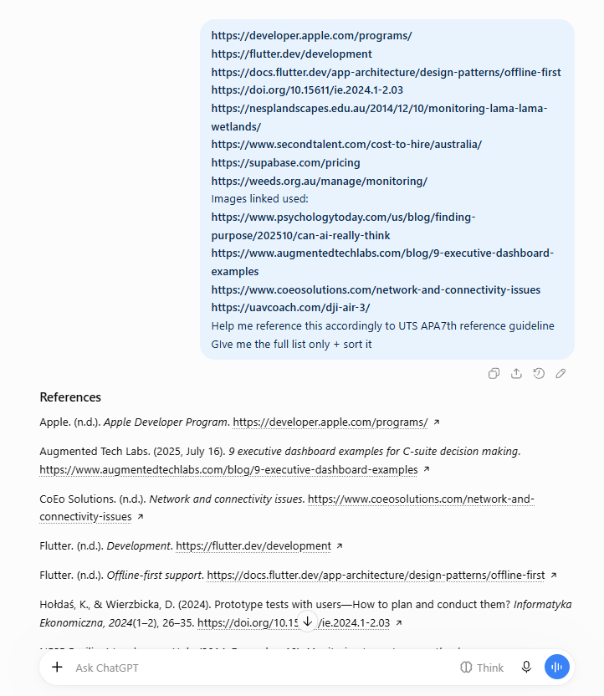

AI was used to estimate needed development hours
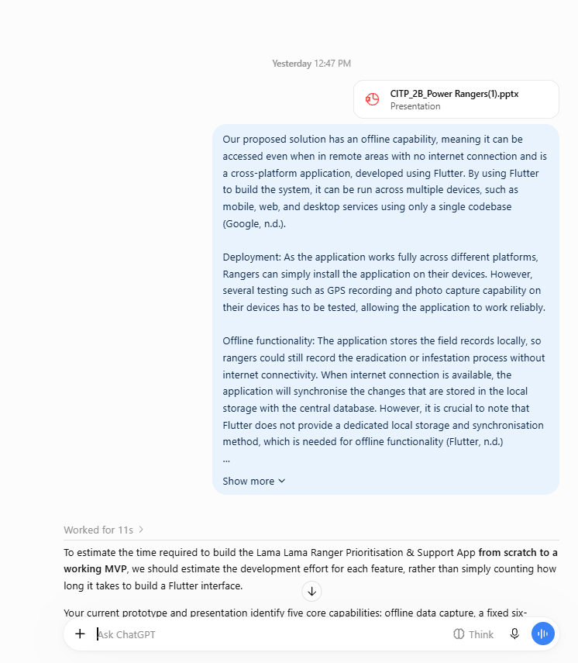
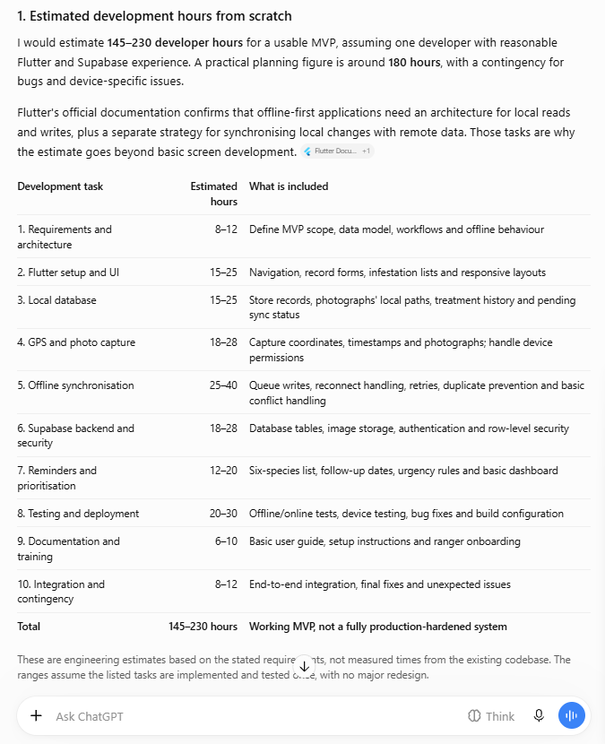
AI was used to generate the template for the website
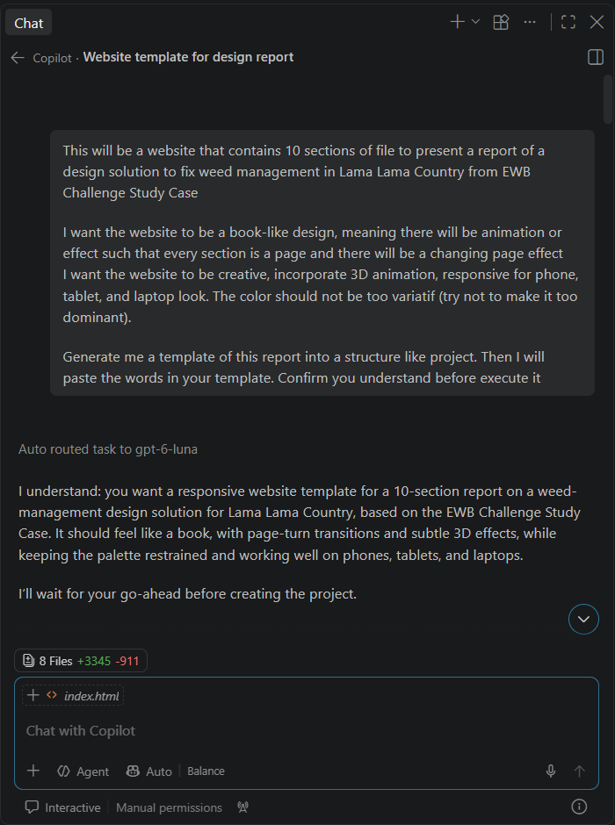

AI was used to ask how to generate executive summary
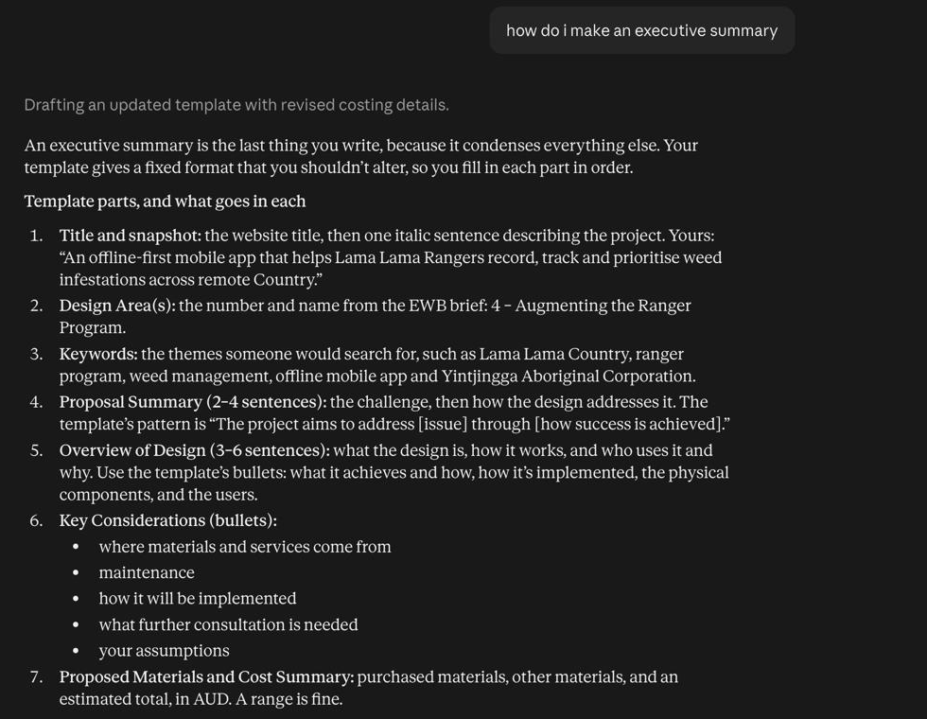

AI was used to verify the quality of executive summary
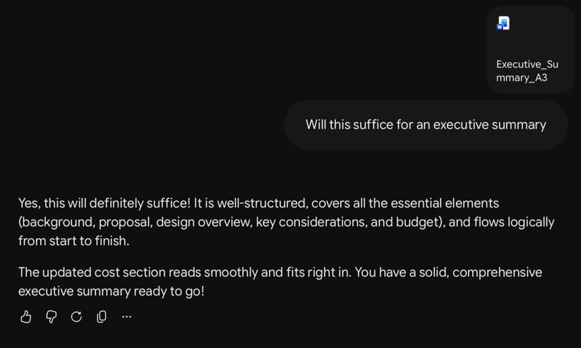

AI was partially used to merge content among peers
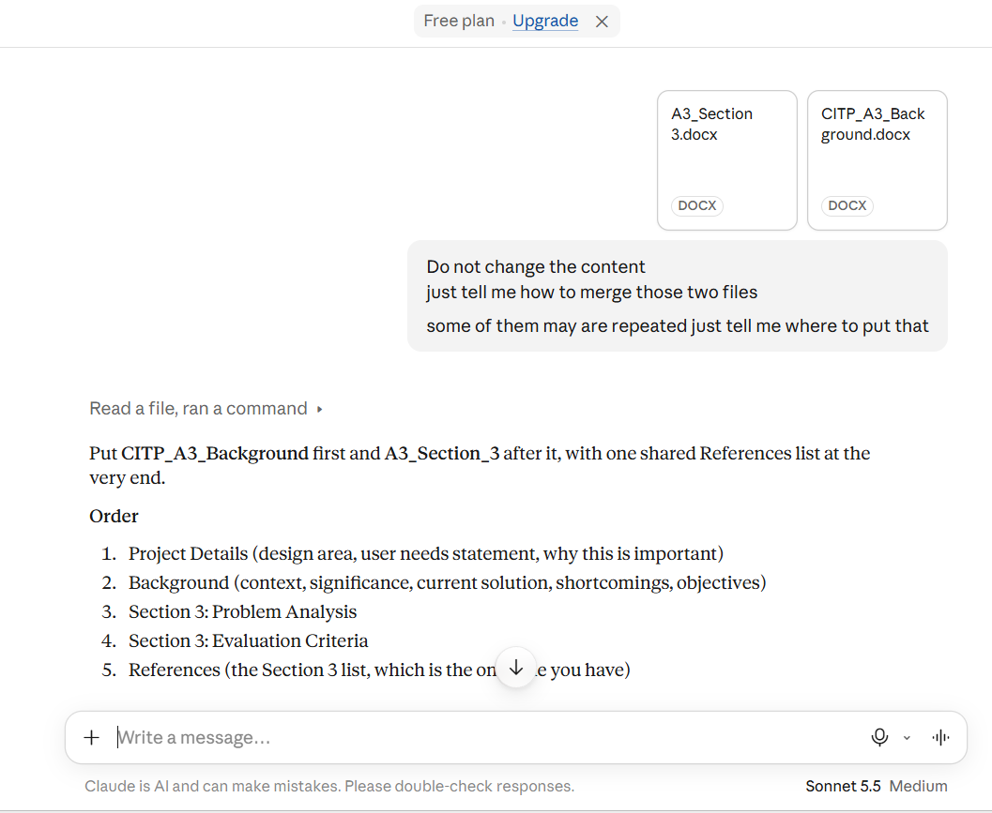

AI was used to merge content to the website
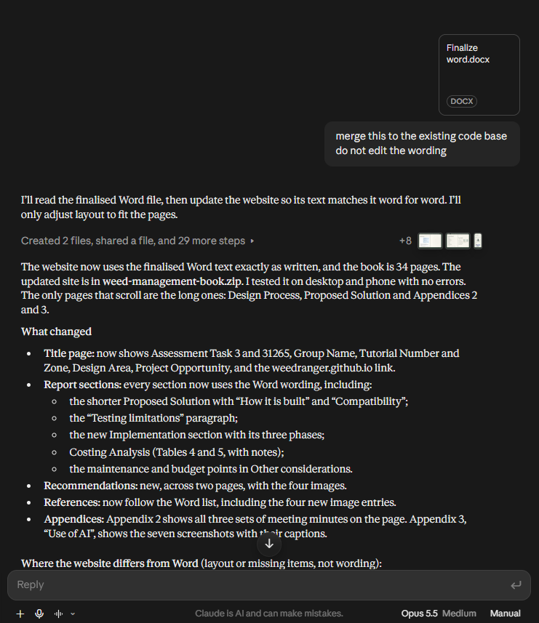

AI was used to generate pictures as visualization
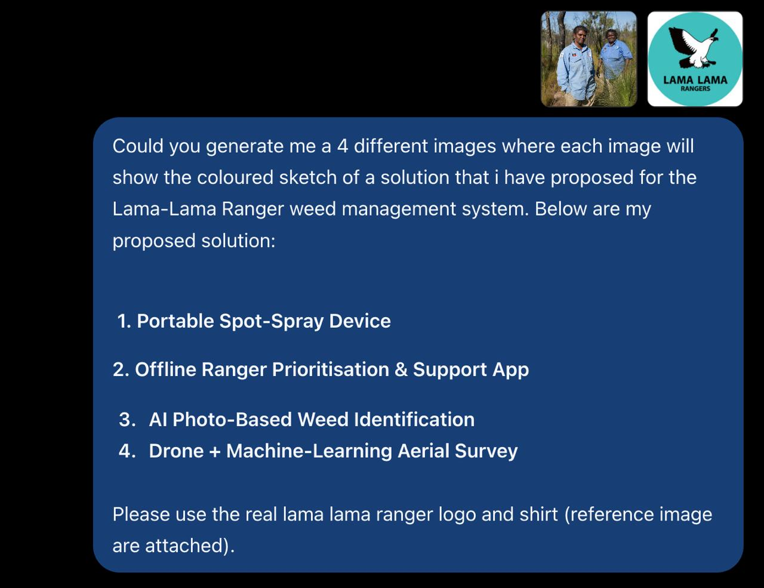
AI was used to check the content
