**Creating a New GitHub Project and Setup for RisKy1 using MINGW64 on Windows 10**

**by Kirk Weedman**

1. First run MINGW (a bash type shell for Windows) and go to the RisKy1 folder

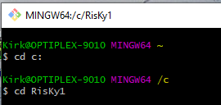

1. Now enter the following commands which depend on the users name and email address

* git config --global user.name "Kirk Weedman"
* git config --global user.email "kirk@hdlexpress.com"
* git init
* touch README.md

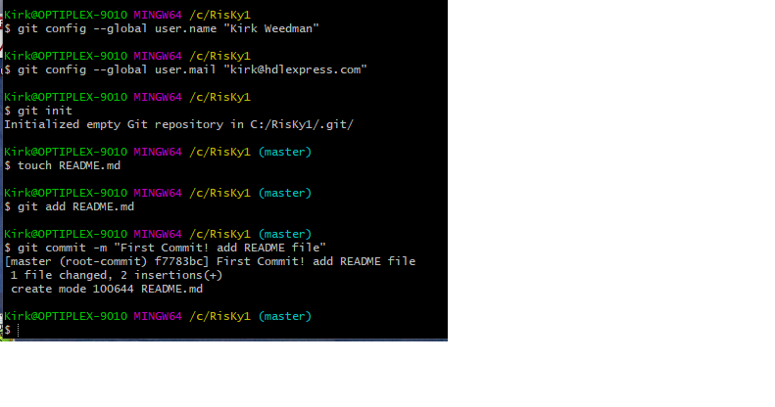

1. Edit and add some markdown text to README.md, such as the following

# RisKy1

RISC-V ISA based 5 stage pipelined CPU (RV32IMC)

1. Now add and commit the README.md file to the Git project

* git add README.md
* git commit -m "First commit! add README file"



Note: git add will add files or folders to the git project index.

1. At this point, realize that nothing has been added to github.com, we're just setting up the Github project on the PC. Now we'll begin adding files and folders to the Git project before creating the project on github.com
2. Now we'll add the "design" folder. NOTE: we are still in the RisKy1 folder. Also notice that if working on a PC you may get messages about converting from LF to CRLF. This is not a problem. Git will maintain the original file contents but may store it differently

* git add design

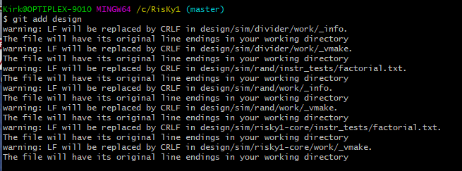

1. Now add the "verification" folder

* git add verification



1. These are the two top level folders in the design. Since I have files & folders that are not intended for the github project that are down in the "design" folder I will now remove them from the project before committing the design and verification folders.

* cd design
* ls
* cd src
* ls

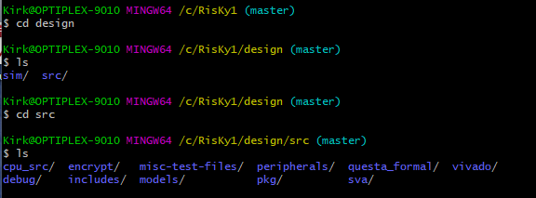

1. Now I'll remove an unwanted git project folder such as encrypt from the project

* git rm –r --cached encrypt

Note: The -r option means recursively. --cached means – " Use this option to unstage and remove paths only from the index. Working tree files, whether modified or not, will be left alone."

MINGW will pop open a browser help page if you enter something like this

* git rm –help

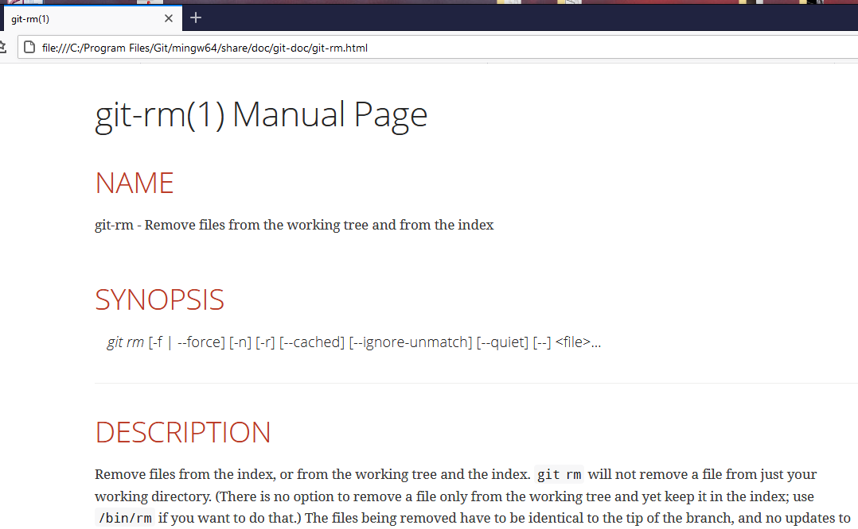

Other files or folders can also be removed from the project index in this manner. Just be careful to not use commands that physically remove files/folders from your hard drive, such as rm –r –force encrypt which would force removal from your hard drive of the encrypt folder.

1. Once all files and/or folders have been added or removed, we'll commit the whole project index that will create a snapshot of everything we've informed git about so far. Committing does not send the info to github.com, but merely saves the snapshot of the project in the .git folder (created when using "git init")

* git commit –a –m "Release 22 – fixes to mem.sv Load/Store logic"

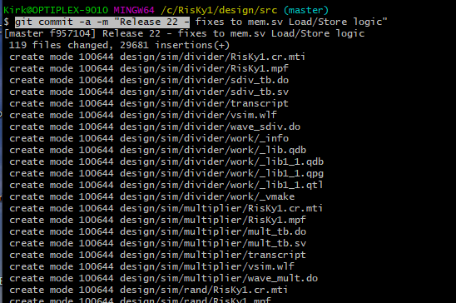

In this case there were a lot more files listed that shown above.

1. Now will push the release to the github.com website. Since we have not yet told git where this repository will be located on the internet, we will need to do the following where <USERNAME> and <PASSWORD> have to be filled in for the specific github.com account

* git remote add origin https://<USERNAME>:<PASSWORD>@github.com/weedmank/RisKy1.git

Note: should you mess up the https location you may need to do a "git remote rm origin" then do the "git remove add …" command again

1. Now we'll save it on the existing github.com account (weedmank/RisKy1)

* git push -u origin master

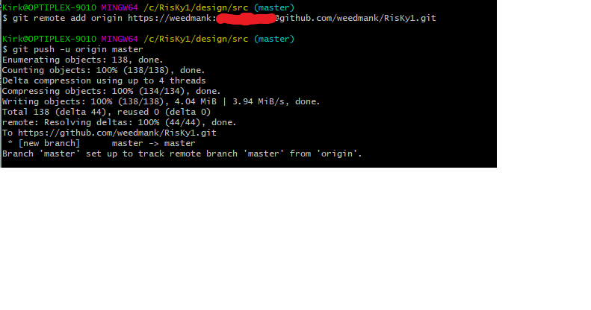

**How the github.com weedmank/RisKy project folder was created.**

It was created by logging into the github.com user account weedmank, then creating the RisKy1 project as follows:

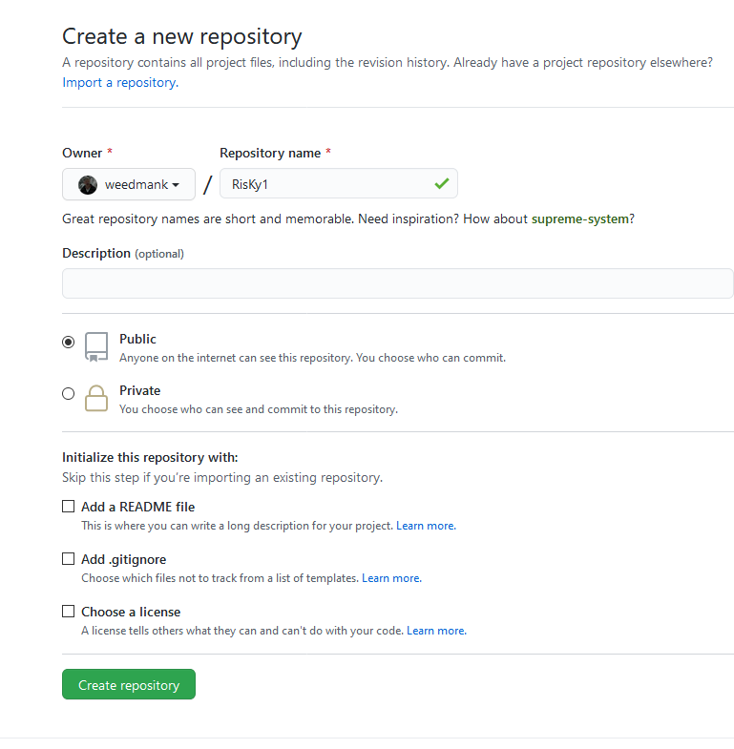

**Resetting when a file is too large and screws up git**

git reset origin/master