How To Reverse Engineer a Csound Instrument
by Nick Hilton

May 1, 2009

1.0 Introduction

This document will outline the steps I took to reverse engineer a Csound drum for use with Nsound. It basically steps one through how to dump signals to disk and plot them with octave to understand how what signals are created and being processed.

2.0 The Orchestra & Score Files

The drum I will be reversing is call BD01.orc, it can be downloaded from:

http://www.csounds.com/istvan/html/drums.html

Below is the orchestra file.

r = 48000
ksmps = 2
nchnls = 1

#include "base_macros.h.orc"
seed 0

instr 1

p3 = p3 + 0.1

icps = $MIDI2CPS(p4)
ivel limit p5, 0, 127
iamp = $VELOC2AMP(ivel)
ifdec = 0.025 * ((ivel / 127.0) * (ivel / 127.0) + 0.1072)

kcps1 expon 1.0, ifdec, 0.5
kcps2 expon 1.0, 0.32, 0.5
kcps = (4.3333 * kcps1 + kcps2) * icps
klpf expon 1.0, 0.04, 0.5
klpf2 expon 1.0, 0.0005, 0.5
klpf2 = klpf2 * 8.0
kamp port 1.0, 0.01, 0.5

a1 oscili 1.0, kcps, 1, 0.25
a1 limit a1, -0.25, 0.25
a1 tone a1, kcps * (0.5 + klpf2)

a2 unirand 2.0
a3 unirand 2.0
a2 = (a2 - 1.0) * (a3 - 1.0)
a_ tone a2, 500.0
a2 = a2 - a_

a1 butterlp kamp * a1, 4.0 * (klpf + klpf2) * kcps
a2 butterlp kamp * a2, kcps
a2 = a2 * sqrt(klpf)
a1 = a1 + a2 * 1.0

aenv linseg 1.0, p3 - 0.1, 1.0, 0.05, 0.0, 1.0, 0.0

out a1 * iamp * aenv * 220000.0

endin

The example score file is:

t 0 140

f 1 0 16384 10 1

i 1 0.000 1.000 31 127

e

Before you can begin reverse engineering, you need to be able to execute Csound with the existing instrument without errors. The bd.zip includes many preprocessor include files. After unziping everything to one directory, I am able to execute make to execute Csound.

$ make
...
csound -d -m7 -H1 -s -W -o bd01.wav bd01.orc bd01.sco
...

3.0 Understanding the Score File

t 0 140

The line above sets the temp for the performance.

t Statement (Tempo Statement)
t — Sets the tempo.

Description
This statement sets the tempo and specifies the accelerations and decelerations for the current section. This is done by converting beats into seconds.

Syntax
t p1 p2 p3 p4 ... (unlimited)

Initialization
p1 -- Must be zero.
p2 -- Initial tempo on beats per minute.
p3, p5, p7,... -- Times in beats per minute (in non-decreasing order).
p4, p6, p8,... -- Tempi for the referenced beat times.

In this case, the tempo is set to 140 beats per minute. The next line in the score is:

f 1 0 16384 10 1

The f-statement creates a function table.

f Statement (or Function Table Statement)
f Statement (or Function Table Statement) — Causes a GEN subroutine to place values in a stored function table.

Description
This causes a GEN subroutine to place values in a stored function table for use by instruments.

Syntax
f p1 p2 p3 p4 p5 ... PMAX

Performance
p1 -- Table number by which the stored function will be known. A negative number requests that the table be destroyed.
p2 -- Action time of function generation (or destruction) in beats.
p3 -- Size of function table (i.e. number of points) Must be a power of 2, or a power-of-2 plus 1 if this number is positive. Maximum table size is 16777216 (224) points.
p4 -- Number of the GEN routine to be called (see GEN ROUTINES). A negative value will cause rescaling to be omitted.
p5 ... PMAX -- Parameters whose meaning is determined by the particular GEN routine.

A function table with 16384 points is filled with GEN10, a simple sine wave.

For complex function tables, dumping to disk and plotting them is the best way to know what is going on.

Here's how I dump f-tables to disk. First, add a new instrument to the orchestra file.

instr 1000

ftsave "ftable1.txt", 1, 1

endin

The ftsave opcode is used to save function table 1 to an ASCII file.

ftsave
ftsave — Save a set of previously-allocated tables to a file.

Description
Save a set of previously-allocated tables to a file.

Syntax
ftsave "filename", iflag, ifn1 [, ifn2] [...]

Initialization
"filename" -- A quoted string containing the name of the file to save.
iflag -- Type of the file to save. (0 = binary file, Non-zero = text file)
ifn1, ifn2, ... -- Numbers of tables to save.

The new debug instrument (i 1000) needs to be called in the score file in order for it to get executed. Here is the modified score file:

t 0 140

f 1 0 16384 10 1

i 1 0.000 1.000 31 127

i 1000 0.0 1.0 ; start and duration doesn't matter

e

To produce the "ftable1.txt" file, run Csound with the modified orchestra and score files:

$ csound -d -m7 -H1 -s -W -o nick-bd01.wav nick-bd01.orc nick-bd01.sco

Next, I delete the extraneous text from ftable1.txt, this includes about 25 lines at the top and one line at the bottom.

$ vi ftable1.txt
...

After the extraneous text is remove, it can be easily plotted with octave.

$ octave
octave:1> x = load("ftable1.txt"); plot(x)

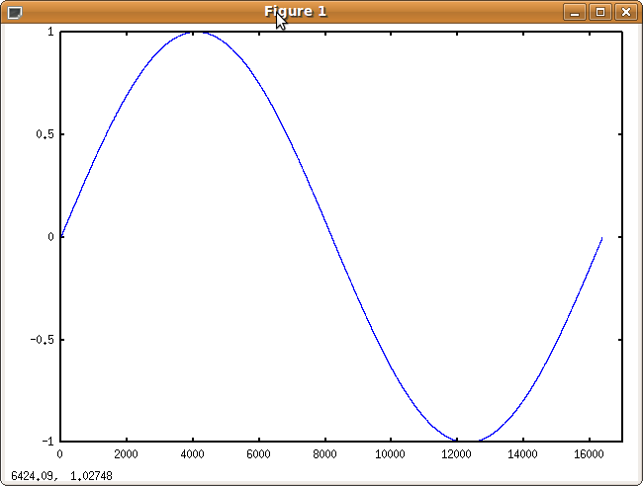

Now lets look at the score file to see how the drum (i 1) is called:

;instrument start_time duration p3 p4
i 1 0.000 1.000 31 127

4.0 Dumping Signals From The Instrument

We are ready to take a look at the actual instrument definition.

To start, I changed the control sample rate to 1, this means the control signals are the same length as the audio signals.

sr = 48000
ksmps = 1
nchnls = 1
...

Next, I dump all the values for i-rate variables. We can easily do this with the print command:

...
icps = $MIDI2CPS(p4)
ivel limit p5, 0, 127
iamp = $VELOC2AMP(ivel)
ifdec = 0.025 * ((ivel / 127.0) * (ivel / 127.0) + 0.1072)

print icps, ivel, iamp, ifdec
...

Running Csound produces:

instr 1: icps = 48.999 ivel = 127.000 iamp = 1.000 ifdec = 0.028

The next block of instrument code produces control rate signals. To dump these, I add dumpk calls.

...
kcps1 expon 1.0, ifdec, 0.5
kcps2 expon 1.0, 0.32, 0.5
kcps = (4.3333 * kcps1 + kcps2) * icps
klpf expon 1.0, 0.04, 0.5
klpf2 expon 1.0, 0.0005, 0.5
klpf2 = klpf2 * 8.0
kamp port 1.0, 0.01, 0.5

dumpk kcps1, "kcps1.dat", 6, 0
dumpk kcps2, "kcps2.dat", 6, 0
dumpk kcps, "kcps.dat", 6, 0
dumpk klpf, "klpf.dat", 6, 0
dumpk klpf2, "klpf2.dat", 6, 0
dumpk kamp, "kamp.dat", 6, 0
...

Running Csound produces binary float-32 bit .dat files. Here, the argument 6 means dump binary 32-bit floats, the 0 means dump at the k sample rate.

The .dat files are binary, so I use octal dump to convert them to plain ASCII and plot them with octave.

To convert them to plain ASCII:

$ od -f kcps.dat --width=4 -A n -v > kcps.txt

-f Specifies interpret the data as 32-bit floats
--width=4 Print one value per line
-A n Don't print the file offset address
-v Don't skip any repeated values

Plotting kcps.txt with octave:

$ octave
octave:1> x = load("kcps.txt"); plot(x)
octave:2> size(x)
ans =
25371 1
octave:3> x(1)
ans = 261.33

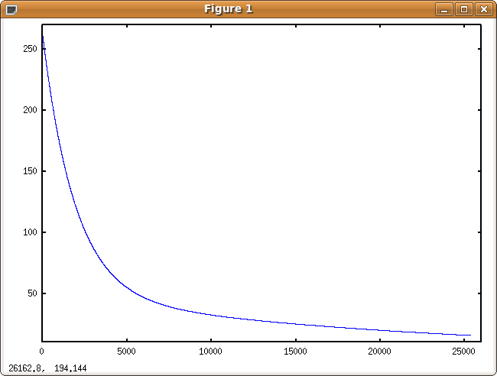

It looks like an exponential decay, that starts at 261.33 Hz.

Plotting "klpf.dat" with octave:

$ od -f klpf.dat --width=4 -A n -v > klpf.txt
$ octave
octave:1> x = load("klpf.txt"); plot(x)

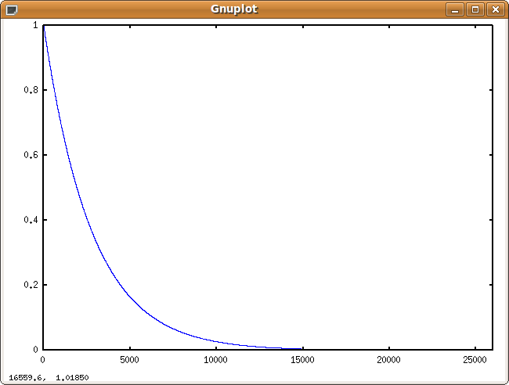

klpf is an exponential decay from 1.0 to 0.0 in less than 15000 control samples.

Plotting "klpf2.dat" with octave:

$ od -f klpf2.dat --width=4 -A n -v > klpf2.txt
$ octave
octave:1> x = load("klpf2.txt"); plot(x)

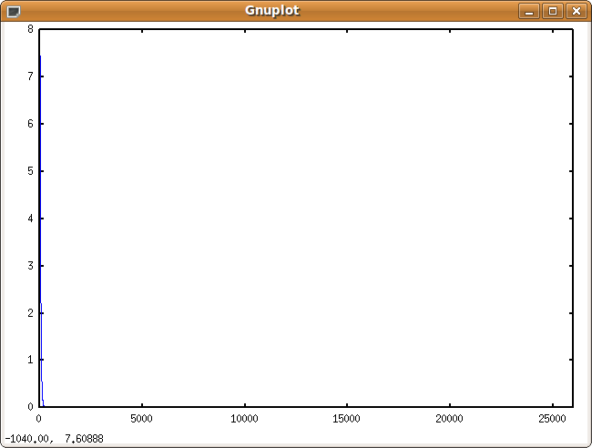

The does not show much, let's plot only the first 200 samples:

octave:2> plot(x(1:200))

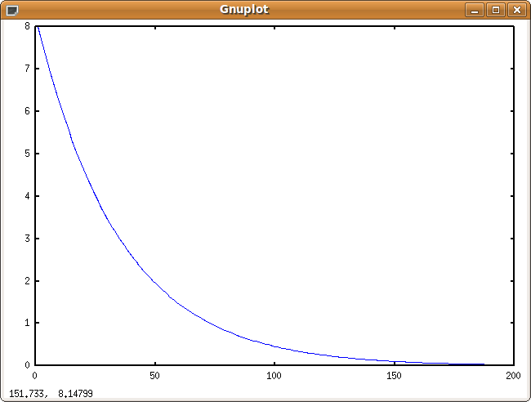

klpf2 is a rapid exponential decay from 8.0 to 0.0 in less than 200 samples.

Plotting "kamp.dat" with octave:

$ od -f kamp.dat --width=4 -A n -v > kamp.txt
$ octave
octave:1> x = load("kamp.txt"); plot(x(1:5000))

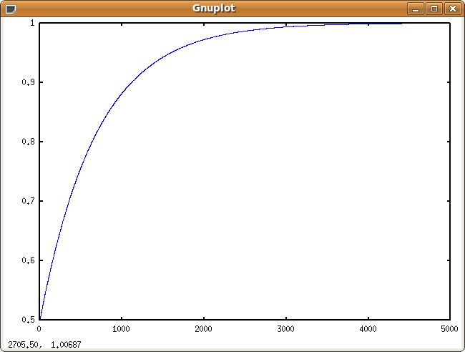

kamp is an exponential that grow from 0.5 to 1.0 in about 5000 samples.
The control rate signals ("k" signals) kamp, klpf, klpf2, kcps, are used to create audio rate signals ("a" signals).

To dump audio rate signals, use the fout command. Below is the instrument with added fout commands to dump the audio rate signals.

a1 oscili 1.0, kcps, 1, 0.25
a1 limit a1, -0.25, 0.25
fout "a1-1.dat", 0, a1
a1 tone a1, kcps * (0.5 + klpf2)
fout "a1-2.dat", 0, a1

a2 unirand 2.0
a3 unirand 2.0
a2 = (a2 - 1.0) * (a3 - 1.0)
fout "a2-1.dat", 0, a2
a_ tone a2, 500.0
a2 = a2 - a_
fout "a2-2.dat", 0, a2

a1 butterlp kamp * a1, 4.0 * (klpf + klpf2) * kcps
k_butterlp1 4.0 * (klpf + klpf2) * kcps
dumpk k_butterlp1, "k_butterlp1.dat", 6, 0
fout "a1-3.dat", 0, a1
a2 butterlp kamp * a2, kcps
a2 = a2 * sqrt(klpf)
fout "a2-3.dat", 0, a2
a1 = a1 + a2 * 1.0
fout "a1-4.dat", 0, a1

aenv linseg 1.0, p3 - 0.1, 1.0, 0.05, 0.0, 1.0, 0.0
fout "aenv.dat", 0, aenv

a_out = a1 * iamp * aenv * 220000.0
fout "a_out.dat", 0, a_out

out a1 * iamp * aenv * 220000.0

endin

Using the same octal dump and octave technique we can plot all of these signals. Lets begin by looking at a1-1.dat.

Plotting a1-1.dat with octave:

$ od -f a1-1.dat --width=4 -A n -v > a1-1.txt
$ octave
octave:1> x = load("a1-1.txt"); plot(x); ylim([-0.35 0.35])
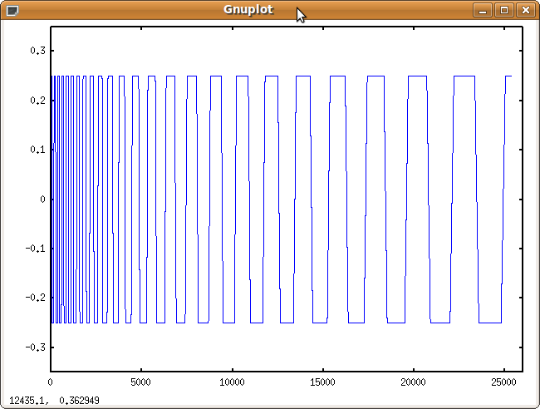

Notice that I changed the default y axis limits so we can see that a1-1 is a square-like wave and that it's frequency changes over time.

a1 oscili 1.0, kcps, 1, 0.25

This line oscillates the signal in function table 1 at kcps frequency. We plotted kcps above earlier. So a1 is a sine-wave that changes in frequency from 261.33 Hz and decays exponentially to 15.6 Hz.

a1 limit a1, -0.25, 0.25

The next line limits the function between -0.25 and 0.25, afterward, it appears like a square wave.

Next a1 is sent through a tone filter.

a1 tone a1, kcps * (0.5 + klpf2)
fout "a1-2.dat", 0, a1

Plot of a1-2.dat:

$ od -f a1-2.dat --width=4 -A n -v > a1-2.txt
$ octave
octave:1> x = load("a1-2.txt"); plot(x);

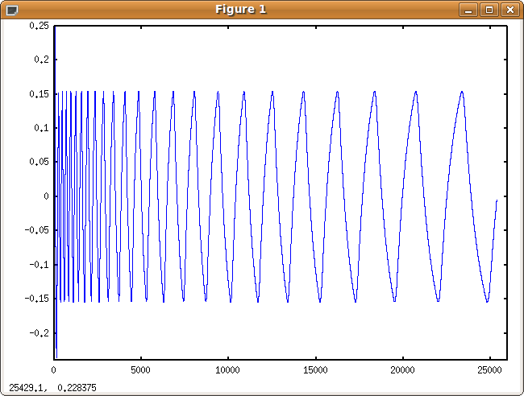

Two new signals are created next.

a2 unirand 2.0
a3 unirand 2.0
a2 = (a2 - 1.0) * (a3 - 1.0)
fout "a2-1.dat", 0, a2

(a2 - 1.0) and (a3 - 1.0) are white noise signals between -1.0 and 1.0. After multiplication, a slightly different noise distribution between -1.0 and 1.0 is produced and is plotted below.

Ploting a2-1.dat:

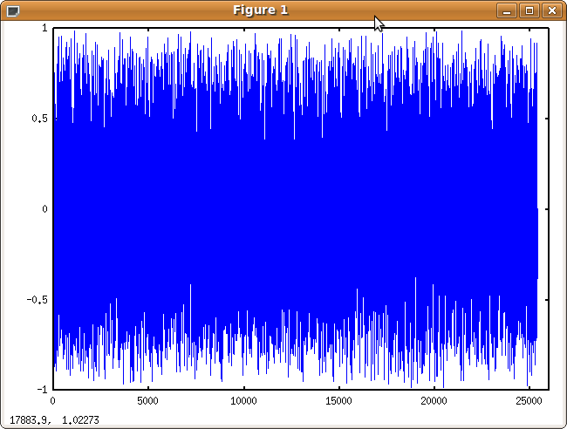

Next, the noise is filtered with a tone filter with a cut off of 500 Hz.

a_ tone a2, 500.0
a2 = a2 - a_
fout "a2-2.dat", 0, a2

The filtered noise is then subtracted from the original noise. So a2 has less noise from 1 to 500 Hz and is very noise above 500 Hz.

Plotting the frequency spectrum of a2-2 with octave:

$ od -f a2-2.dat --width=4 -A n -v > a2-2.txt
$ octave
octave:1> x = load("a2-2.txt");
octave:2> psd_x = abs(fft(x));
octave:3> plot(psd_x(1:2000))

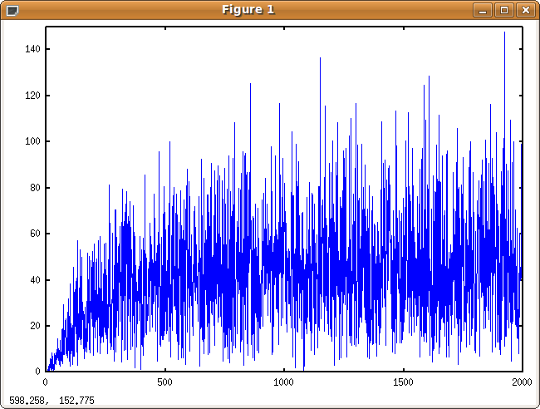

We can see the magnitude of increases over the range 0 to 500, and really noisy above 500.

Next, the a1 signal is filtered with a low pass Butterworth filter.

a1 butterlp kamp * a1, 4.0 * (klpf + klpf2) * kcps
k_butterlp1 = 4.0 * (klpf + klpf2) * kcps
dumpk k_butterlp1, "k_butterlp1.dat", 6, 0
fout "a1-3.dat", 0, a1

The cut off frequency changes over time so I added code to capture and dump the final frequency value to k_butterlp1.

Plotting k_butterlp1 with octave:

$ od -f k_buterlp1.dat --width=4 -A n -v > k_butterlp1.txt
$ octave
octave:1> x = load("k_buterlp1.txt"); plot(x(1:2400))

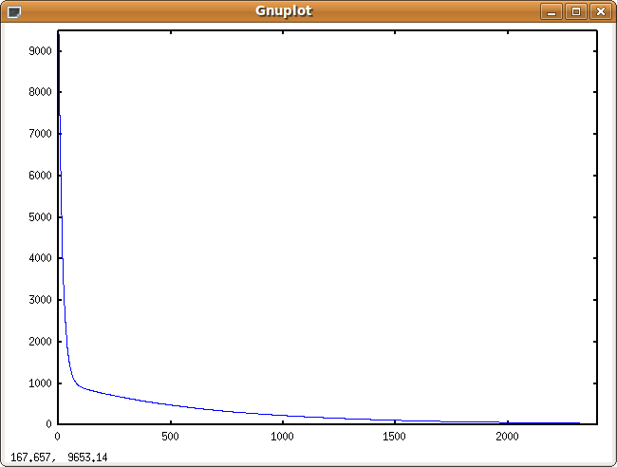

The frequency cutoff is a sharp decay in combination with a low decay.

So a1 before the low pass filter looks like this:

A1 after the filter was captured in a1-3.

Plotting a1-3.dat with octave:

$ od -f a1-3.dat --width=4 -A n -v > a1-3.txt
$ octave
octave:1> x = load("a1-3.txt"); plot(x(1:15000))

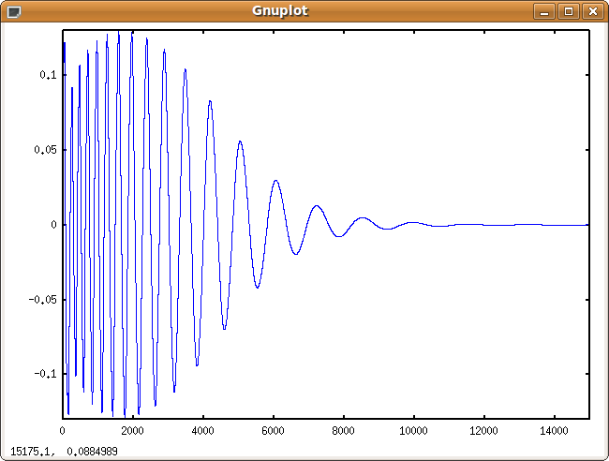

A1 after the low pass filter is above, but only the first 15000 samples is plotted. Also notice how the signal grows for a bit and then decays, this is achieved by multiplying the filter output with kamp. kamp was plotted previously and is a growing exponential signal from 0.5 to 1.0.

Next, a2 is sent through another low pass filter.

a2 butterlp kamp * a2, kcps
a2 = a2 * sqrt(klpf)
fout "a2-3.dat", 0, a2

Plotting a2-3:
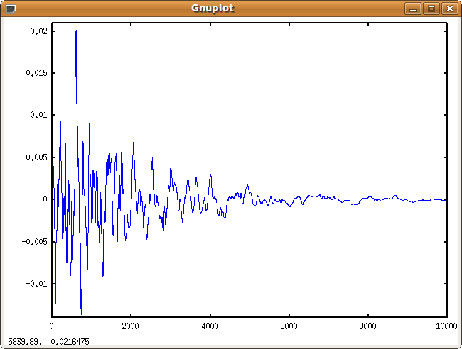

A noisy signal that attenuates over time because the frequency of the noise is very high above 500. Remember that the noise for samples below 500 Hz was knocked down earlier.

a1 = a1 + a2 * 1.0
fout "a1-4.dat", 0, a1

Next the noisy signal is added to a1. Plotting the first 1000 samples of a1-4 is below:

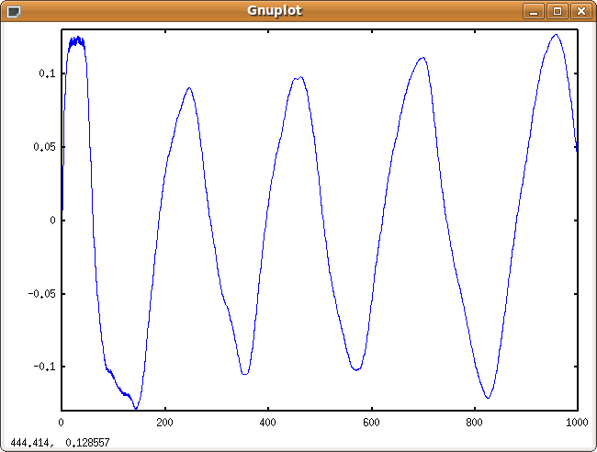

Note that the noise is very small compared to the original a1 signal, and that it really is only apparent in the first cycle.

aenv linseg 1.0, p3 - 0.1, 1.0, 0.05, 0.0, 1.0, 0.0
fout "aenv.dat", 0, aenv

An amplitude envelope is created next, a plot of aenv is below:
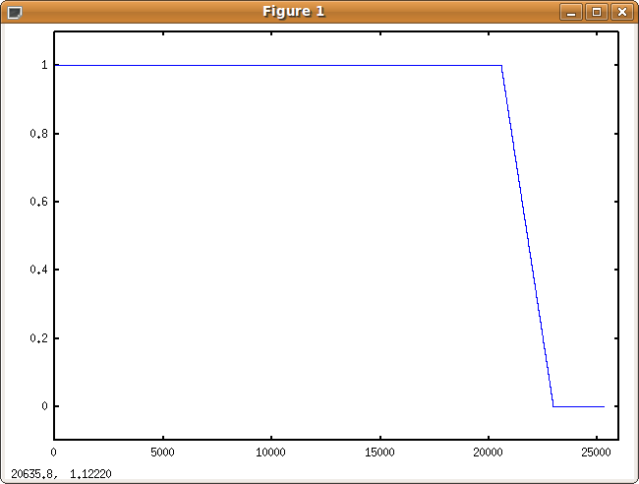

a_out = a1 * iamp * aenv * 220000.0
fout "a_out.dat", 0, a_out

out a1 * iamp * aenv * 220000.0

endin

The final output is scaled up to signed 16 bit integer values (+/- 32000). Below is the final output of the first 10,000 samples.

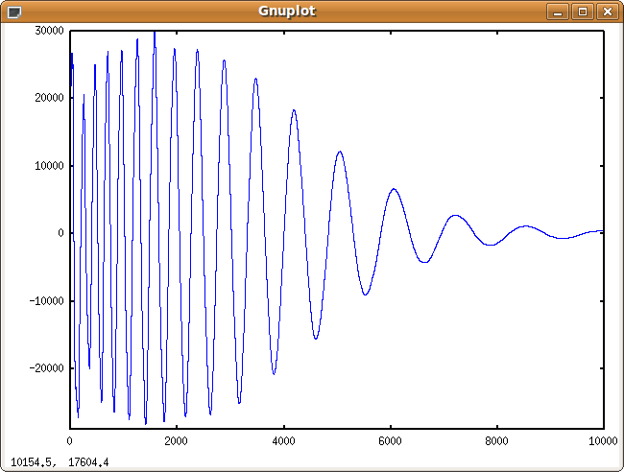

5.0 Implementing The Drum In Nsound

Now that we have a working understanding of the signals the Csound instrument, it is relatively easy to create the equivalent in Nsound.

In Nsound, Buffers are audio rate signals. We can create filters and multiply signals together just like in Csound.

Lets begin! I will be implementing a function in C++ that will return a Buffer with the final audio output.

The function signature:

Buffer
DrumBD01(
const float64 & sample_rate,
const float64 & duration, // seconds
const float64 & frequency, // Hz
const float64 & velocity) // 0.0 - 1.0

First, limit the velocity value and create the fdec value:

float64 v = velocity;

if(v > 1.0) v = 1.0;
if(v < 0.0) v = 0.0;

float64 fdec = 0.025 * (v * v + 0.1072);

Now we need to create the control signals kcps1, kcps2, kcps, klpf, klpf2.

// Create a sine generator
Sine sin(sample_rate);

Buffer kcps1 = sin.drawExponentialIntersection(fdec, 1.0, 0.5)
<< sin.drawLine(duration - fdec, 0.0, 0.0);

Buffer kcps2 = sin.drawExponentialIntersection(0.32, 1.0, 0.5)
<< sin.drawLine(duration - 0.32, 0.0, 0.0);

Buffer kcps = (4.3333 * kcps1 + kcps2) * frequency;

Note the sin.drawLine() calls, this is being done to pad out the buffers with zeros to make them full duration length.

Below is the Nsound plot of kcps:

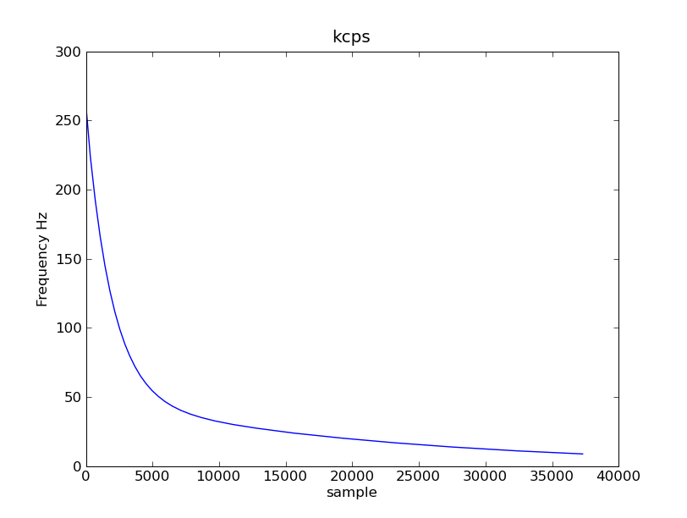

Next, create klpf.

Buffer klpf = sin.drawExponentialIntersection(0.04, 1.0, 0.5);
<< sin.drawLine(duration - 0.04, 0.0, 0.0);
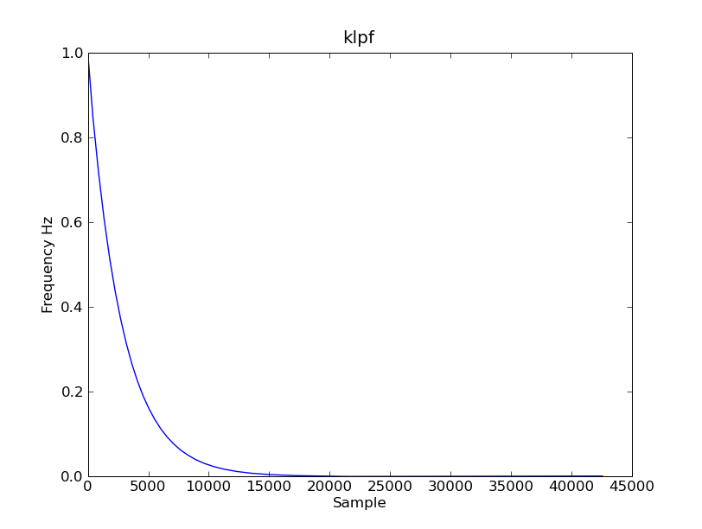

Creating klpf2:

Buffer klpf2 = 8.0
* sin.drawExponentialIntersection(0.0005, 1.0, 0.5)
<< sin.drawLine(duration - 0.0005, 0.0, 0.0);
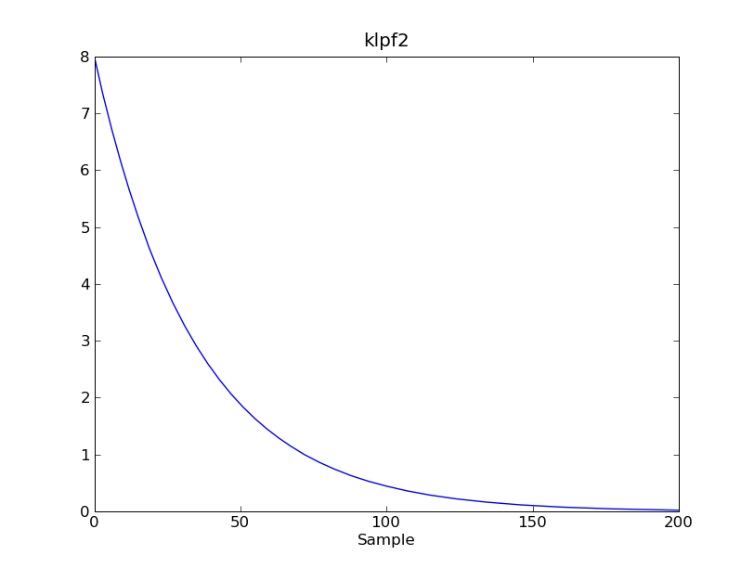

Plotting only the first 200 samples.

Creating kamp. Nsound doesn't have a port function, so I created a regular exponential and just flipped it upside down. I Adjusted the duration until the function approached 1.0 near 5000 samples.

Buffer kamp = 1.5
- sin.drawExponential(0.15, 1.0, 0.5)
<< sin.drawLine(duration - 0.15, 1.0, 1.0);
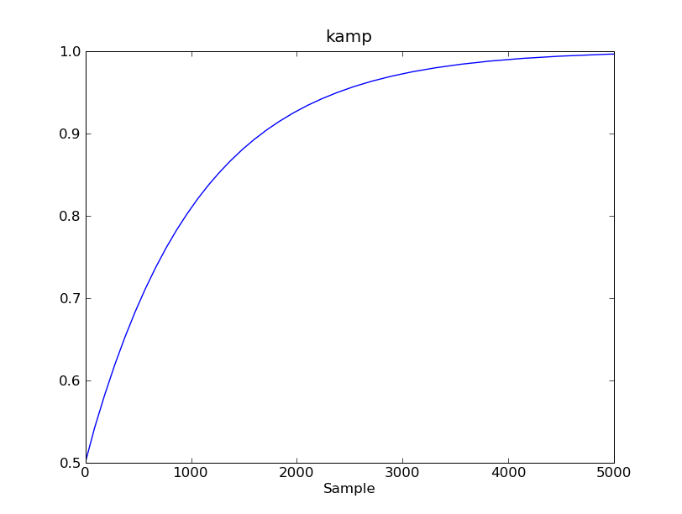
Creating a1:

sin.reset();
sin.seek(0.25);

Buffer a1 = sin.generate(duration, kcps);

a1.limit(-0.25, 0.25);
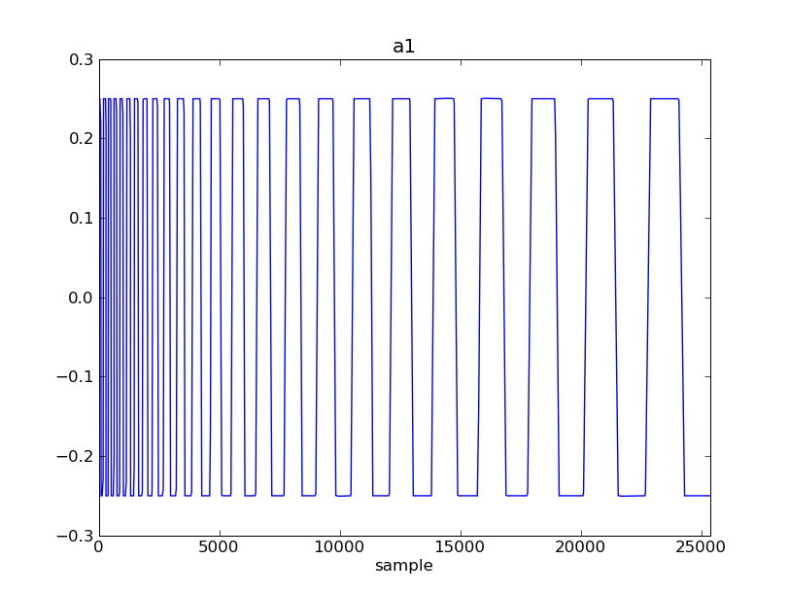

Filtering a1:

Buffer freq = kcps * (0.5 + klpf2);

FilterTone tone(sample_rate, freq[0]);

a1 = tone.filter(a1, freq);
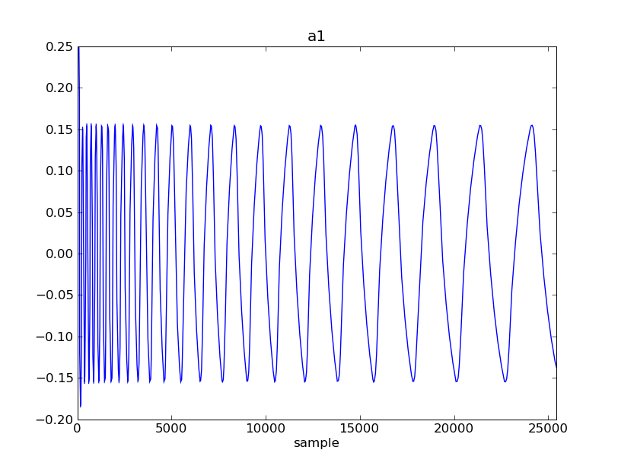

Next, creating a2:

Buffer a2 = sin.whiteNoise(duration) * sin.whiteNoise(duration);

tone.makeKernel(500.0);

a2 -= tone.filter(a2);
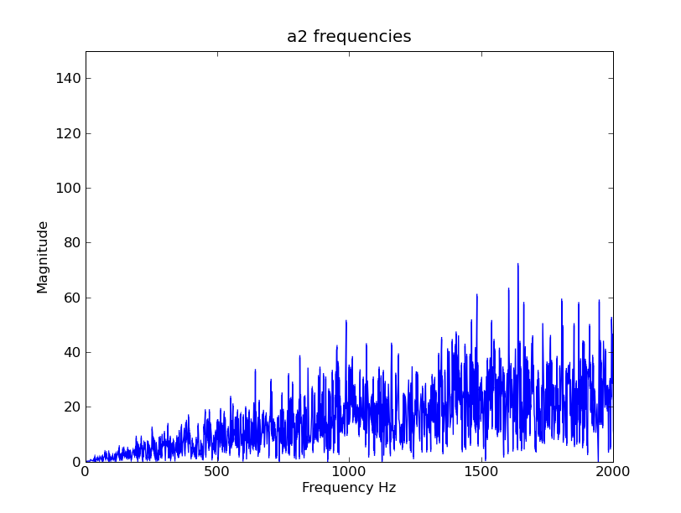

Filtering a1 trough a low pass filter:

freq = 4.0 * (klpf + klpf2) * kcps;

FilterLowPassIIR lpf(sample_rate, 2, freq[0], 0.01);

a1 = kamp * lpf.filter(a1, freq);
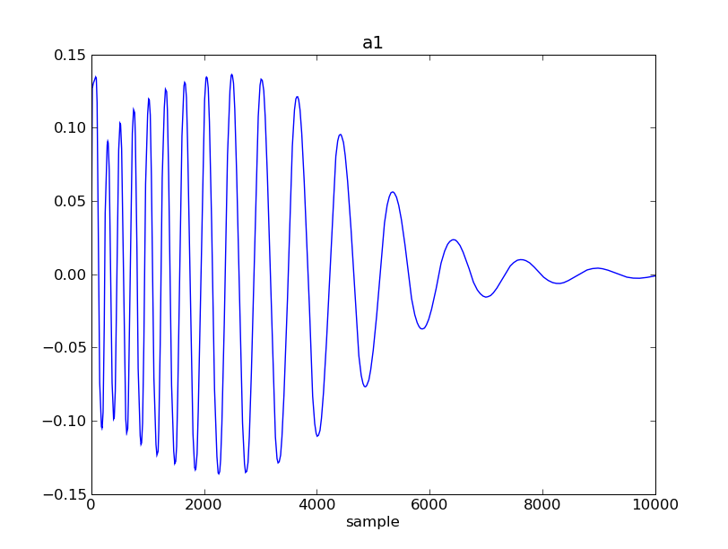

Filtering a2 again:

a2 = kamp * lpf.filter(a2, kcps);
a2 *= 5.0 * klpf.getSqrt();

For some reason the noise is about 1/5 that it should be, so that's why a 5.0 * the sqrt is in there.
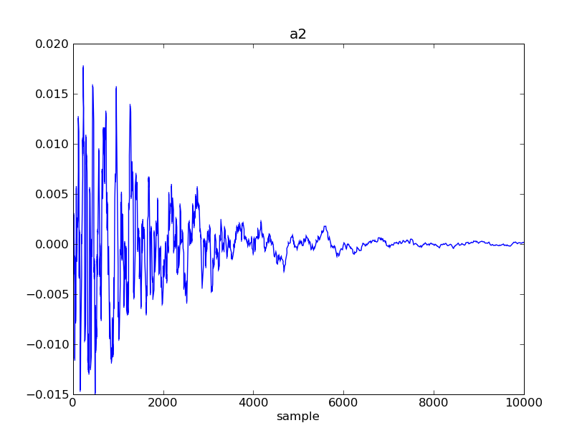

Adding a1 to a2:

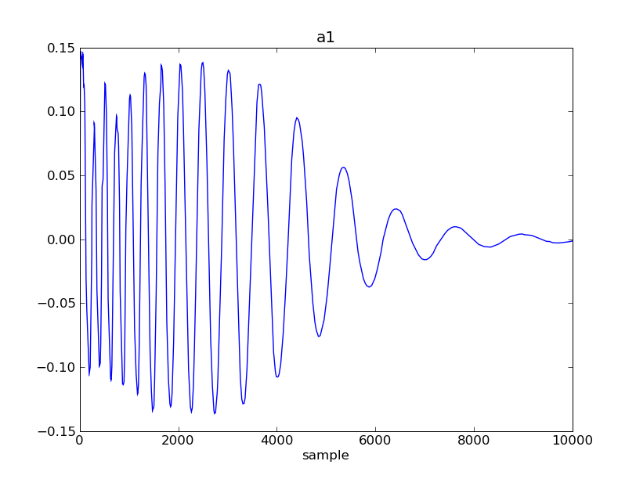
a1 += a2 * 1.0;

The * 1.0 can be used to add more of less noise to the output.

The last thing to do is multiply a1 by an envelope and that's it! Below is the entire function:

Buffer
DrumBD01(
const float64 & sample_rate,
const float64 & duration, // seconds
const float64 & frequency, // Hz
const float64 & velocity) // 0.0 - 1.0
{
float64 v = velocity;

if(v > 1.0) v = 1.0;
if(v < 0.0) v = 0.0;

float64 fdec = 0.025 * (v * v + 0.1072);

// Create a sine generator
Sine sin(sample_rate);

Buffer kcps1 = sin.drawExponentialIntersection(fdec, 1.0, 0.5)
<< sin.drawLine(duration - fdec, 0.0, 0.0);

Buffer kcps2 = sin.drawExponentialIntersection(0.32, 1.0, 0.5)
<< sin.drawLine(duration - 0.32, 0.0, 0.0);

Buffer kcps = (4.3333 * kcps1 + kcps2) * frequency;

Buffer klpf = sin.drawExponentialIntersection(0.04, 1.0, 0.5)
<< sin.drawLine(duration - 0.04, 0.0, 0.0);

Buffer klpf2 = 8.0 * sin.drawExponentialIntersection(0.0005, 1.0, 0.5)
<< sin.drawLine(duration - 0.0005, 0.0, 0.0);

Buffer kamp = 1.5
- sin.drawExponential(0.15, 1.0, 0.5)
<< sin.drawLine(duration - 0.15, 1.0, 1.0);

sin.reset();
sin.seek(0.25);
Buffer a1 = sin.generate(duration, kcps);

a1.limit(-0.25, 0.25);

Buffer freq = kcps * (0.5 + klpf2);

FilterTone tone(sample_rate, freq[0]);

a1 = tone.filter(a1, freq);

Buffer a2 = sin.whiteNoise(duration) * sin.whiteNoise(duration);

tone.makeKernel(500.0);

a2 -= tone.filter(a2);

freq = 4.0 * (klpf + klpf2) * kcps;

FilterLowPassIIR lpf(sample_rate, 2, freq[0], 0.01);

a1 = lpf.filter(kamp * a1, freq);

a2 = lpf.filter(kamp * a2, kcps);
a2 *= 5.0 * klpf.getSqrt();

a1 += a2 * 1.0;

a1.normalize();

Buffer env = sin.drawLine(duration - 0.01, 1.0, 1.0)
<< sin.drawLine(0.005, 1.0, 0.0)
<< sin.drawLine(0.005, 0.0, 0.0);

return env * a1;
}

