Predicting peak suspension travel with numerical simulation and regression
MMA3001 Numerical Methods and Machine Learning
Individual project report | 25 October 2026
Wee Hao Siah | Student ID 33567735

1 Engineering question and principal finding
This project examines how suspension spring stiffness and damping affect maximum body-wheel movement over a prescribed road bump. Numerical simulations provide labels for regression models within a fixed parameter domain. The intended use is rapid comparison of simulated setups before selecting cases for full response analysis.
On 100 reserved simulated cases, the development-selected SVR achieved RMSE 0.029796 mm versus 0.199436 mm for linear regression. In a separate nine-setup benchmark, mean single-case median warm query times were 0.163470 ms for SVR and 222.637844 ms for peak-only simulation. These support a surrogate for the simulated peak; post-bump interpretation still requires simulation. [E3, E4, E6]

The engineering target
The primary output A is max |zs - zu| over the full checked response, including after the bump, in millimetres relative to static equilibrium. It includes extension and compression magnitudes, excludes static sag, and differs from peak-to-peak range and accumulated movement. [E1]
Post-bump peak and settling within a ±1 mm band are separate diagnostics; ML predicts A alone. A smaller post-bump peak need not mean faster settling, and zero relative displacement does not imply stationary masses. [E5]

Scope and evidence status
The passive linear quarter-car model fixes both masses, tyre stiffness and bump while varying stiffness and damping. No measured-car calibration or comfort, grip, safety or lap-time claim is made. Scientific outputs E1 to E6 were published in checkpoint 8ba9808 (11 October). The 12 October profiling supplement in Section 7 was published in checkpoint 1385cf6 (25 October). [E1, E6, E7]
I chose suspension modelling because of my passion for motorsport, sim racing and vehicle dynamics. I wanted to understand how spring stiffness and damping affect suspension movement, and why limiting peak displacement does not necessarily mean the oscillations settle more quickly.
A second motivation was to learn how numerical methods represent a dynamic mechanical system. A simplified quarter-car model allows me to examine stiffness and damping under controlled conditions while learning how modelling assumptions limit the conclusions. It also provides a manageable example of translating equations of motion into a simulation and interpreting the resulting response.
I am also interested in the future role of AI and machine learning in engineering. Working with simulation-generated data provides an opportunity to explore how an ML model can approximate a defined output from the simulation. My broader learning interests include physics-informed neural networks (PINNs), which I see as a possible direction for further study beyond the methods used here.

2 Model inputs outputs and assumptions
Upward displacements zₛ and zᵤ describe the sprung body and unsprung wheel assembly relative to their static equilibrium positions. The suspension spring and viscous damper act between them; a linear tyre spring connects the wheel to the prescribed road r. The governing model follows the quarter car formulation in [1]. With active force absent, the equations are
$$m_{s}z_{s}^{″} = -k_{s}(z_{s} - z_{u}) - c_{s}(z_{s}^{'} - z_{u}^{'})$$
$$m_{u}z_{u}^{″} = k_{s}(z_{s} - z_{u}) + c_{s}(z_{s}^{'} - z_{u}^{'}) + k_{t}(r - z_{u})$$
The four state variables are body displacement, body velocity, wheel displacement and wheel velocity, initially zero. Static equilibrium already includes gravity and spring preload. Subtracting this balance cancels the constant forces, leaving their dynamic changes. With upward positive, extension gives a downward spring-force contribution on the body and an upward contribution on the wheel. The damper opposes relative velocity, so equal velocities give zero damping force even when relative displacement is nonzero. [E1]
Quantity | Adopted value or domain | Role
Body and wheel mass | 365.4 kg and 43.0 kg | Fixed
Tyre stiffness | 350,000 N/m | Fixed
Suspension stiffness kₛ | 18,000 to 30,000 N/m  Nominal 24,000 N/m | Varied input
Suspension damping cₛ | 1,594.8 to 2,658.0 N s/m  Nominal 2,126.4 N s/m | Varied input
Bump height and duration | 0.050 m and 0.50 s | Fixed input
The nominal coefficients are the published generic front corner baseline in Soong et al., Table 2 [2]. They are not measurements of an identified vehicle. The ±25% stiffness and damping ranges are project choices. The raised cosine bump shape is adapted from [3]; its 0.50 s duration is a project choice, rather than the source example duration.
$$r(t) = \frac{h}{2}[1 - cos(\frac{2πt}{τ})], 0 ≤ t ≤ τ; r(t) = 0 otherwise$$

Interface and output meaning
The ML query accepts a nonempty N by 2 numeric array with columns kₛ in N/m and cₛ in N s/m. Guards reject malformed shapes, nonfinite values and inputs outside the inclusive limits. It returns N peaks in mm. Simulator configuration guards require positive physical parameters and solver controls; zero bump height is allowed for checks. Accepting other simulator configurations does not validate them. Bump height is not an ML input: unchanged stiffness and damping still produce the prediction for the fixed 50 mm, 0.50 s bump. A different bump requires separately justified adaptation and validation. [E1, E3]
The model omits tyre damping, pitch and roll, nonlinear springs, bump stops, active forces and contact loss dynamics. The total tyre force screen is a validity check, not a contact loss model or a physical travel clearance calculation.

3 Numerical method and verification
SciPy RK45 integrates the four state initial value problem with an embedded Runge Kutta 5(4) pair [4]. Adaptive internal steps control estimated local integration error. Tighter solver settings check the computed trajectory; finer observations can capture missed peaks or band crossings but cannot correct integration error. A longer horizon checks whether later motion changes the peak or settling time. Small final displacement alone is insufficient: substantial velocity can carry the suspension through equilibrium into another excursion.
The adopted label settings are relative tolerance 10⁻⁶, absolute tolerances [10⁻⁹ m, 10⁻⁸ m/s, 10⁻⁹ m, 10⁻⁸ m/s], maximum internal step 0.005 s, 1 ms observations and a 5 s horizon. The bump and flat road segments share the complete position and velocity state at 0.50 s. Resetting that state would erase the remaining physical response. [E1, E2]

Checks and acceptance criteria
Nine combinations of low, nominal and high stiffness and damping were checked against tighter RK45 integration, finer observation grids, a 10 s horizon and classical RK4 at 0.5 and 0.25 ms. The declared numerical agreement criteria were 0.05 mm for peaks and 0.01 s for settling, with consistent resolved status. These are project numerical criteria, not exact label error bars or engineering design requirements. [E2]
Verification comparison across nine pilots | Largest observed difference in A
Adopted settings versus tighter longer reference | 0.000464924 mm
Solver refinement with observation grid fixed | 0.000000575 mm
Observation grid refinement from 1 to 0.5 ms | 0.000464873 mm
Observation horizon extended from 5 to 10 s | 0 mm
RK4 at 0.5 ms versus RK45 on the same grid | 0.0000000225 mm
RK4 at 0.25 ms versus RK45 on the same grid | 0.0000000128 mm
The largest adopted versus reference post bump peak difference was 7.47 × 10⁻⁷ mm. Across the 0.5, 1 and 2 mm settling bands, the largest settling difference was 8.86 × 10⁻⁶ s. Observation resolution dominated the measured A discrepancy in these pilots; all discrepancies remained below the adopted limits. The evidence therefore supported retaining the less expensive label settings within this checked study. [E2]
A clamped wheel analytical diagnostic checked the body equation, with maximum position discrepancy 3.80 × 10⁻¹³ m. Zero road, state continuity, post bump energy, contact and tail checks supplied complementary evidence. All nine pilots passed. RK4 shares the RK45 force function, and the reduced diagnostic does not solve the full two mass system; agreement cannot eliminate shared formulation errors. [E2]
Each later dataset row also received eligibility, contact and tail checks; full refinement covered nine pilots, rather than all 400 setups. These establish observed numerical consistency, not certified continuous time error bounds or real vehicle validity.
After bump exit, total energy H = ½(mₛvₛ² + mᵤvᵤ² + kₛd² + kₜzᵤ²), where d = zₛ − zᵤ, includes both masses and both springs. On flat road H′ = −cₛ(vₛ − vᵤ)² ≤ 0, so |d(t)| ≤ √(2H(T)/kₛ) for t ≥ T in the exact model. Here T is the observation end. Energy can decrease while displacement oscillates. A bound below the settling band rules out later excursions; a larger bound is inconclusive. Used with refinement and longer observation, the computed bound supports settling; numerical state error has not been rigorously bounded. [E1, E2]

4 Dataset and model development
Each dataset row represents one complete stiffness and damping setup and its simulated response, rather than one time sample. The design contains 400 distinct pairs: a 15 by 15 training grid with 225 rows, 75 uniformly sampled validation pairs using seed 3001, and 100 uniformly sampled reserved test pairs using seed 3002. The nine pilot labels were reused only in training; the remaining 391 labels required new integrations. [E3]
All 400 labels passed the adopted eligibility checks. The smallest sampled total tyre force was 2,398.809 N and the largest terminal relative displacement energy bound was 0.011531 mm. These support label eligibility under this model, without proving every unobserved point in the continuous parameter domain. The generated labels are project data, not downloaded experimental observations. [E3]

A credible baseline and a nonlinear alternative
Linear regression supplies an interpretable affine baseline for A as a function of stiffness and damping. The alternative is support vector regression with a radial basis function kernel. It combines similarities to support vectors to represent a curved response surface, while regularisation and an epsilon insensitive loss limit the fitting incentive for small residuals. Although the motion equations are linear in the state variables, changing their coefficients changes the full trajectory and its peak time; the peak need not be linear in the two parameters. [5, E3]
Each candidate pipeline fitted its own StandardScaler using only the 225 training inputs. Validation inputs used those same training means and standard deviations; refitting on validation would change the coordinate mapping and let evaluation inputs influence preprocessing. Scaling puts stiffness and damping on comparable numerical scales for kernel distances; targets remained in mm. One linear model and 18 predeclared SVR candidates used the same training and validation rows. Validation errors guided selection, not candidate fitting. The SVR search used C = 1, 10 or 100, gamma = 0.1, 1 or 10, and epsilon = 0.05 or 0.20 mm. [E3]
Development metric in mm | Linear regression | Selected SVR
Training RMSE | 0.220778 | 0.034579
Validation RMSE | 0.199456 | 0.031088
Validation MAE | 0.159690 | 0.027277
Validation maximum absolute error | 0.485281 | 0.059600
Selection minimised validation RMSE, giving C = 100, gamma = 1 and epsilon = 0.05 mm, with 49 support vectors in the development fit. The selected SVR improved the sampled validation errors over the linear baseline. Epsilon is the training loss tube, not a guaranteed prediction error, numerical tolerance or safety margin. [E3]

Sensitivity of selection to numerical labels
A check recomputed the 75 validation labels with tighter settings while preserving predictions. Maximum label change was 0.000678 mm and RMS change 0.000310 mm. The 0.001398 mm score gap to the next SVR exceeded twice that RMS change; replacing the reference labels preserved the ranking. This supports selection under this refinement, without guaranteeing the same choice on another dataset. Reserved test responses did not inform development. [E3]

5 Once only held out evaluation
The plan froze SVR settings and the linear comparator before test response access. Both pipelines, including fresh scalers, were then refitted on the same 300 original development rows (225 training plus 75 validation). This reuses development data after selection while preserving the 100 test rows as a separate check; it does not guarantee improved accuracy. Refined validation labels remained verification references, not fitting replacements. The final SVR had 45 support vectors. [E4]
The saved order is plan freeze, completed refits, then first test response access. The UTC timestamps correspond to 5 October 2026 in Sydney. All 100 reserved rows matched the frozen setup identities and remained eligible; predictions were finite and positive. Residual means simulated minus predicted, so a positive value indicates underprediction. RMSE penalises larger residuals more strongly than MAE. [E4]
Metric on the same 100 test setups | Linear regression | Frozen SVR
RMSE in mm | 0.199436 | 0.029796
MAE in mm | 0.161225 | 0.026311
Maximum absolute error in mm | 0.435026 | 0.051826
Maximum underprediction in mm | 0.435026 | 0.051696
Mean residual in mm | −0.013453 | +0.002502
R squared | 0.994254 | 0.999872
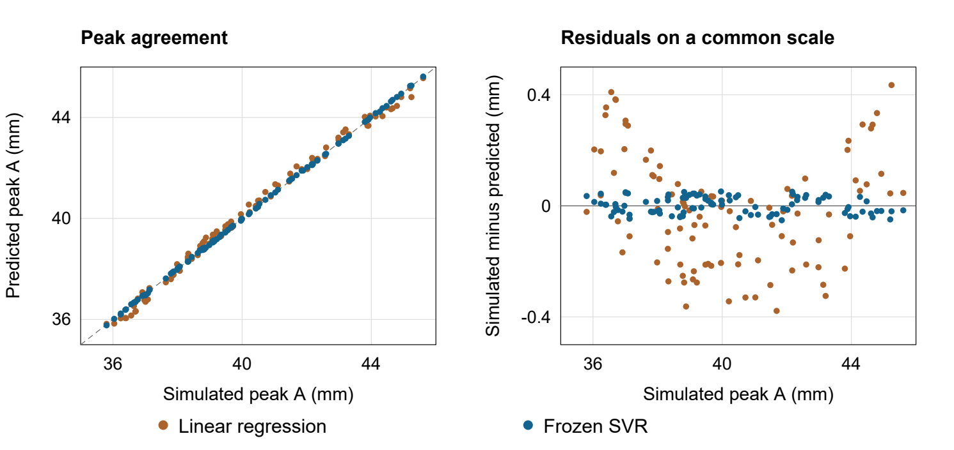
Figure 1 The two frozen refits on the same 100 cases, replotted from saved predictions. Residuals share one scale. Source E4.
SVR had lower observed errors on these simulated test cases, consistent with its prior development selection. This is an independent performance assessment under the recorded sampling design, with finite sample uncertainty. No engineering acceptance threshold was declared. Neither high R squared nor the largest observed error provides a worst case error bound, physical clearance allowance or real vehicle validation. [E4]
These 100 cases are now consumed. No preference or settings changed after access. Tuning against their results would let sample specific errors influence selection, making the same cases unsuitable as an independent check of revised choices; new independent evaluation data would be needed. Errors on the 300 refit rows are fitting errors, not fresh validation evidence.

6 Peak movement and settling answer different questions
The refined nominal full response peak is 40.571155 mm at 0.442 s, in extension. The post bump maximum is 31.891620 mm at the inclusive 0.50 s exit boundary. Later compression reaches approximately −20.427 mm at 0.77075 s. Motion therefore persists after exit, although the nominal largest absolute excursion occurs earlier. [E1, E5]
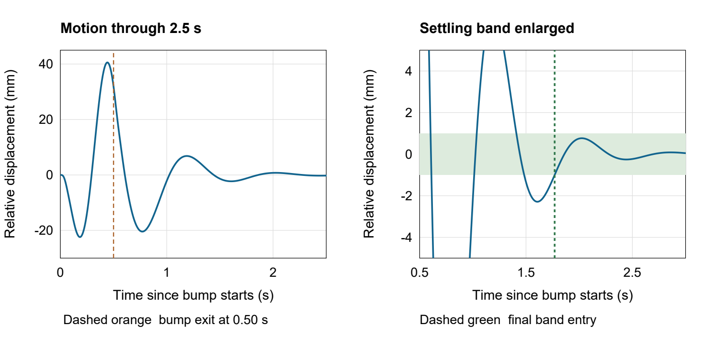
Figure 2 Saved 1 ms trace. Left shows the first 2.5 s of the refined 10 s response; right enlarges the ±1 mm band and clips earlier peaks. Source E1.
Settling is the final sustained entry of relative displacement into ±1 mm, measured from bump exit. The nominal estimate is 1.269332 s after exit, with at least one observed second inside the band and additional numerical and tail checks. A first zero crossing or first band entry is insufficient. A ±0.5 mm band gives 1.644586 s and ±2 mm gives 1.174273 s, so the chosen band must accompany any reported settling time. It is a project tolerance. [E2, E5]
Stiffness at nominal damping | A in mm | Post bump peak in mm | Settling after exit in s
18,000 N/m | 39.343201 | 33.663539 | 1.376665
24,000 N/m | 40.571155 | 31.891621 | 1.269332
30,000 N/m | 40.848021 | 28.673449 | 1.445348
In these saved cases, increasing stiffness from nominal to 30,000 N/m lowers the post bump peak while increasing both A and settling time. All 225 training post bump maxima occur at the exit boundary, so they must not be described as later rebound peaks. [E5]
I expected greater stiffness to reduce motion generally. The smaller post bump peak partly confirmed that expectation, but the larger full response peak and longer settling refined it. These metrics describe different aspects of relative suspension motion, so judging a setup as better requires stated priorities. The approximately 0.277 mm peak increase is small, but the existing tighter pilot results preserve its direction. This supports comparing these two setups without establishing a causal mechanism, a universal stiffness rule or an improvement in body motion. [E2, E5]

7 Runtime comparison and performance analysis
The bounded runtime study compares paths returning the same scalar A at nine previously verified setups. Five measured rounds rotate method order with one numerical library thread. Input guards and scaling are included. Each ML timing observation averages 1,000 real calls to reduce timer noise; its spread is not the distribution of individual request latency. Imports, model loading, file operations, plotting and offline label generation and training are excluded. [E6]
Warm timing in ms | Simulation for A | Linear | SVR
Mean of nine single case medians | 222.637844 | 0.126471 | 0.163470
Median time for one nine row batch | 2,014.271000 | 0.127570 | 0.182364
For these warm single queries, the simulation to SVR ratio is approximately 1,362. The nine row batch ratio is approximately 11,045, reflecting different batching behaviour. These ratios are local query measurements; they do not measure total project speedup or establish a universal hardware result. The benchmark used existing pilots and frozen models, without new training data or a new test accuracy analysis. All seven saved benchmark checks passed. [E6]
Linear regression is somewhat faster and simpler to interpret than SVR, but both query times are small relative to the measured simulation path. The selected SVR trades a modest query cost increase for lower sampled prediction error. Simulation remains necessary for the trajectory, post bump movement, settling, energy and contact outputs. A separately timed full diagnostic path has no equivalent ML output, so no matching replacement ratio is claimed. [E6]

Nominal profiling supplement
On 12 October, a separate study profiled the unchanged full diagnostic nominal calculation. One warmup and three alternating unprofiled and profiled pairs produced seven solves. All non timing summary fields exactly matched the saved baseline, five study checks passed and 13 focused bookkeeping tests passed. The earlier full 433 test suite was not rerun. [E7]
Unprofiled median wall time was 413.608 ms and profiled median 524.979 ms, with median paired overhead ratio 1.328. The integration path accounted cumulatively for 90.82 to 92.32% of each profile total; road height evaluation had the largest self time share at 25.55 to 25.83%. Cumulative parent and child times overlap and cannot be added as independent shares. These full diagnostic instrumented observations are not directly comparable with the earlier peak query benchmark. [E7]
The saved decision retained the correct implementation, precision and diagnostics. A specialised scalar road height path is a possible future optimisation, without a measured improvement claim. The profiler identifies expensive call paths; it does not measure memory bandwidth, arithmetic intensity or FLOPS. Built in cProfile is a documented extension to the course profiling principles. [6, E7]

Preparation costs and trade offs
Existing preparation timings cover partial and nested work. They do not establish a complete fresh build cost, so a numerical break even query count is unsupported. Numerical checks supported retaining the cheaper label settings. The selected surrogate improved sampled prediction accuracy over linear regression, and its warm query cost was measured separately from preparation. [E3, E6]

8 Limitations reproducibility and engineering judgement

What the evidence establishes
Numerical verification checks implementation consistency and resolution. ML evaluation checks simulated peak prediction on a reserved sample. Neither validates a specific physical vehicle. Fixed road input, linear forces and two varying parameters keep this task narrow; changing masses, tyre behaviour or the bump creates a different prediction problem. [E1–E4]
A five second run need not end at rest. The saved 5 to 10 s comparisons and refinement checks support stable peak and settling estimates. On flat road, the terminal energy bound limits future relative displacement; it must be below the settling band and both recorded peaks to protect those quantities. Computed states do not certify integration error, and this bound does not directly establish body displacement. New road forcing invalidates this flat road argument. The 1 N contact margin screens numerical labels; sampled positive force supplies neither a safety rating nor validation of contact loss dynamics. [E1, E2]

Sampled trends and future work
All 210 adjacent training grid damping increases lowered A, post bump peak and settling. Stiffness produced different rankings, as Section 6 illustrates. These sampled trends are not universal rules or continuous optima. Small A downturns of at most 0.02535 mm lack individual refinement and lie below the adopted 0.05 mm agreement criterion; their detailed significance remains unresolved. [E5]
Future work could refine selected sensitivity locations, measure physical vehicle responses, introduce relevant nonlinearities, and test portability in a clean environment. A future scalar road height optimisation would need an equivalent workload and preserved output checks. If any model or setting is chosen using the consumed test results, genuinely new independent cases are needed for a new generalisation claim. No further experiment is implied by this report.

Reproducibility and project organisation
The repository separates code and results in Suspension_Model from decisions and AI records in Project_Setup. It includes a README, docstrings, HTML documentation, tests and an MIT licence for original software and authored documentation. Other materials retain their own terms. The saved 433 passing tests were not rerun for this report. [E1, E6, E8]
A real GitHub Desktop clone at 8ba9808 passed three saved output audits on 11 October in the existing Windows and Anaconda Python 3.12.7 environment, without new simulation, fitting or test prediction. Strict final and runtime audits require matching excluded course sources through authorised access. Clean installation and a full rebuild remain unverified. Direct package pins do not completely lock transitive dependencies. [E8]

Conclusion and lessons supported by the results
For the adopted two parameter simulation task, the development selected SVR provides lower sampled peak error than the linear baseline and inexpensive warm queries. The strongest methodological lessons are to define the response before fitting, separate numerical label error from regression error, and preserve data roles through selection and final evaluation. Physical interpretation still needs full response information: peak size, post bump size and settling measure different features of motion.

9 AI use and reflection
I chose suspension modelling because of my interest in motorsport, sim racing and vehicle dynamics. My role was to define what the project should explain and take responsibility for the final interpretation. I retained max |zs − zu| over the whole response as the primary output and gave post-bump motion and settling particular importance. I adopted the proposed specification, authorised bounded stages and requested checks against the brief. These decisions set the purpose and scope against which I reviewed the work. [E9]
I used ChatGPT, including Codex for implementation and project files, and Claude to cross-check physics questions. AI connected taught methods to the problem and supported unfamiliar coding and GitHub tasks. Its contribution was substantial: detailed specification, most code and automated tests, computational execution, audits, analysis, documentation and initial report drafting. I supplied motivation, technical responses and engineering judgement, selected MIT and performed the recorded upload and clone steps. This qualitative account recognises both my direction and the technical work delegated to AI. [E9]

Human oversight and engineering judgement
My oversight focused on whether the model and outputs answered the intended question. Through explanations and follow-up questions, I worked through relative spring and damper forces, static-equilibrium coordinates, motion after bump exit and the distinction between peak travel, peak-to-peak range and settling. I used Claude as an additional check during these physics discussions. Agreement between tools does not prove correctness; the explanations still need to agree with the governing equations and recorded evidence. [E9]
I reviewed why solver refinement, finer observations, a longer horizon and the remaining-energy bound address different uncertainties, and why validation and final testing have different roles. AI implemented and ran the computational checks, including source comparisons, physical consistency checks, an analytical diagnostic and saved-result audits. My contribution was to question their meaning and judge the limits of the conclusions: numerical consistency supports this simulation study, while real-vehicle behaviour remains unvalidated. [E1, E2, E8, E9]
The stiffness comparison refined my expectation that greater stiffness would generally reduce motion. A smaller post-bump peak accompanied a larger full-response peak and longer settling. I therefore judge a setup against stated priorities, rather than treating one smaller value as sufficient. My conclusion is limited to the model and tested conditions: the peak predictor does not replace trajectory analysis, and changing the bump requires separate justification and validation. These are limits I must preserve when communicating the results. [E3, E5, E9]
Review exposed mistakes as well as progress. Feedback corrected my initial assumptions about changing bump height and using single-oscillator energy for the quarter-car. AI-led checks separately found runtime thread-control and Git line-ending problems. Restating ideas helped expose gaps and refine my reasoning. AI accelerated the workflow, but coding details and reproducing the implementation independently remain learning needs. Recognising those limits helps me avoid treating fluent output as sufficient evidence. [E9]
I remain accountable for the final conclusions and decisions, and for the submitted code, results and references. That includes explaining how the evidence supports my judgement, acknowledging uncertainty, and considering privacy and ownership of uploaded material. The report began as an AI draft on 22 October and was revised through review on 25 October; exact historical model versions were not consistently recorded. AI supported the work, while responsibility for what I submit remains mine. Disclosure does not replace verification. [E9]

References and repository evidence
External sources support the formulation and methods. Repository records support the actual settings, calculations and chronology. No external source supplies the project’s generated dataset or validates its results experimentally. Reference links were checked on 22 October 2026; original project access dates remain in EVIDENCE.md.
[1] Slaets P. A quarter car suspension. KU Leuven Computer Aided Simulation, section 1.6.2, equation 1.11. Formulation source recorded as S002. Quarter car model
[2] Soong M F, Ramli R and Saifizul A. 2017. Between simplicity and accuracy: Effect of adding modeling details on quarter vehicle model accuracy. PLOS ONE 12(6), e0179485. Table 2 supplies the nominal parameters. Article and parameter table
[3] MathWorks. Robust Control of Active Suspension. Time Domain Evaluation. The bump shape is adapted; this project changes its crossing duration. Suspension example
[4] SciPy developers. SciPy 1.13.1 solve_ivp documentation. RK45, tolerance controls and dense output. RK45 documentation
[5] scikit learn developers. SVR documentation, 1.5 series, displayed 1.5.2. The project used scikit learn 1.5.1; the documentation patch version differs. SVR documentation
[6] Python Software Foundation. The Python Profilers. Python 3.12 documentation. Source for the later local cProfile extension. Profiler documentation
[7] MMA3001 teaching team. MMA3001 2026 Project Brief, 15 pages. Requirements pp 4 to 8 and rubric pp 10 to 15. Local course source, excluded from redistribution. SHA256 begins 1029cf7c7c284416; full hash is in EVIDENCE.md. Relevant course notebooks cover Runge Kutta, regression, evaluation and profiling.

Evidence index
E1 to E7 paths are relative to Suspension_Model. After a comma, a bare filename inherits the preceding folder. Scientific outputs E1 to E6 were present in checkpoint 8ba9808f10dcdc84330135870d8b7f92c189f0a8. The E7 profiling supplement was published in checkpoint 1385cf6 on 25 October. E8 and E9 retain dated reproduction, review and AI-use records.
[E1] quarter_car.py; results/CHECK_RESULTS.md; results/summary.json. Model, settings and nominal response.
[E2] verification_results/CHECK_RESULTS.md, summary.json. Nine pilot comparisons, analytical and physical checks.
[E3] DATASET.md; dataset_v1/summary.json; ML_GUIDE.md; ml_development_v1/CHECK_RESULTS.md; ml_reference_v1/summary.json.
[E4] final_evaluation_v1/summary.json, frozen_plan.json, refit.json, test_access.json, CHECK_RESULTS.md. Figure 1 replots test_predictions.csv from that folder.
[E5] PHYSICS_REVIEW.md; interpretation_v1/review.json, CHECK_RESULTS.md. Figure 2 uses results/nominal_trace_1ms.csv.
[E6] runtime_benchmark_v2/summary.json, plan.json, CHECK_RESULTS.md; RUNTIME_GUIDE.md; runtime_benchmark_v1/FAILURE_NOTE.md.
[E7] PROFILING_GUIDE.md; profiling_v1/CHECK_RESULTS.md, TEST_RESULTS.md. The 12 October profiling study, published in checkpoint 1385cf6 on 25 October.
[E8] Suspension_Model/REPRODUCING.md; Project_Setup/clone_review_v1/CHECK_RESULTS.md; Project_Setup/SUBMISSION_CHECKLIST.md. Reproduction and outstanding requirements.
[E9] Project_Setup/AI_USE_LOG.md, EVIDENCE.md and PROJECT_STATE.md, revision 046, including dated implementation, student-review and report-drafting records.
Project repository

