**Software Requirements Specifications**

**for**

**FlyAway**

**Prepared by: Orion Schwab**

**Grey Matter**

**02/17/2022**

1. **Introduction**
   1. **Purpose**

This document specifies the functional and non-functional requirements of FlyAway, a web application under development at Grey Matter developed in the context of COS420: Introduction to Software Engineering at the University of Maine. This application will be developed over the course of the semester by a group of five COS420 students.

* 1. **Intended Audience**

This application is being developed in an academic context. Therefore, the primary intended audience of this document are the instructors and TA’s for COS420 at the University of Maine, as well as any test users of the application.

1. **Overall Description**
   1. **Product Perspective**

FlyAway is a web application under development at Grey Matter that will connect private and commercial pilots - and owners of small aircraft - with potential passengers for short-range trips. The application will function in a similar manner to existing applications such as Uber and AirBNB, but in the context of general aviation, small-scale commercial aircraft operations, and bush flying.

* 1. **Product Functions**

FlyAway will allow both pilots and potential passengers to set up user accounts. Prospective passengers, typically individuals or small groups in need of transportation a short distance away via a small aircraft, may then browse nearby pilots in the area by a number of parameters, including home airport, aircraft type, qualifications, and distance from the user. Prospective passengers will then be given the ability to contact the pilot of their choice and schedule a booking, as well as the ability to make online payments. Passengers will be given the opportunity to leave pilot reviews upon completion of the flight.

1. **External Interface Requirements**
   1. **User Interfaces**

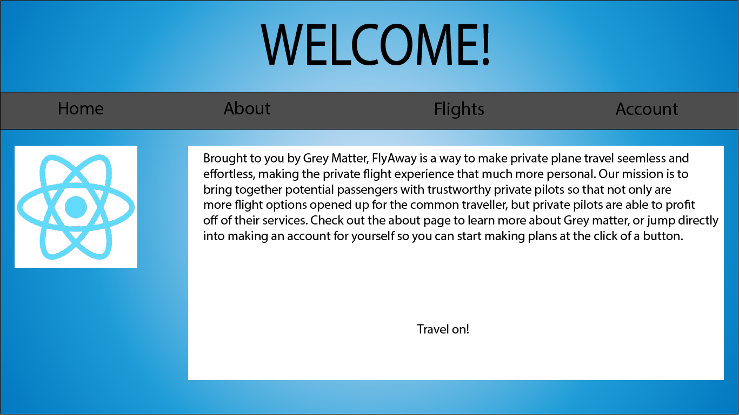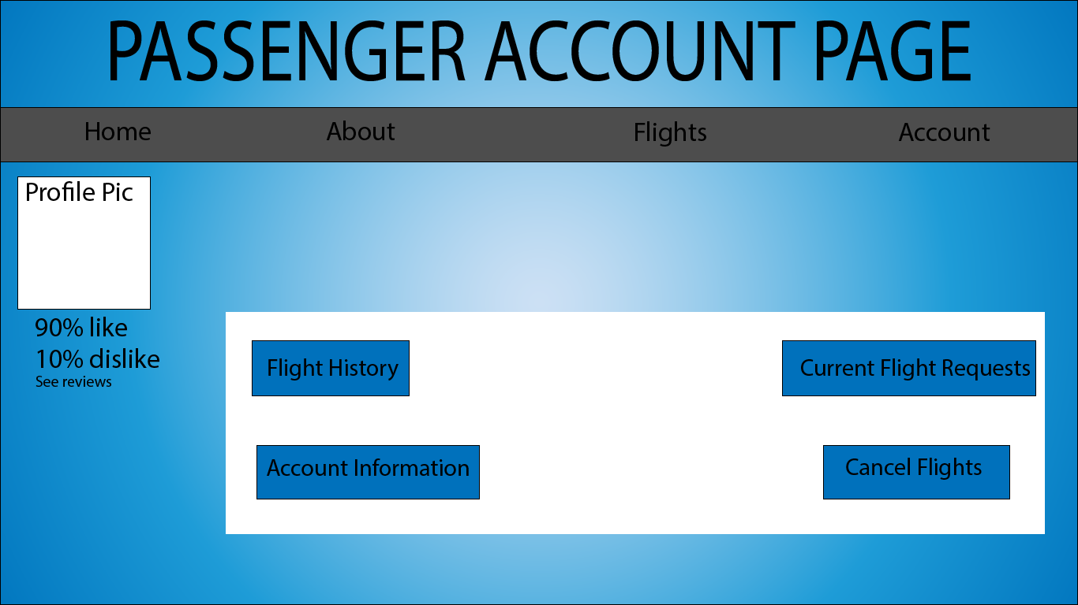

1. **System Features**
   1. **Functional Requirements**

REQ-1: The application shall allow a new user to register an account that includes that user’s name, age, and contact information.

REQ-2: The application shall allow a pilot account to list their home airport, aircraft (or fleet), professional qualifications, experience, and airports that they most frequently fly to.

REQ-3: The application shall allow users to access their account by entering their unique username and password.

REQ-4: The application shall allow passenger users to narrow their search for nearby pilots using the following parameters: *distance from me, a specific airport, seat availability, satisfaction rating, pilot qualifications, aircraft type*.

REQ-5: The application shall allow passenger users to search for pilots as they appear near their home airport on a map.

REQ-6: The application shall allow a passenger account to send a message request to a pilot account.

REQ-7: The application shall allow pilot and passenger users to communicate with each other via direct text messaging after the pilot user accepts the passenger user’s message request.

REQ-8: The application shall allow a passenger user to schedule a booking with a pilot user, which includes the booking’s date, time, fare, aircraft, and departure/arrival airports.

REQ-9: The application shall allow a passenger user to leave a review on a pilot user’s account which will be visible to other passenger users when they browse over the pilot user’s profile.

REQ-10: The application shall allow a pilot user to view all of their scheduled bookings on a schedule planner.

REQ-11: The application shall allow a passenger user to make online payments to a pilot account.

REQ-12: The application shall allow a passenger user to cancel a booking and receive a refund if they choose to do so within a time frame specified by the pilot user.

1. **Other Nonfunctional Requirements**
   1. **Performance Requirements**

REQ-13: The application shall deliver messages sent between users in under 0.5 seconds 95% of the time.

REQ-14: The application shall update changes in user profile information server-side within 1 second 95% of the time.

REQ-15: The application shall send cash transfers between a passenger user and a pilot user in under 1 second 95% of the time.

* 1. **Safety and Privacy Requirements**

REQ-16: The application shall comply with both the California Consumer Privacy Act (California) and the General Data Protection Regulation (European Union).

REQ-17: The application shall never be able to track the user’s location in circumstances where the user has not explicitly authorized the application to do so.

REQ-18: Cash transfers between pilot users and passenger users shall result in an amount being paid to the pilot user equal to that which was deducted from the passenger user 100% of the time.

REQ-19: The application shall never allow individuals or groups other than the user to gain access to that user’s credit card number, security code, or bank routing number.

* 1. **Security Requirements**

REQ-20: The application shall not allow access to a user’s account unless that user’s unique name and password has been entered.

REQ-21: The application shall immediately encrypt a user’s login information and make said information unavailable to any party other than the user.

* 1. **Software Quality Attributes**

REQ-22: Users of the application shall be able to access it and use all of its features 24 hours a day, 7 days a week, 365 days a year 99% of the time.

* 1. **Business Rules**

REQ-23: The application shall not allow pilot users to view the accounts of passenger users unless the passenger user has sent the pilot user a message request.