**Software Requirements Specifications**

**for**

**FlyAway**

**Prepared by: Orion Schwab and team**

**Grey Matter**

**02/17/2022**

**Table of Contents**

Introduction

Purpose

Intended Audience

Overall Description

Product Perspective

Product Functions

External Interface Requirements

User Interfaces

System Features

Functional Requirements

Other Nonfunctional Requirements

Performance Requirements

Safety and Privacy Requirements

Security Requirements

Software Quality Attributes

Business Rules

# Introduction

## Purpose

This document specifies the functional and non-functional requirements of FlyAway, a web application under development at Grey Matter developed in the context of COS420: Introduction to Software Engineering at the University of Maine. This application will be developed over the course of the semester by a group of five COS420 students.

## Intended Audience

This application is being developed in an academic context. Therefore, the primary intended audience of this document are the instructors and TA’s for COS420 at the University of Maine, as well as any test users of the application.

# Overall Description

## Product Perspective

FlyAway is a web application under development at Grey Matter that will connect private and commercial pilots - and owners of small aircraft - with potential passengers for short-range trips. The application will function in a similar manner to existing applications such as Uber and AirBNB, but in the context of general aviation, small-scale commercial aircraft operations, and bush flying.

## Product Functions

FlyAway will allow both pilots and potential passengers to set up user accounts. Prospective passengers, typically individuals or small groups in need of transportation a short distance away via a small aircraft, may then browse nearby pilots in the area by a number of parameters, including home airport, aircraft type, qualifications, and distance from the user. Prospective passengers will then be given the ability to contact the pilot of their choice and schedule a booking, as well as the ability to make online payments. Passengers will be given the opportunity to leave pilot reviews upon completion of the flight.

# External Interface Requirements

## User Interfaces

The welcome page shall feature a greeting at the top of the page and below it the navigation bar that allows the user to easily go between pages within the website. This same navigation will be featured on multiple pages of the website. The welcome page will also feature the FlyAway logo to the left of the page and a general description of what FlyAway is and what it hopes to accomplish on the right.

The passenger account page is where a passenger will be able to view their flights and account information. The passenger account holder will be able to view information such as their flight history, their current flight requests, their account information and their profile picture. This page will also feature the same navigation bar as before. 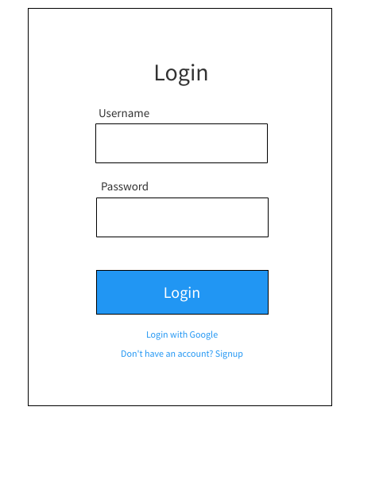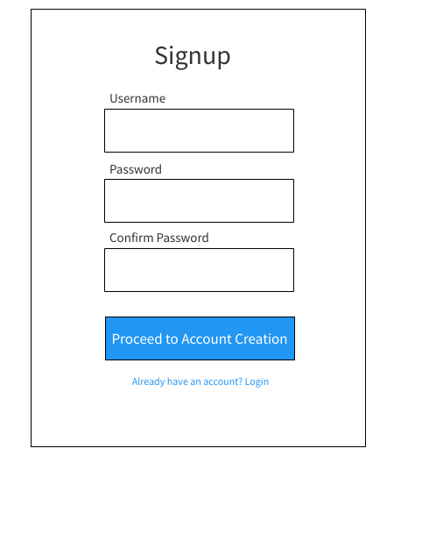

The Login page allows users to input their previously created username and password in order to access their account.

The Signup page is the first step in the account creation process. It requires the user to input their desired username and password.

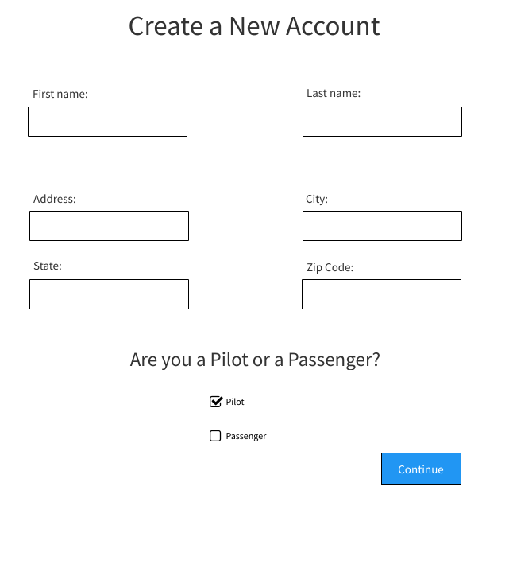

The Create a New Account page follows the signup page and it allows the user to enter necessary personal information and indicate whether they will own a pilot or passenger account.

# System Features

## Functional Requirements

REQ-1: The application shall allow a new user to register an account that includes that user’s name, age, and contact information.

REQ-2: The application shall allow a pilot account to list their home airport.

REQ-3: The application shall allow a pilot account to list their aircraft information.

REQ-4:The application shall allow a pilot account to list their professional qualifications.

REQ-5: The application shall allow a pilot account to list their experience.

REQ-6: The application shall allow a pilot account to list the airport that they frequently fly to.

REQ-7: The application shall allow users to access their account by entering their unique username and password.

REQ-8: The application shall allow passenger users to narrow their search for nearby pilots using the parameter distance from me.

REQ-9: The application shall allow passenger users to narrow their search for nearby pilots using the parameter of a specific airport.

REQ-10: The application shall allow passenger users to narrow their search for nearby pilots using the parameter of seat availability.

REQ-11: The application shall allow passenger users to narrow their search for nearby pilots using the parameter of satisfaction rating.

REQ-12: The application shall allow passenger users to narrow their search for nearby pilots using the parameter pilot qualifications.

REQ-13: The application shall allow passenger users to narrow their search for nearby pilots using the parameter aircraft type.

REQ-14: The application shall allow passenger users to search for pilots as they appear near their home airport on a map.

REQ-15: The application shall allow a passenger account to send a message request to a pilot account.

REQ-16: The application shall allow pilot and passenger users to communicate with each other via direct text messaging after the pilot user accepts the passenger user’s message request.

REQ-17: The application shall allow a passenger user to schedule a booking such that a booking will appear on the passenger’s and pilot’s account.

REQ-18: The application shall allow a passenger user to leave a review on a pilot user’s account.

REQ-19:The application shall allow a passenger to view the reviews on a pilot account.

REQ-20: The application shall allow a pilot user to view all of their scheduled bookings on a schedule planner.

REQ-21: The application shall allow a passenger user to make online payments to a pilot account.

REQ-22: The application shall allow a passenger user to cancel a booking.

REQ-23:The application shall allow a passenger to receive a refund within a time limit specified by the pilot when canceling a booking.

REQ-24:The application shall allow a pilot to set a time limit for how close to a booking a passenger can get a refund when canceling a booking.

REQ-25: The application shall give a pilot access to view a passenger's account after the passenger has sent a message request.

# Other Nonfunctional Requirements

## Performance Requirements

REQ-26: The application shall deliver messages sent between users in under 0.5 seconds 95% of the time.

REQ-27: The application shall update changes in user profile information server-side within 1 second 95% of the time.

REQ-28: The application shall send cash transfers between a passenger user and a pilot user in under 1 second 95% of the time.

## Safety and Privacy Requirements

REQ-29: The application shall comply with the California Consumer Privacy Act (California).

REQ-30: The application shall comply with the General Data Protection Regulation (European Union).

REQ-31: The application shall only be able to track the user’s location in cases that the user gives explicit consent.

REQ-32: The application shall transfer an equal amount of money from one account to another when requested by the user 100% of the time.

REQ-33: The application shall protect user private information from unauthorized access.

## Security Requirements

REQ-34: The application shall protect user accounts from access other than the user’s unique username and password.

REQ-35:The application shall encrypt a user’s login information within 1 second of account creation 99% of the time.

REQ-36:The application shall protect user login information from unauthorized access.

## Software Quality Attributes

REQ-37: The application shall be available to run 24 hours a day, 365 days a year, 99% of the time.

## Business Rules