Sequence Diagram

GreyMatter, group 9

1. Create Passenger Account

| # | Subject | Subject Action | Parameters | Object Acted Upon |
| --- | --- | --- | --- | --- |
| 1. | Passenger | enters | *email, password, type* | CreateAccount GUI |
| 2.1. | CreateAccount GUI | sends | *Email, password, type* | Create handler |
| 2.2. | Create handler | verifies | *email* | Account Authentication |
| 2.3 | Account Authentication | verifies | *email* | Firestore Database |
| 2.4 | Firestore Database | returns | Open or closed | Account Authentication |
| 3.1. | Account Authentication | returns | Open or closed | Create handler |
| 4.1 | If open is returned then |  |  |  |
| 4.1.1. | Create handler | sends | *email, password, type* | Account Authentication |
| 4.1.2. | Account Authentication | creates | *email, password, type* | PassengerAccount |
| 4.1.3. | Account Authentication | adds | *PassengerAccount* | FireStore Database |
| 5.1.1. | Account Authentication | creates | *“Account Created Successfully”* | message |
| 5.1.2. | Account Authentication | returns | *message* | Create handler |
| 4.1.3 | else |  |  |  |
| 4.1.4 | Create handler | creates | *“Account already exists for this email. Login or try a different email”* | message |
| 6.1 | Create handler | returns | *message* | CreateAccount GUI |
| 6.2 | CreateAccount GUI | displays | *message* | Passenger |

2. Create Pilot Account

| # | Subject | Subject Action | Parameters | Object Acted Upon |
| --- | --- | --- | --- | --- |
| 1. | Pilot | enters | *email, password, type* | CreateAccount GUI |
| 2.1. | CreateAccount GUI | sends | *Email, password, type* | Create handler |
| 2.2. | Create handler | verifies | *email* | Account Authentication |
| 2.3 | Account Authentication | verifies | *email* | Firestore Database |
| 2.4 | Firestore Database | returns | Open or closed | Account Authentication |
| 3.1. | Account Authentication | returns | Open or closed | Create handler |
| 4.1 | If open is returned then |  |  |  |
| 4.1.1. | Create handler | sends | *email, password, type* | Account Authentication |
| 4.1.2. | Account Authentication | creates | *email, password, type* | PilotAccount |
| 4.1.3. | Account Authentication | adds | *PassengerAccount* | FireStore Database |
| 5.1.1. | Account Authentication | creates | *“Account Created Successfully”* | message |
| 5.1.2. | Account Authentication | returns | *message* | Create handler |
| 4.1.3 | else |  |  |  |
| 4.1.4 | Create handler | creates | *“Account already exists for this email. Login or try a different email”* | message |
| 6.1 | Create handler | returns | *message* | CreateAccount GUI |
| 6.2 | CreateAccount GUI | displays | *message* | Pilot |

3. Edit Passenger Account

| # | Subject | Subject Action | Parameters | Object Acted Upon |
| --- | --- | --- | --- | --- |
| 3.3. | Passenger | clicks | *button* | PassengerEdit GUI |
| 4.1. | PassengerEdit GUI | sends | *info, button* | Edit handler |
| 4.2. | if button is save then |  |  |  |
| 4.2.1. | Edit handler | update | *info* | Firestore Database |
| 4.2.2. | Edit handler | creates | *“Changes saved”* | message |
| 4.2.3. | else if button is cancel |  |  |  |
| 4.2.3. | Edit handler | creates | *“Changes canceled”* | message |
| 4.3. | Edit hander | returns | *message* | PassengerEdit GUI |
| 4.4. | PassengerEdit GUI | displays | *message* | Passenger |

4. Edit Pilot Account

| # | Subject | Subject Action | Parameters | Object Acted Upon |
| --- | --- | --- | --- | --- |
| 3.3. | Pilot | clicks | *button* | PilotEdit GUI |
| 4.1. | PilotEdit GUI | sends | *info, button* | Edit handler |
| 4.2. | if button is save then |  |  |  |
| 4.2.1. | Edit handler | update | *info* | Firestore Database |
| 4.2.2. | Edit handler | creates | *“Changes saved”* | message |
| 4.2.3. | else if button is cancel |  |  |  |
| 4.2.3. | Edit handler | creates | *“Changes canceled”* | message |
| 4.3. | Edit hander | returns | *message* | PilotEdit GUI |
| 4.4. | PilotEdit GUI | displays | *message* | Pilot |

5. Contact Passenger

| # | Subject | Subject Action | Parameters | Object Acted Upon |
| --- | --- | --- | --- | --- |
| 1. | Pilot | clicks | *accept button* | Messages GUI |
| 2.1. | Messages GUI | sends | *accept button* | Message handler |
| 2.2. | Message handler | creates | *Pilot, Passenger* | Message channel |
| 2.3. | Message handler | adds | *Message channel* | Firestore Database |
| 2.4. | Message handler | creates | *“Message request accepted”* | message |
| 2.5. | Message handler | returns | *message* | Messages GUI |
| 2.6. | Messages GUI | displays | *message* | Pilot |

6. Contact Pilot

| # | Subject | Subject Action | Parameters | Object Acted Upon |
| --- | --- | --- | --- | --- |
| 1.1. | Passenger | clicks | *request messaging button* | Messaging GUI |
| 2.1. | Messaging GUI | sends | *request messaging button* | Message handler |
| 2.2. | Message handler | verifies | open or exists | Firestore Database |
| 2.3. | Firestore Database | returns | open or exists | Message handler |
| 2.4.1. | If open is returned then |  |  |  |
| 2.4.2. | Message handler | creates | *passenger* | MessageRequest |
| 2.4.3. | Messenger handler | adds | *MessageRequest, Pilot* | Firestore Database |
| 2.4.4. | Message handler | creates | *“Message request successfully sent”* | Message |
| 2.4.5. | else |  |  |  |
| 2.4.6. | Message handler | creates | *“Message contact already exists, go to your messages to contact this pilot”* | Message |
| 2.5. | Message handler | returns | *message* | Messages GUI |
| 2.6 | Messages GUI | displays | *message* | Passenger |

7. Write review

| # | Subject | Subject Action | Parameters | Object Acted Upon |
| --- | --- | --- | --- | --- |
| 3. | Passenger | enters | *review* | PilotReview GUI |
| 4.1. | PilotReview GUI | sends | *review* | Review handler |
| 4.2. | Review handler | creates | *review* | Review |
| 4.3. | Review handler | adds | *Review, Pilot* | Firestore Database |
| 4.4. | Review handler | creates | *“Review successfully sent”* | message |
| 4.5. | Review handler | sends | *message* | PilotReview GUI |
| 4.6. | PilotReview GUI | displays | *message* | Passenger |

Analysis Sequence Diagrams

1. Create Passenger Account

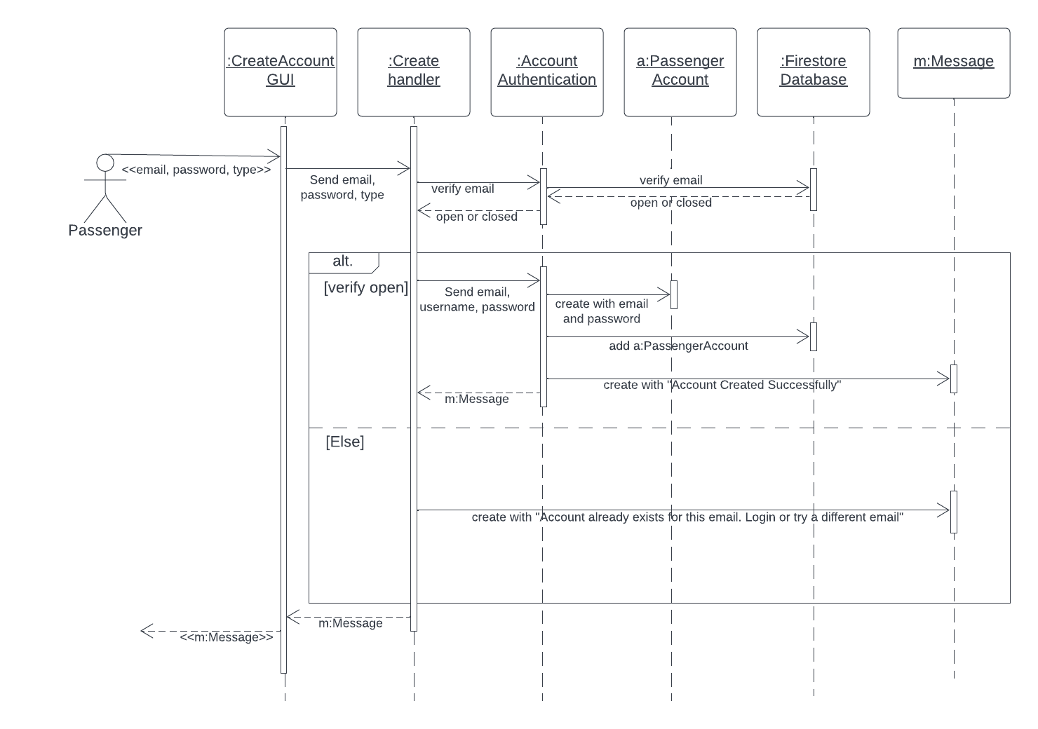

2. Create Pilot Account

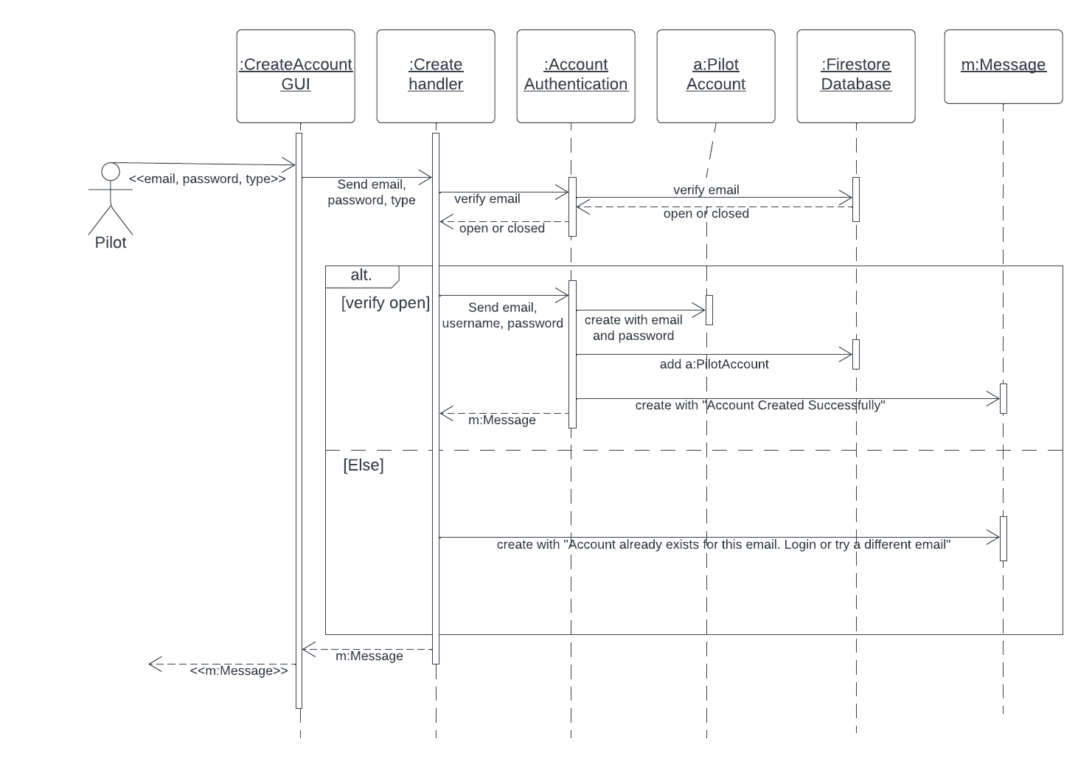

3. Edit Passenger Account

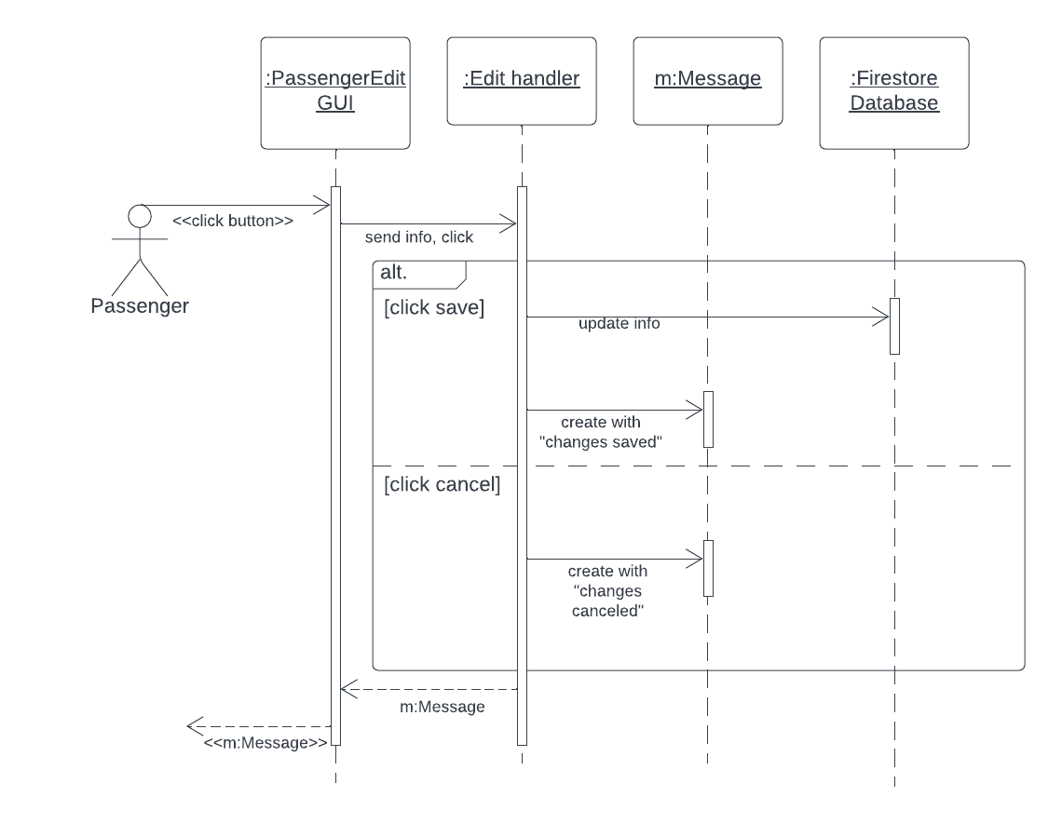

4. Edit Pilot Account

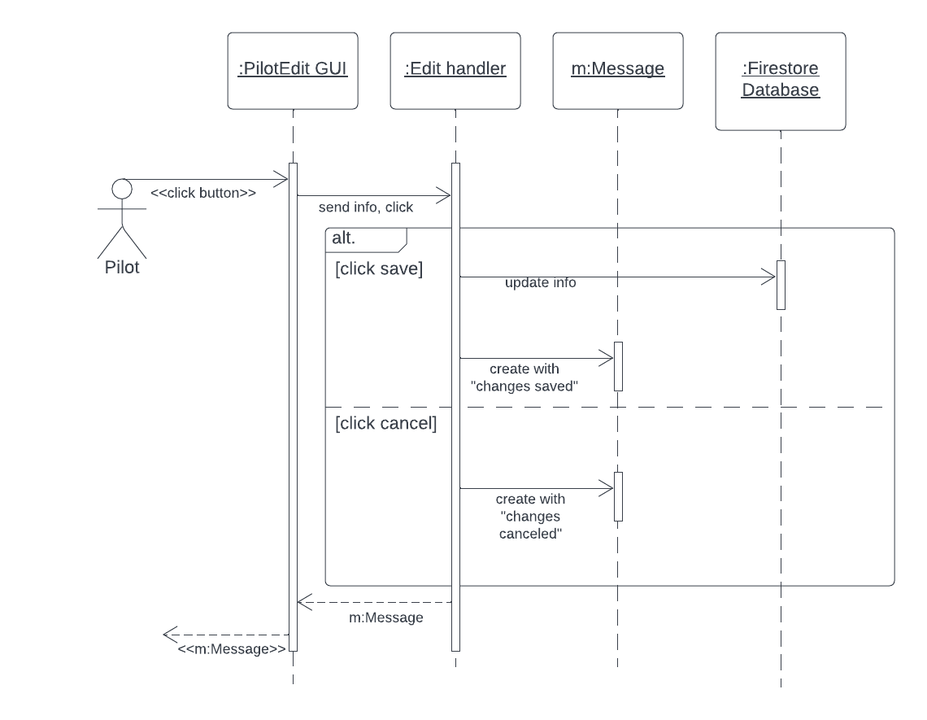

5. Contact Passenger

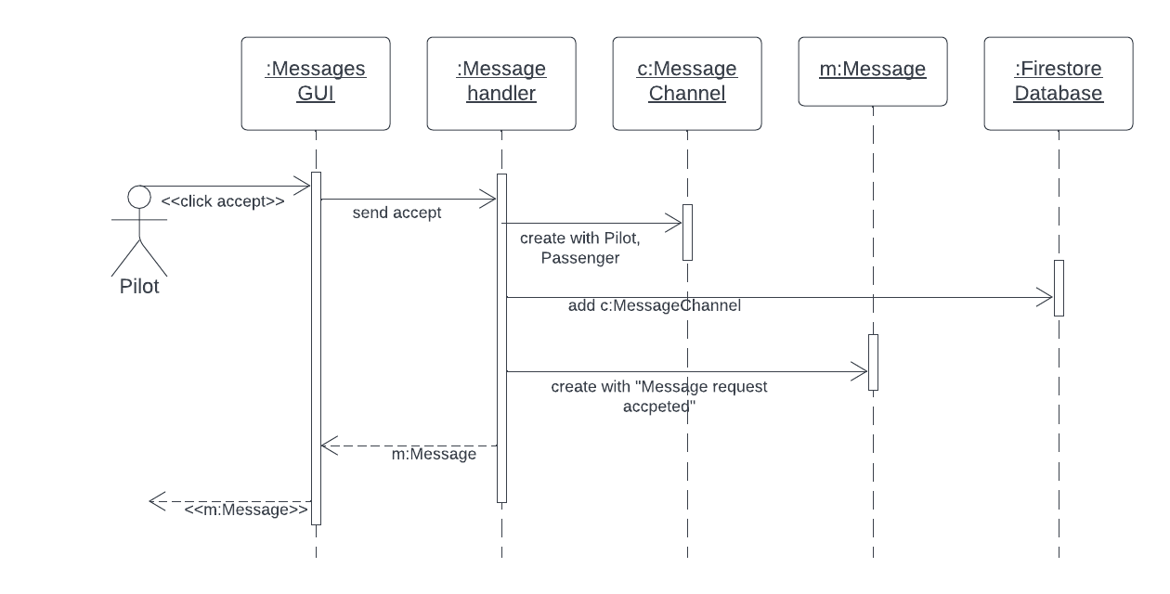

6. Contact Pilot

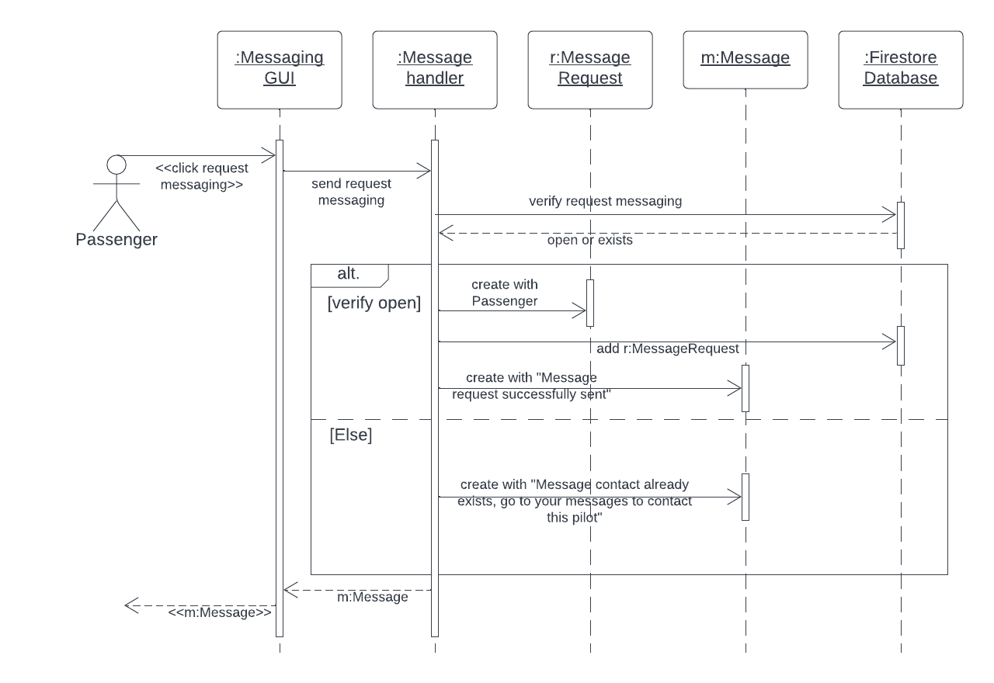

7. Write review

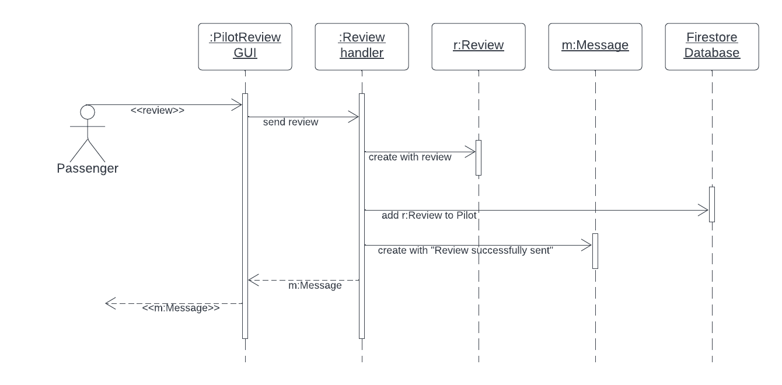

Design Sequence Diagrams

2. Create Pilot Account

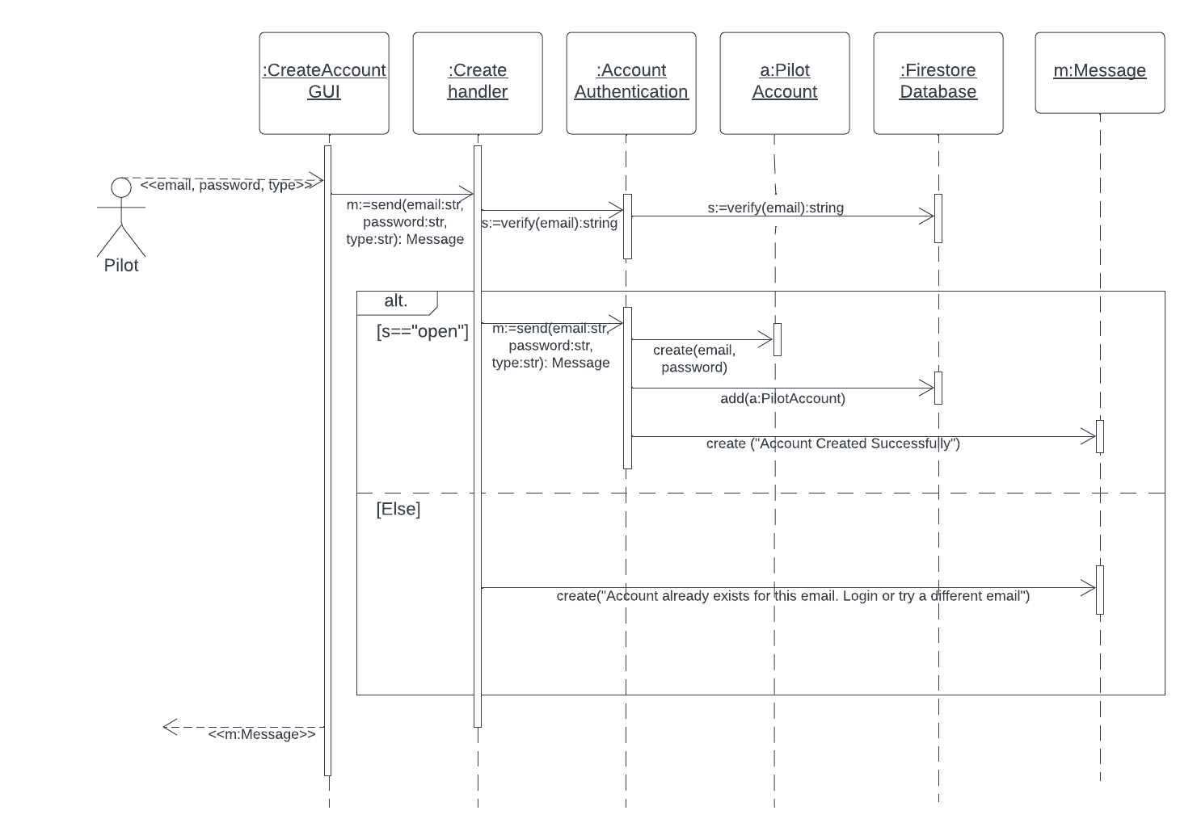

3. Edit Passenger Account

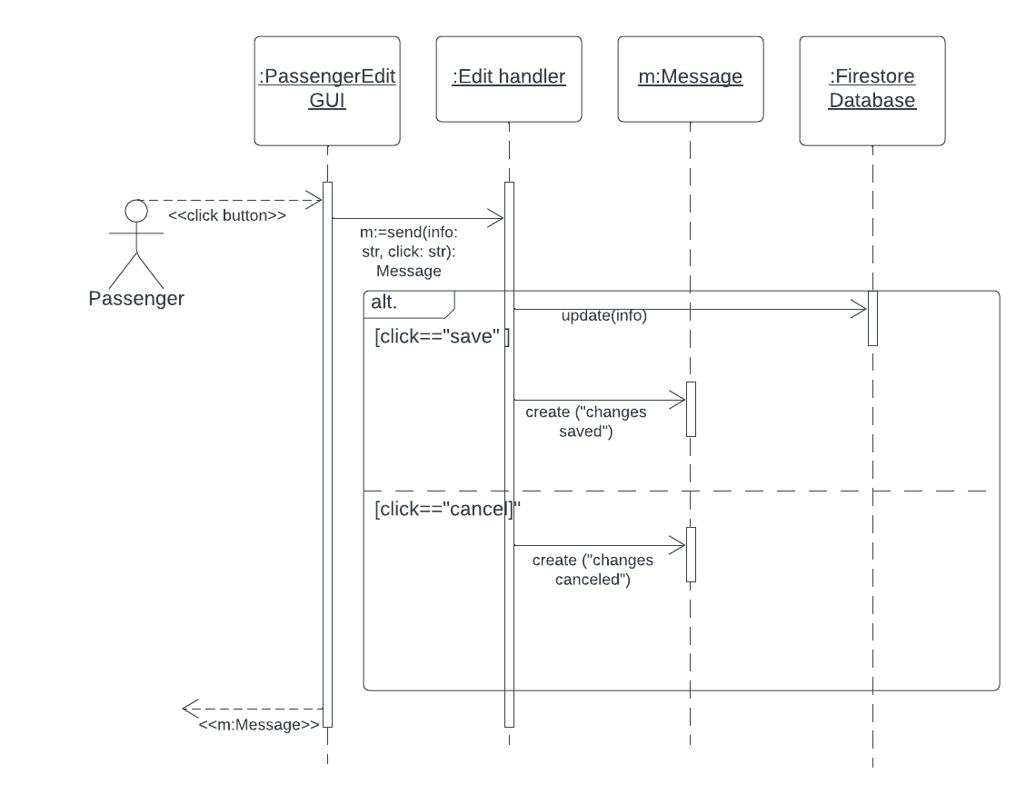

6. Contact Pilot 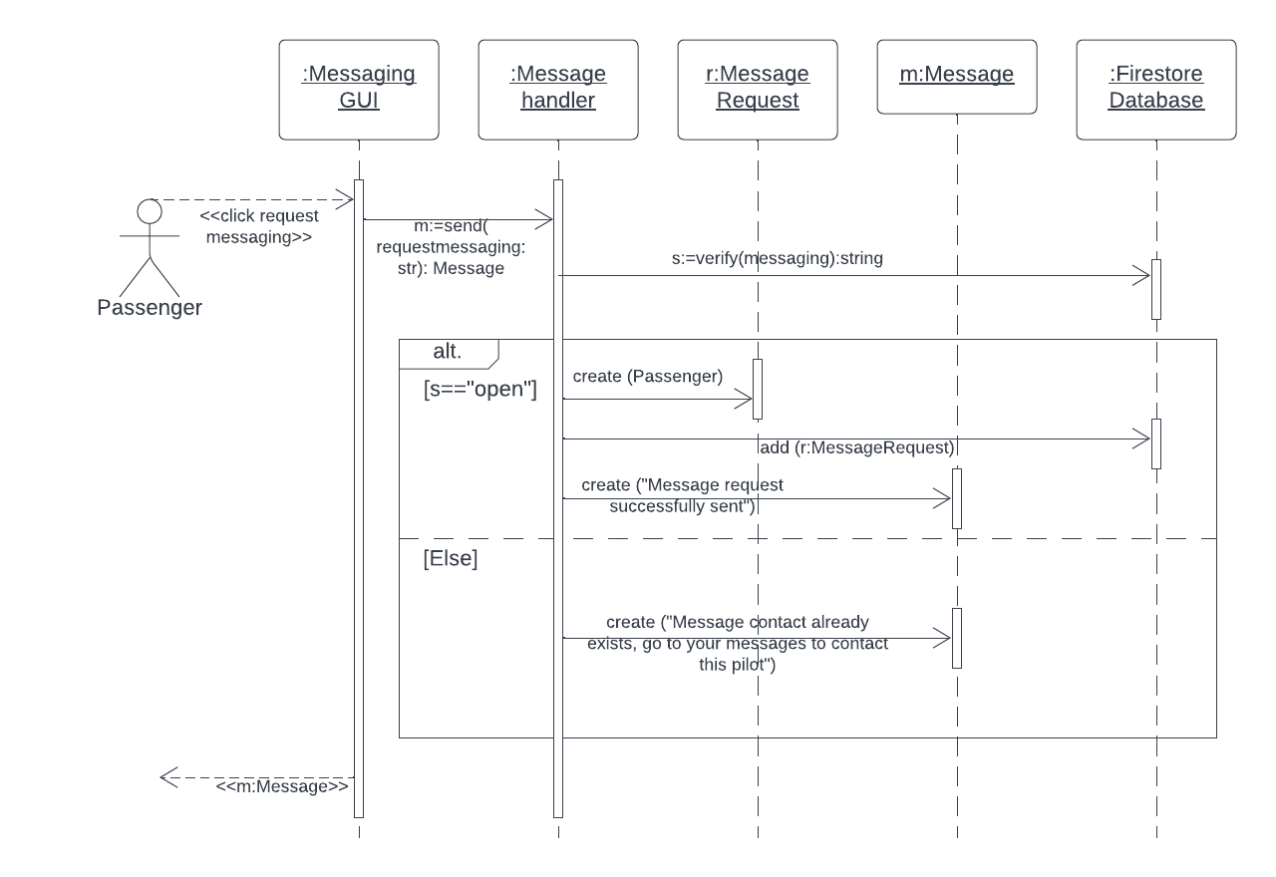

7. Write Review

