Design Pattern and DCD document

GreyMatter

DCD

Create Pilot Account

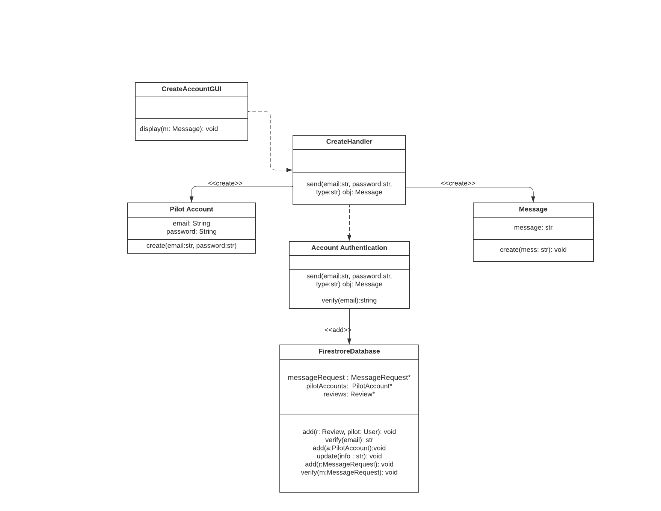

Edit Passenger Account

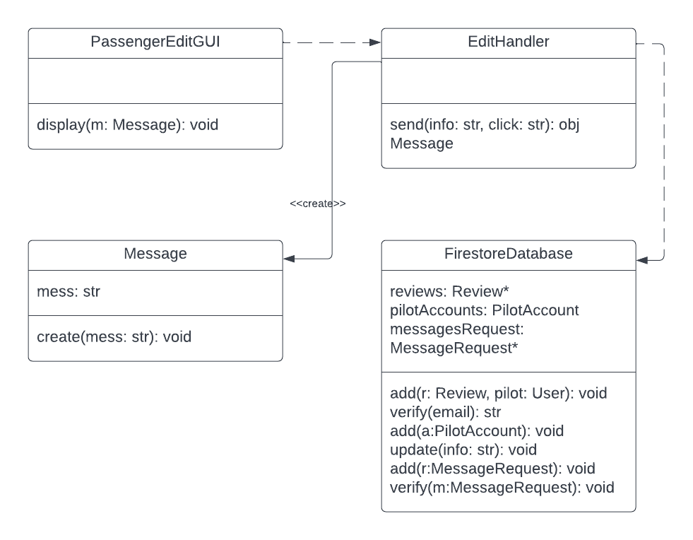

Contact Pilot

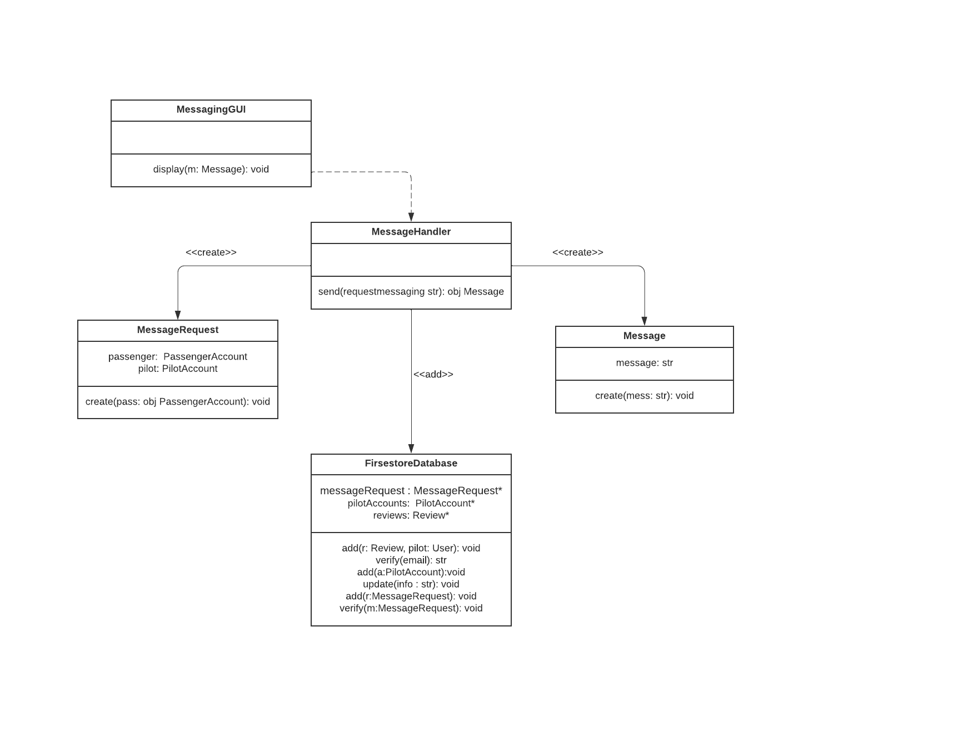

Write Review

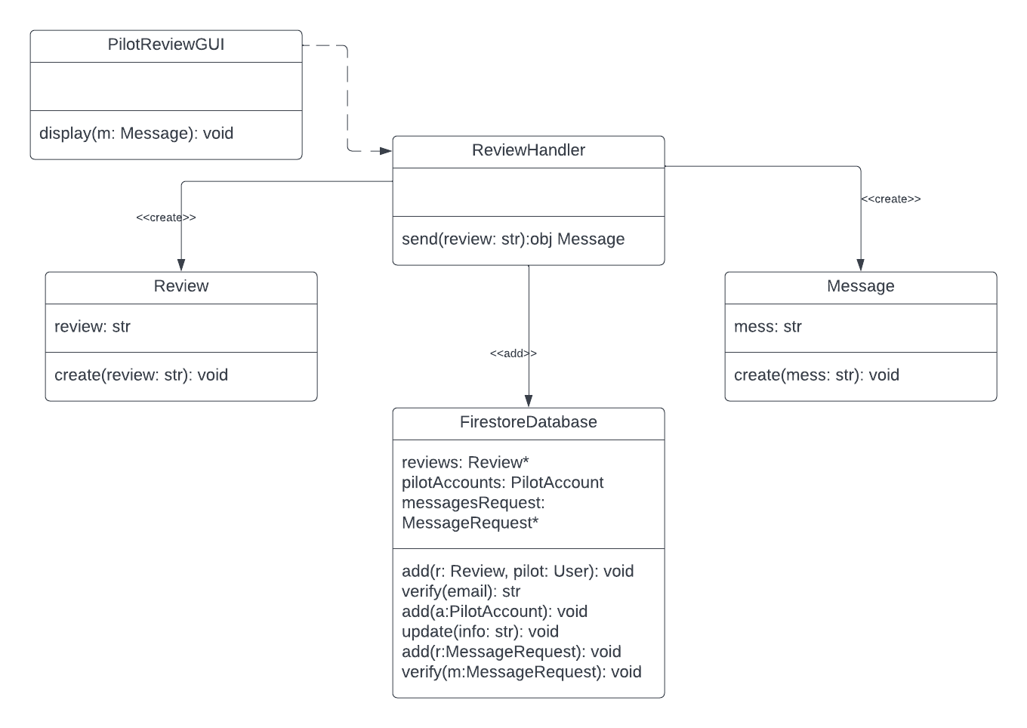

Design Pattern

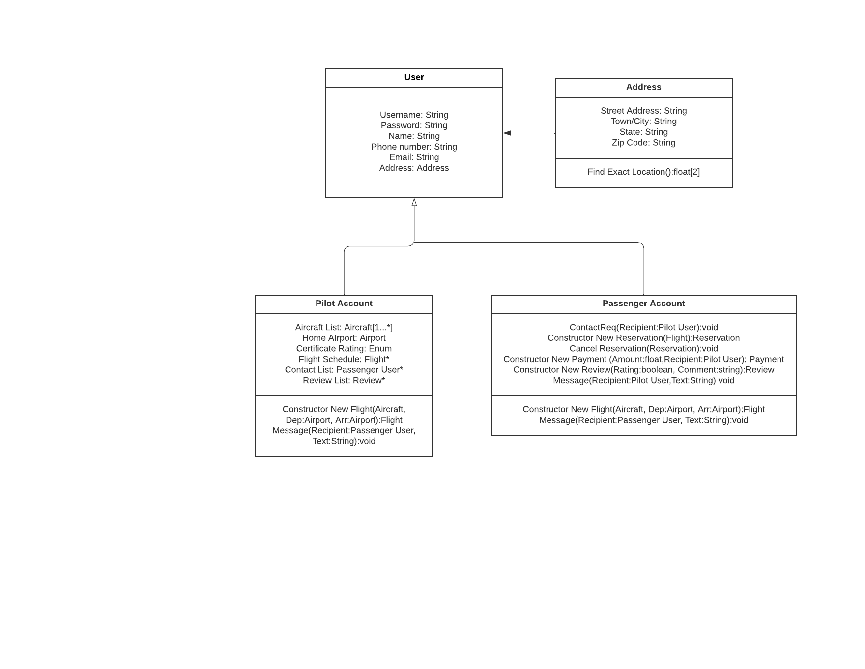

The Template Method is a suitable pattern for FlyAway because there are two different kinds of users, Pilot and Passenger, that have some similar base attributes and methods. This is a perfect place to have an abstract User class with the PilotAccount and PassengerAccount subclasses that can inherit the base attributes and methods needed for a basic User account while also adding other elements needed for the specific class. In this case the User class would be the abstract class and PilotAccount and PassengerAccount would be the concrete subclasses.

This Design Pattern is based on some of the Domain Models featured in the GreyMatter_Deliverable_4_DomainModel document. The above DCD featured on this document shows different relationships than that shown in the above Design Pattern as they are translated from the sequence diagrams which reflect these existing relationships. The relationship reflected within the above Design Pattern is from a relationship featured within the Domain Models that is not featured in the above DCDs, but is still an existing relationship within the application.

Some of the DCD classes are not featured in the coding of the application at this time as the functionality that the DCD describe have yet to be implemented in the code, or are in the process of being implemented.