Task 3 – Part 2

## Exercise 2.1

a)

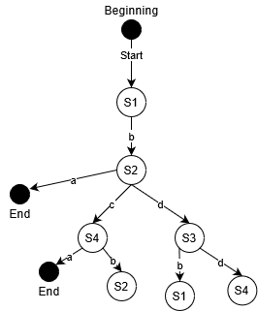

b)

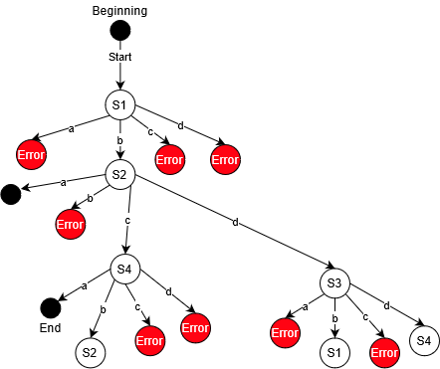

c)

State coverage second diagram

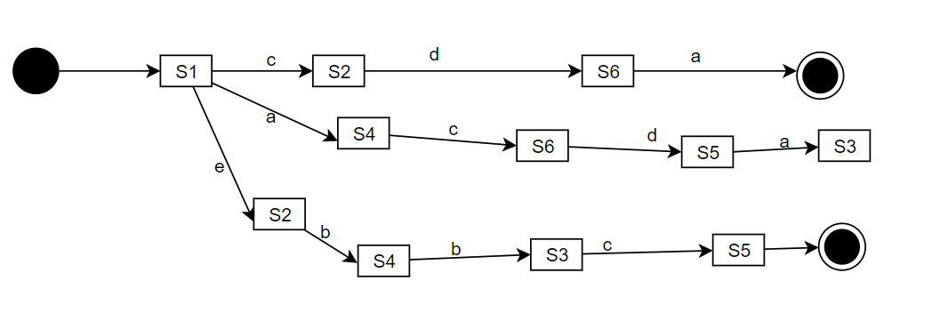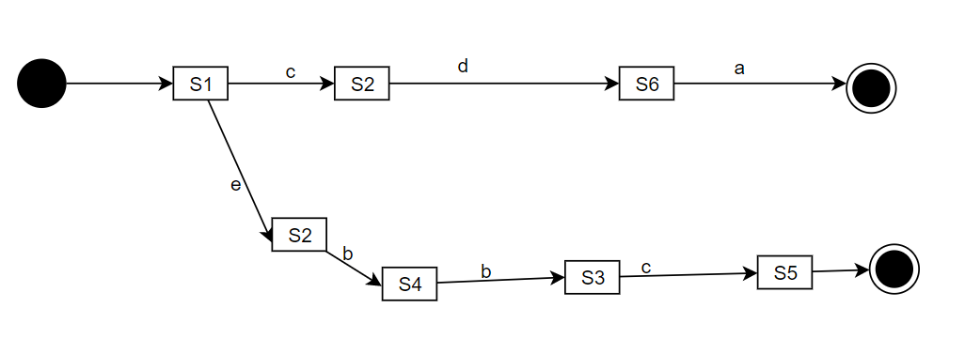Transition coverage second diagram