Individual Assessment Report

H35-660-HCIA-5G V1.0-ENU



The radar chart of personal competence analysis is as below

4.5G Industry Applications and Solutions

3.5G Service Applications

2.5G Network Capabilities and Key Technologies

1.5G Basics and Development Evolution

According to the competence model of the Temp, the following Competence items are needed

1.2.1 Personal Competence Analysis

.

.

.

..

..

..

..

B

N

S

I.

G

G

G

G

.5

.5

.5

.5

1

2

3

4

0

0%

64

20%

80

128

40%

160

160

50%

160

176

192

55%

60%

66.67%

66.67%

240

240

256

80%

Ratio

Test Score

320

100%

Total Score

320

384

120%

Theory Exam Overall Analysis

Ratio

55%

66.67%

50%

66.67%

Test Score

176

160

80

160

Total Score

320

240

160

240

Development Evolution

Key Technologies

Applications

and Solutions

Part

1.5G Basics and

2.5G Network Capabilities and

3.5G Service

4.5G Industry Applications

The exam result for Weerachai Yaemvachi is as below:

Every part of the exam paper matches the required criteria in the competence model

The theory exam paper is composed of 4 parts, with full score of 960.

1.2 Theory Exam Overall Analysis

Job

H35-660-HCIA-5G V1.0-ENU

Department

Temp

Full Name

Weerachai Yaemvachi

Account

uniportal_weerachai.y

1.1 Personal Information

1. Competence Analysis

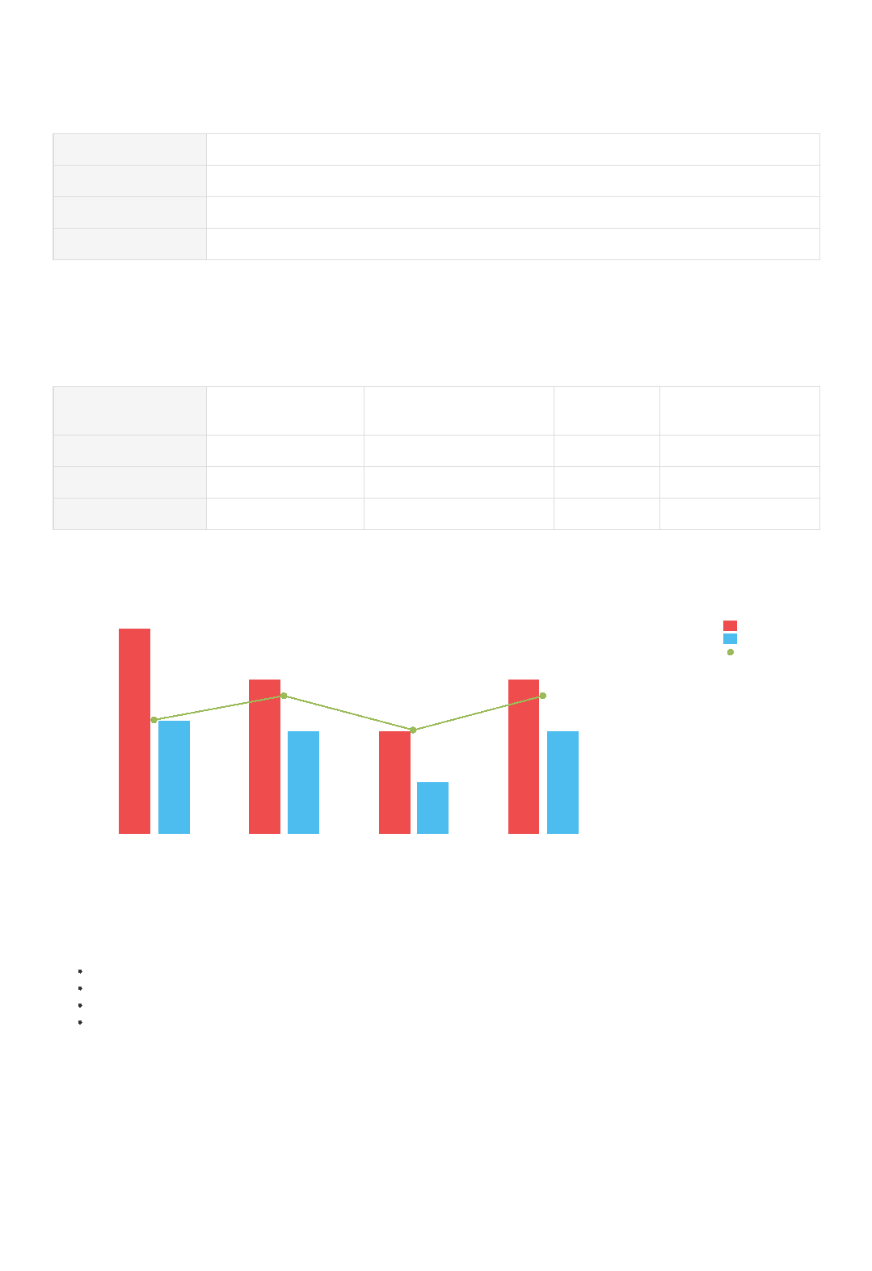

Has satisfactory knowledge of 4.5G Industry Applications and Solutions

Needs to enhance knowledge of 3.5G Service Applications

Has satisfactory knowledge of 2.5G Network Capabilities and Key Technologies

Needs to enhance knowledge of 1.5G Basics and Development Evolution

According to the assessment result of Weerachai Yaemvachi ,

Result Summary

The current level is from the result of the assessment.

Remark

3.5G Service...

4.5G Industr...

2.5G Network...

0%

20%

40%

60%

80%

Expected Level

100%

Current Level

1.5G Basics ...

Personal Competence Analysis

