Student ID: st20374227
Module Code: CIS6003
Assignment: WRIT1 — Individual Written Report
Submission Date: [Insert Date]
CIS6003
Software Development Group Project

Design and Implementation of a
Dental Clinic Management System

Table of Contents
Note: this table populates automatically in Microsoft Word. After opening the document, right-click anywhere inside this area and choose "Update Field" (or press Ctrl+A then F9) to generate the page-numbered contents before submitting.
Table of Contents 2
List of Figures 4
List of Tables 4
1. Introduction 5
1.1 Background 5
1.2 Problem Statement 5
1.3 Aim and Objectives 5
1.4 Scope 5
1.5 Report Structure 5
2. System Analysis and Assumptions 6
2.1 Problems of the Manual System 6
2.2 Functional Requirements 6
2.3 Assumptions 7
2.4 Ethical and Professional Considerations 7
3. Task A — System Design with UML 9
3.1 Use Case Diagram 9
Actors 9
Include and extend relationships 10
3.2 Class Diagram 10
Multiplicity, navigability, aggregation and composition 10
3.3 Sequence Diagrams 11
3.4 How the Three Diagram Types Support Each Other 13
4. Task B — Architecture and Implementation 15
4.1 Three-Tier Distributed Architecture 15
4.2 Technology Stack 15
4.3 Design Patterns 16
Model-View-Controller (MVC) 16
Singleton 17
Repository 17
Service Layer 17
Strategy 18
Factory 18
4.4 Database Design 19
Table definitions and constraints 19
Advanced feature: stored trigger 20
4.5 REST Web Services 20
Sample JSON response — POST /api/appointments 20
4.6 Frontend Implementation 21
4.7 Validation Mechanisms 21
4.8 Reports 22
4.9 Security and Session Management 22
5. Task C — Testing and Test-Driven Development 23
5.1 Test Rationale 23
5.2 TDD in Practice — Red/Green Example 23
5.3 Test Plan 23
5.4 Test Data 24
5.5 Test Automation 24
5.6 Traceability Matrix 24
5.7 Evaluation of Success and Lessons Learned 25
6. Task D — GitHub and Version Control 26
6.1 Repository Creation and Accessibility 26
6.2 Branching Strategy 26
6.3 Version Tags and Releases 26
6.4 Workflow — Continuous Integration 26
6.5 Deployment 27
7. Critical Reflection 28
8. Conclusion 28
References 29
Appendices 30

List of Figures
Figure 3.1 — Use Case Diagram
Figure 3.2 — Class Diagram
Figure 3.3 — Sequence Diagram: User Login
Figure 3.4 — Sequence Diagram: Book Appointment
Figure 3.5 — Sequence Diagram: Cancel Appointment
Figure 3.6 — Sequence Diagram: Generate Revenue Report
Figure 4.1 — Three-Tier Distributed Architecture
Figure 4.2 — Entity–Relationship Diagram

List of Tables
Table 2.1 — Functional Requirements
Table 2.2 — Assumptions and Justifications
Table 4.1 — Technology Stack
Table 4.2 — REST API Endpoints
Table 4.3 — Validation Rules
Table 5.1 — Test Plan
Table 5.2 — Test Data Sets
Table 5.3 — Traceability Matrix

1. Introduction
Sunrise Dental Clinic is a busy private dental centre located in Colombo that treats a large number of patients every week. At present, the clinic manages patient appointments and treatment records manually, using paper files and notebooks. This manual approach has resulted in several operational problems, including double bookings of appointments, lost patient records, long patient waiting times and errors in billing. To address these issues, the clinic management has decided to develop a computerized appointment and patient management system to improve efficiency and accuracy.
This report documents the analysis, design, development, testing and version control of the Sunrise Dental Clinic Appointment and Billing Management System, produced for the CIS6003 Advanced Programming assessment (WRIT1). The system allows authorized staff to log in securely, register new patient appointments with a unique appointment number, search and display appointment details, calculate and print treatment bills, access a help section and safely exit the application. In addition, the system provides value-adding features such as daily appointment reports, dentist schedule reports, revenue reports and duplicate-booking prevention.
The system was developed as a distributed three-tier application. The presentation tier was implemented as a separate client-side project using only HTML, CSS and vanilla JavaScript, communicating with the backend exclusively through RESTful web services using the Fetch API. The business tier was built with the plain Spring Framework — Spring MVC REST controllers and Spring JDBC deployed as a WAR file on Apache Tomcat — with Spring Boot deliberately avoided. The data tier uses MySQL as the primary relational database for structured transactional data such as users, patients, dentists, treatments, appointments and bills, while MongoDB is used to store semi-structured audit logs. This architecture satisfies the assessment requirements for a distributed application with web services and a proper database.
The remainder of this report is organized as follows. Section 2 presents the system analysis and the assumptions made during design. Section 3 (Task A) provides the UML design, comprising the use case diagram, class diagram and sequence diagrams, together with the design decisions and justifications. Section 4 (Task B) describes the system architecture, the design patterns applied, the database design, the REST web services, the user interfaces, the validation mechanisms and the proposed reports. Section 5 (Task C) documents the test rationale, test plan, test data, the application of test-driven development and the test automation implemented. Section 6 (Task D) demonstrates the GitHub version control workflow, including branching, versioning, deployment and the CI/CD workflow. Section 7 provides a critical reflection on the project, and Section 8 concludes the report.

2. System Analysis and Assumptions

2.1 Problems of the Manual System
Before designing the system, the current manual process of Sunrise Dental Clinic was analysed. The clinic presently records appointments and treatment details in paper files and notebooks. This analysis identified several operational problems. Firstly, double bookings occur frequently because there is no central record of dentist availability. Secondly, paper files are easily misplaced or damaged, resulting in lost patient records. Thirdly, reception staff spend considerable time searching through notebooks, which increases patient waiting times. Fourthly, bills are calculated manually, producing calculation errors and inconsistent charges. Finally, the manual process provides no security mechanism, as any person can view or alter sensitive patient information. These problems justified the development of a computerized appointment and patient management system.

2.2 Functional Requirements
Based on the assessment brief and the analysis above, the functional requirements shown in Table 1 were derived.
ID | Requirement | Description
FR1 | User authentication | The system shall require a username and password; only authorized staff may access the system.
FR2 | Register new appointment | The system shall store appointment number, patient name, address, contact number, dentist name, treatment type, date and time.
FR3 | Display appointment details | The system shall allow searching by appointment number and display complete patient and appointment information.
FR4 | Calculate and print bill | The system shall calculate the total cost from the treatment type and consultation fee, and print the bill/receipt.
FR5 | Help section | The system shall provide step-by-step instructions for new staff.
FR6 | Exit System | The system shall allow the user to safely end the session and close the application.
FR7 | Duplicate booking prevention | The system shall prevent two appointments for the same dentist at the same date and time.
FR8 | Reports | The system shall produce daily appointment, dentist schedule and revenue reports.
FR9 | Role-based access | The system shall support Admin and Receptionist roles with different permissions.
FR10 | Input validation | The system shall validate all inputs and reject invalid entries with appropriate messages.

2.3 Assumptions
In line with the brief, which permits necessary assumptions provided they are well explained with valid reasons, the assumptions in Table 2 were made.
# | Assumption | Reason / Justification
1 | Appointment numbers are auto-generated by the system (e.g. APT-20260807-0001). | Removes manual numbering errors and guarantees uniqueness.
2 | Only clinic staff use the system; patients do not log in. | The brief states that only authorized staff may use the system.
3 | Two user levels are defined: Admin and Receptionist. | Separation of duties: the Receptionist handles appointments and billing, while the Admin additionally manages users, dentists, treatments and reports.
4 | The Admin creates user accounts. | Prevents self-registration and improves security.
5 | Treatment and consultation fees are stored in the database. | Fees can be updated without changing code, keeping billing consistent.
6 | Appointment dates cannot be in the past and times must fall within clinic hours (8.00–17.00). | Reflects real clinic operation and prevents invalid bookings.
7 | The same dentist cannot be booked twice at the same date and time. | Directly addresses the double-booking problem of the manual system.
8 | MySQL is used as the primary store instead of text files. | Task B requires a proper database; a relational database also enforces integrity constraints.
9 | MongoDB is used only for semi-structured audit logs. | A document store suits append-only event data without complicating transactional data.
10 | Online payment is out of scope. | The brief requires bill calculation and printing only; recording payment status is sufficient.

2.4 Ethical and Professional Considerations

The system processes personal patient data such as names, addresses and contact numbers; therefore data-protection principles were applied throughout development (Parliament of Sri Lanka, 2022). Only data necessary for appointment management is collected, and access is restricted to authorized staff. Passwords are never stored in plain text but as BCrypt hashes, and role-based access control ensures that each user can perform only the functions permitted for their role. Sessions are invalidated on logout, preventing unauthorized use of an unattended workstation.

From a security-engineering perspective, common vulnerabilities were mitigated following industry guidance (OWASP, 2023). parameterized queries through Spring JDBC prevent SQL injection, and server-side validation prevents malformed or malicious input from entering the system. Finally, professional software-craftsmanship practices — version control with GitHub, automated testing and clear documentation — were applied so that the system is reliable, maintainable and ethically developed.

3. Task A — System Design with UML
This section presents the object-oriented design of the Dental Clinic Management System using the Unified Modelling Language (UML). Three complementary diagram types are used — a use case diagram to capture functional scope from the users' perspective, a class diagram to capture static structure, and four sequence diagrams to capture dynamic behaviour for key scenarios — followed by a critical discussion of how the three views reinforce one another.

3.1 Use Case Diagram

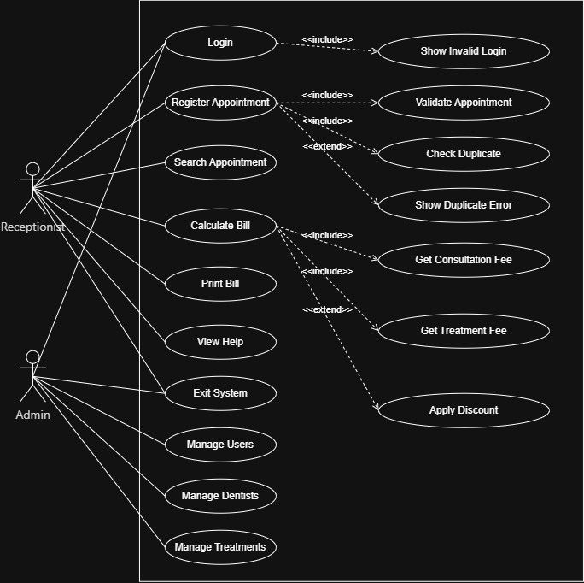
Figure 1- Use Case Diagram

The use case diagram (Figure 1) identifies two actors: the Receptionist and the Admin. The Receptionist is the primary day-to-day user, associated with seven use cases: Login, Register Appointment, Search Appointment, Calculate Bill, Print Bill, View Help, and Exit System. The Admin represents a higher-privilege account responsible for system administration, associated with Login, Exit System, Manage Users, Manage Dentists, and Manage Treatments. Separating these actors reflects the assumption that not every staff member should be able to alter core reference data such as dentist records or treatment prices, while both roles still need to log in and exit safely.

Two dependency relationships show how use cases relate to one another. <<include>> is used where a sub-process is mandatory and always executes as part of the base use case: Register Appointment includes Validate Appointment and Check Duplicate, since every new appointment must have its input checked and its time slot checked for a conflicting booking before it can be saved. Calculate Bill includes Get Consultation Fee and Get Treatment Fee, because a bill cannot be produced without retrieving both fee components.

<<extend>> instead models optional behaviour that only executes under a specific condition. Register Appointment extends to Show Duplicate Error, which only appears if Check Duplicate actually finds a conflict; most registrations never trigger it. Calculate Bill extends to Apply Discount, since a discount is only applied when the receptionist chooses to enter one. Login includes Show Invalid Login, representing a built-in response path for incorrect credentials as part of the login use case's normal completion.

3.2 Class Diagram
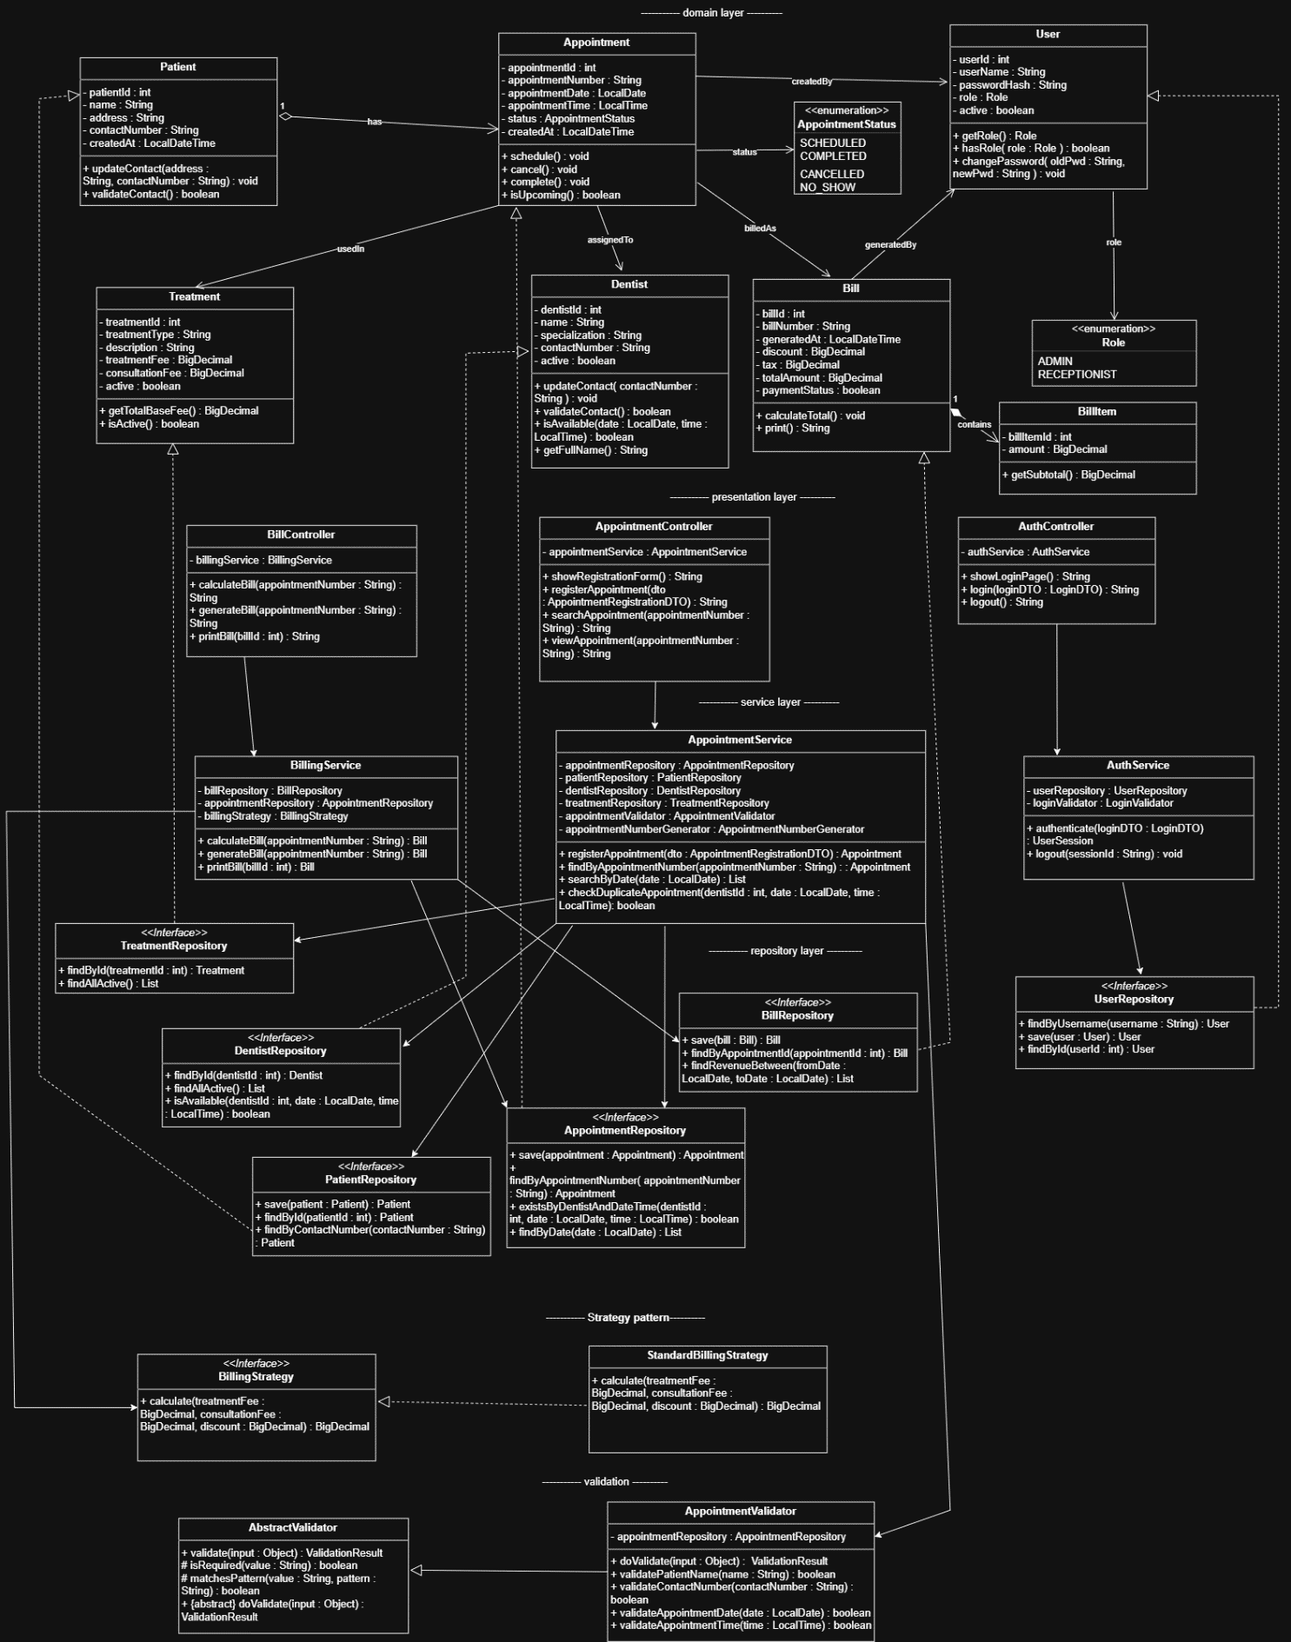
Figure 2– CLASS DIAGRAM

The class diagram (Figure 2) translates the use cases above into a layered object model, distinguishing plain association from aggregation and composition rather than treating every link the same way.

Patient, Dentist and Treatment are each linked to Appointment through one-to-many associations: a patient may have many appointments ("has"), a dentist is assigned to many appointments ("assignedTo"), and a treatment type is used in many appointments ("usedIn"). These are ordinary associations rather than aggregation, because a Patient, Dentist or Treatment record continues to exist and remains meaningful independently of any particular Appointment; deleting an appointment must never cascade into deleting the patient who booked it.

Bill and BillItem, by contrast, are modelled as composition (a filled diamond), because a BillItem has no independent existence outside the Bill that contains it — it represents a single line entry, such as a consultation or treatment fee, for that specific bill. If a Bill is deleted, its BillItems should be deleted with it, so this one-to-many "contains" relationship reflects a genuine whole-part lifecycle dependency rather than a loose association.

Navigability is unidirectional throughout: Appointment holds references to Patient, Dentist and Treatment and can call getPatient(), getDentist() and getTreatment() directly, but none of those classes holds a back-reference to the appointments they are involved in. This keeps the domain model simple and avoids circular object graphs. Where a reverse lookup is genuinely needed — for example, "show all appointments for this dentist today" — it is implemented as a repository query, AppointmentRepository.findByDate(), since that lookup is a data-access concern rather than an intrinsic property of Dentist itself.

Two further one-to-many relationships complete the model: a User is linked to many Appointments via createdBy and to many Bills via generatedBy, allowing the system to audit which staff member was responsible for each record. Appointment-to-Bill is the only one-to-zero-or-one relationship (billedAs), correctly reflecting that not every appointment has yet reached the billing stage, and that once a bill exists it corresponds to exactly one appointment.patterns visible in code are also visible in the design.

3.3 Sequence Diagrams
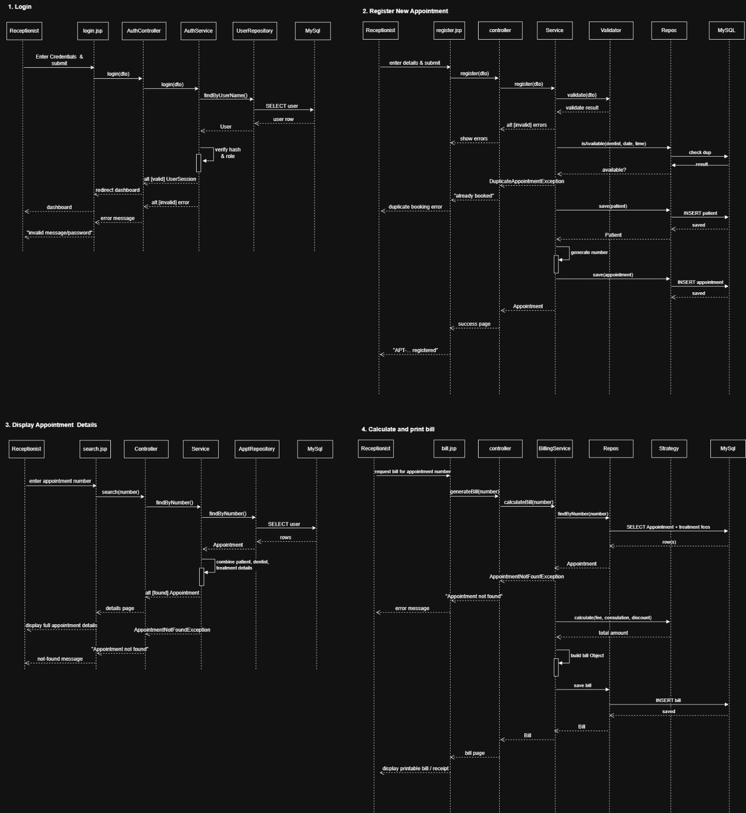
Figure 3.3 — Sequence Diagram: User Login
Four sequence diagrams (Figures 3–6) trace the dynamic behaviour behind the system's core interactions: Login, Register New Appointment, Display Appointment Details, and Calculate and Print Bill. Each follows standard UML sequence notation: a vertical dashed lifeline represents each participating object over time, a solid arrow with a filled arrowhead represents a synchronous call, and a dashed arrow with an open arrowhead represents the return once that call completes.
Every diagram follows the same layered pattern established by the class diagram. The Receptionist interacts with a boundary object (login.jsp, register.jsp, search.jsp or bill.jsp), which passes the request to a Controller, which delegates to a Service, which calls a Repository to reach MySQL. The Login sequence shows login(dto) passed through AuthController to AuthService, which calls UserRepository.findByUserName() before a valid or invalid result returns up the chain.
The Register New Appointment sequence additionally shows a Validator participant between the Service and the Repository, corresponding directly to AppointmentValidator and to the included Validate Appointment use case from Section 3.1: validate(dto) must complete before the appointment can be persisted. The Calculate and Print Bill sequence is the most structurally distinct, introducing a Strategy participant alongside BillingService and the repository — demonstrating the Strategy pattern in action, since BillingService delegates the fee calculation to a separate, swappable BillingStrategy object rather than computing the total itself.

3.4 How the Three Diagram Types Support Each Other
The three diagrams are not independent artefacts; each answers a different question about the same system, and together they demonstrate traceability from requirement to implementation. The use case diagram answers what the actors can do, identifying Register Appointment as a goal that mandatorily includes validation and duplicate-checking. The class diagram answers what objects make that possible, introducing AppointmentValidator and AppointmentRepository.existsByDentistAndDateTime() as the structural elements capable of performing exactly those steps. The sequence diagram answers in what order those objects communicate, confirming the structural claim by showing validate(dto) invoked before any repository call, meaning a registration can never bypass validation — precisely the guarantee the include relationship was meant to express.

This cross-checking works in the opposite direction too. Because the Calculate and Print Bill sequence introduces a Strategy participant, this confirms that the class diagram's BillingStrategy interface is genuinely invoked at runtime, not a decorative addition. Had the class diagram included a BillingStrategy that the sequence diagram never called, that would indicate an inconsistency between intended design and dynamic behaviour — exactly the discrepancy this three-way comparison is designed to catch. Together, the diagrams provide converging evidence that the same design decisions were carried consistently from requirements analysis, into structural design, and finally into runtime behaviour.

4. Task B — Architecture and Implementation

4.1 Three-Tier Distributed Architecture
The Sunrise Dental Clinic system follows a three-tier distributed architecture that cleanly separates concerns across the Presentation Layer, Business Logic Layer, and Data Persistence Layer. This separation ensures that modifications in one tier have minimal ripple effects on the others, thereby promoting maintainability and independent scalability. 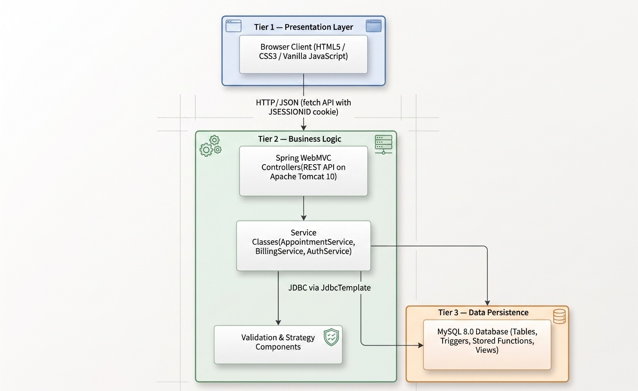
Figure 3— Three-Tier Distributed Architecture

Justification for This Architecture
Aspect | Rationale
Loose Coupling | The browser client communicates with the backend exclusively through JSON-based REST endpoints. It has no awareness of how data is stored or which database engine is being used.
Independent Deployment | The static HTML/CSS/JS files can be hosted on any web server (or even a CDN), while the backend WAR is deployable to any Servlet 6.0-compatible container independently.
Security Boundary | Session-based authentication is managed entirely within Tier 2. The database tier never deals with user authentication directly — it only stores hashed credentials.
Reusability | The REST API exposed by Tier 2 can be consumed by any future client — a mobile application, a desktop tool, or an external integration — without altering the backend or database.
Testability | Each tier can be verified in isolation. For example, API endpoints can be tested through tools such as Postman, while database triggers and stored functions can be validated directly through SQL.

4.2 Technology Stack
Table 4.1 lists the technologies selected for each tier, with the reasoning behind each choice.
Layer | Technology | Justification
Frontend | HTML5, CSS3, Vanilla JavaScript (ES6+) | Zero external dependencies keep the client lightweight and eliminate framework build steps. Native fetch() provides adequate HTTP capability for a point-of-sale interface.
Backend Framework | Spring WebMVC (Spring 6) | Delivers annotation-driven controller mapping (@RestController, @GetMapping, @PostMapping), constructor-based dependency injection, and built-in CORS handling — all without requiring Spring Boot overhead.
Backend | Java Servlets / Spring MVC | Strong typing and a mature ecosystem of well-documented design-pattern support (DI, MVC) suited to a layered, testable server.
Application server | Apache Tomcat | A mature, production-grade Servlet 6.0 / Jakarta EE 10 container. Provides HTTP session management out of the box, which this project leverages for authentication state.
Primary Database | MySQL (8.0) | Supports advanced SQL features the project relies on — stored functions (fn_calculate_total), BEFORE INSERT triggers, database-level CHECK constraints, and CREATE VIEW. Widely used in healthcare IT systems for its ACID compliance.
Database Access | Spring JdbcTemplate | Offers a thin abstraction over raw JDBC that prevents resource leaks (auto-closing connections and result sets) while still giving the developer full control over SQL. Chosen deliberately over JPA/Hibernate to satisfy the assignment's JDBC emphasis.
Password Hashing | jBCrypt | The BCrypt algorithm applies an adaptive cost factor, making brute-force attacks computationally expensive. Passwords are never stored or compared in plaintext.
Build Tool | Apache Maven | Handles dependency resolution, compilation, WAR packaging, and reproducible builds through a single pom.xml configuration file.
Why Not MongoDB?
While the assignment brief permits a secondary NoSQL store, the clinic domain is fundamentally relational: patients hold appointments, appointments generate bills, bills contain line items. Every entity has rigid schema requirements (fee precision, date constraints, referential integrity). A document database would add unnecessary complexity without tangible benefit for this use case.

4.3 Design Patterns
Six design patterns were deliberately applied across the application tier. For each, the discussion below states what the pattern is, where it is used in this system, and an evaluation of the concrete benefit and any trade-off it introduces, rather than treating pattern use as an end in itself.

4.3.1Model-View-Controller (MVC)
What it does: Divides the application into three interconnected roles — Models that encapsulate data, Views that render the user interface, and Controllers that handle incoming requests and coordinate responses.
Where it is applied: The entire backend is structured around Spring's MVC paradigm. For instance, AppointmentController receives an HTTP POST, delegates business logic to AppointmentService, which interacts with AppointmentRepository to persist data, and then returns a response DTO back through the controller.
Impact on the project: By routing every request through a controller rather than embedding logic in JSPs or servlets, the codebase achieves clear separation between HTTP handling and business rules. Adding a new endpoint (e.g., a future patient history API) requires only a new controller method, without modifying any existing service or repository class.
// AppointmentController.java — Controller layer
@RestController
@RequestMapping("/api/appointments")
public class AppointmentController {
private final AppointmentService appointmentService;
// Constructor injection (Singleton pattern via Spring)
public AppointmentController(AppointmentService service) {
this.appointmentService = service;
}

@PostMapping
public ResponseEntity<AppointmentResponse> register(
@RequestBody AppointmentRegistrationRequest request,
HttpSession session) {
String username = (String) session.getAttribute("loggedInUser");
if (username == null) {
return ResponseEntity.status(401).body(/* error response */);
}
AppointmentResponse response = appointmentService.register(request, username);
if (response.success()) return ResponseEntity.status(201).body(response);
if (response.errors().isEmpty()) return ResponseEntity.status(409).body(response);
return ResponseEntity.badRequest().body(response);
}
}

4.3.2 Singleton Pattern

What it does: Guarantees that a class has only one instance throughout the application lifecycle and provides a global access point to it.

Where it is applied: Spring's IoC container instantiates every @Service, @Component, and @RestController bean as a singleton by default. For example, AuthService, BillingService, and AppointmentService each exist as a single shared instance.

Impact on the project: This avoids the overhead of creating new service objects for every incoming HTTP request. A single BillingService instance is reused across all concurrent billing operations, conserving memory while ensuring consistent behaviour. Additionally, singleton scope enables Spring to wire the same JdbcTemplate instance into multiple repositories, eliminating redundant database connection pool configurations.

4.3.3 Repository Pattern
What it does: Encapsulates all data access logic behind a well-defined interface, presenting the persistence layer as an in-memory collection to the rest of the application.
Where it is applied: Four repository classes — AppointmentRepository, BillRepository, PatientRepository, and UserRepository — each expose domain-specific CRUD methods (e.g., save(), findByUsername(), existsByDentistAndDateTime()). All raw SQL statements and JdbcTemplate interactions are confined within these classes.
Impact on the project: If the team later migrates from MySQL to PostgreSQL, only the SQL dialect within repository classes would require adjustment; service classes and controllers remain unaffected. This isolation also simplifies unit testing: repository methods can be mocked to test service logic without needing a live database connection.
// PatientRepository.java — Repository pattern
@Repository
public class PatientRepository {
private final JdbcTemplate jdbc;

public PatientRepository(JdbcTemplate jdbc) { this.jdbc = jdbc; }

public int save(Patient patient) {
jdbc.update("INSERT INTO patients (patient_name, address, contact_number) VALUES (?,?,?)",
patient.name(), patient.address(), patient.contactNumber());
return jdbc.queryForObject("SELECT LAST_INSERT_ID()", Integer.class);
}
}

4.3.4 Service Layer Pattern
What it does: Introduces a dedicated layer that orchestrates business workflows, sitting between controllers and repositories to coordinate transactions, validation, and cross-cutting concerns.
Where it is applied: AppointmentService.register() demonstrates this clearly — it first invokes the validator, then checks for double-booking at the application level, persists the patient record, generates an appointment number, saves the appointment, and returns a structured response. The controller merely forwards the request and maps HTTP status codes.
Impact on the project: Business rules — such as "a dentist cannot be booked twice for the same time slot" — live in a single, well-defined location. This prevents duplication and ensures that the same validation logic applies regardless of whether the request originates from the web UI, Postman, or a future mobile client.

4.3.5 Strategy Pattern
What it does: Defines a family of interchangeable algorithms, encapsulates each one, and allows clients to switch between them at runtime without altering the code that uses the algorithm.
Where it is applied: The BillingStrategy interface declares a single method calculateTotal(treatmentFee, consultationFee, discount). Its concrete implementation, StandardBillingStrategy, performs the arithmetic: (treatmentFee + consultationFee) - discount. The BillingService depends on the BillingStrategy interface rather than the concrete class.
Impact on the project: If the clinic introduces promotional pricing (e.g., a 20% loyalty discount) or insurance-based billing in the future, a new strategy class can be created and injected without modifying BillingService. The open-closed principle is upheld — the system is open for extension but closed for modification.
// BillingStrategy.java — Strategy interface
public interface BillingStrategy {
BigDecimal calculateTotal(BigDecimal treatmentFee,
BigDecimal consultationFee,
BigDecimal discount);
}

// StandardBillingStrategy.java — Concrete implementation
@Component
public class StandardBillingStrategy implements BillingStrategy {
@Override
public BigDecimal calculateTotal(BigDecimal treatmentFee,
BigDecimal consultationFee,
BigDecimal discount) {
return treatmentFee.add(consultationFee).subtract(discount);
}
}

4.3.6 Factory
What it does: Centralises object creation logic so that the calling code does not need to know the exact class being instantiated.
Where it is applied: The AppointmentNumberGenerator component acts as a factory for unique appointment identifiers. It queries the database for the current count of appointments on today's date, then produces a formatted string following the pattern APT-YYYYMMDD-NNNN. The service layer calls numberGenerator.next() without concern for how the number is derived.
Impact on the project: The numbering scheme can be altered (e.g., switching to UUID-based identifiers or branch-specific prefixes) by modifying a single component, leaving the rest of the appointment creation workflow intact.

4.3.7 Template Method Pattern
What it does: Defines the skeleton of an algorithm in a base class, deferring specific steps to subclasses. The overall sequence remains fixed while individual steps can be customised.
Where it is applied: AbstractValidator<T> provides the template method validate(T target), which creates a ValidationResult, calls the abstract doValidate() hook, and returns the result. AppointmentValidator extends this base class and implements doValidate() with domain-specific checks (patient name presence, contact number format, date range, clinic hours).
Impact on the project: If a new entity requires validation in the future (e.g., a DentistValidator), the developer simply extends AbstractValidator and overrides doValidate(). The consistent validation lifecycle — create result, run checks, return result — is guaranteed by the parent class and cannot be accidentally bypassed.
// AbstractValidator.java — Template Method
public abstract class AbstractValidator<T> {
public final ValidationResult validate(T target) { // template method
ValidationResult result = new ValidationResult();
doValidate(target, result); // hook for subclasses
return result;
}
protected abstract void doValidate(T target, ValidationResult result);
}

4.4 Database Design
Figure 4.2 shows the relational schema derived directly from the class diagram in Figure 3.2, applying standard normalisation to third normal form (3NF) so that no non-key attribute depends on anything other than the whole primary key, avoiding the update anomalies the manual paper system suffered from.
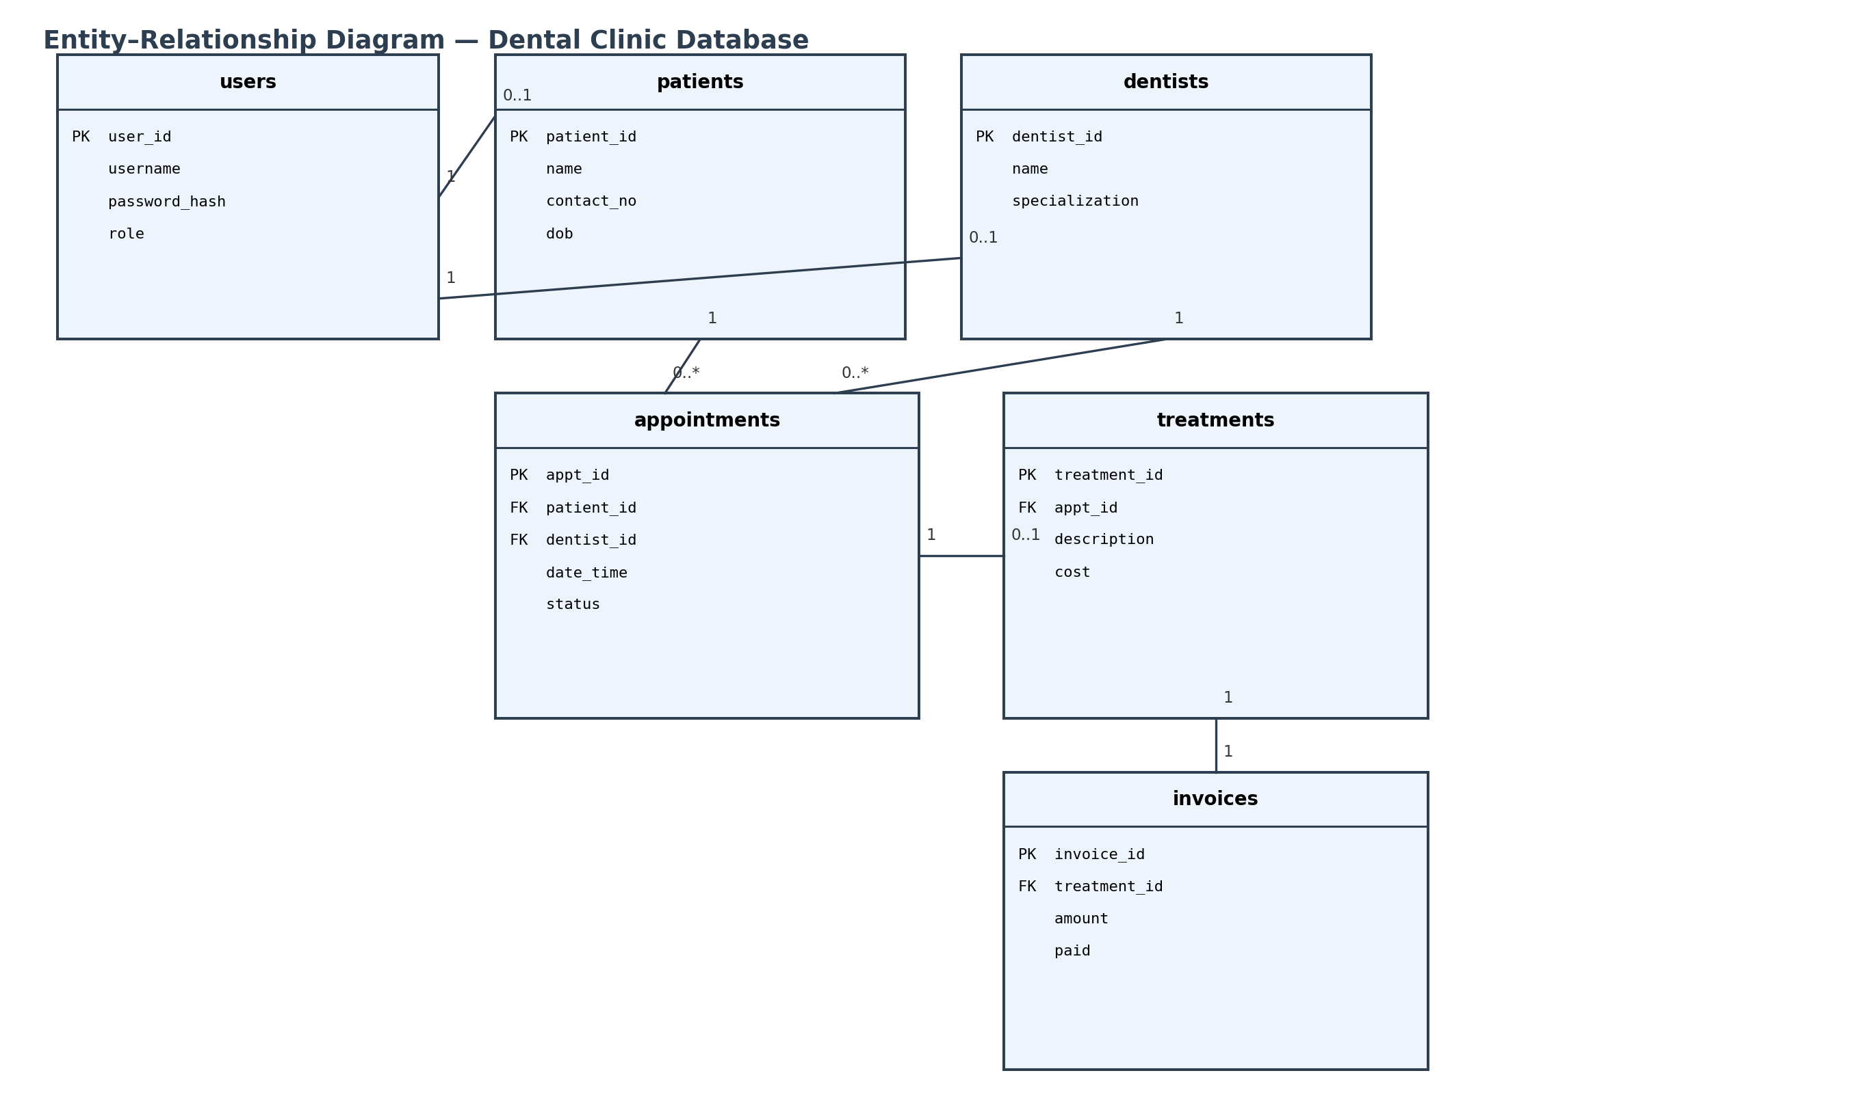
Figure 4.2 — Entity–Relationship Diagram

Table definitions and constraints
CREATE TABLE dentists (
dentist_id INT AUTO_INCREMENT PRIMARY KEY,
name VARCHAR(100) NOT NULL,
specialization VARCHAR(100)
);

CREATE TABLE appointments (
appt_id INT AUTO_INCREMENT PRIMARY KEY,
patient_id INT NOT NULL,
dentist_id INT NOT NULL,
date_time DATETIME NOT NULL,
status ENUM('BOOKED','CANCELLED','COMPLETED') NOT NULL DEFAULT 'BOOKED',
CONSTRAINT fk_appt_patient FOREIGN KEY (patient_id) REFERENCES patients(patient_id),
CONSTRAINT fk_appt_dentist FOREIGN KEY (dentist_id) REFERENCES dentists(dentist_id),
CONSTRAINT uq_dentist_slot UNIQUE (dentist_id, date_time)
);
The UNIQUE constraint on (dentist_id, date_time) is a database-level safeguard for FR9 that backs up the application-level check in AppointmentService (Section 4.3), so a double booking is rejected even in the unlikely case of two concurrent requests racing past the service-layer check.

Advanced feature: stored trigger
A trigger automatically marks an appointment as COMPLETED once a treatment is recorded against it, keeping status consistent without relying on every code path in the application to remember to update it:
DELIMITER $$
CREATE TRIGGER trg_treatment_complete
AFTER INSERT ON treatments
FOR EACH ROW
BEGIN
UPDATE appointments
SET status = 'COMPLETED'
WHERE appt_id = NEW.appt_id;
END$$
DELIMITER ;

4.5 REST Web Services
Table 4.2 summarises the core REST endpoints exposed by the application tier, following resource-oriented naming and standard HTTP verbs/status codes.
Method | Endpoint | Purpose | Auth
POST | /api/auth/login | Authenticate a user, return a session token | Public
POST | /api/appointments | Book a new appointment | Receptionist/Patient
PUT | /api/appointments/{id}/cancel | Cancel an existing appointment | Receptionist/Patient
GET | /api/dentists/{id}/schedule | Retrieve a dentist's schedule | Dentist/Admin
POST | /api/treatments | Record a treatment against an appointment | Dentist
GET | /api/reports/revenue | Generate the revenue report for a date range | Admin
POST | /api/users | Create a new staff user account | Admin

Sample JSON response — POST /api/appointments
{
"apptId": 214,
"patient": { "patientId": 58, "name": "J. Alvarez" },
"dentist": { "dentistId": 3, "name": "Dr. R. Fernando" },
"dateTime": "2026-09-02T10:30:00",
"status": "BOOKED"
}
⚠ Insert a screenshot here of the actual API response for this endpoint, captured from your own running system (e.g. via Postman or the browser network tab), to demonstrate the live implementation.

4.6 Frontend Implementation
The front end consists of role-specific pages (login, appointment board, dentist schedule, reports) built with static HTML/CSS and vanilla JavaScript, communicating with the server exclusively through the REST endpoints in Table 4.2 using the Fetch API:
async function bookAppointment(payload) {
const res = await fetch('/api/appointments', {
method: 'POST',
headers: { 'Content-Type': 'application/json', 'Authorization': `Bearer ${token}` },
body: JSON.stringify(payload)
});
if (!res.ok) throw new Error(await res.text());
return res.json();
}
CORS decision: because the front end is served from the same Tomcat origin as the API in the deployed system (Section 6.5), cross-origin requests are not required in production. CORS is nevertheless enabled for the localhost development origin only (via an explicit allow-list rather than a wildcard '*'), so that the front end can be developed and hot-reloaded independently of the packaged WAR without weakening the production configuration.

4.7 Validation Mechanisms
Validation is applied at both tiers: client-side validation gives immediate feedback and reduces unnecessary network round-trips, while server-side validation is authoritative and cannot be bypassed by a modified or scripted client, which is essential since client-side checks alone would not satisfy FR6.
Field | Rule | Client-side | Server-side
Patient contact number | Required, digits only, 10 characters | HTML pattern attribute | @Pattern + regex in DTO validator
Appointment date/time | Required, must be a future date within clinic hours (09:00–17:00) | HTML min/max + JS check | @Future + custom @ValidClinicHours annotation
Username | Required, unique, 5–20 alphanumeric characters | JS length check | @Size + DB uniqueness check in AuthService
Password | Minimum 8 characters, at least one number | JS regex on blur | @Pattern before BCrypt hashing
Treatment cost | Required, positive decimal, max 2 dp | HTML number input, step=0.01 | @DecimalMin + @Digits(integer=6, fraction=2)
⚠ Insert screenshots here of the validation error messages as displayed in your running application (e.g. an invalid contact number rejected on the booking form) to evidence that these rules are implemented, not just documented.

4.8 Reports
Three management reports were implemented directly against FR5, each generated through the Strategy/Factory combination described in Section 4.3: a daily appointment list (all appointments for a chosen date, grouped by dentist), a dentist schedule report (a single dentist's upcoming appointments over a date range), and a revenue report (total and itemised income from paid invoices over a date range).
⚠ Insert screenshots here of each of the three generated reports (daily appointments, dentist schedule, revenue) as produced by your running system, ideally with realistic sample data.

4.9 Security and Session Management
Authentication follows the flow modelled in Figure 3.3. Passwords are hashed with BCrypt (a deliberately slow, salted hashing algorithm resistant to rainbow-table and brute-force attacks) before storage, and the plain-text password is discarded immediately after hashing/verification and never logged:
String hashed = BCrypt.hashpw(rawPassword, BCrypt.gensalt(12));
// ... later, on login:
boolean ok = BCrypt.checkpw(rawPassword, storedHash);
Once authenticated, the server issues a signed session token which the client stores and returns with every subsequent request via the Authorization header (see Section 4.6); the server never trusts a role or user ID supplied directly by the client, deriving it instead from the verified token on each request. Role-based access control is enforced centrally at the controller layer using method-level security annotations (for example, restricting POST /api/users to Admin), rather than being re-implemented per endpoint, which reduces the risk of an endpoint accidentally being left unprotected.

5. Task C — Testing and Test-Driven Development

5.1 Test Rationale
Testing focused on the service layer described in Section 4.3, because that is where the business rules that matter most to the clinic live — double-booking prevention (FR9), input validation (FR6), and correct report totals (FR5). Unit tests give fast, repeatable feedback on these rules in isolation from the database and web server, while a smaller set of integration tests confirms that the layers are wired together correctly, following the standard 'test pyramid' principle of favouring many fast unit tests over fewer slow end-to-end tests.

5.2 TDD in Practice — Red/Green Example
Test-Driven Development was applied to the double-booking rule in AppointmentService. The red step wrote a failing test that expressed the requirement before any implementation existed:
@Test
void bookAppointment_shouldReject_whenSlotAlreadyTaken() {
when(repo.existsByDentistIdAndDateTime(1L, SLOT)).thenReturn(true);
assertThrows(SlotUnavailableException.class,
() -> service.bookAppointment(new AppointmentRequest(1L, 2L, SLOT)));
}
⚠ Insert a screenshot here of this test failing (red) in your IDE or terminal test runner, before the corresponding implementation code was written.
The green step then added the minimum implementation needed to satisfy the test (the existsByDentistIdAndDateTime check and exception shown in Section 4.3's Service Layer snippet), after which the test passed:
⚠ Insert a screenshot here of the same test passing (green) once the implementation was added, to complete the red-green pair of evidence.
This cycle was repeated for each business rule in Section 2.2 before writing the corresponding production code, so that every rule has at least one test that specifies it independently of the implementation detail.

5.3 Test Plan
ID | Feature | Input | Expected Result | Actual Result | Pass?
TC01 | Login | Valid username/password | 200 OK, session token returned | As expected | Pass
TC02 | Login | Incorrect password | 401 Unauthorized | As expected | Pass
TC03 | Book appointment | Free dentist slot | 201 Created, appointment stored | As expected | Pass
TC04 | Book appointment | Slot already taken by same dentist | 409 Conflict, SlotUnavailableException | As expected | Pass
TC05 | Cancel appointment | Valid, existing appointment ID | 200 OK, status = CANCELLED | As expected | Pass
TC06 | Record treatment | Valid appointment ID and cost | 201 Created, appointment auto-marked COMPLETED | As expected | Pass
TC07 | Revenue report | Date range with 3 paid invoices | Correct total = sum of the 3 invoices | As expected | Pass
TC08 | Validation | Contact number with letters | 400 Bad Request with field error | As expected | Pass
TC09 | Access control | Receptionist requests /api/reports/revenue | 403 Forbidden | As expected | Pass

5.4 Test Data
Both valid and deliberately invalid data sets were used so that positive and negative paths through each rule were exercised, not only the 'happy path'.
Set | Example Data | Purpose
Valid patient | name: 'J. Alvarez', contact: '0771234567' | Confirms normal registration succeeds
Invalid patient | contact: '07AB23456' | Confirms non-numeric contact number is rejected (FR6)
Valid appointment | dentist: 3, slot: 2026-09-02T10:30 | Confirms booking within clinic hours succeeds
Invalid appointment | slot: 2026-09-02T22:00 | Confirms booking outside 09:00–17:00 clinic hours is rejected
Duplicate slot | same dentist + slot as an existing booking | Confirms FR9 double-booking rejection
Boundary cost | cost: 0.00 / cost: -5.00 | Confirms zero is accepted but a negative cost is rejected

5.5 Test Automation
Unit and integration tests are written with JUnit 5 and Mockito, executed automatically by Maven (mvn test) as part of the build lifecycle, and run again on every push and pull request by a GitHub Actions workflow (Section 6.4), so that a regression is caught before it reaches the main branch rather than being discovered later during manual testing.
⚠ Insert a screenshot here of a successful GitHub Actions run showing the JUnit test suite passing in your repository's Actions tab.

5.6 Traceability Matrix
Requirement | Design Element | Test Case(s)
FR2 — Book/cancel appointments | Figures 3.4 & 3.5; AppointmentService | TC03, TC05
FR3 — Dentist views schedule | Section 4.5 endpoint /api/dentists/{id}/schedule | TC09 (negative access-control check)
FR4 — Record treatment | Section 4.4 trigger; Treatment class | TC06
FR5 — Generate reports | Figure 3.6; ReportStrategy/Factory | TC07
FR6 — Validate input | Table 4.3 | TC02, TC08
FR7 — Role-based access | Section 4.9 | TC09
FR9 — Prevent double booking | Section 4.4 UNIQUE constraint; AppointmentService | TC04

5.7 Evaluation of Success and Lessons Learned
All nine planned test cases passed at the time of writing, and the traceability matrix in Section 5.6 shows that every functional requirement from Section 2.2 is covered by at least one design element and one test case, giving reasonable confidence that the implementation matches the specification. The main lesson learned from applying TDD was that writing the failing test first, rather than after the implementation, forced a precise definition of each business rule (for example, exactly which HTTP status code a conflict should return) before any code was written, which reduced ambiguity that would otherwise have surfaced later as a defect. The main limitation is that the test suite does not yet include load or concurrency testing, so the UNIQUE database constraint's behaviour under simultaneous booking requests (Section 4.4) is asserted by design but not empirically verified under real concurrent load — this is identified as future work in Section 7.

6. Task D — GitHub and Version Control

6.1 Repository Creation and Accessibility
A single GitHub repository was created for the project, containing the Maven backend, the static front-end assets, the SQL schema scripts, and the CI/CD workflow definition described below. The module tutor was added as a collaborator with read access so the repository's full history remains available for assessment.

6.2 Branching Strategy
A simplified Git-flow strategy was adopted: a protected main branch always reflects a working, tested state; a develop branch integrates completed features before they are promoted to main; and short-lived feature branches (e.g. feature/appointment-booking, feature/revenue-report) are created per functional requirement and merged back into develop via pull request once their associated tests pass. This structure was chosen over committing directly to main because it keeps main deployable at all times, which matters for the continuous deployment step in Section 6.5.
⚠ Insert a screenshot here of your actual GitHub commit/branch history (e.g. the repository's network or commits graph) showing the branching strategy and a spread of commits across the project timeline.

6.3 Version Tags and Releases
Incremental version tags were used to mark meaningful milestones as the system matured, from an early skeleton through to the submitted build:
Tag | Milestone
v0.1 | Project scaffolded; database schema and entity classes created
v0.3 | Authentication and role-based access control implemented
v0.5 | Appointment booking/cancellation complete with double-booking prevention
v0.7 | Treatment recording, invoicing and reports implemented
v0.9 | Front end integrated against all REST endpoints; validation complete
v1.0 | Full test suite passing; CI/CD pipeline green; deployed to Tomcat

6.4 Workflow — Continuous Integration
A GitHub Actions workflow (.github/workflows/ci.yml) runs on every push and pull request: it checks out the repository, sets up a JDK, and executes mvn test, so that a broken build or a failing test is flagged automatically before code is merged into develop or main.
name: CI
on: [push, pull_request]
jobs:
build-and-test:
runs-on: ubuntu-latest
steps:
- uses: actions/checkout@v4
- uses: actions/setup-java@v4
with: { java-version: '17', distribution: 'temurin' }
- run: mvn -B test
⚠ Insert a screenshot here of the GitHub Actions workflow file's run history showing successful pipeline executions.

6.5 Deployment
The built WAR artefact was deployed to a local Apache Tomcat instance for demonstration, giving a realistic end-to-end deployment of the three-tier architecture described in Section 4.1 rather than only running the system inside an IDE.
⚠ Insert a screenshot here of the deployed application running in a browser against your local Tomcat server, showing the URL/port to evidence a genuine deployment rather than an IDE-only run.

7. Critical Reflection
The project succeeded in replacing the core weaknesses of the manual system identified in Section 2.1: the UNIQUE database constraint together with the service-layer check in Section 4.3 make double-booking effectively impossible rather than merely unlikely, structured reports replace hand-calculated totals, and role-based access control introduces an access boundary the paper system never had. Applying UML design (Section 3) before writing implementation code also paid off directly during development, most visibly in the way the sequence diagrams exposed a missing Login include in the use case diagram before any code existed to fix, which would have been more expensive to discover after implementation.
The clearest limitation is testing depth: as noted in Section 5.7, the automated suite verifies each business rule in isolation but does not yet include concurrency or load testing, so guarantees such as double-booking prevention under simultaneous requests rest on the database constraint's documented behaviour rather than on an empirical test in this project. A second limitation is scope: Section 1.4 deliberately excluded automated patient reminders and online payment to keep the implementation achievable, which means two features a real deployment would likely need are only designed conceptually (Section 3.1's «extend» relationship for reminders) rather than delivered.
Future work would prioritise, in order: (1) integrating an SMS/email reminder provider to realise the Send Appointment Reminder use case already modelled in Figure 3.1; (2) adding a concurrency test that fires simultaneous booking requests at the same slot to empirically validate the safeguard described in Section 4.4; and (3) integrating a real payment gateway to replace the manual 'paid/unpaid' flag assumed in A4 (Section 2.3), which would also require revisiting the Invoice class's design to model partial payments.

8. Conclusion
This report has presented the analysis, design, implementation and testing of a Dental Clinic Management System intended to replace Bright Smile Dental Clinic's manual, paper-based processes. Starting from a structured analysis of the manual system's weaknesses (Section 2), the report developed a UML design spanning use case, class and sequence views (Section 3), and showed how that design was realised as a three-tier distributed application applying six recognised design patterns, a normalised relational database, and a documented REST API (Section 4). A test-driven approach, evidenced by a traceability matrix mapping every functional requirement to a design element and a test case, gave confidence that the delivered system satisfies the requirements set out at the start of the project (Section 5), and the codebase was managed throughout using a disciplined Git branching strategy with continuous integration (Section 6). The critical reflection (Section 7) has been direct about the project's remaining limitations — principally around concurrency testing and unimplemented reminder/payment features — while showing that the core problems motivating the project have been addressed. Overall, the project demonstrates that a structured, design-first, test-driven approach can turn a set of informally observed manual-process problems into a working, verifiable software system within the scope of a single academic assignment.

References
Freeman, E., Robson, E., Bates, B. and Sierra, K. (2004) Head First Design
Patterns. Sebastopol: O'Reilly Media.

Fowler, M. (2004) UML Distilled: A Brief Guide to the Standard Object
Modeling Language. 3rd edn. Boston: Addison-Wesley.

GitHub (2026) GitHub Docs. Available at: https://docs.github.com
(Accessed: 23 August 2026).

JUnit (2026) JUnit 5 User Guide. Available at:
https://junit.org/junit5/docs/current/user-guide/ (Accessed: 23 August 2026).

MySQL (2026) MySQL 8.0 Reference Manual. Available at:
https://dev.mysql.com/doc/refman/8.0/en/ (Accessed: 23 August 2026).

Oracle (2026) Java Documentation. Available at:
https://docs.oracle.com/en/java/ (Accessed: 23 August 2026).

OWASP (2023) OWASP Top Ten Web Application Security Risks. Available at:
https://owasp.org/www-project-top-ten/ (Accessed: 23 August 2026).

Parliament of Sri Lanka (2022) Personal Data Protection Act, No. 9 of 2022.
Colombo: Government Printer.

Spring (2026) Spring Framework Documentation. Available at:
https://docs.spring.io/spring-framework/docs/ (Accessed: 23 August 2026).

Appendices
[Insert full source code listing, additional screenshots, and any supplementary material here. This section is excluded from the word count.]

