Manuscript Questions

- Does habitat type affect P. helianthoides recruitment as defined by greater encounters of juveniles?
- Is habitat or geography more important in driving recruitment?
- Can we identify anything specific within seemingly similar habitats that might influence recruitment?
- Can these results be translated into more effective management or restoration strategies for both sunflower stars and the critical subtidal habitats that they inhabit?

Possible Introduction Paragraphs

Paragraph 1 - Space and habitat as integral components of species recovery. Make this paragraph very broad to set table with co-management of species and habitats in creating successful recovery plans/actions. I imagine there are some high-level papers out there with lists of most effective management/recovery strategies that include identifying/protecting/enhancing limiting habitats. Weertman

Species recovery is fundamentally a spatial problem. Declining populations cannot rebound if the habitats that sustain critical life-history stages—recruitment, foraging, refuge from predation—are themselves degraded or lost [Possingham et al. 2012; IUCN 2023]. Meta-analyses of conservation interventions consistently rank habitat protection and restoration among the most effective strategies for reversing population declines, often outperforming species-focused actions such as captive propagation or translocation when deployed in isolation [Lester et al. 2009; McLeod et al. 2009]. This principle holds across taxa and ecosystems: terrestrial rewilding programs succeed most often where suitable habitat is secured first [Seddon et al. 2014], and salmonid restoration hinges on the availability of functional spawning and rearing habitat [Beechie et al. 2010]. Yet the relationship between habitat and recovery is rarely one-dimensional. Within ostensibly suitable habitats, fine-scale variation in structure, composition, and biogenic features can generate marked heterogeneity in demographic performance [Halpern et al. 2007; Beck et al. 2001]. Identifying which habitat attributes drive recruitment, growth, or survival—and at what spatial scale—is therefore essential for translating broad conservation targets into effective, site-level management actions. This challenge is especially acute for marine invertebrates, where dispersal is often decoupled from adult habitat, larval settlement cues are poorly understood, and population monitoring relies on encounter-based surveys across patchy, heterogeneous landscapes [Caley et al. 1996; Menge et al. 2004].

Paragraph 2 - Pycnopodia story. I hesitate to even make recommendations on this paragraph given it’s more inside Willem/Jason’s realm, but I think we would like to communicate the species role as formerly abundant keystone (?) species, loss through disease, and identification of some holdout areas (Gehman et al. 2025 from BC). Hodin

A prime example of the opportunities for integrated species recovery and habitat restoration is the inter-related decline of predatory sunflower stars (Pycnopodia helianthoides) and foundational bull kelp forests (Nereocystis luetkeana) in the NE Pacific. In 2013-14, the west coast of North America experienced a region-wide marine heat wave event (Bond et al. 2015) coinciding with an unprecedented outbreak of seastar wasting disease (SSWD; Schiebelhut et al. 2022). It soon became clear that while dozens of seastar species were impacted across 1000s of kilometers of coastline – from the shallows to deep waters – sunflower stars were the worst affected. It is estimated that the species experienced approximately 90% loss from Alaska to Baja, with near total extirpation in the southern half of that former range (Gravem et al 2021; Hamiton et al 2021). By 2019, the kelp-stressing levels of heat along with the disappearance of the apex predatory stars led by to dramatic phase shifts in Northern California from healthy kelp forests to purple urchin (Strongylocentrotus purpuratus) barrens, with kelp losses approaching 95% (Rogers-Bennett & Catton 2019; McPherson et al 2021). As sunflower stars were the only remaining major adult urchin predator in these waters, recent studies point to the critical function of sunflower stars in both the kelp losses and their eventual hopes for recovery (Galloway et al 2023; Arroyo-Esquivel et al 2024; Malakooti et al. 2026).

Paragraph 3 - Stock paragraph on seagrass/eelgrass benefits. I think we can keep this paragraph on just the ever-emerging benefits of this habitat (like citing ourselves! <party emoji>) and save the “but we’re losing it” for later paragraph. Sanders

Paragraph 4 - Background from literature on habitat vs spatial distribution in recruitment success. I’m less confident that we will find a trove of literature saying that all coral reefs are not created equal, but there should be something, damn it. We’re looking to set up not just the geographic complexity of eelgrass/soft bottom, but also the decaying blades as cue. Obaza
Capturing heterogeneity within habitat types requires fine-scale data that are understandably beyond the scope of studies primarily focused on the likely greater differences among habitats. Differences in fish assemblages associated with artificial or natural reefs (Buckley 1997; Carr and Hixon 1997) or invertebrate use of submerged aquatic vegetation and algal mats (D’Agata et al. 2025) allow for sampling across more conspicuous differences. Intra-habitat variation over space and time may also have substantial influence over function: oceanographic conditions drive recruitment of rockfishes within kelp and seagrass systems (Moser and Boehlert 1991; Markel et al. 2017; Markel and Shurin 2020), sea star predation on urchins can affect algae diversity and species richness in complex patch mosaics (Duggins 1983) and microhabitat structure in both temperate, rocky ecosystems (Anderson and Yoklavich 2007) and coral reefs affects trait group presence (Helder et al. 2022). In some cases, spatial distribution and proximity of habitats may be most important (Henderson et al. 2017). Understanding drivers of intrahabitat variability can lead to application of limited protection resources and policy to protect most important areas (Harborne 2009). The Salish Sea contains multiple habitats of great importance to marine conservation and imperiled species (Wainstein and Gaydos 2022) but is highly dynamic (Moore et al. 2008). Clarifying intrahabitat differences for at-risk species within the Salish Sea will be an important step not only for immediate management, but also similar inland temperate seas throughout the world.

Paragraph 5 - Direct manuscript towards Salish Sea. Cite literature noting the complexities of an inland sea, any Pycno related information specific to Salish Sea, and relevant eelgrass management/science. Lowry

The Salish Sea is an approximately 18,000 km² inland marine water body that spans the international border between British Columbia, Canada, and Washington, USA, and consists of three main basins, numerous sub-basins and prominent inlets, and hundreds of islands and islets (Thomson 1994; BC Geographical Names Office 2026).

Cite Attridge et al. 2025 for Barkley Sound

Paragraph 6 - Goals for manuscript along with any hypotheses. Obaza

Habitat associations for P. helianthoides are quantified following an extensive subtidal survey effort in the southern Salish Sea over the past four years. Anecdotal observations have suggested animals are more often associated with eelgrass habitats in a few remaining regions. This hypothesis is tested alongside a laboratory settlement study to determine whether cues found in eelgrass beds may promote settlement of larval P. helianthoides. Results are synthesized to clarify habitat associations of remaining P. helianthoidies such that restoration actions may be adaptively managed to enhance success.

<note> I do not have a paragraph in introduction about partner/citizen science. That’s currently by design as I feel that might be too many competing points? We aren’t looking to prove/disprove the value of the data in this paper. We can add one if people believe it important.

Methods

- Survey methods for Pycnopodia Obaza

Site Selection

Survey sites in the Salish Sea were initially chosen for ease of access and popularity as regularly visited dive sites. This approach was adopted to encourage divers to consistently survey the same sites throughout the year and improve temporal coverage at select sites. Over time, as both citizen and professional diver survey effort increased, additional sites were added within each of seven sub-basins of Puget Sound (Central Sound, South Sound, Whidbey, San Juan Islands, Admiralty Inlet, the Strait of Juan de Fuca and Hood Canal) and Howe Sound in the Strait of Georgia. The purpose of adding sites was twofold: 1) to increase spatial coverage and capture regional trends in recruitment and, potentially, inter-basin dynamics, and 2) to expand the diversity of habitat types within each region including kelp forests, eelgrass beds, natural and artificial reefs, and other beneficial geological features (e.g., rugose soft bottom ). Figure 1 identifies all sites within the Salish Sea surveyed from 2022 to 2025 with point size corresponding to annual effort.

Surveys
Surveyors collect data using a timed roving dive approach in discrete habitat and depth bins. Divers counted all visible Pycnopodia helianthoides within 1 m on either side of their swimming path. This survey is timed and lasts as long as a single habitat and depth bin is being searched. Habitat types included eelgrass (Z. marina), natural reef, artificial reef, kelp forest (presence of canopy forming kelp Nereocystis luetkeana or Macrocystis pyrifera) and soft bottom (unconsolidated sediments or gravel). If habitat was patchy (i.e., areas of one habitat type are separated by a different habitat type), distinct patches were separated into unique surveys. If macroalgae or eelgrass were being surveyed, the diver lightly disturbed the vegetation to better expose individuals. If rocky substrate was present, the surveyor used a flashlight to illuminate potential hiding places. Length of each P. helianthoides was estimated as the individual’s diameter to the nearest centimeter. Any presence of disease was also noted. Survey depths are recorded and contained within one of three bins: shallow (<7m), intermediate (7-18m), and deep (>18m). Therefore, each survey will have an associated habitat type and depth bin.
Both volunteer citizen divers and professional scientific divers collected P. helianthoides and habitat data throughout the survey area during all months of the year from 2022-25. For the purposes of this report, data from these two surveyor categories were treated uniformly as the methodology was designed for divers of various scientific backgrounds. While no formal training was provided to citizen divers, each participant in the program was vetted for invertebrate and habitat identification competence by an experienced surveyor. This process involved a survey dive where participants would locate and accurately identify species to the more experienced surveyor as well as show methodological proficiency.

- Geographic extent and definition of site habitat types

Habitat classification

Each dive transect was assigned to one of five habitat types based on the dominant benthic substrate and biogenic structure observed along the transect path: Eelgrass (Zostera marina beds), Natural Reef (rocky reef substrate), Artificial Reef (anthropogenic hard substrate), Kelp Forest (canopy-forming kelp, primarily Nereocystis luetkeana), and Soft Bottom (unconsolidated sediment without eelgrass). A sixth category, Sponge Garden, was represented by 15 transects at a single site and was excluded from primary habitat comparisons due to limited sample size and zero Pycnopodia detections. Transects were further classified into three depth bins—Shallow, Intermediate, and Deep—based on [maximum depth thresholds to be specified by survey methods author].

Eelgrass site classification
Because eelgrass may influence Pycnopodia occurrence at spatial scales beyond the individual transect, we developed a site-level eelgrass classification. Sites were designated as "eelgrass sites" if at least one transect at that site was conducted in eelgrass habitat, and "non-eelgrass sites" otherwise. Of the 139 sites surveyed, 34 (24.5%) were classified as eelgrass sites and 105 (75.5%) as non-eelgrass sites. This binary classification allowed us to test whether the presence of eelgrass anywhere at a site was associated with elevated Pycnopodia encounter rates on nearby non-eelgrass transects at the same site.

Four-category habitat scheme
To isolate the site-level eelgrass effect from the direct habitat effect, we further refined the habitat classification into four categories: (1) Eelgrass—transects conducted directly in eelgrass habitat; (2) Hard Bottom (Eelgrass Site)—reef transects (natural or artificial) at sites where eelgrass was also present; (3) Hard Bottom (No Eelgrass)—reef transects at sites with no eelgrass; and (4) Soft Bottom. This scheme partitions the hard-bottom transects into two groups that differ only in whether eelgrass co-occurs at the site, enabling a direct comparison of the site-level eelgrass effect on non-eelgrass habitats.

Settlement experiments
We conducted settlement experiments using eelgrass (Z. marina) and other potential cues in 2023, 2024 and 2025. Each year we raised larval cohorts according to our standard methods (Hodin et al. 2021, 2024), deriving from crosses involving both wild caught and lab-raised sunflower stars (Pycnopodia helianthoides). Table X lists the particulars for each year’s larval batch in terms of fertilization date, parentage, rearing temperature and other factors.

We ran settlement exposures once the larval batches began to reach metamorphic competence, judged by the presence of some juveniles having settled spontaneously in their larval rearing containers. Due to larval cloning (Allen et al. xxx) and other factors, a given batch of advanced larvae contains a mixture of clones, other pre-competent larvae and competent larvae. Furthermore, a batch of larvae can remain competent for more than a month as long as they are deprived of settlement cues, and the larval culturing vessels are regularly cleaned of inductive biofilm.

We thus began each experiment by individually selecting larvae in a binocular scope that appeared competent based upon their well developed rudiments (‘helmets’) and mature brachiolar attachment apparatuses (Hodin et al 2021). We then counted the apparently competent larvae out into individual jars containing 70 ml of 1 µm filtered natural seawater (MFSW), with each jar representing a replicate settlement exposure. Then we randomly assigned each jar to treatment and replicate and began the trials. We conducted trials in wide-mouth half-pint sized glass canning jars, into which we placed 130 ml MFSW and one of several potential settlement cues. Then, we gently poured the larvae from an assigned selection jar into the corresponding canning jar (adding up to 200 ml total) and noted the time that the exposure started. We left the jars undisturbed for 24 hours before counting the numbers of settled and not-settled larvae. For this analysis, we considered larvae at the “settling” and “settled” stage (per Tissot et al. 2025) to be settled. We then rechecked a subset of the settled larvae 4 days later to ensure that they all completed metamorphosis normally into active juveniles, which they did.

- Weertman
- Settlement trial design Hodin
- Data analysis. We will have the following statistical tests: is habitat a driving factor in encounter by, does that vary by Salish Sea basin, does Pycno length vary by those habitats/regions, anything for the settlement experiments Sanders/Hodin

Results
- General effort results: we completed 1,9XX transects, found > 2,XXX Pycno over 1XX sites in eight basins kinda thing Obaza
From 2022 through 2025, divers completed 3,978 survey transects over 50,877 minutes. Surveys were entirely within the Salish Sea and ranged from as for south as Sunnyside Beach Park in Puget Sound and as far north as Anvil Island in Howe Sound, Canada. Effort was focused within Puget Sound, where the majority of data were taken in Whidbey (869 transects), Central Sound (851 transects), San Juan (798 transects) and Hood Canal (497 transects). The majority of effort was focused on hard structure, with natural reef receiving 1,745 transects and artificial reefs 1,016 transects. Kelp forest habitats, technically still hard bottom, were surveyed over 107 transects. Soft bottom habitats received less effort, with unvegetated, unconsolidated bottom at 852 transects and eelgrass at 243 transects. This effort documented 2,651 P. helianthoides, primarily within the Whidbey (1,946 individuals) and Hood Canal (383 individuals) basins. Overall encounter rate was 0.496 individuals/minute (29.74 ind./hour) with 0.19 ind./minute (SD). P. helianthoides averaged 19.36 cm (9.85 cm SD) across all surveys.

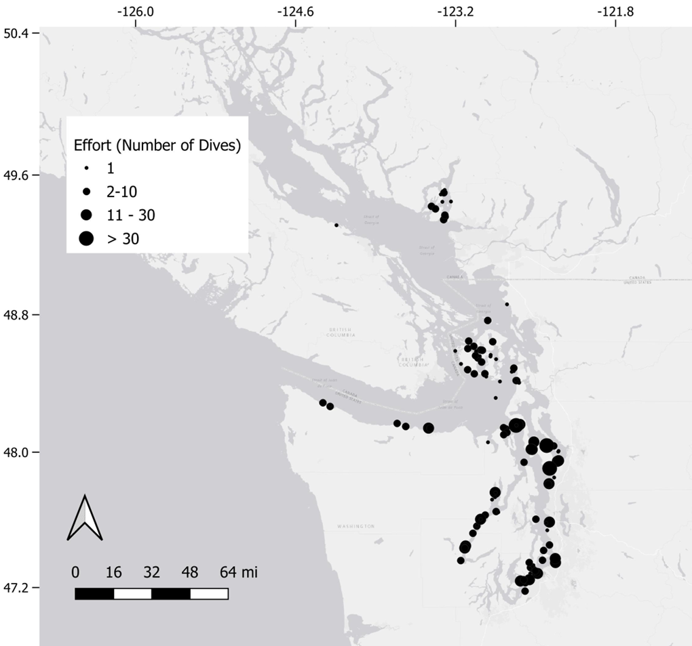

- Habitat/basin analyses Weertman

Results: Habitat and Basin Analyses

Encounter rates by habitat type
- Habitat type was a significant predictor of Pycnopodia helianthoides encounter rate (Kruskal-Wallis H = 81.5, p < 0.0001). Soft Bottom habitat yielded the highest mean encounter rate (8.67 Pycno hr⁻¹, SD = 20.47, n = 852 transects), followed by Eelgrass (4.10 hr⁻¹, SD = 10.46, n = 243), Artificial Reef (1.79 hr⁻¹, SD = 7.76, n = 1,016), Kelp Forest (0.91 hr⁻¹, SD = 2.81, n = 111), and Natural Reef (0.88 hr⁻¹, SD = 4.85, n = 1,761; Table X). Detection rates followed a similar gradient: 29.3% of Soft Bottom transects detected at least one individual, compared with 21.4% for Eelgrass, 12.3% for Artificial Reef, 12.6% for Kelp Forest, and 8.3% for Natural Reef.
- Post-hoc pairwise comparisons (Mann-Whitney U with Bonferroni correction) revealed that Soft Bottom encounter rates were significantly higher than all other habitats (p < 0.001 vs. Natural Reef, Artificial Reef, and Kelp Forest), and Eelgrass was significantly higher than Natural Reef (p < 0.0001) and Artificial Reef (p = 0.001). The Soft Bottom–Eelgrass comparison was significant before correction (p = 0.006) but not after (p_adj = 0.088), indicating that these two habitat types supported comparably elevated encounter rates relative to hard-bottom and kelp habitats (Table X).

Encounter rates by basin
- Geographic basin was also a strong predictor of encounter rate (Kruskal-Wallis H = 427.4, p < 0.0001). Whidbey Basin exhibited the highest mean encounter rate (7.55 Pycno hr⁻¹), followed by Strait of Juan de Fuca (4.18 hr⁻¹) and Hood Canal (3.30 hr⁻¹). Southern and central basins showed markedly lower rates: Admiralty Inlet (0.26 hr⁻¹), San Juan Islands (0.08 hr⁻¹), and South Puget Sound (0.03 hr⁻¹). Zero-inflation was pervasive, with 85.3% of all transects detecting no Pycnopodia, underscoring the rarity and spatial concentration of this species across the study area.

Site-level eelgrass effect
- Sites with eelgrass present supported significantly higher Pycnopodia encounter rates than non-eelgrass sites. The 34 eelgrass sites yielded a mean encounter rate of 5.87 Pycno hr⁻¹ (SD = 16.11) across 1,746 transects, compared with 0.71 hr⁻¹ (SD = 4.49) across 2,252 transects at 105 non-eelgrass sites. This difference was significant at both the transect level (Mann-Whitney U = 2,341,237, p < 0.0001, r = −0.19) and the site level (U = 2,401, p = 0.001, r = −0.35).

Four-category habitat analysis
- The four-category habitat scheme revealed a pronounced site-level eelgrass effect on hard-bottom transects (Kruskal-Wallis H = 290.4, p < 0.0001). Hard Bottom transects at eelgrass sites yielded a mean encounter rate of 2.38 Pycno hr⁻¹ (SD = 8.54, n = 964), nearly four times higher than Hard Bottom transects at non-eelgrass sites (0.61 hr⁻¹, SD = 4.07, n = 1,924). Detection rates followed the same pattern: 16.6% of reef transects at eelgrass sites detected Pycnopodia, compared with only 6.5% at non-eelgrass sites (Fig. X). This result indicates that eelgrass presence at a site confers a measurable benefit to Pycnopodia encounter rates on adjacent, non-eelgrass habitats.

Basin-stratified eelgrass effect
- To assess whether the eelgrass site effect was confounded by geographic variation, we examined eelgrass vs. non-eelgrass encounter rates within each basin. The eelgrass effect was most pronounced in Whidbey Basin, where eelgrass sites averaged 16.34 Pycno hr⁻¹ compared with 1.91 hr⁻¹ at non-eelgrass sites (Mann-Whitney p = 0.030, Cohen's d = 1.42). The effect was directionally consistent in most basins (e.g., Hood Canal: 4.87 vs. 4.09 hr⁻¹; Strait of Juan de Fuca: 4.45 vs. 2.84 hr⁻¹), though only Whidbey reached statistical significance, likely owing to small within-basin sample sizes.

Size structure by habitat type
- Body size differed significantly among habitat types (Kruskal-Wallis H = 128.8, p < 0.0001; n = 1,957 measured individuals). Artificial Reef transects harbored the largest individuals (mean = 20.7 cm, SD = 7.4, n = 399), followed closely by Natural Reef (20.6 cm, SD = 15.5, n = 279) and Soft Bottom (19.6 cm, SD = 8.7, n = 1,111). Kelp Forest individuals were intermediate in size (16.2 cm, SD = 10.8, n = 26), while Eelgrass transects contained the smallest individuals on average (12.1 cm, SD = 7.0, n = 142). The preponderance of small individuals in eelgrass habitat is consistent with a nursery function, wherein eelgrass beds provide settlement or early post-settlement habitat for juvenile Pycnopodia.
- Size also varied by depth (Shallow: 14.3 cm, Intermediate: 20.2 cm, Deep: 19.9 cm) and by season (Summer: 22.3 cm, Autumn: 19.1 cm, Spring: 18.5 cm, Winter: 16.1 cm).

Habitat diversity and encounter rate
- Habitat richness (number of distinct habitat types surveyed at a site) showed a significant raw Spearman correlation with mean encounter rate (ρ = 0.23, p = 0.007). However, this relationship was confounded by spatial sampling coverage: sites with more transect locations necessarily sample more habitat types. After controlling for the number of distinct transect locations per site, the partial correlation was effectively zero (Pearson partial r = −0.01, p = 0.92), indicating that habitat diversity per se does not predict Pycnopodia abundance.

- Settlement analyses Hodin

Figures
- Map of sites by habitat type Weertman
- Panel on encounter by habitat over space Weertman
- Reef habitat with/without eelgrass on site Weertman
- Panel on length by habitat over space Weertman
- Settlement Hodin

Discussion
- Summarize results with specific key findings. Encounter rate was a lot higher in eelgrass and soft bottom, and eelgrass presence improved reef encounter rates. Maybe note this result is not currently documented in literature. Use of eelgrass/soft bottom habitat by Pycnopodia is not uniform over space. Hood Canal is weird, but maybe not the only fjord that shelters Pycnopodia. Obaza
Surveys from this study documented P. helianthoides across a range of substrates and vegetation, coarsely supporting their categorization as a habitat generalist (Shivji et al. 1983; Gravem et al. 2021). Counter to those results, clear habitat preferences were found within that wide range of habitats. Benefits of association with eelgrass may be simple connections with ample evidence this habitat provides rearing habitat which may both shelter P. helianthoides and provide ample forage opportunities (Pohle et al. 1991; Chittaro et al. 2025). Soft bottom habitats are a more curious association, as that habitat is not limited in the Salish Sea and its ubiquity underscores that habitat loss did not drive reductions in P. helianthoides. Reasons for associating with soft-bottom habitat may be similar to forage benefits of eelgrass (Dethier 2006), or their distribution may be an artifact of higher density-dependent susceptibility to bacteria-driven wasting disease on reef habitats (Prentice et al. 2025). Regardless of the cause, habitats supporting the remaining P. helianthoides require additional exploration for features that may make them of greater value in restoration. Proximity to reef habitat is one such feature documented in this study. The greater encounter rates of P. helianthoides on reefs adjacent to eelgrass habitat suggest a spillover effect is likely. This seascape-level relationship would be beneficial in potential outplant planning, or habitat restoration activities.
[add paragraph on spatial distribution]
- Greater detrital material induces settlement. Do any other species use a similar cue? What are implications for finding best Pycno beds in Salish Sea? What about more broadly (e.g. Salish Sea eelgrass beds likely produce a lot more detritus than SoCal) Hodin
- Implications for management within Salish Sea. Outline ongoing Pycno and eelgrass conservation efforts. Could one benefit the other? Lowry
  - The biggest “win” here is that we’re seeing a habitat-specific pattern for a life stage, and we can act on that from a regulatory standpoint. To date, we’ve characterized Pycno as a jack of all trades that can settle and survive anywhere. This precludes designation of Critical Habitat at the federal level. If we can link settlement and survival to a specific type of habitat we can protect that habitat.
- Comparison with management worldwide. Are there any conservation efforts with similar taxa (both to Pycno and Zostera) that may provide comparison for our findings? What benefit might our results provide to them, and them to Salish Sea? Sanders
- Broader scientific implications. I think our angle here is answering any questions presented from first paragraph of introduction: are we thinking differently about eelgrass function, settlement patterns because of this work (I’ll admit a bias to mostly thinking about fish settlement, not invert, but we’ve certainly seen a lot of lobster in SoCal eelgrass). What further questions are created (e.g. causative factors of variability in eelgrass bed Pycno encounter rate). Hodin
- Summarize key findings/implications, leave with thinly veiled quote from The Wire - current proposal “Eelgrass going one way, Pycnopodia another”. Obaza.

