Overview of the Rodin Packages.
Leading to the Theory Plug-in as an example of an extension.

Sources and the Rodin API.

Use Rodin 2.7 zip on sourceforge:

http://sourceforge.net/projects/rodin-b-sharp/files/Core_Rodin_Platform/2.7/rodin-2.7.r15250-sources.zip

Plug-ins
svn+ssh://USER@svn.code.sf.net/p/rodin-b-sharp/svn

But, Rodin 3.0 onwards Core Packages
git://git.code.sf.net/p/rodin-b-sharp/rodincore

Overview of Package architecture.
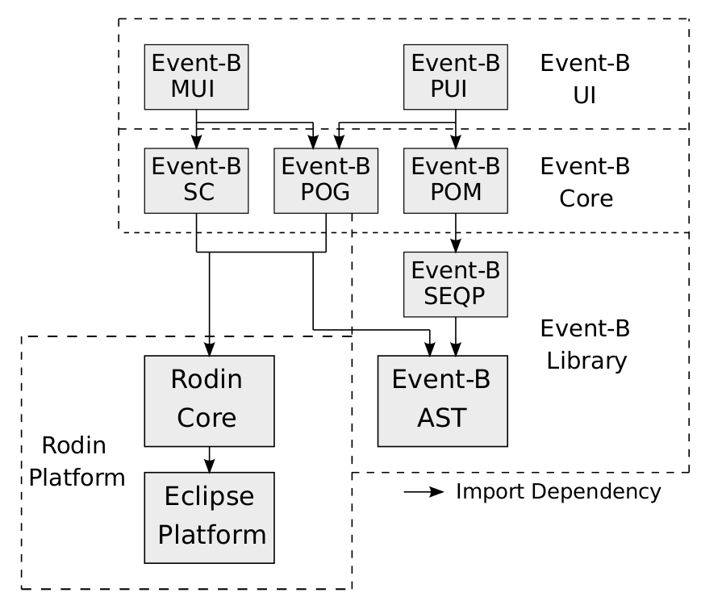

Or another view at:
http://wiki.event-b.org/index.php/Rodin_Developer_Support

Rodin Core.
- The Rodin Core: contains the Rodin repository and the Rodin builder.
- The repository manages the persistence of database elements (Java objects, e.g., proof obligations) in XML files (e.g,. proof obligation files).
- The builder (similar to the Java builder in Eclipse) schedules jobs to rebuild the repository.

The Rodin Database:
http://wiki.event-b.org/index.php/Database

File/Root Separation:
http://wiki.event-b.org/index.php/File_Root_Separation#New_Database_Design

The Library Packages.
- The syntax of the fixed, Event-B mathematical language is specified by the grammar implemented in the abstract syntax tree (AST) module.
- The sequent prover (SEQP) module provides the infrastructure to carry out proofs.

# See org.eventb.core.seqprover

- Prior to Rodin version 2.0, the mathematical language (AST) was hard-wired in the AST sub-module.
- Since Rodin 2.0, we have a dynamic parser; syntax can easily be augmented with new syntax using the theory plug-in.
- From Rodin 3.0 on, the Theory Plug-in will be part of the Rodin Core.

# See org.eventb.theory.core

Event-B Core.
Contains the
- Static checker (SC):
analyses contexts and machines for syntactic conformance, as well as typing.
- Proof obligation generator (POG):
generates proof obligations from the statically checked model.
- The proof obligation manager (POM).
keeps track of proof obligations and their associated proofs.

Static Checker:

Each Rodin file has two versions:
1) an unchecked version, and
2) a statically checked version.
The unchecked file is the version that can be edited by the user. Unchecked machines and contexts have file extensions
1) ‘.bum’ and
2) ‘.buc’
Checked machines and contexts have file extensions
1) ‘bcm’ and
2) ‘bcc’
The static checker creates static checked files from their unchecked counterparts. Therefore Ill-formed elements are prevented.

# Core: See org.eventb.core.sc

POG:

A proof obligation can be:
1) pending,
2) discharged, or
3) reviewed.

A proof obligation is marked as reviewed if it has been 'visually' reviewed by the user, where the proof obligation has not been discharged.

The status of a proof obligation is determined by the state of its proof (i.e., complete or incomplete).

The Rodin prover alters the state of a proof by
1) applying proof rules, or
2) invoking external provers such as ML, and PP.

# Core: See org.eventb.core.pog

The UIs.
MUI – The modelling UI
# See: org.eventb.ui

PUI – The Proving UI
# See: org.eventb.pp.ui

Extending Developments.

Browse through some extension points:
# org.eventb.ui

The Theory Plug-in as an Example.

Or

The following:

A tutorial example: to illustrate extension by adding a new attribute for probabilistic events.
http://wiki.event-b.org/index.php/Introduction_(How_to_extend_Rodin_Tutorial)

Introduction

- 1 Creating the plug-in
- 2 Adding elements to the database (Extending the database)
- 3 Adding elements in the Rodin structured editor (Extending the structured editor)
- 4 Adding elements to the Event-B explorer (Extending the navigator)
- 5 Displaying elements in the Pretty Print Page (Extending the pretty printer)
- 6 Documenting our plug-in (Providing Eclipse Help contents)
Second part:
- 7 Enforcing rules on newly added elements (Extending the static checker)
- 8 Generating proof obligations (Extending the Proof Obligation Generator)

