NUS-${\text{H}}_{\text{2}}$: Nuclear-Upgraded Steam Methane Reforming with Carbon Capture for Low-Carbon Hydrogen in Singapore
Wee Zhern Ray
MIT licence
OUTRAM PARK was consulted as a reference. No OUTRAM PARK code is included and no endorsement is implied.
Table of contents
Executive Summary 1
1. Problem and Proposed Solution 1
1.1 The problem and its Singapore context 1
1.2 Proposed solution 2
1.3 Design basis 4
2. Technical and Practical Feasibility 4
2.1 Process heat and integration 4
2.2 Thermal and electrical balance 5
2.3 MEA carbon capture 6
2.4 Reactor safety and emergency planning 6
2.5 Regulation and community engagement 6
2.6 Risks and limitations 7
2.7 Location and roadmap 7
3. Net Emissions Abatement 8
3.1 Method 8
3.2 System boundary and assumptions 9
3.3 Net emissions abated 9
3.4 Sensitivity and interpretation 9
4. Economics and Implementation 10
4.1 Method and boundary 10
4.2 Reactor capital 10
4.3 Capture, storage, integration and operating costs 11
4.4 Headline result and cost ladder 11
4.5 Uncertainty 12
4.6 Steam methane reforming plus CCS comparator 13
4.7 Closing the gap to the target 13
5. Discussion and Conclusion 14
5.1 Discussion 14
5.2 Conclusion 15
References 16
Appendix A. Reactor design basis 20
Appendix B. Mass and energy balance 22
Appendix C. Emissions 23
Appendix D. Economics 24
Appendix E. Model status 27

Executive Summary
Singapore imports all of its natural gas, and conventional steam methane reforming (SMR) emits ${\text{CO}}_{\text{2}}$ from both its furnace and its reforming chemistry. NUS-${\text{H}}_{\text{2}}$ removes the furnace. A 210 ${\text{MW}}_{\text{th}}$ high-temperature gas-cooled reactor (HTGR) heats the reformer through helium, and 30 $\text{wt\%}$ monoethanolamine (MEA) captures ${\text{CO}}_{\text{2}}$ from shifted syngas. The plant is a new build at SOXAL scale on the proposed Western Island, a siting proposal of this study with no official approval. It makes 100,000 ${\text{Nm}}^{\text{3}} {\text{h}}^{-\text{1}}$ of purified hydrogen, 66,925 $\text{t }{\text{H}}_{\text{2}} {\text{y}}^{-\text{1}}$ at 85% availability, from 120.8 ${\text{MW}}_{\text{th}}$ of process heat and a reactor need of 178.5 ${\text{MW}}_{\text{th}}$. Pressure swing adsorption (PSA) stays an external block, and its reject returns to the reformer as a stream crossing the boundary.
Net abatement is 0.578 ${\text{MtCO}}_{\text{2}}\text{e }{\text{y}}^{-\text{1}}$ against a same-size unabated SMR, which meets the 0.25 ${\text{MtCO}}_{\text{2}}\text{e }{\text{y}}^{-\text{1}}$ target by a factor of 2.3. The $\text{S\$100/}{\text{tCO}}_{\text{2}}\text{e}$ cost target is missed in all 8 central cases. The base full cost is $\text{S\$189.7/}{\text{tCO}}_{\text{2}}\text{e}$ at 25 $\text{y}$ and $\text{S\$165.6/}{\text{tCO}}_{\text{2}}\text{e}$ at 60 $\text{y}$ for a build between first and Nth of a kind (BOAK), and $\text{S\$277.9/}{\text{tCO}}_{\text{2}}\text{e}$ and $\text{S\$241.7/}{\text{tCO}}_{\text{2}}\text{e}$ for a first of a kind (FOAK). A discounted cash flow (DCF) reproduces these within 0.2%. The levelised cost of hydrogen is $\text{S\$5.26/kg}$ at BOAK, 25 $\text{y}$, against $\text{S\$3.62/kg}$ for the unabated SMR.
A named scenario, MATURE_60Y, states what it would take to meet the target. A tenth-of-a-kind reactor on INL's BOAK learning route over 60 $\text{y}$, with gas at $\text{S\$20.7/GJ}$ against the central $\text{S\$15/GJ}$, gives $\text{S\$95.6/}{\text{tCO}}_{\text{2}}\text{e}$ on the ledger and $\text{S\$95.9/}{\text{tCO}}_{\text{2}}\text{e}$ by DCF. That gas price lies above the $\text{S\$10}$ to $\text{S\$20/GJ}$ range tested, and at $\text{S\$20/GJ}$ the scenario gives $\text{S\$99.6/}{\text{tCO}}_{\text{2}}\text{e}$. Dearer gas lowers the abatement cost because NUS-${\text{H}}_{\text{2}}$ burns less gas than the unabated plant. Deployment towards 2050 depends on a qualified reactor and intermediate heat exchanger (IHX), a design-specific emergency planning zone (EPZ), a licensing framework and a contracted ${\text{CO}}_{\text{2}}$ storage pathway.

1. Problem and Proposed Solution

1.1 The problem and its Singapore context
Singapore's energy transition requires reliable industrial energy while reducing carbon emissions. With no domestic natural gas resources, Singapore relies on imported pipeline gas and liquefied natural gas (LNG); natural gas accounted for approximately 94% of electricity-generation fuel in 2024 [1,2]. This dependence highlights the strategic importance of diversifying low-carbon energy supply, particularly for continuous high-temperature industrial processes.
Hydrogen offers a pathway for decarbonising industrial applications and supporting Singapore's future energy system. The National Hydrogen Strategy (October 2022) identifies low-carbon hydrogen as a potential contributor to up to half of the country's power needs by 2050 [3]. SMR is an established hydrogen-production technology; it generates ${\text{CO}}_{\text{2}}$ through methane conversion and conventionally burns fossil fuel to supply the endothermic reforming duty [4]. Addressing both emissions sources creates an opportunity to integrate nuclear process heat with carbon capture and storage (CCS).
CCS captures the ${\text{CO}}_{\text{2}}$ generated in the reforming train [5], while nuclear process heat displaces natural gas combustion for the reforming duty [6]. Steam reforming of natural gas operates within approximately 500 to 900$\text{°C}$ (Figure 1) [7], a range that HTGRs can serve and light-water reactors cannot.
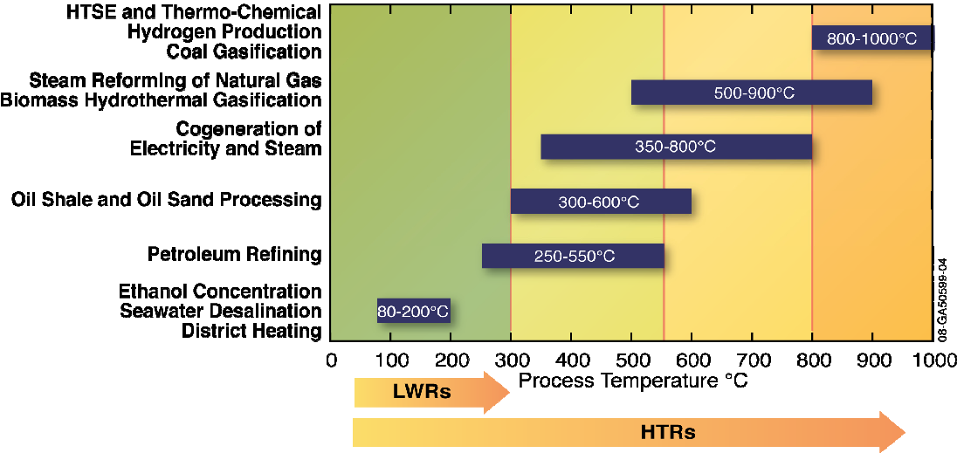
Figure 1. Process heat temperature ranges of industrial applications, with the ranges that light-water reactors (LWRs) and HTGRs can serve [7].
This report proposes NUS-${\text{H}}_{\text{2}}$, a single-train HTGR-heated SMR integrated with MEA carbon capture, as a new build on the proposed Western Island. The site is a proposal of this study and has no official approval. The plant is sized on the SOXAL hydrogen plant on Jurong Island, about 100,000 ${\text{Nm}}^{\text{3}} {\text{h}}^{-\text{1}}$ [8,9], and is compared with a same-size unabated SMR delivering equal hydrogen in equal hours. The design targets are net abatement above 0.25 ${\text{MtCO}}_{\text{2}}\text{e }{\text{y}}^{-\text{1}}$ within Singapore, at a cost below $\text{S\$100/}{\text{tCO}}_{\text{2}}\text{e}$.

1.2 Proposed solution
The proposed configuration integrates a 210 ${\text{MW}}_{\text{th}}$ HTGR with an SMR hydrogen-production system (Figure 2). Nuclear fission heats helium in the primary reactor circuit, and an IHX transfers thermal energy to an independent secondary helium loop supplying the reformer. This arrangement replaces fossil-fired reformer heating and keeps the nuclear and chemical systems physically separate [10]. Reactor capacity beyond the process duty covers the MEA reboiler gap and 19.8 ${\text{MW}}_{\text{e}}$ of site electricity, and the remaining 31.5 ${\text{MW}}_{\text{th}}$ stays as spare with no revenue.

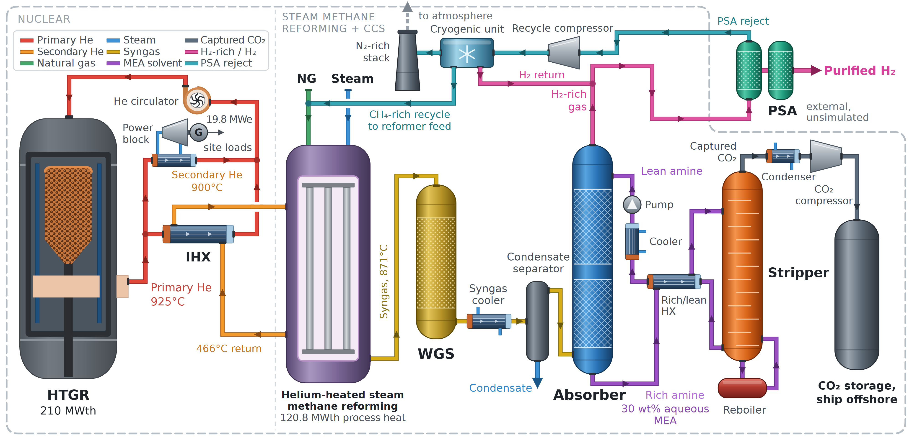
Figure 2. NUS-${\text{H}}_{\text{2}}$ arrangement. A 210 ${\text{MW}}_{\text{th}}$ HTGR supplies 120.8 ${\text{MW}}_{\text{th}}$ of process heat through an IHX and secondary helium circuit. The dashed line is the boundary: ${\text{CO}}_{\text{2}}$ compression and ship offshore storage sit inside it, the external PSA sits outside, and its reject returns across it.

Natural gas and steam react over a nickel catalyst in the helium-heated reformer to produce hydrogen-rich synthesis gas [4,11]. Water-gas shift (WGS) conversion increases hydrogen yield and converts carbon monoxide to ${\text{CO}}_{\text{2}}$. After syngas cooling and condensate removal, a 30 $\text{wt\%}$ aqueous MEA system absorbs ${\text{CO}}_{\text{2}}$ from the hydrogen-rich gas. A stripper regenerates the rich solvent, releasing concentrated ${\text{CO}}_{\text{2}}$ for compression and shipment to offshore storage. The Idaho National Laboratory (INL) reference removes ${\text{CO}}_{\text{2}}$ with Selexol [6,11], so MEA regeneration energy is assessed separately from INL's utility data. Pilot tests of 30 $\text{wt\%}$ MEA on flue gas report specific reboiler duties of approximately 3.46 to 4.0 $\text{GJ }{\text{tCO}}_{\text{2}}^{-\text{1}}$ [12,13]. The lower value excludes heat loss at 26 to 27 $\text{wt\%}$, the upper value is at 85% capture on 3.5 $\text{vol\%}$ ${\text{CO}}_{\text{2}}$, and no measurement on syngas was found.
The PSA stays an unsimulated external block. Its reject returns across the boundary through a recycle compressor and a cryogenic unit, as in INL's Case 6 [6]. Methane-rich gas goes back to the reformer feed, hydrogen returns ahead of the PSA, and a nitrogen-rich cut is burned.

1.3 Design basis
Table 1 sets the headline Case B beside the INL reference Case A. Case B scales the extensive items of INL's 130 MMSCFD Case 6 by 0.6833 to the SOXAL rate, with the reactor resized. Hydrogen reaching the PSA is 10,214 $\text{kg }{\text{h}}^{-\text{1}}$. At the published 88% recovery, 8,988 $\text{kg }{\text{h}}^{-\text{1}}$ leaves as purified product and 1,226 $\text{kg }{\text{h}}^{-\text{1}}$ returns in the reject. Annual output counts the 85% availability hours only (7,446 $\text{h }{\text{y}}^{-\text{1}}$).
Table 1. Headline Case B at the SOXAL rate beside the INL reference Case A, at 85% availability.
Quantity | Case B, headline | Case A, INL Selexol | Case A, with MEA
${\text{H}}_{\text{2}}$ product, $\text{kg }{\text{h}}^{-\text{1}}$ | 8,988 | 13,154 | 13,154
Annual ${\text{H}}_{\text{2}}$, $\text{t }{\text{H}}_{\text{2}} {\text{y}}^{-\text{1}}$ | 66,925 | 97,946 | 97,946
Natural gas, $\text{MMSCFD}$ | 23.2 | 34.0 | 34.0
Process heat, ${\text{MW}}_{\text{th}}$ | 120.80 | 176.80 | 176.80
Process electricity, ${\text{MW}}_{\text{e}}$ | 12.33 | 17.30 | 18.05
Helium circulators, ${\text{MW}}_{\text{e}}$ | 7.45 | 10.44 | 10.89
Reactor needed, ${\text{MW}}_{\text{th}}$ | 178.49 | 242.41 | 260.74
Rating, ${\text{MW}}_{\text{th}}$ | 210.00 | 210.00 | 210.00
Surplus or shortfall, ${\text{MW}}_{\text{th}}$ | 31.51 | −32.41 | −50.74
Captured ${\text{CO}}_{\text{2}}$, ${\text{tCO}}_{\text{2}} {\text{y}}^{-\text{1}}$ | 359,777 | 542,362 | 526,544
Net abatement, ${\text{tCO}}_{\text{2}}\text{e }{\text{y}}^{-\text{1}}$ | 578,052 | 861,812 | 845,994

2. Technical and Practical Feasibility

2.1 Process heat and integration
The proposed system combines established SMR and ${\text{CO}}_{\text{2}}$-capture operations with continuous high-temperature heat. Helium heats the reformer directly, so no natural gas is burned for reforming heat, and the chemical plant retains established reforming and amine equipment. Japan's High Temperature Engineering Test Reactor reached a 950$\text{°C}$ outlet [14], yet it is a 30 ${\text{MW}}_{\text{t}}$ test reactor. China's HTR-PM entered commercial operation in December 2023 [15] and runs near 750$\text{°C}$ [16]. This work identified no commercial reactor at 900$\text{°C}$, so the design assumes a generic 925$\text{°C}$ HTGR and treats Xe-100, also near 750$\text{°C}$ [17], as a labelled analogue only. Secondary helium reaches the reformer at 900$\text{°C}$ and returns at 466$\text{°C}$ [6]. The 871$\text{°C}$ reformer outlet is INL's equilibrium assumption. Run through the Level 3 flowsheet, a cooler outlet leaves more methane unconverted: at 825 and 800$\text{°C}$ abatement falls to 0.559 ${\text{MtCO}}_{\text{2}}\text{e }{\text{y}}^{-\text{1}}$ and 0.544 ${\text{MtCO}}_{\text{2}}\text{e }{\text{y}}^{-\text{1}}$ (Table 5).

2.2 Thermal and electrical balance
Table 2. Heat and power balance, Case B central. Every row is an engine row, and the heat column sums to the reactor need with no residual. Purge recovery is Case 6 fuel-gas recycle and nitrogen removal equipment, split not published; INL's 5.7 ${\text{MW}}_{\text{e}}$ is at Case A [6]. Reboiler steam passes a back-pressure stage first, so the extraction work and the turbine heat sum to less than the power generated divided by 39.7%.
Heat term | $${\text{MW}}_{\text{th}}$$ | Electricity term | $${\text{MW}}_{\text{e}}$$
Process heat to the reformer | 120.80 | Pump, compressors and purge | 9.44
${\text{CO}}_{\text{2}}$ slip sensible heat | 0.88 | Cooling towers and MEA fans | 0.83
IHX loss | 0.97 | Reforming loads | 0.82
Duct loss | 0.31 | Purification loads | 0.01
Vessel loss | 2.66 | Steam system loads | 0.20
Reactor steam to the reboiler | 13.12 | Water system loads | 1.02
Extraction work, reboiler steam | 2.22 | Tail-gas power | 0.00
Heat to the turbine | 44.23 | Helium circulators | 7.45
Less circulator shaft heat | −6.70
Reactor needed | 178.49 | Generated on site | 19.78
Rating | 210.00 | Unmet electricity | 0.00
Spare, no revenue | 31.51 | Unmet heat at rating | 0.00

Table 2 closes the balance at the headline basis term by term, with duct loss, vessel loss and circulator shaft heat as separate rows. Starting from INL's rate with no losses, the sizing walk of Table A2 counts the purge load, heat losses, helium circulators and the reboiler gap and reaches 179.0 ${\text{MW}}_{\text{th}}$ on the anchored terms. The headline runs the syngas heat recovered above 130$\text{°C}$ on its gated model, which passed its benchmark gate, and this lowers the need by 0.55 ${\text{MW}}_{\text{th}}$ to 178.5 ${\text{MW}}_{\text{th}}$, leaving 31.5 ${\text{MW}}_{\text{th}}$ of the rating spare with no revenue. The spare depends on the heat basis: on Ahn and Lee's 143.4 ${\text{MW}}_{\text{th}}$ of process heat [18] it falls to 6.5 ${\text{MW}}_{\text{th}}$. The adverse corner of the sizing range needs 214.1 ${\text{MW}}_{\text{th}}$, 4.1 ${\text{MW}}_{\text{th}}$ above the rating; held at the rating, the heat duties are still met and 1.6 ${\text{MW}}_{\text{e}}$ is imported. Case A with MEA and recycle needs 260.7 ${\text{MW}}_{\text{th}}$, so it stays a reference and is never printed as a 210 ${\text{MW}}_{\text{th}}$ plant.

2.3 MEA carbon capture
The design uses 30 $\text{wt\%}$ MEA as the reference solvent, with Selexol and activated MDEA (aMDEA) as sensitivities. The literature is mixed: IEAGHG 2022-07 calls MEA the preferred chemical solvent [19], while IEAGHG 2017-02 favours aMDEA on shifted syngas [5]. The absorber takes syngas at 40$\text{°C}$ from the last knock-out drum and runs at 26.8 $\text{bar}$ with rich loading capped at 0.50 $\text{mol }{\text{mol}}^{-\text{1}}$, and per-pass capture of 90% is a project assumption. A rate-based absorber solved to that duty needs 15.16 $\text{m}$ of packing at Case B. The specific reboiler duty (SRD) of 3.8 $\text{GJ }{\text{tCO}}_{\text{2}}^{-\text{1}}$, range 3.4 to 4.2, is assumed from flue-gas pilots, since no syngas measurement exists. The equilibrium-stage stripper overstated the DICE pre-FEED design SRD by 46% and the Kwak pilot SRD by 27% [20,21], so the column gate failed and the assumed SRD stays in the headline (Appendix E). The 51.0 $\text{MW}$ reboiler at 121$\text{°C}$ draws first on freed Selexol steam (12.7 $\text{MW}$), then diverted export steam (16.8 $\text{MW}$), syngas heat above 130$\text{°C}$ (8.4 $\text{MW}$) and reactor steam for the remaining 13.1 $\text{MW}$. The column models rest on the Aronu extended UNIQUAC solvent model [22].

2.4 Reactor safety and emergency planning
Tristructural isotropic (TRISO) fuel particles incorporate multiple protective layers that retain fission products, while helium cooling and the graphite-based core support high-temperature operation [10]. The primary helium boundary, IHX and independent secondary loop provide successive physical barriers between the reactor and hydrogen-production equipment.
Singapore's compact geography makes site-specific emergency planning essential [23]. Advanced-reactor assessments use accident frequencies and projected radiological consequences to determine protective actions [24,25,26]. Figure A1 illustrates this method using the Xe-100 safety-case example [27]. That assessment presents a 400 $\text{m}$ emergency-planning reference distance for its specific case [27,28], and HTR-PM studies evaluate offsite arrangements [29,30]. Here 400 $\text{m}$ is a conceptual reference only and is no approved Singapore boundary. Emergency arrangements would come from a reactor-specific safety case and regulatory review.

2.5 Regulation and community engagement
Singapore is strengthening its capability to assess advanced nuclear technologies and has made no decision on nuclear energy [31,32]. A Phase 1 International Atomic Energy Agency (IAEA) Integrated Nuclear Infrastructure Review (INIR) is tentatively set for 2027 and covers 19 areas of infrastructure, including emergency preparedness and radioactive waste management [31]. Manpower schemes for public officers begin in 2027 [33], and separately NUS and NTU are working towards a joint Master's in nuclear engineering in 2027 [34]. The Singapore Nuclear Research and Safety Institute contributes reactor modelling and safety analysis alongside public education [32,35,36]. The National Environment Agency's responsibilities and the Energy Market Authority's feasibility study add to the institutional basis, supported by regulatory cooperation abroad [37,38,39]. A future project needs one licensing framework that spans the reactor and its industrial heat interface, with emergency preparedness built in.
Early engagement with Western Island planners, neighbouring Jurong Island operators and nearby communities would support informed assessment [35,36,40]. Clear communication of the plant's industrial purpose and protective design features is central to project development.

2.6 Risks and limitations
The assessment adopts INL process conditions [6,11] and a 210 ${\text{MW}}_{\text{th}}$ rating, with balances anchored on INL cases and one term on a gated model (Appendix E). IHX performance and the transfer of INL's recycle to MEA need integrated verification, as does the 39.7% power-conversion assumption. Table 3 summarises the principal constraints.
Table 3. Principal risks and constraints.
Area | Risk or constraint | Mitigation or requirement
Technology | No commercial nuclear process heat for hydrogen; IHX unqualified for 900 to 925$\text{°C}$ helium. | Overseas demonstration and component qualification before any Singapore commitment.
Reformer hot end | INL's 29 $\text{K}$ helium-to-process approach at the reformer is untested; JAERI's reformer tube rig ran 102 to 125 $\text{K}$ [41]. | Qualify a helium-heated reformer tube; at an 800$\text{°C}$ outlet abatement falls to 0.544 $\text{Mt }{\text{y}}^{-\text{1}}$.
Recycle with MEA | At Case A, 179 $\text{kmol }{\text{h}}^{-\text{1}}$ of ${\text{CO}}_{\text{2}}$ slip enters the cryogenic unit with MEA, against 17 $\text{kmol }{\text{h}}^{-\text{1}}$ in INL's Selexol case, unmodelled by INL [6]. | Pilot the recycle; without it abatement is 0.467 $\text{Mt }{\text{y}}^{-\text{1}}$.
Outage and backup | No furnace, so hydrogen stops in reactor outages. | Offtake for 85% of hours, or a priced backup furnace.
Safety and siting | A dose-based, design-specific EPZ must be justified on a compact site. | Safety case and EPZ analysis before site approval.
Regulation | No licensing pathway exists for a reactor supplying industrial heat. | INIR review, then one coordinated pathway.
Economics | Central full cost is $\text{S\$165.6/}{\text{tCO}}_{\text{2}}\text{e}$ to $\text{S\$277.9/}{\text{tCO}}_{\text{2}}\text{e}$, above the target. | Overseas replication and contracted costs before investment (Section 4.7).
Storage and offtake | Storage depends on Singapore-Indonesia cooperation; offtake is uncontracted. | Contracted ${\text{CO}}_{\text{2}}$ chain and hydrogen offtake before investment.
Storage accounting | Treatment of offshore storage across the border is unresolved. | Settle under the Singapore-Indonesia arrangement [42].

2.7 Location and roadmap
The proposed Western Island is a siting proposal of this study and has no official approval. The government has announced that smaller islands around Jurong Island will be connected into a new western island, reclaimed over coming decades, and its page names new power generation infrastructure with no mention of nuclear [43,44]. The reference case is a new build at SOXAL scale, so it retires no existing source. Central hydrogen runs only in the 85% availability hours, and backup firing stays a sensitivity. Captured ${\text{CO}}_{\text{2}}$ is shipped to offshore storage abroad under Singapore-Indonesia cooperation [42]. Pipeline links to the island are unpriced.
Figure 3 sets out an indicative roadmap to potential operation by 2050, and every date is illustrative. National capability and overseas reactor and IHX qualification come before Singapore-specific site assessment, licensing, investment and construction, and each gate opens only once its requirements are met. Land may not exist at the 2039 milestone, since reclamation has no published date. Stakeholders also include the Economic Development Board and ${\text{CO}}_{\text{2}}$ storage partners. The roughly 11 years between HTR-PM construction start and commercial operation give one historical reference for the schedule [15].
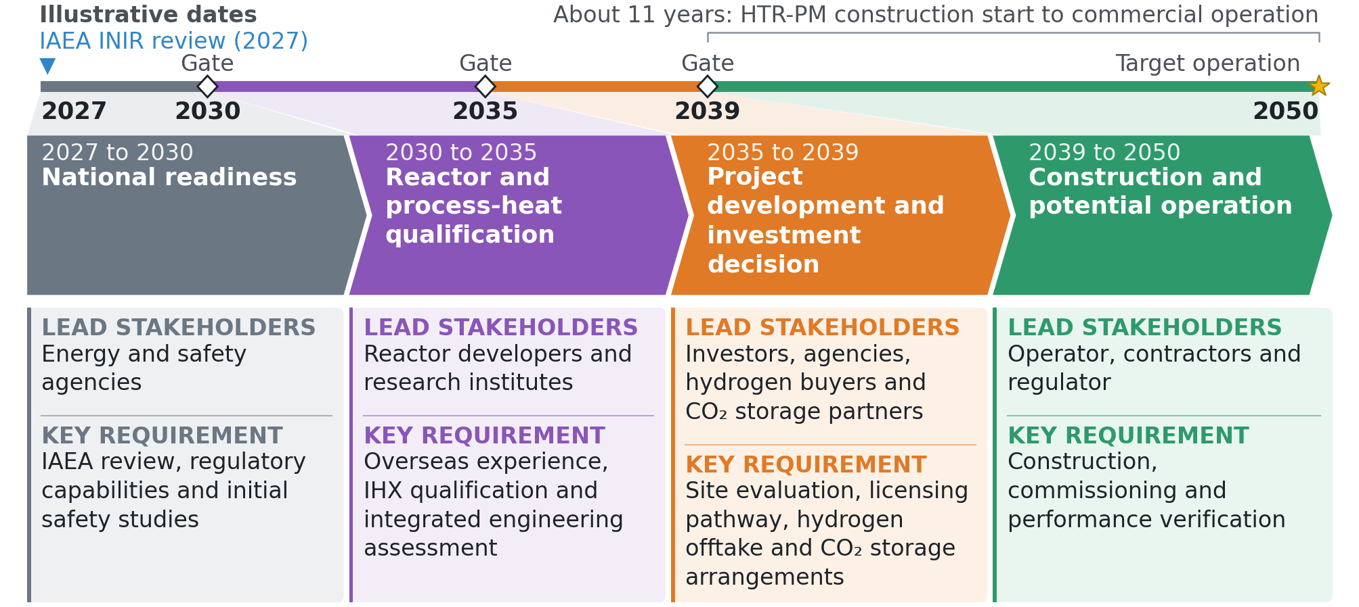
Figure 3. Indicative roadmap with milestones, stakeholders and enabling requirements. All dates are illustrative.

3. Net Emissions Abatement

3.1 Method
Net abatement is the difference between the operational emissions of a same-size unabated SMR and the carbon the proposed plant sends to air:
$$\text{Δ}{\text{E}}_{\text{net}}\text{ = }{\text{E}}_{\text{baseline}} - {\text{E}}_{\text{residual}}$$ | (3.1)
$${\text{E}}_{\text{residual}}\text{ = }{\text{E}}_{\text{cut}}\text{ + }{\text{E}}_{\text{grid}}$$ | (3.2)
The furnace is removed, yet the nitrogen-rich cut of recycled PSA reject is burned, and that carbon ${\text{E}}_{\text{cut}}$ is the residual. Absorber slip returns through the reformer and reaches air only through this cut. The grid term is zero as a calculated result at central inputs: unmet electricity is 0 ${\text{MW}}_{\text{e}}$ at the rated reactor. All values are in tonnes per year at 85% availability.

3.2 System boundary and assumptions
The boundary follows Figure 2. It holds a nuclear island (reactor, primary and secondary helium circuits, small power block) and a chemical plant (reformer, WGS, MEA capture, recycle compressor, cryogenic unit, ${\text{CO}}_{\text{2}}$ compressor and ship offshore storage). The PSA sits outside the line, with its reject returning across it. Ship and storage sit inside the line for mass balance and cost, while ship fuel stays in the lifecycle sensitivity. The ${\text{CO}}_{\text{2}}$ compressor load is INL's pipeline basis scaled to Case B, and the liquefaction a ship needs is neither modelled nor priced.
The baseline uses SOXAL's scale of about 100,000 ${\text{Nm}}^{\text{3}} {\text{h}}^{-\text{1}}$ [8]. At 0.08988 $\text{kg }{\text{Nm}}^{-\text{3}}$ and 7,446 $\text{h }{\text{y}}^{-\text{1}}$, output is 66,925 $\text{t }{\text{H}}_{\text{2}} {\text{y}}^{-\text{1}}$. Baseline intensity is INL's 9.21 $\text{kg }{\text{CO}}_{\text{2}} {\text{kg}}^{-\text{1}} {\text{H}}_{\text{2}}$ [11], with 9.35 from Cho et al. [45] and 8.996, the unrounded IEAGHG Base Case value [5], as bounds. Per-pass capture of 90%, a project assumption, gives 90.4% plant capture because slip returns to the reformer, so the two always print together.

3.3 Net emissions abated
Table 4 gives the carbon ledger. Abatement is 578,052 ${\text{tCO}}_{\text{2}}\text{e }{\text{y}}^{-\text{1}}$ (0.578 ${\text{MtCO}}_{\text{2}}\text{e }{\text{y}}^{-\text{1}}$), a 93.8% reduction that takes direct intensity from 9.21 to 0.57 $\text{kg }{\text{CO}}_{\text{2}} {\text{kg}}^{-\text{1}} {\text{H}}_{\text{2}}$ and stands at 2.3 times the target. As a size comparison only, it equals 1.2% to 1.3% of Singapore's 2035 target level of 45 to 50 ${\text{MtCO}}_{\text{2}}\text{e}$ [46].
Table 4. Carbon ledger, Case B, direct emissions to atmosphere on the INL baseline.
Line | $${\text{tCO}}_{\text{2}}\text{e }{\text{y}}^{-\text{1}}$$
Same-size unabated SMR baseline | 616,361
Less gas saved by nuclear heat and recycle | 216,825
Feed carbon, fresh natural gas | 399,536
Captured and stored | 359,777
Carbon in product methane, not counted at the plant | 1,450
To atmosphere, burned nitrogen-rich cut | 38,309
Net abatement, baseline less atmosphere | 578,052

3.4 Sensitivity and interpretation
Table 5. Net abatement sensitivities, ${\text{MtCO}}_{\text{2}}\text{e }{\text{y}}^{-\text{1}}$. The target is 0.25.
Case | Result | Case | Result
Per-pass capture 80% | 0.564 | Baseline, Cho 9.35 | 0.587
Per-pass capture 85% | 0.571 | Baseline, IEAGHG 8.996 | 0.564
Per-pass capture 95% | 0.584 | Ship fuel burden counted | 0.569
Availability 65% | 0.442 | Lifecycle, burdens only | 0.566
Availability 75% | 0.510 | Lifecycle, with saved upstream gas | 0.616
Availability 90% | 0.612 | System view, with lost steam | 0.528
Selexol reference | 0.589 | No recycle, tail gas burned | 0.467
aMDEA | 0.589 | Capture offline | 0.218
Reformer outlet 825$\text{°C}$ | 0.559 | Condensate ${\text{CO}}_{\text{2}}$ vented | 0.576
Reformer outlet 800$\text{°C}$ | 0.544

Table 5 tests the result. Every case with working capture and recycle stays above the target. Two dependencies matter most. With capture offline, the only abatement left is carbon never generated, 0.218 ${\text{MtCO}}_{\text{2}}\text{e }{\text{y}}^{-\text{1}}$, which is below the target. If recycle fails to transfer from INL's Selexol case to MEA, gas rises to 30.4 $\text{MMSCFD}$ and abatement falls to 0.467 ${\text{MtCO}}_{\text{2}}\text{e }{\text{y}}^{-\text{1}}$. A cooler reformer outlet leaves more methane unconverted, and more carbon then leaves in the burned nitrogen-rich cut.
Backup firing over the 1,314 $\text{h }{\text{y}}^{-\text{1}}$ of outage would add 11,810 $\text{t }{\text{H}}_{\text{2}} {\text{y}}^{-\text{1}}$. An unabated backup train emits 108,770 ${\text{tCO}}_{\text{2}}\text{e }{\text{y}}^{-\text{1}}$, which matches the unabated SMR in those hours and adds no abatement, while a backup train with capture would add 79,753 ${\text{tCO}}_{\text{2}}\text{e }{\text{y}}^{-\text{1}}$; neither train's capital is priced. Abatement is counted at the Singapore source, storage abroad follows the Singapore-Indonesia memorandum [42], and how offshore storage counts across the border remains unresolved.

4. Economics and Implementation

4.1 Method and boundary
Two methods feed one result, both in real 2025 Singapore dollars at 8%, with $\text{S\$1.3065/US\$}$ [47] and escalation factors of 1.6195 from 2019 US dollars and 2.322 from 2014 euros [48,49]. The first is an annual incremental ledger against a same-size new-build unabated SMR at 66,925 $\text{t }{\text{H}}_{\text{2}} {\text{y}}^{-\text{1}}$, with levels L0 to L5 adding items step by step:
$$\text{Δ}\text{C}\text{ = }\sum_{\text{i}}{{\text{C}}_{\text{i}}}\text{,} \text{AC = }\frac{\text{Δ}\text{C}}{\text{A}}\text{,} \text{CRF = }\frac{\text{r}}{\text{1}-{\left(\text{1+}\text{r}\right)}^{-\text{L}}}$$ | (4.1)
Here ${\text{C}}_{\text{i}}$ is an annual cost line, $\text{A}$ is net abatement and CRF annualises capital over life $\text{L}$ at rate $\text{r}$, giving 0.0937 at 25 $\text{y}$ and 0.0808 at 60 $\text{y}$. Common items cancel, including reformer capital differences by assumption. The target sets a ceiling of $\text{S\$57.8M/y}$.
The second is a year-by-year discounted cash flow (DCF) of the unabated SMR and NUS-${\text{H}}_{\text{2}}$ at equal output on a common horizon:
$${\text{LCOH}}_{\text{x}}\text{ = }\frac{\sum_{\text{t}}{{\text{c}}_{\text{x}\text{,}\text{t}}{\left(\text{1+}\text{r}\right)}^{-\text{t}}}}{\sum_{\text{t}}{{\text{m}}_{\text{t}}{\left(\text{1+}\text{r}\right)}^{-\text{t}}}}\text{,} \text{LAC = }\frac{\sum_{\text{t}}{\text{Δ}{\text{c}}_{\text{t}}{\left(\text{1+}\text{r}\right)}^{-\text{t}}}}{\sum_{\text{t}}{{\text{A}}_{\text{t}}{\left(\text{1+}\text{r}\right)}^{-\text{t}}}}$$ | (4.2)
Reactor spend runs uniformly over 5.5 $\text{y}$ [50], then operation runs at 85%. Items with a 25 $\text{y}$ life are replaced on longer horizons with unused life credited at the end, and decommissioning is paid from cash flow at end of life. Both plants carry the SMR island of the IEAGHG Base Case, $\text{S\$517.6M}$ of capital and $\text{S\$17.5M/y}$ of fixed O&M [5]. The two methods share inputs and differ in timing, so their agreement tests the annualisation and does not validate the inputs.

4.2 Reactor capital
INL's recipe removes the 9% conversion share and converts at 40% efficiency [51]:
$${\text{c}}_{\text{BOAK}}\text{ = 6,000 × 0.91 × 0.40 = 2,184 }\text{US}{\text{\$}}_{\text{2019}}\text{/}{\text{kW}}_{\text{t}}\text{,} {\text{c}}_{\text{FOAK}}\text{ = 1.6 }{\text{c}}_{\text{BOAK}}$$ | (4.3)
BOAK is INL's term for a build between a first and Nth of a kind. Central capital uses $\text{n}\text{ = 1.0}$, which charges INL's unit cost at any size: $\text{S\$743M}$ at BOAK and $\text{S\$1,188M}$ at FOAK. Two size treatments print beside it at equal prominence, with BOAK capital of $\text{S\$1,130M}$ and $\text{S\$1,532M}$. Here $\text{n}\text{ = 0.6}$ is a project sensitivity, and its 600 ${\text{MW}}_{\text{th}}$ reference size is a project assumption. The $\text{n}\text{ = 0.31}$ value is the ratio of two single-unit FOAK estimates from INL, so it carries that label [51]. Learning at 10% per doubling reaches a tenth unit by two published routes: $\text{US\$2,462/}{\text{kW}}_{\text{t}}$ from FOAK and $\text{US\$1,539/}{\text{kW}}_{\text{t}}$ from BOAK [51].

4.3 Capture, storage, integration and operating costs
Capture capital is $\text{S\$2.04M per t/h}$ from IEAGHG Case 1A [5], with fixed O&M at an assumed 2.7% of capital. Case 1A is an aMDEA case, and Table 9 carries the MEA flue-gas alternative. Capture energy sits in the heat and power balance, so no energy line appears and nothing is counted twice. MEA make-up and ship liquefaction have no cost line. ${\text{CO}}_{\text{2}}$ transport and storage (T&S) is $\text{S\$60/}{\text{tCO}}_{\text{2}}$, with 23.2 low [5] and 112 high [52]; no published Singapore-Indonesia tariff was found [53,54]. Gas is $\text{S\$15/GJ}$ [55], and the plant saves 12.6 $\text{MMSCFD}$ against the unabated SMR. Reactor O&M and fuel is $\text{US\$10/}{\text{MWh}}_{\text{th}}$ [51]. IHX and loop, licensing and decommissioning are labelled proxies, and the first two rest on primary sources not verified here. Reactor life changes only the reactor, licensing and decommissioning lines.

4.4 Headline result and cost ladder
Table 6 prints the headline. Every real plant cost is in, the reactor is charged at 210 ${\text{MW}}_{\text{th}}$ and $\text{n}\text{ = 1.0}$. The full cost by ledger is $\text{S\$189.7/}{\text{tCO}}_{\text{2}}\text{e}$ and $\text{S\$165.6/}{\text{tCO}}_{\text{2}}\text{e}$ at BOAK, and $\text{S\$277.9/}{\text{tCO}}_{\text{2}}\text{e}$ and $\text{S\$241.7/}{\text{tCO}}_{\text{2}}\text{e}$ at FOAK. The DCF lands within 0.2% on every cell of the grid, inside the 10% test. None of the 8 central cases reaches $\text{S\$100/}{\text{tCO}}_{\text{2}}\text{e}$. Hydrogen costs $\text{S\$1.64/kg}$ more than from the unabated SMR at BOAK, 25 $\text{y}$, which is the premium a buyer would have to carry.
Table 6. Headline rebuilt cost by both methods, $\text{n}\text{ = 1.0}$, 210 ${\text{MW}}_{\text{th}}$ charged, against the unabated SMR.
Measure | BOAK,  25 $\text{y}$ | BOAK,  60 $\text{y}$ | FOAK,  25 $\text{y}$ | FOAK,  60 $\text{y}$
Full cost, ledger L5, $\text{S\$/}{\text{tCO}}_{\text{2}}\text{e}$ | 189.75 | 165.64 | 277.93 | 241.70
Full cost, DCF LAC, $\text{S\$/}{\text{tCO}}_{\text{2}}\text{e}$ | 190.06 | 165.97 | 278.43 | 242.19
DCF less L5, % | 0.16 | 0.20 | 0.18 | 0.20
Over the target, L5, $\text{S\$/}{\text{tCO}}_{\text{2}}\text{e}$ | 89.75 | 65.64 | 177.93 | 141.70
LCOH, NUS-${\text{H}}_{\text{2}}$, $\text{S\$/kg}$ | 5.26 | 5.05 | 6.02 | 5.71
LCOH, unabated SMR, $\text{S\$/kg}$ | 3.62 | 3.62 | 3.62 | 3.62
LCOH premium, $\text{S\$/kg}$ | 1.64 | 1.43 | 2.40 | 2.09
Named step L3, $\text{S\$/}{\text{tCO}}_{\text{2}}\text{e}$ | 137.70 | 117.24 | 209.92 | 179.54

Table 7 shows what each item adds. The gas saved offsets most of the reactor capital line, and T&S and reactor O&M then take the cost past the target. L3 is a named step, $\text{S\$137.7/}{\text{tCO}}_{\text{2}}\text{e}$ and $\text{S\$117.2/}{\text{tCO}}_{\text{2}}\text{e}$, and it omits interest during construction, the power island, the recycle train and lost steam, all real costs of this plant.
Table 7. Cost ladder, annual lines in $\text{S\$M/y}$ against the unabated SMR, $\text{n}\text{ = 1.0}$, 210 ${\text{MW}}_{\text{th}}$ charged, 0.578 ${\text{MtCO}}_{\text{2}}\text{e }{\text{y}}^{-\text{1}}$. IHX, licensing and recycle train are proxies.
Level | Line | BOAK,  25 $\text{y}$ | BOAK,  60 $\text{y}$ | FOAK,  25 $\text{y}$ | FOAK,  60 $\text{y}$
L0 | Gas saved | −64.80 | −64.80 | −64.80 | −64.80
L0 | Reactor capital | 69.58 | 60.01 | 111.33 | 96.02
L0 | Capture capital | 9.25 | 9.25 | 9.25 | 9.25
L0 | Capture fixed O&M | 2.67 | 2.67 | 2.67 | 2.67
L0 | ${\text{CO}}_{\text{2}}$ transport and storage | 21.59 | 21.59 | 21.59 | 21.59
L1 | Reactor O&M and fuel | 25.32 | 25.32 | 25.32 | 25.32
L2 | IHX and secondary loop | 8.36 | 8.36 | 8.36 | 8.36
L3 | Extra licensing | 6.12 | 5.28 | 6.12 | 5.28
L3 | Decommissioning | 1.50 | 0.09 | 1.50 | 0.09
L3 | Named step, $\text{S\$M/y}$ | 79.60 | 67.77 | 121.34 | 103.78
 | Named step, $\text{S\$/}{\text{tCO}}_{\text{2}}\text{e}$ | 137.70 | 117.24 | 209.92 | 179.54
L4 | Interest during construction | 13.75 | 11.86 | 22.01 | 18.98
L4 | Power island | 1.62 | 1.40 | 2.59 | 2.24
L4 | Recycle and cryogenic train | 5.89 | 5.89 | 5.89 | 5.89
L5 | Lost steam export | 15.23 | 15.23 | 15.23 | 15.23
L5 | Baseline purchased power avoided | −6.41 | −6.41 | −6.41 | −6.41
L5 | Full cost, $\text{S\$M/y}$ | 109.69 | 95.75 | 160.66 | 139.71
 | Full cost, $\text{S\$/}{\text{tCO}}_{\text{2}}\text{e}$ | 189.75 | 165.64 | 277.93 | 241.70

4.5 Uncertainty
Table 8 holds the three size treatments at equal weight, and Figure D1 draws them. Table 9 varies one input around BOAK, 25 $\text{y}$, $\text{n}\text{ = 1.0}$; corner runs carry no probability. The transfer of recycle and the reactor cost treatment move the result most, and availability comes next. A discount rate of 5% or 10% gives $\text{S\$136.4/}{\text{tCO}}_{\text{2}}\text{e}$ or $\text{S\$231.4/}{\text{tCO}}_{\text{2}}\text{e}$, a swing close to that of the gas saving, where INL's 35.2% and Ahn and Lee's 18.8% remain unreconciled [6,18]. SRD moves the spare at a fixed 210 ${\text{MW}}_{\text{th}}$ and leaves the cost almost unchanged. Charging only the 178.5 ${\text{MW}}_{\text{th}}$ the process needs gives $\text{S\$161.2/}{\text{tCO}}_{\text{2}}\text{e}$ and $\text{S\$140.4/}{\text{tCO}}_{\text{2}}\text{e}$ and removes the design margin.
Table 8. Rebuilt full cost L5 in $\text{S\$/}{\text{tCO}}_{\text{2}}\text{e}$ at 25 $\text{y}$ / 60 $\text{y}$, 210 ${\text{MW}}_{\text{th}}$ charged, for the three size treatments.
Stage | $$\text{n}\text{ = 1.0}$$ | $$\text{n}\text{ = 0.6}$$ | $$\text{n}\text{ = 0.31}$$
FOAK | 277.9 / 241.7 | 411.0 / 358.2 | 548.8 / 478.8
Tenth unit, from FOAK | 208.5 / 181.8 | 306.0 / 267.7 | 407.0 / 356.6
BOAK | 189.7 / 165.6 | 277.7 / 243.2 | 368.7 / 323.6
Tenth unit, from BOAK | 146.3 / 128.2 | 212.1 / 186.6 | 280.1 / 247.1

Table 9. One-at-a-time changes to full cost L5, $\text{S\$/}{\text{tCO}}_{\text{2}}\text{e}$, around 189.7 at BOAK, 25 $\text{y}$, $\text{n}\text{ = 1.0}$. Every cell is an engine sweep row. The gas-saving row holds captured and emitted carbon at central values, and the Case 3 row takes IEAGHG's MEA capture capital.
Change | Result | Change | Result
T&S $\text{S\$23.2/}{\text{tCO}}_{\text{2}}$ | 166.85 | T&S $\text{S\$112/}{\text{tCO}}_{\text{2}}$ | 222.11
Gas $\text{S\$10/GJ}$ | 218.33 | Gas $\text{S\$20/GJ}$ | 161.17
Reactor, INL low | 141.69 | Reactor, INL high | 213.78
Availability 65% | 252.96 | Availability 90% | 178.34
Gas saving at 18.8% | 242.03 | Capture capital, Case 3 MEA | 220.52
Discount rate 5% | 136.45 | Discount rate 10% | 231.40
SRD 3.4 | 189.72 | SRD 4.2 | 189.77
Selexol reference | 176.32 | aMDEA | 187.84
Baseline, Cho | 186.72 | Baseline, IEAGHG | 194.56
Reformer outlet 825$\text{°C}$ | 204.78 | Reformer outlet 800$\text{°C}$ | 217.00
Reactor sized to need | 161.16 | No recycle, 0.467 $\text{Mt }{\text{y}}^{-\text{1}}$ | 283.11

4.6 Steam methane reforming plus CCS comparator
One labelled comparator is IEAGHG Case 3, an SMR with MEA on flue gas at 90.0% overall capture, scaled to 100,000 ${\text{Nm}}^{\text{3}} {\text{h}}^{-\text{1}}$ [5]. At 85% availability it abates 0.536 ${\text{MtCO}}_{\text{2}}\text{e }{\text{y}}^{-\text{1}}$ against its own 8.996 baseline. Its published cost converts to $\text{S\$162.1/}{\text{tCO}}_{\text{2}}\text{e}$ with T&S at $\text{EUR 10/}{\text{tCO}}_{\text{2}}$, or $\text{S\$203.0/}{\text{tCO}}_{\text{2}}\text{e}$ at this report's $\text{S\$60/}{\text{tCO}}_{\text{2}}$. At those T&S values NUS-${\text{H}}_{\text{2}}$ at BOAK, 25 $\text{y}$, gives $\text{S\$166.8/}{\text{tCO}}_{\text{2}}\text{e}$ and $\text{S\$189.7/}{\text{tCO}}_{\text{2}}\text{e}$, while FOAK gives $\text{S\$277.9/}{\text{tCO}}_{\text{2}}\text{e}$ at central T&S. The row is indicative, since gas price and scale differ (Table D5).

4.7 Closing the gap to the target
At BOAK, 25 $\text{y}$, the full cost is $\text{S\$109.7M/y}$, which is $\text{S\$51.9M/y}$ over the ceiling. Table 10 tests the levers one at a time. No single lever closes this gap within its tested range: gas would need $\text{S\$30.7/GJ}$, reactor capital would need $\text{US\$824/}{\text{kW}}_{\text{t}}$ against INL's low of $\text{US\$1,456/}{\text{kW}}_{\text{t}}$, and T&S would have to go negative.
Table 10. Value each lever alone would need to reach $\text{S\$100/}{\text{tCO}}_{\text{2}}\text{e}$ at BOAK, $\text{n}\text{ = 1.0}$.
Lever | L5, 25 $\text{y}$ | L5, 60 $\text{y}$ | L3, 25 $\text{y}$ | Reference
Gas, $\text{S\$/GJ}$ | 30.7 | 26.5 | 20.0 | Central 15, high 20
Reactor, $\text{US\$/}{\text{kW}}_{\text{t}}$ | 824 | 1,031 | 1,500 | Central 2,184, low 1,456
T&S, $\text{S\$/}{\text{tCO}}_{\text{2}}$ | −84.2 | −45.5 | −0.6 | Central 60, low 23.2

The named scenario MATURE_60Y stacks the changes that a mature reactor fleet and dearer gas would bring (Figure 4). A tenth-of-a-kind reactor on INL's BOAK learning route brings the base $\text{S\$189.7/}{\text{tCO}}_{\text{2}}\text{e}$ down to $\text{S\$146.3/}{\text{tCO}}_{\text{2}}\text{e}$ at 25 $\text{y}$, and a 60 $\text{y}$ life takes it to $\text{S\$128.2/}{\text{tCO}}_{\text{2}}\text{e}$. Gas at $\text{S\$20.7/GJ}$ against the central $\text{S\$15/GJ}$ then gives $\text{S\$95.6/}{\text{tCO}}_{\text{2}}\text{e}$ on the ledger and $\text{S\$95.9/}{\text{tCO}}_{\text{2}}\text{e}$ by DCF, below the target. The printed price is the larger of two solves for $\text{S\$96/}{\text{tCO}}_{\text{2}}\text{e}$, $\text{S\$20.63/GJ}$ on the ledger and $\text{S\$20.68/GJ}$ by DCF, rounded up to 0.1; at $\text{S\$20/GJ}$, the top of the tested range, the scenario sits at $\text{S\$99.6/}{\text{tCO}}_{\text{2}}\text{e}$. Dearer gas lowers the abatement cost because NUS-${\text{H}}_{\text{2}}$ burns 23.2 $\text{MMSCFD}$ against 35.9 $\text{MMSCFD}$ for the unabated plant, so each rise in price enlarges the credit for the gas saved. No central case meets these conditions, and the base result stays the reference.
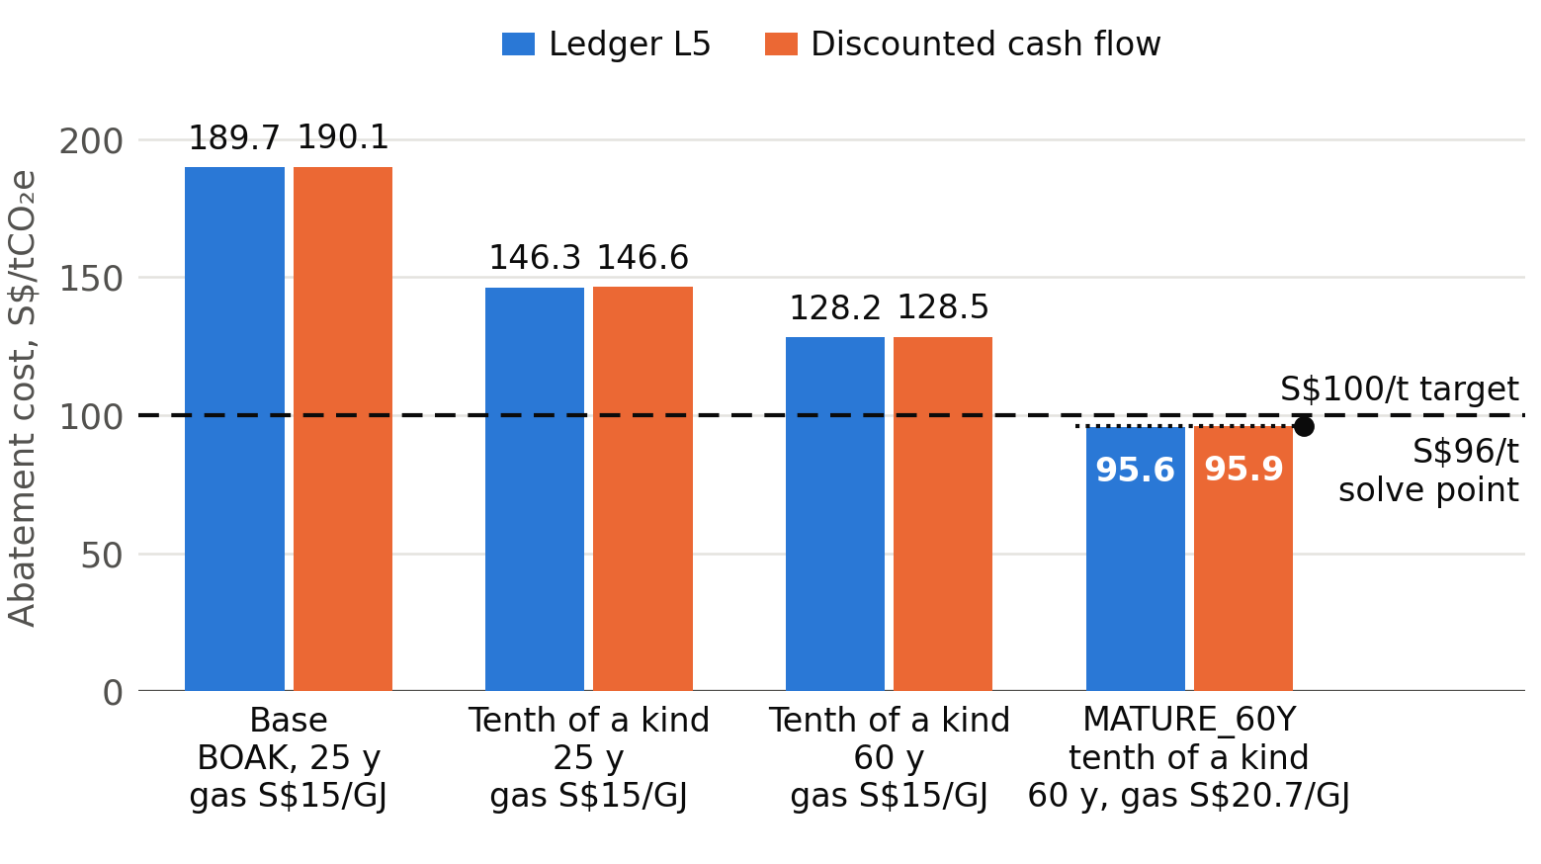
Figure 4. Step-down from the base full cost to the MATURE_60Y scenario. Every bar is an engine row, ledger L5 with the DCF beside it. The dotted line marks the $\text{S\$96/}{\text{tCO}}_{\text{2}}\text{e}$ point that sets the printed gas price of $\text{S\$20.7/GJ}$, against the central $\text{S\$15/GJ}$.
For deployment, the result favours waiting for a design replicated overseas before any Singapore commitment, and replacing proxies with reactor quotations and a contracted T&S tariff. Figure 3 places these steps in time. Carbon tax stays out of the headline because it is a transfer. For an operator, the published rate for 2026 to 2027 and the band stated for 2030 [56] both sit well below the base full cost of $\text{S\$189.7/}{\text{tCO}}_{\text{2}}\text{e}$, so the tax alone would not close the gap. The Future Energy Fund gives a policy context with no allocation assumed [57].

5. Discussion and Conclusion

5.1 Discussion
Environmental performance. The plant abates 0.578 ${\text{MtCO}}_{\text{2}}\text{e }{\text{y}}^{-\text{1}}$ at 90% per-pass and 90.4% plant capture, and the result holds across the baseline bounds. It rests on working capture and on recycle transferring to MEA.
Economic performance. The full cost of $\text{S\$165.6/}{\text{tCO}}_{\text{2}}\text{e}$ to $\text{S\$277.9/}{\text{tCO}}_{\text{2}}\text{e}$ at $\text{n}\text{ = 1.0}$ misses the target in every central case, by both methods. The MATURE_60Y scenario reaches $\text{S\$95.6/}{\text{tCO}}_{\text{2}}\text{e}$ only with a tenth-of-a-kind reactor on INL's BOAK learning route over 60 $\text{y}$ and gas at $\text{S\$20.7/GJ}$, above the $\text{S\$10}$ to $\text{S\$20/GJ}$ range tested; at $\text{S\$20/GJ}$ it gives $\text{S\$99.6/}{\text{tCO}}_{\text{2}}\text{e}$.
Comparison with conventional SMR plus CCS. IEAGHG Case 3 at $\text{S\$203.0/}{\text{tCO}}_{\text{2}}\text{e}$ on matched T&S sits above the NUS-${\text{H}}_{\text{2}}$ BOAK case and below its FOAK case, so the proposal competes only once a reactor is past first of a kind. The comparison is indicative. NUS-${\text{H}}_{\text{2}}$ remains distinct by removing the furnace, with residual emissions of 0.57 $\text{kg }{\text{CO}}_{\text{2}} {\text{kg}}^{-\text{1}} {\text{H}}_{\text{2}}$.
Implementation in Singapore. Reactor qualification, the nuclear-chemical heat interface, site-specific emergency planning and contracted ${\text{CO}}_{\text{2}}$ transport and storage form the main requirements (Figure 3). A competing pathway exists: Air Liquide and Aster have signed a memorandum on autothermal reforming with integrated capture in Singapore [58].
Principal uncertainties. Reactor size treatment spans $\text{S\$189.7/}{\text{tCO}}_{\text{2}}\text{e}$ to $\text{S\$368.7/}{\text{tCO}}_{\text{2}}\text{e}$ at BOAK, 25 $\text{y}$. The gas saving, the SRD on syngas, IHX performance and the spare on Ahn and Lee's heat basis all remain unresolved. The column models and the Level 3 flowsheet failed their gates, so most terms stay anchored (Appendix E).

5.2 Conclusion
NUS-${\text{H}}_{\text{2}}$ pairs a 210 ${\text{MW}}_{\text{th}}$ HTGR with an SMR and 30 $\text{wt\%}$ MEA at SOXAL scale. The abatement target is met at 0.578 ${\text{MtCO}}_{\text{2}}\text{e }{\text{y}}^{-\text{1}}$. The cost target of $\text{S\$100/}{\text{tCO}}_{\text{2}}\text{e}$ is missed in every central case, with a base full cost of $\text{S\$189.7/}{\text{tCO}}_{\text{2}}\text{e}$ at BOAK, 25 $\text{y}$. It is met only under the stated MATURE_60Y conditions, a tenth-of-a-kind reactor on INL's BOAK learning route over 60 $\text{y}$ with gas at $\text{S\$20.7/GJ}$, a price above the $\text{S\$10}$ to $\text{S\$20/GJ}$ range tested; at $\text{S\$20/GJ}$ the scenario gives $\text{S\$99.6/}{\text{tCO}}_{\text{2}}\text{e}$. Singapore's next steps are reactor and IHX qualification overseas, site-specific safety and licensing, hydrogen offtake and a contracted ${\text{CO}}_{\text{2}}$ storage pathway.

References
[1] Energy Market Authority of Singapore. Our Energy Story: Gas. https://ema.gov.sg/our-energy-story/energy-market-landscape/gas
[2] Energy Market Authority of Singapore. Singapore Energy Statistics 2025, Chapter 2: Energy Transformation. https://www.ema.gov.sg/resources/singapore-energy-statistics/chapter2
[3] Ministry of Energy, Trade and Industry, Singapore. Hydrogen. https://www.meti.gov.sg/energy-and-carbon/energy-supply/low-carbon-alternatives/hydrogen/
[4] P. Nikolaidis and A. Poullikkas. A comparative overview of hydrogen production processes. Renewable and Sustainable Energy Reviews 67 (2017) 597-611. https://doi.org/10.1016/j.rser.2016.09.044
[5] IEAGHG. Techno-Economic Evaluation of SMR Based Standalone (Merchant) Hydrogen Plant with CCS. Report 2017-02, 2017. https://ieaghg.org/publications/techno-economic-evaluation-of-smr-based-standalone-merchant-hydrogen-plant-with-ccs/
[6] Idaho National Laboratory. Sensitivity of Hydrogen Production via Steam Methane Reforming to High Temperature Gas-Cooled Reactor Outlet Temperature Process Analysis. Technical Report TEV-961 Rev. 0, 2010.
[7] D. Mears. Module 2b: HTGR Motivations and Applications. NRC HTGR Technology Course, Technology Insights for Idaho National Laboratory, 24 to 27 May 2010 (slide: Process Application Temperatures).
[8] Air Liquide. SOXAL develops key hydrogen business in Singapore. Press release, 15 January 2008. https://www.airliquide.com/group/press-releases-news/2008-01-15/soxal-develops-key-hydrogen-business-singapore
[9] Air Liquide. Further investment in Singapore. Press release, 30 November 2011. https://www.airliquide.com/group/press-releases-news/2011-11-30/further-investment-singapore
[10] Idaho National Laboratory. Determining the Appropriate Emergency Planning Zone Size and Emergency Planning Attributes for an HTGR. INL/MIS-10-19799 Rev. 0, October 2010.
[11] Idaho National Laboratory. HTGR-Integrated Hydrogen Production via Steam Methane Reforming (SMR) Process Analysis. Technical Report TEV-953 Rev. 0, 2010.
[12] S.H.B. Vinjarapu, R. Neerup, A.H. Larsen, J.K. Jørsboe, S.N.B. Villadsen, S. Jensen, J.L. Karlsson, J. Kappel, H. Lassen, P. Blinksbjerg, N. von Solms and P.L. Fosbøl. Results from pilot-scale ${\text{CO}}_{\text{2}}$ capture testing using 30 wt% MEA at a Waste-to-Energy facility: Optimisation through parametric analysis. Applied Energy 355 (2024) 122193. https://doi.org/10.1016/j.apenergy.2023.122193
[13] N. Brigman, M.I. Shah, O. Falk-Pedersen, T. Cents, V. Smith, T. De Cazenove, A.K. Morken, O.A. Hvidsten, M. Chhaganlal, J.K. Feste, G. Lombardo, O.M. Bade, J. Knudsen, S.C. Subramoney, B.F. Fostås, G. de Koeijer and E.S. Hamborg. Results of amine plant operations from 30 wt% and 40 wt% aqueous MEA testing at the ${\text{CO}}_{\text{2}}$ Technology Centre Mongstad. Energy Procedia 63 (2014) 6012-6022. https://doi.org/10.1016/j.egypro.2014.11.635
[14] Japan Atomic Energy Agency. Testing and Research Using HTTR, 2026. https://www.jaea.go.jp/04/o-arai/nhc/en/research/httr/index.html
[15] World Nuclear Association. Shidaowan HTR-PM 1, Nuclear Reactor Database (construction start 9 December 2012, commercial operation 5 December 2023). https://world-nuclear.org/nuclear-reactor-database/details/Shidaowan-HTR-PM-1
[16] World Nuclear News. Chinese HTR-PM demo begins commercial operation. December 2023. https://world-nuclear-news.org/articles/chinese-htr-pm-demo-begins-commercial-operation
[17] X-energy. Xe-100 reactor page. https://x-energy.com/reactors/xe-100
[18] S. Ahn and C.-J. Lee. Comparative techno-economic and environmental assessment of HTGR-integrated hydrogen production via helium-heated and electrified steam methane reforming. International Journal of Hydrogen Energy 247 (2026) 155890.
[19] IEAGHG. Low-Carbon Hydrogen from Natural Gas: Global Roadmap. Report 2022-07, 2022.
[20] Nexant. 100 MWe Coal-Fired Direct Injection Carbon Engine (DICE) Compound Reheat Combined Cycle (CRCC) with 90 Percent Post-Combustion ${\text{CO}}_{\text{2}}$ Capture: Final Report for Pre-FEED Study. US DOE National Energy Technology Laboratory, 2020. https://netl.doe.gov/sites/default/files/2020-05/DICE-CRCC-Pre-FEED-Final-Report_1.pdf
[21] N.-S. Kwak, J.H. Lee, I.Y. Lee, K.R. Jang and J.-G. Shim. A study of the ${\text{CO}}_{\text{2}}$ capture pilot plant by amine absorption. Energy 47 (2012) 41-46. https://doi.org/10.1016/j.energy.2012.07.016
[22] U.E. Aronu, S. Gondal, E.T. Hessen, T. Haug-Warberg, A. Hartono, K.A. Hoff and H.F. Svendsen. Solubility of ${\text{CO}}_{\text{2}}$ in 15, 30, 45 and 60 mass% MEA from 40 to 120 °C and model representation using the extended UNIQUAC framework. Chemical Engineering Science 66 (2011) 6393-6406.
[23] Singapore Department of Statistics. Environment: latest news and data (total land area, 744.3 km2 as at December 2025). https://www.singstat.gov.sg/find-data/explore-data-themes/society/environment/latest-news-data
[24] US Nuclear Regulatory Commission. Emergency Preparedness for Small Modular Reactors and Other New Technologies. Final rule, Federal Register 88(220), 16 November 2023. https://www.federalregister.gov/documents/2023/11/16/2023-25163/emergency-preparedness-for-small-modular-reactors-and-other-new-technologies
[25] World Nuclear News. US regulator approves methodology for [small modular reactor] emergency planning. 28 October 2022. Online at world-nuclear-news.org.
[26] M. Ilvonen. Review of [small modular reactor] siting and emergency preparedness. VTT Research Report VTT-R-01612-20, VTT Technical Research Centre of Finland, 2022. Online at cris.vtt.fi.
[27] Long Mott Energy, LLC. Long Mott Generating Station Construction Permit Application, Part VI, Supplemental Information, including the X-energy Xe-100 plume exposure pathway EPZ technical report (Doc. ID 010810 Rev. 3, preliminary). NRC ADAMS ML25090A066, 2025. https://ww2.nrc.gov/docs/ML2509/ML25090A066.pdf
[28] BIC Magazine. NRC accepts Dow's construction permit for [small modular reactor] plant in Texas. 15 May 2025. Online at www.bicmagazine.com.
[29] H. Ding, J. Tong, Y. Wang and L. Zhang. Development of emergency planning zone for high temperature gas-cooled reactor. Annals of Nuclear Energy 111 (2018) 347-353. https://doi.org/10.1016/j.anucene.2017.08.039
[30] H. Ding, J. Tong and L. Zhang. Study on offsite emergency preparedness for the industry application of HTR-PM. Proceedings of the 26th International Conference on Nuclear Engineering (ICONE 2018), London, ASME, 2018. https://hit.globalimpact.cn/en/publications/study-on-offsite-emergency-preparedness-for-the-industry-applicat/
[31] Ministry of Energy, Trade and Industry, Singapore. Singapore to undertake IAEA review by international experts to assess its ability to make informed decision on nuclear energy deployment. 19 May 2026. https://www.meti.gov.sg/newsroom/singapore-to-undertake-iaea-review-by-international-experts--to-assess-its-ability-to-make-informed-decision-on-nuclear-energy-deployment/
[32] Ministry of Energy, Trade and Industry, Singapore. Nuclear Energy. https://www.meti.gov.sg/energy-and-carbon/energy-supply/low-carbon-alternatives/nuclear-energy/
[33] Energy Market Authority and Ministry of Energy, Trade and Industry, Singapore. Launch of manpower development schemes. Media release, 26 October 2026. https://www.ema.gov.sg/content/dam/corporate/news/media-releases/2026/20262610-EMA-Media-Release-METI-EMA-Launch-Manpower-Development-Schemes.pdf.coredownload.pdf
[34] Ministry of Energy, Trade and Industry, Singapore. Singapore Energy Lecture 2026 by the Minister. 26 October 2026. https://www.meti.gov.sg/newsroom/singapore-energy-lecture-2026-by-minister-for-energy--trade-and-industry--energy-and-industry--dr-tan-see-leng/
[35] NUS Singapore Nuclear Research and Safety Institute. SNRSI Lectures (public lectures open to anyone, including students). https://snrsi.nus.edu.sg/outreach/snrsi-lectures
[36] Shabana Begum. First CEO of NUS nuclear institute lays out plans to help energy transition. The Straits Times, 18 May 2026, p. A3. https://nus.edu.sg/newshub/news/2026/2026-05/2026-05-18/CEO-st-18may-pA3.pdf
[37] Energy Market Authority and National Environment Agency of Singapore. Safety in using nuclear energy is overriding priority. Forum reply, 1 June 2026. https://www.ema.gov.sg/news-events/news/forum-replies/2026/safety-in-using-nuclear-energy-is-overriding-priority
[38] Energy Market Authority of Singapore. EMA to conduct study on safety and technical feasibility of advanced nuclear energy technologies. Media release, 2 September 2025. https://ema.gov.sg/news-events/news/media-releases/2025/ema-to-conduct-study-on-safety-technical-feasibility-of-advanced-nuclear-energy-technologies
[39] World Nuclear News. UK to cooperate with Singapore on nuclear regulation. 2 June 2026. https://world-nuclear-news.org/articles/uk-to-cooperate-with-singapore-on-nuclear-regulation
[40] International Atomic Energy Agency. Stakeholder Engagement in Nuclear Programmes. IAEA Nuclear Energy Series No. NG-G-5.1, 2021. https://www-pub.iaea.org/MTCD/Publications/PDF/PUB1967_web.pdf
[41] A. Shimizu et al. Heat transfer performance of the heat exchangers in the full-scale single reformer tube test facility of the HTTR hydrogen production system (in Japanese). JAERI-Tech 2005-031, Japan Atomic Energy Research Institute, June 2005.
[42] Ministry of Energy, Trade and Industry, Singapore. Singapore and Indonesia sign memoranda of understanding on cross-border electricity trade, carbon capture and storage, and sustainable industrial zone. 13 June 2025. https://www.meti.gov.sg/newsroom/singapore-and-indonesia-sign-three-memoranda-of-understanding-with-indonesia-on-cross-border-electricity-trade--carbon-capture-and-storage--and-sustainable-industrial-zone/
[43] Government of Singapore. National Day Rally 2026: Future Ready. https://www.gov.sg/ndr2026/future-ready/
[44] British Chamber of Commerce Singapore. Government will do studies on rich marine biodiversity before Western Island reclamation. 25 August 2026. https://www.britcham.org.sg/news/government-will-do-studies-rich-marine-biodiversity-western-island-reclamation
[45] H.H. Cho, V. Strezov and T.J. Evans. Environmental impact assessment of hydrogen production via steam methane reforming based on emissions data. Energy Reports 8 (2022) 13585-13595. https://doi.org/10.1016/j.egyr.2022.10.053
[46] National Climate Change Secretariat, Singapore. Singapore submits 2035 Nationally Determined Contribution. 10 February 2025. https://nccs.gov.sg/singapore-submits-2035-nationally-determined-contribution
[47] Federal Reserve Bank of St. Louis (FRED). Singapore Dollars to U.S. Dollar Spot Exchange Rate, annual average (AEXSIUS). https://fred.stlouisfed.org/series/AEXSIUS
[48] US Bureau of Economic Analysis. Gross Domestic Product: Implicit Price Deflator (index 2017 = 100), via FRED. https://fred.stlouisfed.org/series/GDPDEF
[49] Federal Reserve Bank of St. Louis (FRED). U.S. Dollars to Euro Spot Exchange Rate, annual average (AEXUSEU). https://fred.stlouisfed.org/series/AEXUSEU
[50] Idaho National Laboratory. Nuclear Energy Cost Estimates for Net Zero World Initiative (NZW09), 2024. https://www.energy.gov/sites/default/files/2024-10/NZW09%20Nuclear%20Energy%20Cost%20Estimates%20for%20Net%20Zero%20World%20Initiative.pdf
[51] A. Abou-Jaoude, L. Lin, C. Bolisetti, E. Worsham, L.M. Larsen and A. Epiney. Literature Review of Advanced Reactor Cost Estimates. Idaho National Laboratory, INL/RPT-23-72972 Rev. 3, October 2023. https://gain.inl.gov/content/uploads/4/2024/11/INL-RPT-23-72972-Literature-Review-of-Adv-Reactor-Cost-Estimates.pdf
[52] Economic Research Institute for ASEAN and East Asia. Comprehensive CCUS Research Report, 2024 (Fig. 2.13). https://www.eria.org/uploads/Comprehensive-CCUS-Research-Report.pdf
[53] Ministry of Energy, Trade and Industry, Singapore. Written reply to PQ on projected cost per tonne of carbon dioxide abated through carbon capture and storage in Singapore. 8 April 2025. https://www.meti.gov.sg/newsroom/written-reply-to-pq-on-projected-cost-per-tonne-of-carbon-dioxide-abated-through-carbon-capture-and-storage-in-singapore/
[54] P. Srivastav, M. Schenkel, G.U.R. Mir, T. Berg and M. Staats. Carbon Capture, Utilisation and Storage (CCUS): Decarbonisation Pathways for Singapore's Energy and Chemicals Sectors. Navigant Netherlands B.V., 2019. https://isomer-user-content.by.gov.sg/519/f15410c8-3428-412e-b2e3-b056c978ff6a/carbon-capture-utilisation-and-storage-decarbonisation-pathway-for-singapore-energy-and-chemical.pdf
[55] International Monetary Fund. Global price of LNG, Asia (PNGASJPUSDM), US dollars per million BTU, monthly, via FRED, Federal Reserve Bank of St. Louis. https://fred.stlouisfed.org/series/PNGASJPUSDM
[56] National Climate Change Secretariat, Singapore. Carbon Tax. https://nccs.gov.sg/singapores-climate-action/mitigation-efforts/carbontax
[57] Singapore Economic Development Board. Singapore Budget 2025: Government to reorganise for greater focus on nuclear energy, build new capabilities. https://www.edb.gov.sg/en/business-insights/insights/singapore-budget-2025-government-to-reorganise-for-greater-focus-on-nuclear-energy-build-new-capabilities.html
[58] Air Liquide and Aster. Air Liquide and Aster sign MOU to collaborate on low-carbon hydrogen production in Singapore. Joint release, 24 November 2025. https://sg.airliquide.com/sites/al_sg/files/2025-11/20251124_pr_air-liquide-and-aster-sign-mou-to-collaborate-on-low-carbon-hydrogen-production-in-singapore-v1.docx.pdf
[59] United Nations Economic Commission for Europe. Life Cycle Assessment of Electricity Generation Options, 2022. https://unece.org/sed/documents/2021/10/reports/life-cycle-assessment-electricity-generation-options
[60] International Energy Agency. Assessing Emissions from LNG Supply and Abatement Options, 2026. https://www.iea.org/reports/assessing-emissions-from-lng-supply-and-abatement-options

Appendix A. Reactor design basis
This appendix records the source-traceable design basis and the reactor sizing used in Chapters 1 and 2. Reference values are from INL TEV-961, Table 2, 925$\text{°C}$ case [6], with the process configuration of TEV-953 [11]. Sizing rests on balances anchored on these cases and does not demonstrate self-sufficiency of a built plant.
Table A1. Design basis. Case A here is INL's Case 6 with 30 $\text{wt\%}$ MEA in place of its published Selexol. Published values are from INL TEV-961 [6] and TEV-953 [11]; assumed and calculated values are labelled.
Parameter | Case B | Case A, with MEA | Label
Reactor outlet, $\text{°C}$ | 925 | 925 | Published
Secondary helium supply, $\text{°C}$ | 900 | 900 | Published
Secondary helium return, $\text{°C}$ | 466 | 466 | Published
Secondary helium flow, $\text{kg }{\text{s}}^{-\text{1}}$ | 54.0 | 79.1 | Calculated
Primary helium flow at need, $\text{kg }{\text{s}}^{-\text{1}}$ | 79.2 | 115.6 | Calculated
Reformer outlet, $\text{°C}$ | 871 | 871 | Published
Process heat, ${\text{MW}}_{\text{th}}$ | 120.80 | 176.80 | Scaled; published
Electricity demand, ${\text{MW}}_{\text{e}}$ | 19.78 | 28.94 | Calculated, with MEA
Power conversion efficiency, % | 39.7 | 39.7 | Published, interpolated
PSA recovery, % | 88 | 88 | Published, external
Availability, % | 85 | 85 | Assumed
Proposed ${\text{CO}}_{\text{2}}$ capture | 30 $\text{wt\%}$ MEA | 30 $\text{wt\%}$ MEA | Assumed
SRD, $\text{GJ }{\text{tCO}}_{\text{2}}^{-\text{1}}$ | 3.8 | 3.8 | Assumed
Rich and lean loading, $\text{mol }{\text{mol}}^{-\text{1}}$ | 0.50, 0.25 | 0.50, 0.25 | Assumed
Reactor rating, ${\text{MW}}_{\text{th}}$ | 210.00 | 210.00 | Design decision

Table A2. Sizing walk in ${\text{MW}}_{\text{th}}$. Steps not exported by the results are marked n/e.
Step | Case B | Case A, MEA
INL's rate: process heat plus power at 39.7%, no purge load | 206.02 | 206.02
Same sum at Case B | 140.77 | n/a
Restore purge load | 150.58 | 220.38
Add vessel, IHX and duct losses | 154.27 | n/e
Add helium circulators | 165.95 | 242.41
Swap Selexol for MEA, zero reboiler heat | 166.25 | n/e
Add reboiler gap at 3.8 $\text{GJ }{\text{tCO}}_{\text{2}}^{-\text{1}}$, anchored terms | 179.04 | n/e
Headline, syngas heat on its gated model | 178.49 | 260.74
Rated | 210.00 | 210.00
Margin | 31.51 | −50.74

Note 1. INL quotes an equivalent reactor size of 178.8 ${\text{MW}}_{\text{th}}$ for Case 6 because it imports 16.5 ${\text{MW}}_{\text{e}}$ [6], so that figure carries almost no site electricity.
Note 2. Losses and the reboiler are counted in the walk, and Case 5 duties stand in for Case 6, whose stream sheets are not held. The walk runs on the anchored terms; its last row is the headline need, with the syngas heat above 130$\text{°C}$ on its gated model.
Note 3. The 17.3 ${\text{MW}}_{\text{e}}$ demand belongs to the INL Selexol and PSA flowsheet, including ${\text{CO}}_{\text{2}}$ compression and purge recovery [6]. The purge row is Case 6 fuel-gas recycle and nitrogen removal equipment, split not published.
Note 4. INL's rate of 29,000 lb/h over 7,446 $\text{h }{\text{y}}^{-\text{1}}$ gives 97,946 $\text{t }{\text{y}}^{-\text{1}}$ of product including 0.79 mass% methane. At Case B, 100,000 ${\text{Nm}}^{\text{3}} {\text{h}}^{-\text{1}}$ gives 66,925 $\text{t }{\text{y}}^{-\text{1}}$.
The emergency planning zone of Chapter 2 rests on the frequency-consequence method drawn in Figure A1.
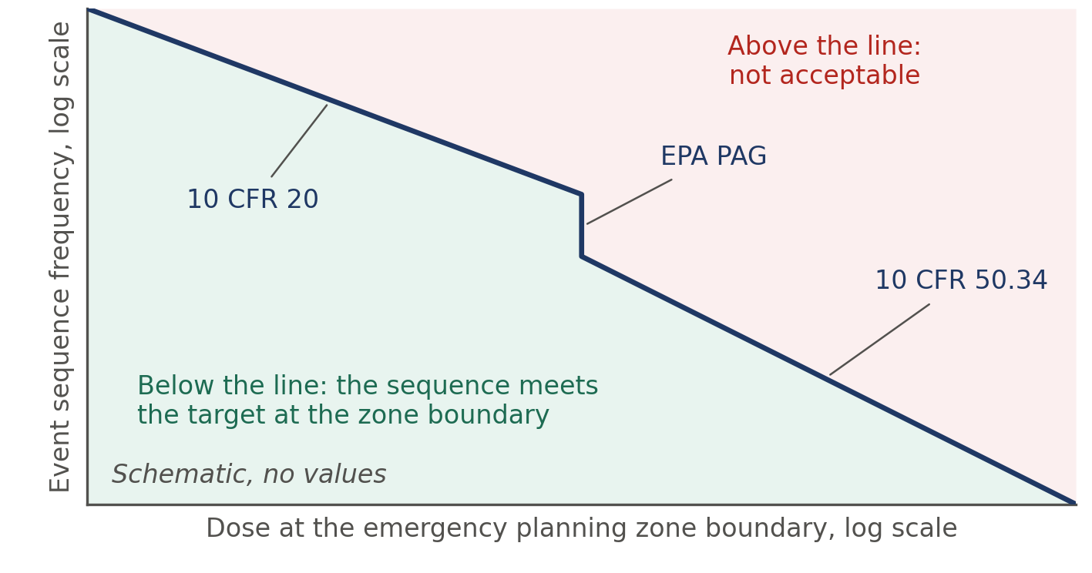
Figure A1. The frequency-consequence method behind an EPZ, drawn as a schematic after the Xe-100 example in the construction permit application [27]. Each accident sequence is placed by its frequency and its 30-day dose at the zone boundary, 400 $\text{m}$ in that example, and must fall below the target line. The axes carry no values; the dose criteria and the source figure are in [27].

Appendix B. Mass and energy balance
Stream values come from the integrated balance files, and the PSA streams are external boundary values. The cryogenic unit returns 560 $\text{kmol }{\text{h}}^{-\text{1}}$ of hydrogen ahead of the PSA, a stream with no carbon. The carbon, hydrogen and mass residuals all print as zero, and the shift releases 8.1 $\text{MW}$.
Table B1. Carbon streams, Case B, from the integrated mass balance, kmol C per hour. A stream crosses the dashed line of Figure 2 when exactly one end sits inside it; the gas supply, the PSA, the product and offsite users sit outside.
Stream | From | To | Crosses | Carbon
Purified ${\text{H}}_{\text{2}}$ after external PSA | PSA | Product | No | 4.4
Compressed ${\text{CO}}_{\text{2}}$ to storage | ${\text{CO}}_{\text{2}}$ compressor | Storage | No | 1,097.9
Burned nitrogen-rich cut | Cryogenic unit | Stack | No | 116.9
Fresh natural gas | Gas supply | Reformer | Yes | 1,219.2
Cryogenic ${\text{H}}_{\text{2}}$ return ahead of the PSA | Cryogenic unit | PSA | Yes | 0.0
${\text{H}}_{\text{2}}$-rich gas into the PSA | MEA capture | PSA | Yes | 476.2
PSA reject returning across the line | PSA | Cryogenic unit | Yes | 471.7
Recycled methane-rich gas | Cryogenic unit | Reformer | No | 354.8
Tail gas leaving the boundary | PSA | Offsite | No | 0.0
Carbon residual |  |  |  | 0.0

Table B2. Reboiler heat stack, Case B central, $\text{MW}$, in the order of use.
Source, in order of use | Duty
Freed Selexol steam | 12.73
Export steam diverted | 16.76
Syngas heat above 130$\text{°C}$ | 8.39
Reactor steam, the reboiler gap | 13.12
Reboiler duty at 3.8 $\text{GJ }{\text{tCO}}_{\text{2}}^{-\text{1}}$ | 51.00

Helium circulation at the need is 79.2 $\text{kg }{\text{s}}^{-\text{1}}$ primary and 54.0 $\text{kg }{\text{s}}^{-\text{1}}$ secondary, and the circulators draw 7.45 ${\text{MW}}_{\text{e}}$. The sizing range of 155.8 ${\text{MW}}_{\text{th}}$ to 214.1 ${\text{MW}}_{\text{th}}$ spans the best and adverse corners of SRD, losses and circulator terms. SRD alone moves the need to 174.1 ${\text{MW}}_{\text{th}}$ and 182.9 ${\text{MW}}_{\text{th}}$.

Appendix C. Emissions
The direct method is the headline. Baseline 616,361 ${\text{tCO}}_{\text{2}}\text{e }{\text{y}}^{-\text{1}}$ less residual 38,309 ${\text{tCO}}_{\text{2}}\text{e }{\text{y}}^{-\text{1}}$ gives net abatement of 578,052 ${\text{tCO}}_{\text{2}}\text{e }{\text{y}}^{-\text{1}}$. Lifecycle factors for nuclear power and upstream gas come from the cited sources and were not re-verified against their primary data [59,60]. Ship fuel uses an assumed 0.025 $\text{t }{\text{t}}^{-\text{1}}$ of ${\text{CO}}_{\text{2}}$ stored.
Table C1. Emissions ledger, Case B on the INL baseline. Lifecycle rows are sensitivities and stay out of the headline.
View | Line | $${\text{tCO}}_{\text{2}}\text{e }{\text{y}}^{-\text{1}}$$ | $$\text{kg }{\text{CO}}_{\text{2}} {\text{kg}}^{-\text{1}} {\text{H}}_{\text{2}}$$
Direct | Unabated SMR baseline | 616,361 | 9.21
Direct | Captured and stored | 359,777 | 5.38
Direct | Residual to atmosphere | 38,309 | 0.57
Direct | Net abatement | 578,052 | 8.64
Lifecycle, burdens | Nuclear lifecycle burden | −2,902 | −0.04
Lifecycle, burdens | T&S burden | −8,994 | −0.13
Lifecycle, burdens | Net abatement | 566,155 | 8.46
Lifecycle, upstream | Saved upstream gas | 49,677 | 0.74
Lifecycle, upstream | Net abatement | 615,832 | 9.20
System | Net abatement with lost steam | 527,632 | 7.88

Appendix D. Economics
Table entries come from the ledger and DCF results. INL's overnight cost already holds owner costs, licensing and decommissioning shares [51], so the extra licensing and decommissioning lines are labelled proxies that may overlap them.
Table D1. Cost inputs. Label P is published, A assumed, C calculated, U a project decision.
Input | Low | Central | High | Label, source
Reactor overnight cost, $\text{US\$/}{\text{kW}}_{\text{t}}$ | 1,456 | 2,184 | 2,548 | P, C [51]
FOAK premium, multiple of BOAK | 1.3 | 1.6 | 2.1 | P [51]
Reactor O&M and fuel, $\text{US\$/}{\text{MWh}}_{\text{th}}$ | 6 | 10 | 14 | P, C [51]
Gas, $\text{S\$/GJ}$, higher heating value | 10 | 15 | 20 | P, A [55]
T&S, $\text{S\$/}{\text{tCO}}_{\text{2}}$ | 23.2 | 60 | 112 | U [5,52]
Capture capital, $\text{S\$M per t/h}$ | n/a | 2.04 | 5.09 | C [5]
Capture fixed O&M, % of capital | n/a | 2.7 | 6.0 | A, P [18]
IHX and loop line, $\text{S\$M/y}$ | 0.88 | 8.36 | 17.24 | Proxy, primary not verified
Licensing line, 25 $\text{y}$, $\text{S\$M/y}$ | 0.00 | 6.12 | 16.83 | Proxy, primary not verified
Decommissioning, $\text{US\$/}{\text{kW}}_{\text{e}}$ | 750 | 1,000 | 1,250 | P [50]
Recycle train line, $\text{S\$M/y}$ | 0.00 | 5.89 | 25.35 | Proxy from [5]
Discount rate, % | n/a | 8 | n/a | A [5]
Availability, % | 65 | 85 | 90 | A

Table D2. Reactor capital at 210 ${\text{MW}}_{\text{th}}$ and its annual lines.
Stage and size treatment | Capital, $\text{S\$M}$ | 25 $\text{y}$, $\text{S\$M/y}$ | 60 $\text{y}$, $\text{S\$M/y}$
BOAK, $\text{n}\text{ = 1.0}$ | 742.8 | 69.58 | 60.01
BOAK, $\text{n}\text{ = 0.6}$ | 1,130.4 | 105.89 | 91.33
BOAK, $\text{n}\text{ = 0.31}$ | 1,531.5 | 143.47 | 123.75
FOAK, $\text{n}\text{ = 1.0}$ | 1,188.4 | 111.33 | 96.02
FOAK, $\text{n}\text{ = 0.6}$ | 1,808.6 | 169.43 | 146.13
FOAK, $\text{n}\text{ = 0.31}$ | 2,450.5 | 229.56 | 197.99
Tenth, from BOAK, $\text{n}\text{ = 1.0}$ | 523.4 | 49.03 | 42.29
Tenth, from FOAK, $\text{n}\text{ = 1.0}$ | 837.5 | 78.45 | 67.67

Table D3. Stage, life and size matrix at 25 $\text{y}$ / 60 $\text{y}$. Costs are $\text{S\$/}{\text{tCO}}_{\text{2}}\text{e}$, LCOH is $\text{S\$/kg}$. Cells marked n/e are not exported.
Case | L3 | L5 | DCF LAC | LCOH
BOAK, $\text{n}\text{ = 1.0}$ | 137.7 / 117.2 | 189.7 / 165.6 | 190.1 / 166.0 | 5.26 / 5.05
BOAK, $\text{n}\text{ = 0.6}$ | 213.2 / 184.1 | 277.7 / 243.2 | 278.2 / 243.7 | 6.02 / 5.72
BOAK, $\text{n}\text{ = 0.31}$ | 291.4 / 253.4 | 368.7 / 323.6 | 369.4 / 324.2 | 6.81 / 6.42
FOAK, $\text{n}\text{ = 1.0}$ | 209.9 / 179.5 | 277.9 / 241.7 | 278.4 / 242.2 | 6.02 / 5.71
FOAK, $\text{n}\text{ = 0.6}$ | 323.1 / 278.9 | 411.0 / 358.2 | 411.8 / 358.9 | 7.17 / 6.72
FOAK, $\text{n}\text{ = 0.31}$ | 440.3 / 381.8 | 548.8 / 478.8 | 549.8 / 479.8 | 8.37 / 7.76
Sized to need, BOAK, $\text{n}\text{ = 1.0}$ | 112.7 / 95.1 | 161.2 / 140.4 | 161.4 / 140.7 | 5.01 / 4.83
Case A at its own need, BOAK | 109.1 / 91.9 | 157.5 / 137.2 | n/e | n/e

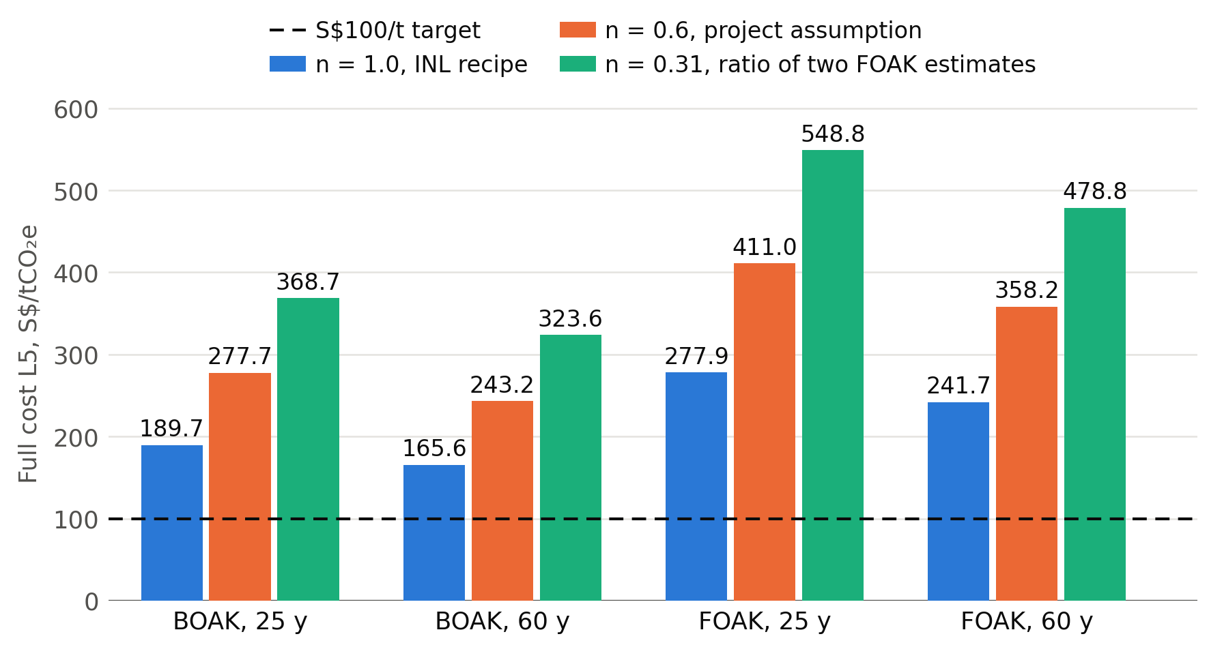
Figure D1. Rebuilt full cost L5 for the three size treatments at equal weight, against the $\text{S\$100/}{\text{tCO}}_{\text{2}}\text{e}$ target.
Table D4. Currency and escalation.
Factor | Value
Singapore dollars per US dollar, 2025 average [47] | 1.3065
2025 Singapore dollars per 2019 US dollar [48] | 1.6195
2025 Singapore dollars per 2014 euro [49] | 2.322

Table D5. SMR plus CCS comparator, indicative only, since gas price and scale differ.
Item | IEAGHG Case 3 | NUS-${\text{H}}_{\text{2}}$, BOAK, 25 $\text{y}$
Capture route | MEA on flue gas | MEA on syngas
Overall capture, % | 90.0 | 90.4
Abatement, ${\text{MtCO}}_{\text{2}}\text{e }{\text{y}}^{-\text{1}}$ | 0.536 | 0.578
Baseline, $\text{kg }{\text{CO}}_{\text{2}} {\text{kg}}^{-\text{1}} {\text{H}}_{\text{2}}$ | 8.996 | 9.21
Cost at low T&S, $\text{S\$/}{\text{tCO}}_{\text{2}}\text{e}$ | 162.1 | 166.8
Cost at $\text{S\$60/}{\text{tCO}}_{\text{2}}$, $\text{S\$/}{\text{tCO}}_{\text{2}}\text{e}$ | 203.0 | 189.7

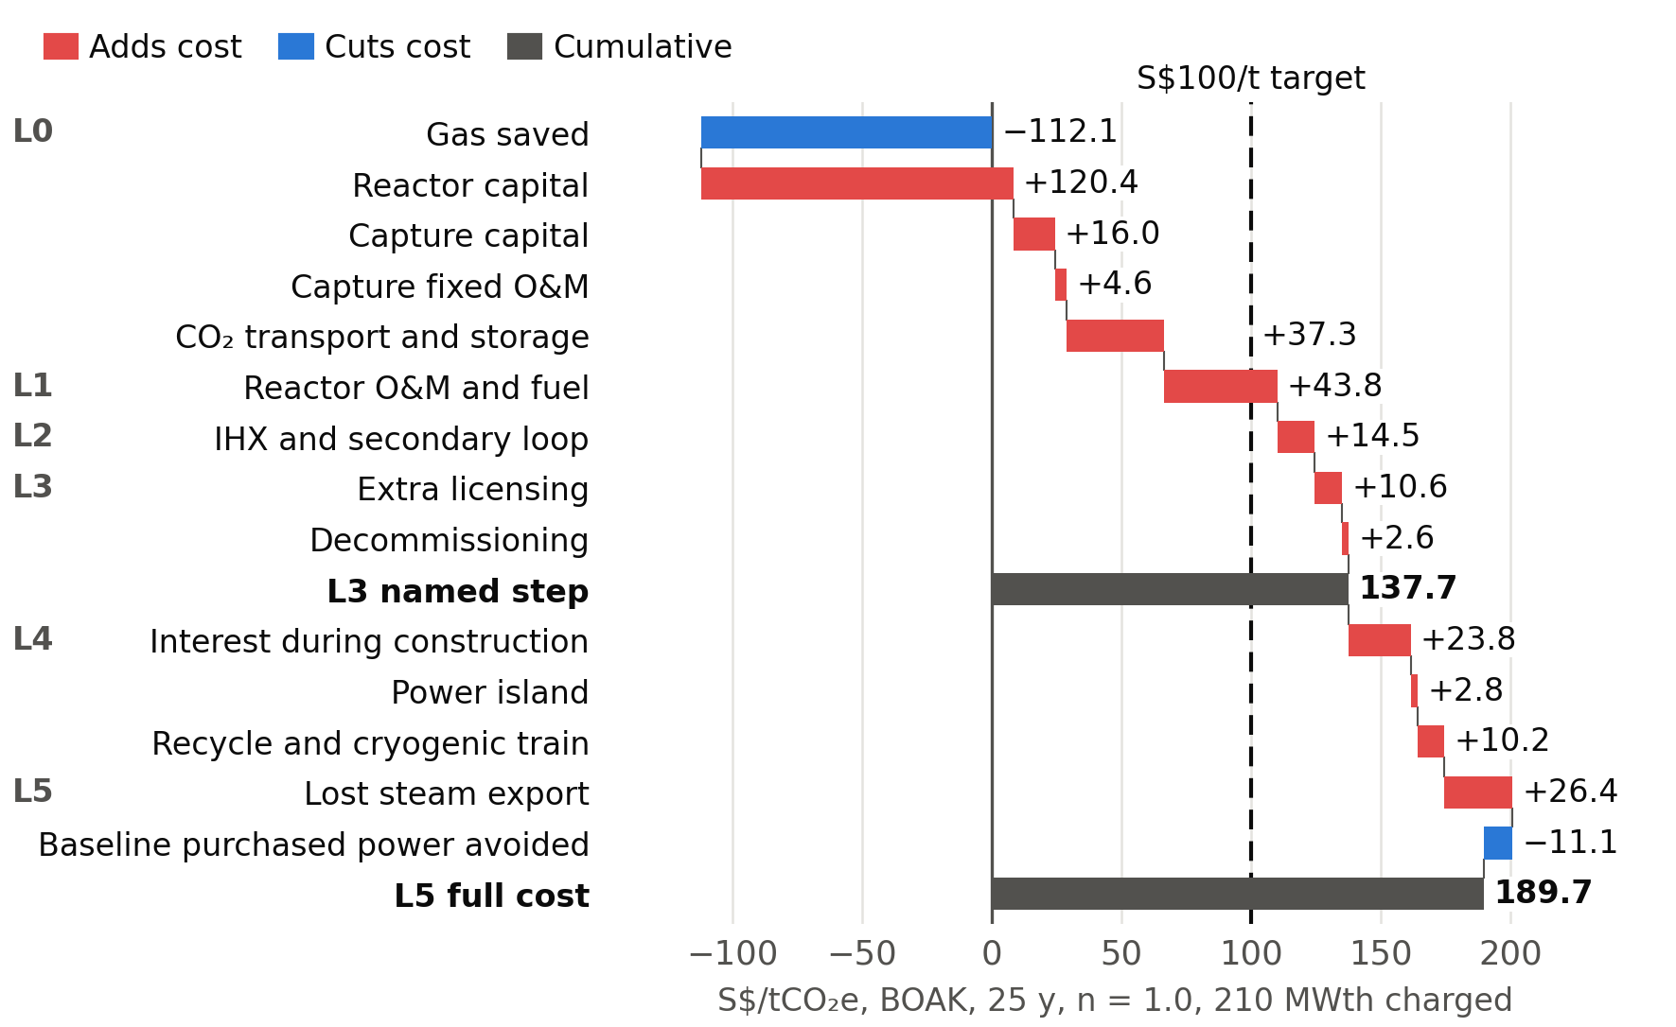
Figure D2. Cost ladder at BOAK, 25 $\text{y}$, in $\text{S\$/}{\text{tCO}}_{\text{2}}\text{e}$, with L3 as a named step.
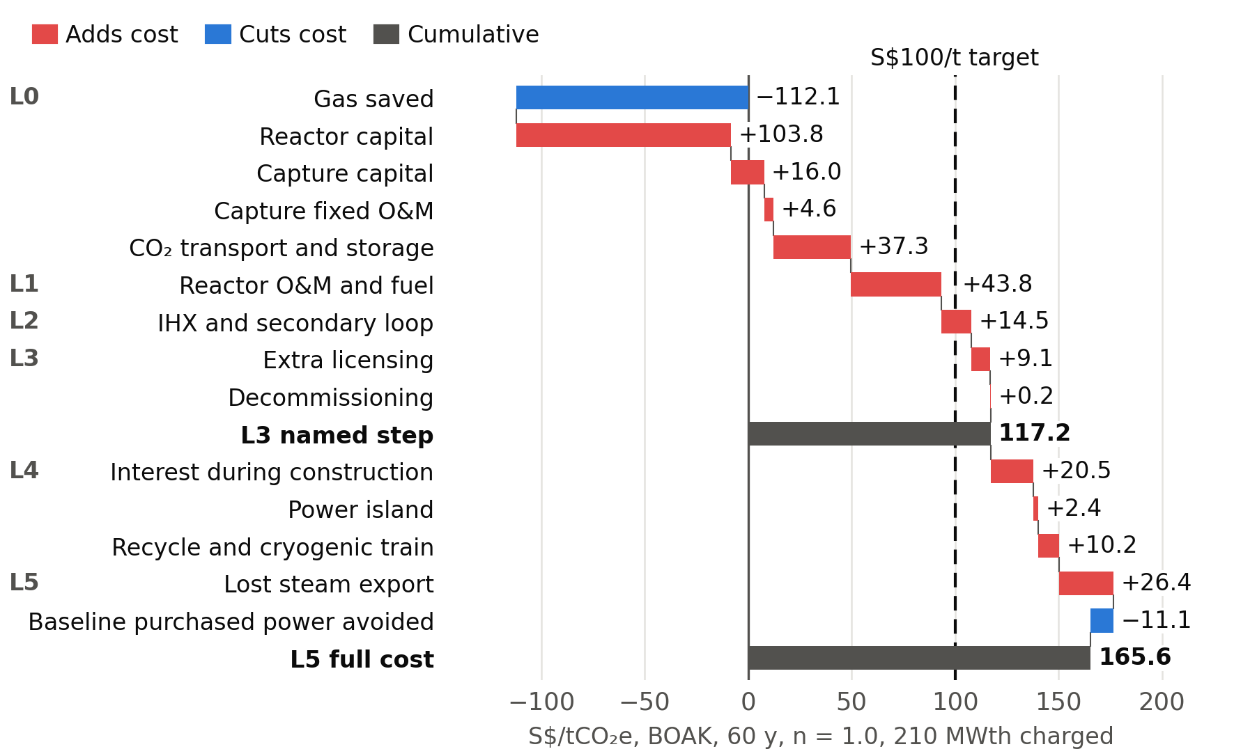
Figure D3. Cost ladder at BOAK, 60 $\text{y}$, in $\text{S\$/}{\text{tCO}}_{\text{2}}\text{e}$, with L3 as a named step.

Appendix E. Model status
This appendix prints only what ran. Each result row carries a status. On the headline preset, term T05, the syngas heat recovered above 130$\text{°C}$, runs on its gated model, and every other term keeps its anchored value: an algebraic balance anchored on INL cases and reproduced in the Rust engine. The rows of the six results tables hold 1,571 anchored rows, 1,800 rows that move with term T05 and 67 rows of the preset that also takes term T01 from its model. Unit models give 2 gas-unit rows and 4 reformer-tube rows, and the column models give 8 rows whose terms keep their anchored values because the column gate failed. The rest are 350 Level 3 flowsheet rows, 99 sensitivity rows that rest on a flowsheet result, 120 heat-recovery rows, 231 input rows and 9 rows not run. PSA streams are external boundary values, and the 39.7% conversion, availability and capture fraction are fixed assumptions.
The validation file records 650 rows: 325 pass, 32 fail, 251 are reported with no limit and 42 did not run. 360 rows use independent data, 269 share a dataset with the model and 21 are calibration, so a pass on a shared dataset verifies code and validates no physics. Table E1 groups the rows by level.
Table E1. Validation rows by level, generated from the validation results. Reported rows print a value with no limit.
Level | Rows | Pass | Fail | Reported | Not run | Independent
1. Properties, equilibria and solvent model | 207 | 189 | 6 | 4 | 8 | 78
2. Unit benchmarks against published data | 345 | 55 | 14 | 247 | 29 | 280
3. Level 3 flowsheet | 28 | 20 | 5 | 0 | 3 | 2
4. Screening reproduction, sizing walk and term gates | 47 | 38 | 7 | 0 | 2 | 0
5. Cost grid, DCF and headline checks | 21 | 21 | 0 | 0 | 0 | 0
6. Export and parameter checks | 2 | 2 | 0 | 0 | 0 | 0
All rows | 650 | 325 | 32 | 251 | 42 | 360

Table E2 lists the thirteen model terms. A term leaves its anchored value only when its gate passes. The column gate failed on six benchmark rows, among them the high-pressure absorber pilot at 72.6% removal against 85% and the two SRD rows of Section 2.3, so the capture terms stay anchored. The Level 3 flowsheet failed its carbon gate: reformer tube carbon is 4.9% below the anchor and tail-gas carbon 19.7% below, so the recycle, compression and gas terms stay anchored. Two gates could not run: the upstream preheat behind the process heat term rests on Case 6 stream states the library lacks, and no measured helium-side pressure drop exists for the secondary circulator.
Table E2. Model terms on the headline preset. A term uses its model only when its gate passes; the carbon split passed and is used on the modelled preset alone.
Term | Quantity | Gate | Result | Headline value | Source
T01 | Carbon split after shift | Gas-train benchmarks | Passed | 0.775 | Anchored
T02 | Per-pass capture | Column benchmarks | Failed | 0.9 | Anchored
T03 | Process heat | Gas-train benchmarks | Not run | 120.80 $\text{MW}$ | Anchored
T04 | Recycle slip heat | Flowsheet carbon | Failed | 0.88 $\text{MW}$ | Anchored
T05 | Syngas heat above 130$\text{°C}$ | Gas-train benchmarks | Passed | 8.39 $\text{MW}$ | Model
T06 | Specific reboiler duty | Column benchmarks | Failed | 3.8 $\text{GJ }{\text{tCO}}_{\text{2}}^{-\text{1}}$ | Anchored
T07 | Lean pump | Column benchmarks | Failed | 0.87 ${\text{MW}}_{\text{e}}$ | Anchored
T08 | MEA cooling load | Column benchmarks | Failed | 0.77 ${\text{MW}}_{\text{e}}$ | Anchored
T09 | ${\text{CO}}_{\text{2}}$ compression | Flowsheet carbon | Failed | 4.25 ${\text{MW}}_{\text{e}}$ | Anchored
T10 | Secondary circulator pressure drop | Helium pressure drop | Not run | 200 $\text{kPa}$ | Anchored
T11 | Primary circulator pressure drop | None | No gate | 150 $\text{kPa}$ | Anchored
T12 | Losses | None | No gate | 3.95 $\text{MW}$ | Anchored
T13 | Natural gas | Flowsheet carbon | Failed | 23.2 $\text{MMSCFD}$ | Anchored

Two open heat terms move the reactor need. The higher secondary helium pressure drop in the sweep raises it to 184.7 ${\text{MW}}_{\text{th}}$, and reading the 39.7% conversion as already net of primary circulation lowers it to 172.0 ${\text{MW}}_{\text{th}}$. Circulator power has no measured basis, and 85% availability has no measured HTGR record behind it.

