METEO 597 Assignment 1: Optimal Interpolation (Due by 11pm on February 19)
We will work through a simple data assimilation example using both hand calculation and MATLAB programming.
Define the state space of three grid points representing the temperature at Pittsburgh, State College and New York City, let’s label them as x₁, x₂ and x₃, respectively. Pittsburgh is 140 miles away from State College, and New York City is 240 miles from State College.
Model forecast predicted the temperatures to be 18 C at Pittsburgh, 15 C at State College, and 20 C at New York City. Let’s assume the forecast error uncertainties are $±$2 C at each grid point. The error correlations are 0.8 between Pittsburgh and State College, 0.2 between Pittsburgh and New York City, and 0.5 between State College and New York City.
Now we have temperature observations of 16 C at Pittsburgh and 17 C at State College. We assume the observation errors are uncorrelated and their uncertainties are $±1$ C.
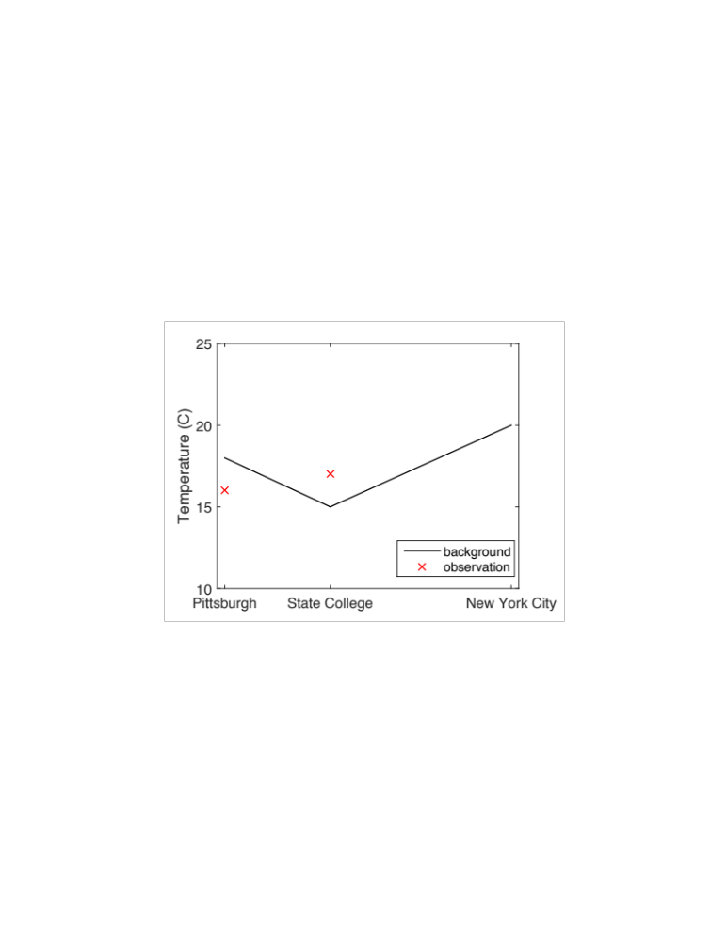
1. Write down the optimal interpolation equation (matrix form) for the temperature analyses. For each component of the equation, indicate their dimensionality for this example.
2. Now calculate by hand the value of each matrix, given the information above. Find the temperature analyses at each grid point. What is the temperature variance before/after assimilation at State College?
3. Write a piece of MATLAB code to repeat the calculation. Visualize your result in a plot similar to the one above (add your analysis curve). Check if results match with hand calculation.
4. What is the sign of the analysis increment at New York? Without changing observation and background values, is there a way to get the analysis increment at New York to change sign?
5. If you double the observation error standard deviation, how do results change? Why?
6. If background errors are not correlated (between grid points), how do results change? Why?
7. Add an observation at Altoona (100 miles from Pittsburgh and 40 miles from State College) of 18$±1$ C. Assume observation errors are not correlated. Use linear interpolation in H operator. Plot the results assimilating three observations.
8. Repeat 3 with sequential assimilation algorithm (no need for hand calculation), does the sequential method give the same results as the original equation?
Bonus question: In 3, if observation errors are correlated (correlation coefficient is 0.6), how are the analyses different from the case with no observation error correlation? Why?
Note: for questions 3 and 8, include plots to illustrate your answer; also include your code for questions 3 and 8.

