METEO 527 Assignment 2: 3DVar for Lorenz-96 system (Due by 11pm on March 15)
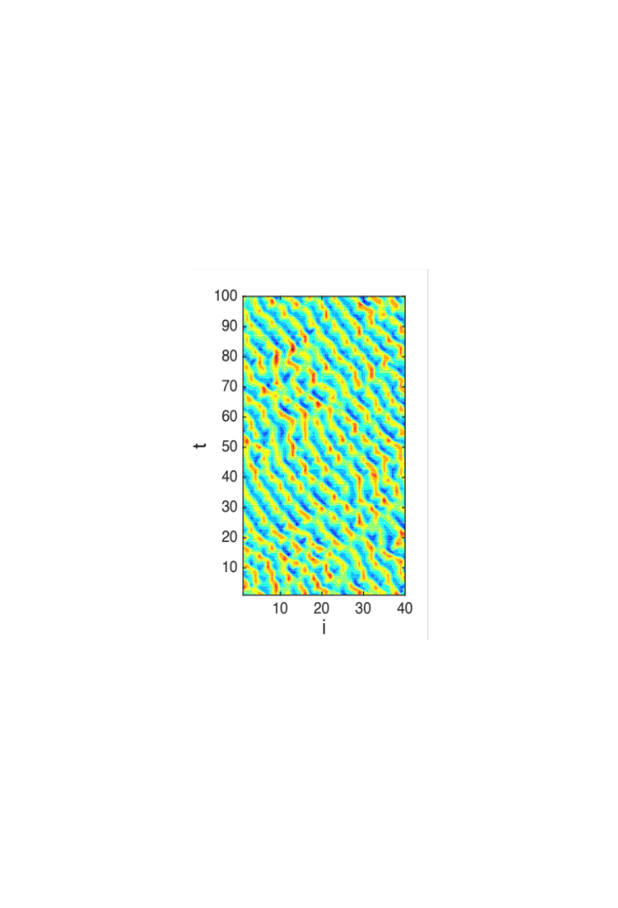
In this assignment, we will write computer code to perform an Observing System Simulation Experiment (OSSE) using the Lorenz (1996) model. Model domain is defined on a cyclic grid indexed by i = 1, 2, …, n. The governing equation is
$\frac{dx_{i}}{dt}=\left(x_{i+1}-x_{i-2}\right)x_{i-1}-x_{i}+F$,
Let n = 40, and F = 8. To integrate the model, use Euler forward discretization scheme in time with time step dt = 0.005. Initialize the model with a random white noise field $x\sim N\left(0, I\right)$, integrate forward for 1000 time steps to yield a typical model solution. We will use this solution as our initial condition.
Starting from the initial condition, create a truth $x^{tr}$ (nature run) of 100 cycles, each cycle containing 40 time steps. Let t denote the number of cycles. Now plot the Hovmöller diagram of model solution, your result should look like the figure to the right.
Now let’s generate synthetic observations from the truth. At each cycle, all variables are observed (H = I), and observation errors are randomly drawn, $y^{o}\sim N\left(x^{tr},σ_{o}^{2}I\right)$, $σ_{o}$=0.3. Perturb the truth state at the first cycle, $x_{t=1}^{b}\sim N\left(x_{t=1}^{tr},σ_{b}^{2}I\right)$, $σ_{b}$=1, to yield a first guess (background). Run a free forecast from $x_{t=1}^{b}$ to the last cycle, and we call this free forecast the “NoDA” case. Save a copy of $x^{tr}$, $y^{o}$, $x_{t=1}^{b}$, and $x^{NoDA}$ for repeated use in later experiments.
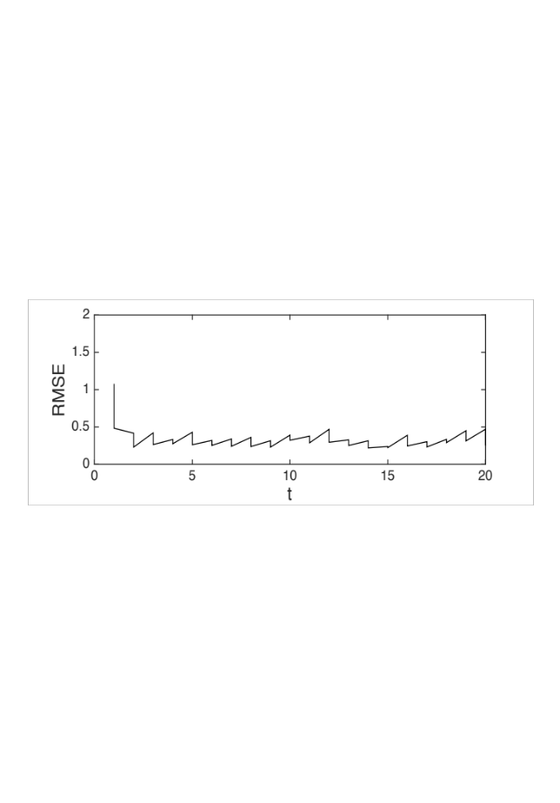
To model background error covariance B, we assume equal error variance $σ_{b}^{2}$ at each grid point, and a correlation function $ρ_{ij}=\exp\left(-d_{ij}^{2}/2l^{2}\right)$, where $d_{ij}$ is the distance between grid i and j, and l is a tunable length scale (let the grid spacing be 1 distance unit).
Now perform a control experiment (CNTL), let H = I, $σ_{o}$ = 0.3, $σ_{b}$= 1.0, and l = 1. Use the OI update equation as a benchmark, perform 100 data assimilation cycles and make a saw tooth graph of domain-averaged root-mean-square errors, RMSE = $\sqrt{\frac{1}{n}\sum_{i=1}^{n}{{\left(x_{i}^{b, a}-x_{i}^{tr}\right)}^{2}}}$, similar to the figure to the right.
1. Demonstrate the chaotic behavior of L96 model solution. Plot the time series of RMSE for NoDA. Compare error growth behavior when initial perturbation is reduced from $σ_{b}$= 1 to 0.01, then to 0.0001.
2. Implement 3DVar with preconditioning and a minimization algorithm. There is no need for outer loop because the H operator is already linear. Debug your code, and make sure 3DVar assimilation results are the same as OI update. In your answer, include a saw tooth graph of RMSEs from CNTL and NoDA, as well as a copy of your code.
3. Change the background error variance $σ_{b}$ and repeat the experiment. Test a range of $σ_{b}$ values from 0.1 to 10. How does the choice of $σ_{b}$ influence analysis accuracy? Plot the time-averaged RMSEs from each case with respect to $σ_{b}$, and interpret your results.
4. How does observation density influence assimilation results? Consider a uniform network observing every k grid points. Test for the cases k = 1, 2, 4, and 8, and interpret your results.
Bonus question: How does correlation length l influence assimilation results? Test for the cases l = 1, 2, 3, 4, and 5. What do the results inform about the true correlation structure?

