Putney High Street Dataset
There are three sensors. I have highlighted 100 minutes from 8am from the first day. There is measurements in NO2 and CO. The three sensor are labelled (352, 355, 356)
I have shown some graphs from the AirNode software analysis.
356 Sensor
NO2
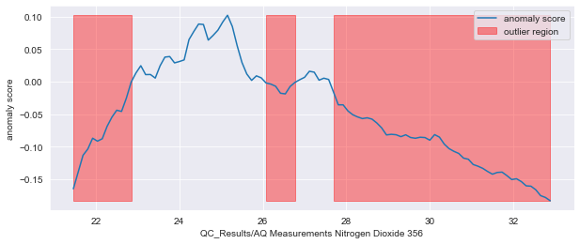
This graph plots the anomaly score of measurements for the timestamps on the x axis.
It highlights areas that have potential outliers. It highlights measurements which change and lead to outliers. This shows the prediction of the AQ levels and true AQ measurements for last 16 minutes of 100 minutes. 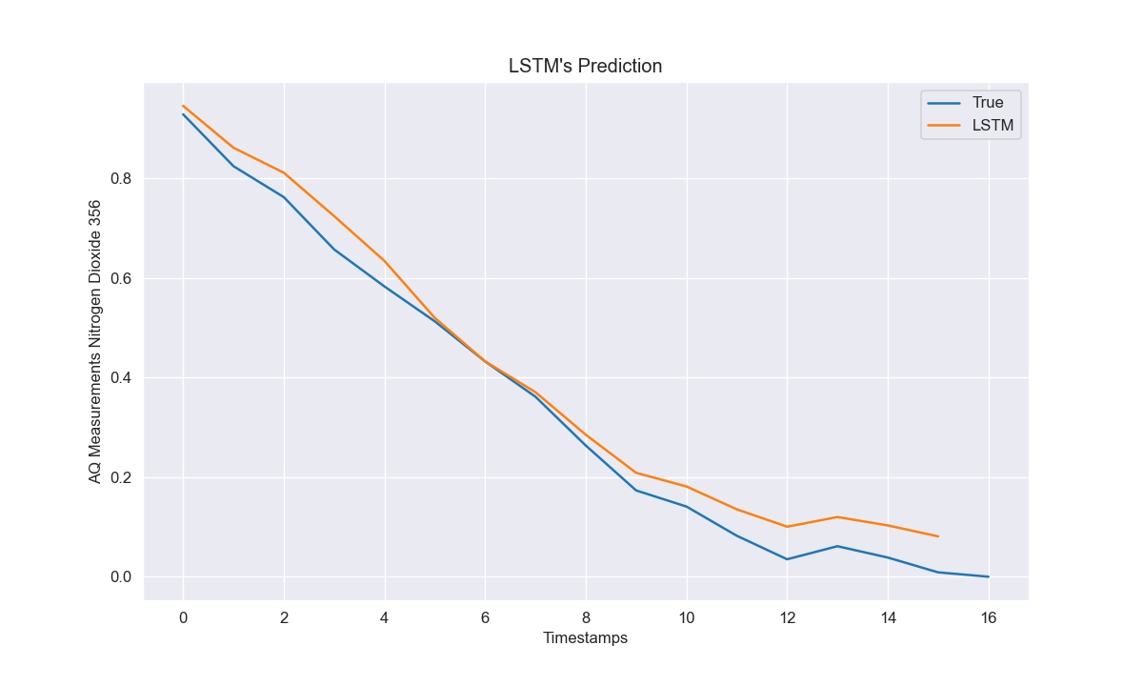
CO
This shows the prediction of AQ levels from a neural network for the last 16 minutes of the 100 minutes.
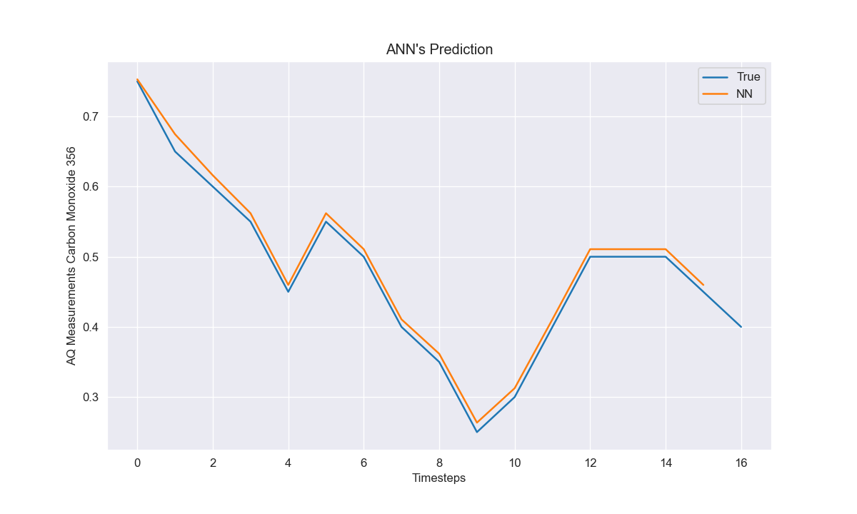
355 Sensor
CO
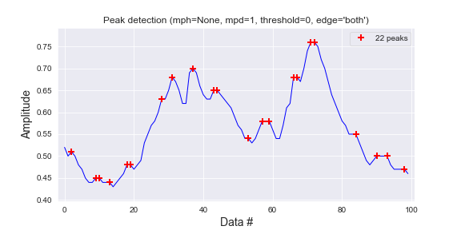
This graph shows the peak in the AQ measurements.
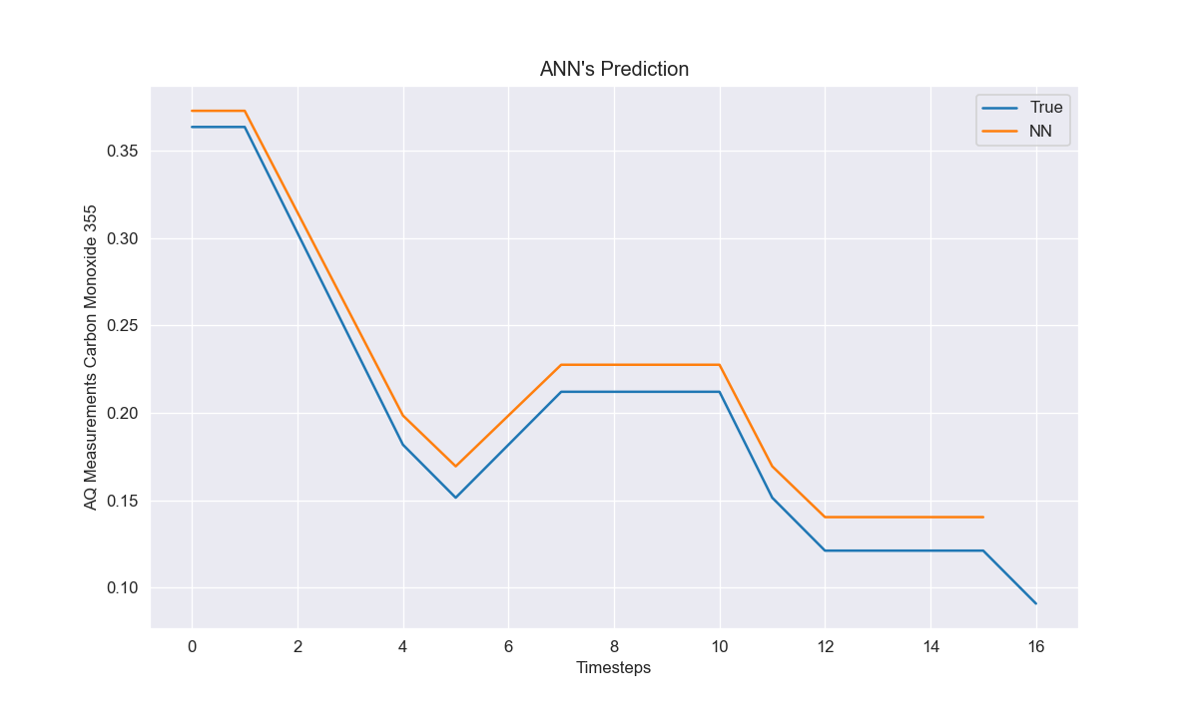
This graph predicts the AQ levels using a neural network. The results show that the pattern of the prediction is same as the true measurements.
352 Sensor
NO2
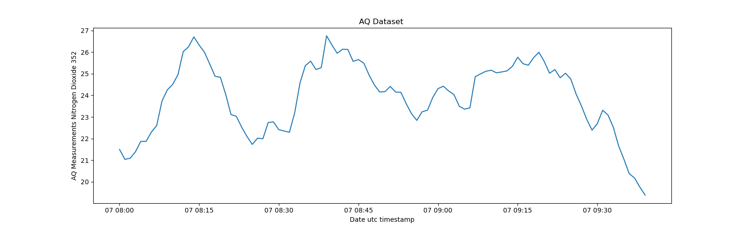
This is the AQ measurements for NO2 from 8am for 100 minutes.
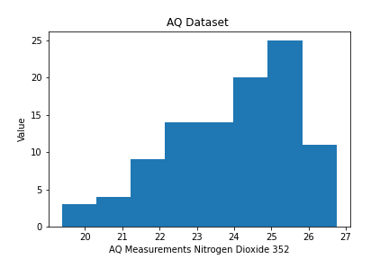
This is the histogram of the AQ measurements

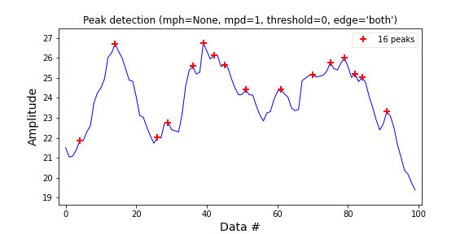
This highlights the peaks in the AQ measurements
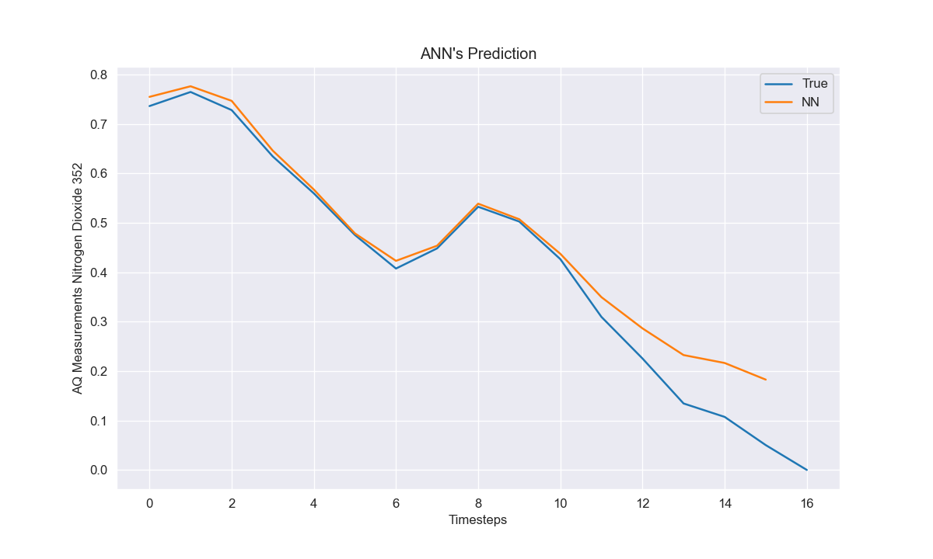
This graph shows the prediction for the last 16 minutes of 100 minutes using a neural network
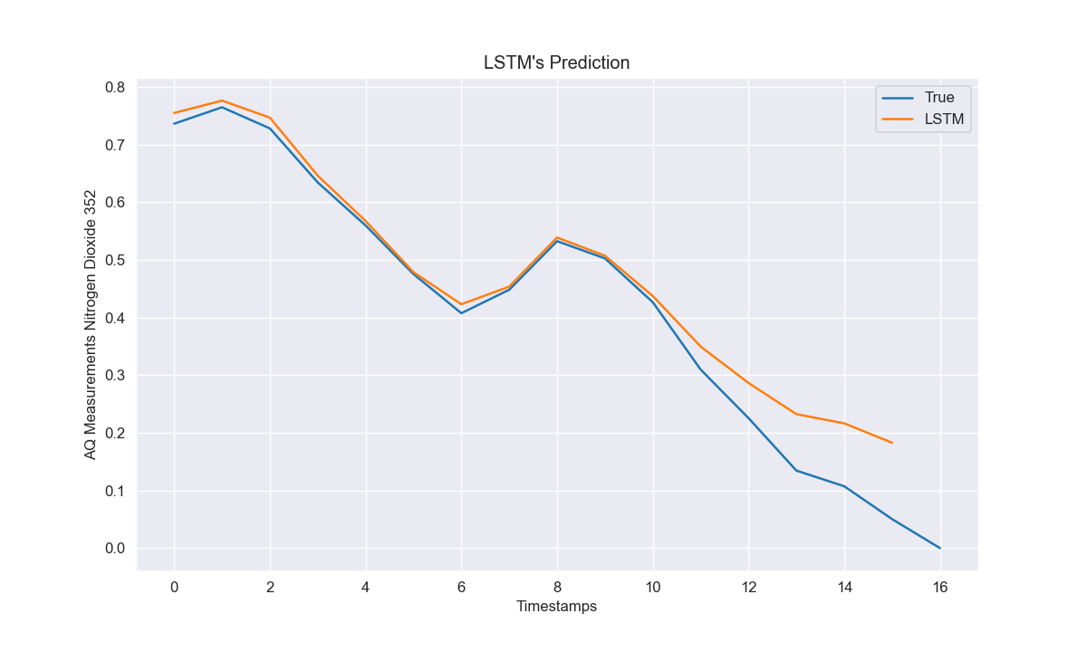
This graph show the predictions for the last 16 mins of the 100 minutes.

CO
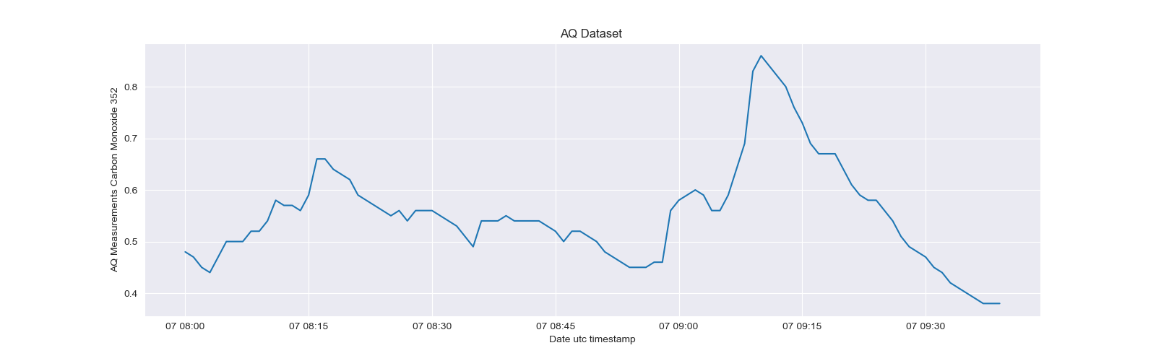
This graph shows the AQ measurements with a large peak around rush hour of 9.15am.
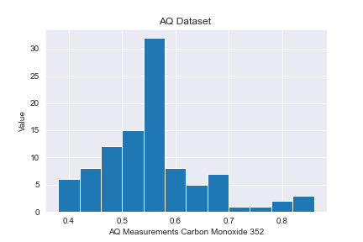
This graph show the distribution of AQ measurements with majority at 30 µg/m.
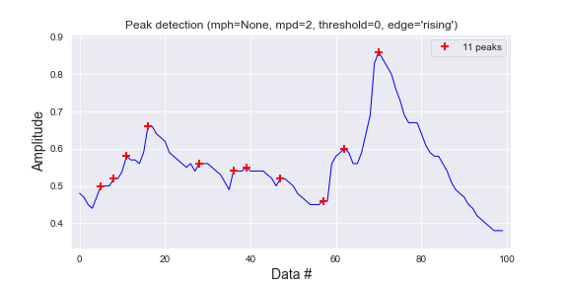
This graph automatically picks out the peak AQ measurements. This can be useful when needing to find peak AQ levels to link to the causation. It is over 100 minutes from 8 am.

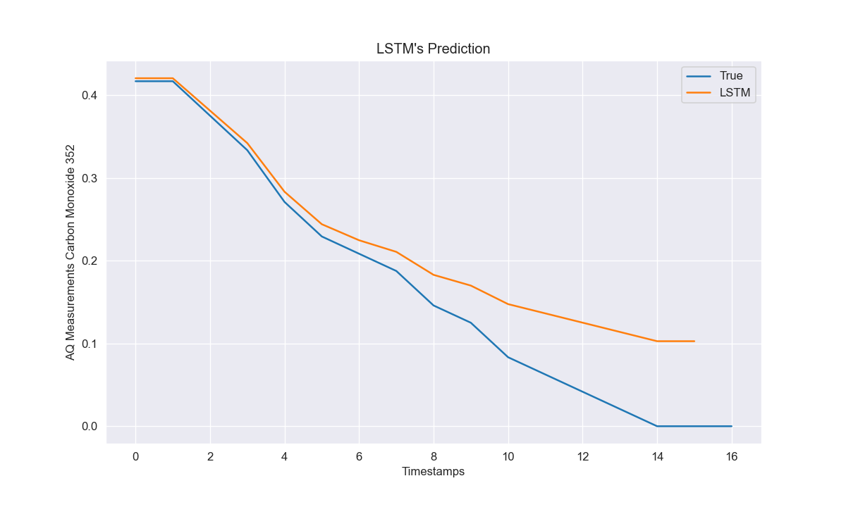
This graph show predictions compared to the true AQ measurements for last 16 minutes timestamps using the LSTM methods.

