WP4 Lesson Plans Guidance
Lessons on air pollution and its effects can be linked to the National Curriculum in science, PHSE or citizenship, English and geography. Teachers can hold clean air assemblies, and encourage pupils to talk to their parent and write to their MP, MSP, AM or local councillors. Some councils are now working centrally to reduce air pollution around schools. It’s worth approaching your council to find out what’s being done in your area.
Lesson Ideas
Links to curriculum
English
• Years 5 and 6 programme of study: Pupils should be taught to plan their writing by identifying the audience and purpose of the writing, selecting the appropriate form and using other similar writing as models for their own.
• Years 3 and 4 programme of study: Pupils should continue to have opportunities to write for a range of real purposes and audiences as part of their work across the curriculum.
Science
• Year 4 programme of study: Living things and their habitats: Recognise that environments can change which can sometimes pose dangers to living things. Pupils should explore examples of human impact (both positive and negative) on environments. States of matter: Compare and group materials together, according to whether they are solids, liquids or gases.
• Year 2 programme of study Animals including humans Find out about and describe the basic needs of animals, including humans, for survival (water, food and air).
Lesson 1
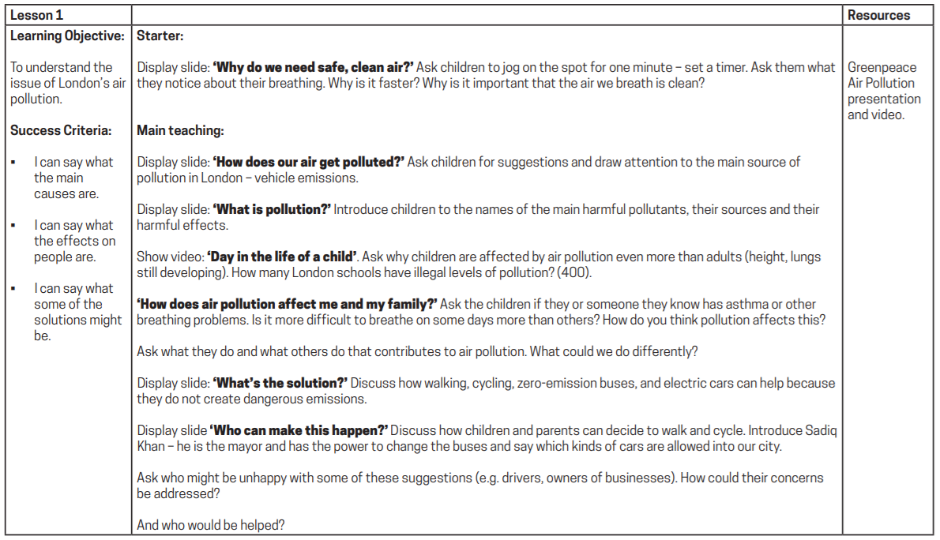
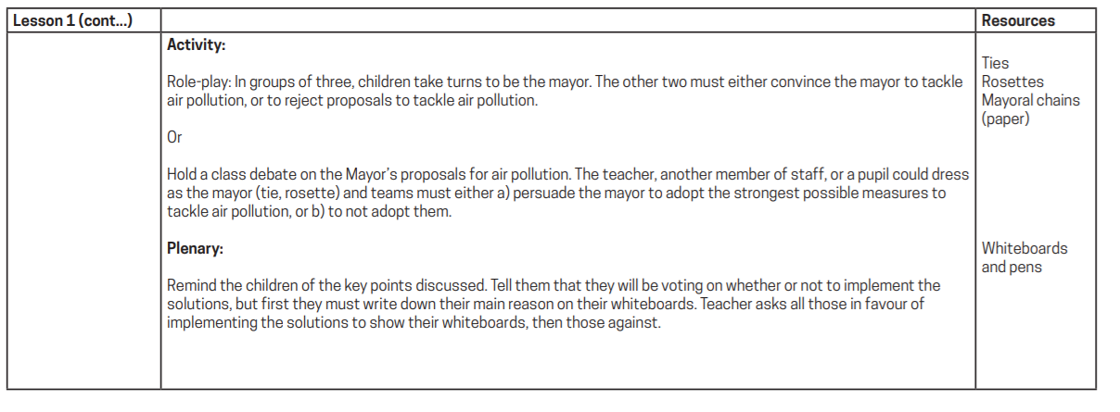

Resources for teachers
• The Clean Air Parents’ Network has campaign resources for parents, carers and schools to use, including a map of polluted schools. https://www.clientearth.org/latest/documents/clean-air-parents-network-london-mayoral-election-2021-summary-of-manifestos/
• Greenpeace offer an Air Pollution teaching pack for KS2. https://www.eco-schools.org.uk/wp-content/uploads/2016/11/Air-Pollution-Teachers-Pack.pdf
• Living Streets has produced a report on the benefits of active travel on the school run.
• Find out about what’s being done in London to clean up pollution around schools for ideas and inspiration for your area.

