MINDPULSE: AI-Enhanced IoT Multimodal Stress Management System
INDIVIDUAL THESIS
Wehara Soyza
IT22060594
Individual component: AI-DRIVEN PERSONALIZED STRESS ​​
DETECTION USING MULTIMODAL HRV AND GSR​ SIGNALS​
R26-DS-016
Report submitted in partial fulfilment of the requirements for the
Bachelor of Science (Hons) in Information Technology
Data Science
Department of Computer Science
Sri Lanka Institute of Information Technology
Sri Lanka
2026.10.11

DECLARATION AND SUPERVISOR CERTIFICATION
Candidate declaration. I declare that this thesis is my own work and does not incorporate, without acknowledgement, material previously submitted for a degree or diploma at any university or institute of higher learning. To the best of my knowledge, it contains no material previously published or written by another person except where acknowledgement is made in the text. I grant the Sri Lanka Institute of Information Technology the non-exclusive right to reproduce and distribute this thesis, in whole or in part, in print, electronic, or other media, while retaining the right to use the content in future work.
Academic integrity and AI disclosure. I have disclosed all use of generative AI and other automated tools in accordance with the module policy (Appendix B). I remain responsible for the accuracy, originality, citations, code, data, analyses, and conclusions in this thesis.
Student name: Wehara Soyza
Student ID: IT22060594

Signature: Date: 2026.10.10
Supervisor certification. The above candidate carried out this research for the bachelor's degree thesis under my supervision.
Role and name | Signature | Date
Supervisor: Dr. Mahima Weerasinghe
Co-supervisor: Dr. Junius Anjana
Abstract
Stress is difficult to notice early, and most wearable stress detectors judge every wearer against one population threshold. This individual component of the MindPulse multimodal system develops a personalised stress detector for a low-cost smart ring that carries a pulse sensor (MAX30102), a galvanic skin response (GSR) sensor and an accelerometer. A binary Normal/Stress XGBoost classifier was trained on 913 sixty-second windows from the 15 subjects of the WESAD dataset, using 23 heart-rate-variability (HRV), electrodermal and motion features, and was chosen from ten classifiers under leave-one-subject-out (LOSO) validation, where it reached 85.1% accuracy and an AUC of 0.938 on raw features. Because the system scores each wearer against their own baseline, the model was then trained on baseline-normalized features; under LOSO validation this reached 94.5% accuracy, a macro F1 of 0.939 and an AUC of 0.986 at a ROC-derived threshold of 0.6447 (93.4% at the default 0.5 cut-off). Personalization was built in layers: a 3.5-minute calm-breathing baseline, an eight-minute cognitive battery that sets a personal stress threshold only when the user's rest and task scores differ by at least 0.10, exponential-moving-average baseline updates at recalibration, a seven-day drift check, and a feature-voting trend indicator. The trend indicator detected stress onset in all 15 WESAD subjects within six windows, against 63% expected by chance, at an 18% false-alarm rate in calm windows. Checking the pipeline end to end exposed a mismatch between the first model's training features and its baseline-normalized inputs, which was corrected by retraining. The component is delivered through Flask services, a Firebase database, a mobile application and a web dashboard that present a plain-language stress state. The work shows both the value of personalization and the need to validate the deployed pipeline, not only the offline experiment.
Keywords: stress detection, heart-rate variability, electrodermal activity, personalisation, wearable sensors
ACKNOWLEDGEMENTS
I would like to express my sincere gratitude to my supervisor, Dr. Mahima Weerasinghe, and my co-supervisor, Dr. Junius Anjana, for their guidance, feedback and encouragement throughout this research. Their advice shaped the scope of this component and the way its results are validated.
I thank my group members, K. A. H. N. Jayasekara (IT22064868, stress detection using temporal EEG channels), U. C. P. Unagalle (IT22555144, stress detection using smartphone-based behavioral digital phenotyping), and A. O. N. Jayasinghe (IT22084040, context-aware personalized intervention system), whose components this work integrates with, and the participants who wore the ring and tested the system. I am also grateful to the Department of Information Technology of the Sri Lanka Institute of Information Technology for the facilities that made this work possible.
Contents
1 INTRODUCTION 1
1.1 Overall Project Context 1
1.2 Individual Component Context 1
1.3 Problem Statement 1
1.4 Research Gap 2
1.5 Aim and Objectives 2
1.6 Research Questions 3
1.7 Scope, Limitations and Assumptions 3
1.8 Individual Contribution 3
1.9 Thesis Structure 4
2 LITERATURE REVIEW AND RELATED WORK 5
2.1 Review Method and Scope 5
2.2 Domain and Theoretical Foundations 5
2.2.1 Physiology of stress 5
2.2.2 Heart-rate variability features 6
2.2.3 Electrodermal activity features 6
2.2.4 The WESAD dataset and stress induction 6
2.2.5 Evaluation and decision thresholds 7
2.3 Related Research 7
2.3.1 Wearable stress detection with HRV and EDA 7
2.3.3 Personalisation and inter-subject variability 8
2.3.4 Confounders and real-life performance 8
2.3.5 Low-cost IoT systems 8
2.3.6 Reviews and methodological observations 9
2.4 Existing Systems, Products and Techniques 11
2.5 Gap Synthesis and Conceptual Framework 12
3 RESEARCH METHODOLOGY 14
3.1 Research Design 14
3.2 Data, Participants and Study Materials 14
3.2.1 WESAD training data 14
3.2.2 Ring data 15
3.3 Experimental or Study Procedure 15
3.3.1 Signal processing and feature extraction 15
3.3.2 Feature selection 16
3.3.3 Model comparison and decision threshold 17
3.3.4 Personalisation procedure 17
3.3.5 Validation procedures 19
3.4 Measures and Evaluation Metrics 20
3.5 Data Analysis 20
3.6 Ethics, Privacy, Security and Responsible AI 20
3.7 Reproducibility and Research Artefacts 21
4 PRODUCT AND SOLUTION DESIGN 22
4.1 Requirements 22
4.2 Component Architecture within the Complete Solution 23
4.3 Design Alternatives and Decisions 23
4.4 Detailed Design 24
4.4.1 Signal processing and decision logic 24
4.4.2 Data model 24
4.4.3 Backend services 24
4.4.4 Interface design 25
4.5 Standards and Professional Practice 27
5 IMPLEMENTATION, INTEGRATION AND TESTING 28
5.1 Development Environment and Technology Stack 28
5.2 Component Implementation 29
5.2.1 Feature extraction and scoring 29
5.2.2 Calibration 29
5.2.3 Processed signal storage 29
5.2.4 Interfaces 29
5.3 Integration with the Other Components 30
5.4 Verification and Software Testing 30
5.4.1 Offline experiments 30
5.4.2 Software testing 30
5.4.3 Findings of the verification 30
5.5 Deployment and Operation 32
6 RESULTS AND VALIDATION 33
6.1 Research Results 33
6.1.1 Model comparison (RQ1) 33
6.1.2 Personalization of the baseline (RQ2) 36
6.1.3 Cross-dataset check 37
6.1.4 Personal thresholds on real ring data (RQ2) 37
6.1.5 Trend indicator (RQ3) 38
6.2 Product and Technical Results 39
6.3 User or Stakeholder Validation 39
6.4 Integration Results 39
6.5 Summary of Findings 40
7 DISCUSSION 41
7.1 Interpretation of Findings 41
7.2 Comparison with Literature Baselines and Existing Solutions 42
7.3 Research Contribution 42
7.4 Product Contribution 43
7.5 Limitations and Threats to Validity 43
7.6 Implications 44
8 COMMERCIALISATION AND SUSTAINABILITY 45
8.1 Value Proposition and Target Users 45
8.2 Market and Competitive Position 45
8.3 Business or Sustainability Model 45
8.4 Scalability, Intellectual Property and Compliance 45
8.5 Contribution to the Sustainable Development Goals 46
9 CONCLUSION AND FUTURE DIRECTIONS 47
9.1 Conclusion 47
9.2 Achievement of Objectives 47
9.3 Individual Research and Product Contributions 48
9.4 Future Directions 48
REFERENCES 49
GLOSSARY 53
APPENDIX A: RESEARCH INSTRUMENTS AND EXTENDED RESULTS 54
A.1 Per-class classification report of the deployed model 54
A.2 Personalisation experiment: personal-baseline model 54
A.3 Trend indicator: results per subject at the deployed threshold (0.35) 54
A.4 Feature selection summary 55
A.5 Research artefacts 55

APPENDIX B: ACADEMIC INTEGRITY AND AI USE DISCLOSURE 56

LIST OF FIGURES
Figure 2.1: Conceptual framework of the personalised stress detector 13
Figure 3.1: Signal processing and feature extraction for one 60-second window 16
Figure 3.2: Calibration and personal-threshold procedure 17
Figure 4.1: System architecture and data flow of the ring component 23
Figure 4.2: Home screen of the mobile application 25
Figure 4.3: Ring screen with the Stress, Heart and Skin chart 26
Figure 4.4: Calm-breathing calibration with progress ring and per-device progress 26
Figure 4.5: Baseline-change card on the home screen 27
Figure 6.1: Accuracy, balanced accuracy and recall gap of ten classifiers under LOSO validation 34
Figure 6.2: Pooled LOSO evaluation of the deployed model: confusion matrix, ROC curve, feature importance and summary 35
Figure 6.4: Personal thresholds produced on real ring data compared with the population threshold 37

LIST OF TABLES
Table | Title | Page
Table 2.1 | Summary of the main studies reviewed | 11
Table 2.2 | Research gaps, supporting evidence and the response in this component | 12
Table 3.1 | Window statistics of the WESAD training table | 14
Table 3.2 | The 23 deployed features by category | 16
Table 3.3 | The cognitive battery used to find the personal threshold | 18
Table 4.1 | Functional and non-functional requirements of the ring component | 22
Table 5.1 | Technology stack of the ring component | 28
Table 5.2 | Train–serve inconsistencies found during verification | 31
Table 6.1 | Ten classifiers under LOSO validation (913 windows, 15 subjects) | 33
Table 6.2 | Pooled LOSO confusion matrix of the deployed (baseline-normalised) XGBoost model at threshold 0.6447 | 35
Table 6.3 | Static versus personal-baseline model under LOSO (both at the 0.5 cut-off) | 37
Table 6.4 | Trend indicator versus vote threshold on WESAD (15 subjects) | 39
Table 9.1 | Achievement of the objectives | 48
Table A.1 | Pooled LOSO report of the deployed (baseline-normalised) XGBoost model at threshold 0.6447 (913 windows) | 55
Table A.2 | Pooled LOSO report of the baseline-normalised model at the 0.5 cut-off | 55
Table A.3 | Per-subject trend-indicator results on WESAD | 55
Table B.1 | Generative AI use in this work | 57

LIST OF ABBREVIATIONS
Abbreviation | Description
ACC | Accelerometer
API | Application Programming Interface
AUC | Area Under the (ROC) Curve
AVNN | Average of Normal-to-Normal intervals
CORS | Cross-Origin Resource Sharing
ECG | Electrocardiogram
EDA | Electrodermal Activity
EEG | Electroencephalography
EMA | Exponential Moving Average
GSR | Galvanic Skin Response
HRV | Heart Rate Variability
IBI | Inter-Beat Interval
IoT | Internet of Things
LDA | Linear Discriminant Analysis
LOSO | Leave-One-Subject-Out
MQTT | Message Queuing Telemetry Transport
PPG | Photoplethysmography
PSS | Perceived Stress Scale
ROC | Receiver Operating Characteristic
RTDB | Realtime Database (Firebase)
SCL | Skin Conductance Level
SCR | Skin Conductance Response
SUS | System Usability Scale
SWELL | SWELL knowledge-work dataset
TSST | Trier Social Stress Test
WESAD | Wearable Stress and Affect Detection (dataset)
XGBoost | Extreme Gradient Boosting
LIST OF APPENDICES
Appendix A Research instruments and extended results
Appendix B Academic integrity and AI use disclosure

1 INTRODUCTION

1.1 Overall Project Context
Stress is one of the most common and costly health burdens of modern life. Prolonged, unmanaged stress contributes to cardiovascular disease, sleep disruption and anxiety and depressive disorders, yet it builds up gradually and is often invisible to the person experiencing it until symptoms are severe [1], [2]. Tools that surface a person's stress state continuously and understandably, ideally before it fully develops, could support earlier self-management.
MindPulse is an AI-Enhanced IoT Multimodal Stress Management System​ developed by a four-member group. It combines four components. A smart ring measures heart-rate variability (HRV), skin conductance and motion. An EEG headband estimates cognitive load. A phone-behaviour component analyses typing and scrolling patterns. A relaxation guide delivers breathing exercises, audio and games. A fusion engine combines the ring and EEG probabilities into one stress state, and a mobile application and a web dashboard present that state to the wearer. The guiding idea is that every signal is judged against the wearer's own calibrated baseline and threshold, rather than against a population average.

1.2 Individual Component Context
This thesis reports the physiological component: stress detection from the smart ring. The component covers the signal processing and feature extraction for the ring's heart-rate and skin-conductance signals, a stress classifier trained on a public dataset, the personalisation layers that adapt the classifier to each wearer, a trend indicator for rising stress, the backend services that run the pipeline, and the user and clinical interfaces for the ring's results. Its output, a "Body" probability judged against the wearer's own threshold, is one of the two inputs to the fusion engine.

1.3 Problem Statement
Physiological stress responses differ greatly between people, and between devices. A model trained in a laboratory on one set of sensors is applied here to a different, low-cost ring worn by a different person. A single population decision threshold therefore risks two failures: missing real stress for some wearers and raising false alarms for others.

1.4 Research Gap
The reviewed literature reports strong subject-independent results on the WESAD dataset [3]–[5] and several low-cost IoT systems [6], [7], but five gaps remain for a ring-based system intended for real daily use:
1. Models are usually evaluated with k-fold splits that mix windows from the same person, which inflates accuracy; leave-one-subject-out (LOSO) evaluation is used by only a minority of studies [8].
2. Individual variability is widely acknowledged but rarely handled end to end: personalisation is proposed as necessary, yet it is seldom implemented, validated on real devices, and tied to a per-person decision threshold [9]–[11].
3. Baselines are treated as fixed after calibration, although physiology drifts over weeks.
4. Indicators of rising stress are shown to users in many applications without being validated against any ground truth.

1.5 Aim and Objectives
The aim of this component is to build and evaluate a personalised stress detector for a cost smart ring that gives accurate, understandable output.
The specific objectives are:
1. To train and compare stress classifiers on WESAD under LOSO validation and select one with documented evidence, including balanced metrics.
2. To build a signal-processing and feature pipeline for the ring that produces the same 23 features used in training.
3. To implement personalisation: a calm baseline, a personal decision threshold with a safe fallback, baseline adaptation at recalibration, and drift detection.
4. To implement and validate a trend indicator for rising stress.
5. To deliver the results through backend services, a mobile application and a web dashboard that present a plain-language state.

1.6 Research Questions
• RQ1. Which classifier gives the best subject-independent Normal/Stress detection from HRV, GSR and motion features, and does the choice hold under balanced metrics?
• RQ2. Does personalizing the baseline improve detection, and how does a personal decision threshold differ from the population threshold on real ring data?
• RQ3. Does a feature-voting trend indicator respond to the onset of stress better than chance, and at what false-alarm cost?

1.7 Scope, Limitations and Assumptions
In scope are binary Normal/Stress detection from the ring, the personalisation layers, the backend services and the ring-related interface screens. Out of scope are the EEG, phone-behaviour and relaxation components (developed by other group members).
The component assumes that the wearer keeps the ring on the finger with good contact and sits still during calibration, and that processed ring signals are comparable to the chest and wrist signals used for training after the same processing. The principal limitation is that training data come from different sensors than the deployed ring (Chapter 7).

1.8 Individual Contribution
The contributions of the author are:
• the preprocessing and feature-extraction pipeline for the ring and the four-method feature selection;
• the ten-model LOSO comparison with a balanced-accuracy and recall-gap analysis, and the ROC-based choice of the population decision threshold;
• the calm-breathing baseline, the personal-threshold procedure with its safety fallback, baseline adaptation at recalibration and the drift check;
• the empirical validation of the trend indicator on WESAD, and the validation of personal thresholds on real ring data;
• the backend services, the processed-signal storage design, and the mobile and web interfaces for the ring and for calibration;
• identification, during verification, of a mismatch between the deployed model and its baseline-normalised inputs (Section 5.4).

1.9 Thesis Structure
Chapter 2 reviews the literature and distils the gap. Chapter 3 describes the research methodology. Chapter 4 presents the product and solution design, and Chapter 5 the implementation, integration and testing. Chapter 6 reports results and validation, Chapter 7 discusses them, Chapter 8 covers commercialisation and sustainability, and Chapter 9 concludes.

2 LITERATURE REVIEW AND RELATED WORK

2.1 Review Method and Scope
The review covers wearable physiological stress detection with heart-rate variability (HRV) and electrodermal activity (EDA), public stress datasets, personalisation of stress models, and low-cost Internet-of-Things (IoT) stress-monitoring systems. The literature was gathered around five questions: which signals detect stress from a wearable, which public datasets exist, how the models are evaluated, how they are personalised, and how low-cost IoT systems are built. The sixteen sources retained were published between 2012 and 2026 by IEEE, ACM, MDPI, Springer, Elsevier, Frontiers, AIMS Press and SciTePress. They comprise one public dataset paper [3], five reviews [1], [2], [8], [9], [12] and ten empirical studies [4]–[7], [10], [11], [13]–[16]. Eleven of these were analysed in depth for their sensors, data, methods, reported results, limitations and the gaps they name themselves; they are summarised in Table 2.1, together with the other sources used in this thesis. Studies were retained when they used HRV and/or EDA from a wearable, reported an evaluation, and were peer reviewed.

2.2 Domain and Theoretical Foundations

2.2.1 Physiology of stress
Psychological stress activates the sympathetic branch of the autonomic nervous system and reduces parasympathetic activity. The heart beats faster and with less beat-to-beat variability, and the sweat glands increase their activity, which raises skin conductance [17], [18]. Because EDA is driven by the sympathetic branch alone, it is regarded as a cleaner arousal signal than HRV, which mixes sympathetic and parasympathetic influences [1], [12]. Both effects are involuntary and can be measured on the finger or wrist, so HRV and EDA are the two signal families most used for wearable stress detection, and the pairing of HR/HRV with GSR is the combination recommended by a recent review [1], [13].

2.2.2 Heart-rate variability features
HRV is computed from the series of inter-beat intervals (IBI). The time-domain measures used in this work are the average normal-to-normal interval (AVNN, in ms), the mean heart rate (MeanHR, in beats per minute), the standard deviation of heart rate (SDHR), the proportion of successive interval differences larger than 20 ms (pNN20), and the Poincaré short-term variability SD1, which equals the standard deviation of successive interval differences divided by the square root of two [17], [19]. Under stress, AVNN, pNN20 and SD1 tend to fall while MeanHR rises [13]. Reviews find that time-domain features are the most consistently used and outperform frequency-domain features alone, and that ultra-short recordings of a few minutes are viable for real-time use [2], [13]. One study found pNN20 more discriminative than the more common pNN50 [11].

2.2.3 Electrodermal activity features
The EDA signal is separated into a slow tonic component, the skin conductance level (SCL), and fast phasic bursts, the skin conductance responses (SCR) [18], [20]. A common implementation low-pass filters the signal at 5 Hz and high-pass filters it at 0.05 Hz to separate the phasic part [14]. Features include the mean and slope of the level, counts, amplitudes and widths of responses, percentiles of the signal, its first and second derivatives, and wavelet energies at several scales. Stress raises the level and the number of responses [14], [15].

2.2.4 The WESAD dataset and stress induction
WESAD provides synchronised chest-worn (ECG, EDA, respiration, accelerometer at 700 Hz) and wrist-worn recordings from 15 subjects across baseline, stress, amusement and meditation conditions [3]. Stress is induced with the Trier Social Stress Test (TSST), which combines public speaking with mental arithmetic [21]. Other cognitive tasks, such as the Stroop color-word test [22], are also widely used to raise arousal. Self-report instruments such as the Perceived Stress Scale [23] provide a subjective reference.

2.2.5 Evaluation and decision thresholds
Because windows from one person are strongly correlated, k-fold cross-validation that mixes a person's windows across training and test folds overstates performance. Leave-one-subject-out (LOSO) validation trains on all but one person and tests on the held-out person; it reflects deployment, where the wearer is unseen, and is the stricter protocol [6], [8]. For stress detection, missing a stress episode is the costlier error, so some studies priorities recall over accuracy [13]. For a probabilistic classifier, the decision threshold on the stress probability can be chosen from the receiver operating characteristic (ROC) curve, for example by maximizing Youden's J statistic, J = sensitivity + specificity − 1 [24].

2.3 Related Research

2.3.1 Wearable stress detection with HRV and EDA
Most wearable stress detectors frame the task as binary classification over hand-crafted HRV and EDA features and report strong accuracy on held-out data [1], [2], [5], [12]. A review of 43 HRV-based studies reports best accuracies of about 99% for support vector machines in controlled laboratories but roughly 80–88% for random forests and boosting in more realistic settings [2]. HRV alone has been classified with random forest and gradient boosting at an area under the ROC curve of 0.85 on a driving dataset, and with a multilayer perception at 0.75 on smartwatch data from four volunteers, with labels derived from a GSR cut-off, not from self-report [13]. A rule-based algorithm on GSR and skin temperature detected moments of stress with 84% accuracy in real-world cycling and walking but is binary and tied to one sensor [14]. On WESAD, one study compared ten algorithms and three preprocessing strategies with subject-dependent models, reported 99.8% accuracy for a convolutional network and found ECG and EDA the most informative signals [4]. Subject-dependent evaluation, however, does not show how a model performs on a new person.2.3.2 Multimodal signals
Multimodal combinations outperform single sensors [2], [6]. In a five-level Stroop-based study with PPG, GSR and respiration, the best combination reached the highest accuracy with a linear support vector machine, and a convolutional network underperformed the classical learners because of the small dataset [6]. A cautionary study with fNIRS, EEG, ECG and EDA found that ECG and EDA did not separate workload conditions that participants rated very differently for stress, while fNIRS and EEG did; physiological arousal and perceived stress can diverge [11]. Kyriakou and colleagues likewise report moments where the algorithm detected a response that participants did not report as stressful [14].

2.3.3 Personalisation and inter-subject variability
Individual differences are a recurring finding. Baselines vary between people and over the day [1]; the baseline voltage of a GSR sensor varied from 0.7 V to 1.6 V across 16 adults, and per-person thresholds were required for reliable detection [10]; universal models perform worse than subject-specific ones [6]. Reviews state that personalisation is essential but unsolved in real-life settings and that continuous baseline recalibration in dynamic environments is an open problem [1], [9], [12]. Where baselines are used, they are rarely re-estimated, and their benefit is seldom quantified under a subject-independent protocol. Personalising the decision threshold itself, not only the input features, is even less common. Temporal context also helps: a two-layer model that considers the stress state of the preceding minute outperformed single-window classification [12].

2.3.4 Confounders and real-life performance
Models trained in laboratories degrade in free-living conditions because wearables measure the physiological response to stress and not stress itself; physical activity, temperature, laughter and caffeine can mimic stress signals, and motion artefacts contaminate PPG and GSR [1], [10], [12]. Accelerometer-based gating and context are recommended [9], [12]. Cross-device generalisation, where a model trained on one device is used on another, is untested in most studies [12].

2.3.5 Low-cost IoT systems
IoT systems pair small microcontrollers and low-power sensors with edge, fog and cloud processing [6], [10]. The study most similar in hardware to this work uses an ESP32, a MAX30102 pulse sensor and a Grove GSR sensor with a dual-branch convolutional network on 60-second windows with 50% overlap; it reports 91.3% accuracy for four stress levels with 30 participants, a latency of 1.47 s and a battery life of 13.6 h, compares against XGBoost (84.3%) and random forest (81.7%) on hand-crafted features, and includes no motion sensor, no personalisation and no perceived-stress labelling [7]. Wrist-worn EDA devices have also been used for stress detection in a clinical setting [15]. A 2025 paper names smart rings as an emerging direction because of their size and comfort [9].

2.3.6 Reviews and methodological observations
A systematic review of machine-learning stress prediction on wearable data notes that few studies use LOSO evaluation and few align their labels with a validated self-report instrument [8]. Several reviews also note that there is no large public benchmark, no standard evaluation metric, and little attention to real-time operation [2], [9]. These observations motivate the evaluation choices of this thesis.
Table 2.1: Summary of the main studies reviewed
Study | Data and setting | Method and reported result | Limitation relevant to this work
[3] | WESAD: 15 subjects, chest and wrist sensors, TSST | Public dataset used for training here | Laboratory stress; different sensors from the ring
[1] | Review of wearable stress detection | Recommends HR/HRV with GSR; names baseline recalibration, motion artefacts and real-life monitoring as open problems | Review; no new model
[13] | PhysioNet driving data (27 subjects); smartwatch data (4 volunteers) | HRV only; random forest and gradient boosting AUROC 0.85, 80% recall; MLP AUROC 0.75 on watch data | Binary; labels from a GSR cut-off; small watch dataset
[2] | Review of 43 HRV studies, 2016–2021 | Best accuracy about 99% in the laboratory and 80–88% in realistic settings | No benchmark or standard metric; personalisation and real-time use under-studied
[12] | Review of real-time stress prediction and commercial devices | Lab models degrade in free living; personalisation unsolved | Cross-device generalisation untested
[14] | Empatica E4; 19 lab and 56 field participants | Rule-based GSR and skin-temperature algorithm; 84% accuracy in the field | Binary; sensor-specific; motion artefacts
[9] | Review with a proposed methodology | Random forest and XGBoost the best performers; smart rings named as a direction | Few demographics; real-time feedback missing
[6] | 30 subjects; five Stroop-based levels; PPG, GSR, respiration | LOSO validation; linear SVM best with respiration; CNN underperformed | Subject-to-subject variability high
[10] | Custom GSR sensor over ZigBee; 16 adults at home and office | Per-person thresholds; classifiers about 91–94% | Cannot separate stress from physical effort, laughter or caffeine
[11] | Tetris task with fNIRS, EEG, ECG, EDA | ECG and EDA did not separate workload conditions; fNIRS and EEG did | Physiological and perceived stress diverged
[7] | ESP32 + MAX30102 + Grove GSR; 30 participants; four levels | Dual-branch CNN 91.3%; XGBoost 84.3%; latency 1.47 s | No motion sensor, no personalisation, laboratory tasks
[4] | WESAD; 15 participants; ten algorithms | CNN 99.8% accuracy; ECG and EDA most informative | Subject-dependent evaluation
[5] | 37 healthy adults aged 20–30; Shimmer3 GSR+ on fingers and earlobe; air-raid siren as stressor; 3 min no-stress against 3 min stress | HRV features chosen by random forest plus GSR peak count and width; k-nearest neighbours best at 0.833 accuracy | Best result measured on a 12-sample test set (10 of 12 correct); single session; siren stressor in the laboratory
[16] | 50 Indian housewives; ECG, GSR and skin temperature; three classes (no, acute and chronic stress) | LSTM with recursive feature elimination; 97.51% accuracy on a 75/25 split | Random split, not LOSO; no personalization; not a ring
[8] | Systematic review of 66 studies, 2010–2025 (PRISMA) | ECG/HRV used in 79% of studies and EDA in 70%; random forest 85–99%; F1 falls from 0.84 in the laboratory to 0.71 in real life; only 11% use perceived stress | Review only
[15] | 41 patients before surgery; wrist EDA; three classes from the STAI anxiety questionnaire | Wavelet, derivative and quantile features; localized personalized model 85.06% accuracy under LOSO, a 6.12% improvement from personalization | EDA only, no HRV; clinical pre-surgery setting
Table 2.1: Summary of the main studies reviewed

2.4 Existing Systems, Products and Techniques
Consumer and research wearables already estimate stress or arousal. A review lists the Empatica E4 (EDA, temperature, HRV, motion), the Oura Ring (HRV and sleep), the Moodmetric Ring (EDA and a stress level), the WHOOP strap (HRV, stress and recovery), the Shimmer3 GSR+ (GSR and skin temperature), the Fitbit Sense (HRV and stress tracking) and the Garmin Vivosmart (HRV and other metrics) [12]. The Oura and Moodmetric rings are the closest to this work in form. Research-grade devices record EDA but are expensive and not designed for everyday wear, while consumer devices rely mostly on HRV. In all of them the score is a black box: the wearer is not shown how it relates to their own normal range, and no source describes a personal decision threshold derived from a calibration task.

2.5 Gap Synthesis and Conceptual Framework
Table 2.2 lists the gaps distilled from the review, the evidence for each, and the response taken in this work.
Table 2.2: Research gaps, supporting evidence and the response in this component
Gap | Description and evidence | Response in this work
G1 | Evaluation mixes a person's windows across folds; LOSO is used by a minority [6], [8] | LOSO validation of every model
G2 | Individual variability acknowledged but population thresholds remain [1], [2], [10], [12] | Personal baseline and personal threshold with safe fallback
G3 | Baselines treated as fixed; continual recalibration unsolved [1], [9] | EMA blend at recalibration; seven-day drift check
G4 | Temporal context helps [12], but no reviewed study validates a rising-stress flag | Trend indicator validated against WESAD onsets
Table 2.2: Research gaps, supporting evidence and the response in this component

The conceptual framework (Figure 2.1) places these responses in sequence: a population model gives a first probability, a personal baseline normalizes the inputs, a personal threshold decides what counts as stress for this person, a drift check warns when the baseline is stale, a trend indicator warns of a rising pattern.
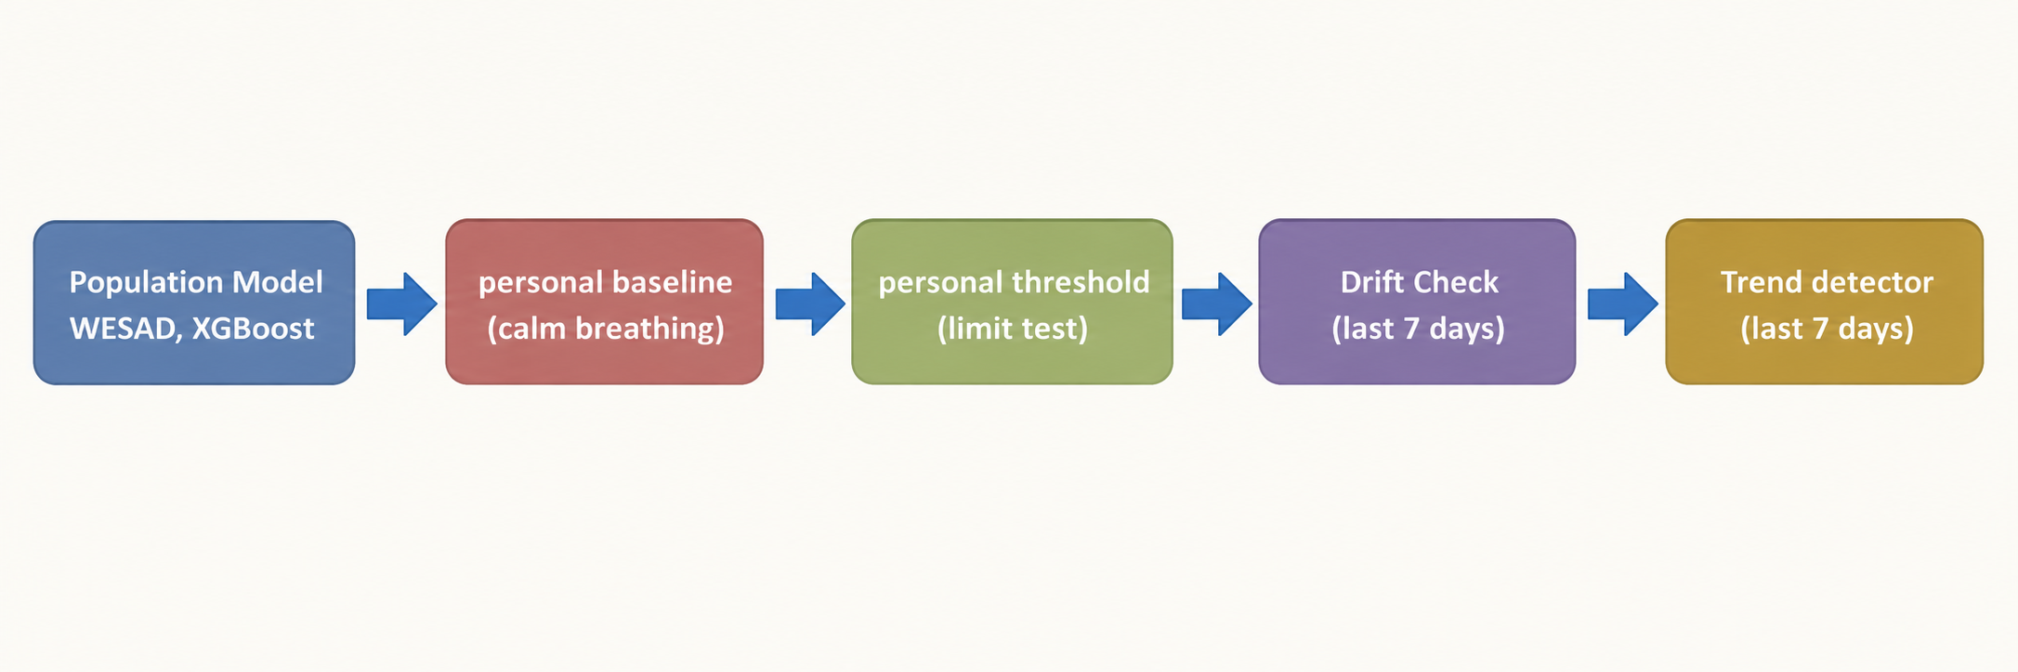
Figure 2.1: Conceptual framework of the personalised stress detector

3 RESEARCH METHODOLOGY

3.1 Research Design
The study follows a design-science approach with quantitative evaluation. A pipeline is designed and built (Chapters 4 and 5), evaluated offline on a public dataset under a subject-independent protocol, then examined on real ring data and, in a user study, for understandability. Each research question is tied to one evaluation: RQ1 to the LOSO model comparison, RQ2 to the personalisation experiments and the real-user threshold check, RQ3 to the trend-indicator validation.

3.2 Data, Participants and Study Materials

3.2.1 WESAD training data
The WESAD dataset provides chest-worn ECG, EDA and accelerometer recordings at 700 Hz from 15 subjects (identifiers S2–S11 and S13–S17) during a resting baseline and the Trier Social Stress Test [3], [21]. The baseline condition is labelled Normal (0) and the stress condition Stress (1). Signals were cut into 60-second windows with a 30-second step. The final feature table contains 913 windows, of which 587 are Normal (64.3%) and 326 are Stress (35.7%) (Table 3.1). Samples within 30 seconds of any change of condition were excluded from labelling, and a window was rejected if it contained mixed labels, less than 90% clean signal, or fewer than 10 inter-beat intervals.
Table 3.1: Window statistics of the WESAD training table
Item | Value
Subjects | 15 (S2–S11, S13–S17)
Window length / step | 60 s / 30 s
Normal windows | 587 (64.3%)
Stress windows | 326 (35.7%)
Total windows | 913
Candidate features | 40
Deployed features | 23
Table 3.1: Window statistics of the WESAD training table

3.2.2 Ring data
The ring is an ESP32-C3 based device carrying a MAX30102 pulse sensor, a Grove GSR sensor and an MPU-6050 accelerometer (Section 4.4). Ring data come from the live system.Ring data are not labelled with ground-truth stress and are therefore used for calibration checks and usability, not for accuracy claims.

3.3 Experimental or Study Procedure

3.3.1 Signal processing and feature extraction
For WESAD, ECG was band-pass filtered and R-peaks were detected with an adaptive detector in the Pan–Tompkins family [25]. Inter-beat intervals were limited to 300–2000 ms and values deviating by more than 20% from the local median were removed. EDA was cleaned by interquartile-range clipping, linearly detrended, low-pass filtered at 5 Hz, and high-pass filtered at 0.05 Hz to obtain the phasic component; the tonic component is the filtered signal minus the phasic part. First and second derivatives and a five-level Haar wavelet decomposition were computed. Acceleration magnitude was used both to flag windows with strong motion (more than 1.2 g) and as two features. Forty candidate features were extracted per window: 15 HRV features, 22 EDA features and 3 motion features. Figure 3.1 shows the same processing as applied to the ring, whose filter cut-offs are clamped below the Nyquist frequency because the ring samples GSR at about 5 Hz instead of 700 Hz. A window with fewer than four clean inter-beat intervals is rejected by the ring pipeline rather than filled with placeholder values. These settings follow published practice: a 5 Hz low-pass and 0.05 Hz high-pass for EDA [14], a 300–2000 ms interval limit for pulse-derived intervals [7], and pNN20 in place of pNN50 [11].
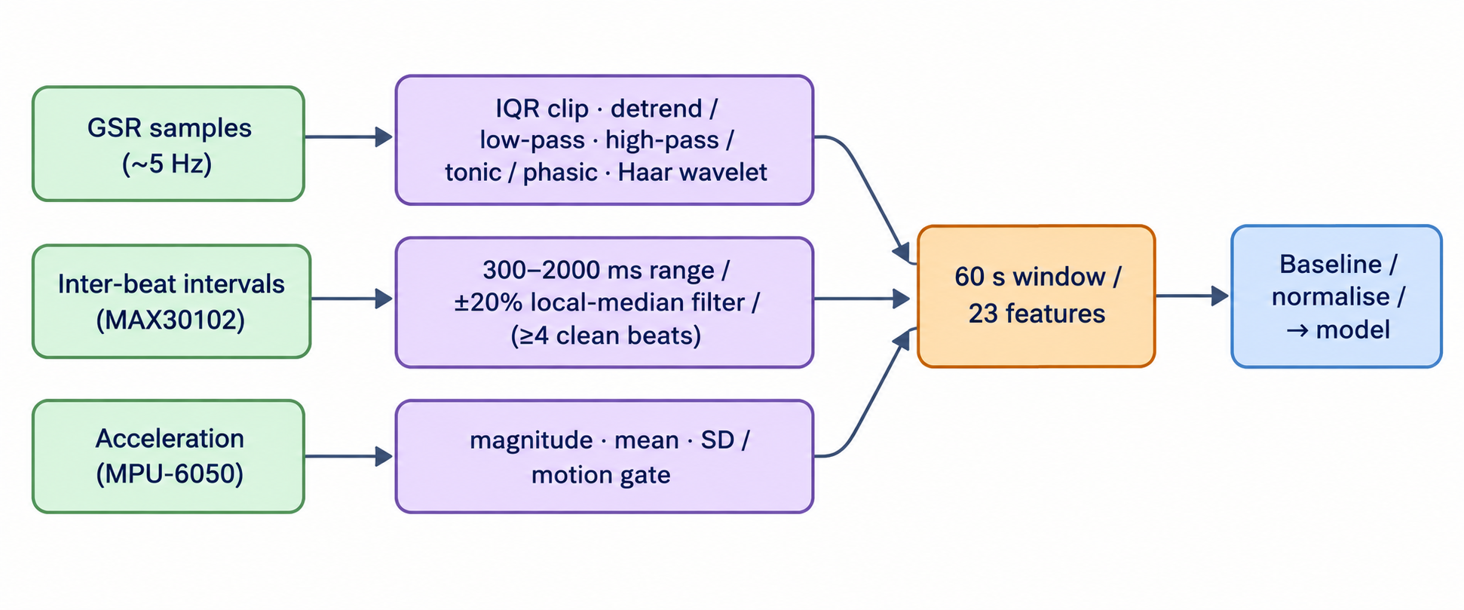
Figure 3.1: Signal processing and feature extraction for one 60-second window

3.3.2 Feature selection
Features were selected by a four-method vote: Spearman correlation with the label, Extra Trees importance, recursive feature elimination (RFE) and permutation importance. A feature kept at least two votes; this produced 22 features. The deployed set is a fixed, literature-grounded list of 23 features that agrees with the vote on 16 features; it adds SCL_slope, a tonic-level trend indicator of stress onset [7], [14], and keeps SD1, SCL_mean, EDA_std, EDA_q90, wavelet_d1_energy and the two accelerometer features, which the vote did not retain, for physiological reasons and because the ring provides them. Table 3.2 lists the deployed features.
Table 3.2: The 23 deployed features by category
Category | Features | Count
HRV | AVNN, MeanHR, SDHR, pNN20, SD1 | 5
EDA level and trend | SCL_mean, SCL_slope, EDA_mean, EDA_slope, EDA_std | 5
EDA responses | SCR_count, SCR_amp_mean, SCR_width_mean | 3
EDA distribution | EDA_q10, EDA_q75, EDA_q90, EDA_range | 4
EDA derivatives | deriv1_std, deriv2_mean | 2
EDA wavelet energy | wavelet_d1_energy, wavelet_d3_energy | 2
Motion | ACC_mean, ACC_std | 2
Total |  | 23
Table 3.2: The 23 deployed features by category

3.3.3 Model comparison and decision threshold
Ten classifiers were compared under LOSO validation: LDA, k-nearest neighbours, random forest, XGBoost [26], gradient boosting, RBF-kernel and linear support vector machines, a multilayer perceptron, logistic regression and AdaBoost, all from scikit-learn [27] or the XGBoost library. In every fold the feature scaler was fitted on the training subjects only, and class imbalance was handled by balanced sample weights. The XGBoost settings were 300 trees, maximum depth 6, learning rate 0.1 and random seed 42. Besides accuracy and F1, balanced accuracy and the recall gap, defined as |recall(Normal) − recall(Stress)|, were computed to check that no model gains accuracy by favouring the majority class. The pooled out-of-fold probabilities of the chosen model were used to draw the ROC curve, and the population decision threshold was set where Youden's J is maximal [24].

3.3.4 Personalisation procedure
Personalisation has five layers, shown in Figure 3.2.
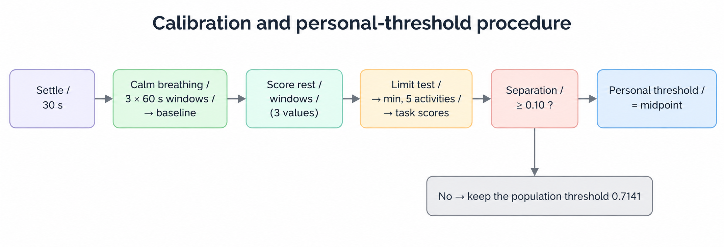
Figure 3.2: Calibration and personal-threshold procedure

Layer 1: personal baseline. After a 30-second settling period, three 60-second windows are captured while the user breathes calmly, giving a personal mean and standard deviation for each feature. Subsequent windows are normalised against it: EDA features by ratio to the personal mean, other features by z-score, with the standard deviation floored at 10% of the absolute mean and at least 0.01 ((3.1), (3.2)).
r = x / μ_personal (EDA features) (3.1)
z = (x − μ_personal) / max(σ_personal, 0.10 × |μ_personal|) (other features) (3.2)
Layer 2: personal decision threshold. The three resting windows are scored, then the user performs an eight-minute cognitive battery (Table 3.3), during which eight 60-second windows are scored. If the mean task score exceeds the mean rest score by at least 0.10, the personal threshold is the midpoint of the two means ((3.3)); otherwise the population threshold is kept.
T_personal = ( mean(rest scores) + mean(task scores) ) / 2, only if mean(task) − mean(rest) ≥ 0.10 (3.3)
Table 3.3: The cognitive battery used to find the personal threshold
Activity | Duration | Demand
Serial subtraction (count down by 13; a mistake restarts the count) | 150 s | Mental arithmetic under penalty
Speed math quiz (nine question types, six difficulty levels) | 100 s | Arithmetic under time pressure
Sequence-recall puzzle (3×3 tiles, growing length) | 70 s | Working memory
Even/odd sorter (falling numbers, speed penalty on a miss) | 90 s | Speeded decisions with negative feedback
Stroop colour-word test (ten colours, ink or word instruction) | 70 s | Cognitive conflict
Total | 480 s
Table 3.3: The cognitive battery used to find the personal threshold

Layer 3: baseline adaptation. When a user recalibrates, the new baseline is blended into the old one with an exponential moving average ((3.4), α = 0.2), so the baseline follows slow change without being overwritten by one session.
μ_new = α × x̄_recalibration + (1 − α) × μ_old, α = 0.2 (3.4)
A session-based variant that updated the baseline from ordinary daily windows was implemented first and then removed: real data showed that it never produced an update for any user, and everyday windows are not controlled resting measurements.
Layer 4: drift check. The mean stress probability of the last seven days (at least ten readings) is compared with the mean of the user's calm baseline scores; a difference larger than 0.15 is reported as a change, and recalibration is suggested.
Layer 5: trend indicator. Twenty-two features vote on whether the signal is moving towards stress over the last five windows: six tonic EDA features and twelve phasic or arousal features vote when they rise, and four HRV and motion features vote when they fall. The "trending towards stress" flag is raised when the share of voting features reaches 0.35 ((3.5)). The flag is advisory and never changes the Normal/Stress label.
V = (features voting for rising stress) / (features evaluated) ≥ 0.35 (3.5)

3.3.5 Validation procedures
Personalisation (RQ2). The static LOSO experiment was repeated with every subject's features, in the training folds and in the held-out subject, normalised by that subject's own baseline (their first three Normal windows) before training. This quantifies the ceiling of feature-level personalisation in a research setting. Real-user thresholds (RQ2). The calibrated records in the live database were read to count how many produced a personal threshold and how far these deviate from the population value. Cross-dataset check. The HRV-only version of the model was tested on the SWELL knowledge-work dataset [28] as a sanity check on transfer to a different protocol and device. Trend indicator (RQ3). The production trend class was replayed on the WESAD windows of each subject in time order, with the baseline taken from the first three windows. A flag counts as a false alarm if it is raised in a calm window, and as a detection if it is raised within the first six stress windows. The detection rate was compared with that of a random flag with the same false-alarm rate, 1 − (1 − FA)^6, and the vote threshold was swept from 0.15 to 0.60. Synthetic stable, noisy and rising signals built from each subject's own statistics served as scenario tests.

3.4 Measures and Evaluation Metrics
Classification quality is reported as accuracy, macro-averaged F1, per-class precision and recall, balanced accuracy, recall gap, confusion matrix and area under the ROC curve (AUC). Threshold quality is reported by the Youden index J. The trend indicator is reported by false-alarm rate, detection rate within six windows and the difference from chance. Personalisation on real data is reported as the number of users with a personal threshold and the shift from the population value. Usability is reported by the System Usability Scale score [29] and task success.

3.5 Data Analysis
LOSO folds hold out one subject at a time, and predictions are pooled across folds for the overall metrics. Thresholds are derived only from out-of-fold probabilities, so the held-out subject never influences its own threshold. No significance test was run, so all comparisons between models, and between the static and personalised pipelines, are descriptive. With 15 subjects, small differences in accuracy should not be read as reliable.

3.6 Ethics, Privacy, Security and Responsible AI
Passwords are stored as scrypt hashes and the Flask services use bearer tokens. Raw sensor streams are never written to the cloud database: only derived features and a down-sampled, filtered preview of each window (at most 80 GSR points and 150 inter-beat intervals) are stored. The system is a wellbeing aid, not a medical device, and does not diagnose. A calibration that does not clearly separate rest from task is rejected, so a poor calibration cannot make a user's results worse than the population model.

3.7 Reproducibility and Research Artefacts
The work is reproducible from the repository: six notebooks cover environment checks, dataset checks, preprocessing, feature selection, model training and personalisation validation; the trained model, scaler and feature list are saved as artefacts; and `validate_trend_detector.py` reproduces the trend results. Random seeds are fixed at 42. The code is available at https://github.com/weharaSliit/ai-neuro-monitor. The experiments used Python 3.11.9 with NumPy 1.26.4, pandas 2.2.1, SciPy 1.12.0, scikit-learn 1.4.2, XGBoost 2.0.3, NeuroKit2 0.2.7, PyWavelets 1.5.0, Matplotlib 3.8.3 and joblib 1.3.2. The WESAD dataset is not included in the repository; it is publicly available from its authors, and the folder containing the subject directories (S2 to S17) is set as the dataset path in the configuration file `src/utils/config.py` before running notebook 03.

4 PRODUCT AND SOLUTION DESIGN

4.1 Requirements
Requirements were derived from the research aim, the supervisor's feedback and the need of user group: wearers. The research topic was agreed with the supervisor, and the requirements were set through discussion with the supervisor and a review of the literature (Chapter 2); no interviews or survey of prospective users were carried out. The usability evaluation in Chapter 6 is the first point at which user feedback is collected.
Table 4.1: Functional and non-functional requirements of the ring component
ID | Requirement | Priority
FR1 | Stream ring data (inter-beat intervals, GSR, acceleration) to the backend | High
FR2 | Extract the 23 features from each 60-second window and return a stress probability | High
FR3 | Capture a calm baseline in about 3.5 minutes with live progress | High
FR4 | Set a personal threshold from rest and task scores, or fall back to the population threshold | High
FR5 | Warn when the recent average moves away from the calm baseline | Medium
FR6 | Flag a rising stress pattern without changing the label | Medium
FR7 | Show a plain-language state, with ring, slider and chart, in the app and on the web | High
NFR1 | A new reading appears within about one minute of the window ending | High
NFR2 | Interfaces fit phones, tablets and desktops | High
NFR3 | No raw sensor streams stored in the cloud database | High
NFR4 | A failed or poor calibration never makes results worse than the population model | High
Table 4.1: Functional and non-functional requirements of the ring component

4.2 Component Architecture within the Complete Solution
Figure 4.1 shows the architecture. The ring publishes its samples over MQTT with TLS to a cloud broker. A bridge forwards each window to the Flask physiological service, which extracts features, scores the window, applies the user's baseline and threshold, and writes the result to the Firebase Realtime Database. The fusion engine, shared with the EEG component, reads the ring and EEG probabilities for the same minute, judges each against its own personal threshold, and writes a fused state. The mobile application, the web dashboard and call the Flask routes for history, baseline and calibration. Authentication is a bearer token issued by the Flask service.
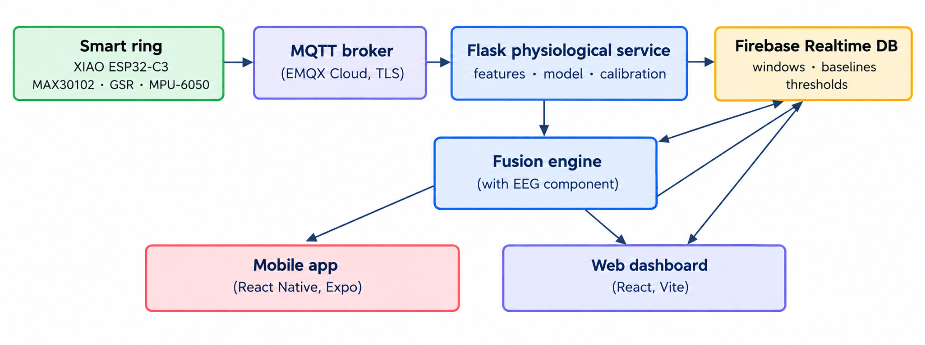
Figure 4.1: System architecture and data flow of the ring component

4.3 Design Alternatives and Decisions
Model. Ten classifiers were compared (Section 6.1). XGBoost was kept as the deployed model although it is not the most accurate model in the comparison: LDA reaches higher accuracy (0.908) but catches only 80.7% of stress windows against 96.4% of Normal windows, a recall gap of 0.157. XGBoost has a recall gap of 0.017, a balanced accuracy of 0.853, and returns well-behaved probabilities that suit a ROC-derived and later personalised threshold. The decision therefore rests on balanced errors and probability behaviour rather than on peak accuracy, and is stated as such.
Personalisation by baseline, threshold and adaptation. A personal baseline corrects the inputs, a personal threshold corrects the decision point, and an EMA blend lets the baseline move slowly. A personal threshold is accepted only when rest and task scores separate by at least 0.10, which makes the mechanism safe by design: it can help or do nothing.
Processed previews instead of raw streams. Storing raw signals would fill the database and expose more personal data, so only features and small processed previews are stored.
Two interfaces from one backend. A mobile application serves wearers on the move and a web dashboard serves desktop use and demonstrations; both read the same services so that they always agree.

4.4 Detailed Design

4.4.1 Signal processing and decision logic
The processing chain is shown in Figure 3.1 (Chapter 3). Each 60-second window yields 23 features, and the window is rejected, not filled in, if motion exceeds the gate or fewer than four clean beats are found. The classifier outputs a stress probability p. A window is labelled Stress if p is at least the user's threshold T, where T is the personal threshold when one exists and 0.6447otherwise. For display, the state is Low if p < T − 0.12, Moderate if p lies within 0.12 below T, and High if p ≥ T.

4.4.2 Data model
The Realtime Database holds, per user, the baseline mean and standard deviation of every feature, the resting scores, the personal threshold, per-session windows (features, probability, label, trend flag, and the processed preview), baseline-adaptation records, and the fused windows written by the fusion engine. Window keys of the fused records are epoch minutes, so the ring and EEG records of the same minute meet in one record.

4.4.3 Backend services
The Flask service exposes routes to register and log in, to score a window (`/predict`), to run the calm baseline (`/calibrate/start`, `/calibrate/status`) and the limit test (`/calibrate/threshold/start`, `/calibrate/threshold/status`), and to read baselines, history, drift history, adaptation history and, for the clinical view, the same data for any user.

4.4.4 Interface design
The home screen shows a greeting, a coloured state card (Calm, Rising, Stressed), two rings (Mind and Body), an overall stress slider with the user's own limit marked, a stress-rhythm chart, shortcuts, and the status of the ring, headband and phone. The Ring screen shows the Body ring with a Stress, Heart and Skin chart. The Profile holds the calibration steps and personal limits, and the baseline-change card appears on the home screen. All charts size themselves to their container, scroll sideways when crowded, and show a value on touch or hover. The website mirrors these screens. Figure 4.2 to Figure 4.6 show the main screens.
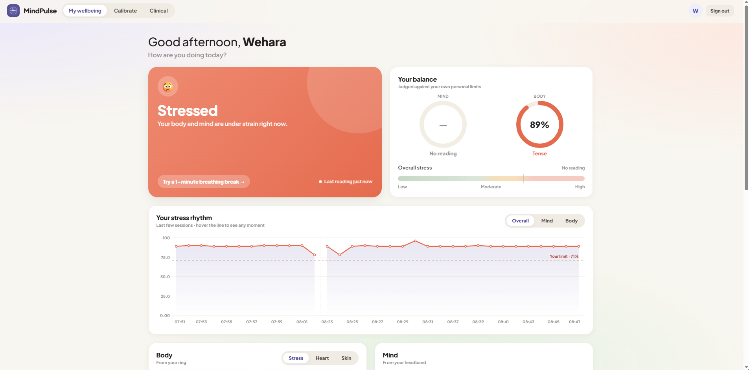
Figure 4.2: Home screen of the mobile application

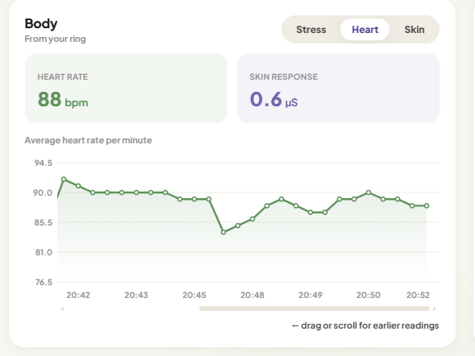
Figure 4.3: Ring screen with the Stress, Heart and Skin chart

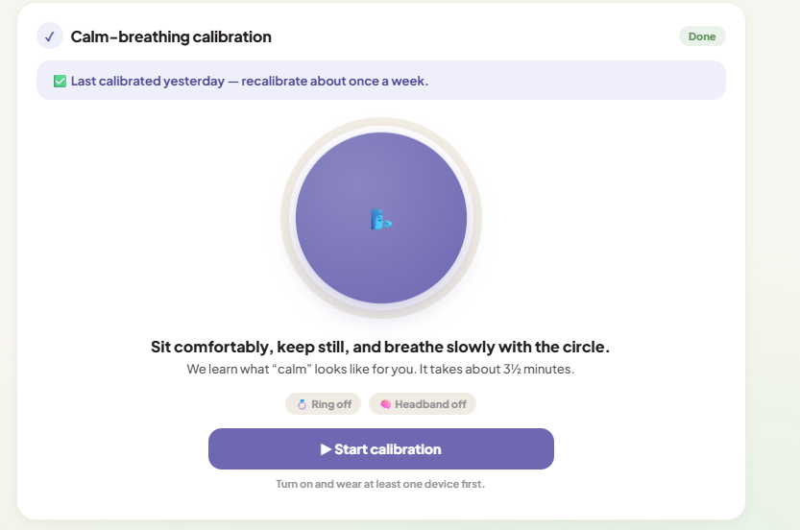Figure 4.4: Calm-breathing calibration with progress ring and per-device progress

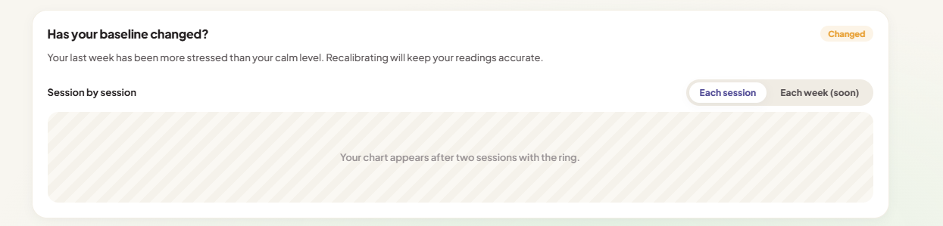Figure 4.5: Baseline-change card on the home screen

4.5 Standards and Professional Practice
HRV measures follow the standards of measurement [17], and EDA processing follows the tonic and phasic decomposition of the literature [18], [20]. References follow the IEEE style. Passwords are hashed, tokens expire after 30 days, and data minimisation is applied by storing derived values only. Interfaces use sufficient colour contrast and plain language.

5 IMPLEMENTATION, INTEGRATION AND TESTING

5.1 Development Environment and Technology Stack

Table 5.1: Technology stack of the ring component
Layer | Technology
Ring hardware | Seeed XIAO ESP32-C3, MAX30102 pulse sensor (I2C 0x57), Grove GSR sensor, MPU-6050 (I2C 0x68), 250 mAh LiPo with TP4056 charger
Transport | MQTT over TLS (EMQX Cloud broker)
Modelling | Python 3.11, NumPy, SciPy, PyWavelets, pandas, scikit-learn [27], XGBoost [26], Jupyter notebooks
Backend | Flask services hosted on Render; Firebase Realtime Database
Mobile application | React Native 0.81 with Expo SDK 54, react-native-svg
Web dashboard | React 19, Vite 7, React Router, Firebase web SDK
Version control | Git and GitHub
Table 5.1: Technology stack of the ring component

The ring firmware is written in C++ as an Arduino sketch for the ESP32-C3 and uses the Arduino ESP32 WiFi libraries, PubSubClient for MQTT, ArduinoJson for message construction, the MAX3010x library for the pulse sensor and the Adafruit MPU6050 library for the accelerometer. The analogue GSR input is read with a 12-bit converter, and the I2C bus runs at 400 kHz. The physiological backend runs on Python 3.11 with Flask 3.0.0, Flask-CORS 4.0.0, firebase-admin 6.4.0, paho-mqtt 2.1.0, XGBoost 2.0.3, scikit-learn 1.4.2, NumPy 1.26.4, pandas 2.2.1, joblib 1.3.2 and PyWavelets 1.6.0, as pinned in the service's requirements file.

5.2 Component Implementation

5.2.1 Feature extraction and scoring
`extract_features.py` converts a window of inter-beat intervals, raw GSR values and acceleration into the 23 features, applying the cleaning described in Chapter 3. GSR cut-offs are clamped to a safe fraction of the Nyquist frequency because the ring publishes at about 5 Hz. A window whose heart-rate data are too short returns a flag that makes `/predict` reject the window instead of scoring placeholder numbers. `predictor.py` loads the saved model, scaler and feature list, normalizes features against the user's baseline, scores the window, and updates the trend state machine. The population threshold (0.6447) and the vote threshold of the trend indicator (0.35) are held in a shared configuration file.

5.2.2 Calibration
`calibration_capture.py` implements the calm baseline and the limit test. Capture runs in the background: the app starts it and polls a status route every two seconds, and each window is checked for motion and for enough clean beats before it counts. Windows that fail are retried, with six extra windows allowed. Resting scores are saved after the baseline so that a later limit test can use them, possibly in a separate request. The personal threshold is computed and stored only when the separation rule is met; otherwise the record shows that the population threshold is kept.

5.2.3 Processed signal storage
Each stored window carries its 23 features, probability, label and trend flag. For the clinical view it also carries a filtered GSR preview reduced to 80 points and the inter-beat intervals capped at the most recent 150. Raw ADC and raw interval arrays are never written to the database.

5.2.4 Interfaces
The mobile application and the web dashboard read the same routes. A shared chart component, written once for each platform, sizes itself to its container, draws the user's own limit as a dashed line and colours the line green, amber or red around it, scrolls sideways when readings are crowded, and shows the value on touch or hover. The calibration card shows a breathing circle inside a progress ring, with one progress bar per device in plain words.

5.3 Integration with the Other Components
The ring writes its probability and threshold into the fused record of the current minute; the EEG component writes its own probability and threshold into the same record. The fusion engine weights each modality by its signal quality, combines them, and compares the result with a weighted combination of the two personal thresholds to give the fused label, a trend, and an alert message. The app and the web dashboard show "Mind" (EEG) and "Body" (ring) rings side by side from these records. The phone-behaviour component and the relaxation guide are reached from the same home screen.

5.4 Verification and Software Testing

5.4.1 Offline experiments
The experiments of Chapter 6 are the main verification of the model: LOSO validation of ten models, ROC analysis, the personalisation experiment, the cross-dataset check, and the trend-indicator validation.

5.4.2 Software testing
The mobile application and the web dashboard were built and bundled after every change to confirm that all imports resolve, and the screens were exercised manually against the live backend.

5.4.3 Findings of the verification
Writing and checking this chapter against the code and data revealed four train–serve inconsistencies (Table 5.2). The most important was the first: the first classifier and its scaler were trained on raw WESAD features (the scaler mean of AVNN is 778 ms), but for every user who has a baseline, /predict first normalises the features against that baseline (a ratio for EDA features and a z-score for the others) and then passed them to the same scaler and model. As a diagnostic, the baseline-normalised inputs of all 913 WESAD windows were passed through the original scaler and model; this gave an AUC of 0.829 and a mean stress probability of 0.51 for Normal and 0.80 for Stress windows, and 26.1% of Normal windows and 70.6% of Stress windows reached the earlier threshold of 0.7141. This check is in-sample, because the model was trained on the same windows, so it demonstrates the mismatch and not a new accuracy figure. The mismatch was corrected by retraining the classifier on baseline-normalized features with the notebook 06 protocol (script retrain_personalised.py), and the decision threshold was re-derived from the pooled out-of-fold probabilities (Section 6.1). The original raw-feature model is kept only for the path that scores a user who has no baseline yet. The LOSO values reported for the model comparison (accuracy 0.851, AUC 0.938) describe the raw-feature model.
Table 5.2: Train–serve inconsistencies found during verification
ID | Finding | Effect | Status
V1 | Model and scaler fitted on raw features; live path scores baseline-normalized features | Probabilities for users with a baseline were not those validated offline | Fixed: the model was retrained on baseline-normalised features, LOSO accuracy 0.945 and AUC 0.986 at a re-derived threshold of 0.6447.
V2 | pNN20 is a percentage (0–95) in training and a proportion (0–1) in the ring code | Wrong scale for users without a baseline; cancels for users with one | Fixed: the no-baseline path converts pNN20 to the training scale (× 100)
V3 | Training intervals come from chest ECG R-peaks; ring intervals come from PPG pulse peaks | Interval noise differs by device | Documented limitation
V4 | Training signals at 700 Hz; ring GSR at about 5 Hz, with clamped filter cut-offs | Slow features are comparable; fast features (SCR counts, derivatives) may differ | Documented limitation
Table 5.2: Train–serve inconsistencies found during verification

5.5 Deployment and Operation
The Flask services run on a free Render tier, which sleeps when idle, so the first request after a pause can take 20 to 40 seconds; the clients use long time-outs and show a clear waiting message. The database is a Firebase Realtime Database. The mobile application is built as an Android package with Expo, and the website is a static build that any static host can serve. Deployment followed four steps. First, the backend services (physiological, EEG, phone behaviour and relaxation guide) were published as separate Flask services on Render, and changes reached them by pushing the repository to GitHub. Second, the Firebase Realtime Database was shared by all services and clients. Third, the mobile application was built as an installable Android package with Expo Application Services (preview profile) and was also run during development through Expo Go. Fourth, the web dashboard was produced with `npm run build` and served as a single-page application, with a rewrite rule that sends every path to the main page. The clients point to the deployed service addresses and use time-outs of 20 to 45 seconds to cope with the cold start.

6 RESULTS AND VALIDATION

6.1 Research Results

6.1.1 Model comparison (RQ1)
Table 6.1 and Figure 6.1 report the ten classifiers under LOSO validation on 913 windows from 15 subjects. LDA has the highest accuracy (0.908), followed by k-nearest neighbours and random forest (0.864 each); XGBoost, the RBF support vector machine and the multilayer perceptron reach 0.851. The balanced analysis changes the picture: LDA's accuracy comes from recalling 96.4% of Normal but only 80.7% of Stress windows (recall gap 0.157), whereas XGBoost recalls 84.5% of Normal and 86.2% of Stress windows (gap 0.017, balanced accuracy 0.853). The RBF support vector machine has the smallest gap (0.007) at a similar balanced accuracy (0.850), and k-nearest neighbours the second highest balanced accuracy (0.860).
Table 6.1: Ten classifiers under LOSO validation
Model | Accuracy | F1-macro | Balanced accuracy | Recall Normal | Recall Stress | Recall gap
LDA | 0.908 | 0.897 | 0.885 | 0.964 | 0.807 | 0.157
k-nearest neighbours | 0.864 | 0.854 | 0.860 | 0.874 | 0.847 | 0.027
Random forest | 0.864 | 0.854 | 0.858 | 0.879 | 0.837 | 0.042
XGBoost (deployed) | 0.851 | 0.842 | 0.853 | 0.845 | 0.862 | 0.017
Gradient boosting | 0.850 | 0.842 | 0.857 | 0.833 | 0.880 | 0.047
SVM, RBF kernel | 0.851 | 0.841 | 0.850 | 0.853 | 0.847 | 0.007
Multilayer perceptron | 0.851 | 0.840 | 0.845 | 0.867 | 0.822 | 0.045
Logistic regression | 0.838 | 0.832 | 0.853 | 0.799 | 0.908 | 0.109
SVM, linear kernel | 0.808 | 0.802 | 0.823 | 0.772 | 0.874 | 0.103
AdaBoost | 0.811 | 0.801 | 0.816 | 0.797 | 0.834 | 0.037
Table 6.1: Ten classifiers under LOSO validation (913 windows, 15 subjects)
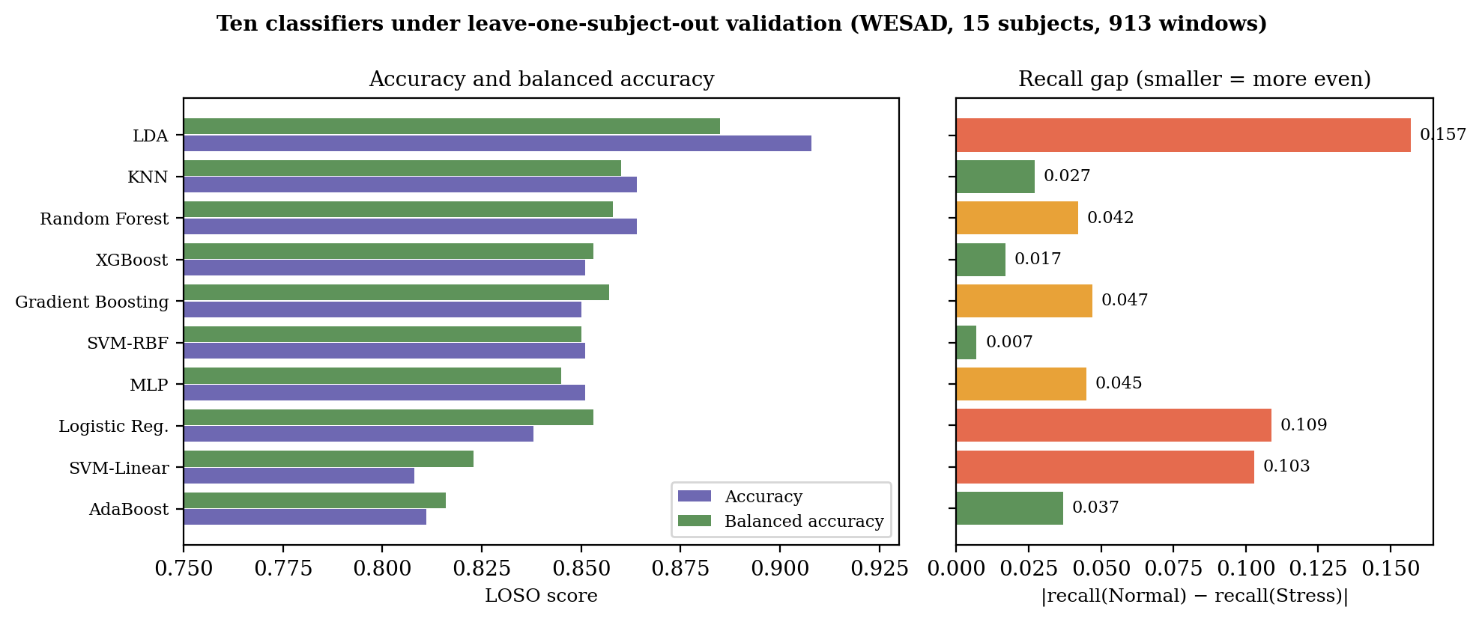
Figure 6.1: Accuracy, balanced accuracy and recall gap of ten classifiers under LOSO validation

The ten classifiers were compared on raw features. XGBoost was then retrained on baseline-normalised features, which is the form in which it receives its inputs when deployed (see Section 6.1.2), so the pooled LOSO confusion matrix of the deployed model in Table 6.2 comes from that retrained model at its ROC-derived threshold of 0.6447. Precision is 0.941 for Normal and 0.954 for Stress, and F1 is 0.958 and 0.921. The model errs towards missed stress (36 of 326 Stress windows) more than towards false alarms (14 of 587 Normal windows).
Table 6.2: Pooled LOSO confusion matrix of the deployed
Actual \ Predicted | Normal | Stress
Normal | 573 | 14
Stress | 36 | 290
Table 6.2: Pooled LOSO confusion matrix of the deployed (baseline-normalised) XGBoost model

For the deployed model, the pooled out-of-fold probabilities give an AUC of 0.986 (Figure 6.2). The Youden-optimal decision threshold is 0.6447, with a true-positive rate of 0.893 and a false-positive rate of 0.024 (J = 0.869), giving accuracy 0.945, macro F1 0.939 and recall of 0.976 for Normal and 0.890 for Stress. At the default cut-off of 0.5 the same predictions give accuracy 0.934 and Stress F1 0.907. The threshold was chosen on the same pooled predictions on which these figures are reported, so the accuracy at 0.6447 is slightly optimistic and the figure at 0.5 is the cleaner like-for-like comparison with the static model. For the raw-feature model compared above, the AUC is 0.938 and its Youden threshold is 0.7141 (true-positive rate 0.850, false-positive rate 0.121, J = 0.729); that model is now used only to score a user who has no baseline.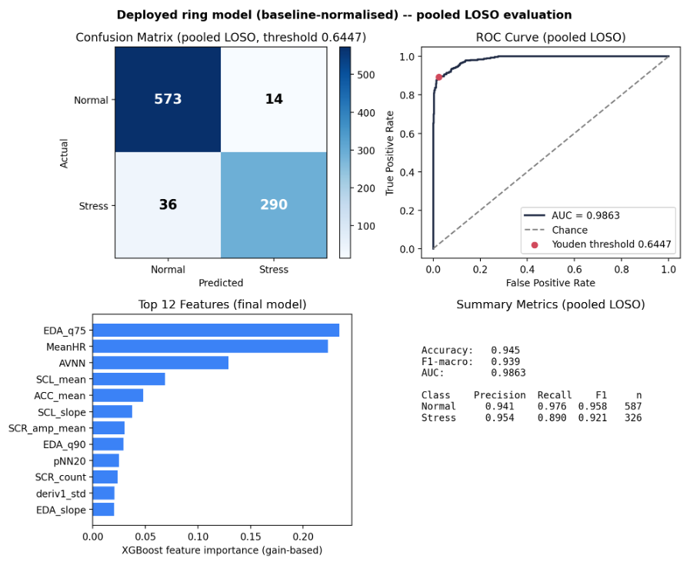
Figure 6.2: Pooled LOSO evaluation of the deployed model: confusion matrix, ROC curve, feature importance and summary

6.1.2 Personalization of the baseline (RQ2)
When every subject's features were normalized by that subject's own baseline before training and testing, LOSO accuracy at the 0.5 cut-off rose from 0.851 to 0.934, macro F1 from 0.842 to 0.928, and Stress F1 from 0.805 to 0.907 (Table 6.3, Figure 6.3). The confusion matrix at 0.5 was 560 and 27 for Normal and 33 and 293 for Stress. The AUC rose from 0.938 to 0.986. Each subject's baseline was formed from that subject's first three Normal windows, which assumes that the calibration windows were truly calm; in the deployed system the baseline comes from the user's own three calm calibration windows. This protocol is the one used to train the deployed model.
Table 6.3: Static versus personal-baseline model under LOSO
Metric | Static | Personal baseline | Change
Accuracy | 0.851 | 0.934 | +0.083
F1-macro | 0.842 | 0.928 | +0.086
F1 Normal | 0.879 | 0.949 | +0.070
F1 Stress | 0.805 | 0.907 | +0.102
AUC | 0.938 | 0.986 | +0.048
Table 6.3: Static versus personal-baseline model under LOSO (both at the 0.5 cut-off)
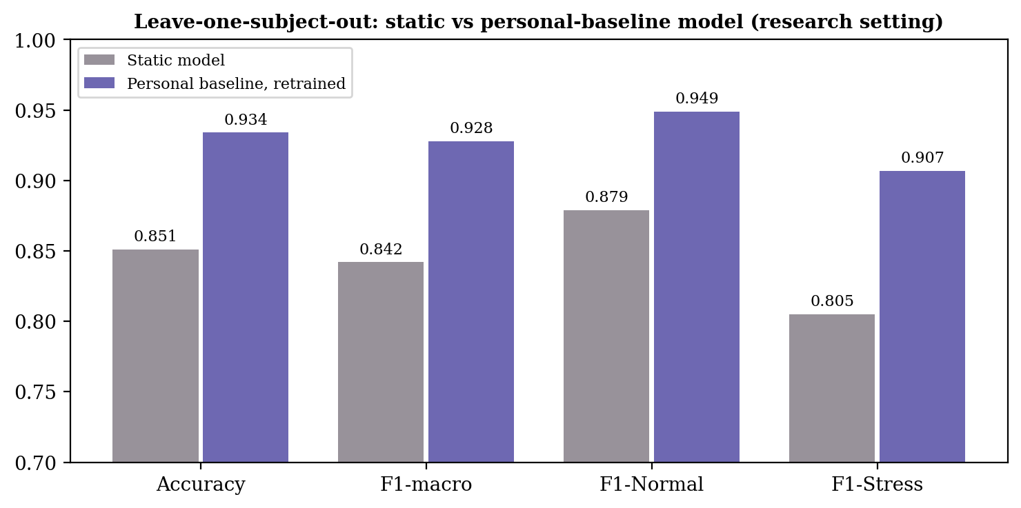
Figure 6.3: Static versus personal-baseline model under LOSO validation

6.1.3 Cross-dataset check
Applied to the SWELL knowledge-work dataset [28] using only the five HRV features that both datasets share, the WESAD-trained model reached an accuracy of 0.429, macro F1 of 0.367 and Stress F1 of 0.169, with only 12.7% of Stress windows recalled. The model therefore did not transfer. This result cannot be attributed to the missing GSR alone, because the dataset, protocol, device and label definition all differ; it is a directional warning that a laboratory-trained model should not be assumed to transfer to a different setting.

6.1.4 Personal thresholds on real ring data (RQ2)
Of the 17 calibrated records in the live database, 5 have a personal threshold. The values are 0.348, 0.353, 0.405, 0.477 and 0.572 (mean 0.431, median 0.405), all below the population threshold of 0.6447 (Figure 6.4). The mean shift is therefore −0.283. The sign and size of the shift can reflect real differences between the ring and the WESAD sensors, between users and the dataset, or the train–serve mismatch of Section 5.4 (V1); the present data cannot separate these, so the result is evidence that a population threshold does not carry over to the ring, not a measurement of the true size of the difference.
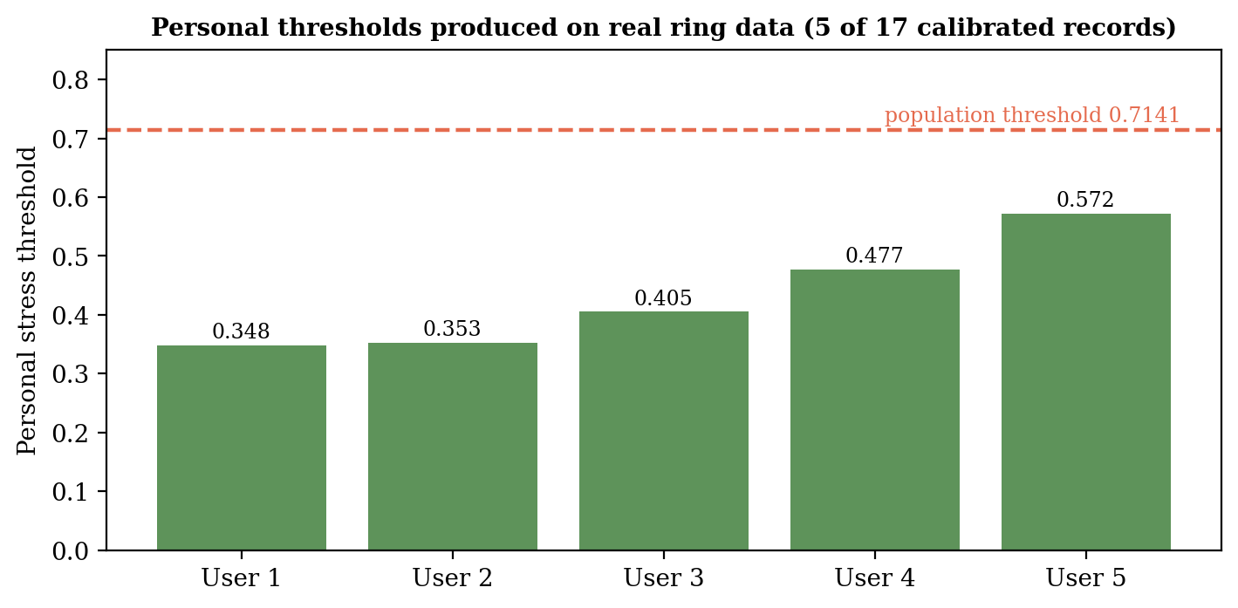
Figure 6.4: Personal thresholds produced on real ring data compared with the population threshold

6.1.5 Trend indicator (RQ3)
Replaying the production trend class on the WESAD windows of each subject gave the results in Table 6.4 and Figure 6.5. At the deployed vote threshold of 0.35 the indicator flagged stress onset within six windows in all 15 subjects (median latency 0 windows, maximum 3), where a random flag with the same false-alarm rate would catch 62.7%. It flagged 18.4% of calm windows. Subject-level variation is large: the false-alarm rate reached 0.486 for one subject and 0.389 for another, and for the subject with 0.486 the indicator fired in only 4.8% of the stress windows, so for that subject it was not informative. Raising the vote threshold to 0.45 halves false alarms to 8.9% while still detecting onset in 14 of 15 subjects (93.3%); at 0.50 false alarms fall to 6.6% and detection to 86.7%. In the synthetic scenarios the indicator stayed nearly quiet on stable and noisy signals at thresholds of 0.40 and above (at most 3.6% of windows flagged), and detected the ramp in every subject at 0.40 and in 86.7% at 0.45.
Table 6.4: Trend indicator versus vote threshold on WESAD
Vote threshold | False alarms in calm windows | Onset detected within 6 windows | Random flag, same false-alarm rate | Synthetic stable: false alarms | Synthetic rising: detected
0.30 | 0.264 | 1.000 | 0.773 | 0.210 | 1.000
0.35 (deployed) | 0.184 | 1.000 | 0.627 | 0.105 | 1.000
0.40 | 0.133 | 0.933 | 0.512 | 0.010 | 1.000
0.45 | 0.089 | 0.933 | 0.390 | 0.010 | 0.867
0.50 | 0.066 | 0.867 | 0.308 | 0.005 | 0.800
Table 6.4: Trend indicator versus vote threshold on WESAD (15 subjects)

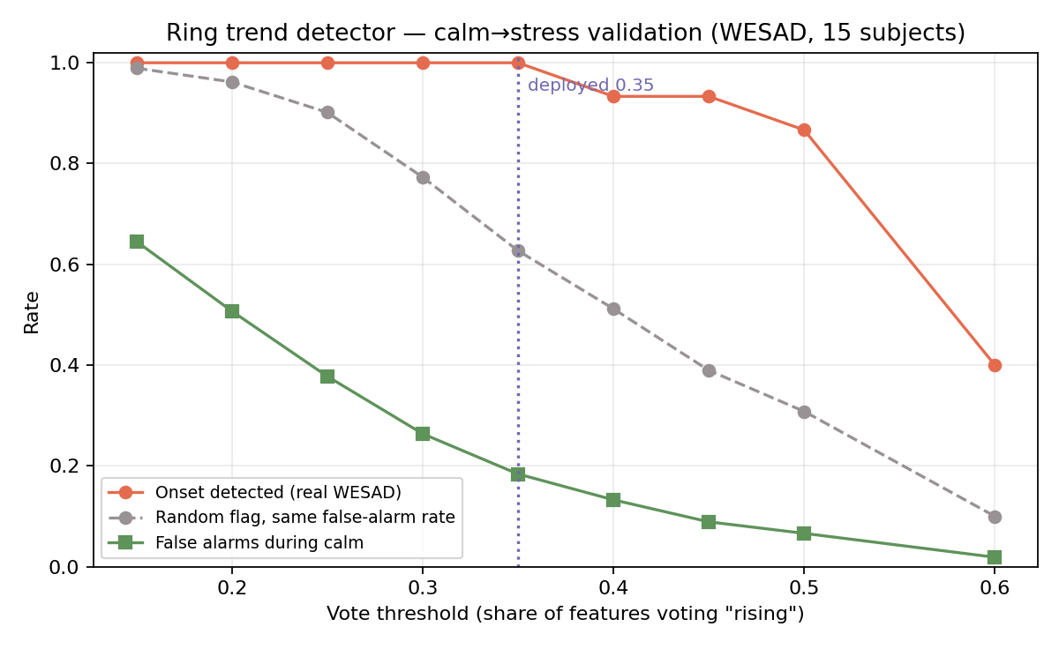
Figure 6.5: Trend indicator: detection and false alarms against the vote threshold

6.2 Product and Technical Results
The ring pipeline runs end to end: a window arrives over MQTT, features are extracted, the window is scored against the user's baseline and threshold, and the probability, label, trend flag and processed preview are written to the database and shown within about a minute.
[Need to add in final: add measured values]

6.3 User or Stakeholder Validation
[Need to add in final]

6.4 Integration Results
[Need to add in final : report how the ring and the EEG probabilities combined in the fusion engine: number of fused windows, how often the two modalities agreed or disagreed, and one or two example sessions with the fused state.]

6.5 Summary of Findings
1. Under subject-independent validation, XGBoost reached an accuracy of 0.851, macro F1 of 0.842 and AUC of 0.938 with balanced class recall. It is not the most accurate model (LDA 0.908), and it was kept for balanced errors and probability behaviour.
2. A ROC-derived population threshold outperformed the default 0.5 on Youden's index, both for the raw-feature model (0.7141) and for the deployed baseline-normalised model (0.6447)
3. Training on baseline-normalised features raised LOSO accuracy from 0.851 to 0.934 at the 0.5 cut-off and Stress F1 from 0.805 to 0.907; at the re-derived threshold of 0.6447 the deployed model reaches accuracy 0.945 and AUC 0.986.
4. A WESAD-trained HRV model did not transfer to the SWELL dataset (accuracy 0.429).
5. The trend indicator detected onset in all 15 subjects at the deployed setting but with an 18.4% false-alarm rate; a vote threshold of 0.45 is a better balance.
7. [Need to add to final: user-study finding.]

7 DISCUSSION

7.1 Interpretation of Findings
Choosing a model (RQ1). The comparison shows why accuracy alone is a poor guide. LDA is the most accurate model but misses almost one in five stress windows while rarely misjudging calm ones; for a stress-awareness tool, missed stress is the costlier error, and accuracy hides it. The ten models fall into a narrow band of balanced accuracy (0.816 to 0.885), and several are statistically indistinguishable at 15 subjects, so the choice of XGBoost rests on balanced errors, well-behaved probabilities and low serving cost, and not on a clear performance win. A reader should treat the choice as defensible but not uniquely optimal; k-nearest neighbours, random forest and the RBF support vector machine are comparable alternatives.
Personalisation (RQ2). Normalising each person's features by their own calm baseline raised accuracy by 8.3 percentage points and Stress F1 by 10.2 points at the default cut-off, and the deployed model is trained this way. This supports the argument that a large share of error under subject-independent validation is inter-person variability, not a limitation of the features. Two cautions apply. Each baseline was taken from a subject's first three labelled Normal windows, so it assumes a clean calm period, and a real user's calibration may be less clean than WESAD's baseline condition. The reported accuracy is also from laboratory data and from the same 15 subjects used to choose the threshold, so it is expected to be lower on the ring.
Personal thresholds on real data. All five personal thresholds fell below the population threshold, by 0.14 to 0.37. At face value, a wearer judged against 0.6447 would rarely be reported as stressed. This supports the central design decision, to personalise the decision point, but the size of the shift is not a clean measurement, since it is confounded by the device change and by the mismatch between training and serving.
Transfer. The failure on SWELL supports the view that laboratory-trained models should not be assumed to transfer across protocols and devices, and is a second reason, besides the threshold shift, to treat the population model as a starting point.
Trend indicator (RQ3). The indicator responds to the onset of stress far better than chance, and it is quiet on stable and noisy signals at moderate vote thresholds. Its cost is a noticeable false-alarm rate at the deployed setting, and its behaviour varies by person, from uninformative for one subject to immediate for most. For an advisory flag that does not change the label, a threshold of 0.45 offers a better trade-off than 0.35.

7.2 Comparison with Literature Baselines and Existing Solutions
Studies on WESAD [4] and on other wearable data [5], [16] report a wide range of accuracies, and the closest hardware system reports 91.3% [7]. On WESAD, a study of ten algorithms reports 99.8% accuracy for a convolutional network, but with a subject-dependent evaluation [4]. A study of 37 adults using finger and earlobe GSR reports 0.833 accuracy for k-nearest neighbors, measured on a test set of only 12 samples [5]. A study of 50 housewives with ECG, GSR and skin temperature reports 97.51% accuracy for three classes, from a random 75/25 split and not a leave-one-subject-out protocol [16]. One reviewed study combines LOSO validation with personalization and reports 85.06% with a localized personalized model on wrist EDA from 41 pre-surgery patients . Direct comparison is limited because those studies differ in label definition, window length, feature set, and, for many, in the validation protocol, and a LOSO protocol is the stricter one [8]. The LOSO accuracy of the deployed model (0.945 at its ROC-derived threshold, 0.934 at the default cut-off) is above the 91.3% of the hardware-similar system, but that figure is for a different dataset and protocol, and the deployed model has been validated only on laboratory data, not on labelled ring data. The distinguishing features of this work against the compared systems are the personal threshold with a safe fallback, the baseline adaptation and drift check, the validated trend indicator, the checking of the pipeline on real ring data, and the plain-language interface.

7.3 Research Contribution
The research contributions are: a balanced, subject-independent comparison of ten classifiers with an explicit recall-gap analysis; a ROC-derived population threshold; a personal-threshold procedure with a measurable safety rule; the first quantification, in this work's data, of the shift between a population threshold and personal thresholds on real ring data; the empirical validation of the trend indicator with a chance baseline and a threshold sweep; and a documented train–serve inconsistency that offline reporting alone would have hidden.

7.4 Product Contribution
The product contribution is a working ring-to-interface pipeline that scores each minute, personalises the decision, and presents a plain-language state in a mobile application, a web dashboard and a clinical view, and that integrates with the EEG, phone-behaviour and relaxation components through a shared fused record.

7.5 Limitations and Threats to Validity
1. Device and signal shift. Training used chest ECG at 700 Hz, whereas the ring uses PPG-derived intervals and GSR at about 5 Hz (V3 and V4 in Table 5.2).
2. Laboratory stress. TSST stress is stronger and shorter than everyday stress, and generalisation to daily life is not shown.
3. Sample size. Fifteen training subjects and a small number of real ring users limit confidence, especially for personalisation, which depends on individual variability.
4. No ground truth on the ring. Real ring data are unlabelled, so accuracy on the ring has not been measured; at most, threshold behaviour and usability can be examined, and the threshold check must be repeated with the retrained model.
5. Baseline assumption. The calm baseline assumes the user was calm during calibration; the drift check cannot separate a stale baseline from a genuinely stressful week.
6. Trend indicator. It was validated on 30-second-step WESAD windows with separately recorded conditions, so onset may look sharper than in daily life; the synthetic scenario is idealised.
7. Labels. Training labels come from the experimental condition (baseline or TSST), not from self-report. Other studies show that physiological arousal and perceived stress can differ [11], [14], so these labels cannot be assumed to match what each person felt.

7.6 Implications
A population model can be a useful starting point for a new device only if the decision point is personalised and the output is checked on the target hardware; reporting offline accuracy is not sufficient. For practice, the safe-fallback rule is a reusable design pattern: personalise when the evidence is clear and fall back otherwise. For this system, the next step is to retrain on baseline-normalised features and re-derive the threshold, then repeat the real-user check.

8 COMMERCIALISATION AND SUSTAINABILITY

8.1 Value Proposition and Target Users
MindPulse offers stress awareness that is personal, low-cost and understandable. The ring is built from inexpensive off-the-shelf parts, and each reading is judged against the wearer's own calibrated normal range and not an average. The principal target users are university students and young professionals who face study or workplace pressure; secondary users are wellness and counselling services, employers running wellbeing programmes, and researchers who need an open, inspectable pipeline.

8.2 Market and Competitive Position
Consumer wearables and smart rings report stress or readiness scores, mostly from heart-rate variability, and a few include an electrodermal sensor; research-grade devices record electrodermal activity but are expensive and not designed for everyday wear. MindPulse differs by combining pulse and skin-conductance sensing in a finger-worn form, by personalising the decision point and not only the score, by validating its trend warning, and by being open for inspection. Its weaknesses are an early-stage prototype, a small validation sample and the open verification items of Section 5.4.

8.3 Business or Sustainability Model
Three paths are plausible. A direct-to-consumer model would sell the ring at cost and a subscription for the application and history. A business-to-business model would offer the clinical view and anonymised team-level trends to universities and employers. A research-kit model would supply the ring, the open pipeline and the dashboard to laboratories. Costs are the bill of materials, hosting (currently free tiers, which would need paid tiers at scale), support and regulatory review.

8.4 Scalability, Intellectual Property and Compliance
Scalability. The services are stateless. Flask applications and the data sit in a managed realtime database, so users can be added by scaling hosting; the free tier's cold start and the polling of the clinical view would need to be replaced by push updates and pagination at scale.
Intellectual property. The code uses open-source libraries whose licences permit this use; WESAD is available for research use under its own terms [3], so any commercial model should be retrained on data collected with consent.
Compliance. The system collects health-related personal data, so consent, minimisation and security matter. Only derived features and small processed previews are stored, passwords are hashed, and the service is positioned as wellbeing support, not as a medical device or diagnostic tool, which keeps it outside medical-device regulation while the wording makes clear it must not replace professional advice.

8.5 Contribution to the Sustainable Development Goals
The work supports Sustainable Development Goal 3 (good health and well-being) by helping people notice and manage stress early, and Goal 9 (industry, innovation and infrastructure) through a low-cost, open sensing platform. It also relates to Goal 8 (decent work) where it supports workplace wellbeing programmes, and to Goal 4 (quality education) where it helps students manage pressure. Its environmental footprint is small, because the ring is built from few components, though battery disposal and device lifetime need attention in any product version.

9 CONCLUSION AND FUTURE DIRECTIONS

9.1 Conclusion

This thesis developed and evaluated a personalised stress detector for a low-cost smart ring. A binary XGBoost classifier on 23 HRV, electrodermal and motion features was chosen from ten models under leave-one-subject-out validation (85.1% accuracy, AUC 0.938 on raw features); it is not the most accurate of the ten but has even errors and well-behaved probabilities. Trained on features normalised by each person's calm baseline, which is how it is used on the ring, it reached 94.5% accuracy and an AUC of 0.986 at a ROC-derived threshold of 0.6447 (93.4% at the default cut-off). Layered personalisation, namely a calm baseline, a personal threshold with a safe fallback, baseline adaptation and a drift check, addresses the individual variability that limits population models. The trend indicator detected stress onset in every WESAD subject but with an 18% false-alarm rate, and a higher vote threshold is recommended. Checking the pipeline end to end revealed a mismatch between how the first model was trained and how it was used, which was corrected by retraining; this shows that offline accuracy is insufficient evidence for a deployed system.

9.2 Achievement of Objectives
Table 9.1: Achievement of the objectives
Objective | Status | Evidence
1. Compare classifiers under LOSO and select one | Achieved | Table 6.1, Figure 6.1
2. Ring pipeline producing the training features | Achieved with caveats | Section 5.2; findings V2 to V4 in Table 5.2
3. Personalisation layers | Implemented | Sections 3.3, 6.1, 5.4
4. Validated trend indicator | Achieved on WESAD; ring validation pending | Table 6.4
5. Services, mobile app and web dashboard | Achieved | Chapters 4 and 5
6. Technical and user evaluation | Technical achieved; user study | Chapter 6
Table 9.1: Achievement of the objectives

9.3 Individual Research and Product Contributions
The research contributions are the balanced model comparison, the personal-threshold procedure with a measurable safety rule, the first measurement in this project of the gap between a population and personal thresholds on real ring data, the validation of the trend indicator against chance, and the documented train–serve inconsistency. The product contribution is the working pipeline and its mobile and web interfaces, integrated with the other three components.

9.4 Future Directions
1. Collect labelled ring data with consent, using the limit test and self-report, to measure accuracy on the target device and to fine-tune the model.
2. Raise the trend vote threshold to about 0.45 and validate the indicator on real ring sessions.
3. Run a long-term study of the baseline adaptation and the drift check.
4. Compare PPG-derived and ECG-derived intervals against a reference device, and measure latency, heart-rate accuracy and battery life of the assembled ring.
6. Extend the usability study to more participants and to everyday use.

REFERENCES
[1] G. V. Taskasaplidis, D. Fotiadis, and P. D. Bamidis, "Review of stress detection methods using wearable sensors," IEEE Access, vol. 12, pp. 38219–38246, 2024, doi: 10.1109/ACCESS.2024.3373010.
[2] Y. Haque, R. S. Zawad, C. S. A. Rony, H. Al Banna, T. Ghosh, M. S. Kaiser, and M. Mahmud, "State-of-the-art of stress prediction from heart rate variability using artificial intelligence," Cognitive Computation, vol. 16, pp. 455–481, 2024.
[3] P. Schmidt, A. Reiss, R. Duerichen, C. Marberger, and K. Van Laerhoven, "Introducing WESAD, a multimodal dataset for wearable stress and affect detection," in Proc. 20th ACM Int. Conf. Multimodal Interaction (ICMI '18), 2018, pp. 400–408, doi: 10.1145/3242969.3242985.
[4] A. Calvo, J. Martin, and C. Martín, "Early detection of chronic stress using wearable devices: A machine learning approach with the WESAD database," in Proc. Int. Conf. Inf. Commun. Technol. Ageing Well e-Health (ICT4AWE), 2025, doi: 10.5220/0013209700003938.
[5] A. Nechyporenko, M. Frohme, Y. Strelchuk, V. Omelchenko, V. Gargin, L. Ishchenko, and V. Alekseeva, "Galvanic skin response and photoplethysmography for stress recognition using machine learning and wearable sensors," Applied Sciences, vol. 14, no. 24, art. no. 11997, 2024, doi: 10.3390/app142411997.
[6] E. Mozafari, F. Firouzi, and B. Farahani, "Towards IoT-enabled multimodal mental stress monitoring," in Proc. IEEE Int. Conf. Omni-Layer Intell. Syst. (COINS), 2020, doi: 10.1109/COINS49042.2020.9191392.
[7] Y. Segono, E. Y. M. Hutagalung, H. G. Simbolon, N. I. Us, et al., "IoT-based stress monitoring using CNN for HRV-GSR analysis," SinkrOn, vol. 10, no. 1, pp. 621–637, 2026, doi: 10.33395/sinkron.v10i1.15671.
[8] A. O. Pataca, E. Zdravevski, P. J. Coelho, N. M. Garcia, M. Deryuck, C. Albuquerque, et al., "Use of machine learning for predicting stress episodes based on wearable sensor data: A systematic review," Computers in Biology and Medicine, vol. 198, Part A, art. no. 111166, 2025, doi: 10.1016/j.compbiomed.2025.111166.
[9] Prasad and Upadhyaya, "Stress monitoring using wearable technology," in Proc. IEEE Int. Conf. Comput. Autom. (ICCA), 2025.
[10] A. Villarejo, B. Zapirain, and A. Zorrilla, "A stress sensor based on galvanic skin response (GSR) controlled by ZigBee," Sensors, vol. 12, no. 5, pp. 6075–6101, 2012.
[11] A. Dybvik et al., "fNIRS, EEG, ECG, and GSR reveal an effect of complex, dynamically changing environments on cognitive load, affective state, and performance, but not physiological stress," Frontiers in Human Neuroscience, vol. 19, 2025, doi: 10.3389/fnhum.2025.1459653.
[12] E. Lazarou and T. P. Exarchos, "Predicting stress levels using physiological data: Real-time stress prediction models utilizing wearable devices," AIMS Neuroscience, vol. 11, no. 2, pp. 76–102, Apr. 2024, doi: 10.3934/Neuroscience.2024006.
[13] D. Dalmeida and G. L. Masala, "HRV features as viable physiological markers for stress detection using wearable devices," Sensors, vol. 21, no. 8, 2021, doi: 10.3390/s21082873.
[14] N. Kyriakou et al., "Detecting moments of stress from measurements of wearable physiological sensors," Sensors, vol. 19, no. 17, 2019, doi: 10.3390/s19173805.
[15] A. S. Anusha, P. Sukumaran, V. Sarveswaran, S. Surees Kumar, A. Shyam, T. J. Akl, S. P. Preejith, and M. Sivaprakasam, "Electrodermal activity based pre-surgery stress detection using a wrist wearable," IEEE J. Biomed. Health Inform., vol. 24, no. 1, pp. 92–100, Jan. 2020, doi: 10.1109/JBHI.2019.2893222.
[16] S. Gedam, P. Pranav, S. Dutta, and R. Jha, "A deep learning approach with wearable physiological sensors and feature selection methods to detect mental stress in Indian housewives," Discover Artificial Intelligence, vol. 6, art. no. 113, 2026.
[17] Task Force of the European Society of Cardiology and the North American Society of Pacing and Electrophysiology, "Heart rate variability: Standards of measurement, physiological interpretation, and clinical use," Circulation, vol. 93, no. 5, pp. 1043–1065, 1996.
[18] W. Boucsein, Electrodermal Activity, 2nd ed. New York, NY, USA: Springer, 2012.
[19] F. Shaffer and J. P. Ginsberg, "An overview of heart rate variability metrics and norms," Frontiers in Public Health, vol. 5, art. no. 258, 2017.
[20] M. Benedek and C. Kaernbach, "A continuous measure of phasic electrodermal activity," Journal of Neuroscience Methods, vol. 190, no. 1, pp. 80–91, 2010.
[21] C. Kirschbaum, K.-M. Pirke, and D. H. Hellhammer, "The 'Trier Social Stress Test' — a tool for investigating psychobiological stress responses in a laboratory setting," Neuropsychobiology, vol. 28, no. 1–2, pp. 76–81, 1993.
[22] J. R. Stroop, "Studies of interference in serial verbal reactions," Journal of Experimental Psychology, vol. 18, no. 6, pp. 643–662, 1935.
[23] S. Cohen, T. Kamarck, and R. Mermelstein, "A global measure of perceived stress," Journal of Health and Social Behavior, vol. 24, no. 4, pp. 385–396, 1983.
[24] W. J. Youden, "Index for rating diagnostic tests," Cancer, vol. 3, no. 1, pp. 32–35, 1950.
[25] J. Pan and W. J. Tompkins, "A real-time QRS detection algorithm," IEEE Transactions on Biomedical Engineering, vol. BME-32, no. 3, pp. 230–236, 1985.
[26] T. Chen and C. Guestrin, "XGBoost: A scalable tree boosting system," in Proc. 22nd ACM SIGKDD Int. Conf. Knowledge Discovery and Data Mining, San Francisco, CA, USA, 2016, pp. 785–794.
[27] F. Pedregosa et al., "Scikit-learn: Machine learning in Python," Journal of Machine Learning Research, vol. 12, pp. 2825–2830, 2011.
[28] S. Koldijk, M. Sappelli, S. Verberne, M. A. Neerincx, and W. Kraaij, "The SWELL knowledge work dataset for stress and user modeling research," in Proc. 16th Int. Conf. Multimodal Interaction (ICMI '14), Istanbul, Turkey, 2014, pp. 291–298.
[29] J. Brooke, "SUS: A quick and dirty usability scale," in Usability Evaluation in Industry, P. W. Jordan et al., Eds. London, U.K.: Taylor & Francis, 1996, pp. 189–194.

GLOSSARY
Baseline (personal). The wearer's own calm-state profile (mean and spread of each feature), captured during calm breathing and used to normalise later readings.
Calibration. The procedure in which the wearer sits calmly for about 3.5 minutes so that the system can learn their baseline; a second, eight-minute procedure, the limit test, finds their personal threshold.
Drift. Movement of the recent average stress probability away from the level measured at calibration.
Fusion. Combining the ring's and the EEG headband's stress probabilities into one state, each judged against its own personal threshold.
Leave-one-subject-out (LOSO) validation. Evaluation in which a model is trained on all subjects but one and tested on the held-out subject, repeated for every subject.
Personal threshold. The stress probability above which this particular wearer is reported as stressed; it replaces the population threshold when calibration separates rest from task clearly.
Phasic and tonic (EDA). The fast responses and the slow level of skin conductance.
Population threshold. The decision threshold (0.6447) derived from the ROC curve of the model on WESAD, used when no personal threshold exists.
Recall gap. The absolute difference between the recall of the Normal and Stress classes; a small gap means both classes are detected about equally well.
Train–serve mismatch. A difference between the data a model was trained on and the data it receives in use.
Trend indicator. An advisory flag raised when most monitored features move towards a stress pattern over recent windows; it never changes the Normal/Stress label.
Window. A 60-second slice of signal from which one set of features and one stress probability are computed.

APPENDIX A: RESEARCH INSTRUMENTS AND EXTENDED RESULTS

A.1 Per-class classification report of the deployed model

Class | Precision | Recall | F1 | Support
Normal | 0.941 | 0.976 | 0.958 | 587
Stress | 0.954 | 0.890 | 0.921 | 326
Macro average | 0.947 | 0.933 | 0.939 | 913
Table A.1: Pooled LOSO report of the deployed XGBoost model (913 windows)

A.2 Personalisation experiment: personal-baseline model

Class | Precision | Recall | F1 | Support
Normal | 0.944 | 0.954 | 0.949 | 587
Stress | 0.916 | 0.899 | 0.907 | 326
Accuracy |  |  | 0.934 | 913
Table A.2: Pooled LOSO report of the personal-baseline model 0.5 cut-off)

A.3 Trend indicator: results per subject at the deployed threshold (0.35)
Table A.3: Per-subject trend-indicator results on WESAD
Subject | Calm windows | False-alarm rate | Detected within 6 windows | Latency (windows) | Flag rate during stress
S2 | 34 | 0.147 | Yes | 0 | 0.526
S3 | 34 | 0.235 | Yes | 0 | 0.500
S4 | 35 | 0.171 | Yes | 0 | 0.474
S5 | 36 | 0.056 | Yes | 0 | 0.421
S6 | 35 | 0.114 | Yes | 0 | 0.500
S7 | 35 | 0.143 | Yes | 0 | 0.737
S8 | 35 | 0.314 | Yes | 0 | 0.571
S9 | 35 | 0.171 | Yes | 0 | 0.737
S10 | 35 | 0.057 | Yes | 3 | 0.273
S11 | 36 | 0.389 | Yes | 0 | 0.476
S13 | 36 | 0.111 | Yes | 1 | 0.750
S14 | 36 | 0.167 | Yes | 0 | 0.222
S15 | 35 | 0.486 | Yes | 3 | 0.048
S16 | 35 | 0.086 | Yes | 0 | 0.667
S17 | 35 | 0.114 | Yes | 0 | 0.550
Table A.3: Per-subject trend-indicator results on WESAD

A.4 Feature selection summary
The four-method vote (Spearman correlation, Extra Trees importance, recursive feature elimination and permutation importance) gave four votes to AVNN, MeanHR, SDHR, wavelet_d3_energy and EDA_slope, three votes to SCR_count, pNN50, pNN20 and SCL_slope, and two votes to a further 14 features, 22 in total. The full table is in feature_selection_summary.csv

A.5 Research artefacts
Notebooks: 01_environment_verification, 02_dataset_verification, 03_preprocessing_pipeline, 04_feature_selection, 05_model_training and 06_binary_personalization_validation. Scripts: validate_trend_detector.py. Saved artefacts: best_model_obj1_v2.pkl, scaler_obj1_v2.pkl, feature_cols_obj1_v2.pkl.

APPENDIX B: ACADEMIC INTEGRITY AND AI USE DISCLOSURE
Table B.1: Generative AI use in this work
Item | Disclosure
Tool | Claude Code (Anthropic),codex, a coding and writing assistant.
Purpose | Writing and refactoring code .
Representative workflow | Described a requirement or a defect; the tool proposed code or text; the author ran the code, inspected the outputs and the data.
Sections and artefacts affected | Code under backend/physiological, StressApp and web
Responsibility | The author remains responsible for the accuracy, originality, citations, code, data, analyses and conclusions in this thesis.
Table B.1: Generative AI use in this work

