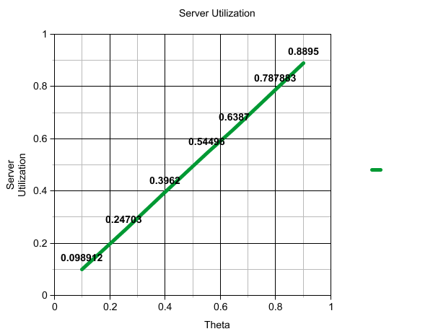Part 1)

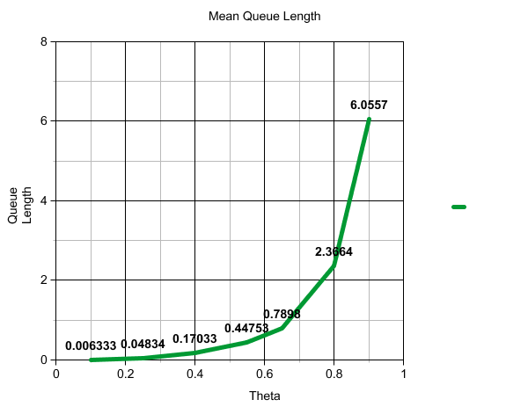

Part 2)

A) Mean Queue Length

Starting from the markov chain analysis from discussion we have $$N=λ/{(μ-λ)}$$

Then the mean delay, $T=w+x$ and therefore

$$w=T-x$$

And the mean queue length is $N_{Q}=wλ$

$$N_{Q}=(T-x)λ=(1/{(μ-λ)}-1/μ)λ=λρ(μ-λ)={ρ^{2}}/{(1-ρ)}$$

a) λ = 0.1, μ = 1

(0.1/1)^2 / (1-(0.1/1)) = 0.01111

b) λ = 0.25, μ = 1

(0.25/1)^2 / (1-(0.25/1)) = 0.083333

c) λ = 0.4, μ = 1

(0.40/1)^2 / (1-(0.40/1)) = 0.26666

d) λ = 0.55, μ = 1

(0.55/1)^2 / (1-(0.55/1)) = .672222

e) λ = 0.65, μ = 1

(0.65/1)^2 / (1-(0.65/1)) = 1.207

f) λ = 0.80, μ = 1

(0.80/1)^2 / (1-(0.80/1)) = 3.2

g) λ = 0.90, μ = 1

(0.90/1)^2 / (1-(0.90/1))= 8.1

These results are larger than our simulation results however, they did follow the same trend.

B) Sever utilization

Sever utilization can be calculated by taking the average number of packets and dividing the average service time, this variable is known as rho.

a) λ = 0.1, μ = 1

0.1/1 = 0.1

b) λ = 0.25, μ = 1

0.25/1 = 0.25

c) λ = 0.4, μ = 1

0.4/1 = 0.4

d) λ = 0.55, μ = 1

0.55/1 = 0.55

e) λ = 0.65, μ = 1

0.65/1 = 0.65

f) λ = 0.80, μ = 1

0.80/1 = 0.80

g) λ = 0.90, μ = 1

0.90/1 = 0.90

These answer are extremely close to the ones we got in out simulation results.

Part 3)