# Function

A Pokédex is a catalogue of the Pokémons in the titular game which has the function of indicating if a Pokémon has been caught. Similarly, the main functionality of this thematic content management system is to let players track their progress in catching all the Pokémons. In addition, users can find Pokémon information and see other users’ progress. Contents of the web can be edited directly, given that the user has the privileges. Functionalities accessible to users depend on their user groups.

# User Group

The website expects 3 types of users, non-members, members and administrators. There are two sub-groups to members, public and private.

# Database and Data

There are four database tables 1) updates, 2) pokedex, 3) users and 4) users_pokemon.

* updates:
  + Stores information of update announcement posts.
* pokedex:
  + Stores information about Pokémons.
* users:
  + Stores information of the CMS users.
* users_pokemon:
  + Stores information of users and their caught Pokémons

# CMS Functions – General

Home

The “Home” page serves as the landing page of the website. All users can access and see different content based on their user groups.

Update

The “Update” page serves as the announcement page telling all users any updates made to the website. For instance, new functions or Pokémons being added. The content is managed by the administrators but can be viewed by all users, including non-members.

Pokedex

The “Pokedex” page serves as the main page for the tracker function, but only members or administrators can access the tracker. All users can click on the Pokémons and view information associated with them.

Community

The “Community” page serves as the page to see other users’ progress. Non-members, who have no access, are redirected to the “Login” page to ask them to register.

Register

The “Register” page serves as the page for users to register an account to be a member. They are required to provide a name and password as login details, and the year of registration for authentication. The visibility setting can also be set during registration.

Further functionality could be implemented to include more input and build a user profile, such as including birth date, sex etc, and allow users to browse the users profile on the “Community” page.

# CMS Functions - Member

Pokedex

Members and administrators are allowed to use the Pokémon tracking functions. The “Pokédex” page is used to show display which Pokémon was caught by the logged users. A Pokéball icon appears on the bottom right corner of the Pokémon if it is caught (Figure 1).

To register which Pokémon was caught, the logged user has to go to the Pokémon’s information page where a button appears only to logged users, allowing them to change the catch status. The button allows the player to switch between the caught status (Figure 2).



Figure “Pokédex” page showing uncaught (left) and caught Pokémon (right).

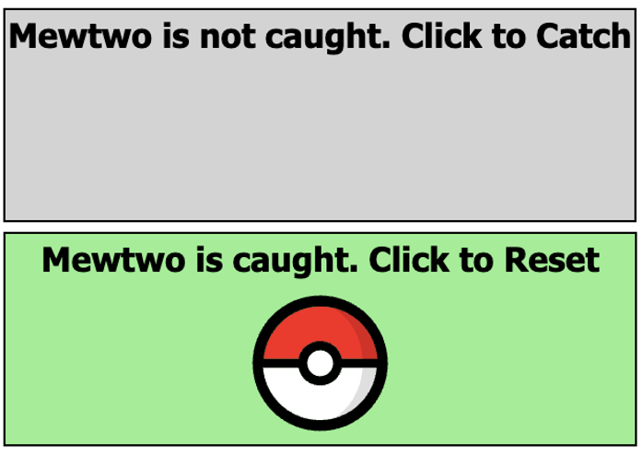

Figure “Pokémon” page showing uncaught (above) and caught Pokémon (bottom).

A filtering function was not implemented, since the “Pokédex” page is designed to showcase all Pokémons. However, a search and filtering would enhance the user’s experience in finding specific content.

Community

The “Community” page allows registered users to view other registered users. The page shows a table of the users which has a searchable function in the “Name” column. Viewers can see other information about the users such as ID, user group and a clickable link to view the user’s Pokémon catching progress.

The link brings the logged user to a view similar to the “Pokédex” page. However, instead of the logged user’s progress, it shows the associated public users’ progress. The Pokéball icon is different to distinguish the logged user’s and public users’ progress.

Further functionalities could be implemented for the “Community” page allowing users to build their user profile a let other users view it. Other social features would be suiting to the page and associated subpages, such as creating journals, comments and replies, following user’s activity, etc.

Settings

The “Settings” page allows the logged user to change their profile visibility to other users, including “Public” and “Private”.

This page could be further extended to allow user to edit their user profile.

# CMS Functions – Administrator

In addition to the functions accessible to members, administrators are allowed to edit content in “Update”, “Pokédex” and User Management.

Update

Administrators can add update announcements from the “Update” page with a clickable link leading them to an editor. The administrators are required to input relevant information, including updated versions, titles, content etc. It is noted that the URL field will become the query string identifier of the URL input.

The edit existing announcement posts, the administrator can either access the edit button from the “Update” page or the update post page. The editor shows existing information of the post and allows users to make necessary alterations.

Pokédex

The “Pokédex” editor is similar to the “Update” editor. However, it is noted that the query string identifier of the URL input is the pokemon_id instead. Furthermore, the pokemon_id can only be added and not edited since the Primary Key to the database should be immutable.

The information of Pokémons acquired for the content management system originated from the Pokémon Database[1]. It provides extensive information as well as links to their associated images. It is recommended for the administrator to input information using the Pokémon Database, especially

* img_url (type: varchar): Link to image of each Pokémon to be displayed on its information page. It is recommended to use large artwork images within the Pokémon page from the Pokémon Database. The URL format is “https://img.pokemondb.net/artwork/large/name-of-pokemon.jpg”
* sprit_url (type: varchar): Link to image of each Pokémon to be displayed on the Pokédex page. It is recommended to use the sprites artwork from the Pokémon Database. The artwork can be found at https://pokemondb.net/sprites.

Further functionalities should be added to allow users to upload images instead of relying on URL links online. However, using the URL links is sufficient enough since there is a pre-existing and complete list of Pokémons in the database.

User Management

Administrators are allowed to view a table of all registered users in the CMS. They are allowed to change user groups and remove users. Changing information of the logged user and main administrator (ID = 1) is not allowed.

# Reference

Pokémon Database. (2024). *Pokémon Database*. <https://pokemondb.net/pokedex>.

1. Pokémon Database. (2024). *Pokémon Database*. <https://pokemondb.net/pokedex>.