Introduction
“Westward Ho!” written by Charles Kingsley is a historical novel following the story of Amyas Leigh, who as a young man followed Francis Drake to sea.
This report aims to analyse the text mining process conducted on the book of how the main character(s) are discussed in terms of positive, negative or neutral sentiments. It presents the information extraction pipeline and discusses the results of the text mining process.

Pipeline Design
The following discusses the several stages of the text mining process. The process mainly used SpaCy for the main text processing and VADER for sentiment analysis. The programming process is conducted using Jupyter Notebook, saved as “23109181-INST0073.ipynb” with this report.

Stage 0: Setup
Import the required libraries and setup the SpaCy English model for the following stages. Then, Save a clean text version of the book.

Stage 1: Named Entity Recognition
Finding the main characters
It is noted without processing the text that Amyas Leigh is the main character of the book. However, the NER process allows the recognition of other prominent characters, which the report aims to discuss two main characters. The named entity is counted and the two most mentioned entities are considered as the main characters. The SpaCy framework is used for its accuracy and ease of use. The clean text is processed to a Doc object through the SpaCy pipeline “nlp”.
Note that the text is not processed i.e., stop-word removal and lemmatisation, to avoid loss of information surrounding the entities’ environments and prevent inaccuracy.

Creating a list of names for each character
There are variations of names associated with the identified characters. Finding the variations of names requires generating a list of relevant names from the extracted named entities, and filtering manually.
The result of this stage is the list of character names which will be used to extract the sentences relevant to the characters from the text.

Stage 2: Sentence Extraction
For sentiment analysis, a list of sentences is required as input. In this stage, the Doc object is split into sentences using the sentencizer method “.sents” and filtered by matching the named entities in sentences to the list of character names generated above. Hence, the sentences are joined as strings and processed with the “nlp()” pipeline again for NER. After the sentencising process, some of the name entities may take different forms in the name lists. The filtered sentences are then processed and saved into a dataframe. The sentence processing takes reference to Sarkar’s sentiment analysis process.
Sentences processing
- Remove stop word
- Lemmatisation
- HTML tag striping
- Convert words to lowercase
- Remove accented character
- Expand Contraction
- Remove special character

Stage 3: Sentimental Analysis
The sentiment analysis process is conducted using the VADER module. It assigns a sentiment score to each word in the text, taking into account both the word itself and its context. Sentiment scores are computed for the sentence based on the words, in terms of positive, negative and neutral. A compound score is compounded for each sentence which is normalised to -1 (most negative) and 1 (most positive). This analysis uses the standard threshold to classify the compound score into positive, negative and neutral sentiment. Where it is positive if the compound score >= 0.5, negative if score <= -0.5, neutral if score < 0.5 and > -0.5.

Stage 4: Data Visualisation
The result will be visualised by 1) the proportion of positive, negative and neutral sentiments discussing the characters in the book. 2) the sentiments discussing the characters throughout the book. 3) the mood words associated with the characters.

Findings
Named Entity Recognition (NER)
Finding the main characters
The NER process identified 5407 named entities that are ‘PERSON’. The most frequently mentioned entity is ‘Amyas’, mentioned 967 times, which is not unexpected since he is the main character of the book. The second most frequently mentioned entity is ‘Frank’ is mentioned 326 times, which is significantly less than ‘Amyas’. The two entities are checked within the context to confirm the two characters to be Amyas Leigh and Frank Leigh.

Creating a list of names for each character
The identification of name variations is based on finding names containing ‘Amyas’ or ‘Frank’ respectively. These names are then checked manually that some names are similar but do not refer to the entity. For instance, Amyas Preston, Franky, Franky or Frank Drake refers to other characters.
The process produced a name list for ‘Amyas’ and ‘Frank’.
Amyas_names = ['Amyas,--"Ayacanora quite English', 'Whereon Amyas', 'Amyas', ‘Amyas Leigh's’, ‘Amyas Leigh’]
Frank_names = [‘Frank Leigh's’, ‘Frank spoke--', ‘Frank’, ‘Frank Leigh’, ‘Whereon Frank’, ‘Master Frank’, ‘Frank Leigh?’, ‘Frank three’, ‘Frank--']

Sentence Extraction
There are 1000 sentences associated with Amyas Leigh and 273 sentences associated with Frank Leigh.

Sentiment Analysis
Amyas Leigh
The sentiment analysis on Amyas Leigh shows that the sentences relevant to the character are discussed 58.90% neutrally, 26.30% positively and 14.80% negatively (Figure 1). It has a mean compound score of 0.01 which suggests the character is generally discussed neutrally throughout the book. It also suggested the character is discussed positively slightly more often than negatively.
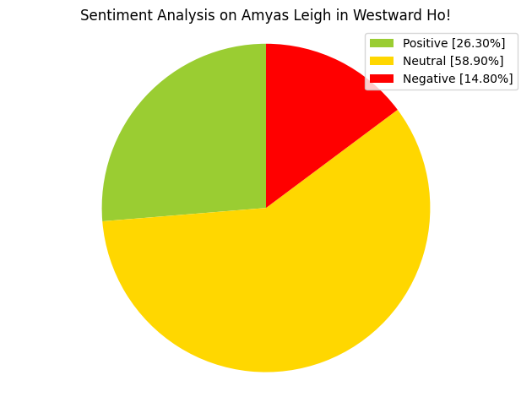
Figure 1 Pie Chart of Compound Score Result Distribution of Sentiment Analysis on Amyas Leigh

An analysis of sentiment change (Figure 2) is conducted to find sentiment patterns throughout the book, but no pattern is found suggesting the character is not discussed specifically positively or negatively in any part of the book.

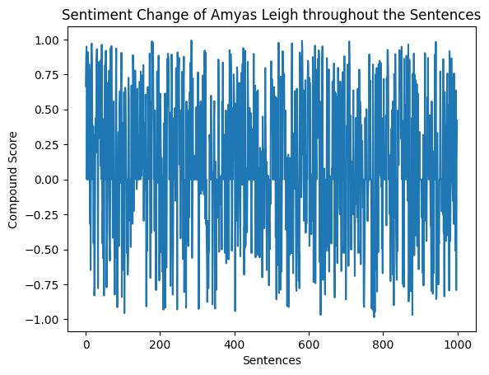
Figure 2 Line Plot of Compound Score of Amyas Leigh of the Sentences

Common mood words are identified for positive and negative sentiments. For positive sentiment, the words ‘great’, ‘love’, and ‘laugh’ are the top three most mentioned words that are expressed positively (Figure 3). For the negative sentiment, the words ‘dead’, ‘kill’, and ‘die’ are the top three most mentioned words that are expressed negatively.
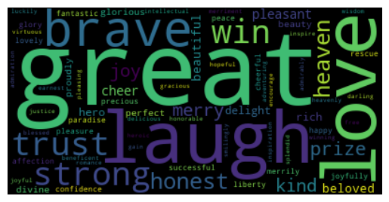
Figure 3 Wordcloud of Positive Mood Words of Amyas Leigh
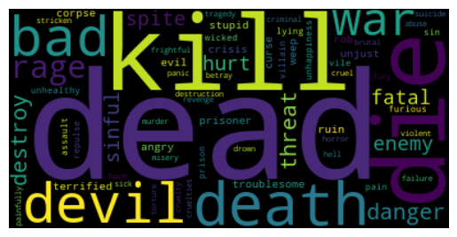
Figure 4 Wordcloud of Negative Mood Words of Amyas Leigh

Frank Leigh
The sentiment analysis on Frank Leigh shows that the sentences relevant to the character are discussed 58.97% neutrally, 30.77% positively and 10.26% negatively (Figure 5). It has a mean compound score of 0.19 which suggests the character is generally discussed neutrally throughout the book. It also suggested the character is discussed positively more often than negatively. Frank Leigh is discussed more positively in proportion compared to Amyas Leigh.
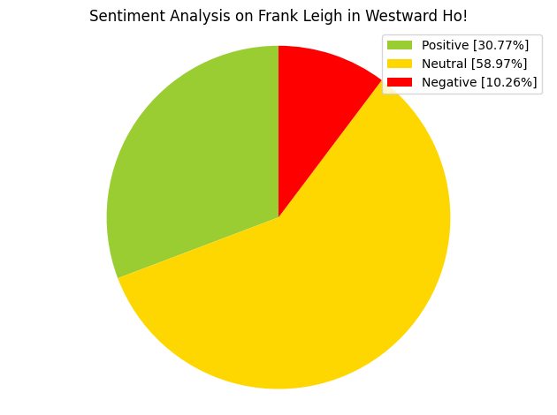
Figure 5 Pie Chart of Compound Score Result Distribution of Sentiment Analysis on Frank Leigh
Similar to Amyas Leigh, the analysis of sentiment change on Frank Leigh (Figure 6) yields no pattern suggesting the character is not discussed specifically positively or negatively in any part of the book.

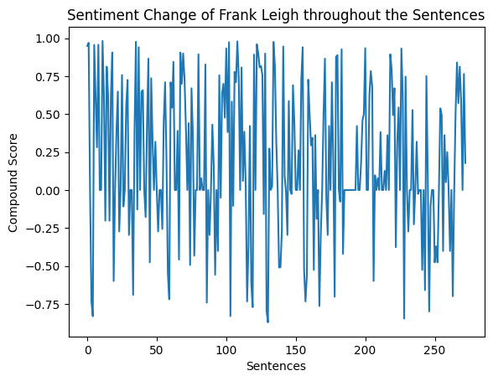
Figure 6 Line Plot of Compound Score of Frank Leigh of the Sentences

For positive sentiment, the words ‘love’, ‘great’, and ‘win’ are the top three most mentioned words that are expressed positively (Figure 3). For the negative sentiment, the words ‘death’, ‘weep’, ‘horror’ are the top three most mentioned words that are expressed negatively.
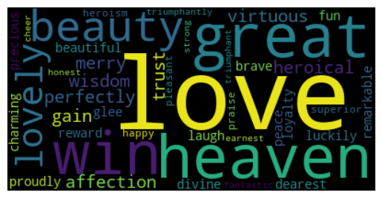
Figure 7 Wordcloud of Positive Mood Words of Frank Leigh
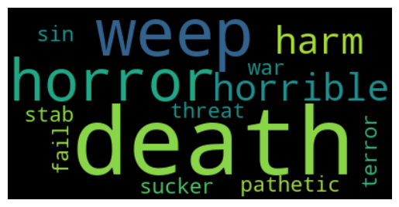
Figure 8 Wordcloud of Negative Mood Words of Frank Leigh

Limitation and Challenges
There are limitations to the sentiment analysis, when identifying the name variations of the characters, it is challenging to find all name entities associated with the characters and whether the selected name entities are correctly identifying the characters. For instance, there are entities named ‘Leigh’ which may or may not be associated with the characters, or there are similarly named characters such as Amyas Presto or Franky Drake which may be represented as ‘Amyas’ or ‘Frank’. It is challenging to validate these name variations without looking closely at the context of these entities.
Furthermore, it is unclear from the analysis if the sentiment is directly related to how the character is discussed or simply a mood word is present. For instance, the lemmatised sentence ‘amyas half laugh’ has a compound score of 0.5574, which is classified as a positive sentiment, but the character is not necessarily discussed positively. The context of the sentiment should be looked at closely to see how the characters are discussed.
Sentiment analysis should be conducted as a sentence instead of words by words, since a phrase of mood words may refer to opposite sentiment, notably ‘love’ and ‘not love’. Hence, the pipeline filters the sentences using sentiment tags before processing the words. However, isolating the words from the sentence context would affect the accuracy on the sentiment score.

Conclusion
To conclude, the two main characters Amyas Leigh and Frank Leigh are generally discussed neutrally. Furthermore, due to the limitations and challenges of the sentiment analysis, further study is required to understand the discussed sentiment in context.
Bibliography

Dickens, C. (1895). Westward Ho! Or, The Voyages and Adventures of Sir Amyas Leigh, Knight, of Burrough, in the County of Devon, in the Reign of Her Most Glorious Majesty Queen Elizabeth. Accessible on https://www.gutenberg.org/ebooks/1860.

Hutto, C. J. and Gilbert, E. E. (2014). “VADER: A Parsimonious Rule-based Model for Sentiment Analysis of Social Media Text”. Eighth International Conference on Weblogs and Social Media (ICWSM-14). Ann Arbor, MI, June 2014.

Sarkar, D. (2019). Text Analytics with Python: A Practitioner’s Guide to Natural Language Processing. https://link.springer.com/book/10.1007/978-1-4842-4354-1

Dickens, C. (1895). Westward Ho! Or, The Voyages and Adventures of Sir Amyas Leigh, Knight, of Burrough, in the County of Devon, in the Reign of Her Most Glorious Majesty Queen Elizabeth. Accessible on https://www.gutenberg.org/ebooks/1860.
Sarkar, D. (2019). Text Analytics with Python: A Practitioner’s Guide to Natural Language Processing. https://link.springer.com/book/10.1007/978-1-4842-4354-1
Hutto, C. J. and Gilbert, E. E. (2014). “VADER: A Parsimonious Rule-based Model for Sentiment Analysis of Social Media Text”. Eighth International Conference on Weblogs and Social Media (ICWSM-14). Ann Arbor, MI, June 2014.

