Car Rent System
--Requirement and System Design

Requirement Analysis
- User Operation Flow
1.1 Register and Login
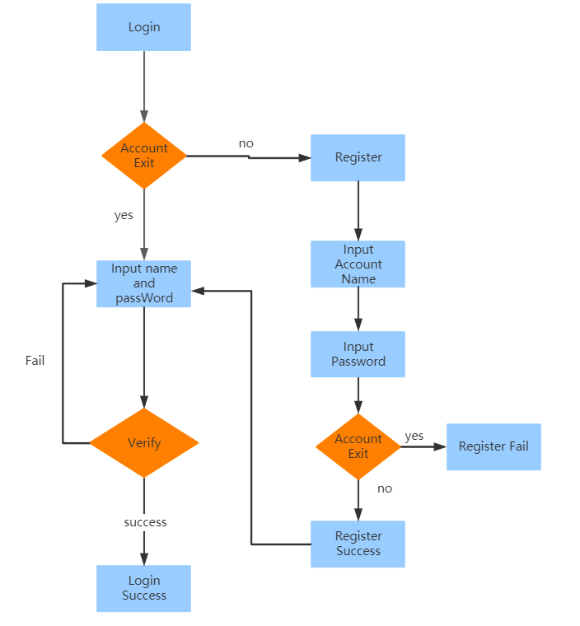
1.2 Booking car
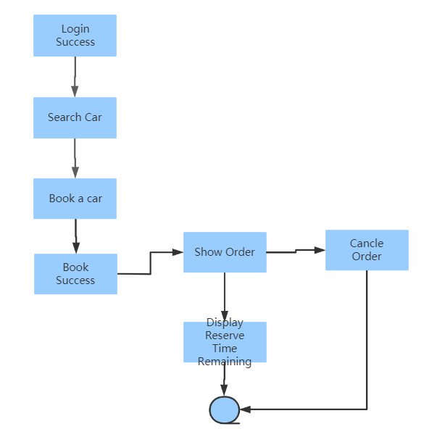

System Design
- Modules
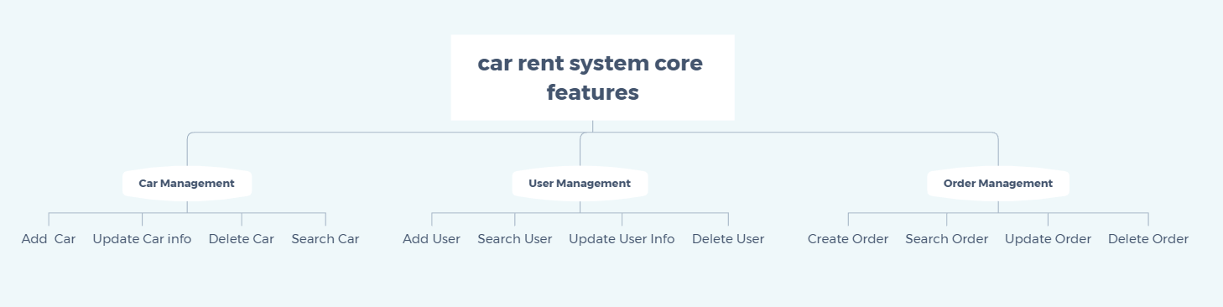
- Database Design
  - car
Field | Type | Description | Nullable
id
name
category
price
color

  - order
Field | Type | Description | Nullable
id
order_time
user_id
car_id

  - user
Field | Type | Description | Nullable
id
name
password
phone

- API

