Assembly Language HW2
數學三B 107201537詹偉翔
1.After we change the chstrs1 by change function, we get 00111110
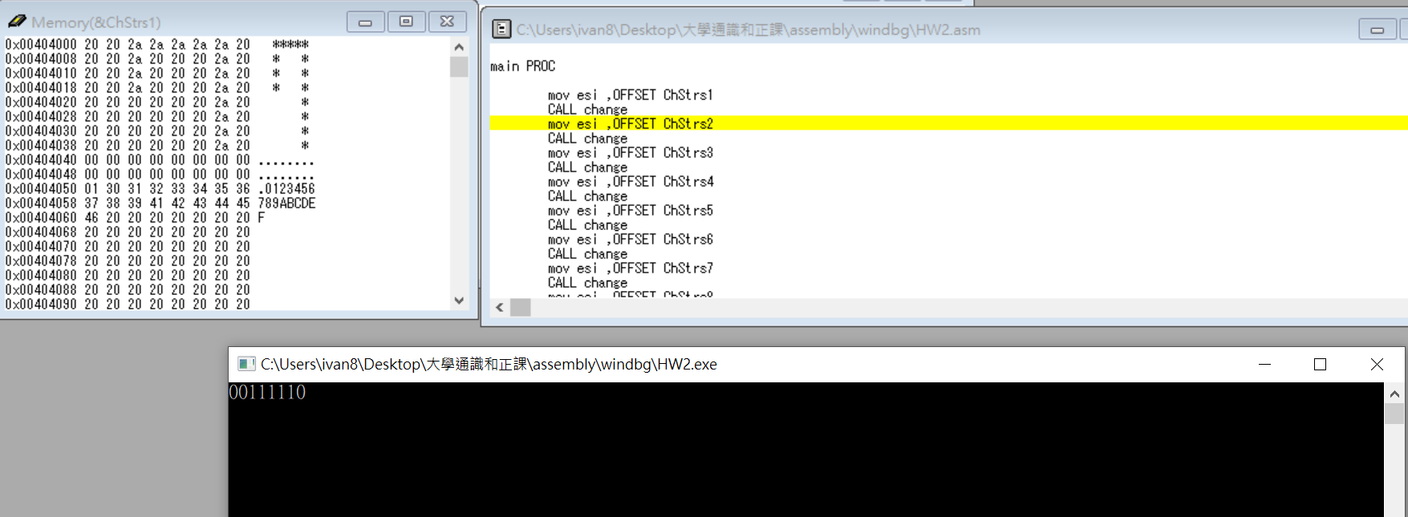
2. 1.After we change the chstrs1 by change function, we get 00100010
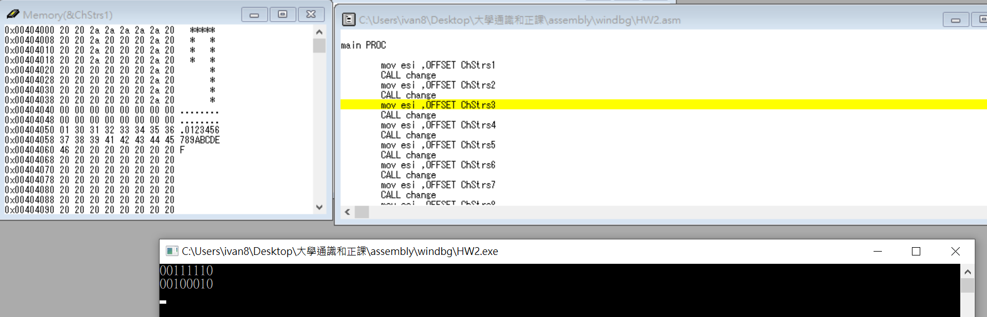
3.After we change the chstrs1 by change function, we get 00100010
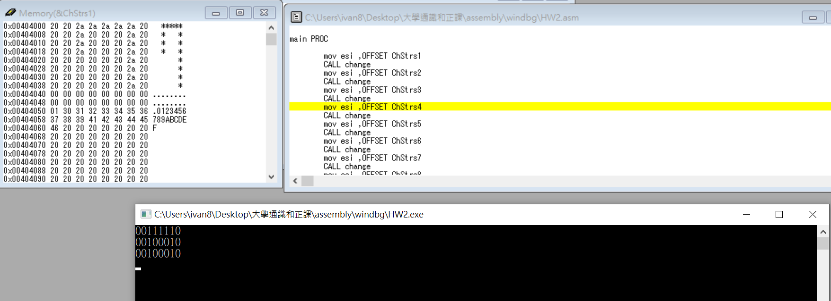

4.After we change the chstrs1 by change function, we get 00111110
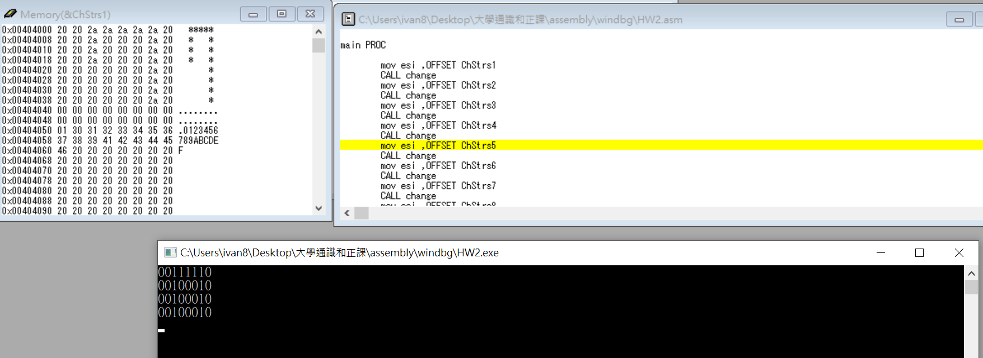
5. After we change the chstrs1 by change function, we get 00000010
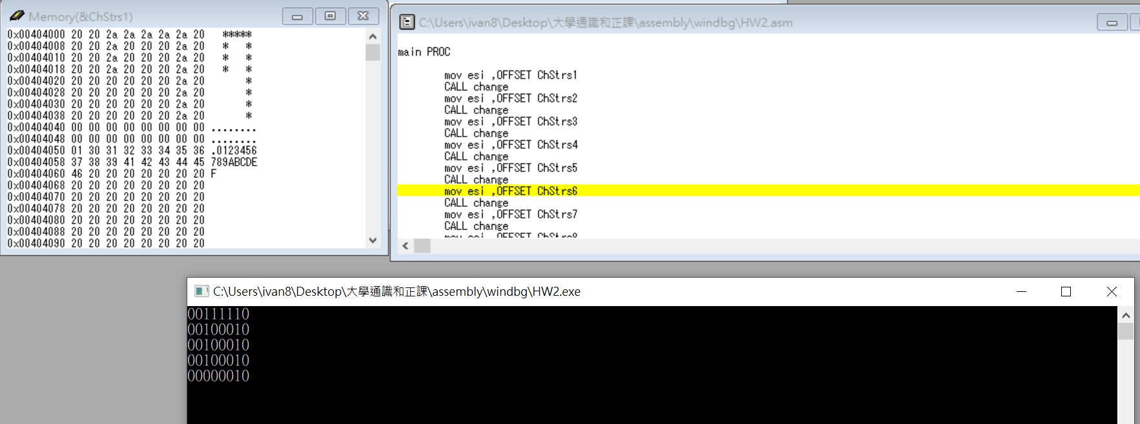
6. After we change the chstrs1 by change function, we get 00000010
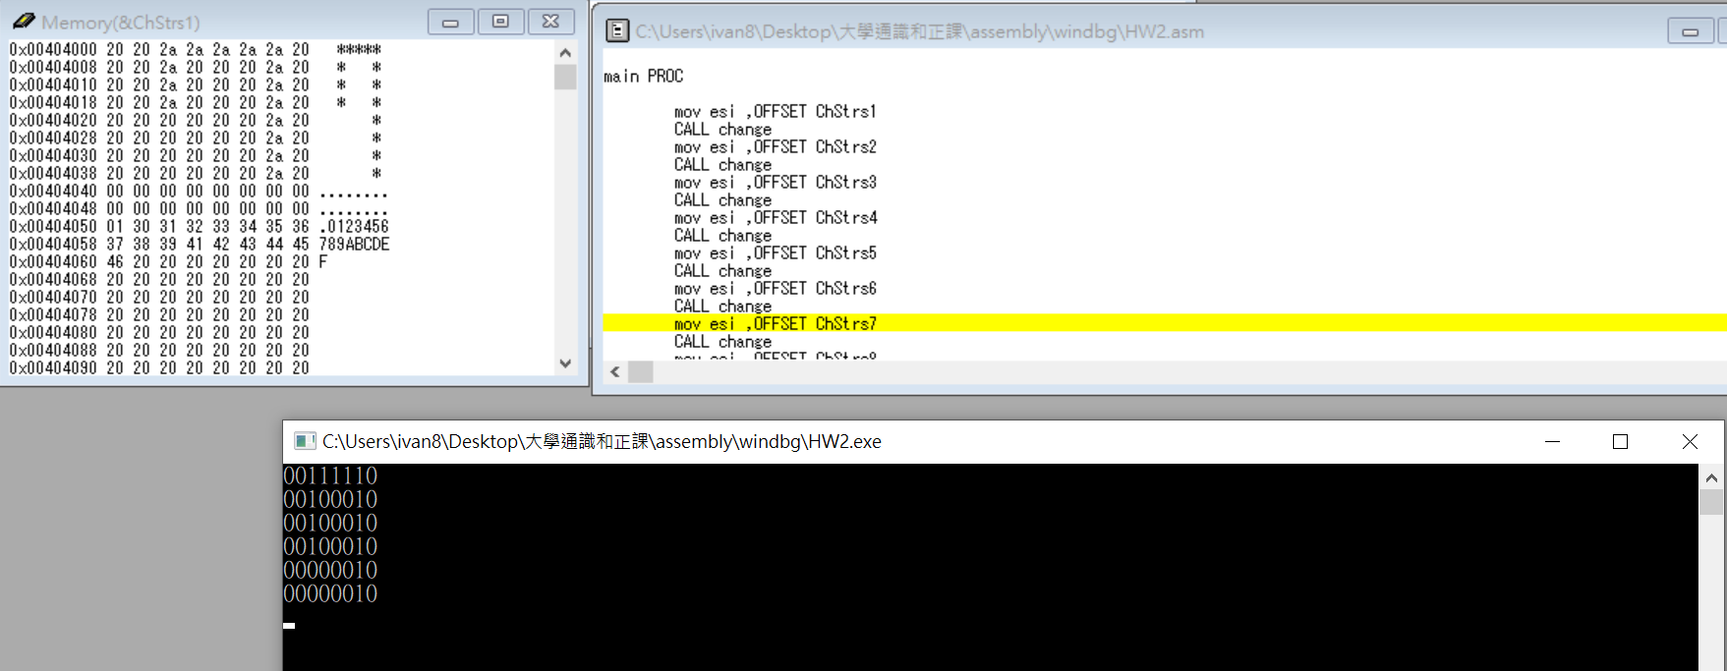

7. After we change the chstrs1 by change function, we get 00000010
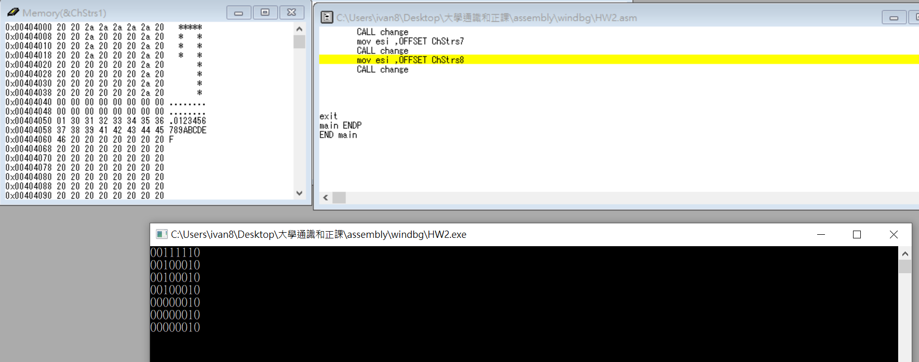
8. After we change the chstrs1 by change function, we get 00000010
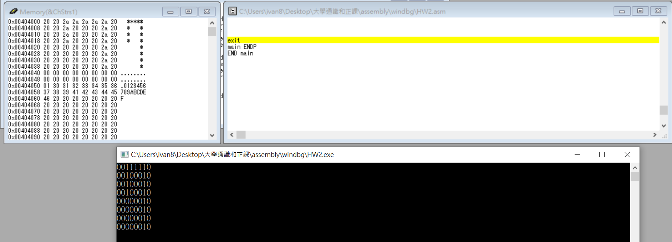
After changing eight times, we can know the answer is true.

Ivan’s report:
I think that this homework is harder than last time. I spend at least three hours for doing this homework, but I learn some skills in this homework. For example, I forget to add “ret” in the change function so that I always print chstrs1 instead of another chstrs, fortunately, I finally find my fault and print the right answer. Although the homework is difficult, I think not only me but also everyone can learn their faults and correct it, next time we will not get the same fault.

