Vhost-pci RFC 2.0

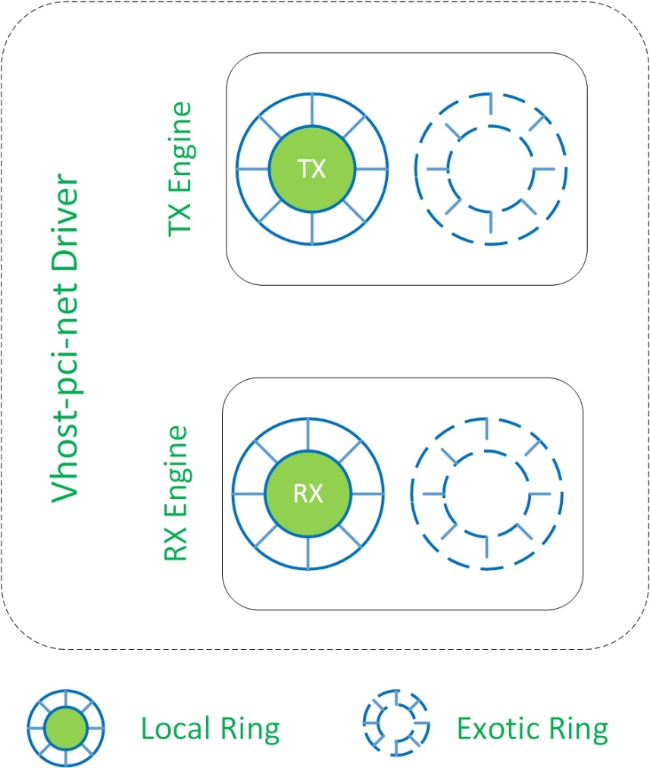

Fig. 1 Driver Frame

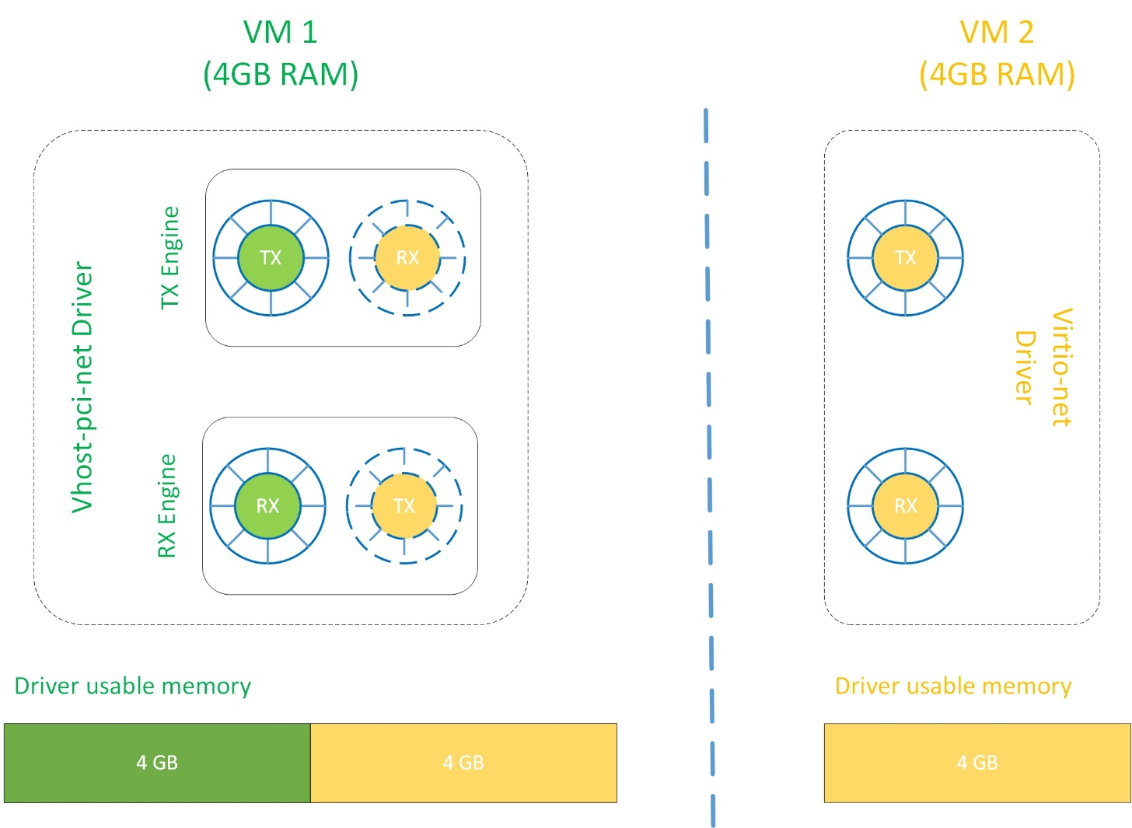

x

x

Y

Y

Pkt “X” from the network stack

Pkt “Y” from the network stack

Fig. 2 Inter-VM Datapath 2.0

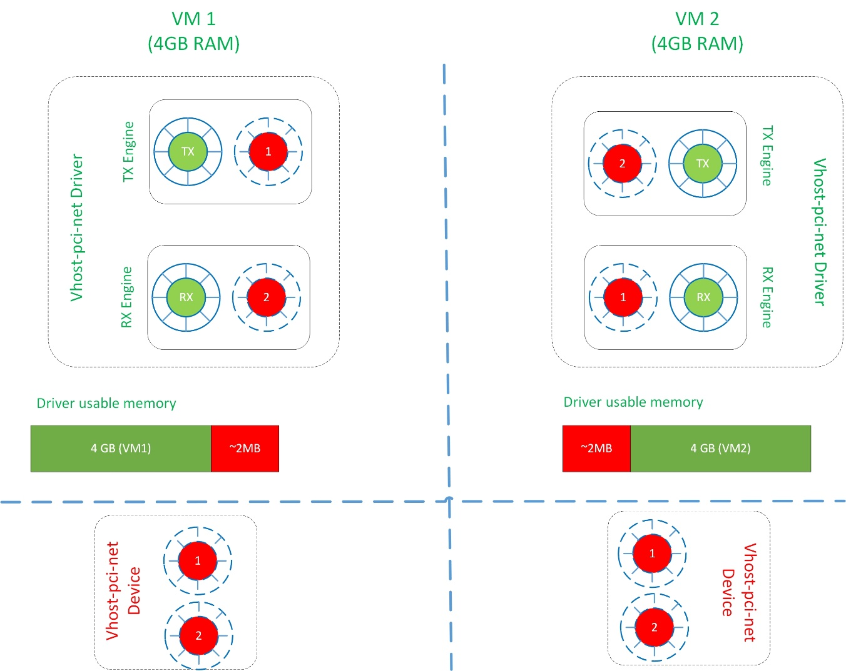

Share ring memory

x

x

x

Pkt “X” from the network stack

Fig. 3 Inter-VM Datapath 2.1

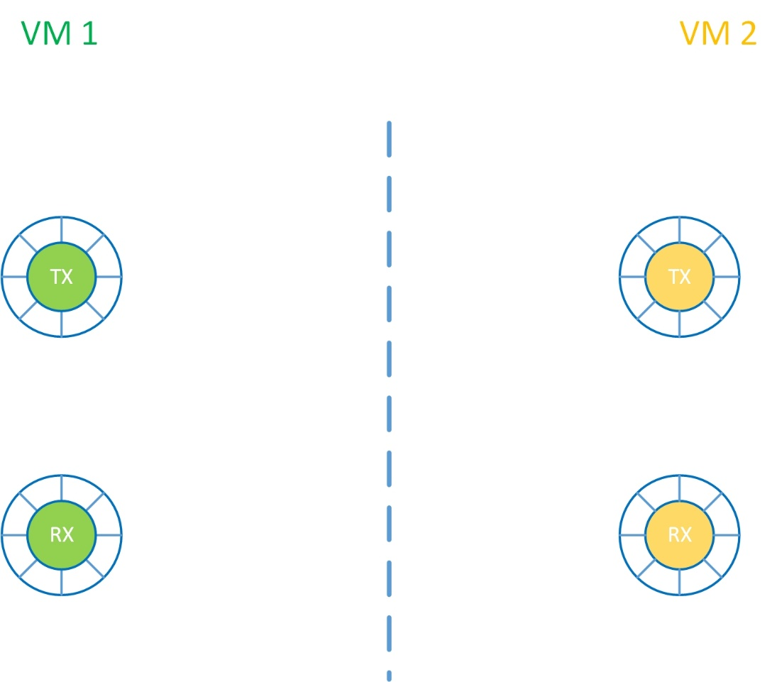

Kickfd: fd3

Callfd: fd2

Kickfd: fd1

Callfd: fd0

Kickfd: fd0

Callfd: fd1

Kickfd: fd2

Callfd: fd3

eventfd allocation

eventfds shared from VM2

Fig. 4 Inter-VM notification