Supporting Information
What transfers between cell lines? Learning improves genetic and chemical response prediction
Wei Chen* and Xiaohong Lu
Louisiana State University Health Sciences Center, Shreveport, LA 71103, USA
*Corresponding author: wei.chen@lsuhs.edu
Contents: Figures S1–S3; Tables S1–S2; Supporting Methods; Supplementary Note 1. Reference numbers refer to the main manuscript. Full source tables and retired exploratory analyses remain archived with the code.
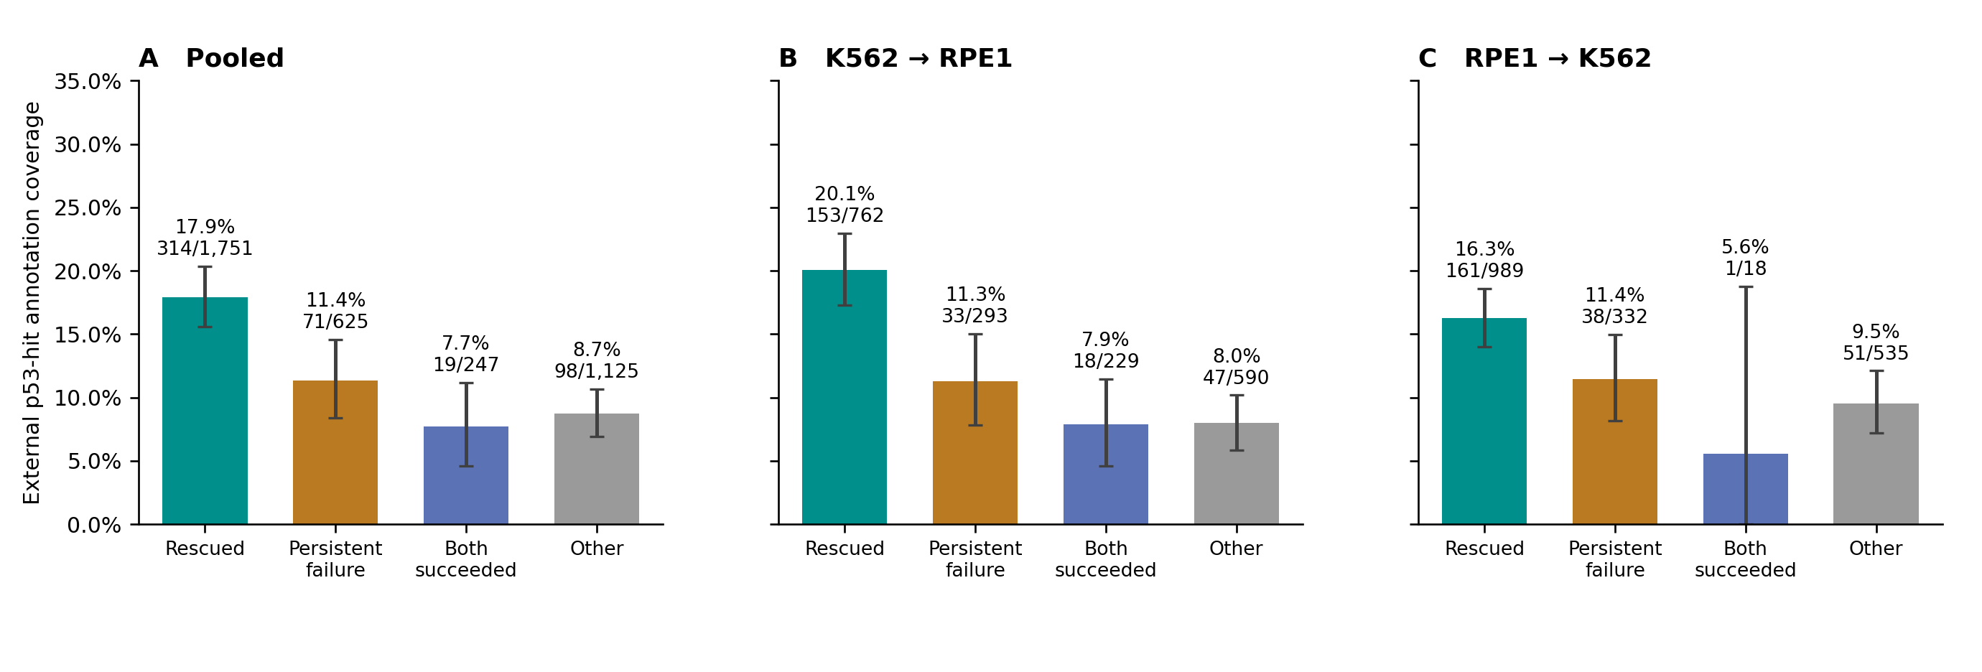
Figure S1. p53-hit coverage by transfer direction. External A549 p53-hit coverage across the four outcome groups, pooled and separately by direction. Error bars are exploratory 95% intervals from 20,000 target-gene bootstrap draws, keeping both directions together. The RPE1→K562 both-succeeded group contains only 18 cases (1 hit), limiting precision.
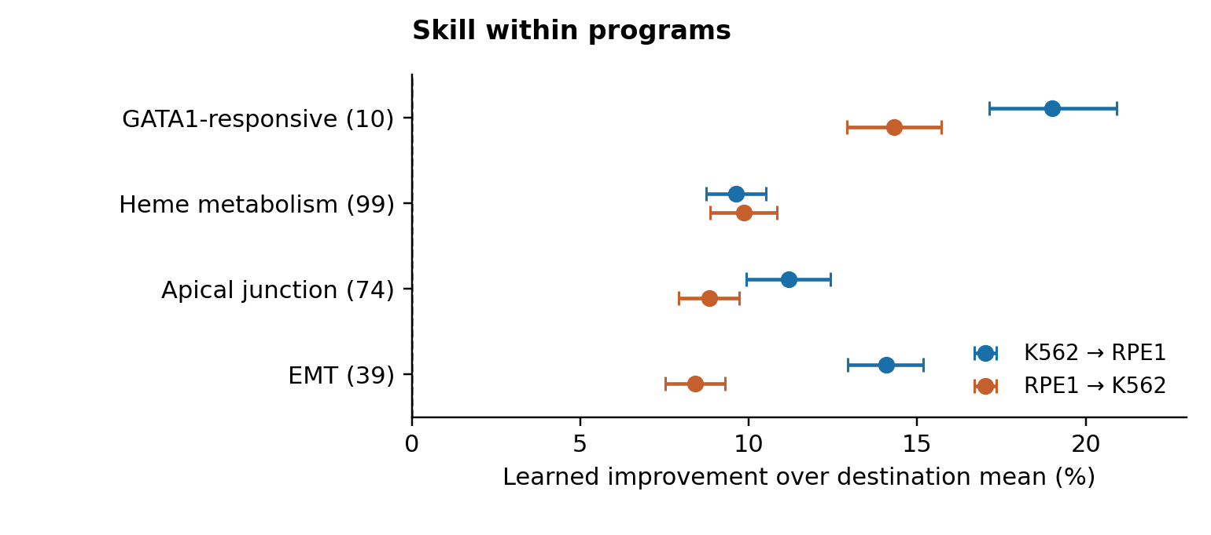
Figure S2. Absolute learned skill within external response programs. Skill against the destination mean within four fixed programs, in both directions; parentheses give measured readout counts. Conditional 95% intervals use 10,000 shared target-cluster draws, fixing fits, controls and masks. Own-target readouts are excluded. Relative program-versus-complement contrasts appear in Figure 3C.
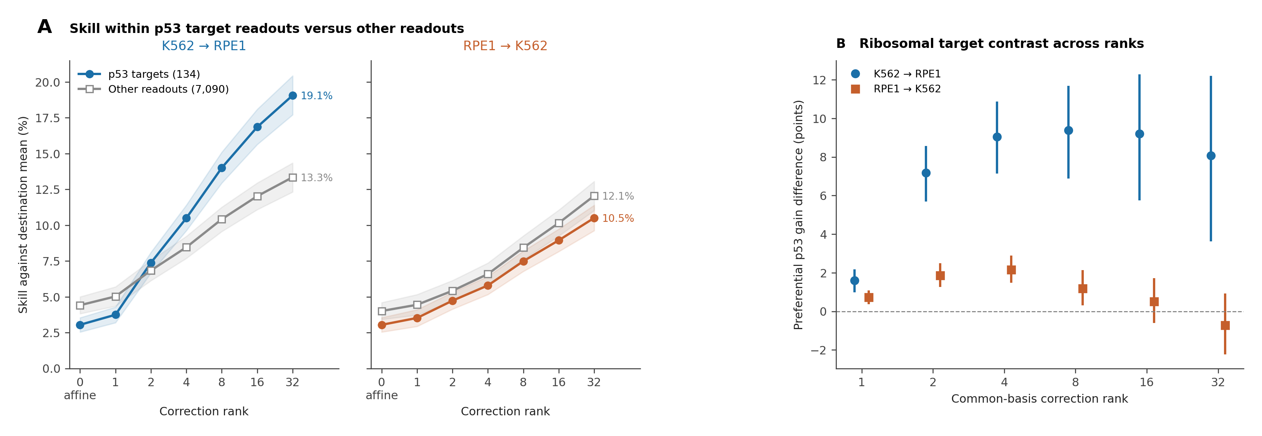
Figure S3. Absolute p53 readout skill and secondary ribosomal contrasts. A, Skill within 134 p53 target readouts (filled) and 7,090 complementary readouts (open), across ranks in both directions; intervals are conditional 95%. B, Ribosome-minus-nonmember preferential p53 gain across the common 40-column rank grid; intervals are adjusted 99.583% across twelve contrasts. Both use 10,000 target-cluster draws, stratified by target group in B. The original rank-16 primary contrast is in Figure 4D; its 24-column source basis differs from this grid. Measurement properties remain unmatched.
Table S1. LINCS held-out chemical transfer
Direction | Predictor | Skill versus mean | Conditional 95% interval
MCF7→PC3 | Zero | −5.50% | −5.69 to −5.31
MCF7→PC3 | Copy | −90.54% | −94.55 to −86.73
MCF7→PC3 | Diagonal affine | 1.11% | 0.99 to 1.23
MCF7→PC3 | Cross-gene, rank 16 | 3.19% | 2.80 to 3.60
PC3→MCF7 | Zero | −4.26% | −4.38 to −4.13
PC3→MCF7 | Copy | −78.59% | −82.10 to −75.23
PC3→MCF7 | Diagonal affine | 1.08% | 0.97 to 1.20
PC3→MCF7 | Cross-gene, rank 16 | 3.56% | 3.14 to 4.00
Identity-weighted held-out MSE reduction against the destination training mean across 4,185 identities, 4,902 compound IDs and 978 measured genes. The cross-gene gain over affine was 2.08 (1.80 to 2.38) and 2.48 (2.17 to 2.81) percentage points. Intervals use 10,000 shared identity-cluster draws, fixing fits and technical splits. Median split-half cosine was 0.115 in MCF7 and 0.117 in PC3.
Table S2. p53 rescue matching sensitivity
Comparison | Hit cases | Gap (points) | Conditional 95% interval
Unmatched, full panel | 461 | 15.8 | 10.0 to 21.5
Response magnitude and cell recovery | 461 | 10.4 | 3.7 to 17.0
Same covariates, baseline subset | 446 | 10.5 | 3.5 to 17.9
Add untreated expression, same subset | 446 | 6.3 | −0.6 to 15.2
As above, K562→RPE1 only (exploratory) | 209 | 10.5 | 1.4 to 20.4
As above, RPE1→K562 only (exploratory) | 237 | 2.5 | −6.3 to 13.4
Gaps compare p53-hit with below-threshold rescue among copy-worse cases. Unmatched intervals resample target IDs; matched intervals resample dependency components linking reused hit/control IDs across directions (10,000 draws; matches and fits fixed). The original match retained one pair above the distance limit. Expanded matching had incomplete balance and overlap. Direction-specific estimates were not prespecified; their difference was not tested. Below-threshold annotation is not biological absence.

Supporting Methods

Genetic data and fixed splits
Constructs required at least 20 cells in each line. SHA-256(seed|barcode), seed 2026101301, assigned cells to disjoint halves within construct/GEM group; odd allocations kept construct-half counts within one cell. Native counts were averaged within construct and half. Controls were equal-weight means of 97 K562 or 113 RPE1 control-construct means. Native responses used log1p(perturbation mean) − log1p(control baseline), without library-size normalization. Both lines retained 1,977 constructs, 1,874 targets and 7,226 readouts. Own-target readouts were removed from scoring, not model fitting. Construct losses were averaged within target, then across targets and orientations. Five target folds used SHA-256(ICE_PRN_TRANSFER_RESPONSE_EXPORT_v1_20261012|target ID) modulo five. Each training target had equal total weight.
Normalization divided each cell’s counts by its total over all deposited genes (8,563 K562; 8,749 RPE1), multiplied by 10,000, then repeated averaging and log1p transformation. Cells, controls, splits, readouts, folds and settings were unchanged. Native reconstruction and all 80 original checks passed before refitting. Cross-gene skills were 15.4% [14.3, 16.5] toward RPE1 and 10.8% [10.0, 11.7] in reverse (conditional 95%; 10,000 shared target draws, seed 2026102021). Annotation/program analyses retained the native scale.

Predictor implementation and rank replay
Genetic affine slopes were weighted source–destination covariance divided by source variance, with numerically degenerate slopes set to zero. Centered target-weighted source responses were projected through 24 Gaussian columns (seed 2026101401), followed by QR/SVD; up to 16 right-singular directions predicted the affine residuals. The ridge penalty equaled the mean diagonal of the weighted score Gram matrix. Settings followed development inspection and were fixed thereafter. The rank grid used one 40-column decomposition with nested ranks 0–32 and the same penalty rule; no rank was selected. Original 24-column rank-16 skills were 12.04%/9.94%, compared with 12.15%/10.14% at grid rank 16. All 80 anchor checks passed before grid evaluation. All 44 saved rank-loss vectors were reproduced before readout analysis. Adjacent-rank marginal intervals were descriptive, unadjusted across twelve contrasts.

Chemical profiles and predictors
Exact names, InChIKeys, connectivity prefixes and canonical SMILES grouped 5,667 perturbagen IDs conservatively. A fixed hash assigned each RNA plate wholly to one half within cell line. Requiring profiles in all four cell/half combinations retained 4,902 IDs, 4,185 identities and 53,635 profiles at 10 µM/24 h, without signal-based exclusions. Deposited GSE92742 Level-4 ZSPCINF values were averaged over profiles within ID/cell/half for 978 measured landmarks. Inferred genes and Level-5 signatures were not substituted. Training weights were equal by identity, then by eligible ID within identity; folds held whole identities out. The chemical affine denominator added mean source variance to each readout’s source variance. Residual prediction used 24 Gaussian projections (seed 2026102105), 16 scores and the mean weighted Gram diagonal as ridge penalty. Both ridge multipliers were one, without tuning. All 978 landmarks were scored. Original chemical intervals used 10,000 shared identity draws, seed 2026102106.

Component risk and RPL3 example
Hallmark E2F/G2M panels contained 183/177 common readouts. Component responses averaged panel genes, excluding own-target readouts, then halves and constructs within target. Ridge models predicted log squared copying error from log absolute source magnitude, alone or with log source-half disagreement (offset 10⁻⁸). Features were standardized on training folds; intercepts were unpenalized and the mean-squared-log-error objective added the sum of squared slopes. Five fixed target folds were shared across programs/directions. Held-out risk ordered targets at 20–100% coverage in 20% steps, rounding upward and breaking ties by target ID. Zero skill used copying MSE divided by destination component energy on the same retained lists; rankings were fixed during resampling.
RPL3 was selected retrospectively as the worst native RPE1→K562 copy skill against zero (−5,583%; copy MSE 0.0368, zero 0.00065). Its squared response was 0.0360 in RPE1 and 0.00065 in K562, excluding own-target readout. Split-half cosines were 0.62/0.58, and own-target log1p responses −0.96/−0.27. The construct had 30 measured RPE1 cells versus 1,996 K562 cells. Comparator choice defines this rank; the example provides no independent or p53-mediation test.

p53 annotation and matching diagnostics
A549 status followed the archived external threshold and mapping.²⁸ Screen-expressed below-threshold genes were annotation controls; unmapped/screen-unexpressed genes stayed separate. Coverage used all 3,748 target–direction cases: 1,751 rescued, 625 persistent failures, 247 both succeeded and 1,125 mixed/tied. Unknown annotations remained in coverage denominators without being called biological non-hits. Recovery comparisons used copy-worse hit/below-threshold cases. Full-panel matching used ln(source-response RMS), log1p source cell count and log1p destination cell count, standardized by eligible-pool population SD within direction. RMS excluded own-target readout and was floored at 10⁻¹². Nearest Euclidean controls were selected with replacement; target IDs broke ties. Diagnostic limits were absolute mean imbalance 0.1 and distance 2. Pairs exceeding limits were retained without retuning.^{31,39}
Untreated baselines were available in both lines for 1,628/1,874 targets and 446/461 copy-worse hit cases. Baselines averaged the two technical halves; missing values were not zero. Three-covariate matching was repeated within this subset before adding log1p untreated target counts in both lines. Expanded maximum pair distances were 4.257/2.635 and maximum absolute imbalances 0.102/0.069 by direction. Native counts mix expression, depth and RNA-content effects. The full three-covariate match had 145 dependency components over 461 pairs, largest 48, including one distance-2.204 pair. Subset three-covariate/expanded matches had 136/141 components, largest 32/88. Component resampling kept reused controls, both directions and all linked pairs together. Direction-specific estimates were exploratory.

Fixed readout masks and endpoints
The four program sets retained exact unambiguous saved-symbol matches: GATA1 10/25, heme 99/200, apical junction 74/200 and EMT 39/200.^{30,32} GATA1 derives from a mouse study with curated human mappings. Two ambiguous HSPA14 coordinates were excluded from program/complement scoring but retained in whole-response evaluation. No aliases were added. Program losses averaged readouts, constructs within target, targets and orientations. Complements used remaining unambiguous readouts among 7,224 coordinates. The eight fixed program–direction contrasts were retained.
Fischer’s census contained 343 unique symbols; 134 mapped to readouts, with 7,090 complement coordinates.³⁴ The primary rank endpoint was (p53 skill_rank − p53 skill_affine) − (complement skill_rank − complement skill_affine), at six nonzero ranks in both directions. Contracts/masks preceded subgroup error inspection but followed the original benchmark. Ribosomal targets used the complete 88-member KEGG_RIBOSOME snapshot by exact saved-symbol match: 72 members, 1,796 nonmembers and six unavailable-symbol exclusions.^{30,33} This legacy annotation includes mitochondrial/pseudogene entries and is not an exhaustive pure cytoplasmic-ribosome definition. Nonmembers are not stress-negative. The original rank-16 primary contrast subtracted nonmember preferential gain from ribosome preferential gain; the common-basis rank grid was secondary. Target groups, models and masks were fixed.
KEGG breast/prostate sets retained 33/148 and 23/106 members among 978 landmarks, with 13 shared.³³ Original primary endpoints were within-pathway learned skill and pathway-minus-complement skill in each direction (four total). These estimates and all source losses remain in the figure package, although Figure 3D displays the relative contrasts. The continuous analysis followed sparse outcome-group comparisons; no drug or gene list was selected for favorable outcomes. Saved losses passed 100 original checks, four global-loss checks and 12 archived pathway/complement point checks.
Early/late estrogen sets retained 30/34 landmarks, with 16 shared, and were tested toward MCF7 only.³⁰ The sets are external to benchmark errors but include separate MCF7 studies in their construction. For estrogen and KEGG sets, each member was matched with replacement to its nearest nonmember on four standardized covariates: Level-3 DMSO vehicle intensity and arctanh-transformed half-response correlation in each line. Intensities averaged profiles within plate then plates equally; repeatability used identity-averaged responses across all 4,185 identities. Entrez ID broke distance ties. Adequacy required all distances ≤2, absolute mean imbalances ≤0.1 and effective controls ≥half the set size.³⁹ Early estrogen retained MCF7-repeatability imbalance 0.156; late passed all rules. Both KEGG matches retained PC3-repeatability imbalance (0.128 prostate; 0.168 breast). Matches preceded new outcome inspection and were not changed to improve diagnostics.

Bootstrap families and reproducibility
All percentile intervals condition on fits, masks, controls and fixed analysis choices.^{40,41} Unless noted, 10,000 draws were shared across methods, directions and readout sets. Seeds: genetic benchmark 20261016; zero/rank grid 2026102121; unmatched p53 rescue 20261018; p53 coverage 20261020 (20,000 target draws); original/subset/expanded matched rescue 20261017/20261022/20261023; identity programs 2026102010; cancer pathways 2026102213; matched cancer pathways 2026102303; p53 rank readouts 2026102304; estrogen 2026102305; ribosomal groups 2026102306. Matched rescue resampled dependency components; ribosomal draws were stratified within fixed target groups. Adjusted marginal intervals were 99.375% for eight identity contrasts, 98.75% for four original cancer or four estrogen endpoints, 97.5% for two matched cancer or two original-model ribosomal contrasts, and 99.583% for twelve p53-rank or twelve secondary ribosomal contrasts. These adjustments apply within each exploratory family, not across all analyses in the paper.

Supplementary Note 1. Endpoint equivalence of coupling and entry changes in a constructed system
Constructed dynamics followed dr/dt = K[(A − I)r + Bu], with r(0) = 0. A describes coupling, B maps intervention u into the system, and K holds positive response rates. We retained 240 conditions: 12 fixed seeds, 64 observed nodes, two input designs, two times (t = 2 and equilibrium) and five context-change scenarios. No parameter was tuned to the empirical benchmark.
With unrestricted, potentially multivariate entry, an entry-only twin with unchanged coupling reproduced every equilibrium response of the coupling-change system (maximum absolute discrepancy 1.55×10⁻¹⁵). Rate changes altered finite-time responses but left equilibrium unchanged. Equilibrium responses therefore cannot identify rates, and unrestricted entry leaves coupling nonunique. These linear-system properties bound interpretation rather than establish a new identification result.³⁵ The constructed conditions did not reproduce the empirical copying-versus-mean failure and do not identify a mechanism for the real data. The endpoint equivalence need not hold when intervention entry is known to be diagonal.

