What transfers between cell lines? Learning improves genetic and chemical response prediction
Running title: Learning perturbation transfer across cell lines
Article type: Research Article
Wei Chen,* and Xiaohong Lu
Louisiana State University Health Sciences Center, Shreveport, LA 71103, USA
*Correspondence: Wei Chen, Louisiana State University Health Sciences Center, Shreveport, LA 71103, USA. Email: wei.chen@lsuhs.edu

Abstract
Responses to the same perturbation can differ between cell lines, limiting reuse of perturbation atlases. We evaluated genetic transfer between K562 and RPE1 and chemical transfer between MCF7 and PC3, holding out whole interventions and scoring opposite technical halves. Copying was worse than predicting the destination mean or no change in every direction. A simple cross-gene correction improved on the destination mean by 10–12% for genetic and 3.2–3.6% for chemical responses. Identical copying errors produced different directional skills, and low predicted error selected responses with little advantage over no change. Added correction capacity preferentially improved p53 readouts toward RPE1; this advantage was greater after ribosomal knockdown. Estrogen-response readouts also showed preferential improvement toward MCF7. These exploratory associations locate some of the recovered information without identifying its mechanism. The benchmark provides explicit tests of predictive gain and biological interpretation for cross-context models.
Keywords: Perturb-seq; CRISPR interference; L1000; perturbation response prediction; transfer learning; benchmarking; skill score; p53

Introduction
Perturb-seq combines pooled CRISPR screens with single-cell RNA sequencing to measure how gene perturbations change expression.^{1,2} CRISPR interference (CRISPRi), which represses a target without cutting DNA,³ has enabled genome-scale screens in K562 and RPE1 cells.⁴ Chemical screens such as the L1000 Connectivity Map measure drug responses across cell lines at a similar scale.⁵ Yet the same intervention often acts differently in different cells. If a response measured in one context could predict another, fewer experiments would be needed. What fails to transfer may also show which effects are cell-specific.
Context dependence is well established. Using TRADE across four cell lines, Nadig et al.⁶ identified perturbations with greater-than-expected context effects. Grabski et al.⁷ used RNA fingerprinting to show that ribosomal stress elicits different responses in K562 and RPE1, nominating RPL10 and RPL24 as p53 regulators. Ribosomal-protein loss activates p53 through nucleolar stress,^{8,9} and RPE1, unlike K562, retains a functional p53 response.^{7,10} This raises the question of whether model transfer failures highlight context-specific biology, and whether learning recovers these differences.
Methods predict perturbation responses through latent-space arithmetic (scGen¹¹), compositional models (CPA¹²), optimal transport (CellOT¹³), network simulation (CellOracle¹⁴), knowledge graphs (GEARS,¹⁵ TxPert¹⁶) and foundation models.^{17–19} Their apparent performance depends on the comparator and metric. Deep models did not outperform simple linear baselines in Ahlmann-Eltze et al.,²⁰ and training-perturbation means beat foundation models in Csendes et al.²¹ Conversely, Miller et al.²² showed that calibrated metrics can reveal advantages hidden by common scores, and Systema²³ separates systematic from perturbation-specific differences. Wei et al.²⁴ compared methods across multiple datasets. Cross-context evaluation adds a complication: reversing direction changes comparator loss, so the same copying error can produce different percentage scores. Forecast verification separates correlation from bias in MSE skill;²⁵ the same care is needed before transfer errors are read as biology.
Prediction errors also need careful interpretation. In TxPert, the worst-predicted perturbations showed no significant functional enrichment,¹⁶ a caution against reading an error set as a pathway list. Transportability theory states when causal effects carry across populations,²⁶ and Qi and Chapfuwa²⁷ applied it to cellular perturbations. An independent A549 screen for regulators of p53 protein stability²⁸ lets us ask whether a known context modifier concentrates among transfer failures or among cases that learning rescues.
We evaluate held-out genetic and chemical transfer against explicit comparators. We ask whether learning improves prediction, how scoring changes its interpretation, and where the recovered information aligns with independent biology. A rank analysis then tests which readouts benefit from added correction capacity. The contribution is a benchmark and a way to interpret transfer gains; the predictor itself is deliberately simple.

Results

Learning improved genetic and chemical response transfer
We compared copying, per-gene affine correction and cross-gene correction across K562 erythroleukemia and RPE1 retinal epithelial cells, and across MCF7 and PC3 cancer cells. Copying assumes identical expression changes. Affine correction rescales and shifts each readout using its own source response; cross-gene correction also uses coordinated changes in other source genes. Whole interventions were held out, and predictions were scored on opposite technical halves. The main comparator was the destination mean: the average response of training interventions in the destination line. Skill is the fractional MSE reduction against this comparator; negative skill means higher error.
Copying increased error in both directions for genetic and chemical transfer and also lost to predicting no change (Fig. 1A). Affine correction helped modestly; cross-gene correction improved on the destination mean in both systems (Fig. 1B; Table S1). The genetic gain persisted after library-size normalization. The smaller chemical gain accompanied low technical repeatability and does not by itself establish poorer transferability.
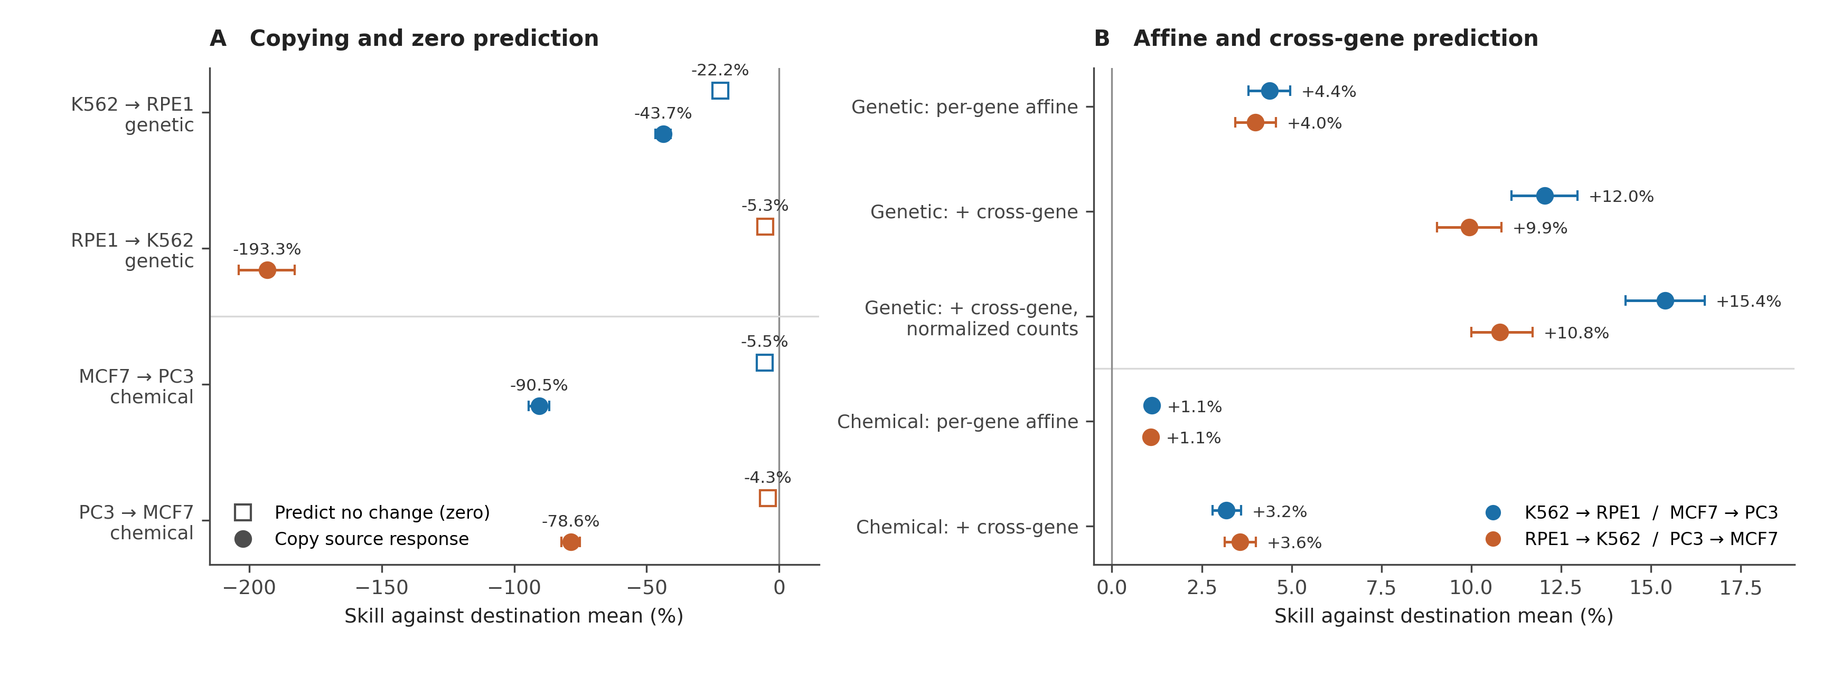
Figure 1. Genetic and chemical response transfer. A, Skill against the destination training mean for predicting no change (open squares) and copying (filled circles). B, Affine and rank-16 cross-gene skill, including genetic fits on normalized counts. Analyses include 1,874 genetic targets and 4,185 chemical identities. Blue, K562→RPE1 or MCF7→PC3; orange, reverse. Interventions are held out and opposite technical halves scored; genetic scoring excludes own-target readouts. Intervals: conditional 95% cluster bootstrap, 10,000 draws, with fits and controls fixed.

Transfer scores depended on the comparator and response magnitude
To understand how transfer scores depend on response magnitude, we separated squared error into alignment and magnitude. For a nonzero scalar destination response y and source copy s,
$${\left(s−y\right)}^{2}\text{<}y^{2}⇔0\text{<}\frac{s}{y}\text{<}2$$
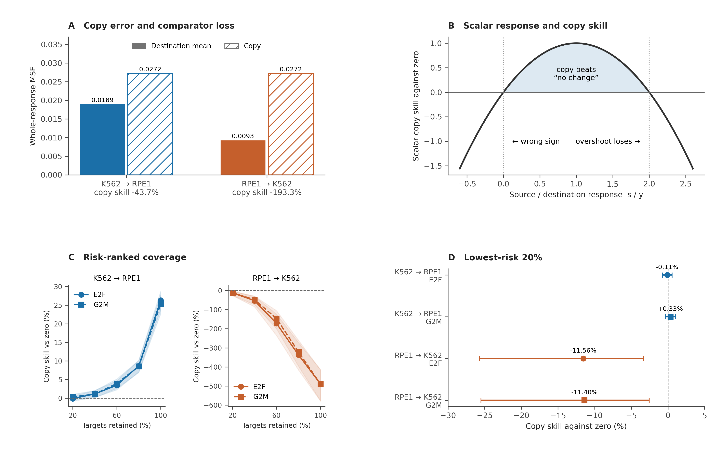
Figure 2. Transfer scores depend on the comparator and response magnitude. A, Copying has identical whole-response MSE in both genetic directions, but destination-mean loss differs, so percentage skill differs. B, For nonzero scalar destination response y, copying beats predicting no change only when 0 < s/y < 2. C, Copy skill against zero for Hallmark E2F and G2M component responses on lists ranked by predicted risk (source magnitude) and retained from 20% to 100% of targets; vertical scales differ. D, Skill for the lowest-risk 20% (375 targets per task). Intervals in A, C and D are conditional 95% target-bootstrap intervals (10,000 draws), with fits, rankings and controls fixed.
A copy with the correct sign therefore loses to predicting no change once its magnitude exceeds twice the destination response (Fig. 2B). For a prediction vector p and destination vector y over G readouts,
$$MSE\left(p\right)−MSE\left(0\right)\text{=}\frac{∥p∥^{2}−2p^{T}y}{G}$$
A response can point in the right direction yet overshoot enough to lose. A pathway may respond in both lines but more strongly in the source, for example because knockdown is more efficient there.
Copying had identical absolute error in both genetic directions because it compares the same responses (Fig. 2A). The destination mean predicted K562 more accurately, making RPE1→K562 copy skill more negative. More negative skill alone therefore does not establish poorer transfer in that direction.
Low predicted error also did not mean useful transfer. A fixed risk model based on source magnitude ranked copied E2F and G2M responses, two cell-cycle programs affected by essential-gene knockdowns.^{29,30} It selected lower-error responses than random selection; adding source-split agreement did not help. Yet copying the lowest-risk targets was no better than predicting no change for K562→RPE1 and worse in reverse (Fig. 2C,D). Small responses can yield low error with little added information.

Biological associations of the learned correction
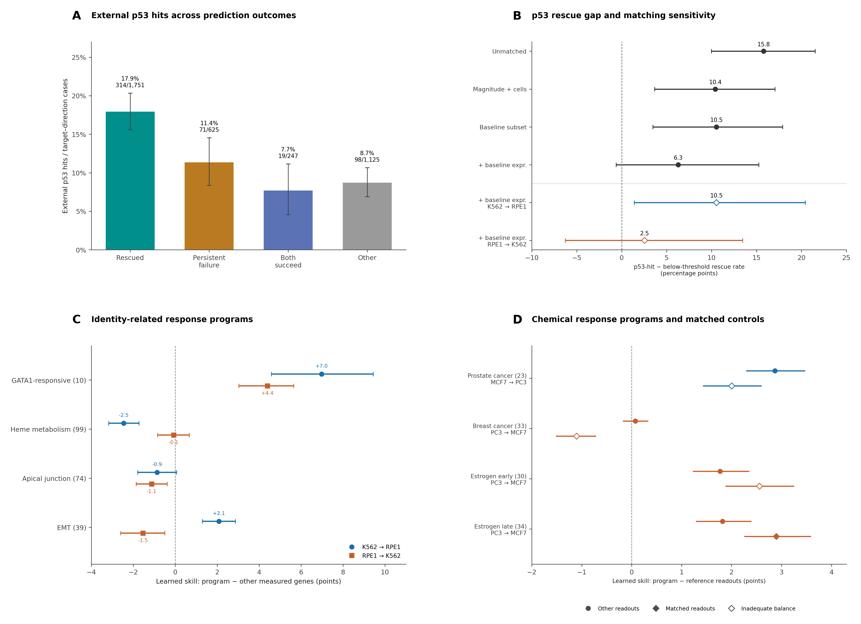
Figure 3. Biological associations of learned transfer. A, External p53-hit coverage by prediction outcome; labels give hits/cases. B, p53-hit minus below-threshold rescue-rate gaps before and after matching; open diamonds are exploratory directional estimates. C, Learned skill within four identity-related programs minus skill over complementary readouts. D, The same contrast for cancer-pathway and estrogen-response readouts, against complements (circles) or matched references (diamonds); open markers indicate inadequate matching balance. Parentheses give measured gene counts. Intervals: conditional 95% in A–B, adjusted 99.375% across eight C contrasts, 98.75% for original pathway and estrogen contrasts in D, and 97.5% for its two matched cancer-pathway contrasts. Bootstrap draws: 20,000 in A and 10,000 otherwise, resampling targets, matching components or chemical identities as appropriate. Fits, masks and matches are fixed. Matching diagnostics and endpoint families are detailed in the Supporting Methods.
We first asked whether prediction outcomes align with known context biology. Using Lü et al.’s independent A549 screen for regulators of p53 protein stability,²⁸ p53 hits were most frequent among copy failures rescued by learning and least frequent where both predictors succeeded (Fig. 3A); the ordering held in each direction (Fig. S1). Among copy-worse cases, learning rescued hits more often than genes below the screen’s threshold. Matching on response magnitude and cell recovery narrowed this gap; adding untreated expression attenuated it further, with an interval spanning zero (Fig. 3B; Table S2).³¹ Imperfect balance and overlap left the association beyond baseline expression unresolved.
We next evaluated four external readout programs related to erythroid or epithelial state: GATA1-responsive genes, heme metabolism, apical junction and EMT.^{30,32} GATA1-responsive readouts showed greater learned skill than their complement in both directions, whereas the other programs showed mixed differences (Fig. 3C; Fig. S2). The gain therefore did not uniformly favor lineage-related programs.
For chemical transfer, we evaluated destination-matched KEGG cancer-pathway readouts.³³ Learned skill exceeded complementary readouts for prostate cancer toward PC3 but was comparable for breast cancer toward MCF7 (Fig. 3D). Matching on vehicle expression and technical repeatability retained the prostate advantage and made the breast contrast negative, although balance remained inadequate in both. We then examined the narrower early and late estrogen-response programs toward MCF7.³⁰ Both showed greater skill than complementary readouts; the advantage also remained against matched references, with adequate balance for the late set. These follow-ups were exploratory. They support program-level predictive associations without showing that subtype mismatch caused the broad breast-cancer result.

Added capacity recovered p53 readouts after ribosomal knockdown
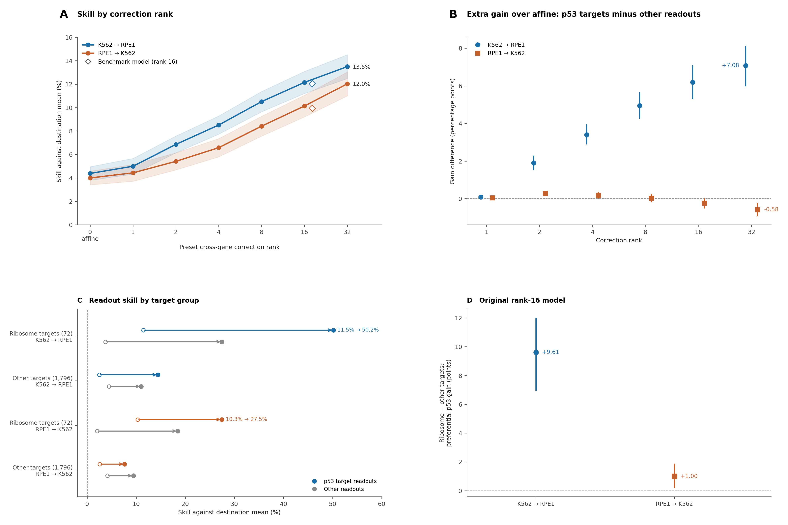
Figure 4. Correction capacity and p53-associated readouts. A, Held-out genetic skill across preset ranks; open diamonds mark the original rank-16 model. B, Gain over affine within 134 p53 readouts minus gain within 7,090 complementary readouts. C, Affine (open) and original rank-16 cross-gene (filled) skill within p53 readouts (direction colour) and complements (grey), after ribosome or other-target knockdown. For 72 ribosome targets, p53 skill rises from 11.5% to 50.2% toward RPE1 and from 10.3% to 27.5% toward K562. D, Ribosome minus nonmember difference in preferential p53 gain: +9.61 points [6.95, 12.01] forward and +1.00 [0.17, 1.89] reverse. Nonmembers comprise 1,796 targets; six unmapped targets are excluded. Own-target readouts are excluded. Intervals use 10,000 conditional target-cluster draws: 95% in A, adjusted 99.583% across 12 contrasts in B and 97.5% across two contrasts in D. C shows descriptive points; D stratifies resampling by target group. Directions were not formally compared, and measurement properties were not matched.
To test whether additional source-response patterns improve prediction, we varied the correction rank from affine-only to rank 32. Each step adds leading directions of source variation. Held-out skill increased at every tested step, with no plateau established by rank 32 (Fig. 4A). Because directions are ordered by source variance, this curve describes capacity within the chosen basis, rather than biological dimensionality.
We then asked which readouts benefit. Using a fixed external census of p53 target genes,³⁴ we compared each rank’s gain over affine within p53 readouts with its gain over complementary readouts. Toward RPE1, p53 readouts gained more at every tested rank from 2 to 32 (Fig. 4B). In reverse, they also improved, but their gain eventually lagged behind other readouts (Fig. S3A). The original rank-16 model was retained outside the rank grid; its approximate source basis differs from the grid’s.
Ribosomal-protein loss is a known p53 trigger,^{8,9} so we asked whether the preferential readout gain was greater after ribosomal knockdown. With the original rank-16 model, it was greater than for other targets in both directions (Fig. 4C,D). The secondary rank grid retained this pattern toward RPE1 but gave mixed results in reverse (Fig. S3B). This connects the perturbation class to the recovered outputs; unmatched response magnitude, cell recovery and repeatability still limit biological attribution.

Discussion
Learning recovered information beyond the destination mean in both genetic and chemical transfer. The practical question is whether a predictor adds information beyond a shared destination response, and whether predicting any change improves on no change. These comparators answer different questions. Here, directional skill changed despite identical copying error, and low-error selection favored small responses with little skill against zero. Reporting model loss, comparator loss and response scale together makes both distinctions visible.^{20–25} This gives more complex models a concrete benchmark to beat.
The biological analyses locate some of the added information. Cross-gene correction preferentially improved p53 readouts toward RPE1, with a greater advantage after ribosomal knockdown, and estrogen-response readouts toward MCF7. A possible explanation is that other source genes record a trigger whose downstream output differs in the destination. Affine correction can already capture a shared destination response through its intercept; the cross-gene gain asks whether coordinated source changes add intervention-specific information. The present results support that predictive possibility without identifying the source features or proving the triggering pathway. Source-variance rank cannot count biological pathways, and the GATA1 advantage in both directions cautions against attributing all gain to destination identity.
The target and readout annotations ask different biological questions. The A549 screen asks which perturbed genes are rescued; the p53 census asks which measured outputs improve. Baseline-expression matching weakened the former association, while magnitude and repeatability remain unmatched in the ribosomal readout contrast. Functional p53 manipulation or cell-line pairs with matched and differing p53 status would test whether recovery follows p53 competence rather than correlated context differences.^{6–10} The current results motivate those experiments; they do not establish mediation.
A response model separates coupling (A), intervention entry (B) and response rates (K). RPL3 illustrates why this matters: its weaker own-target repression in K562 is consistent with different entry, while its unequal stress response could also reflect coupling. Endpoint responses alone do not distinguish them. In our constructed system, unrestricted entry reproduces the equilibrium responses of a coupling change, while rates affect the approach to equilibrium (Supplementary Note 1).^{35–37} We have not estimated these matrices in the real data. The framework instead guides the next measurements: intervention-strength calibration constrains entry, time courses constrain rates, and additional interventions under explicit structural assumptions constrain coupling. Each explanation should then be tested by held-out prediction. This turns a transfer error into a choice of discriminating experiments, rather than a mechanism assigned from an error score.

Limitations
The data were development-exposed, without untouched confirmation or comparison with published predictors on the same splits. Technical halves are not biological replicates, and LINCS halves share deposited normalization. Bootstrap intervals condition on fitted models and fixed analysis choices. The rank, ribosomal, estrogen and matching follow-ups are exploratory; annotation coverage is incomplete, and balance was inadequate for early estrogen and both matched cancer pathways. The p53 target-annotation association remains unresolved beyond baseline expression. Predictive associations therefore require independent biological tests before they can support mechanism or disease-specific claims.

Conclusions
A simple learned correction improved cross-cell-line prediction where copying failed. Explicit comparators separated that gain from response scale, and external annotations showed where prediction improved without establishing its mechanism. The next step is to test which source features carry the information and which differences in entry, coupling or timing explain it.

Materials and Methods

Response data and evaluation
Genetic responses comprised 1,977 constructs targeting 1,874 genes and 7,226 readouts in K562 and RPE1.⁴ Responses were log1p differences between construct means and control baselines, evaluated on two disjoint cell halves. Chemical responses comprised 4,185 identities and 978 measured L1000 landmarks in MCF7 and PC3 at 10 µM and 24 h.⁵ Deposited Level-4 profiles were averaged within perturbagen and cell-line/plate-defined half, then equally across IDs within identity. Whole targets or chemical identities were assigned to five fixed folds. Training used four folds; held-out source responses predicted the opposite destination half. Genetic scoring excluded each target’s own readout. Losses were averaged within target or chemical identity before averaging units and orientations. Technical halves do not establish biological replication.

Predictors and skill
We compared no change, source copying, the destination training mean, per-gene affine correction and affine plus a rank-16 cross-gene residual correction. Means and source decompositions used training folds only, with equal total weight per target or chemical identity. Genetic affine slopes used weighted covariance/variance; chemical slopes additionally used ridge shrinkage. Cross-gene residuals were regressed on source scores with a fixed ridge penalty.³⁸ No hyperparameter search was added for the follow-ups. Skill was 1 − MSE_model/MSE_comparator, using averaged losses rather than averaged unit-specific ratios. Genetic normalization sensitivity retained cells, splits, controls and settings, refitting after per-cell counts-per-10,000 normalization. Full construction, seeds and parity checks are in the Supporting Methods.

Annotations and readout contrasts
Prediction outcomes were classified against the destination mean only when loss ordering agreed across both technical orientations; ties and mixed cases remained separate. External A549 p53 hits were compared with genes below the screen threshold, which was not treated as absence of p53 activity.²⁸ Copy-worse hits were matched with replacement within direction on source-response RMS and cell recovery, then additionally on untreated expression in the baseline-available subset.³¹ Matches were fixed before sensitivity outcomes were examined. Incomplete balance or overlap restricted interpretation.
External readout masks comprised four erythroid/epithelial-related programs,^{30,32} destination-matched cancer pathways,³³ p53 census targets³⁴ and early/late estrogen response. Each set’s skill used its own destination-mean loss; relative skill subtracted the complementary-readout value. Chemical matching used vehicle expression and technical repeatability in both lines. Adequacy required every distance ≤2, absolute standardized mean imbalance ≤0.1 and effective controls ≥half the set size.³⁹ Sets, matches and endpoint families were retained regardless of sign or adequacy.

Capacity and ribosomal contrasts
The rank grid used ranks 0, 1, 2, 4, 8, 16 and 32 in one training-only 40-column source decomposition; rank 0 was affine. The original benchmark used a separate 24-column decomposition. For p53 readouts, preferential gain was the gain over affine within p53 targets minus the gain within complementary readouts. The ribosomal test compared this endpoint between 72 KEGG ribosome targets and 1,796 nonmembers using the original rank-16 model; six unmapped targets were excluded. Both directions were retained. These follow-ups were specified after earlier results were known and are exploratory. No direction interaction or p53 mediation test was performed.

Uncertainty and selective prediction
Conditional percentile intervals resampled targets or chemical identities jointly across paired directions and methods, with models, masks, controls and selection rules fixed.^{40,41} Matched p53 intervals resampled connected components linking reused hit/control target IDs. Ribosomal intervals stratified by target group. Prespecified endpoint families used Bonferroni-adjusted marginal intervals as stated in legends. The component-risk analysis ranked held-out E2F/G2M responses by predicted copying error and scored the retained lists against zero; its fitted risk models and rankings stayed fixed during resampling. Detailed definitions, draw counts and diagnostic results are in the Supporting Methods.

Data and Software Availability
Genetic responses are from Replogle et al.⁴ and chemical profiles from GEO GSE92742.⁵ External annotations are from the A549 p53-stability screen,²⁸ Fischer’s p53 census,³⁴ MSigDB,³⁰ the GATA1 study³² and KEGG.³³ Code, fixed splits, masks, contracts, input hashes and figure source data will be deposited at [repository URL and archival DOI required before submission]. The supplied figure package rebuilds all active figures from saved estimates without model fitting. Large response arrays remain outside the code repository; regeneration instructions and exact software versions accompany the analysis packages.

Associated Content

Supporting Information
The Supporting Information is available free of charge.
Supporting Information: p53 coverage by direction (Figure S1); absolute skill within external readout programs (Figure S2); p53 readout skill and secondary ribosomal rank contrasts (Figure S3); chemical benchmark estimates (Table S1); p53 matching sensitivity (Table S2); detailed computational methods; and a constructed coupling–entry equivalence example (Supplementary Note 1).

Author Information
Corresponding Author: Wei Chen, Louisiana State University Health Sciences Center, Shreveport, LA 71103, USA. Email: wei.chen@lsuhs.edu
Author Contributions: [To confirm: W.C. conceived the study, performed the analyses and wrote the manuscript; X.L. …]
Funding: This research received no specific funding.
Notes: The authors declare no competing financial interest.

Acknowledgments
AI assistance disclosure for author confirmation: ChatGPT (OpenAI) and Claude (Anthropic) assisted with code review, figure preparation and manuscript editing. Confirm the tools, dates and uses before submission. The authors are responsible for checking the final content.

References
1. Dixit A, Parnas O, Li B, et al. Perturb-Seq: dissecting molecular circuits with scalable single-cell RNA profiling of pooled genetic screens. Cell 2016;167:1853-1866.e17. doi:10.1016/j.cell.2016.11.038.
2. Adamson B, Norman TM, Jost M, et al. A multiplexed single-cell CRISPR screening platform enables systematic dissection of the unfolded protein response. Cell 2016;167:1867-1882.e21. doi:10.1016/j.cell.2016.11.048.
3. Gilbert LA, Horlbeck MA, Adamson B, et al. Genome-scale CRISPR-mediated control of gene repression and activation. Cell 2014;159:647-661. doi:10.1016/j.cell.2014.09.029.
4. Replogle JM, et al. Mapping information-rich genotype-phenotype landscapes with genome-scale Perturb-seq. Cell 2022;185:2559-2575.e28. doi:10.1016/j.cell.2022.05.013.
5. Subramanian A, Narayan R, Corsello SM, et al. A next generation connectivity map: L1000 platform and the first 1,000,000 profiles. Cell 2017;171:1437–1452.e17. doi:10.1016/j.cell.2017.10.049.
6. Nadig A, et al. Transcriptome-wide analysis of differential expression in perturbation atlases. Nat Genet 2025. doi:10.1038/s41588-025-02169-3.
7. Grabski IN, Lee J, Blair JD, et al. Mapping transcriptional responses to cellular perturbations with RNA fingerprinting. Cell. Published online 9 October 2026. doi:10.1016/j.cell.2026.09.017.
8. Zhang Y, Lu H. Signaling to p53: ribosomal proteins find their way. Cancer Cell 2009;16:369-377. doi:10.1016/j.ccr.2009.09.024.
9. Levine AJ. p53: 800 million years of evolution and 40 years of discovery. Nat Rev Cancer 2020;20:471-480. doi:10.1038/s41568-020-0262-1.
10. Haapaniemi E, Botla S, Persson J, Schmierer B, Taipale J. CRISPR-Cas9 genome editing induces a p53-mediated DNA damage response. Nat Med 2018;24:927-930. doi:10.1038/s41591-018-0049-z.
11. Lotfollahi M, Wolf FA, Theis FJ. scGen predicts single-cell perturbation responses. Nat Methods 2019;16:715-721. doi:10.1038/s41592-019-0494-8.
12. Lotfollahi M, Klimovskaia Susmelj A, De Donno C, et al. Predicting cellular responses to complex perturbations in high-throughput screens. Mol Syst Biol 2023;19:e11517. doi:10.15252/msb.202211517.
13. Bunne C, Stark SG, Gut G, et al. Learning single-cell perturbation responses using neural optimal transport. Nat Methods 2023;20:1759-1768. doi:10.1038/s41592-023-01969-x.
14. Kamimoto K, Stringa B, Hoffmann CM, Jindal K, Solnica-Krezel L, Morris SA. Dissecting cell identity via network inference and in silico gene perturbation. Nature 2023;614:742-751. doi:10.1038/s41586-022-05688-9.
15. Roohani Y, Huang K, Leskovec J. Predicting transcriptional outcomes of novel multigene perturbations with GEARS. Nat Biotechnol 2024;42:927-935. doi:10.1038/s41587-023-01905-6.
16. Wenkel F, et al. TxPert: using multiple knowledge graphs for prediction of transcriptomic perturbation effects. Nat Biotechnol 2026. doi:10.1038/s41587-026-03113-4.
17. Cui H, Wang C, Maan H, et al. scGPT: toward building a foundation model for single-cell multi-omics using generative AI. Nat Methods 2024;21:1470-1480. doi:10.1038/s41592-024-02201-0.
18. Theodoris CV, Xiao L, Chopra A, et al. Transfer learning enables predictions in network biology. Nature 2023;618:616-624. doi:10.1038/s41586-023-06139-9.
19. Adduri AK, et al. Predicting cellular responses to perturbation across diverse contexts with State. bioRxiv 2025. doi:10.1101/2025.06.26.661135.
20. Ahlmann-Eltze C, Huber W, Anders S. Deep-learning-based gene perturbation effect prediction does not yet outperform simple linear baselines. Nat Methods 2025;22:1657-1661. doi:10.1038/s41592-025-02772-6.
21. Csendes G, Sanz G, Szalay KZ, Szalai B. Benchmarking foundation cell models for post-perturbation RNA-seq prediction. BMC Genomics 2025;26. doi:10.1186/s12864-025-11600-2.
22. Miller HE, Mejia GM, Leblanc FJA, Swain B, Wang B, de Lima Camillo LP. Deep learning perturbation models can outperform baselines on calibrated metrics. Nat Biotechnol. Published online 1 October 2026. doi:10.1038/s41587-026-03307-w.
23. Viñas Torné R, et al. Systema: a framework for evaluating genetic perturbation response prediction beyond systematic variation. Nat Biotechnol 2026;44:1050-1059. doi:10.1038/s41587-025-02777-8.
24. Wei Z, Wang Y, Gao Y, et al. Benchmarking algorithms for generalizable single-cell perturbation response prediction. Nat Methods 2026;23:451-464. doi:10.1038/s41592-025-02980-0.
25. Murphy AH. Skill scores based on the mean square error and their relationships to the correlation coefficient. Mon Weather Rev 1988;116:2417-2424. doi:10.1175/1520-0493(1988)116<2417:SSBOTM>2.0.CO;2.
26. Pearl J, Bareinboim E. External validity: from do-calculus to transportability across populations. Stat Sci 2014;29:579-595. doi:10.1214/14-STS486.
27. Qi S, Chapfuwa P. Mechanisms Matter: transportability of cellular perturbation effects. bioRxiv preprint, version 2, 2 July 2026. doi:10.64898/2026.05.08.723625. Preprint (not peer reviewed).
28. Lü Y, et al. Genome-wide CRISPR screens identify novel regulators of wild-type and mutant p53 stability. Mol Syst Biol 2024;20:719-740. doi:10.1038/s44320-024-00032-x.
29. Geifman Y, El-Yaniv R. Selective classification for deep neural networks. In: Advances in Neural Information Processing Systems 30 (NeurIPS 2017). 2017.
30. Liberzon A, Birger C, Thorvaldsdóttir H, Ghandi M, Mesirov JP, Tamayo P. The Molecular Signatures Database (MSigDB) hallmark gene set collection. Cell Syst 2015;1:417-425. doi:10.1016/j.cels.2015.12.004.
31. Stuart EA. Matching methods for causal inference: a review and a look forward. Stat Sci 2010;25:1-21. doi:10.1214/09-STS313.
32. Welch JJ, Watts JA, Vakoc CR, et al. Global regulation of erythroid gene expression by transcription factor GATA-1. Blood 2004;104:3136-3147. doi:10.1182/blood-2004-04-1603.
33. Kyoto Encyclopedia of Genes and Genomes. Breast cancer (hsa05224), prostate cancer (hsa05215) and ribosome (KEGG_RIBOSOME, via MSigDB) pathway gene memberships retrieved 22–23 October 2026. https://www.kegg.jp/pathway/hsa05224; https://www.kegg.jp/pathway/hsa05215.
34. Fischer M. Census and evaluation of p53 target genes. Oncogene 2017;36:3943-3956. doi:10.1038/onc.2016.502. Target-gene table accessed via https://tp53.cancer.gov/target_genes on 23 October 2026.
35. Kholodenko BN, Kiyatkin A, Bruggeman FJ, Sontag E, Westerhoff HV, Hoek JB. Untangling the wires: a strategy to trace functional interactions in signaling and gene networks. Proc Natl Acad Sci U S A 2002;99:12841-12846. doi:10.1073/pnas.192442699.
36. Meinshausen N, Hauser A, Mooij JM, Peters J, Versteeg P, Bühlmann P. Methods for causal inference from gene perturbation experiments and validation. Proc Natl Acad Sci U S A 2016;113:7361-7368. doi:10.1073/pnas.1510493113.
37. Brown BC, et al. Large-scale causal discovery using interventional data sheds light on gene network structure in K562 cells. Nat Commun 2025. doi:10.1038/s41467-025-64353-7.
38. Hoerl AE, Kennard RW. Ridge regression: biased estimation for nonorthogonal problems. Technometrics 1970;12:55-67. doi:10.1080/00401706.1970.10488634.
39. Austin PC. Balance diagnostics for comparing the distribution of baseline covariates between treatment groups in propensity-score matched samples. Stat Med 2009;28:3083-3107. doi:10.1002/sim.3697.
40. Efron B, Tibshirani RJ. An Introduction to the Bootstrap. New York: Chapman & Hall; 1993.
41. Field CA, Welsh AH. Bootstrapping clustered data. J R Stat Soc Series B Stat Methodol 2007;69:369-390. doi:10.1111/j.1467-9868.2007.00593.x.
Table of Contents graphic
