Supplementary Information

Table S1, Protein residues excluded as genuine crystallographic modeling defects.
Excluded residues identified by close-contact scanning ($\text{<}1.5$ Å) and torque magnitude ($\text{|}τ\text{|}\text{>}10,000$ kcal·mol⁻¹·rad⁻¹), excluding handled artifacts. Listed by PDB ID, index, and name.
pdb_id | res_idx | res_name
1R0M | 316 | ARG
1T1U | 194 | ARG
1U53 | 190 | CYS
1YN3 | 80 | THR
1YN3 | 82 | ASN
2IU4 | 281 | LYS
2Q8O | 29 | ASP
2WOY | 176 | LYS
2WOY | 308 | ASN
2Y69 | 238 | HIS
2Y69 | 242 | TYR
3HR6 | 134 | LYS
3HR6 | 256 | ASN
3HR6 | 298 | LYS
3HR6 | 417 | ASN
3M6N | 84 | ARG
3M6N | 231 | GLU
3M6N | 235 | ARG
3NJN | 95 | LYS
3PF2 | 8 | LYS
3PF2 | 149 | ASN
3PF2 | 185 | LYS
3PF2 | 313 | ASN
3QHB | 15 | PHE
3QHB | 125 | VAL
3S8G | 224 | HIS
3S8G | 228 | TYR
3TG7 | 871 | ARG
3UXF | 148 | LYS
3UXF | 277 | ASN
3UXF | 321 | LYS
3UXF | 445 | ASP
4NI6 | 3 | THR
4NI6 | 130 | GLN
4QRE | 337 | LEU
4U5Q | 31 | GLU
4U5Q | 33 | ARG
4UZG | 2 | LYS
4UZG | 136 | ASN
4UZG | 164 | LYS
4UZG | 268 | ASN
4YAR | 83 | ARG
4YAR | 95 | TYR
4Z0Y | 96 | CYS
4Z0Y | 115 | HIS
5A0L | 43 | CYS
5A0L | 195 | GLN
5A0N | 52 | CYS
5A0N | 205 | GLN
5ECK | 169 | LYS
5ECK | 183 | ASP
5HGJ | 149 | SER
5HGJ | 151 | GLU
5J81 | 408 | ARG
5U5O | 6 | THR
5U5O | 159 | GLN
5U5O | 174 | LYS
5U5O | 282 | ASN
5YXG | 2 | LYS
5YXG | 146 | ASN
5YXG | 171 | LYS
5YXG | 283 | ASN
6B2V | 241 | ARG
6BBW | 12 | LYS
6BBW | 149 | ASN
6BBW | 160 | LYS
6BBW | 276 | ASN
6F8A | 120 | ARG
6JCH | 9 | LYS
6JCH | 168 | ASN
6JCH | 179 | LYS
6JCH | 321 | ASN
6TO1 | 12 | LYS
6TO1 | 419 | ASN
7COH | 238 | HIS
7COH | 242 | TYR
7LGR | 5 | LYS
7LGR | 119 | ASN
7OXD | 47 | ASN
7QBP | 70 | VAL
7QBP | 161 | TYR
8EEN | 291 | ASN
8EEN | 384 | THR
9IFR | 100 | ASN
9N3U | 180 | CYS
9N3U | 240 | TYR
9NDR | 228 | CYS
9NDR | 272 | TYR
9UVM | 145 | LYS
9UVM | 266 | ASN
9UVM | 302 | LYS

Table S2, Overview of MechLib performance benchmarks
Result | Value | 95% CI / detail | n
Protein vs. AMBER ff14SB | 39.6% | [39.0%, 40.1%] | 1,698,562 res
Protein, blind test (2020–2026 structures) | 40.6% | 38.7% on pre-2020 training set; no CI reported | 428,750 res
Protein vs. OPLS-AA/M (mean) | ≈ same as AMBER | 10/11 terms identical | 1,698,562 res
Protein vs. CHARMM36 CMAP | r = −0.261 | P = 5.43 × 10⁻¹³ | 740 bins
DNA vs. parm10 (median) | 85.4% | [84.9%, 85.9%] | 118,233 BI / 20,508 BII strain-scored nt
DNA — BI / BII state (median) | 85.4% / 85.8% | — | 118,233 / 20,508 nt
DNA δ–χ coupling, C1'-O4'-C4' angle | η² = 0.073 | cf. control 0.026 | 150,022 nt
DNA denominators differ by plotted observable: the strain panels include 118,233 BI nucleotides, whereas the filtered O3′–P density plot includes 118,227 BI bond measurements.

Figure S1, Cross-force-field comparison of backbone strain.
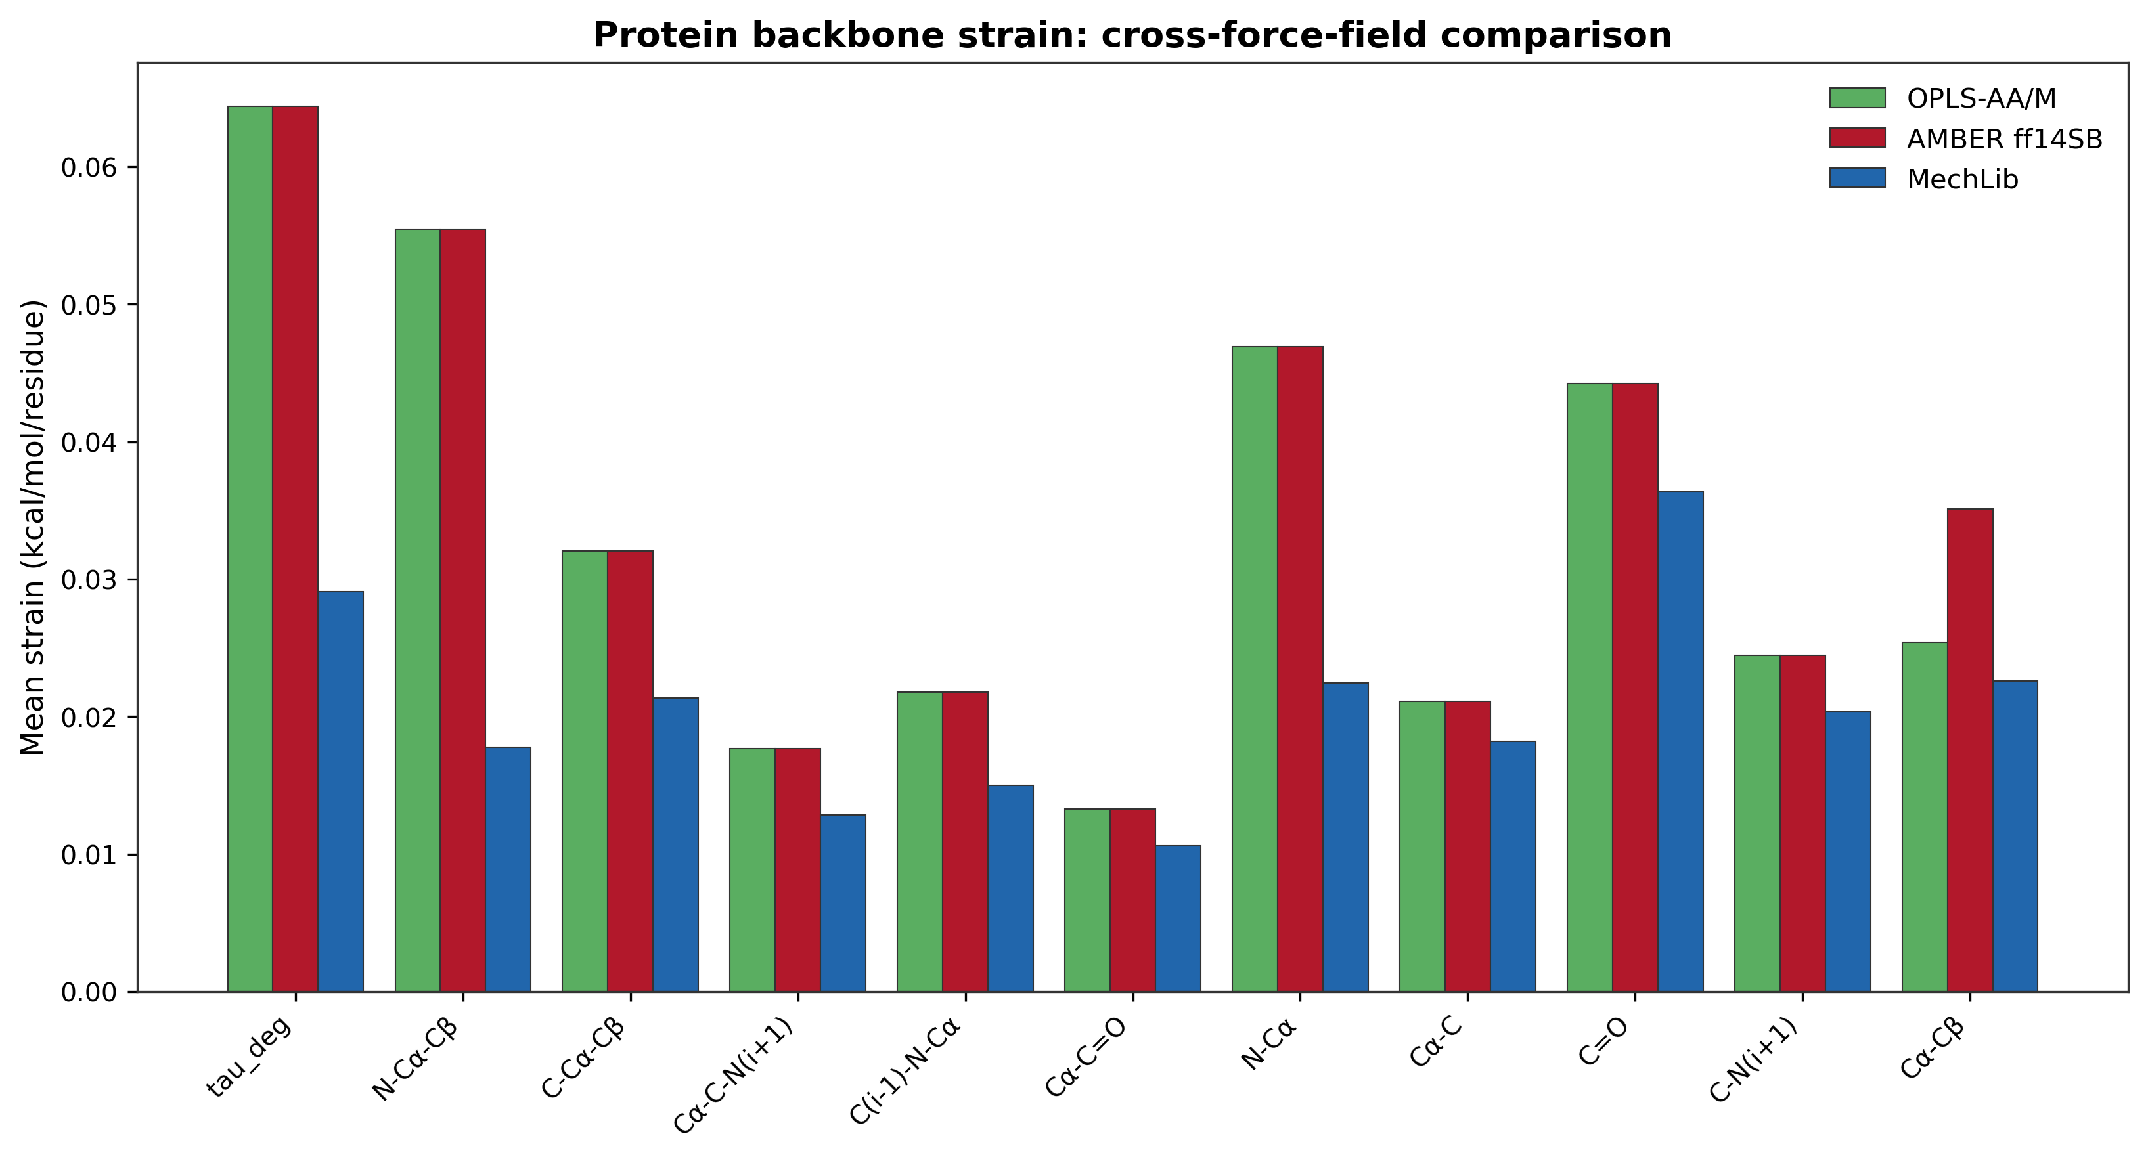
Mean phantom strain per residue by bonded observable for OPLS-AA/M, AMBER ff14SB, and MechLib. Ten of eleven backbone bond and angle parameters are numerically identical in AMBER ff14SB and OPLS-AA/M, so the two baselines overlap except for Cα–Cβ; this comparison is therefore not independent of the AMBER comparison (main text, Section 3.1).

Figure S2, MechLib geometric strain versus CHARMM36 CMAP energy.
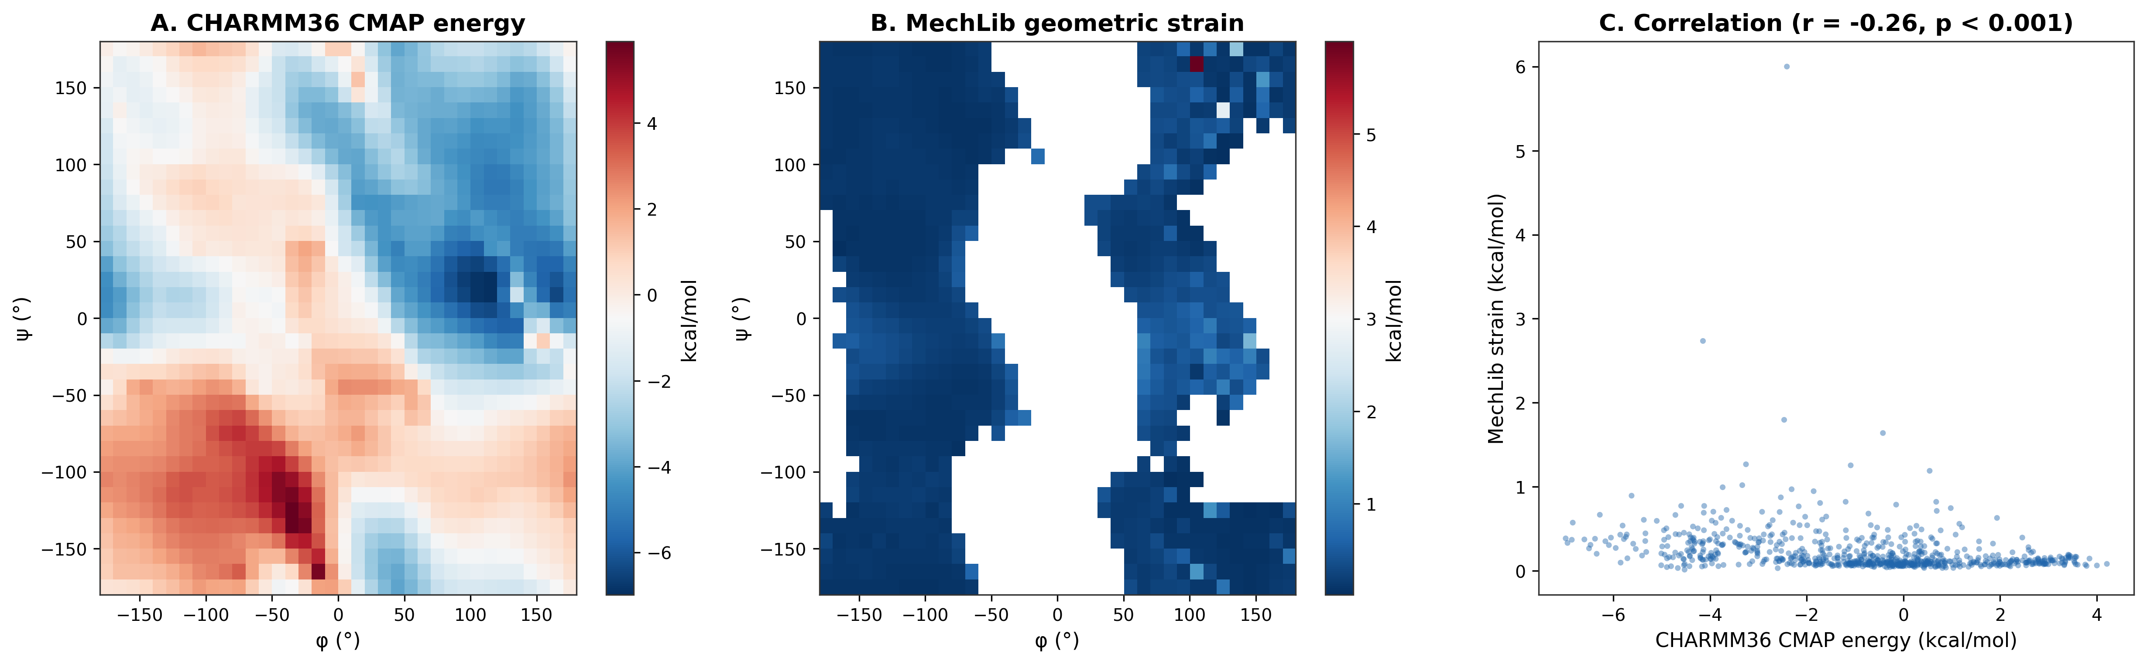
(A) CHARMM36 CMAP energy (general backbone grid). (B) MechLib geometric strain on the same (φ,ψ) grid. (C) Bin-wise correlation across 740 sampled bins (Pearson r = −0.261, P = 5.43 × 10⁻¹³). This is a contextual association between a geometric and an energetic correction, not independent validation of either.

Figure S3, Strain reduction stratified by refinement software and secondary structure.
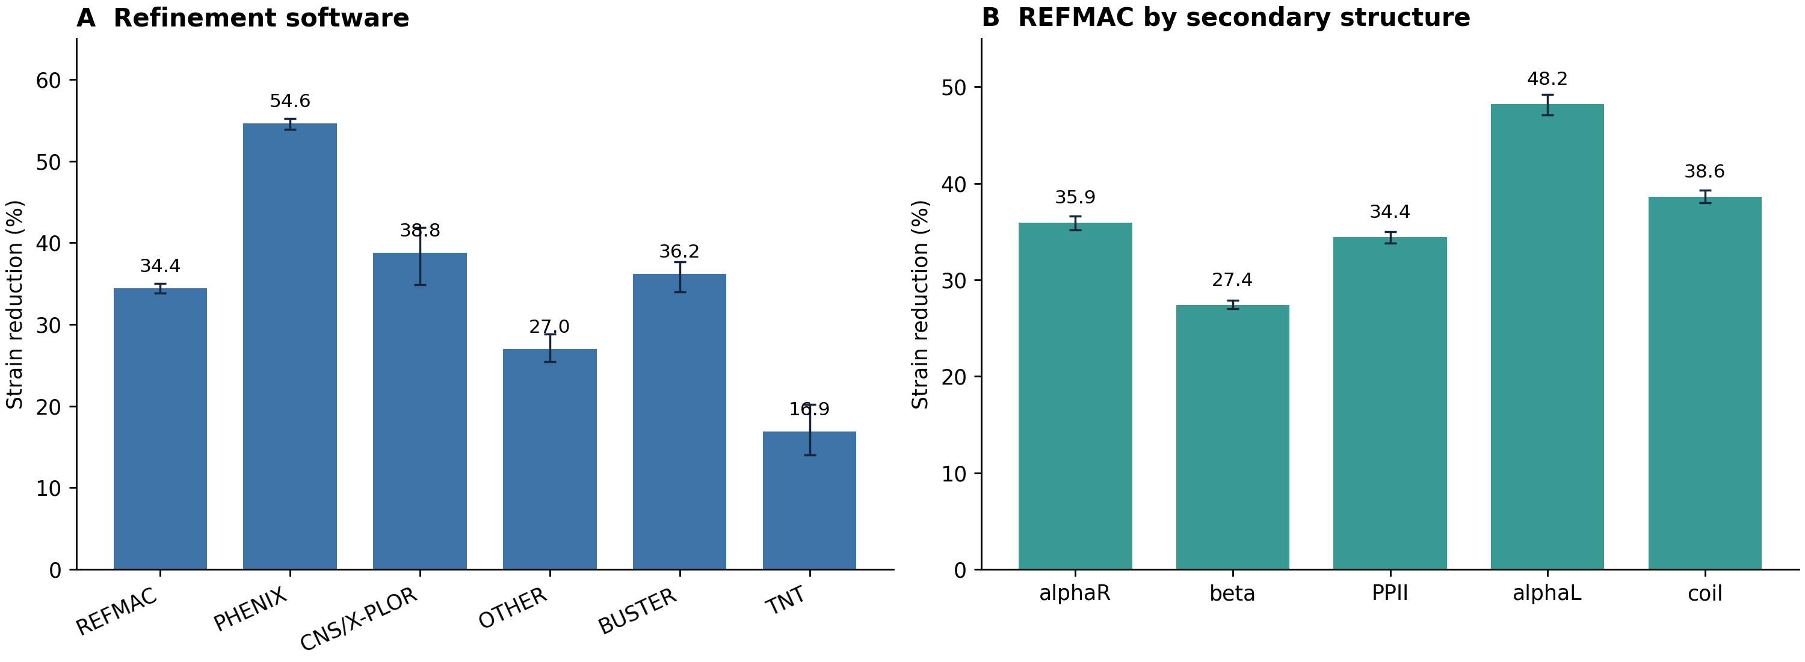
(A) Strain reduction by refinement software, classified from REMARK 3 (REFMAC 34.4% (95% CI 33.8–35.0%), PHENIX 54.6% (95% CI 53.9–55.2%), CNS/X-PLOR 38.8%, OTHER 27.0%, BUSTER 36.2%, TNT 16.9%). (B) REFMAC-only reduction by secondary-structure class (αR 35.9%, β 27.4%, PPII 34.4%, αL 48.2%, coil 38.6%). Error bars: 95% confidence intervals from 2,000 bootstrap resamples by structure. Software identity is a proxy for refinement restraints; it does not prove which restraint set was active for each structure.

Independent constrained-QM benchmark
The confirmatory benchmark comprised all 20 standard amino acids in ACE–X–NME at four registered central-residue φ/ψ coordinates (80 cases). Model predictions and the analysis contract were frozen before confirmatory outcome access. All cases passed convergence, constraint, connectivity, and finite-value checks. The primary weighted mean favored MechLib, but the strict four-condition endpoint failed because three bond terms were Holm-significantly worse (main-text Fig. 3; Tables S3 and S4).

Table S3. Registered term-level constrained-QM results
Term | Unit | n | AMBER MAE | MechLib MAE | Mean weighted Δ | Holm p (worse)
∠CA-C-O | degrees | 80 | 0.68841 | 0.54132 | 0.02296 | 1
∠C-N-CA | degrees | 80 | 1.46217 | 1.31464 | 0.01821 | 1
∠C-CA-CB | degrees | 76 | 1.17898 | 1.10477 | 0.01028 | 1
∠CA-C-N | degrees | 80 | 1.64244 | 1.47844 | 0.02395 | 1
∠N-CA-CB | degrees | 76 | 2.28024 | 1.67332 | 0.09475 | 1
CA-C | Å | 80 | 0.01442 | 0.01202 | 0.04288 | 1
CA-CB | Å | 76 | 0.01015 | 0.00519 | 0.08824 | 1
C-N(next) | Å | 80 | 0.02081 | 0.02512 | -0.09541 | 6.31e-37
C-O | Å | 80 | 0.01206 | 0.01632 | -0.10163 | 1.2e-32
N-CA | Å | 80 | 0.00561 | 0.01224 | -0.12179 | 3.96e-15
∠N-CA-C | degrees | 80 | 1.82167 | 0.87583 | 0.13103 | 1
Angles are reported in degrees and bonds in Å. Weighted Δ uses radians for angles and Å for bonds. Positive values favor MechLib. The one-sided term tests ask whether MechLib is worse; p values are Holm-adjusted across 11 registered terms.

Table S4. Registered primary-decision criteria
Criterion | Decision | Observed
Residue-clustered 95% CI lower bound > 0 | PASS | 0.00263134
At least 12/20 residue means positive | PASS | 14/20
No Holm-significant worse registered term | FAIL | 3 worse terms
At least 68/80 cases pass QC | PASS | 80/80
All four conditions | FAIL | Registered endpoint FAIL

Reproducibility and evidentiary boundary
The deterministic constrained-QM analysis used 10,000 bootstrap replicates and seed 20260915. Primary outputs include the endpoint JSON, case-, residue-, region-, and term-level TSV files, the complete term-detail table, the analysis script, and SHA-256 manifest. The QM benchmark tests constrained local equilibrium geometry only. It does not evaluate dynamics, populations, thermodynamics, folding, or NMR/RDC observables.

Exploratory MD scalar-coupling pilot
The scoring contract and input hashes were frozen before scores were computed. The six GB3 lineages were regenerated after DCD corruption was discovered; the six intact ubiquitin lineages were byte-identical copies of completed trajectories. The verified input comprised 120 readable trajectory chunks (1,200 frames), 120 state reports, 12 run audits, two prepared structures, two primary-source PDFs, two experimental table transcriptions and the integrity report. All 259 manifest entries passed hash preflight. All 113 primary non-glycine experimental rows mapped without exclusions after scoring. The pilot inherited serialized OpenMM molecular systems, prepared protein structures and exact final states from the separately verified upstream preparation archive (SHA-256 7e22f95e45735144296ebe1d65341aee8048ef5f636014e2d29f0c2ee4a8f592); its protocol was NPT at 298 K and 1 bar with 2 fs Langevin middle integration (friction 1 ps⁻¹) and a Monte Carlo barostat every 25 steps.
For each residue and trajectory frame, the backbone dihedral φ=C(i−1)–N(i)–Cα(i)–C(i) was transformed into a predicted ³J(HN,Hα) using J=6.7 cos²(φ−60°)−1.3 cos(φ−60°)+1.5 Hz. Predictions were averaged over all 100 frames, then compared with experimental observations by residue-level MSE for each protein, arm and seed. The coefficients were derived independently of either test protein. The primary contrast is fixed-AMBER MSE minus MechLib MSE, averaged over three paired seeds per protein and then equally over the two proteins.
GB3 paired contrasts for seeds 2026092201/02/03 were +0.008934811, +0.082287288, and +0.579101565 Hz²; ubiquitin contrasts were +0.115545832, +0.069545592, and −0.099618097 Hz². Protein means were +0.223441221 and +0.028491109 Hz², respectively; the equal-protein mean was +0.125966165 Hz². The per-seed and time-block tables, frozen scoring lock, source transcriptions and SHA-256 inventory are in the frozen endpoint archive. This is a descriptive 1 ns pilot without significance inference; the registered constrained-QM FAIL remains in force.
In a post hoc sensitivity analysis that excluded the first 200 ps from each 1 ns trajectory, the equal-protein mean MSE contrast was +0.092391 Hz². Protein means were +0.206507 Hz² (GB3) and −0.021724 Hz² (ubiquitin). The original full-trajectory score and the registered QM result were not recalculated or changed. The preparation used 20 ps NVT followed by scored NPT production, with no separate NPT density-equilibration interval. This sensitivity does not establish convergence.

Table S5. Post hoc ten-term crystal-coordinate comparison
Test group | Rows | AMBER strain/row | MechLib reduction | CDL reduction
All post-2020 | 428,750 | 0.303156 | 43.3% | 44.9%
REFMAC | 135,257 | 0.446089 | 29.1% | 27.2%
PHENIX | 278,172 | 0.229585 | 57.1% | 62.4%
Fixed AMBER, pre-2020 global-mean and residue-type-mean targets, pre-2020-trained MechLib, and cctbx CDL (2026.7) were compared on identical post-2020 rows. Across all 428,750 matched rows, the two mean baselines reduced strain versus AMBER by 16.1% and 29.7%, respectively (MechLib, 43.3%; CDL, 44.9%). C–N(next) is excluded from every arm because its CDL target is keyed to the following residue. Reductions use the same ten-term AMBER reference. REFMAC and PHENIX are REMARK 3 software labels, not confirmed restraint usage.

Table S6. Static minimization by refinement program
Test group | Structures | RMSD reduction (95% CI) | Fixed-AMBER wins
All | 300 | 33.1% (32.0–34.1%) | 0
REFMAC | 87 | 25.4% (24.2–26.7%) | 0
PHENIX | 201 | 37.4% (36.3–38.4%) | 0
Other known | 12 | 25.6% | 0
Post hoc split of the same frozen 300-structure minimization cohort. Reduction is 100 × [1 − (sum MechLib RMSD / sum fixed-AMBER RMSD)] within each subgroup. No structure in these groups favored fixed AMBER. CIs use 10,000 deterministic resamples of whole structures (seed 20260925).

Table S7. Exploratory NMR equilibration sensitivity
Trajectory window | GB3 Δ MSE (Hz²) | Ubiquitin Δ MSE (Hz²) | Equal-protein Δ MSE (Hz²)
Full 1 ns, frozen | +0.223441 | +0.028491 | +0.125966
Last 800 ps, post hoc | +0.206507 | −0.021724 | +0.092391
The later-frame analysis excluded the first 200 ps. Positive MSE difference favors MechLib. The full-trajectory result remains the original frozen score.

