Supplementary information for peptide and protein backbone angle coupling

Numerical checks and perturbation definitions
The precision return records 81 of 81 passing endpoints. Maximum start-to-start τ ranges were 0.000123°, 0.000134°, and 0.000156° for α, β, and PPII. The matched grid included 300 nodes and 192 midpoint checks, with 492 of 492 minimizations passing. The maximum tested midpoint error was below 0.0047°. These checks establish numerical consistency within the assigned model, not its physical accuracy.
Table S1 lists the 15 ordinary heavy-atom pairs whose r⁻¹² coefficient was scaled. Their attraction was retained. Force-field exceptions and hydrogen-involving pairs were unchanged. Complete removal passed only 78 of 81 endpoints and was excluded from the plotted contrast series.

Table S1 Selected heavy atom repulsion pairs
i | j | atom_i | atom_j | sigma_nm | epsilon_kj_mol | A
1 | 10 | ACE:CH3 | ALA:CB | 0.339967 | 0.457730 | 4.364248e-06
1 | 14 | ACE:CH3 | ALA:C | 0.339967 | 0.405835 | 3.869456e-06
1 | 15 | ACE:CH3 | ALA:O | 0.317980 | 0.634176 | 2.710570e-06
1 | 16 | ACE:CH3 | NME:N | 0.332483 | 0.570591 | 4.165090e-06
1 | 18 | ACE:CH3 | NME:C | 0.339967 | 0.457730 | 4.364248e-06
4 | 15 | ACE:C | ALA:O | 0.317980 | 0.562277 | 2.403262e-06
4 | 16 | ACE:C | NME:N | 0.332483 | 0.505901 | 3.692878e-06
4 | 18 | ACE:C | NME:C | 0.339967 | 0.405835 | 3.869456e-06
5 | 10 | ACE:O | ALA:CB | 0.317980 | 0.634176 | 2.710570e-06
5 | 14 | ACE:O | ALA:C | 0.317980 | 0.562277 | 2.403262e-06
5 | 15 | ACE:O | ALA:O | 0.295992 | 0.878640 | 1.589403e-06
5 | 16 | ACE:O | NME:N | 0.310496 | 0.790544 | 2.538974e-06
5 | 18 | ACE:O | NME:C | 0.317980 | 0.634176 | 2.710570e-06
6 | 18 | ALA:N | NME:C | 0.332483 | 0.570591 | 4.165090e-06
10 | 18 | ALA:CB | NME:C | 0.339967 | 0.457730 | 4.364248e-06

Table S2 Matched residual contrasts by metadata subset
Subset | Region | Residual ° | 95% interval °
ALL | alpha | -0.1485 | [-0.2014, -0.0950]
ALL | beta | -0.0378 | [-0.1305, 0.0541]
ALL | ppii | -0.1812 | [-0.2468, -0.1173]
resolution:<=1.5A | alpha | -0.1715 | [-0.2535, -0.0837]
resolution:<=1.5A | beta | -0.0556 | [-0.1753, 0.0764]
resolution:<=1.5A | ppii | -0.1722 | [-0.2618, -0.0874]
resolution:>1.5-2.0A | alpha | -0.1346 | [-0.2039, -0.0671]
resolution:>1.5-2.0A | beta | -0.0261 | [-0.1556, 0.1118]
resolution:>1.5-2.0A | ppii | -0.1908 | [-0.2803, -0.0950]
software:PHENIX | alpha | -0.2131 | [-0.2887, -0.1400]
software:PHENIX | beta | -0.0760 | [-0.1858, 0.0374]
software:PHENIX | ppii | -0.2206 | [-0.2971, -0.1505]
software:REFMAC | alpha | -0.1348 | [-0.2084, -0.0632]
software:REFMAC | beta | -0.0245 | [-0.1590, 0.1132]
software:REFMAC | ppii | -0.1824 | [-0.2750, -0.0896]
Window ±3° | alpha | -0.2016 | [-0.3116, -0.0823]
Window ±3° | beta | 0.0209 | [-0.1303, 0.1748]
Window ±3° | ppii | -0.1263 | [-0.2305, -0.0130]
Primary intervals use the ALL rows of the metadata sensitivity return. They share point estimates with the original matched return; small interval differences between historical returns reflect bootstrap draws. The main text and Fig. 3 use the same sensitivity return throughout.

Table S3 Held out predictive gain sensitivities
Analysis | Test PDBs | Gain deg² | 95% interval deg²
≤1.5 Å | 688 | 0.1126 | [0.1023, 0.1223]
>1.5–2.0 Å | 900 | 0.101 | [0.0905, 0.1118]
PHENIX | 643 | 0.0968 | [0.0864, 0.1073]
REFMAC | 711 | 0.0946 | [0.0843, 0.1046]
Historical cluster split | 1586 | 0.0995 | [0.0930, 0.1059]
Alanine only | 1570 | 0.051 | [0.0262, 0.0740]
Subset gain estimates apply the full-cohort frozen models. The historical cluster and alanine-only rows use separately selected fits. The cluster-map coverage check passed for all atlas chains; sequence/extraction provenance and remote homology remain relevant limitations. Software labels do not establish restraint-library provenance.

Paired environment audit in a separate cohort
The paired apo/holo audit processed 10,928 targets, audited 10,906, and rejected 22 without pair-level errors. The 18 strict side-chain-switch sites span 15 proteins, with mapped distances crossing between ≤3.5 Å and ≥4.5 Å. Ten sites show larger τ with the contact present and eight show smaller τ, with no resolved directional shift at the protein level (Fig. S2). The complete site table is supplied as Table_S4_sidechain_switches.csv. This cohort is distinct from the alternate-state screen of 45,857 matched pairs and must not be treated as its final funnel stage.
Mapped-distance-stable and changed sites showed broadly similar median |Δτ|, with the changed group slightly larger (Fig. S2). These unmatched groups have different residue and quality distributions. Only 19 sites met the stricter clean-stable descriptor. The clean descriptor excludes specified observed nearby unmatched or unresolved protein atoms and water/hetero components; it is not density or interaction validation.
Distal displacement was positively associated with |Δτ| both across sites and across per-protein medians (Fig. S2). The latter is a correlation of protein medians, not a median of within-protein correlations. Distal Cα partners are >8 Å away in both structures; displacement is measured in a target local frame excluding target C. Domain movement, frame changes, shared state, and coordinate quality may contribute. The association does not identify force transmission.

Additional mechanism branches
Carbonyl oxygen displacement, VAL57 structural audits, packing and relaxation interventions, hydrogen-preparation checks, and SAPT/MM fragment analyses are retained as exploratory execution records; none is used to establish the main peptide–protein discrepancy or a hydrogen-bond energy mechanism.

Figure S1 Numerical precision and interpolation checks
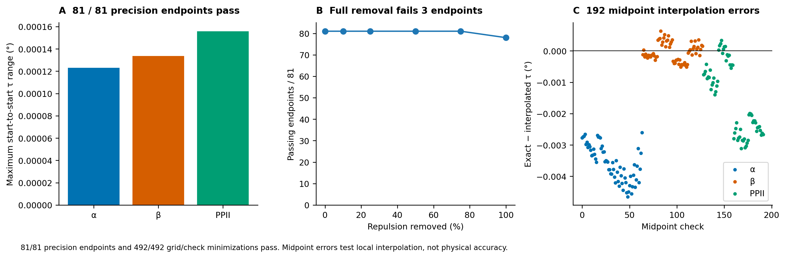

Figure S2 Paired environment summaries
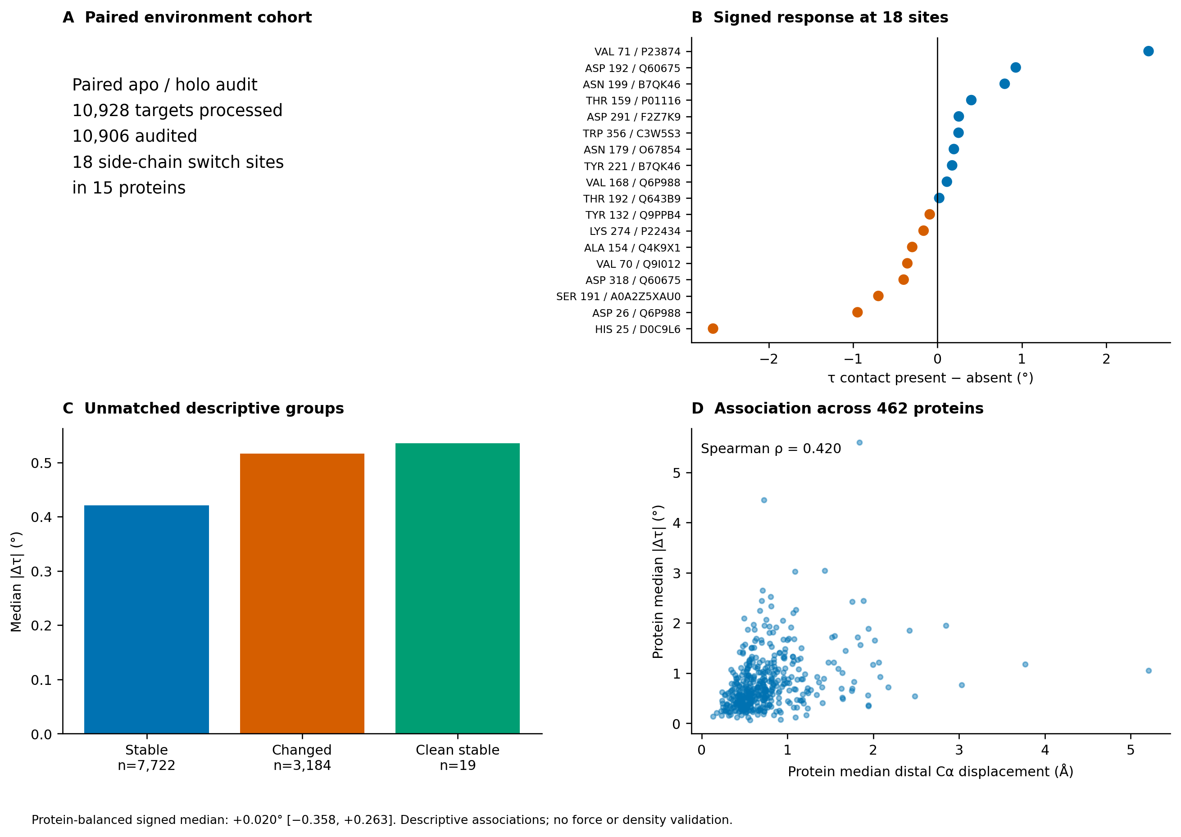

Paired environment numerical summaries
For the 18 strict switch sites, the residue-weighted signed median is +0.0656°. The median of within-protein medians is +0.0201°, with a protein-resampling interval of −0.3579° to +0.2631°. Mapped-distance-stable sites number 7,722, with median |Δτ| = 0.4209°; changed sites number 3,184, with median |Δτ| = 0.5162°. The 19 clean-stable sites have median |Δτ| = 0.5358°. The pooled distal Spearman association is 0.2944; the correlation of per-protein medians is 0.4200 across 462 proteins. These values describe the separate paired-environment cohort.

