Protein Backbone Mechanics I: The Ramachandran Plot as a Mechanical Force Field
Wei Chen
Department of Computer Science, Louisiana State University Shreveport, One University Place, Shreveport, LA 71115, USA
Corresponding Author: Wei Chen (wei09128@gmail.com)

Abstract
In contemporary structural biology, the Ramachandran plot is frequently read as a population census — a static map of where backbone dihedral angles are found. Yet, the original 1963 Ramachandran, Ramakrishnan, and Sasisekharan paper was rooted in a hard-sphere steric and mechanical argument. We revisit this framing to show that the plot represents, instead, a mechanical force field: each (φ, ψ) position associates with a measurable local balance among steric, electrostatic, and hydrogen-bond forces, consistent with a causal mechanical origin, and the plot's topology encodes the direction and magnitude of the restoring or driving forces that hold every residue in place.
Analyzing 1,698,562 residues from quality-filtered high-resolution crystal structures (8,292 unique chains), we decompose the torques acting on each backbone dihedral and establish three results. First, the net torque carries limited predictive signal; most conformational information resides in the per-source force decomposition. Second, steric torques dominate both dihedral axes, with the steric torque about the φ rotation axis emerging as the strongest predictor of ψ. Third, effective torsional resistance varies across Ramachandran space according to spatial position rather than amino-acid identity, defining three mechanical regimes—confinement in α-helices, persistence against a mechanical gradient in β-sheets, and chemistry-dependent driving in polyproline II—together with orthogonal steric discontinuities whose intersection defines the αR minimum. Finally, comparison with AMBER ff14SB reveals systematic ψ-dependent variation in empirical stiffness at fixed φ, violating the additive V(φ)+V(ψ) assumption underlying standard torsional parameterizations.
These findings recast the Ramachandran plot from a purely statistical summary into a mechanically structured landscape whose organization is consistent with, though does not on its own prove, an underlying causal force balance. We offer this as a foundation for environment-aware force-field development, backbone validation, and protein design.
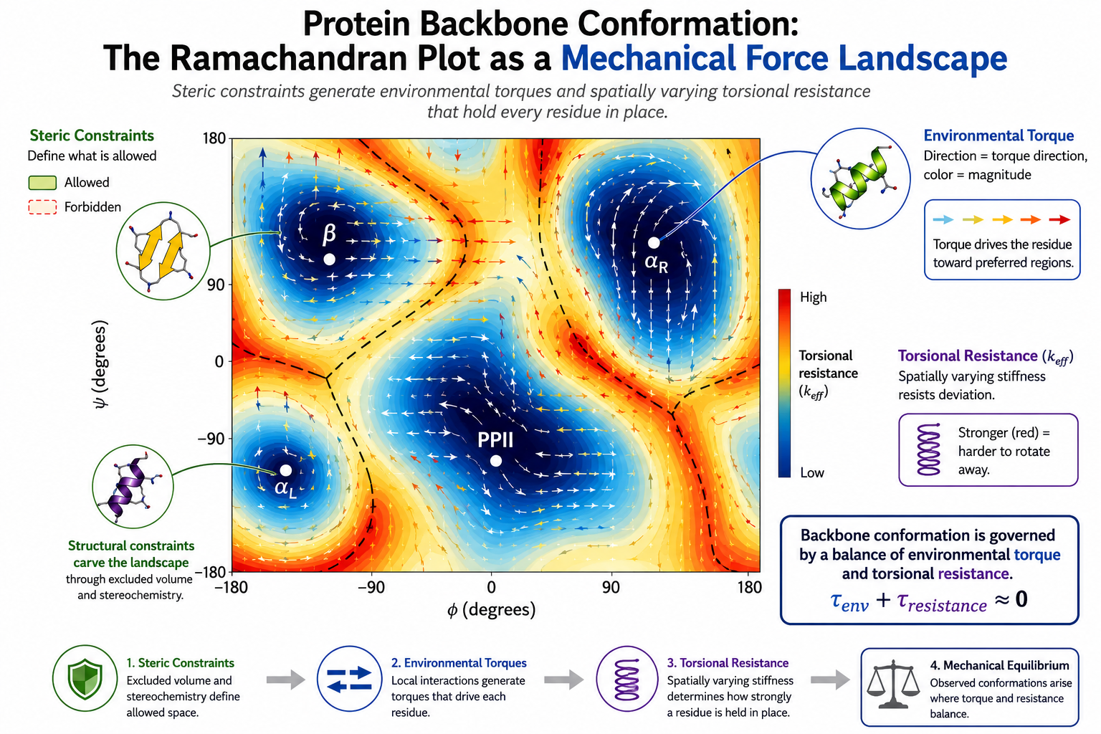
For Table of Contents Only. The three-channel mechanical hierarchy governing protein backbone strain: fundamental steric constraints, the underlying torque field, and a spatially varying effective torsional resistance across the Ramachandran plane.

1. Introduction
Protein backbone conformation is defined by the dihedral angles φ and ψ. The Ramachandran plot¹ maps their allowed values, and its clustered regions — αR, β, PPII, 3₁₀, π, and αL — form the structural alphabet of protein architecture^{2,3}. Later, knowledge-based statistical potentials, backbone-dependent rotamer libraries, structure-validation tools, and more recently inference models such as AlphaFold⁴ largely interpreted Ramachandran distributions as empirical population frequencies. Statistical potentials and inference models exploit these distributions for prediction, molecular dynamics simulations model atomic forces but typically attribute non-canonical conformations to thermal fluctuations⁵, and empirical validation tools classify rare conformations as statistical outliers⁶. Despite their methodological differences, these approaches implicitly assume that Ramachandran restriction is binary and that positions within allowed regions are otherwise unconstrained.
The limitations of additive one-dimensional $V(ϕ)\text{+}V(ψ)$torsional potentials are well recognized. They motivated CHARMM's CMAP correction¹²˒¹³, and related work has shown that backbone bond lengths and angles vary systematically with (φ,ψ)¹⁴. Rather than introducing two-dimensional φ,ψ coupling itself, this study advances three complementary directions. First, whereas CMAP provides an empirical energy correction, we decompose the environmental torque governing (φ,ψ) positioning into steric, electrostatic, and hydrogen-bonding components, identifying a candidate structural pathway for cross-axis coupling. Second, we evaluate this behavior quantitatively against the additive AMBER ff14SB force field using crystallographic data and bootstrap confidence intervals. Third, whereas previous work focused on (φ,ψ)-dependent covalent geometry, we characterize the environmental torque landscape underlying dihedral positioning.
To address these limitations, we present a three-layer mechanical representation of backbone conformational space (Fig. 1) that integrates steric constraints, torque fields, and effective torsional resistance. By analyzing 1,698,562 residues across 8,292 unique high-resolution chains, we show that: (i) Net torque is weakly predictive on its own: It is the per-source force decomposition—rather than the net sum—that carries the primary conformational signal. (ii) Steric torques dominate both axes: We observe a strong cross-axis association through the ${\text{C}}_{α}$ center, which persists even after controlling for geometric circularity. (iii) Torsional resistance is position-dependent: The effective stiffness varies systematically across Ramachandran space, governed by spatial position rather than amino-acid identity. (iv) The stiffness landscape reveals orthogonal discontinuities: Two basin-independent steric boundaries intersect to define the $α_{R}$ minimum as a physical mechanical trap. (v) The empirical stiffness field violates standard additive models: Our results show that backbone stiffness is inconsistent with the separable $V\left(ϕ\right)\text{+}V\left(ψ\right)$ potential assumed by force fields like AMBER ff14SB.
Together, these findings extend the binary Ramachandran model to a continuous, spatially structured mechanical landscape and provide a force-based framework that complements statistical and inference-based descriptions of backbone conformation.
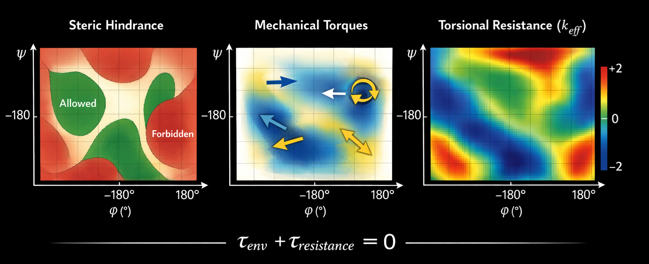
Fig. 1: A Three-Channel Hierarchy of Backbone Strain. Backbone conformation is governed by fundamental steric constraints, the underlying torque field, and a spatially varying effective torsional resistance across the Ramachandran plane.

2. Results
2.1 The Ramachandran Plot Encodes a Graded Mechanical Landscape
We analyzed 8,292 unique chains from quality-filtered high-resolution PDB structures (Methods 4.1). Using a normalized angular distance metric (Methods 4.2), the six canonical Ramachandran states cover 79.6% of the (φ, ψ) plane. A greedy density-peak algorithm identifies eight additional clusters at basin peripheries, raising coverage to 92.2% (Fig. 2A–B). These satellite states are displaced 10–30° from canonical centers, confirming that Ramachandran basins are not rigid boundaries but elastic regions whose effective centers shift with the local mechanical environment.
The eight new states occupy characteristic positions: bridge conformations between αR and 3, type-II turn conformations at the αR–PPII boundary, extended loop conformations, and an αL extension at positive φ. Their locations at basin edges rather than between basins indicate continuous deformation from canonical geometry, not discrete intermediates.
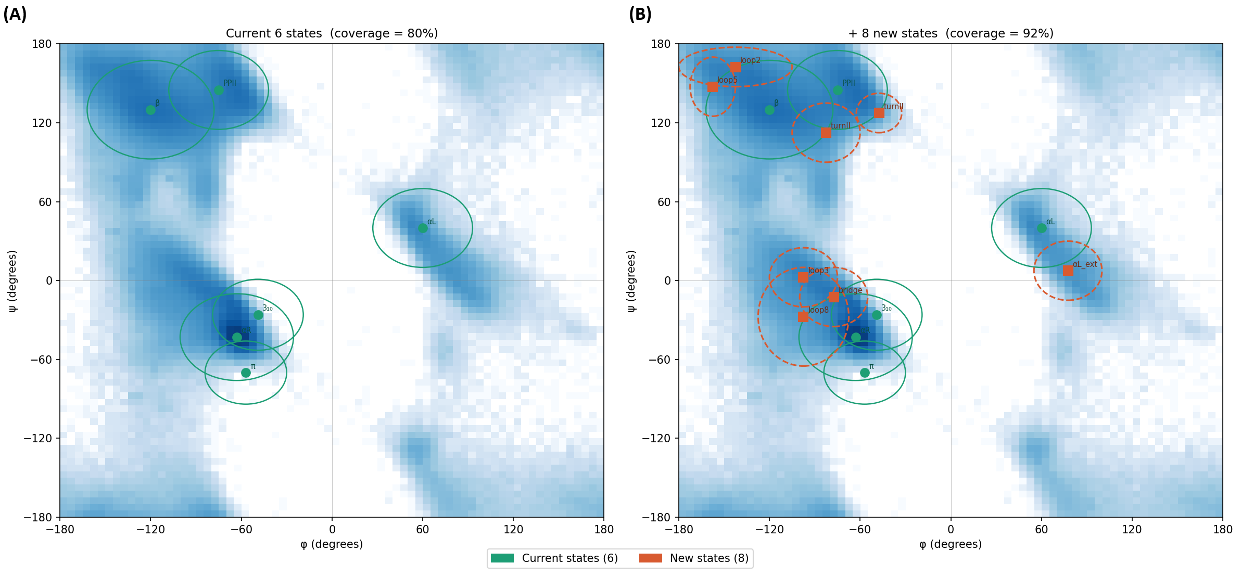
Fig. 2: Ramachandran coverage. (A) Six canonical states (green ellipses) cover 79.6% of the (φ, ψ) plane. (B) Adding eight data-driven states (orange squares) raises coverage to 92.2%, including bridge (φ ≈ −78°, ψ ≈ −13°), type-II (φ ≈ −83°, ψ ≈ 113° and φ ≈ −48°, ψ ≈ 128°), extended loop (φ ≈ −98° to −158°, ψ ≈ 8° to 163°), and an α_{L} extension (φ ≈ 78°, ψ ≈ 8°). Background: log-density heatmap of the quality-filtered dataset.
2.2 Force Decomposition, Not Total Environmental Torque, Determines Conformation
To identify what determines position within this landscape, we extracted features per residue in three physically motivated groups (Methods 4.3–4.5): steric hindrance field (Group A), mechanical torques (Group B), and molecular context (Group C). Backbone angles were predicted using both Δ-reference targets (deviation from the αR reference at −63°, −43°) and sin/cos encoding to handle circular topology (Methods 4.6).
Table 1. Model comparison: structure-grouped 5-fold cross-validated R² (CV_φ, CV_ψ). Environmental torque = 2 features (τ_φ, τ_ψ); Full = all features described in Methods 4.3–4.5.
Model | CV_φ | CV_ψ
Environmental torque only (2 features) | 0.185 | 0.003
Linear Ridge (58 features, Δ-ref) | 0.472 | 0.208
Linear Ridge (58 features, sin/cos) | 0.518 | 0.865
Random Forest (58 features, Δ-ref) | 0.795 | 0.575
Gradient Boosting (58 features, Δ-ref) | 0.767 | 0.559
MLP (58 features, Δ-ref; 2-layer) | 0.876 | 0.664
This progression reveals a central mechanical insight (Table 1). A minimal environmental representation using only net torque explains 18.5% of φ variance but virtually none of ψ (0.3%). At equilibrium, net environmental torques balance against intrinsic torsional resistance, leaving a near-zero sum that carries only limited positional information. Expanding to the full feature set increases cross-validated performance to 47.2% (φ) and 20.8% (ψ) for linear prediction, and to 51.8% and 86.5% with reference-free circular encoding. These results indicate that most conformational information is associated with the decomposition of environmental forces rather than with their net sum. Mechanical equilibrium causes opposing force contributions to cancel in the aggregate, whereas the individual steric, electrostatic, and hydrogen-bonding components preserve much of the associated positional information.
The reference-free sin/cos encoding dramatically improves the linear model for ψ (CV 0.208 → 0.865), indicating that much of the apparent ψ prediction difficulty arises from multi-basin topology rather than missing physical features. The φ–ψ asymmetry persists across models: φ is more predictable because it is confined to a narrow sterically allowed corridor with a steep force gradient, whereas ψ spans multiple allowed basins (αR, β, PPII) with flatter and more heterogeneous force landscapes.
2.3 Steric Torques Are Strongly Associated with Both Axes, with a Cross-Axis Cα Signal — Largely, but Not Entirely, Circular
Random Forest feature importance (Fig. 3) reveals that backbone conformation is more strongly associated with steric torque than with electrostatic. For φ, steric torques dominate: $τ_{ϕ,steric}$ and $τ_{ψ,steric}$ together account for over one-third of feature importance, followed by Cα–Cα distance to $i\text{-}2$, a proxy for local curvature, and corrected electrostatic torque along ψ. Smaller contributions reflect molecular context, including sidechain rigidity, mass, and heavy-atom count. For ψ (given φ), $τ_{ϕ,steric}$ is the dominant feature, exceeding all other predictors by more than fourfold, while χ₁ rotamer, backbone geometry, and local curvature contribute smaller effects. Electrostatic terms remain minor.
Because φ strongly determines Ramachandran basin identity, we first tested whether this cross-axis association could arise from geometric conditioning through the two-stage φ→ψ architecture. Removing explicit φ-coordinate information (sinφ and cosφ) left $τ_{ϕ,steric}$ as the highest-ranked feature (0.616→0.628) and minimally changed ψ prediction (R² = 0.955→0.949), indicating that the association is not explained by a predicted-φ intermediate.
However, this analysis does not by itself establish causal mechanical transmission, because $τ_{ϕ,steric}$ is computed from the observed conformation. We therefore isolated the only genuinely non-circular feature class in our dataset: virtual-rotation clash probes that evaluate steric contacts after a counterfactual ±20° backbone rotation. Using only these off-equilibrium features, structure-grouped cross-validation achieved circular $R_{ψ}^{2}\text{=}0.172$ and improved basin classification by 14 percentage points over the majority-class baseline. Thus, while most predictive power in the full model originates from conformation-derived features, a smaller but measurable non-circular association remains.
The observed cross-axis association is consistent with a candidate structural mechanism involving the tetrahedral Cα center, which connects the φ and ψ rotation axes. Steric strain generated around one dihedral could be transmitted through this junction and expressed along the other axis. This interpretation remains mechanistic but not yet causal; the off-equilibrium probe provides the more direct evidence for a non-circular association.
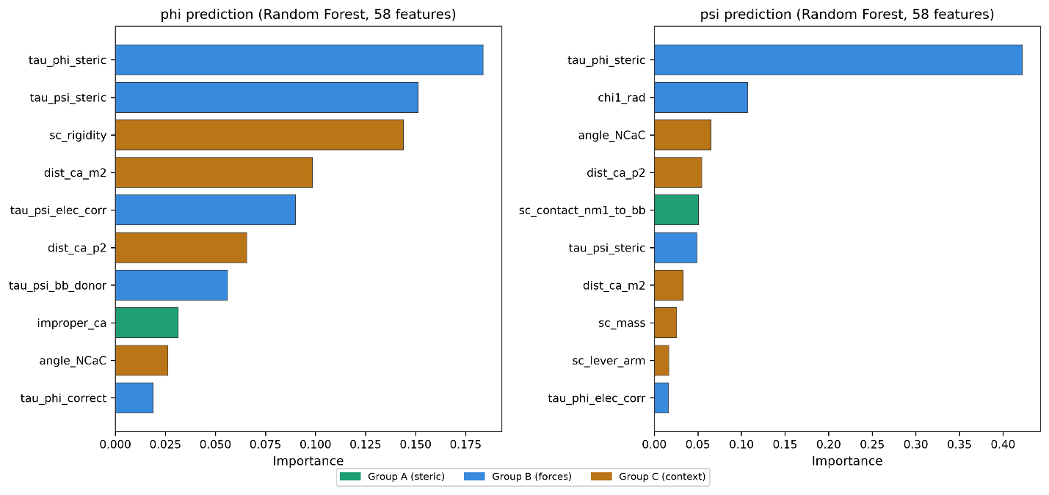
Fig. 3: Feature importance for φ and ψ prediction (Random Forest, full model). Left: φ is associated with steric torques (τ_φ,steric; τ_ψ,steric), with secondary geometric support (Cα–Cα_i−2). Right: ψ (given φ) shows strong cross-axis association — τ_φ,steric alone accounts for 44% of importance. See Section 2.3 for the separate, more conservative estimate of the non-circular component of this signal. Colors: green, steric geometry (Group A); blue, mechanical torques (Group B); amber, molecular context (Group C).
2.4 Three Mechanical Regimes Map onto Secondary Structure Function
The environmental torque field across Ramachandran space (Fig. 4A) is basin-specific in both magnitude and direction. While the αR basin exhibits ambivalent signals, others show strongly polarized torque distributions (Table 2), indicating regions of significant mechanical driving. Projection of the net torque toward the αR reference (−63°, −43°) and stratification by amino-acid chemistry (Fig. 4B) reveal three mechanically distinct regimes.
Basin | n | ⟨τ_proj⟩ | % Rest. | % Driv. | Regime
αR | 685,423 | [−0.063, −0.059] | 44.7 | 49.7 | Confined (stiff cage)
β | 418,323 | [+1.254, +1.264] | 84.7 | 7.0 | Persistent (against gradient)
PPII | 306,729 | [−0.211, −0.203] | 34.3 | 45.5 | Chemistry-dependent
loop | 217,539 | [+0.305, +0.312] | 52.4 | 26.6 | Funneled
αL | 70,548 | [+0.081, +0.102] | 37.2 | 45.3 | Chemistry-dependent
All confidence intervals exclude zero and are non-overlapping between basins for k_φ, confirming these basin-level differences are statistically robust rather than point estimates of uncertain precision.
αR: confinement without restoring force. In αR, restoring and driving torques are balanced, and the torque–displacement Pearson correlation is negligible (r = −0.004; Fig. 4E). αR is therefore not stabilized by convergent forces. Instead, it lies at the intersection of two orthogonal steric contacts — the C_{i−1}=O···Cβ collision along φ and the O···N_{i+1} collision along ψ (Section 2.5) — forming a steric cage from which displacement in either direction encounters an immediate barrier.
Chemistry refines but does not alter this picture. Proline alone shows strong restoring projection (+0.55; Fig. 4D), consistent with its ring constraint. All other classes show weak outward bias (−0.14 to −0.02; Fig. 4D), insufficient to escape the stiffness cage. Confinement is geometric, not chemical.
β: persistence against mechanical gradient. The β basin shows the strongest coherent restoring signal, with uniformly positive projections across chemistries (+1.13 to +1.33), with the sole exception of Proline (+0.46), whose cyclic constraint reduces the local mechanical gradient. This near-universal ‘outward’ pressure provides a mechanical basis for the long-observed sequence tolerance and local instability of β-sheets⁸. Consistent with its role as a sheet breaker⁹, glycine shows the strongest restoring projection in the β basin (+1.33).
PPII: chemistry-dependent driving. PPII shows mixed directionality overall with strong chemical dependence. Proline is strongly driven into PPII, reflecting ring geometry. Polar and charged residues are moderately favored (≈ −0.18), whereas aromatic and aliphatic residues show weak restoring bias toward αR (+0.03 to +0.12). PPII occupancy thus reflects coupling between residue identity and local mechanics, consistent with its solvent sensitivity¹⁰.
Loops: mechanical funnels. Loops show coherent restoring and a positive torque–displacement correlation (r = +0.263, k = +0.0034; Fig. 4E): the farther from αR, the stronger the restoring torque, consistent with loops acting as deformable elements that return to canonical states after perturbation.
Summary. αR satisfies confinement without coherence — it is a stiff cage, not a force-driven funnel. β shows coherence without confinement — persistence requires cooperative hydrogen bonding. PPII and αL show neither condition fully, relying on chemistry-dependent local forces. Loops alone combine coherence with displacement-dependent strengthening, defining a true mechanical funnel.
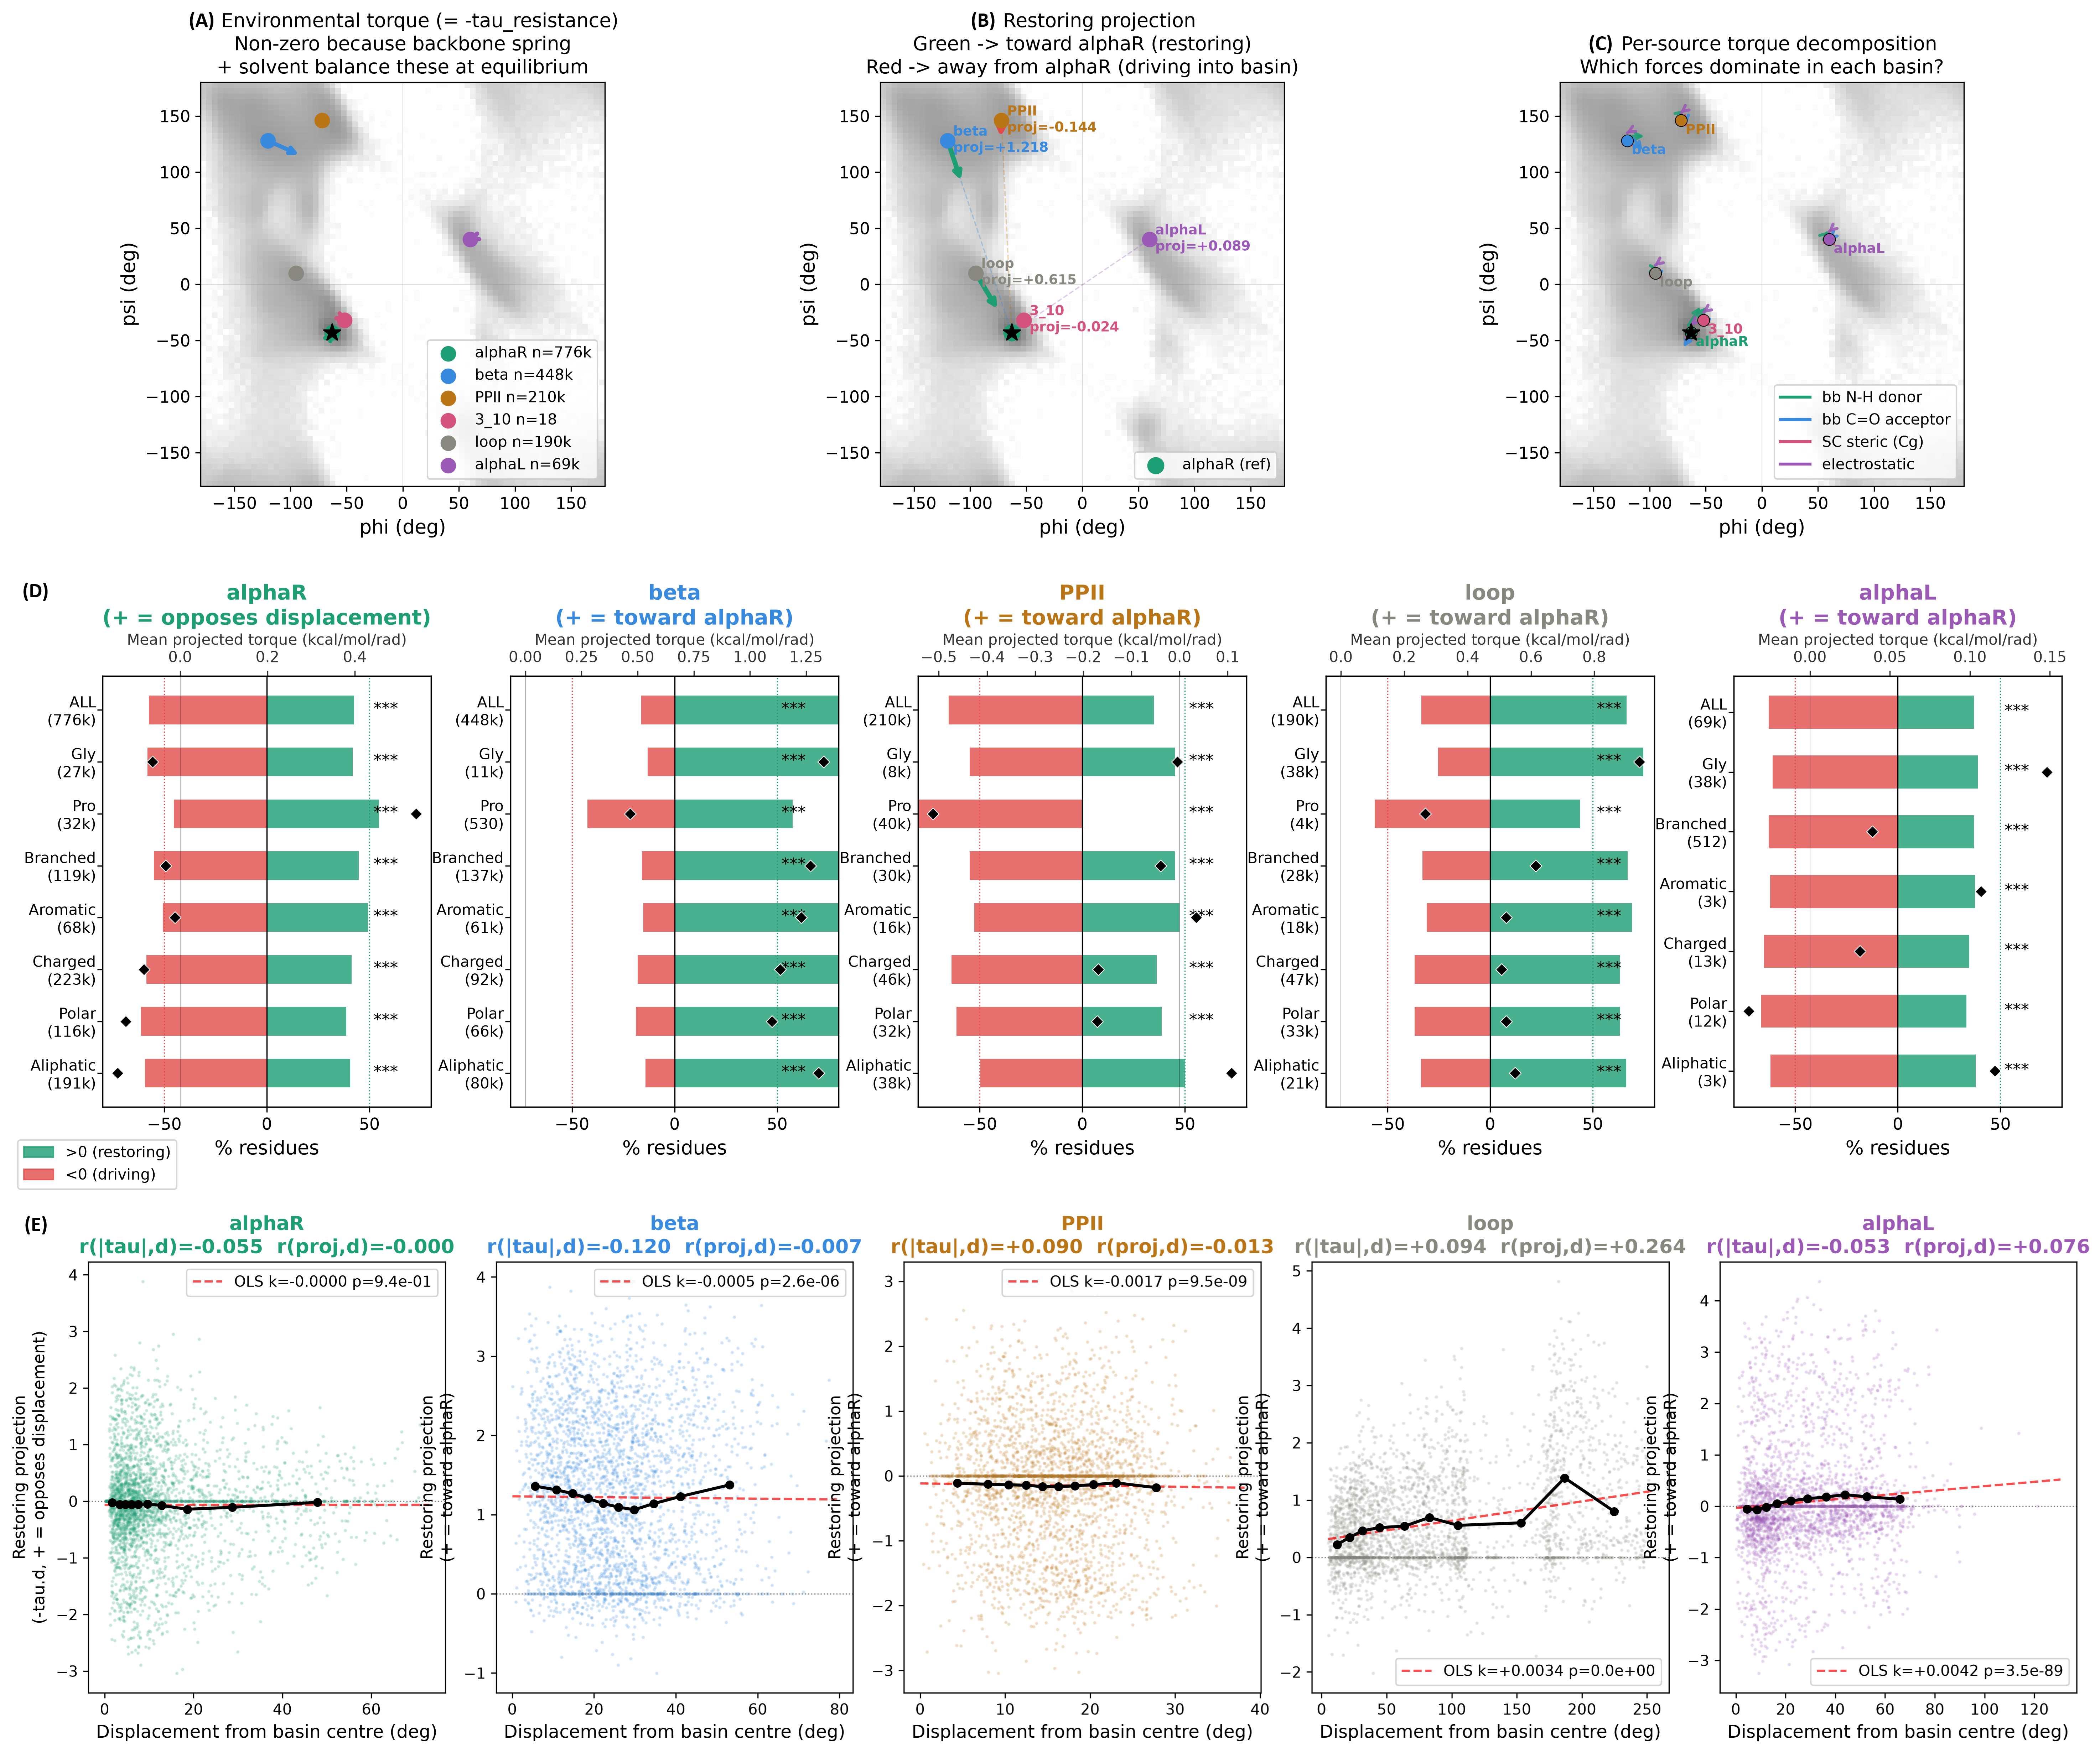
Fig. 4: Mechanical landscapes and basin-specific force environments. (A) Environmental torque vectors per basin overlaid on Ramachandran density. (B) Restoring projection toward αR (green = restoring, red = driving). (C) Per-source torque decomposition showing which forces dominate in each basin. (D) Directional coherence and mean projected torque (black diamond).Torque–displacement profiles. (E) Torque–displacement profiles.
2.5 Orthogonal Stiffness Walls and the αR Mechanical Trap
We map backbone resistance as effective stiffness k_eff = −τ_env / Δθ per residue (Methods 4.7). Because k_eff diverges as Δθ → 0, walls are identified from regions far from the reference where the ratio is well-behaved, and validated by known steric contacts rather than from intensity near the reference point (Fig. 5). Two orthogonal discontinuities organize the Ramachandran plane:
- φ wall: A sharp vertical wall at φ ≈ −60° to −80° forms a high-stiffness ridge. It arises from C_{i−1}=O···Cβ collision, where rotation through φ ≈ −60° triggers a steric clash and sharply resists further displacement.
- ψ wall: A horizontal wall at ψ ≈ −40° to −60° reflects O···N_{i+1} collision along ψ. Below this boundary (ψ < −60°), k_ψ reverses sign, indicating a compliant region.
- αR at the intersection. The αR minimum (−63°, −43°) sits at the crossing of these two steric barriers — a direct geometric consequence of the steric contacts themselves. This explains mutational robustness, narrow angular dispersion, and the absence of a need for active restoring force.
Other basins lack this dual confinement. The β region lies in the compliant trough on both axes, meaning its stability requires non-local cooperativity. Meanwhile, PPII sits near the φ wall but above the ψ wall, resulting partial confinement only.
Sidechain complexity sets stiffness by packing, not length. The magnitude of k_eff varies non-monotonically with sidechain rotatable-bond count. Structure-level bootstrap confidence intervals (2,000 resamples) confirm this pattern is robust: mean |k_φ| = 1.944 [1.928, 1.960] at 0 rotatable bonds, rising to 2.669 [2.649, 2.690] at 3 rotatable bonds, then falling to 2.539 [2.519, 2.559] at 4 — confidence intervals for adjacent groups are non-overlapping throughout, confirming the peak-then-decline pattern is not an artifact of estimation uncertainty. Mean |k_ψ| follows the same pattern (1.489 → 2.248 → 2.041). This identifies local packing geometry — three-χ sidechains long enough to contact backbone atoms across the rotation axis but short enough to remain geometrically ordered — rather than mass or flexibility, as the physical quantity determining backbone mechanical response.
Position dominates over identity: the same amino acid exhibits different stiffness in different basins. Chemistry rescales |k| without altering its spatial structure.
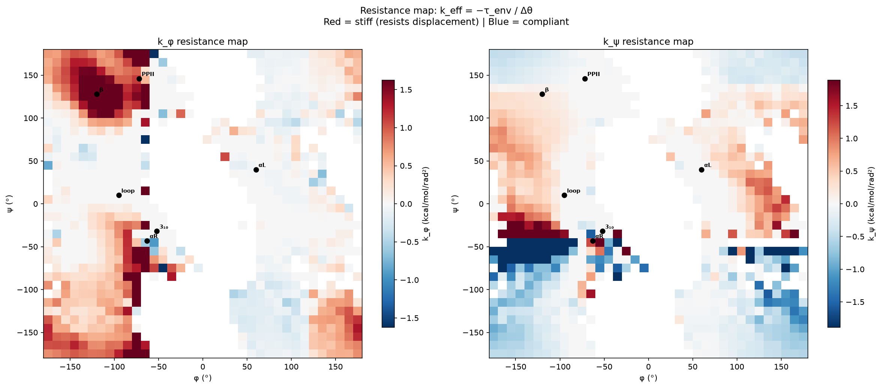
Fig. 5: Effective torsional resistance across Ramachandran space. Left: k_φ map showing a vertical stiffness wall near φ ≈ −60° to −80°. Right: k_ψ map showing a horizontal wall near ψ ≈ −40° to −60°. This is the same secant-based quantity used, binned, in Fig. 7 (Methods 4.7/4.8; Section 2.6). 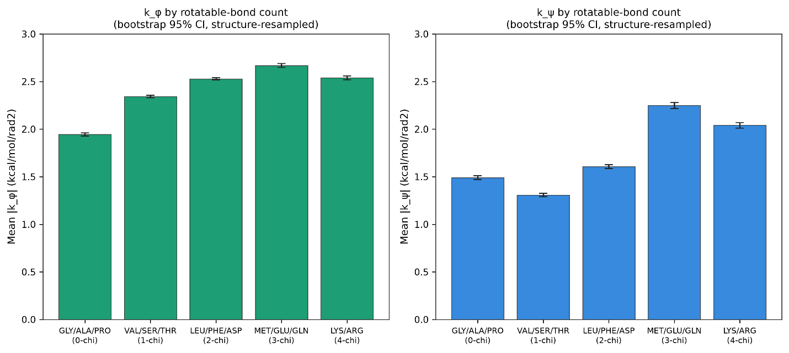
Fig. 6: Non-monotonic stiffness with sidechain complexity. Error bars: bootstrap 95% CI, resampled by structure (2,000 iterations); replaces a naive residue-level SEM identified during revision as understating true uncertainty by 5–8×.
2.6 Coupled Torsional Stiffness and the Limits of the Additive V(φ)+V(ψ) Form
The additive functional form underlying standard torsional parameterizations, V(φ,ψ) = V(φ) + V(ψ), predicts that the curvature ∂²V/∂φ² is independent of ψ for any fixed φ. We tested this prediction against the empirical effective stiffness field (k_eff). Because empirical k_eff is evaluated as a finite secant relative to the αR reference (k_eff = −τ_env/Δφ; Fig. 5, Fig. 7; Methods 4.7) rather than a true analytic second derivative, the two quantities are not directly equivalent. Nevertheless, under a strictly additive potential, both quantities should depend only on φ.
To evaluate this separability prediction, we computed bootstrap 95% confidence intervals (1,000 structure-level resamples) for every populated (φ,ψ) bin. Analyses were restricted to the 445 bins containing at least 100 residues to ensure adequate statistical power (median confidence-interval width = 0.12 kcal·mol⁻¹·rad⁻²; Supplementary Table S1). AMBER reference values were computed from the source-verified ff14SB backbone torsional parameters reported by Maier et al.⁷ (Methods 4.7).
The empirical stiffness exhibits robust, systematic ψ-dependence at fixed φ. Along the α-helical corridor, for example, the empirical secant varies continuously from −0.44 (ψ ≈ −35°) to +6.0 (ψ ≈ 165°). Across all adequately powered bins, 99.8% have confidence intervals that exclude the ψ-independent prediction of the additive model. These observations are incompatible with the ψ-independence predicted by an additive V(φ) + V(ψ) torsional form. Importantly, this topological discrepancy does not imply that the ff14SB torsional term is quantitatively miscalibrated. The AMBER torsional term represents only the isolated dihedral potential, whereas the empirical stiffness reflects the combined effects of local steric, electrostatic, and hydrogen-bonding interactions within the folded protein.
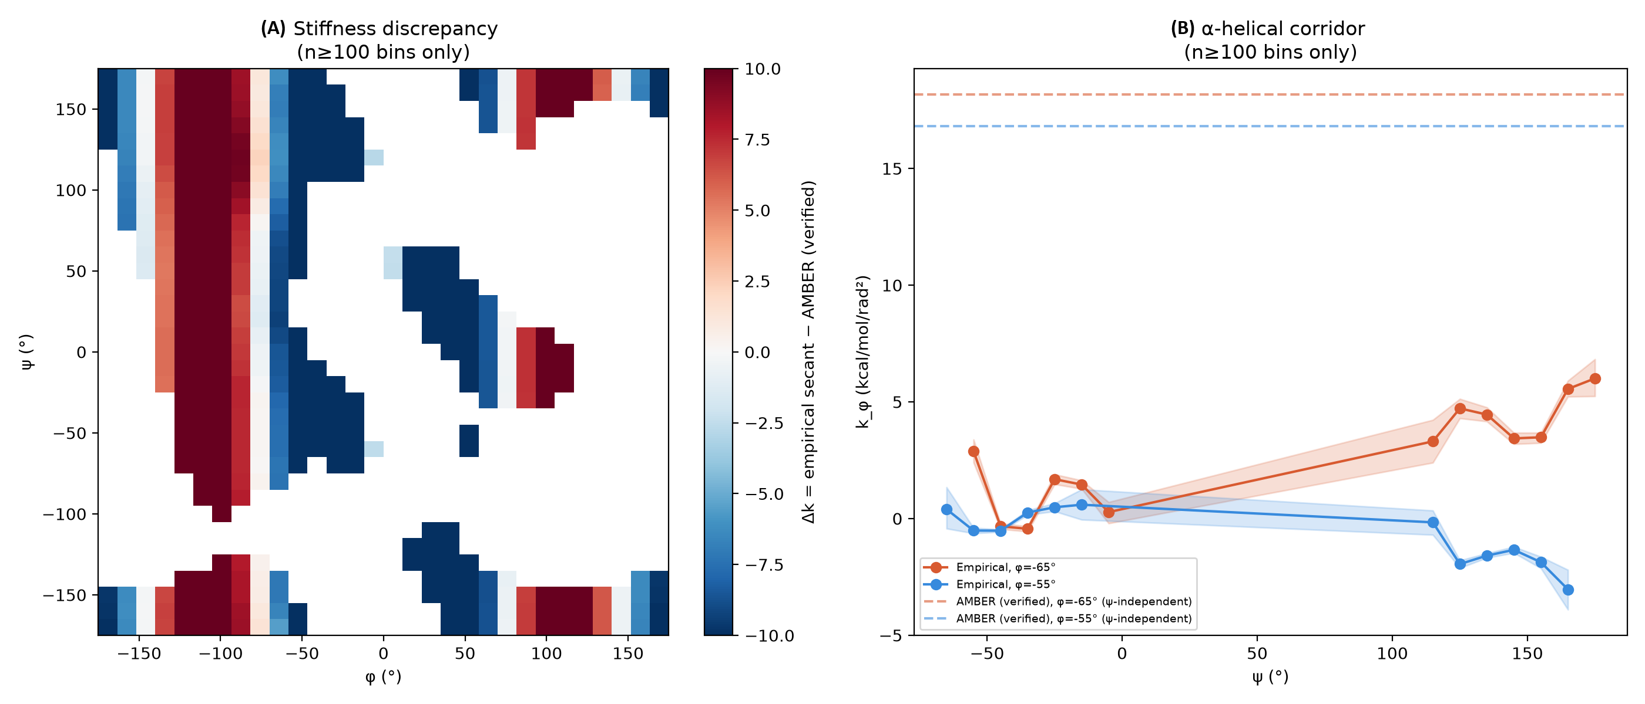
Fig. 7: Empirical backbone stiffness landscape and comparison with AMBER ff14SB reference values. (A) Stiffness discrepancy field δk_φ across Ramachandran space (n ≥ 100 bins) showing systematic ψ-dependent modulation of φ resistance — reported as a separability violation, not a magnitude-calibration claim. (B) Within the α-helical corridor (φ = −65°, solid; φ = −55°, dashed), empirically derived k_φ (the same secant quantity as Fig. 5) varies systematically with ψ, whereas AMBER assigns a ψ-independent value by construction. Full bin-level values, occupancies, and confidence intervals are provided in Table S1.

3. Discussion
The Ramachandran plot itself can be interpreted as a force landscape rather than merely an occupancy map. Our results reinforce the foundational framework established by Ramachandran et al. in 1963. Rather than representing only the empirical distribution of conformations, it can also be viewed as a spatial map of the mechanical constraints experienced by the protein backbone.
This perspective changes what constitutes a useful backbone descriptor. Equilibrium populations summarize where proteins are observed, whereas local force decompositions provide information about why those conformations are mechanically favored. The present analysis shows that much of this information is embedded in geometry-derived features, while a smaller but measurable component persists under an off-equilibrium probe.
The observed ψ-dependence of the empirical stiffness field provides an independent line of evidence that backbone mechanics cannot be fully represented by separable one-dimensional torsional terms. Rather than arguing for a particular replacement potential, our results identify a structural property that any mechanically complete description should reproduce.
The three regimes imply that different regions of Ramachandran space are stabilized by fundamentally different physical mechanisms. Consequently, a single global description of backbone mechanics may obscure the distinct constraints governing helices, sheets, and extended conformations.
Limitations. First, and most centrally: the majority of this paper's predictive power for ψ comes from features that are, by construction, strict functions of the observed conformation, not independent mechanical probes; only the corrected virtual-rotation clash features constitute a genuinely non-circular test, and that test shows a real but modest effect (Section 2.3). We no longer interpret the larger, full-model R² as evidence of causal mechanical transmission. Second, the AMBER comparison (Section 2.6) is a topological separability test, not a validated magnitude comparison, following correction of two errors in our AMBER reference calculation identified during revision. Third, this analysis relies on static crystallographic snapshots, without explicit solvent or dynamics; establishing any of the associations reported here as causal mechanisms would require perturbation or molecular-dynamics-based evidence beyond the static-structure regression presented here. Fourth, sidechain contributions are treated through geometric proxies rather than explicit Lennard-Jones gradients throughout most of the analysis. Fifth, given the very large sample sizes throughout (up to 1.7 million residues), nominal statistical significance is expected even for practically negligible effects; we emphasize effect sizes and bootstrap confidence-interval widths rather than p-values throughout, and the basin- and chemistry-stratified comparisons (Table 2, Fig. 4D) are evaluated via non-overlapping confidence intervals rather than uncorrected pairwise significance testing.
The Ramachandran plot is therefore not a purely statistical summary but a mechanically structured landscape. Conformation shows strong, decomposable statistical association with local mechanical force balance; establishing this as a causal mechanism would require perturbation or dynamics-based evidence beyond the static-structure regression presented here.

4. Methods
4.1 Dataset
Non-redundant protein crystal structures were compiled from the RCSB Protein Data Bank¹¹, filtered to X-ray resolution ≤ 2.0 Å, crystallographic R-factor ≤ 0.25, and <30% maximum pairwise sequence identity. After chain-continuity validation, backbone dihedral extraction, and exclusion of terminal residues, a quality filter was applied: residues with Cα B-factor > 30 Å² were excluded, and any residue within 3 positions of a chain gap was removed. Features were extracted directly from observed atomic coordinates. The resulting dataset comprises 1,698,562 residues across 8,292 unique chains, which were confirmed one-to-one with the cross-validation grouping variable.
4.2 Backbone Coverage Analysis
Each residue was assigned to the nearest canonical state using a normalized angular distance d = √[(Δφ/σ_φ)² + (Δψ/σ_ψ)²]. A residue was "covered" if d ≤ 1.5 for any state. New states were identified by greedy selection of the densest uncovered bin in a smoothed 2D histogram.
4.3 Feature Group A: Steric Hindrance Field
Contact shells: heavy atoms counted within 3, 4, and 5 Å radii for each backbone atom. Directional asymmetry: weighted steric vector. Rotational clash (corrected in this revision): the downstream atom set is rotated ±20° about the φ and ψ rotation axes using the Rodrigues rotation formula around the corresponding pivot and axis. Steric contacts (sub-2.5 Å) are counted, and the minimum post-rotation contact distance is recorded as a continuous feature alongside the binary clash counts.
4.4 Feature Group B: Mechanical Torques
For each force source, torque along the φ and ψ rotation axes was computed as τ = (r × F) · â. Torque values are in kcal·mol⁻¹·rad⁻¹, computed from AMBER ff14SB⁷ partial charges and crystallographic coordinates. Sources: backbone N–H donor H-bonds; backbone C=O acceptor H-bonds; sidechain H-bonds; sidechain steric via Cβ/Cγ offset; corrected electrostatic from all atoms within 6 Å; net torques; χ₁ dihedral angle and presence flag.
4.5 Feature Group C: Molecular Context
χ₂ dihedral and presence flag; sidechain mass, heavy atom count, rotatable bond count, rigidity ratio, branching flag, aromaticity flag, effective lever arm length; number of strong H-bonds and best H-bond energy; Cα B-factor; next-residue proline flag; backbone bond angles; Cα–Cα distances to i±2; neighbor sidechain masses.
4.6 Target Encoding, Models, and Cross-Validation
Two target representations were used: (1) Δ-reference (Δφ, Δψ relative to −63°/−43°, wrapped) and (2) sin/cos encoding. Two-stage architecture: Stage 1 predicts φ; Stage 2 predicts ψ from all features plus the Stage 1 prediction. Models: Ridge regression, Random Forest, Gradient Boosting, MLP. All features standardized.
Cross-validation (revised): all reported CV figures use GroupKFold with 5 folds, grouped by protein chain (pdb_id, confirmed one-to-one with chain in this dataset), with an explicit runtime assertion verifying zero group overlap between training and test partitions in every fold. The original submission's residue-level (ungrouped) K-fold CV allowed residues from the same or homologous chains to appear in both training and test partitions; all CV figures in this revision use the chain-grouped scheme instead.
4.7 Restoring Projection and Effective Stiffness
For each basin b centered at (φ_b, ψ_b), the restoring direction is the unit vector toward the αR reference. Effective stiffness k_eff = −τ_env / Δθ, computed per residue for |Δθ| > 5°.
4.8 Force-Field Comparison and Delta-Stiffness Mapping
The empirical quantity k_φ,empirical(φ,ψ) used in the force-field comparison (Fig. 7) is identical to k_eff as defined in Methods 4.7 — a secant slope relative to the fixed αR reference, not an independently computed local curvature — binned into 10°×10° Ramachandran bins and aggregated as the per-bin median (minimum 3 residues per bin for inclusion; n ≥ 100 threshold used for the confidence-interval analysis in Section 2.6). Because this is a secant rather than a true second derivative, it is not directly equivalent to AMBER's analytic curvature; the comparison in Section 2.6 is framed as a test of separability rather than a magnitude-matched comparison.
AMBER ff14SB backbone torsional curvature was computed analytically as k_AMBER(φ) = d²V/dφ² = −Σₙ (Vₙ/2) n² cos(nφ − γₙ) from the standard Fourier torsional form. During revision we identified and corrected two independent errors in an earlier implementation: (1) a sign error (the earlier version omitted the leading minus sign, giving curvature values of the opposite sign from the correct convention at every basin), and (2) use of Fourier coefficients that had not been independently verified against the published source. The corrected coefficients, verified directly against the AmberTools/OpenMM ff14SB parameter distribution (Maier et al., 2015⁷), are given in Section 2.6. The stiffness discrepancy map is defined as δk_φ(φ,ψ) = k_φ,empirical(φ,ψ) − k_φ,AMBER(φ), evaluated across the 445 of 1,057 populated bins with n ≥ 100 residues; because the ff14SB torsional potential depends only on φ, k_φ,AMBER is constant along each ψ column by construction — precisely the property Section 2.6 tests against the empirical field's ψ-dependence at fixed φ.
Acknowledgments This research received no specific grant from funding agencies in the public, commercial, or not-for-profit sectors. The authors thank the Louisiana State University Health Sciences Center Shreveport (LSUHS) for logistical support, and special thanks to Dr. Xiaohong Lu for helpful discussions and technical assistance.
Data Availability The Python scripts and analysis framework, including a documented record of every issue identified and corrected during peer review and its fix, are available at: https://github.com/wei09128/protein-backbone-mechanics

References
(1) Ramachandran, G. N.; Ramakrishnan, C.; Sasisekharan, V. Stereochemistry of Polypeptide Chain Configurations. J. Mol. Biol. 1963, 7 (1), 95–99.
(2) Hollingsworth, S. A.; Karplus, P. A. A Fresh Look at the Ramachandran Plot and the Occurrence of Standard Structures in Proteins. Biomol. Concepts 2010, 1 (3–4), 271–283.
(3) Sobolev, O. V.; Afonine, P. V.; Moriarty, N. W.; Hekkelman, M. L.; Joosten, R. P.; Perrakis, A.; Adams, P. D. A Global Ramachandran Score Identifies Protein Structures with Unlikely Stereochemistry. Acta Crystallogr., Sect. A: Found. Adv. 2023, 79 (a2), C13.
(4) Jumper, J.; Evans, R.; Pritzel, A.; et al. Highly Accurate Protein Structure Prediction with AlphaFold. Nature 2021, 596 (7873), 583–589.
(5) Frauenfelder, H.; Sligar, S. G.; Wolynes, P. G. The Energy Landscapes and Motions of Proteins. Science 1991, 254 (5038), 1598–1603.
(6) Chen, V. B.; Arendall, W. B., III; Headd, J. J.; et al. MolProbity: All-Atom Structure Validation for Macromolecular Crystallography. Acta Crystallogr., Sect. D: Biol. Crystallogr. 2010, 66 (Pt 1), 12–21.
(7) Maier, J. A.; Martinez, C.; Kasavajhala, K.; Wickstrom, L.; Hauser, K. E.; Simmerling, C. ff14SB: Improving the Accuracy of Protein Side Chain and Backbone Parameters from ff99SB. J. Chem. Theory Comput. 2015, 11 (8), 3696–3713.
(8) Overington, J.; Donnelly, D.; Johnson, M. S.; Sali, A.; Blundell, T. L. Environment-Specific Amino Acid Substitution Tables. Protein Sci. 1992, 1 (2), 216–226.
(9) Chou, P. Y.; Fasman, G. D. Empirical Predictions of Protein Conformation. Annu. Rev. Biochem. 1978, 47 (1), 251–276.
(10) Shi, Z.; Woody, R. W.; Kallenbach, N. R. Is Polyproline II a Major Backbone Conformation in Unfolded Proteins? Adv. Protein Chem. 2006, 62, 163–240.
(11) Burley, S. K.; Bhikadiya, C.; Bi, C.; et al. RCSB Protein Data Bank. Nucleic Acids Res. 2021, 49 (D1), D437–D451.
(12) MacKerell, A. D., Jr.; Feig, M.; Brooks, C. L., III. Improved Treatment of the Protein Backbone in Empirical Force Fields. J. Am. Chem. Soc. 2004, 126, 698–699.
(13) Best, R. B.; Zhu, X.; Shim, J.; Lopes, P. E. M.; Mittal, J.; Feig, M.; MacKerell, A. D., Jr. Optimization of the Additive CHARMM All-Atom Protein Force Field Targeting Improved Sampling of the Backbone φ, ψ and Side-Chain χ1 and χ2 Dihedral Angles. J. Chem. Theory Comput. 2012, 8 (9), 3257–3273.
(14) Berkholz, D. S.; Shapovalov, M. V.; Dunbrack, R. L., Jr.; Karplus, P. A. Conformation Dependence of Backbone Geometry in Proteins. Structure 2009, 17, 1316–1325.

