Protein Backbone Mechanics II: Systematic Bond-Angle Deformation
Across Conformational Space
Wei Chen^{1,*}, Xiaohong Lu²
¹Department of Computer Science, Louisiana State University Shreveport, One University Place, Shreveport, LA 71115, USA
²Louisiana State University Health Sciences Center, Shreveport, LA 71103, USA
Corresponding Author: Wei Chen (wei09128@gmail.com)

Abstract
Backbone bond angles in proteins are commonly treated as fixed geometric parameters, yet high-resolution structures show systematic deviations from ideal values. What determines these deviations, and how they relate to backbone conformation, remains unclear. Here we analyze 1.7 million residues from crystal structures to quantify how bond angles vary as a function of backbone dihedrals, sidechain properties, and the surrounding environment (Fig. 1). We show that bond-angle variation is not stochastic but highly structured across Ramachandran space, with distinct deformation patterns in α, β, PPII, and αₗ basins. These patterns follow a mechanical hierarchy. First, backbone dihedrals define a basin-specific strain field that sets baseline geometry. Second, sidechain identity and χ₁ rotamer state act through the tetrahedral Cα center to modulate deformation amplitude and direction, with β-branched residues producing the largest effects and χ₁ rotations shifting τ (the N–Cα–C backbone valence angle) by up to ~1.7° within fixed (φ, ψ). Third, residual variance reflects coupling to the non-local environment: τ shows additional dependence on hydrogen bonding and steric density, whereas ω deviations from planarity are primarily determined by local packing rather than backbone or sidechain features. In contrast, ∠N–Cα–Cβ is predominantly determined by sidechain identity (R² ≈ 0.67), and ∠C–Cα–Cβ remains largely uncoupled. These results establish backbone geometry as a multi-scale mechanical system linking dihedrals, sidechains, and environment. Among the backbone angles examined, ω showed the strongest statistical association with environmental features, challenging its treatment as a rigid planar unit. Incorporating basin-, sidechain-, and environment-dependent bond-angle terms should improve the physical accuracy of force fields and structure prediction.
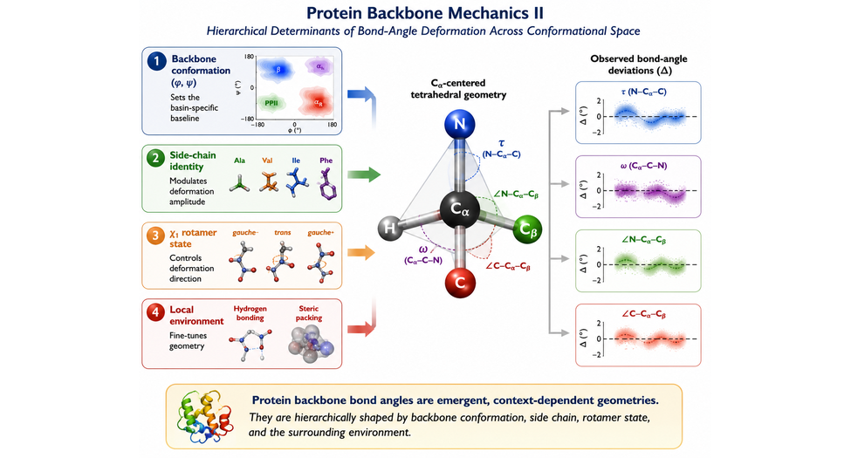
For Table of Contents Only. Systematic, basin-dependent deformation of backbone bond angles across Ramachandran space, governed by a three-layer mechanical hierarchy of dihedral, sidechain, and environmental effects.
1. Introduction
The Ramachandran plot¹ records the preferred backbone dihedral conformations of proteins, but a complementary question has received far less attention: once a residue occupies a given (φ, ψ) state, what determines the precise bond angles that define its local geometry? Although these deviations are typically only a few degrees, bond angles determine the covalent framework on which torsional energetics, side-chain placement, hydrogen bonding, and atomic packing depend. In a preceding study² (Paper I), we showed that Ramachandran space exhibits basin-specific mechanical organization, with αR, β, and PPII occupying distinct regimes of torsional stiffness and restoring-force directionality. Here we ask whether local bond geometry follows a similarly organized landscape, and whether side-chain identity, rotamer state, and the surrounding protein environment contribute additional layers of organization.
The tetrahedral Cα atom provides the natural geometric link between the backbone and side chain. Because it connects N, C, Cβ, and H, deformation of any one bond angle must be accommodated by the remaining three. Among these substituents, Cβ is unique in varying size, topology, and rotamer state across amino acids, making it the principal source of systematic geometric variation. We therefore asked whether Cβ substitution and χ₁ rotamer state are statistically associated with deformation of the Cα-centered bond angles and whether these changes covary with τ (∠N–Cα–C) and ω. Such relationships would be consistent with mechanical coupling through the tetrahedral Cα center, although the present observational analyses cannot establish the underlying physical mechanism.
Systematic deviations from ideal backbone geometry have long been recognized. The τ angle varies with secondary structure, with α helices generally exhibiting larger values than extended conformations, and β-branched residues display characteristic conformational preferences commonly attributed to local steric effects³–⁵. More broadly, small-molecule crystallography has established that bond lengths and bond angles vary systematically with substituent identity and torsion angle, providing the basis for structure–correlation analyses of covalent geometry⁸–¹⁰. Whether analogous principles organize bond-angle variation throughout protein backbones, however, has not been systematically quantified.
Here we analyze ~1.7 million residues from high-resolution crystal structures to characterize systematic deformation of τ, ω, ∠N–Cα–Cβ, and ∠C–Cα–Cβ. We test whether bond-angle variation is primarily determined by backbone conformation or whether residue identity, χ₁ rotamer state, and the surrounding protein environment provide additional explanatory power. Together, these analyses establish a hierarchical statistical framework linking backbone conformation, side-chain structure, and environmental context to local backbone geometry.
2. Methods
Structural dataset
Starting from 2,516,297 residues across the full PDB, structures were culled using the PISCES server (cullpdb_pc25.0_res0.0-2.0_len40-10000_R0.25_Xray_d2026_05_14_chains9162; ≤25% sequence identity, resolution ≤2.0 Å, R-free ≤0.25, chain length 40–10,000, X-ray only), yielding 9,162 chains. After retaining highest-occupancy alternates (altloc 'A'; lexicographic tiebreak), discarding HETATM records, reducing NMR ensembles to model 1, and excluding residues flanking chain breaks (Cα–Cα > 4.5 Å or C–N > 1.8 Å), 1,770,786 residues across all 20 standard amino acids passed initial structural-quality filters (resolution ≤2.0 Å, R-free ≤0.25, B-factor ≤30 Å², no chain gaps within ±3 residues). An additional 72,224 residues (4.1%) were then removed by a sliding-window B-factor criterion (mean Cα B-factor ≤30 Å² over a ±3-residue window, applied per chain) and a minimum chain-length requirement (≥10 residues per chain after filtering), yielding the final 1,698,562-residue analysis dataset (features_lj_v3_FINAL_CLEAN.csv; 8,292 structures) used throughout the analyses reported below. Per-type counts range from 24,730 (CYS) to 173,138 (LEU); glycine and proline are retained globally but excluded from Cβ-angle and χ₁ analyses. Backbone and sidechain geometric features were computed for this residue set using the feature-extraction pipeline described in Paper I.
Feature extraction
All geometric features were computed from real crystallographic coordinates (pdb_loader.py); NeRF-reconstructed positions were explicitly avoided owing to systematic bias in the Ramachandran-dependent deformation signal (Supplementary Note S1). Per residue: backbone dihedrals φ, ψ, ω by the signed-dihedral formula; bond angles τ (∠N–Cα–C), ∠N–Cα–Cβ, ∠C–Cα–Cβ as arc-cosines of normalised bond vectors; χ₁ and χ₂ where defined; sidechain mass, heavy-atom count, β-branching and aromaticity flags. Non-local features include per-atom steric density within 5 Å (N, Cα, C, O separately), backbone-local steric asymmetry vectors, Kabsch–Sander hydrogen-bond statistics (threshold −0.5 kcal/mol; strong bonds < −2 kcal/mol), sidechain–backbone contact counts for residues i ± 1, and Cα B-factor. H-bond detection was validated against DSSP on 1UBQ and 1CRN (recall = 1.000, donor–acceptor Pearson r = 1.000).
Ramachandran basins
Four (φ, ψ) windows isolate basin cores: α [−80°,−40°] × [−60°,−20°]; β [−150°,−90°] × [100°,160°]; PPII [−90°,−60°] × [120°,160°]; αₗ [40°,80°] × [20°,80°]. Windows are intentionally narrow to minimise cross-basin contamination.
Per-residue deviation
To remove composition bias, deviations are defined as Δ = angle − median(angle | residue type), computed over the full dataset. For ω, median and difference use circular statistics (antipode method; shortest signed arc in [−180°,180°]).
Ramachandran heatmaps
Residues binned into 10° × 10° (φ, ψ) cells (minimum 30 residues); mean Δ per cell displayed with diverging colormap (limits: τ ±8°, ω ±18°, ∠N–Cα–Cβ ±4°, ∠C–Cα–Cβ ±5°, set at 99th percentile of |Δ|). Glycine and proline shown separately (Supplementary Fig. S1).
Sidechain class stratification
Residues assigned to five classes: G (glycine), A (alanine), U (unbranched: SER, CYS, LEU, MET, ASP, ASN, GLU, GLN, LYS, ARG), B (β-branched: VAL, ILE, THR), Ar (aromatic: PHE, TYR, TRP, HIS); proline excluded. Mean Δ and SEM computed per (angle × basin × class); pairwise Welch t-tests for B vs U and Ar vs U (32 comparisons, all p < 10⁻⁴ except where marked).
χ₁ rotamer analysis
χ₁ wells: g⁻ (−150° to −30°), trans (|χ₁| ≥ 150°), g⁺ (30° to 150°); eclipsed residues (~5%) discarded. Rotamer shift reported as Δ(g⁺) − Δ(g⁻) with propagated SEM (cells with n < 30 in either well excluded).
Local vs non-local decomposition
Local contributions were modeled using gradient boosting regression (scikit-learn; squared-error loss, 200 estimators, maximum depth 4, learning rate 0.05, random seed 42) trained on a random subset of 100,000 residues (70/30 train/test split). Predictors comprised φ, ψ, residue type (integer label encoded), χ₁, χ₂, mass, heavy-atom count, β-branching, aromaticity, and χ₁/χ₂ availability. Rows containing missing values were excluded. No hyperparameter optimization or cross-validation was performed because the models were used to estimate the relative explanatory power of local features rather than optimize prediction.
Sidechain lever arm
The sidechain lever arm was defined as the Euclidean distance between Cα and the geometric center of mass of all sidechain heavy atoms. Glycine was assigned to a lever arm of zero.
Molecular mechanics force field validation
To test whether basin-dependent backbone distortions reflect physical strain rather than crystallographic refinement artifacts, energy minimizations were conducted using the AMBER ff14SB and ff19SB force fields^{6,7}. Representative terminally blocked dipeptide models (Ace–X–Nme) covering 10 major residue classes were constructed across the four primary Ramachandran basins (α, β, PPII, and αₗ). Minimizations were performed with backbone (φ, ψ) dihedrals restrained to their basin centroids, allowing all remaining non-bonded, torsional, and covalent degrees of freedom—including bond angles—to fully relax. Residual angular deviations were computed relative to standard equilibrium parameters to evaluate whether fixed harmonic angle terms oppose physical basin-dependent deformations.
Software and reproducibility
Python 3.11; NumPy 1.26, pandas 2.1, scikit-learn 1.4, SciPy 1.11, matplotlib 3.8. All p-values two-tailed; random seed 42 throughout.

3. Results
3.1 Bond angle deviations are universal across Ramachandran basins and residues.
Protein backbones are commonly modeled using idealized geometries⁵, yet bond angles in folded structures show systematic deviations that depend on both Ramachandran basin and residue identity. To quantify these effects, we mapped mean angular deviations (Δ = θ_{observed} – θ_{median}) across the α, β, PPII, and αₗ basins for 18 standard amino acids excluding glycine and proline (restricting to Cβ-containing and non-cyclic), using 1,698,562 residues.
The backbone angles τ and ω (Fig. 2A,B) exhibit strong, basin-dependent deformations, indicating that local geometry is coupled to dihedral state: the relative orientation of successive peptide units modulates both peptide bond planarity and the Cα vertex. In contrast, ∠N–Cα–Cβ (φ-dependent) and ∠C–Cα–Cβ (ψ-dependent) deform in a complementary, antisymmetric manner (Fig. 2. C,D), consistent with coordinated redistribution of strain around the Cα center.
These patterns are highly reproducible across the dataset: 269 of 288 angle–residue–basin combinations were significant (P < 0.01; Table S1), with the few non-significant cases largely confined to sparsely populated αₗ regions. The observed deviations therefore represent a pervasive feature of protein backbone geometry rather than stochastic variation.
Table 1 | Per-residue backbone angle deformation. Median τ (N–Cα–C) and mean deviation (Δτ ± SEM) for each amino acid across the α, β, PPII, and αₗ Ramachandran basins (signs reversed; Table S1).
Residue | Median τ (°) | α Δτ (°) | β Δτ (°) | PPII Δτ (°) | αₗ Δτ (°)
ALA | 111.077 | +0.310±0.005 | -1.777±0.016 | -0.709±0.017 | +0.983±0.047
ARG | 111.011 | +0.386±0.008 | -1.833±0.016 | -0.925±0.024 | +1.056±0.043
ASN | 111.425 | +0.331±0.011 | -2.393±0.023 | -1.370±0.031 | +0.963±0.021
ASP | 111.080 | +0.382±0.009 | -2.505±0.022 | -1.246±0.022 | +0.984±0.029
CYS | 110.808 | +0.658±0.018 | -1.365±0.030 | -0.444±0.045 | +1.412±0.099
GLN | 111.096 | +0.312±0.009 | -1.817±0.020 | -0.972±0.028 | +0.890±0.047
GLU | 111.167 | +0.286±0.006 | -1.994±0.017 | -1.118±0.021 | +0.996±0.044
HIS | 111.011 | +0.503±0.014 | -1.779±0.023 | -0.999±0.034 | +1.228±0.050
ILE | 109.746 | +0.914±0.007 | -1.450±0.010 | -0.616±0.023 | +1.447±0.310
LEU | 110.923 | +0.447±0.005 | -1.884±0.011 | -0.823±0.017 | +1.093±0.059
LYS | 111.069 | +0.372±0.007 | -1.853±0.017 | -1.049±0.022 | +0.869±0.035
MET | 110.942 | +0.434±0.013 | -1.653±0.025 | -0.725±0.037 | +0.943±0.094
PHE | 110.711 | +0.563±0.010 | -1.354±0.015 | -0.642±0.026 | +1.615±0.066
SER | 111.189 | +0.552±0.009 | -1.539±0.017 | -0.578±0.019 | +1.179±0.048
THR | 110.647 | +0.553±0.009 | -1.414±0.013 | -0.717±0.024 | +1.588±0.152
TRP | 110.859 | +0.599±0.015 | -1.499±0.027 | -0.720±0.038 | +1.396±0.112
TYR | 110.808 | +0.506±0.010 | -1.304±0.016 | -0.665±0.027 | +1.396±0.067
VAL | 109.665 | +1.027±0.007 | -1.171±0.009 | -0.442±0.020 | +1.053±0.191
3.2 Sidechain identity and χ₁ rotamer state are associated with systematic deformation of Cα-centered angles
We next asked whether the observed backbone deformations are systematically associated with side-chain identity and χ₁ rotamer state. Because Cβ is the only substituent whose size, branching, and rotameric state vary among amino acids, it provides a natural candidate for modulating local backbone geometry through the tetrahedral Cα center, which geometrically couples the backbone (N and C) to the side chain. Consistent with this expectation, deformation amplitudes follow a clear hierarchy—Gly < Ala < unbranched < β-branched < aromatic—with both magnitude and sign dependent on Ramachandran basin (Fig. 3A).
These trends are not explained by side-chain mass (|r| < 0.10 for τ and ∠C–Cα–Cβ; Fig. S3) but instead reflect side-chain topology. β-branching produces the largest angular deviations at the two Cβ-coupled angles (∠N–Cα–Cβ and ∠C–Cα–Cβ), where it is the largest-magnitude sidechain class in 5 of 8 angle–basin combinations (Fig. 3A), whereas unbranched residues consistently show the smallest deviations. Aromatic residues follow this same overall hierarchy but diverge in the β and PPII basins, where their planar geometry produces the largest negative deviations in ∠C–Cα–Cβ (Fig. 3A). By contrast, τ and ω exhibit a different pattern. In the β and PPII (compression) basins, β-branched residues show the smallest deviations, whereas glycine shows the largest deviations for τ and aromatic and alanine residues show the largest deviations for ω (Fig. 3A). This asymmetry suggests that Cβ topology primarily modulates local geometry at the Cα junction rather than acting as a general amplifier of backbone strain.
Notably, glycine is not a neutral baseline for either τ or ω. It is the only residue class with negative shifts in the α basin (τ: −0.39°; ω: −1.16°) and also exhibits large negative deviations in the β basin (τ: −2.44°, the largest among all classes; ω: −1.88°, second only to aromatic residues at −2.09°). This pattern suggests that idealized protein geometry is not an intrinsic property of the peptide backbone but instead emerges through constraints imposed by side-chain packing.
χ₁ rotation provides an independent axis of variation. Whereas residue class primarily determines deformation magnitude, χ₁ largely determines deformation direction. Across residues and Ramachandran basins, Δ(g⁺) − Δ(g⁻) is positive for τ, ∠N–Cα–Cβ, and ∠C–Cα–Cβ (Fig. 3B), with only a few exceptions (Val for τ and ∠N–Cα–Cβ; Thr for ∠C–Cα–Cβ). This consistent directional bias indicates that χ₁ rotation induces a coherent reorientation of the Cα framework.
ω does not follow the steric hierarchy observed for the Cα-centered angles. Instead, its response is dominated by Ramachandran basin: 7 of 17 residues (Asn, Cys, His, Met, Phe, Trp, and Tyr) retain a consistent sign across all basins, whereas the remaining classes reverse sign. This behavior points to basin-dependent electronic and hydrogen-bonding effects rather than a residue-intrinsic steric mechanism.
Together, these results define a hierarchical statistical coupling at Cα, consistent with a mechanical picture in which side-chain class sets amplitude and χ₁ sets direction: Cα-centered angles respond coherently and near-universally, with isolated residue-specific exceptions. In contrast, ω falls outside this pattern entirely and requires residue-specific treatment.
3.3 Non-local interactions contribute an angle-specific fourth layer of backbone mechanics
We next asked whether the remaining variation reflects coupling to the surrounding protein environment. We therefore modeled all local determinants and analyzed the residuals for dependence on hydrogen bonding, steric packing and neighboring-residue contacts (Methods). The four backbone angles separated into distinct statistical regimes (Fig. 4).
The strongest and most broadly distributed environmental coupling was observed for τ (N–Cα–C). Local features explained approximately half of its variance (R² = 0.488), leaving a substantial residual component that was systematically associated with the surrounding structure: hydrogen-bonding state (effect = 0.111 SD), local steric density around the backbone N and C atoms (0.078–0.101 SD), and sidechain–backbone contact from the following residue (0.110 SD, p = 1.0×10⁻¹⁷) (Fig. 4B,C). Notably, hydrogen bonding produced the single largest residual effect despite showing negligible linear correlation (r = −0.008), indicating a threshold-like rather than continuous response. Thus, τ is determined jointly by local backbone geometry and multiple, largely independent non-local structural channels.
In contrast, ∠N–Cα–Cβ was predominantly determined by local properties (R² = 0.674), while environmental effects were weak, with the largest (steric_C_5A, 0.088 SD) only marginally exceeding the 0.08 SD detection threshold. Once residue identity and conformation are known, little additional information is contributed by the surrounding protein.
The peptide bond angle ω exhibited the opposite pattern. Local geometry explained only a small fraction of its variance (R² = 0.112), whereas non-local factors had the strongest influence, with Cα B-factor contributing the largest effect (0.126 SD; Fig. 4B,D), followed by local packing density (steric_CA_5A, 0.098 SD) and neighboring contacts (0.100 SD; Fig. 4B). As shown in Fig. 4D, ω residuals decrease sharply in rigid, low-B-factor regions (<25 Å²) before reaching a plateau, indicating a non-linear coupling between backbone rigidity and peptide-bond non-planarity, consistent with numerous prior reports of ω non-planarity in proteins¹⁵ and, more specifically, previous reports linking environment-dependent pyramidalization to n→π* donation^{11–13} and N–H···N interactions¹⁴.
Finally, ∠C–Cα–Cβ was only weakly explained by either local or non-local variables (R² = 0.219), with its largest non-local effect (steric_C_5A, 0.085 SD) again sitting just above the detection threshold, suggesting this angle is comparatively unconstrained within the present framework.
Together, these results show that environmental associations are angle-specific rather than uniform: τ integrates several independent, statistically robust non-local channels; ω is dominated by a single strong effect (B-factor/packing) despite minimal local determinacy; and the two Cβ-centered angles show only marginal environmental sensitivity, hovering near the 0.08 SD detection threshold. This defines a fourth hierarchical layer of backbone geometry in which non-local interactions fine-tune, rather than determine, the final equilibrium structure.
3.4 Basin-dependent deformations are supported by restrained molecular mechanics relaxation
To test whether the observed bond-angle deformations reflect genuine structural preferences rather than crystallographic refinement artifacts, we performed restrained energy minimizations on Ace–X–Nme dipeptide models spanning 10 residue classes across the four Ramachandran basins.
Raw agreement between relaxed and crystallographic deformation directions was weak: 20 of 36 residue-class × basin combinations (56%). The relaxation was dominated by regression toward AMBER ff14SB's fixed τ equilibrium (≈111.1°), independent of basin (r = 0.53, n = 778 residues). After removing this equilibrium-directed artifact, residual agreement rose to 31 of 36 combinations (86%; Table S4). The five remaining mismatches — Ala-PPII, Ile-α, Ile-αL, Val-α, and Phe-β — cluster among β-branched and aromatic residues, which also show the strongest χ₁-dependent effects (Section 3.2).
This basin-dependent signal is independently robust to structure quality: restricting the dataset to ≤1.0 Å resolution left all 16 angle-basin combinations unchanged in sign, with most strengthening in magnitude (Table S2). Together, the molecular mechanics residuals and the resolution stratification show that these deformations are not refinement artifacts, but a real, force-field-independent feature of backbone geometry.
3.5 A hierarchy of angular versus bond-length variance across the protein backbone
To quantify the relative compliance of the backbone, we calculated the stiffness hierarchy across all degrees of freedom. We find that bond angles respond to sidechain loading more strongly than bond lengths (r² ratio 2.4; Fig. 5C). Specifically, the Cα–C bond length is remarkably stable, shifting a mean of only 2.7 mÅ across the entire range of sidechain lever arms (Fig. 5D). This suggests that the Cα center acts as a semi-rigid junction where sidechain-mediated forces are resolved primarily through angular bending (Fig. 5A) rather than covalent distension (Fig. 5B).
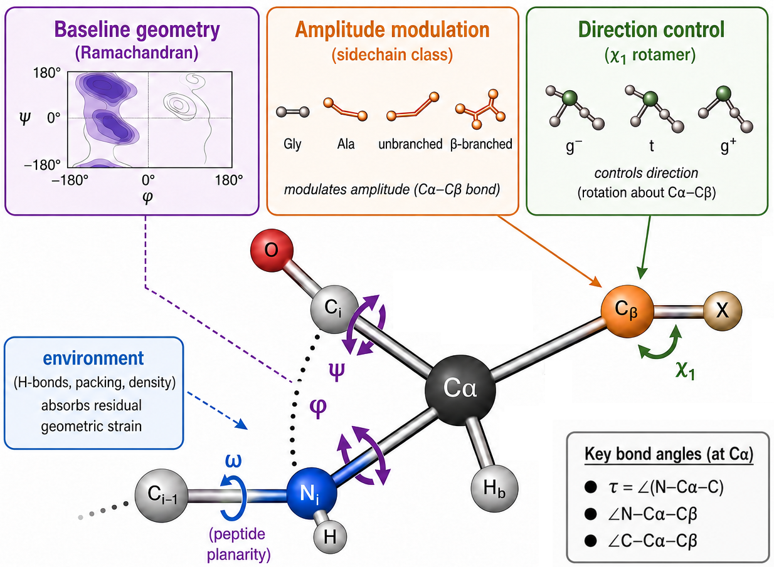
Figure 1 | Three geometric channels determine local backbone geometry at Cα. The backbone conformation (Ramachandran position) establishes the baseline geometry, residue identity modulates the magnitude of bond-angle changes, and χ₁ rotamer state determines their direction. Together these factors predict the local backbone bond angles at Cα, while remaining variation is absorbed by the surrounding molecular environment.

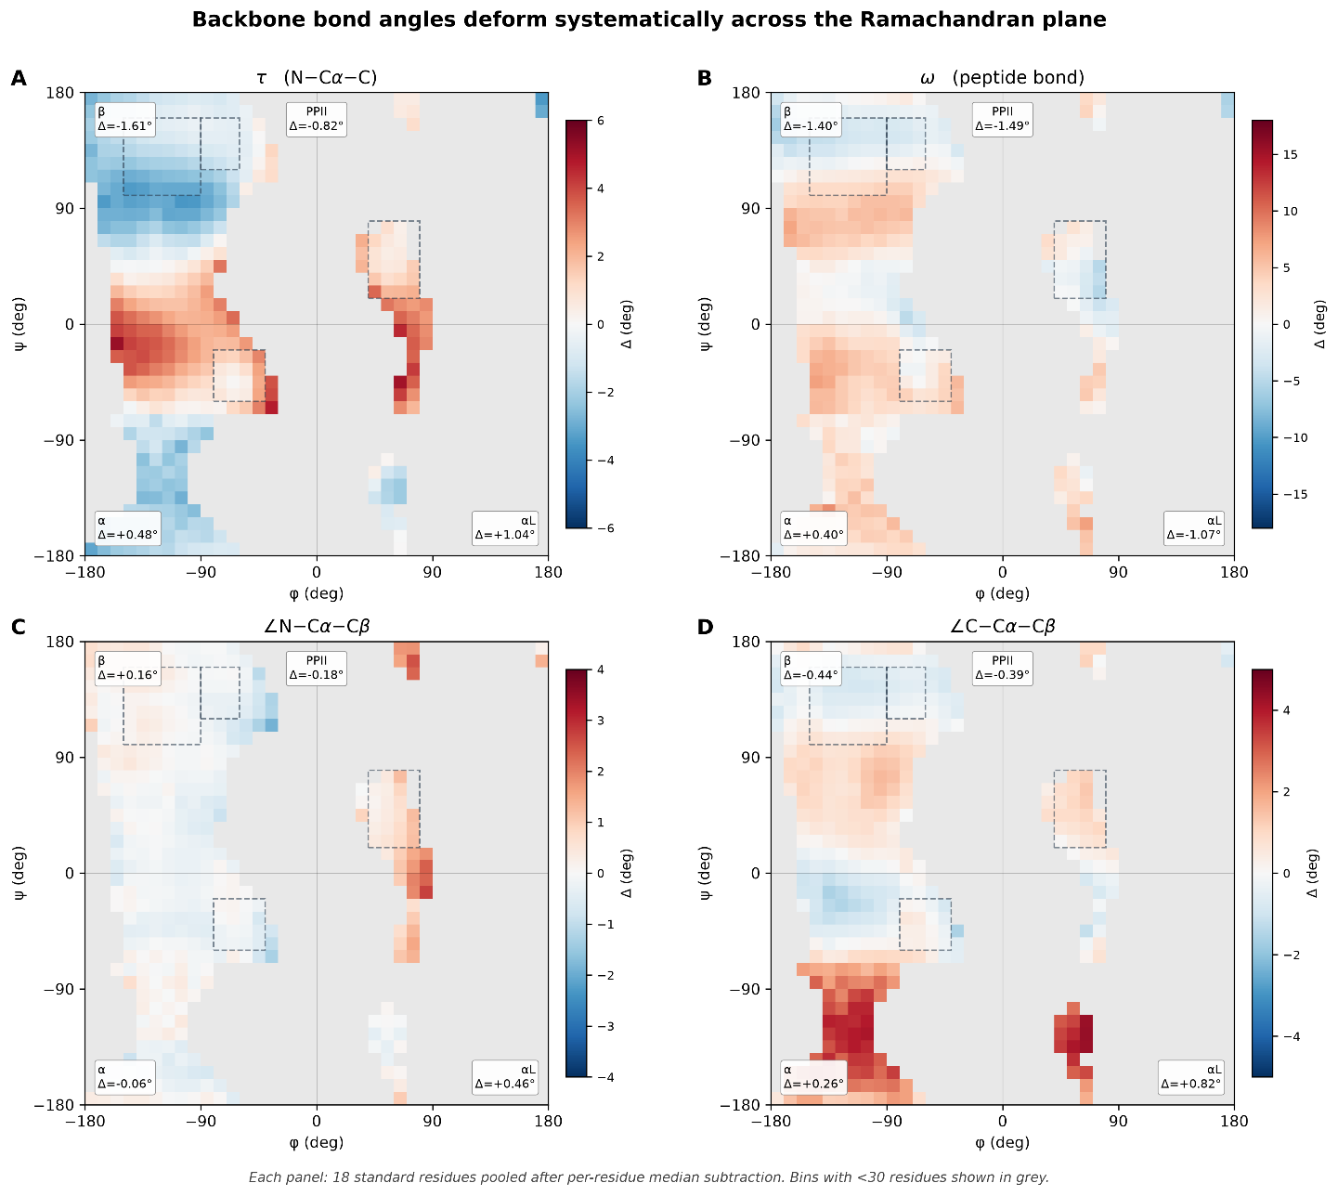
Fig. 2 | Backbone bond-angle deviations.
(Δ from ideal Engh–Huber geometry) mapped over the Ramachandran plane (φ, ψ) for 18 amino acids (low-occupancy bins masked; α, β, PPII, αₗ basins indicated). (A) τ varies strongly with ψ; (B) ω shows systematic non-planarity; (C) ∠N–Cα–Cβ is near-zero on average but bimodal; (D) ∠C–Cα–Cβ is complementary/antisymmetric to (C), consistent with tetrahedral constraints at Cα. Note: the variations in Cβ coupled angles (C, D) are primarily associated with sidechain properties, τ variation is primarily backbone-driven (ψ dominance) and reflects secondary conformational modulation (Section 3.3).
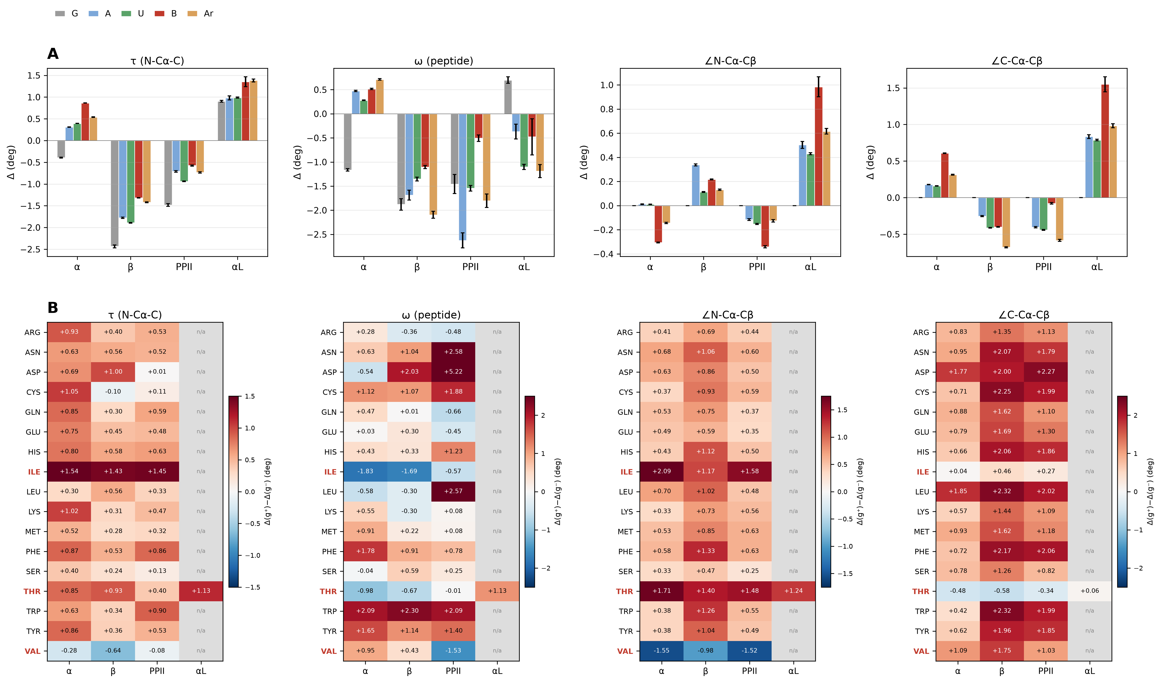Fig. 3 | Sidechain substitution and χ₁ rotamer state modulate Cα-centered angles.
(A) Backbone angle deformations stratified by sidechain class (G, A, unbranched, β-branched, aromatic) across Ramachandran basins show systematic amplification with sidechain complexity. β-branching produces the largest shifts (2–5× relative to unbranched) in τ and ∠C–Cα–Cβ, along with a sign inversion in ∠N–Cα–Cβ. Glycine exhibits distinct behavior, including a large negative τ shift in β, consistent with a backbone-only response, whereas alanine and unbranched residues define the baseline sidechain contribution. The shared structure across all four angles is consistent with common geometric coupling at Cα.
(B) Stratification by χ₁ rotamer (g⁻, trans, g⁺) shows that sidechain rotation systematically modulates backbone geometry, producing ~1° shifts within the same residue and basin. This effect is strongest in τ and the Cβ-coupled angles, consistent with coupling through Cβ, whereas ω shows weaker and less consistent coupling.
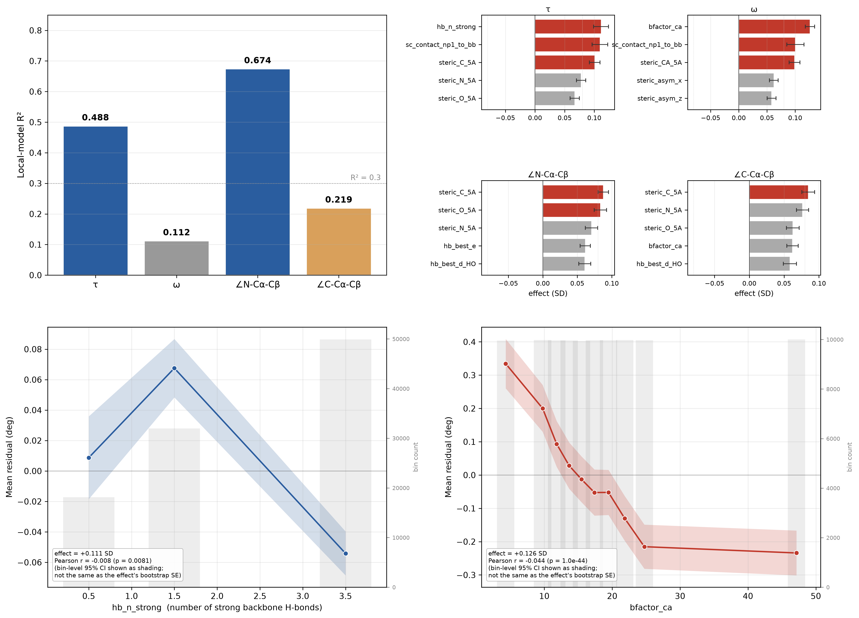Figure 4 | Non-local channel.
(A) Local-feature models capture most variance for ∠N–Cα–Cβ (R² = 0.674) and τ (R² = 0.488), but perform poorly for ω and ∠C–Cα–Cβ (R² = 0.112 and 0.219), leaving substantial unexplained structure. (B) Residual analysis reveals angle-specific environmental coupling, with τ showing modest but consistent H-bonding and steric effects, ω exhibiting non-local contributions comparable to its weak local signal, and Cβ angles lacking structured non-local dependence. (C) τ residuals vary nonlinearly with backbone H-bonding, producing a small but reproducible shift (~0.13°) that is undetectable by linear correlation but captured by quartile-based effect size. (D) ω deviations from ideal trans geometry decrease with local backbone mobility (bfactor_Cα), demonstrating that local structural rigidity and dynamic constraints strongly modulate peptide-bond planarity beyond local side-chain interactions.
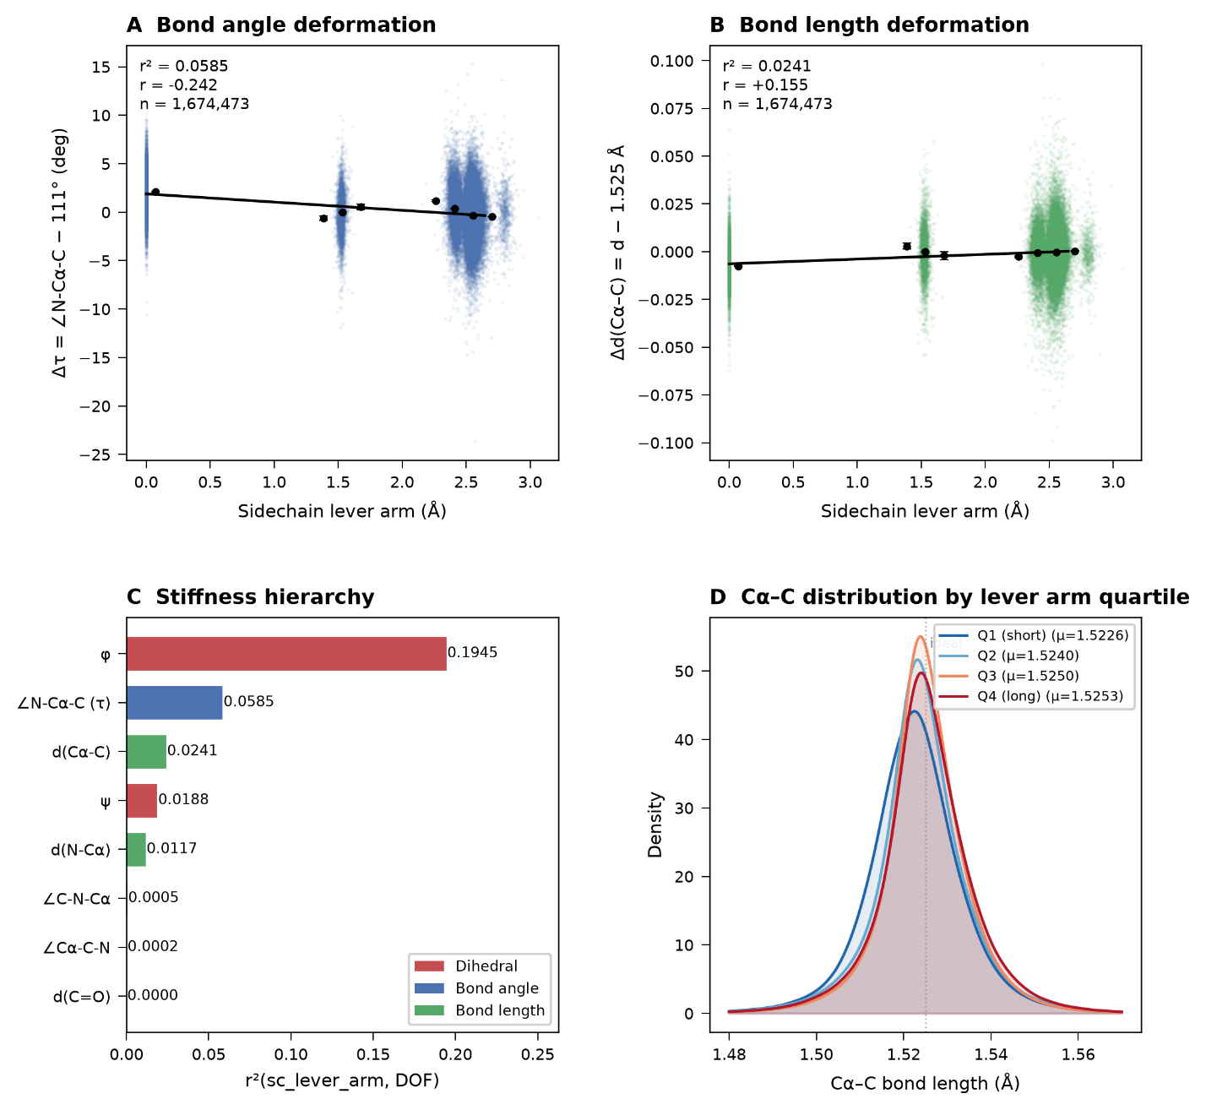

Figure 5 | Mechanical stiffness hierarchy of protein backbone.
Sidechain-induced strain is accommodated non-uniformly across backbone degrees of freedom. (A,B) Deformation of the bond angle τ (∠N–Cα–C) and bond length d(Cα–C) act as a function of sidechain lever arm (distance from Cα to the sidechain center of mass). (C) Variance (R²) reveals a mechanical hierarchy: the dihedral φ and valence angle τ show principal sinks for sidechain-induced strain, whereas bond lengths and bond angle ∠Cα–C–N remain largely invariant. (D) Cα–C bond-length distributions by lever-arm quartile. Higher loading shifts bonds longer, but the Q1–Q4 mean difference is only ~2.7 mÅ, indicating much greater stiffness in extension than bending.
4. Discussion
Protein backbone bond angles are better described as context-dependent equilibrium geometries than fixed ideal values. Rather than fluctuating randomly around canonical values, they vary systematically across nested structural scales. Backbone conformation establishes the primary geometric framework, side-chain substitution modifies it through the tetrahedral Cα center, χ₁ rotamer state fine-tunes it within residue classes, and the local environment provides angle-specific corrections (Fig. 1). Together, these layers show that backbone geometry is an emergent property of coupled structural constraints.
This hierarchy also explains how proteins accommodate conformational strain. Backbone conformation produces the largest shifts by defining the relative orientation of adjacent peptide units, side-chain identity adjusts this baseline through Cα substitution, χ₁ introduces finer within-residue variation, and environmental effects provide residual corrections. Backbone geometry reflects constraints operating across multiple structural scales.
The tetrahedral Cα atom is the geometric hub of this hierarchy. As the only atom linking backbone and side chain, deformation of one bond angle necessarily redistributes strain among the others. The coordinated behavior of τ, ∠N–Cα–Cβ, and ∠C–Cα–Cβ is consistent with a mechanically coupled tetrahedral network rather than independent angular fluctuations. Although observational, the near-universal coupling across residues, conformational basins, and rotamer states is consistent with geometric coupling through the tetrahedral Cα center.
This network separates into two mechanical regimes. The α and αₗ basins expand τ and ∠C–Cα–Cβ while contracting ∠N–Cα–Cβ, whereas the β and PPII basins show the opposite pattern. Rather than continuous variation around a single equilibrium, the major Ramachandran basins represent distinct geometric solutions for distributing strain around Cα.
The peptide bond appears to occupy a distinct regime. Unlike the Cα-centered angles, ω is only weakly determined by backbone conformation and side-chain identity but is strongly influenced by local packing and backbone rigidity (B-factor), consistent with numerous prior reports of ω non-planarity in proteins¹⁵ and, more specifically, environment-dependent peptide non-planarity arising from n→π* donation^{11–13} and N–H···N interactions¹⁴. Among the backbone angles, ω therefore appears the most environmentally responsive, rather than behaving as a rigid planar constraint.
These findings expose a limitation of current molecular mechanics force fields and crystallographic refinement protocols. Most bonded models describe each backbone angle with a single harmonic potential centered on one equilibrium value per atom type. Although effective as a mean-field approximation, this representation neglects systematic shifts associated with conformation, residue identity, rotamer state, and local environment. Our molecular mechanics validation further indicates that this information is not recovered by existing torsional or non-bonded terms: even after local relaxation, fixed equilibrium angles continue to oppose the basin-dependent deformations observed experimentally. The limitation therefore lies in assuming that equilibrium geometry is context independent.
By unifying conformation-dependent bond geometry, substituent effects, and peptide non-planarity within a single framework, this work provides a unified view of backbone mechanics. Rather than independent phenomena, conformation, side-chain substitution, rotamer state, and environmental interactions emerge as nested determinants acting through the same tetrahedral Cα center. This extends the mechanical interpretation of Ramachandran space from torsional energetics to complete covalent backbone geometry.
Context-dependent equilibrium geometry also provides a simple physical explanation for structural compliance. Small bond-angle adjustments redistribute strain among steric, electrostatic, hydrogen-bonding, and packing interactions while preserving bond lengths. Accordingly, bond angles accommodate most structural deformation, whereas covalent bond lengths remain comparatively invariant.
These results have broad implications for structural modeling. Any framework assuming fixed local geometry—including crystallographic refinement, molecular mechanics force fields, protein design energy functions, and deep-learning geometric priors—necessarily discards systematic structural information. Although individual deviations are modest (1–3°), they accumulate across protein chains and may influence energetic accuracy, structural refinement, and structure prediction. Incorporating context-dependent equilibrium geometry should therefore improve physically realistic models of protein structure.
Several limitations remain. Our analyses are observational and do not establish the underlying quantum mechanical mechanisms. Although molecular mechanics relaxation argues against refinement artifacts, explicit density functional theory calculations were not performed. In addition, the analysis is limited to high-resolution X-ray structures and excludes cryo-EM models and most intrinsically disordered regions. Future studies combining quantum chemistry, molecular dynamics, and experimental structural ensembles should clarify how this statistical hierarchy arises from the underlying energy landscape.
Acknowledgments This research received no specific grant from funding agencies in the public, commercial, or not-for-profit sectors. The authors thank the Louisiana State University Health Sciences Center Shreveport (LSUHS) for logistical support.

Data Availability
The Python scripts and analysis framework are available at: https://github.com/wei09128/protein-backbone-mechanics
Supporting Information
Basin-resolved sidechain and χ₁-rotamer effect sizes for τ (Table S1); molecular-mechanics-relaxed vs. crystallographic residuals by observable (Table S2); force-field cross-validation agreement across 36 basin/observable combinations (Table S4) (PDF).

References
(1) Ramachandran, G. N.; Ramakrishnan, C.; Sasisekharan, V. Stereochemistry of Polypeptide Chain Configurations. J. Mol. Biol. 1963, 7 (1), 95–99. https://doi.org/10.1016/S0022-2836(63)80023-6
(2) Chen, W. Protein Backbone Mechanics I: The Ramachandran Plot as a Mechanical Force Field. Manuscript submitted to ACS Omega, 2026.
(3) Carey, J.; Benoff, B.; Harish, B.; Yuan, L.; Lawson, C. L. Environment-Dependent Long-Range Structural Distortion in a Temperature-Sensitive Point Mutant. Protein Sci. 2012, 21 (1), 63–74. https://doi.org/10.1002/pro.759
(4) Towse, C.-L.; Vymetal, J.; Vondrasek, J.; Daggett, V. Insights into Unfolded Proteins from the Intrinsic φ/ψ Propensities of the AAXAA Host–Guest Series. Biophys. J. 2016, 110 (2), 348–361. https://doi.org/10.1016/j.bpj.2015.12.008
(5) Engh, R. A.; Huber, R. Accurate Bond and Angle Parameters for X-ray Protein Structure Refinement. Acta Crystallogr., Sect. A: Found. Crystallogr. 1991, 47 (4), 392–400. https://doi.org/10.1107/S0108767391001071
(6) Maier, J. A.; Martinez, C.; Kasavajhala, K.; Wickstrom, L.; Hauser, K. E.; Simmerling, C. ff14SB: Improving the Accuracy of Protein Side Chain and Backbone Parameters from ff99SB. J. Chem. Theory Comput. 2015, 11 (8), 3696–3713. https://doi.org/10.1021/acs.jctc.5b00255
(7) Tian, C.; Kasavajhala, K.; Belfon, K. A. A.; Raguette, L.; Huang, H.; Migues, A. N.; Bickel, J.; Wang, Y.; Pincay, J.; Wu, Q.; Simmerling, C. ff19SB: Amino-Acid-Specific Protein Backbone Parameters Trained Against Quantum Mechanics Energy Surfaces in Solution. J. Chem. Theory Comput. 2020, 16 (1), 528–552. https://doi.org/10.1021/acs.jctc.9b00591

(8) Allen, F. H. The Geometry of Small Rings. I. Substituent-Induced Bond-Length Asymmetry in Cyclopropane. Acta Crystallogr., Sect. B: Struct. Sci. 1980, 36 (1), 81–96. https://doi.org/10.1107/S0567740880002711

(9) Allen, F. H.; Kennard, O.; Taylor, R. Systematic Analysis of Structural Data as a Research Technique in Organic Chemistry. Acc. Chem. Res. 1983, 16 (5), 146–153. https://doi.org/10.1021/ar00089a001

(10) Bürgi, H.-B.; Dunitz, J. D., Eds. Structure Correlation, Vols. 1–2; VCH: Weinheim, 1994.

(11) Choudhary, A.; Raines, R. T. Signature of n→π* Interactions in α-Helices. Protein Sci. 2011, 20 (6), 1077–1081. https://doi.org/10.1002/pro.627

(12) Esposito, L.; Vitagliano, L.; Zagari, A.; Mazzarella, L. Pyramidalization of Backbone Carbonyl Carbon Atoms in Proteins. Protein Sci. 2000, 9 (10), 2038–2042. https://doi.org/10.1110/ps.9.10.2038

(13) Newberry, R. W.; VanVeller, B.; Guzei, I. A.; Raines, R. T. n→π* Interactions of Amides and Thioamides: Implications for Protein Stability. J. Am. Chem. Soc. 2013, 135 (21), 7843–7846. https://doi.org/10.1021/ja4033583

(14) Daniecki, N. J.; Yap, G. P. A.; Zondlo, N. J. Amide Nitrogen Pyramidalization via N–H•••N Interactions That Stabilize the δ/α Conformations in Turns, Loops, and 3(10)- and α-Helices. ACS Chem. Biol. 2025, 20 (11), 2617–2629. https://doi.org/10.1021/acschembio.5c00451
(15) MacArthur, M. W.; Thornton, J. M. Deviations from Planarity of the Peptide Bond in Peptides and Proteins. J. Mol. Biol. 1996, 264 (5), 1180–1195. https://doi.org/10.1006/jmbi.1996.0705

