Protein Backbone Mechanics III: Geometric Coupling and Bonded Strain

Wei Chen, Xiaohong Lu
Louisiana State University Health Sciences Center, Shreveport
Corresponding Author: Wei Chen (wei09128@gmail.com)

Abstract
Classical molecular mechanics force fields treat backbone bond lengths, bond angles, and peptide-bond planarity as fixed, conformation-independent equilibrium values. Analyzing 1.7 million residues from crystal structures, we show this assumption fails systematically: backbone geometry exhibits significant non-additive φ×ψ coupling, strongest in coil regions and for sidechain-linked angles, with a magnitude comparable to a hydrogen bond at conformational basin boundaries. This coupling is not explained by proposed quantum-mechanical effects (n→π*, hyperconjugation), which are geometrically redundant with it. We provide correction lookup tables enabling conformation-dependent bonded-geometry refinements in existing force fields.

Keywords: protein backbone geometry, force field parameterization, geometric coupling, Ramachandran, generalized additive model
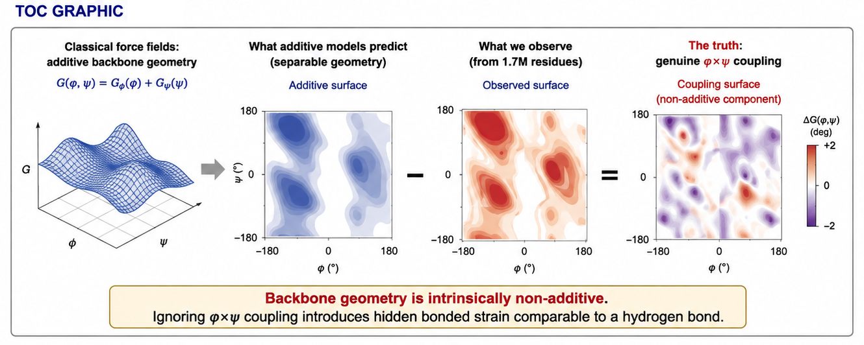

1. Introduction
The Ramachandran plot remains the cornerstone of protein structural analysis¹, yet classical force field parameterizations traditionally model backbone dihedrals using separable 1D Fourier terms ($V_{ϕ}\text{+}V_{ψ}$) alongside fixed baseline equilibrium geometries². Grid-based corrections such as CMAP³ were introduced decades ago for precisely this reason. Conformation-dependent backbone geometry is likewise: Berkholz et al. showed that bond lengths and angles vary systematically with (φ,ψ)⁴, consistent with earlier quantum-mechanical calculations⁵ and with Karplus's discussion of conformation-dependent “hidden strain”⁶; Tronrud and Karplus subsequently provided a full two-dimensional (φ,ψ) representation of this dependence⁷. What has not previously been reported, to our knowledge, is a large-scale quantification of this geometric coupling using formal variance-decomposition methods with calibrated uncertainty, its residue- and secondary-structure-specific structure, and its relationship to sidechain rotamer state and candidate electronic effects.
In companion studies, we showed that the Ramachandran landscape defines an effective mechanical force field with two orthogonal steric discontinuities at φ ≈ −60° and ψ ≈ −40°⁸, while local backbone geometry varies systematically with backbone conformation and residue identity⁹, with the bond angle τ (N–Cα–C) spanning 8.4° across the Ramachandran plane.
Here, analyzing 1,698,562 residues from 8,292 structures, we decompose bond angles, bond lengths, peptide planarity, and sidechain-coupled geometry into additive and interaction terms. We employ generalized additive models (GAMs)^{10,11} with smooth spline bases to obtain properly calibrated coupling estimates with confidence intervals, avoiding the non-orthogonality artifacts inherent in unbalanced factorial designs. We find pervasive, residue-specific nonseparability in backbone bonded geometry that classical fixed-equilibrium models miss and show that candidate quantum-mechanical corrections add negligible information beyond the geometric coupling surface (Figure 1). This study of conformation-dependent geometry does not, on its own, test the separability of the classical torsional energy term.

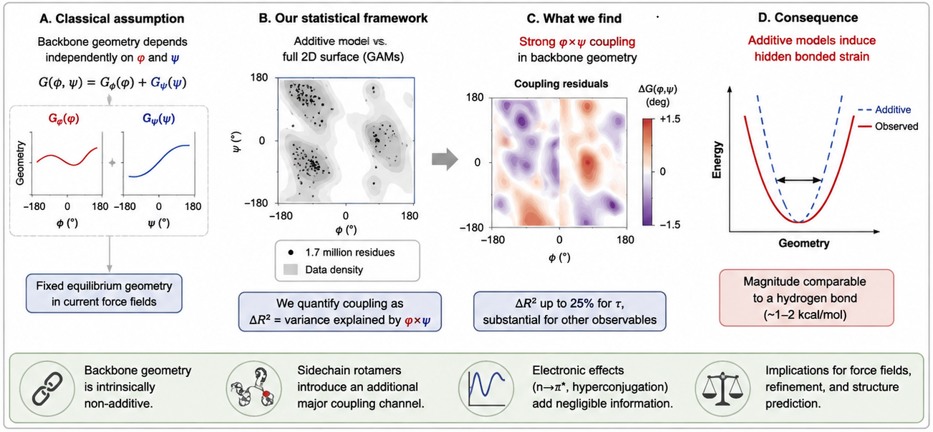
2. Methods

2.1 Dataset
Backbone geometry was extracted from a non-redundant set of protein chains obtained via the PISCES server (≤25% sequence identity, resolution ≤2.0 Å, R-factor ≤0.25, length ≥40 residues), yielding 8,292 structures downloaded in batch from the RCSB PDB, using backbone bond lengths, angles, and torsion angles computed directly from atomic coordinates, with alternate-location atoms resolved to the highest-occupancy conformer and hydrogen atoms excluded from all geometric calculations. Quality filtering retained 1,698,562 residues with standard amino acids only, B-factor < 30 Å², complete backbone atoms, defined φ and ψ, and at least 3 residues from any chain break (chain breaks identified geometrically, as any residue-index-adjacent C–N distance exceeding 2.0 Å), with 91 residues across 43 structures further excluded as confirmed crystallographic modeling defects⁸.

2.2 GAM Decomposition
For each backbone observable y, we fitted two models using pyGAM¹² with 15-knot cubic spline bases:
Model A (additive): y = s(φ, 15) + s(ψ, 15)
Model B (full): y = te(φ, ψ, 15×15)
where s() denotes a univariate penalized spline and te() a tensor-product spline. The coupling is ΔR² = R²_B − R²_A. Models were fitted on 50,000-residue random subsamples; 20 bootstrap iterations provided 95% percentile confidence intervals. The tensor-product smooth te() represents the combined additive and interaction components; conceptually, it can be decomposed into s(φ)+s(ψ)+ti(φ,ψ), where ti() denotes the pure interaction.

2.3 Cell-Means ANOVA
The Ramachandran plane was gridded into 10° × 10° bins (cells with < 5 observations excluded). R²_full was computed from cell-mean predictions; R²_additive from the sum of φ-marginal and ψ-marginal means minus the grand mean. Coupling maps (Δfφψ) were computed as cell mean minus additive prediction.

2.4 Three-Way Decomposition
For residues with defined χ¹ (excluding Gly and Ala; n = 1,488,353), we encoded φ, ψ as dummy variables (20° bins) and χ¹ as three rotamer classes (gauche+, trans, gauche−). R² was computed from linear models with all factors additive, then adding φ×ψ interactions, then all two-way interactions.

2.5 Quantum-Mechanical Geometry
n→π* geometry (Oᵢ···Cᵢ₊₁ distance, Bürgi–Dunitz angle) and hyperconjugation overlap (cos² of Cγ–Cβ–Cα–N dihedrals) were extracted from PDB coordinates. Predictive power was assessed via gradient boosting regressors with 5-fold cross-validation, comparing a baseline model to one with n→π* features added. We report two baselines: a coarse one (conformational basin plus residue type, following the original analysis) and a stricter one (the full (φ,ψ) 10° grid plus residue type, consistent with the binning used elsewhere in this paper). The coarse basin classification used only three categories (αR, β, αL) without a separate PPII class, which we found inflated the apparent incremental value of n→π* (ΔR² = 0.012) relative to the stricter grid baseline (ΔR² = 0.006); we report the latter, more conservative estimate as the primary result. The n→π* geometric descriptors used here (contact distance, Bürgi–Dunitz angle, donor angle, and pyramidalization) do not include, and this analysis does not report, an estimated interaction energy: no published empirical formula converts this geometry into a kcal/mol value, and published n→π* energies (Bartlett et al., Newberry & Raines) are derived exclusively from natural bond orbital (NBO) calculations on specific model systems, an electronic-structure quantity not obtainable from crystallographic geometry alone. Because this analysis addresses incremental predictive value rather than variance decomposition, ΔR² values are not directly comparable with those reported for the GAM analyses.
2.6 Energy Estimation
Coupling magnitudes in degrees were converted to energies using E = ½ k (Δθ)² with AMBER ff14SB spring constants: kτ = 63 kcal/mol/rad². Force constants for all bond lengths and angles were taken from the AMBER ff14SB parameter set. Angular deviations were converted to radians prior to energy calculation.

3. Results

3.1 Systematic Failure of Additive Geometric Separability
We first asked whether backbone bonded geometry can be represented as the sum of independent φ- and ψ-dependent contributions. Seven backbone observables were decomposed using two complementary approaches: penalized generalized additive models (GAMs) comparing additive marginals with a full tensor-product surface, and a cell-means ANOVA on the complete dataset. Coupling was quantified as ΔR², the variance uniquely explained by the φ×ψ interaction beyond additive effects.
Every observable exhibited statistically significant coupling (Figure 3; full variance decomposition in Figure 2). The largest effects occurred for the backbone angle τ, the sidechain-anchored angle ∠N–Cα–Cβ, and peptide planarity (ω), whereas bond lengths showed smaller but reproducible interactions. For τ, the interaction contributes only a modest increase in explained variance, yet the associated geometric deviations correspond to harmonic bonded strain energies approaching those of a hydrogen bond.
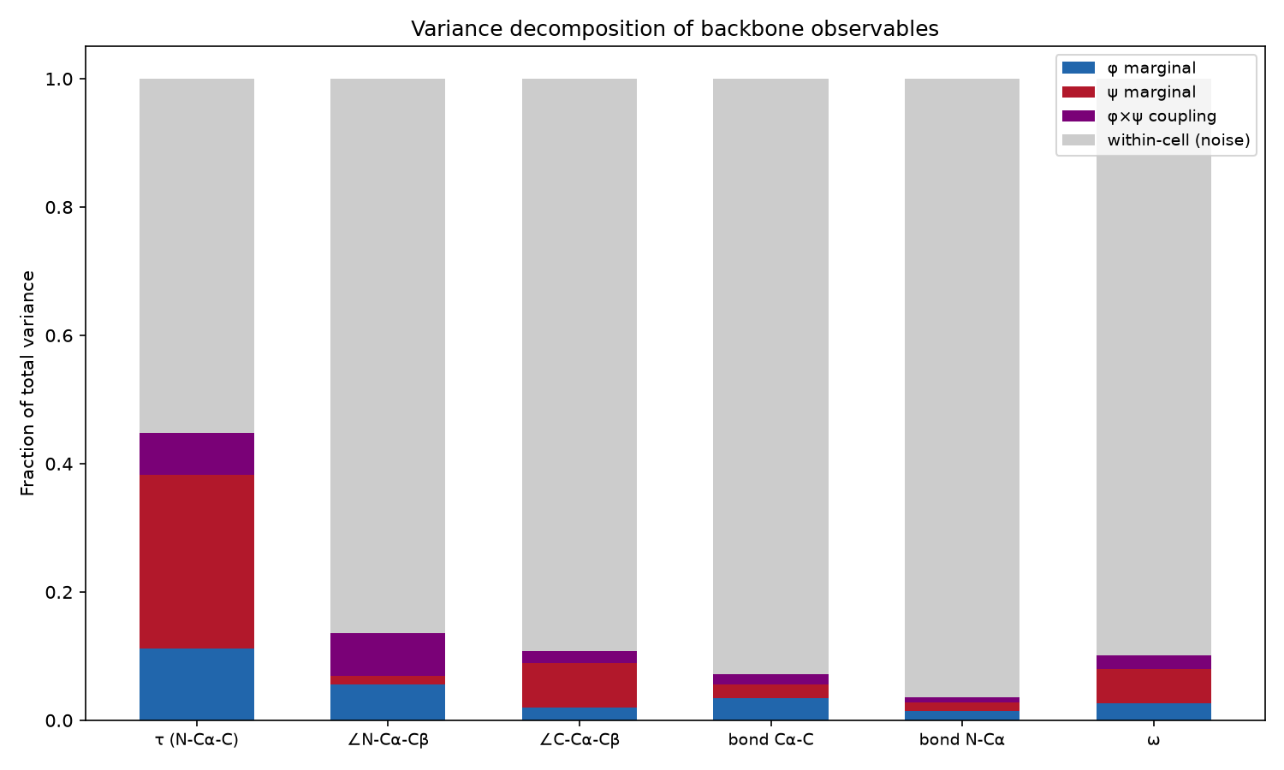
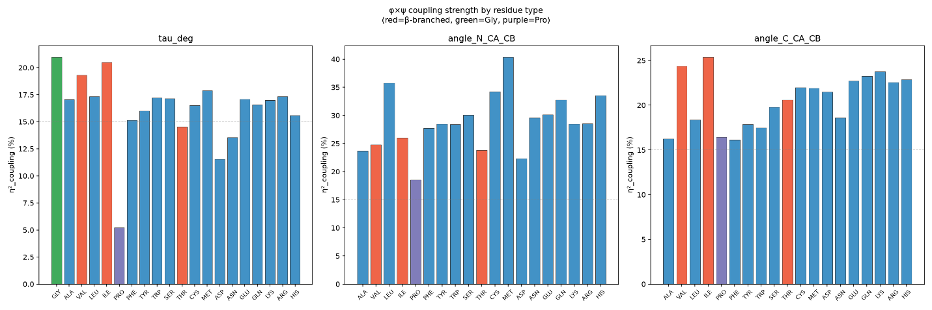
Figure 2 | Variance decomposition and residue-specific coupling of backbone geometry.
(A) Total variance for seven backbone observables partitioned into φ (blue) and ψ (red) marginal contributions, φ×ψ interaction (purple), and within-cell variance (gray). (B) Coupling strength (η²_coupling) across the 20 amino acids, showing higher values for glycine and lower values for proline.
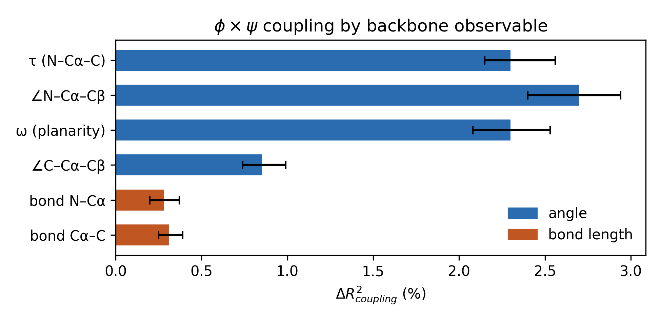
Figure 3 | ΔR²_coupling by backbone observable, with 95% bootstrap confidence intervals (full values in Table S1).
Importantly, the interaction is not randomly distributed across conformational space. The τ coupling residual forms a coherent surface over the Ramachandran plane rather than scattered local deviations (Figure 4). Coupling is weakest within the αR basin core (⟨|Δτ|⟩ = 0.44°), whereas the largest amplitudes occur near basin boundaries (ψ ≈ −40° wall: 1.94°; φ ≈ −60° wall: 1.42°). The coupling changes sign between the αR and β basins (−0.44° versus +0.84°), indicating that the αR basin occupies a nodal region where positive and negative interaction components cancel rather than a region devoid of coupling (secondary-structure and residue-class breakdown in Figure 5).
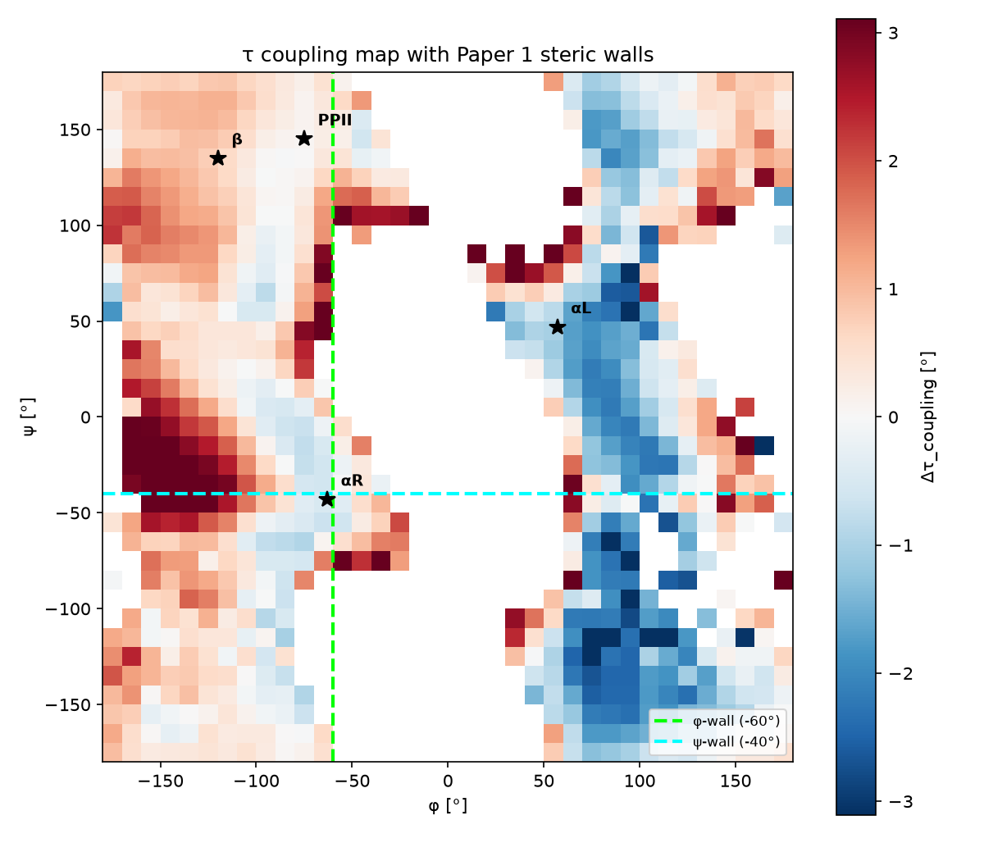

Figure 4. Coupling map of τ on the Ramachandran plane. Colour indicates Δτ_coupling in degrees (red positive, blue negative). Dashed lines mark steric discontinuities⁸, which lie near, but do not exactly coincide with, the principal transition zones of the coupling surface. The αR core sits near a coupling node; basin boundaries show the strongest coupling. Note the pronounced negative band around φ ≈ +60°–+110°, outside the canonical αR/β region.
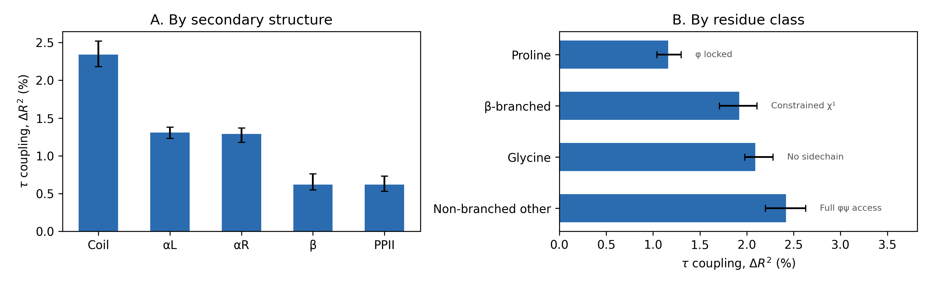
Figure 5 | τ coupling by secondary structure (A) and residue class (B), with 95% bootstrap confidence intervals (full values in Tables S2–S3).
The steric walls represent transition regions rather than infinitely thin boundaries⁸. Consistent with this interpretation, the coupling residual exhibits broad sign-change zones rather than abrupt flips at φ = −60° or ψ = −40° (Figure 4), indicating that the steric walls lie near—but do not exactly coincide with—the principal transitions of the coupling surface. A second feature of the map is a pronounced band of negative coupling spanning φ ≈ +60° to +110°, well outside the canonical αR/β region, suggesting that the coupling surface extends into left-handed and bridge conformations. Whether this pattern reflects a distinct transmission mechanism or reduced sampling in these sparsely populated regions remains unresolved.
This organization is consistent with the mechanical framework proposed previously⁸, although the relationship is more nuanced than a simple coincidence of boundaries. We tested both global sign changes (comparing mean coupling across each half-plane separated by the reported walls) and local sign changes within a ±20° band adjacent to each wall (Table S6). The results are mixed rather than uniformly supporting or refuting the proposed boundaries. For τ and ω, both tests were significant at the φ wall, whereas for ω at the ψ wall the local and global tests differed in sign, indicating that the immediate vicinity of the wall behaves differently from the broader surrounding region. For ∠N–Cα–Cβ, the local test detected a significant effect at the φ wall (p = 3.3 × 10⁻³) that was absent globally (p = 0.62), suggesting that averaging across the entire half-plane obscures a localized transition. Conversely, for the bond lengths, significant global differences disappeared in the local analysis, indicating broad regional shifts rather than discontinuities at the wall itself. Together, these results indicate that the proposed steric walls are not universal coupling boundaries, but instead show observable-dependent local significance, particularly for τ and ω.

3.2 Sidechain Modulation Introduces a Second Coupling Channel
Having established the backbone φ×ψ coupling architecture, we next asked whether sidechain conformation contributes an additional interaction channel. Expanding the decomposition to include χ₁ revealed a clear mechanistic division (Table 1). For the sidechain-anchored angle ∠N–Cα–Cβ, χ₁ coupling exceeded the φ×ψ contribution, indicating that local rotamer state is the dominant determinant of its geometry. In contrast, χ₁ contributed negligibly to τ, for which backbone φ×ψ coupling remained the principal source of non-additivity.
Table 1. Three-way decomposition (φ, ψ, χ¹). Δ(φψ) = R² gain from φ×ψ interactions; Δ(χ¹×) = additional gain from χ¹ interactions.
Observable | R²_add | +φψ | +all 2-way | Δ(φψ) | Δ(χ¹×)
τ (N–Cα–C) | 40.3% | 42.6% | 42.9% | +2.3% | +0.3%
∠N–Cα–Cβ | 11.0% | 13.9% | 18.3% | +2.8% | +4.5%
∠C–Cα–Cβ | 11.1% | 11.9% | 13.6% | +0.8% | +1.7%
ω | 7.4% | 9.2% | 9.4% | +1.8% | +0.1%
bond Cα–C | 6.2% | 6.3% | 6.4% | +0.1% | +0.1%
These results reveal two distinct coupling architectures. Backbone-intrinsic observables are governed primarily by backbone conformation alone, whereas sidechain-linked observables require both backbone and rotamer state for accurate description. Thus, χ₁ does not simply strengthen the existing backbone interaction but introduces an independent coupling channel specific to sidechain-associated geometry.

3.3 Geometric Redundancy of Electronic Effects
To test whether the observed coupling simply reflects previously proposed electronic effects rather than an independent geometric phenomenon, we evaluated two leading quantum-mechanical interactions—n→π* orbital overlap and σ→σ* hyperconjugation^{13,14}. The n→π* interaction exhibited the expected φ–ψ dependence, with the αR basin showing the shortest O···C distances (3.17 Å; mean multi-criterion geometry score 1.39/4, combining contact distance, Bürgi–Dunitz angle, donor angle, and pyramidalization) and the β region the longest (3.54 Å; score 0.73/4). We emphasize that these geometric criteria indicate consistency with an n→π* interaction, not confirmation of orbital overlap, which requires electronic-structure methods (NBO, QTAIM) applied to specific structures rather than statistics over a crystallographic database; no published formula converts this geometry into an interaction energy, and we report none. This analysis instead serves as a test of whether the geometric signature commonly associated with n→π* could account for the φ×ψ coupling: incorporating explicit n→π* descriptors into a model already accounting for conformational basin and residue type produced only a negligible improvement in τ prediction (ΔR² = 0.006 using a strict (φ,ψ)-grid baseline; a coarser basin-only baseline gave an inflated ΔR² = 0.012, see Methods 4.5), arguing against an n→π*-based alternative explanation for the coupling (Figure 6). Hyperconjugative descriptors contributed even less (all ΔR² < 0.004; Figure 6), including in β-branched residues (Table 1).
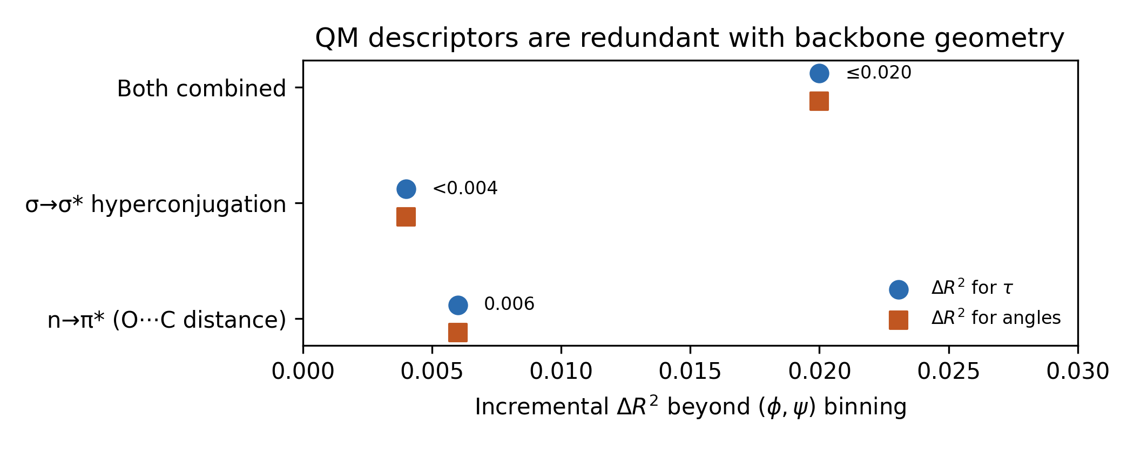
Figure 6 | Quantum-mechanical descriptors (n→π*, σ→σ* hyperconjugation) do not improve backbone geometry prediction beyond (φ,ψ) binning (full values in Table S4).
These findings indicate that although both electronic interactions are physically real, their geometric consequences are already encoded in the φ–ψ dependence of backbone structure. Because both interactions are determined by backbone and side-chain dihedral geometry, models based on φ and ψ implicitly capture most of their predictive information. Explicit quantum-mechanical descriptors therefore provide little additional explanatory power beyond the empirical geometric coupling model.

3.4 Energetic Significance and Robustness
Estimating the energetic consequences of the observed geometric deviations using the harmonic bonded terms of AMBER ff14SB indicates peak-to-peak deformation energies of 1.59 kcal/mol for τ and 0.70 kcal/mol for ∠N–Cα–Cβ, placing the associated bonded strain on the order of typical hydrogen-bond energies near conformational basin boundaries. Sensitivity analyses confirmed the robustness of the coupling estimates: τ coupling remained stable across B-factor strata (16.2% for B < 10 Å² versus 14.5% for B = 25–30 Å²), and increasing the size of the i+1 neighboring atom altered the estimated coupling only modestly (13.8% to 16.7%).
We next evaluated whether the observed coupling could instead reflect crystallographic resolution or refinement artifacts. This concern arises because the Berkholz conformation-dependent library (CDL), which introduces φ–ψ-dependent stereochemical restraints during refinement, has been implemented in PHENIX and TNT.¹⁵˒¹⁶ If such restraints were the primary source of the observed geometry, structures refined using these programs would be expected to exhibit systematically different coupling estimates. We therefore repeated the analysis after stratifying the dataset by resolution (≤1.5 Å, n = 787,959 residues; 1.5–2.0 Å, n = 910,231 residues) and by refinement software (REFMAC, n = 792,750 residues; PHENIX, n = 651,552 residues). Coupling estimates (η²) for τ, ω, and both backbone bond lengths remained stable to within only a few percentage points across all strata (Table S5). The only observable exhibiting a measurable difference, ∠N–Cα–Cβ (45.1% at ultrahigh resolution versus 51.9% at standard resolution; 53.6% for REFMAC versus 43.5% for PHENIX), varied in the opposite direction to that predicted by a CDL-restraint artifact: if conformation-dependent refinement restraints were the dominant source of the observed coupling, the PHENIX subset would be expected to exhibit stronger, rather than weaker, coupling. Together, these analyses argue against crystallographic resolution or CDL-based refinement restraints being the primary drivers of the observed backbone coupling.

4. Discussion
The present study demonstrates that protein backbone geometry is not completely separable into independent φ- and ψ-dependent components. Across seven backbone observables, statistically significant φ×ψ interactions form smooth, reproducible surfaces over Ramachandran space rather than isolated local deviations. Although the interaction explains only a modest fraction of geometric variance for most observables, the associated bonded deformation energies reach approximately 1.6 kcal mol⁻¹ for τ, indicating that apparently small geometric departures from additivity can nevertheless have mechanically meaningful consequences.
It is important to distinguish the quantity measured here from the torsional potentials used in classical molecular mechanics force fields. The coupling maps derived in this work characterize conformation-dependent equilibrium geometry within the bonded (bond-length and bond-angle) terms, with energetic consequences estimated using the corresponding AMBER harmonic spring constants. They do not represent the torsional energy surface itself, nor do they imply that existing torsional potentials require explicit φ×ψ interaction terms. Instead, these empirical coupling surfaces provide conformation-dependent bonded-geometry corrections that are complementary to the geometry library developed in our companion study.
This distinction also clarifies the relationship to CHARMM's CMAP correction. CMAP introduces a φ–ψ-dependent correction to the torsional component of the potential energy function based on quantum-mechanical calculations of model peptides, whereas the present work quantifies conformation-dependent equilibrium bond geometry directly from experimental protein structures. These approaches therefore address different physical components of the molecular mechanics potential rather than alternative descriptions of the same phenomenon. The observation that both bonded geometry and torsional energetics exhibit substantial φ–ψ dependence suggests that conformation dependence is a general feature of protein backbone mechanics expressed through multiple components of the force field.
A related question is how this work differs from the conformation-dependent library (CDL) of Berkholz and colleagues, which similarly bins backbone bond lengths and angles by (φ,ψ) to obtain local, conformation-specific equilibrium values. The two efforts share the same starting observation — that bonded geometry depends on backbone conformation — but differ in what they establish beyond it. CDL provides local conditional means as a practical refinement restraint; it does not decompose how much of that conformation-dependence is uniquely attributable to the φ×ψ interaction specifically, as opposed to φ and ψ acting independently, nor does it quantify this with calibrated uncertainty. The present work adds that formal decomposition, extends it to an independent sidechain-rotamer coupling channel not addressed by CDL, tests and rules out candidate electronic-structure explanations (n→π*, hyperconjugation) for the observed coupling, and directly tests — rather than assumes — whether the coupling is an artifact of CDL-based refinement restraints now built into common crystallographic refinement software. We view this work as complementary to, rather than a replacement for, CDL: it provides statistical characterization and mechanistic context for a conformation-dependence that CDL was built to correct in practice.
The analyses further indicate that previously proposed electronic mechanisms are not required as independent descriptors for predicting backbone geometry. Although both n→π* interactions and σ→σ* hyperconjugation exhibit the expected conformational dependence, explicitly incorporating these descriptors provides little additional predictive information once φ, ψ, conformational basin, and residue identity are taken into account. Their structural consequences therefore appear to be largely encoded within the empirical geometric coupling surface itself, providing a more parsimonious description of local backbone geometry.
An important outcome of this work is that the observed coupling is highly organized rather than stochastic. The interaction surface exhibits reproducible nodal structure, consistent basin-dependent sign changes, and systematic residue-class effects that remain stable across crystallographic resolution, B-factor, neighboring atom identity, and refinement software. Moreover, the absence of enhanced coupling in PHENIX-refined structures argues against conformation-dependent refinement restraints being the primary source of the observed patterns. Together, these observations support the interpretation that the coupling reflects an intrinsic geometric property of protein backbones rather than an artifact of crystallographic refinement or dataset composition.
More broadly, these findings provide an empirical framework for describing conformation-dependent bonded geometry independently of torsional energetics. Rather than replacing existing force-field corrections such as CMAP, the present coupling surfaces complement them by characterizing a distinct component of backbone mechanics. Incorporating experimentally derived conformation-dependent equilibrium geometry into molecular mechanics models therefore represents a promising avenue for improving structural realism while remaining fully compatible with existing energetic formalisms.

Limitations
Several limitations should be considered when interpreting these results. First, the analysis is based on crystallographic structures, which represent refined, ensemble-averaged conformations and may not fully capture solution-phase backbone geometry. Second, the conversion of geometric deviations into energetic values uses harmonic bonded force constants from AMBER ff14SB and should therefore be interpreted as an approximate estimate of bonded deformation energy rather than a direct measurement of total conformational energy. Third, although coupling remained stable after stratification by crystallographic resolution and refinement software, and the observed software dependence was inconsistent with a simple conformation-dependent library (CDL) refinement artifact, the specific restraint settings used during refinement are not recoverable for every deposited structure. Consequently, refinement-related influences cannot be excluded completely. Finally, the present analysis is empirical and characterizes geometric coupling rather than the underlying physical mechanisms responsible for it. Establishing the microscopic origins of these interactions will require complementary quantum-mechanical calculations and molecular dynamics simulations.

Conclusions
The assumption of fixed, conformation-independent equilibrium bond geometry used by conventional bonded terms fails for every backbone geometric observable tested. The GAM-based coupling term adds ΔR² = 0.3–2.7% of total variance beyond the additive model, is strongest in loop regions (ΔR² = 2.3%), and reaches energies of 1.6 kcal/mol at basin boundaries. The χ¹ rotamer state provides a second, independent coupling channel for sidechain-linked angles. Quantum-mechanical corrections (n→π*, hyperconjugation) are geometrically redundant with the coupling surface. The supplementary coupling maps provide a practical framework for implementing conformation-dependent bonded-geometry corrections within existing molecular mechanics force fields.

Data Availability
The Python scripts and analysis framework are available at: https://github.com/wei09128/protein-backbone-mechanics

Supporting Information
Supplementary methods, robustness analyses, and full numerical tables underlying Figures 2, 5, and 6, including resolution- and refinement-software-stratified coupling estimates, local versus global wall sign-change tests, and the k(eff, φ) correlation analysis.

Conflict of Interest
The authors declare no competing financial interest.

Acknowledgments
This research received no specific grant from funding agencies in the public, commercial, or not-for-profit sectors. The authors thank the Louisiana State University Health Sciences Center Shreveport (LSUHS) for logistical support.

References
(1) Ramachandran, G. N.; Ramakrishnan, C.; Sasisekharan, V. Stereochemistry of Polypeptide Chain Configurations. J. Mol. Biol. 1963, 7 (1), 95–109. https://doi.org/10.1016/S0022-2836(63)80023-6
(2) Maier, J. A.; Martinez, C.; Kasavajhala, K.; Wickstrom, L.; Hauser, K. E.; Simmerling, C. ff14SB: Improving the Accuracy of Protein Side Chain and Backbone Parameters from ff99SB. J. Chem. Theory Comput. 2015, 11 (8), 3696–3713. https://doi.org/10.1021/acs.jctc.5b00255
(3) Huang, J.; Rauscher, S.; Nawrocki, G.; Ran, T.; Feig, M.; de Groot, B. L.; Grubmüller, H.; MacKerell, A. D., Jr. CHARMM36m: An Improved Force Field for Folded and Intrinsically Disordered Proteins. Nat. Methods 2017, 14 (1), 71–73. https://doi.org/10.1038/nmeth.4067
(4) Berkholz, D. S.; Shapovalov, M. V.; Dunbrack, R. L., Jr.; Karplus, P. A. Conformation Dependence of Backbone Geometry in Proteins. Structure 2009, 17 (10), 1316–1325.
(5) Jiang, X.; Yu, C.-H.; Cao, M.; Newton, S. Q.; Paulus, E. F.; Schäfer, L. Structures of Model Peptides: Ramachandran Plot for Terminally-Blocked Dipeptides Studied with Density Functional Theory. J. Mol. Struct. 1997, 403, 83–93.
(6) Karplus, P. A. Experimentally Observed Conformation-Dependent Geometry and Hidden Strain in Proteins. Protein Sci. 1996, 5 (7), 1406–1420.
(7) Tronrud, D. E.; Karplus, P. A. A Conformation-Dependent Stereochemical Library Improves Crystallographic Refinement Even at Atomic Resolution. Acta Crystallogr. D 2021, 77, 249–266.
(8) Chen, W.; Protein Backbone Mechanics I: The Ramachandran Plot as a Mechanical Force Field . Manuscript submitted for publication, 2026.
(9) Chen, W.; Protein Backbone Mechanics II: Systematic Bond-Angle Deformation Across Conformational Space. Manuscript submitted for publication, 2026.
(10) Wood, S. N. Generalized Additive Models: An Introduction with R, 2nd ed.; Chapman and Hall/CRC, 2017. https://doi.org/10.1201/9781315370279
(11) Hastie, T.; Tibshirani, R. Generalized Additive Models. Stat. Sci. 1986, 1 (3), 297–318. https://doi.org/10.1214/ss/1177013604
(12) Servén, D.; Brummitt, C. pyGAM: Generalized Additive Models in Python. Zenodo, 2018. https://doi.org/10.5281/zenodo.1208723
(13) Bartlett, G. J.; Newberry, R. W.; VanVeller, B.; Raines, R. T.; Woolfson, D. N. Interplay of Hydrogen Bonds and n→π* Interactions in Proteins. J. Am. Chem. Soc. 2013, 135 (49), 18682–18688. https://doi.org/10.1021/ja4106122
(14) Newberry, R. W.; Raines, R. T. The n→π* Interaction. Acc. Chem. Res. 2017, 50 (8), 1838–1846. https://doi.org/10.1021/acs.accounts.7b00121
(15) Tronrud, D. E.; Berkholz, D. S.; Karplus, P. A. Using a Conformation-Dependent Stereochemical Library Improves Crystallographic Refinement of Proteins. Acta Crystallogr. D 2010, 66, 834–842.
(16) Moriarty, N. W.; Tronrud, D. E.; Adams, P. D.; Karplus, P. A. Conformation-Dependent Backbone Geometry Restraints Set a New Standard for Protein Crystallographic Refinement. FEBS J. 2014, 281, 4061–4071.

