Supporting Information for: Protein Backbone Mechanics III: Geometric Coupling and Bonded Strain

Table S1. GAM-based coupling decomposition. ΔR²_coupling = R²(te(φ,ψ)) − R²(s(φ)+s(ψ)). 50,000-residue subsamples × 20 bootstrap iterations. All CIs exclude zero.
Observable | R²_add | R²_full | ΔR²_coup | p-p (°) | 95% CI
τ (N–Cα–C) | 43.17% | 45.46% | +2.30% | 14.55 | [2.15, 2.56]
∠N–Cα–Cβ | 11.13% | 13.83% | +2.70% | 9.18 | [2.40, 2.94]
ω (planarity) | 7.87% | 10.17% | +2.30% | 12.73 | [2.08, 2.53]
∠C–Cα–Cβ | 9.93% | 10.78% | +0.85% | 5.00 | [0.74, 0.99]
bond N–Cα | 3.51% | 3.79% | +0.28% | 0.07 | [0.20, 0.37]
bond Cα–C | 7.09% | 7.40% | +0.31% | 0.05 | [0.25, 0.39]
Table S2. τ coupling by secondary structure (GAM ΔR² with 95% CI).
SS type | ΔR²_coupling | 95% CI | R²_additive
Coil | +2.34% | [2.18, 2.52] | 43.8%
αL | +1.31% | [1.23, 1.38] | 35.2%
αR | +1.29% | [1.18, 1.37] | 26.2%
β | +0.62% | [0.55, 0.76] | 13.6%
PPII | +0.62% | [0.53, 0.73] | 6.2%
Table S3. τ coupling by residue class (GAM ΔR² with 95% CI).
Residue class | ΔR²_coupling | 95% CI | Mechanism
Non-branched other | +2.42% | [2.20, 2.63] | Full φψ access
Glycine | +2.09% | [1.98, 2.28] | No sidechain
β-branched | +1.92% | [1.71, 2.11] | Constrained χ¹
Proline | +1.16% | [1.04, 1.30] | φ locked
Table S4. Quantum-mechanical descriptors do not improve backbone geometry prediction beyond (φ,ψ) binning.
QM descriptor | ΔR² for τ | ΔR² for angles | Conclusion
n→π* (O···C distance) | +0.006 | +0.006 | Marginal
σ→σ* hyperconjugation | <0.004 | <0.004 | Negligible
Both combined | ≤0.02 | ≤0.02 | Redundant
Table S5. Coupling estimates (η²_coupling) stratified by resolution and refinement software.
Observable | Full dataset | ≤ 1.5 Å | 1.5–2.0 Å | REFMAC | PHENIX
τ (N–Cα–C) | 14.5% | 14.2% | 14.9% | 14.3% | 14.9%
∠N–Cα–Cβ | 49.0% | 45.1% | 51.9% | 53.6% | 43.5%
∠C–Cα–Cβ | 17.4% | 16.6% | 18.6% | 16.1% | 18.0%
ω (planarity) | 21.3% | 21.2% | 21.6% | 21.6% | 21.1%
bond C–Cα | 22.4% | 22.5% | 22.8% | 22.7% | 22.4%
bond N–Cα | 21.9% | 21.1% | 23.4% | 22.9% | 21.6%
Full dataset: n=1,698,562 residues (angle columns: n=1,575,268), 8,292 structures. ≤ 1.5 Å: n=787,959 residues, 3,559 structures. 1.5–2.0 Å: n=910,231 residues, 4,727 structures. REFMAC: n=792,750 residues, 3,683 structures. PHENIX: n=651,552 residues, 3,312 structures. Refinement software classified from each structure’s REMARK 3 header. CNS/X-PLOR, BUSTER, and TNT categories are excluded from this table due to small structure counts (783, 217, and 25 respectively) producing unstable per-cell estimates.

Figure S1. Correlation between Degradation Coupling τ and Effective Rate Constant k(eff, φ) across 445 well-populated (φ,ψ) bins.
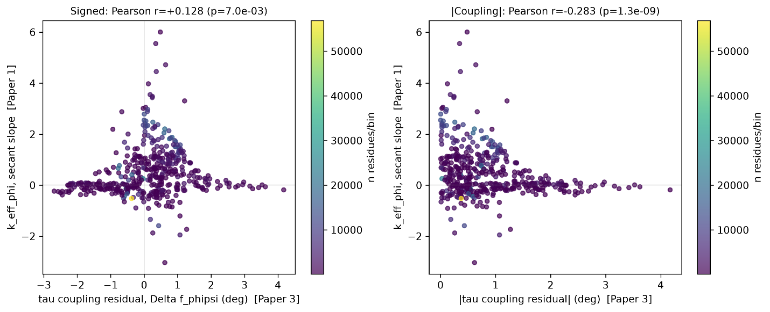
Left panel: signed τ coupling residual (x-axis) vs. k(eff, φ)⁸ secant slope (y-axis), each point a (φ,ψ) bin with ≥100 residues; point color indicates the number of residues contributing to that bin (colorbar, right). Right panel: the same comparison using |coupling| (absolute value) on the x-axis, testing whether coupling magnitude specifically tracks curvature magnitude regardless of sign. Signed coupling vs. k_eff_φ: Pearson r=+0.128 (p=6.99e-03), Spearman ρ=+0.211 (p=7.42e-06). |Coupling| vs. k_eff_φ: Pearson r=−0.283 (p=1.28e-09), Spearman ρ=−0.263 (p=1.86e-08). n=445 (φ,ψ) bins with ≥100 residues in both quantities. Both correlations are weak in magnitude (|r| < 0.3) despite reaching statistical significance at this sample size; we do not interpret this as evidence that the two quantities track the same underlying phenomenon (see Discussion, Section 3).

Table S6. Local (±20° band) vs. global (full half-plane) sign-change tests at Paper 1’s reported wall positions.
Observable | Wall | Global Δ | Global p | Local Δ | Local p | Pattern
τ (N–Cα–C) | φ=−60° | −0.81 | 2.5e-6 | +0.79 | 4.8e-3 | Sig. both; opposite sign
τ (N–Cα–C) | ψ=−40° | +0.11 | 0.39 | +0.11 | 0.35 | Neither significant
∠C–Cα–Cβ | φ=−60° | −0.64 | 3.4e-7 | −0.12 | 0.25 | Global only
∠C–Cα–Cβ | ψ=−40° | +0.18 | 1.1e-2 | −0.39 | 8.8e-4 | Sig. both; opposite sign
∠N–Cα–Cβ | φ=−60° | −0.06 | 0.62 | −0.46 | 3.3e-3 | Local only
∠N–Cα–Cβ | ψ=−40° | +0.04 | 0.71 | +0.04 | 0.79 | Neither significant
ω | φ=−60° | +31.2 | 1.5e-7 | +41.0 | 9.9e-3 | Sig. both; same sign
ω | ψ=−40° | +16.3 | 0.039 | −46.6 | 1.9e-7 | Sig. both; opposite sign
bond Cα–C | φ=−60° | −0.0010 | 1.3e-3 | −0.0002 | 0.58 | Global only
bond Cα–C | ψ=−40° | −0.0013 | 1.2e-2 | +0.0002 | 0.68 | Global only
bond N–Cα | φ=−60° | +0.0002 | 0.58 | −0.0006 | 0.24 | Neither significant
bond N–Cα | ψ=−40° | −0.0010 | 5.7e-3 | −0.0012 | 0.11 | Global only
Local test uses only cells within ±20° of the wall on each side; global test averages over the entire half-plane (Methods 4.6). Neither test is uniformly "correct" — they measure different constructs — but agreement/disagreement between them indicates whether a wall behaves as a genuine local discontinuity versus a broad regional split.

