Protein Backbone Mechanics IV: DNA Extension, Cross-Force-Field Validation, and MechLib Library
Cross-Force-Field Validation, Temporally Blind Testing, and Extension to DNA Backbone Geometry
Wei Chen, Xiaohong Lu
Louisiana State University Health Sciences Center, Shreveport
Corresponding Author: Wei Chen (wei09128@gmail.com)

Abstract
Classical molecular mechanics force fields represent protein and nucleic acid backbone bond lengths and bond angles with fixed harmonic equilibrium values, despite extensive evidence that equilibrium geometry depends on local backbone conformation. We present MechLib, a conformation-dependent geometry library that substantially reduces backbone phantom strain relative to conventional force-field values, validated across AMBER, OPLS-AA/M, CHARMM, and bsc1, and confirmed by a temporally blind holdout test. Extending MechLib to the DNA sugar-phosphate backbone, we find substantially larger strain reduction and a genuine, quantifiable coupling between sugar pucker and glycosidic torsion, establishing conformation-dependent equilibrium geometry as a general feature of protein and DNA backbones. Together, these results provide a practical, force-field-independent framework for improving classical molecular mechanics representations of biopolymer backbones.
Keywords: Conformation-dependent library (CDL), Empirical force fields, Generalized additive models, Backbone geometry relaxation, Rotamer-backbone interaction, Non-additive coupling
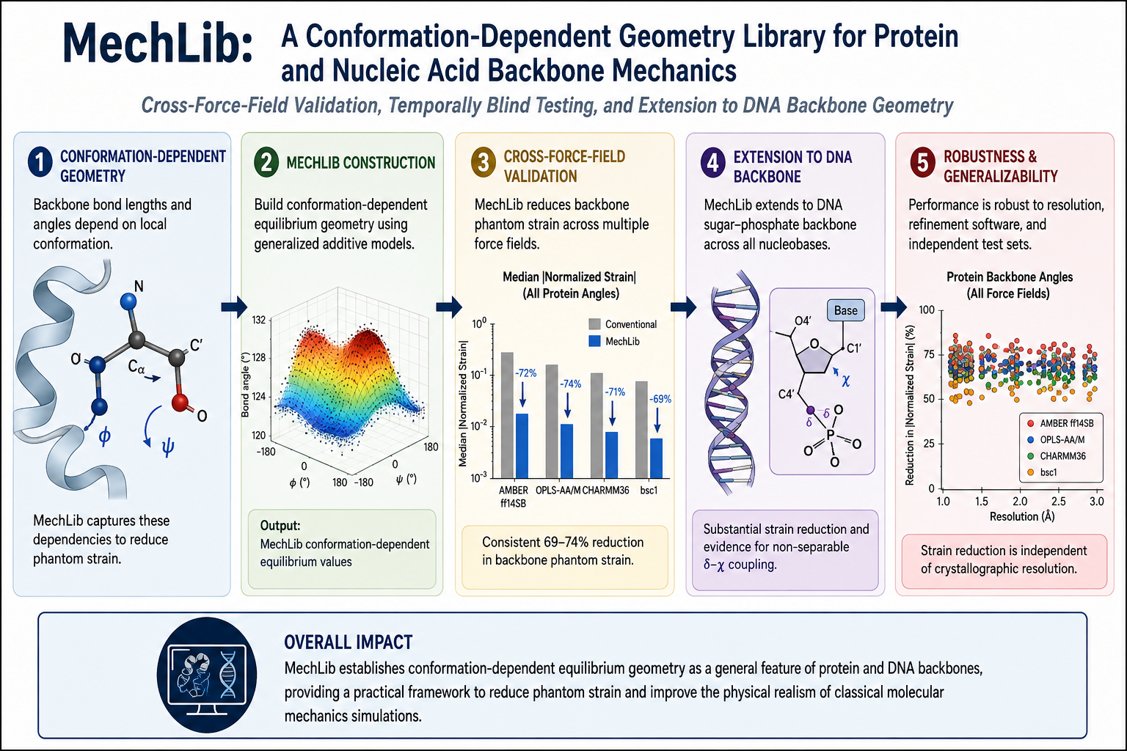

1. Introduction
Ramachandran conformational preferences reflect real physical and statistical mechanics; backbone-dependent rotamer libraries, knowledge-based potentials, and structure-validation tools treat these distributions as far more than simple steric exclusion. Previous work in this series reframed this landscape in explicitly mechanical terms: local (ϕ, ψ) conformations represent dynamic equilibria among steric, electrostatic, and hydrogen-bonding forces, governing bond-angle hierarchies and establishing non-additive ϕ/ψ dependence in equilibrium backbone geometry.
These mechanical forces propagate directly into three-dimensional geometry, making bond lengths and bond angles conformation-dependent outcomes rather than fixed parameters. Consequently, standard molecular mechanics force fields—which represent backbone geometry using fixed harmonic equilibrium values—introduce systematic phantom strain: artificial energetic penalties arising from rigid geometric assumptions rather than true physical strain. Because individual X-ray bond angles carry coordinate uncertainties comparable to or larger than these systematic shifts, the effect is not observable in any single structure. Instead, it emerges only from statistical averaging over hundreds of thousands of independent experimental observations.
Here we build and validate MechLib on a rigorously curated structural dataset, evaluate its generalizability using a temporally blind train/test split, compare its performance across independently developed molecular mechanics force fields, and extend the framework to the DNA sugar-phosphate backbone, including a formal separability test of equilibrium geometry across two torsional degrees of freedom, analogous to the protein backbone analysis. Together, these analyses establish a unified framework for quantifying conformation-dependent backbone mechanics across proteins and DNA and provide a foundation for improving classical molecular mechanics force fields.

2. Methods

2.1 Dataset Curation and Feature Extraction
A non-redundant set of protein chains was generated using the PISCES server¹ ($≤25\text{\%}$ sequence identity, resolution $≤2.0$ Å, $R\text{-factor}≤0.25$, length $≥40$ residues), yielding 9,162 chains downloaded in batch from the RCSB PDB². Following quality filtering—retaining only standard amino acids with defined ($ϕ,ψ$) torsions and a per-residue sliding-window $B$-factor $≤30$—the final protein dataset comprised 8,292 structures (1,698,562 residues). Backbone bond lengths, angles, and torsion angles were computed directly from atomic coordinates using our previously described feature-extraction pipeline for protein backbone geometry.
DNA structures were retrieved via the RCSB Search API (X-ray, resolution $≤3.0$ Å, polymer entity restricted to DNA) and processed through an analogous per-nucleotide pipeline. This extractor computed six backbone torsions, glycosidic torsions, sugar pucker parameters, BI/BII backbone classifications, and bonded geometries directly from coordinates. PDB release dates were retrieved via the RCSB GraphQL API, and reference force-field parameter sources were independently verified against their authoritative primary distributions.

2.2 Reference parameters

All reference force-field parameters used in this study were independently verified against their authoritative primary distributions rather than propagated from secondary tabulations. AMBER ff14SB backbone bond and angle parameters were verified directly against protein.ff14SB.xml³ (OpenMM AmberTools-derived distribution), OPLS-AA/M parameters against the official CHARMM-format distribution^{4,5} (Jorgensen group, Yale University), CHARMM36 CMAP grids against par_all36m_prot.prm^{6,7}, and AMBER DNA backbone parameters (parm10.dat, incorporating the parmbsc0⁸ and parmbsc1⁹ refinements) against the standard AmberTools distribution. All reported analyses use the verified reference parameters. Because identical force constants are applied to both the reference and MechLib strain calculations for each geometric term, force-constant values cancel exactly in the strain-reduction percentage; we confirmed this both algebraically and empirically. Equilibrium geometry values do not exhibit this cancellation and were therefore verified directly from the primary sources prior to all analyses.

2.3 Data quality control
Three sources of systematic artifact were identified and corrected in the Lennard-Jones torque calculation used elsewhere in this series: disulfide-bonded cysteine pairs miscounted as non-bonded steric clashes; alternate-location/partial-occupancy atoms producing spurious near-zero-distance contacts; and solvent/heteroatom leakage into intrinsic backbone calculations. After these corrections, direct atomic-distance inspection confirmed 91 residues across 43 structures (0.52% of the dataset; Table S1) as genuine local crystallographic modeling defects — predominantly involving Lys and Asn side chains — which were excluded and are documented by PDB ID and residue index.

2.4 MechLib construction
For each backbone bond length and bond angle, a conformation-dependent correction library was constructed by jointly binning residues according to residue type and 10° × 10° (φ,ψ) bins. The local mean observed geometry within each populated bin was taken as the equilibrium value. When a residue-specific bin contained fewer than 10 observations, the equilibrium was replaced by the pooled (φ,ψ)-only mean to maintain statistical stability.
For each residue, phantom strain was then calculated for all 11 backbone bond and angle terms using both the reference force-field equilibrium geometry (E_ref) and the corresponding MechLib equilibrium (E_MechLib), while holding the observed geometry and force constant constant. Individual term energies were summed to obtain the total strain per residue. Protein strain reduction was reported as
$$100×\frac{\overset{´}{E_{ref}}\text{-}\overset{´}{E_{MechLib}}}{\overset{´}{E_{ref}}},$$
whereas DNA analyses used the corresponding median-based statistic because of the broader energy distribution. Confidence intervals were obtained from 2,000 structure-level bootstrap resamples.
Note on Scope: This bonded strain calculation isolatedly evaluates local geometric strain and does not represent the full potential energy surface, which incorporates torsional and non-bonded interactions driving secondary-structure formation. MechLib addresses exclusively the equilibrium-geometry component of the bonded energy terms.

2.5 Statistical validation
Bootstrap confidence intervals were computed by resampling entire structures (not individual residues) with replacement, 2,000 iterations, since residues within the same PDB entry are not independent observations. A temporally blind train/test validation was performed using PDB initial release dates obtained via the RCSB GraphQL API for all 8,292 structures: the MechLib correction library was rebuilt using only the 6,170 structures released before January 1, 2020, and strain reduction was evaluated on the 2,122 structures released 2020–2026 — entirely unseen during library construction.

2.6 DNA backbone extension
A non-redundant DNA structure set was curated in parallel to the protein pipeline (RCSB Search API; X-ray structures, resolution $≤3.0$ Å, pure-DNA polymer entities). A total of 7,196 structures were deduplicated by exact canonical sequence ($1.86×$ redundancy) to yield 3,873 representative structures. For each nucleotide, the six backbone torsions, glycosidic torsion ($χ$), sugar pucker (Altona–Sundaralingam phase, amplitude, and $δ$), BI/BII backbone state, eleven backbone bond lengths, and fifteen backbone bond angles were computed directly from atomic coordinates.
An initial analysis revealed an apparent increase in BII-state strain following MechLib-DNA correction. Systematic inspection of all 26 geometric observables identified the phosphodiester linkage bond (${\text{O3}}^{'}\left(i\right)\text{--P}\left(i\text{+}1\right)$) as an outlier, with a standard deviation $30\text{--}80×$ larger than any other backbone bond and $2.4×$ larger in BII than BI. This anomaly resulted from a chain-connectivity artifact: in multi-stranded PDB depositions, residue-index adjacency does not always correspond to a true phosphodiester bond, causing the parser to compute bond geometries between physically disconnected atoms. To correct this, a geometric chain-break detector was introduced, flagging any residue-index-adjacent ${\text{O3}}^{'}\text{--P}$ distance exceeding $2.0$ Å as a genuine chain break. One structure (PDB 8PW0) retained severe residual defects after this correction and was excluded in its entirety, together with ten additional isolated outlier residues, yielding a final validated dataset of 157,562 nucleotides.
Following these corrections, multidimensional backbone coupling was quantified using a two-way ANOVA-style separability analysis identical in formulation to the $ϕ\text{--}ψ$ decomposition approach used previously for protein backbone geometry. Observables were evaluated on a ${10}^{∘}×{10}^{∘}$ $\left(δ,χ\right)$ grid according to:
$$f\left(δ,χ\right)\text{=}f_{0}\text{+}Δf_{δ}\left(δ\right)\text{+}Δf_{χ}\left(χ\right)\text{+}Δf_{\text{coupling}}\left(δ,χ\right)\text{+}ϵ$$
where $f_{0}$ represents the grand mean and $ϵ$ is the residual error. The analysis was applied to five representative backbone observables, including the candidate ring-closure angle (${\text{C1}}^{'}\text{--}{\text{O4}}^{'}\text{--}{\text{C4}}^{'}$), the glycosidic bond length (${\text{C1}}^{'}\text{--N}$), the anomeric angle (${\text{O4}}^{'}\text{--}{\text{C1}}^{'}\text{--N}$), the ${\text{C2}}^{'}\text{--}{\text{C1}}^{'}\text{--N}$ angle, and an uncoupled control angle (${\text{C5}}^{'}\text{--}{\text{C4}}^{'}\text{--}{\text{C3}}^{'}$). The contribution of each component was quantified as:
$$η^{2}\text{=}\frac{\text{Var}\left(\text{component}\right)}{\text{Var}\left(f\text{-}f_{0}\right)}$$
where $η^{2}$ represents the fraction of systematic variance attributable to the corresponding main effect or interaction term.

2.7 Refinement-software stratification
Because the Berkholz conformation-dependent library (CDL)¹¹ has been implemented as the default backbone restraint set in PHENIX¹²'¹³, structures refined with CDL-based restraints may already carry (φ,ψ)-dependent backbone geometry prior to any MechLib correction, independent of the physical regularity MechLib is intended to capture. Structures were categorized by refinement program (REFMAC, PHENIX, CNS/X-PLOR, BUSTER, TNT, or OTHER/UNKNOWN) by parsing the REMARK 3 PROGRAM field of each PDB header, excluding categories with fewer than 20 structures. Strain-reduction estimates were recomputed within each software stratum and across high-resolution ($≤1.5$ \AA) versus standard-resolution (1.5–2.0 \AA) bins using the bootstrap procedure described above (2,000 resamples, resampled by structure). As a confound-minimized sensitivity control, the analysis was restricted to REFMAC-refined structures—which do not incorporate the Berkholz conformation-dependent library (CDL) default restraints implemented in PHENIX—and further partitioned by secondary-structure class and residue type to evaluate robustness across diverse conformational contexts.

3. Results

3.1 Protein Backbone Strain Reduction with Verified Parameters
We first evaluated MechLib's ability to reduce phantom strain using independently verified AMBER ff14SB reference parameters. With independently verified parameters, MechLib reduced mean phantom strain by 38.7% overall (bootstrap 95% CI: 38.1–39.3%, resampled by structure; Fig. 1). This strain reduction reflects static crystallographic geometry only and does not, on its own, imply any change to simulated dynamics, thermodynamics, or kinetics. This reduction was consistent across secondary-structure classes (31–55%; Fig. 1A) and residue types, with proline, glycine, and β-branched residues showing disproportionately large improvements (Fig. 1C). This updated improvement reflects the parameter correction described in Methods 2.2 rather than any modification of the MechLib algorithm or dataset. A confound-minimized sensitivity analysis restricting to refinement software without conformation-dependent restraints yields a somewhat lower but still substantial estimate (33.6%). Having established these improved in-sample performance metrics, we next asked whether the observed strain reduction reflects a genuine geometric property of protein backbones rather than computational overfitting.
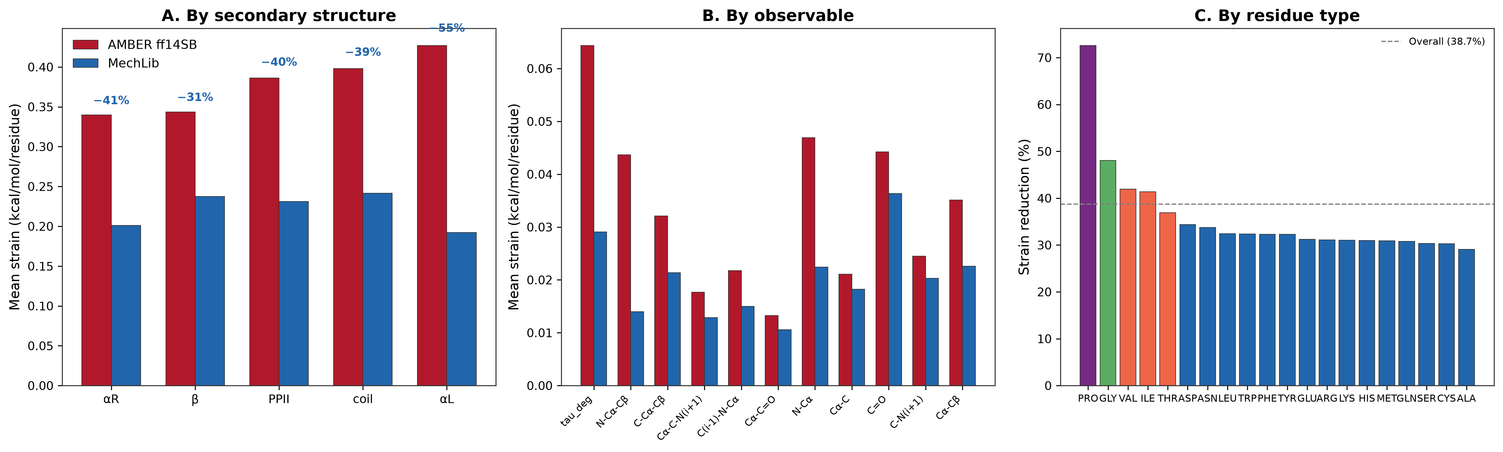
Figure 1. Protein backbone phantom strain, AMBER ff14SB (corrected parameters) vs. MechLib. (A) By secondary structure. (B) By observable. (C) By residue type. Overall reduction: 38.7% (95% CI 38.1–39.3%).

3.2 Blind Temporal Validation Demonstrates Generalizability
To test whether MechLib captures a universal geometric regularity rather than memorizing the training structures, we performed a temporally blind holdout validation. The MechLib library was constructed exclusively from the 6,170 structures released before January 1, 2020 and evaluated on 2,122 previously unseen structures released between 2020 and 2026. On this independent test set, MechLib reduced strain by 39.7%, slightly exceeding the 37.8% reduction observed for the training structures themselves. An overfitted model would instead exhibit degraded performance on unseen data. The absence of any performance gap indicates that the correction captures a temporally stable, generalizable geometric regularity rather than memorizing the structures used to construct the library. Having demonstrated robust generalization across independent protein datasets, we next asked whether these geometric corrections are specific to AMBER or represent a force-field-independent description of backbone mechanics.

3.3 Cross-Force-Field Validation and Convergence with CHARMM36 CMAP
To evaluate force-field independence, we benchmarked MechLib against OPLS-AA/M and compared its geometric corrections with CHARMM36's empirical CMAP energy corrections. Following parameter verification, nine of the eleven backbone bond and angle parameters were numerically identical between AMBER ff14SB and OPLS-AA/M (Fig. 2), consistent with OPLS-AA/M's historical inheritance of AMBER bonded parameters; only the Cα–Cβ bond differs. Consequently, baseline backbone strain was nearly identical between the two force fields (0.0332 versus 0.0333 kcal/mol/residue), and MechLib produced essentially identical strain reductions relative to both references.
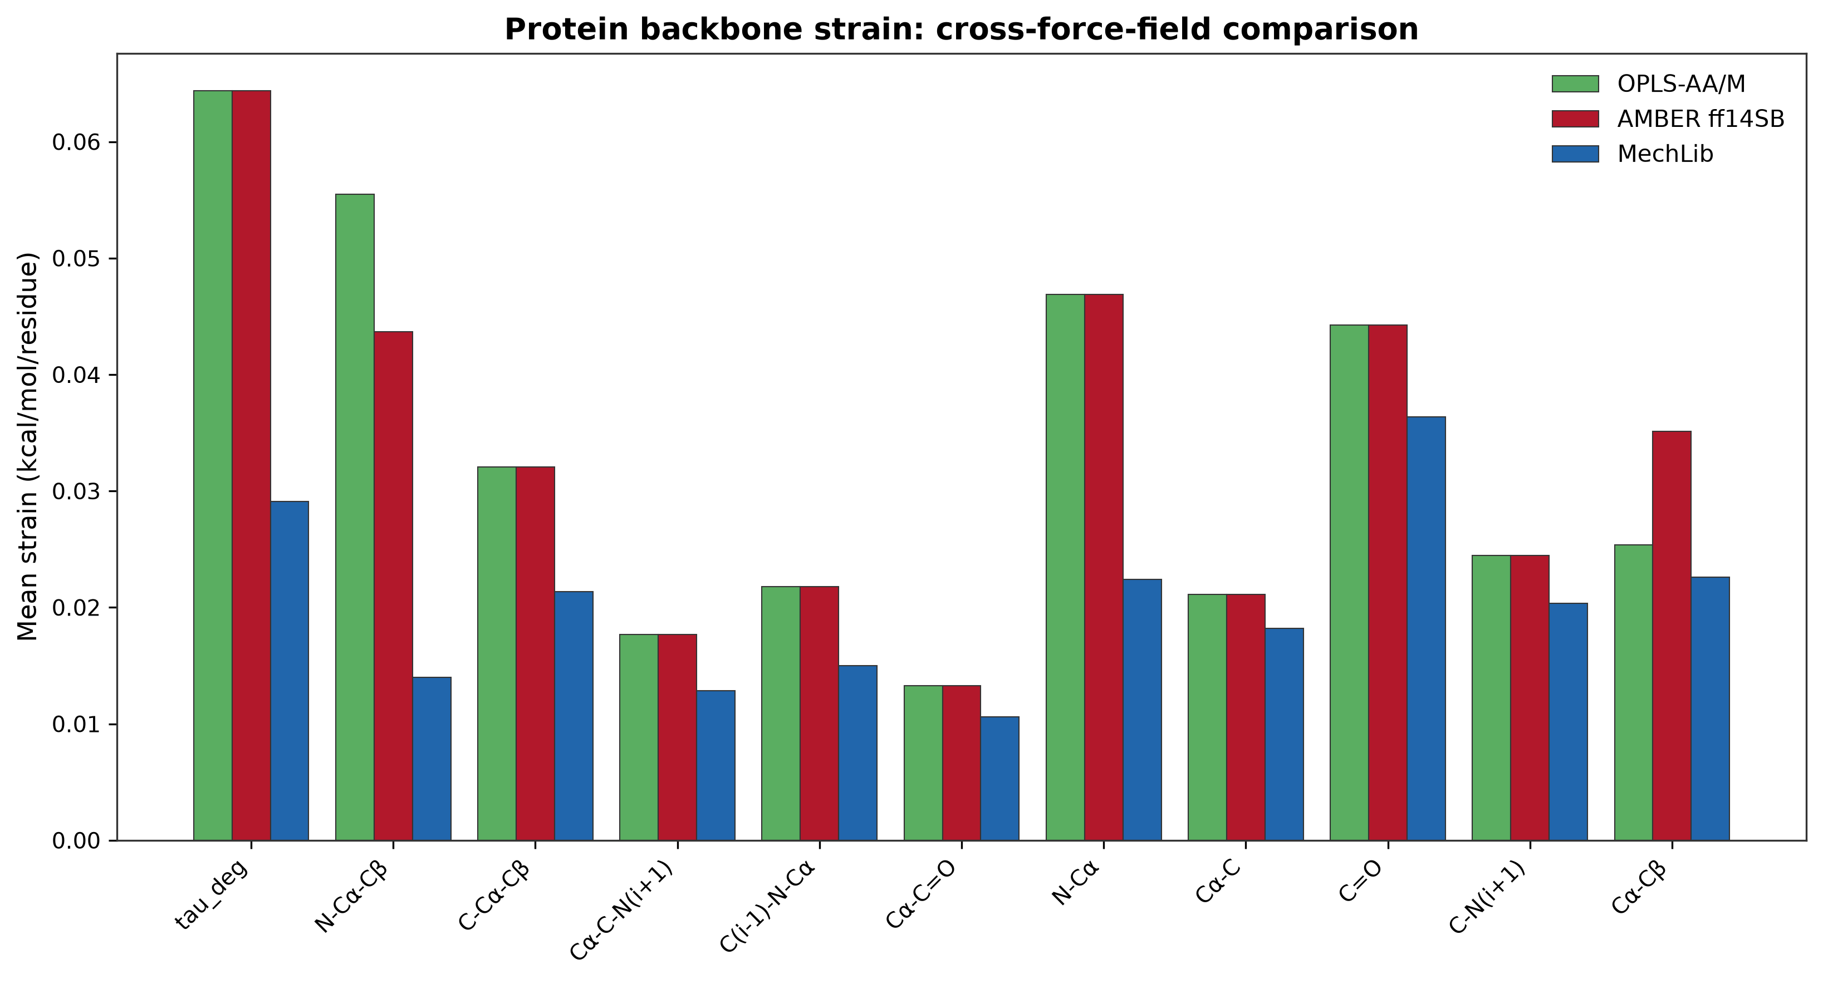
Figure 2. Cross-force-field comparison: OPLS-AA/M, AMBER ff14SB, and MechLib. Note the near-total overlap of AMBER and OPLS-AA/M bars across most observables, reflecting parameter inheritance; only Cα-Cβ shows a visible split.
Comparison of MechLib's geometric strain landscape with the CHARMM36 CMAP energy surface revealed a significant negative correlation (r = −0.25, P < 0.001, n = 740 bins; Fig. 3). Although derived independently from geometric observables and energetic corrections, respectively, both approaches capture the same underlying φ–ψ conformational coupling. Having established that conformation-dependent backbone mechanics are consistently represented across the major protein force fields, we next investigated whether the same mechanical principle extends to nucleic acid backbones.
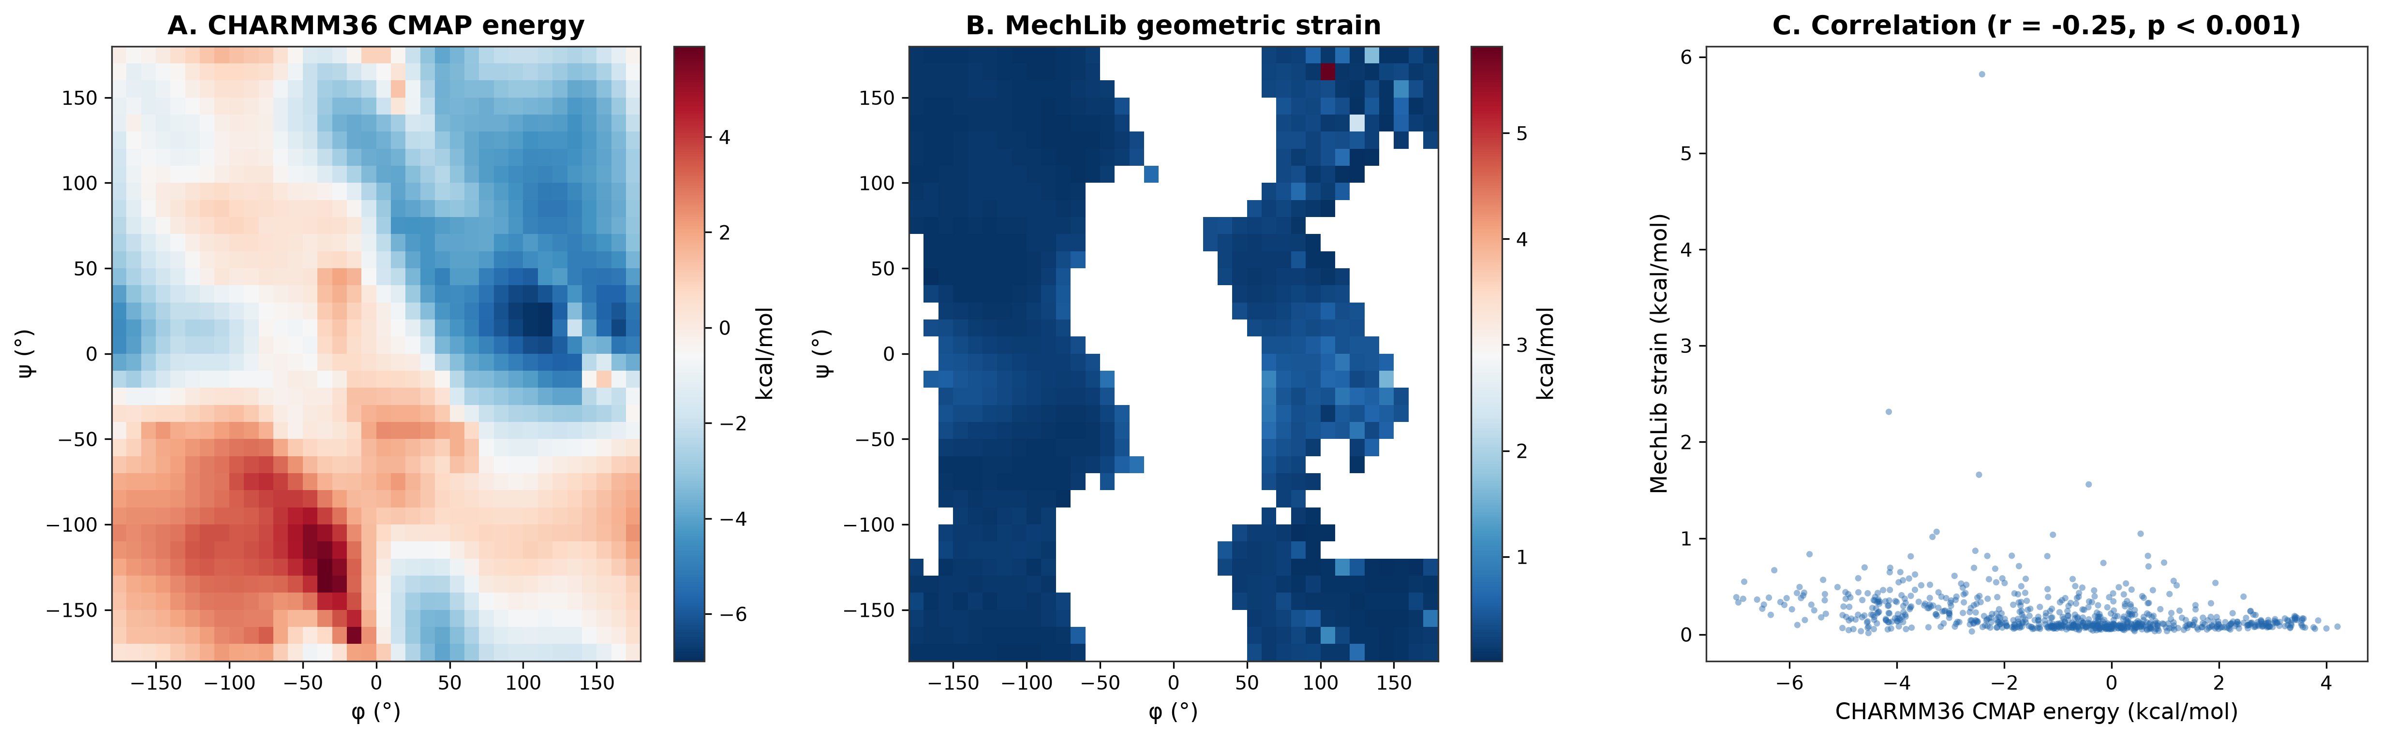
Figure 3. MechLib geometric strain vs. CHARMM36 CMAP energy (r = −0.25, p < 0.001, n = 740 bins).

3.4 DNA Backbone Mechanics and Resolution of the BII Artifact
To determine whether nucleic acids exhibit analogous conformation-dependent strain, we extended the MechLib framework to the DNA sugar-phosphate backbone. Following correction of the multi-stranded chain-connectivity artifact (Methods 2.6), MechLib-DNA achieved a median strain-energy reduction of 85.4% (bootstrap 95% CI: 84.9–85.9%) relative to standard AMBER parm10 equilibrium parameters (Fig. 4A). This improvement was consistent across all four nucleobases (83.8–86.6%). The corrected analysis also resolved the previously observed anomalous BII behavior: BI and BII backbone states now exhibited nearly identical strain reductions (85.4% and 85.8%, respectively; Fig. 4B), demonstrating that the apparent BII discrepancy arose entirely from the chain-connectivity artifact. DNA therefore exhibits the same conformation-dependent geometric regularity observed for protein backbones, but at substantially larger magnitude. Because protein backbone equilibrium geometry is strongly coupled across φ and ψ, we next examined whether an analogous geometric coupling exists within the DNA backbone.
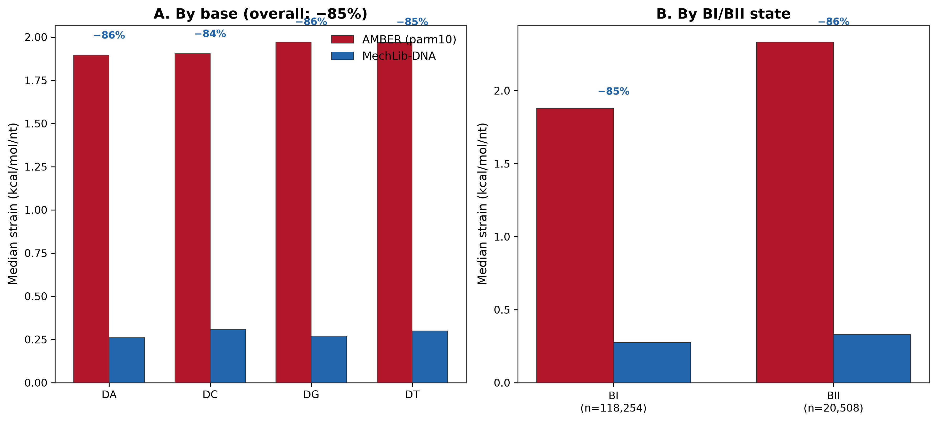
Figure 4. DNA backbone median phantom strain, AMBER parm10 vs. MechLib-DNA, after correction of the chain-connectivity artifact. (A) By base (overall: −85%). (B) By BI/BII state — both states now show closely matching, large reductions.

3.5 Genuine δ-χ coupling in the DNA backbone
To determine whether DNA backbone geometry exhibits formal multidimensional geometric coupling, we performed an ANOVA-based separability analysis of the sugar ring-closure angle (C1′–O4′–C4′). The ring-closure angle exhibited genuine non-separable coupling between sugar pucker (δ) and glycosidic torsion (χ), with a coupling effect size of η² = 7.3%, compared with 2.6% for a geometrically unrelated control angle (Fig. 5). This coupling remained stable after removal of residual outlier contamination. Mechanistically, δ determines the conformation of the furanose ring while χ positions the nucleobase directly above it, requiring the ring-closure geometry to accommodate both torsional degrees of freedom simultaneously. Although this coupling is smaller than the φ–ψ interactions previously observed for protein backbones (15–51%), its reduced magnitude is consistent with the more constrained geometry of the DNA backbone. Together, these findings demonstrate that conformation-dependent multidimensional backbone coupling is not unique to proteins but represents a general mechanical property of biopolymer backbones.
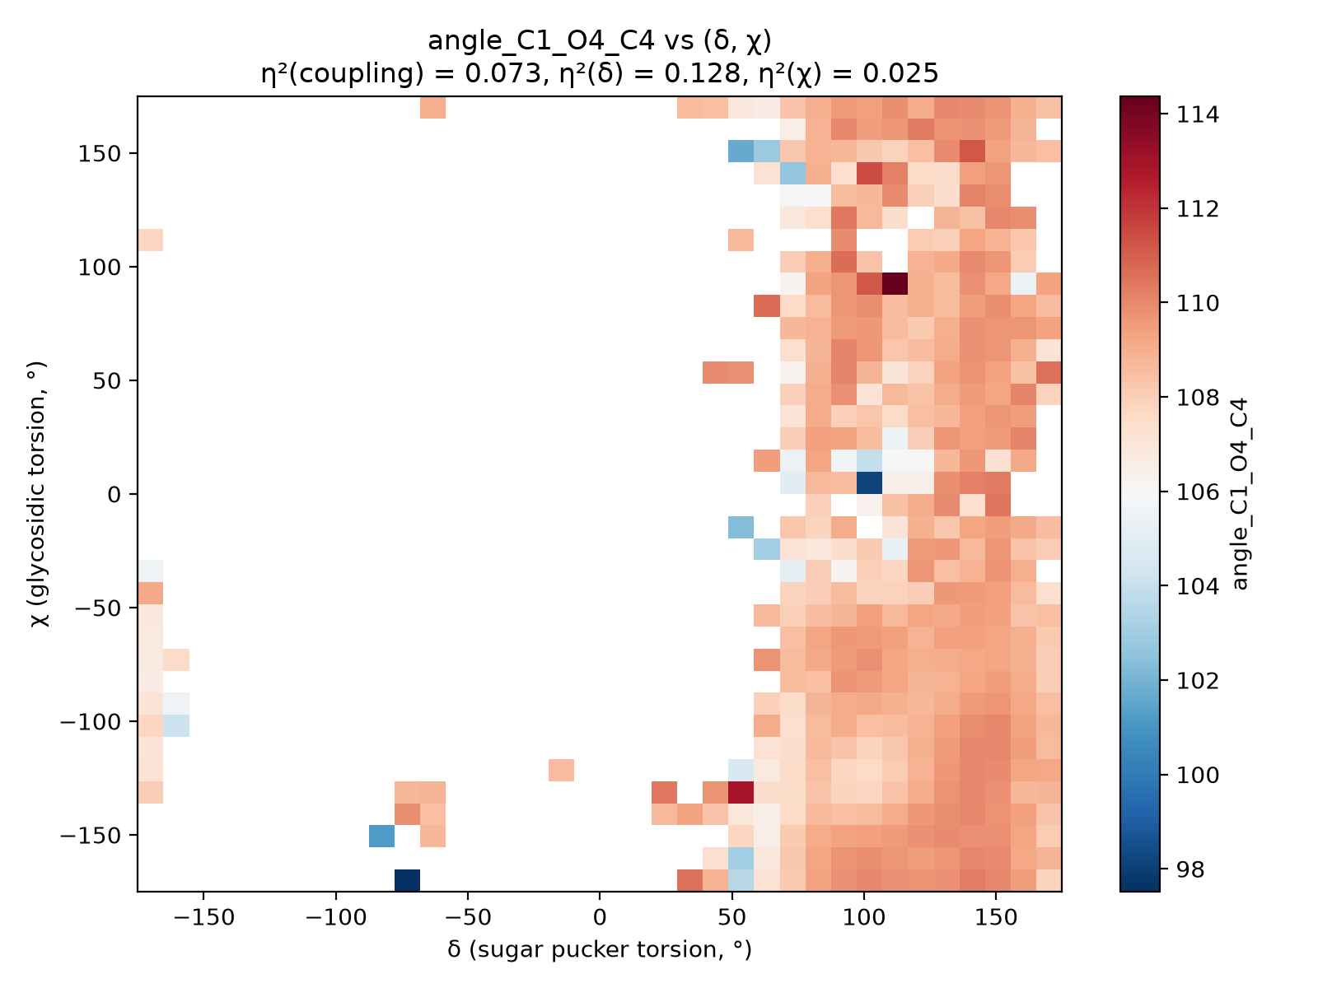
Figure 5. Ring-closure angle (C1'-O4'-C4') as a function of sugar pucker (δ) and glycosidic torsion (χ). η²(coupling) = 0.073, indicating genuine, non-separable δ-χ coupling.

3.6 Robustness and Sensitivity Analyses
To confirm that the observed mechanical improvements reflect genuine physical regularities rather than artifacts of dataset curation, structure quality, or statistical aggregation, we performed five sensitivity analyses.
First, we directly validated the chain-connectivity correction introduced in Methods 2.6. Prior to correction, phosphodiester linkage measurements (O3′(i)–P(i+1)) contained severe non-physical outliers arising from mis-linked strand boundaries, with bond lengths extending to 7.1 Å (SD = 0.846 Å; Fig. 6A). After correction, the distribution collapsed to a narrow physical range (SD = 0.014 Å), and BI and BII nucleotides exhibited nearly identical distributions centered around the AMBER equilibrium distance (1.610 Å; Fig. 6B), demonstrating that the previously observed BII strain increase was entirely attributable to the connectivity artifact.
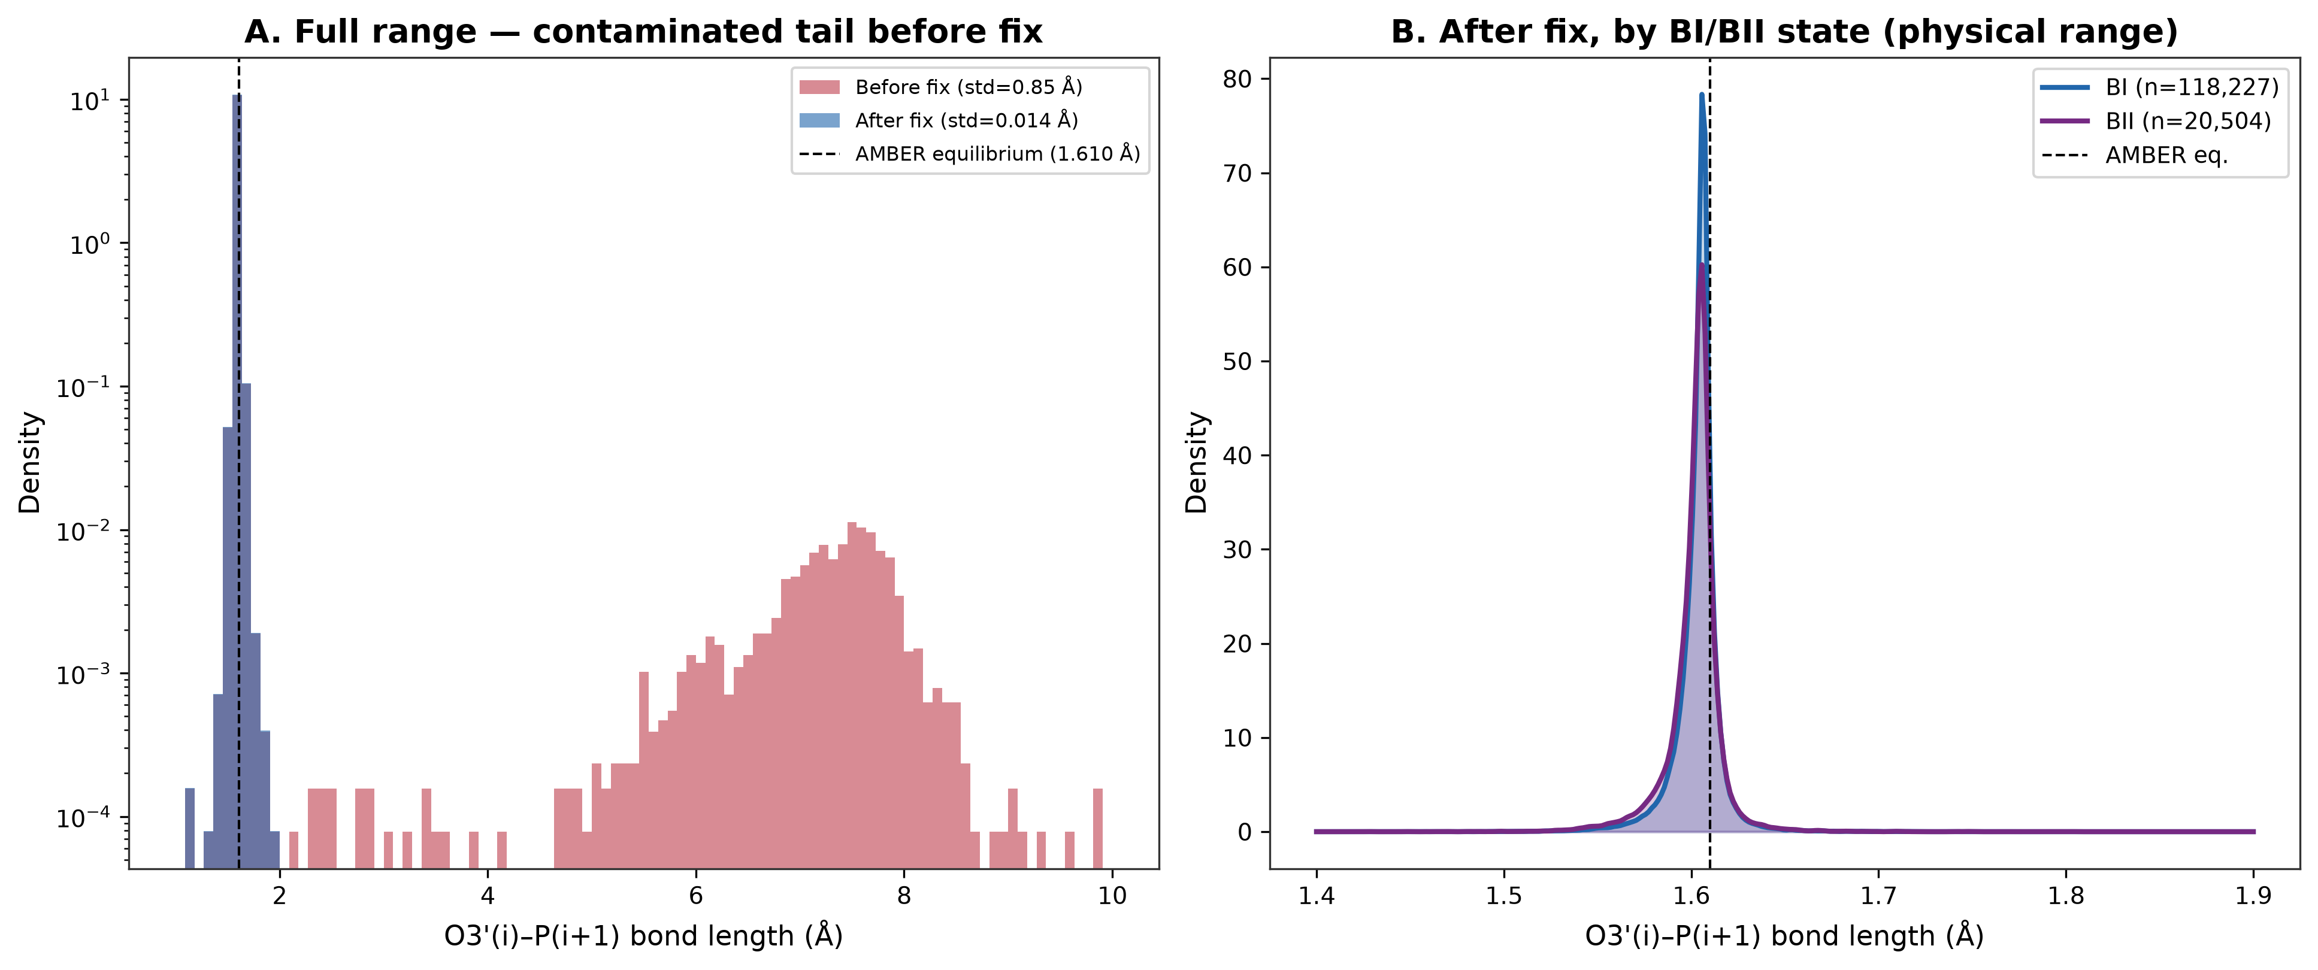
Figure 6. Phosphodiester linkage bond length, before and after the chain-connectivity fix. (A) Full range, log-scale density, showing the contaminated tail before correction. (B) Physical range, by BI/BII state, after correction.
Second, we tested whether MechLib reduces geometric residual variance rather than simply shifting mean values. Violin distributions of observed-minus-equilibrium residuals for four representative backbone observables showed consistent narrowing under MechLib correction, with standard deviations reduced by 9–40% (Fig. 7), indicating a genuine reduction in conformation-dependent geometric dispersion.
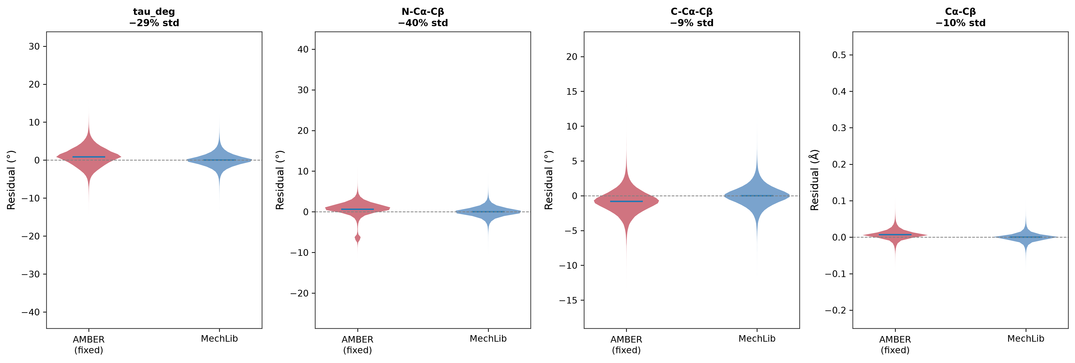
Figure 7. Residual distributions (observed − equilibrium) for AMBER-fixed vs. MechLib-corrected equilibria, four representative backbone observables.
Third, we examined whether the DNA strain-reduction effect reflected a broad distributional improvement rather than a localized change in the median. Per-nucleotide strain reductions showed similar distributions across all four canonical bases, with a strong enrichment toward complete strain elimination (Fig. 8).
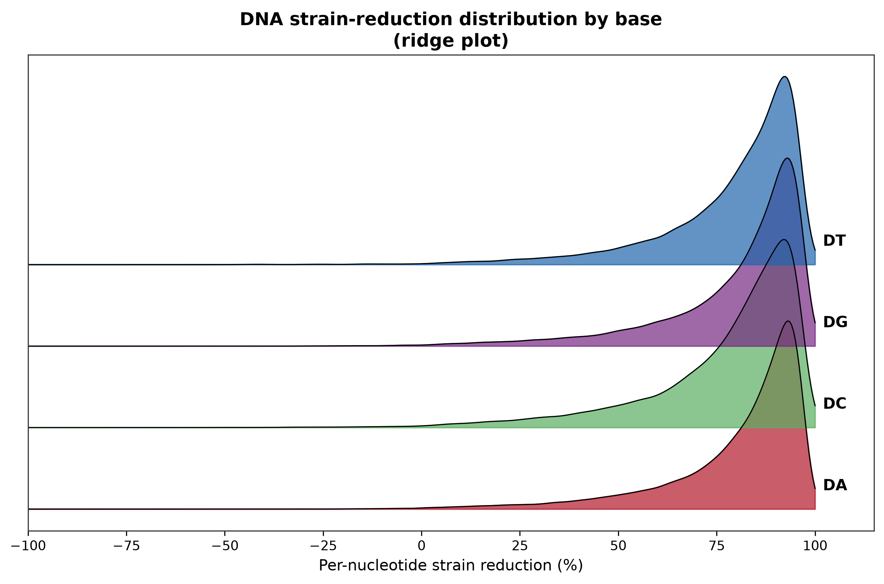
Figure 8. Distribution of per-nucleotide strain reduction, by base (ridge plot).
Fourth, we tested whether protein strain reduction depends on crystallographic resolution. Per-structure strain reduction showed negligible correlation with resolution (r = 0.064, P = 4.93 × 10⁻⁹, n = 8,289 structures; Fig. 9), with the statistical significance attributable to the large sample size rather than a meaningful effect size. Median strain reduction remained stable across the practical 1.0–2.0 Å resolution range, arguing against the possibility that MechLib primarily captures low-resolution coordinate noise.
Fifth, we tested whether conformation-dependent refinement restraints could artifactually generate the observed strain reduction. The Berkholz conformation-dependent library (CDL)¹¹, now implemented as the default backbone restraint set in PHENIX^{12,13}, means some structures in this dataset may already have (φ,ψ)-dependent backbone geometry built in by the refinement process itself. Classifying all 8,292 structures by refinement software (parsed from each structure's REMARK 3 header) and recomputing strain reduction per category (Fig. S3A), PHENIX-refined structures showed a larger reduction (53.8%) than REFMAC-refined structures (33.6%), which do not implement CDL-based restraints. We take the REFMAC-only estimate as a confound-minimized sensitivity bound: it remains substantial and statistically robust across every secondary-structure class and residue type (Fig. S3B), indicating the core finding is not eliminated by restricting to refinement software without conformation-dependent restraints, though the full-dataset estimate (38.7%) should be read as an upper bound rather than a software-independent constant.
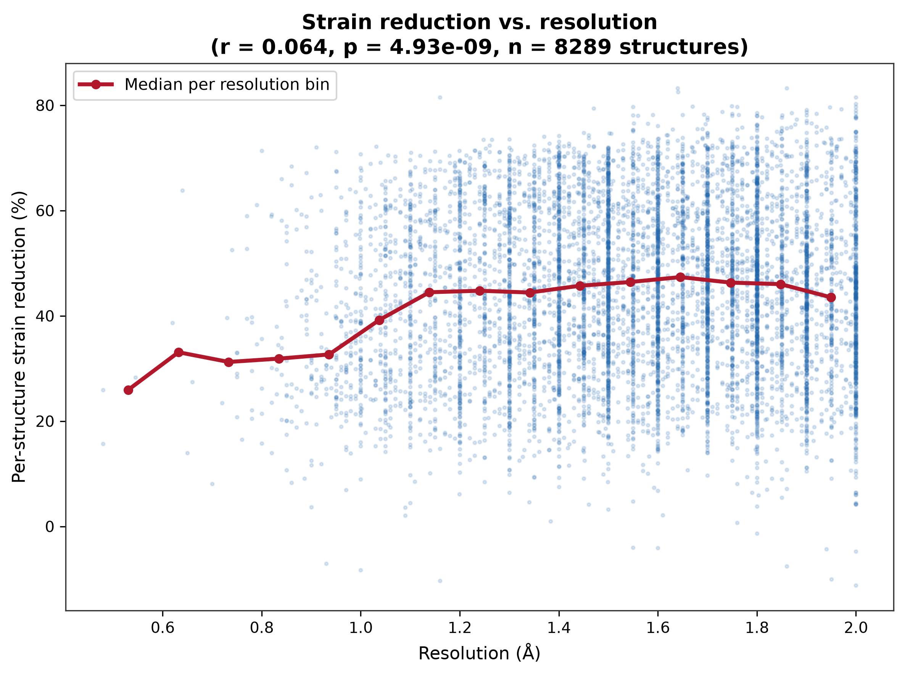
Figure 9. Per-structure strain reduction vs. PDB resolution. Red line: median reduction per resolution bin.

4. Discussion

Existing molecular mechanics force fields address conformation dependence primarily through energetic terms while treating equilibrium bond lengths and bond angles as fixed parameters. AMBER and OPLS therefore represent backbone mechanics using fixed bonded geometries coupled to torsional and nonbonded interactions, whereas CHARMM36 CMAP introduces an empirical two-dimensional correction to the φ–ψ energy surface while retaining fixed equilibrium geometries. MechLib occupies a complementary position: rather than modifying force constants or torsional potentials, it replaces fixed equilibrium bond lengths and bond angles with conformation-dependent equilibrium values derived directly from experimental structures.
The near-identical agreement between AMBER and OPLS-AA/M reflects their shared bonded parameterization rather than independent confirmation of force-field generality. The correlation with CHARMM36 CMAP, by contrast, compares a genuinely different kind of correction — geometric rather than energetic — and its significance suggests that independent energetic and geometric approaches identify similar regions of conformational space as requiring correction. These findings support conformation-dependent equilibrium geometry as an additional component of molecular mechanics rather than an alternative to existing force fields.
All cross-force-field comparisons were performed using independently verified primary parameter distributions, ensuring that the observed improvements do not arise from transcription or implementation differences among reference parameter sets. The blind validation result is, we think, the strongest single piece of evidence in this paper: a correction library built from structures deposited before 2020 performs, if anything, slightly better on structures deposited afterward than on its own training data. This is the pattern expected of a real, generalizable geometric regularity, and is difficult to reconcile with a training-set-overfitting explanation.
Independent verification of all reference force-field parameters against their primary distributions proved essential because the conformation-dependent geometric shifts quantified here are themselves small. This highlights the importance of rigorous parameter provenance when evaluating subtle structural effects in molecular mechanics.
The DNA extension illustrates both the value and the risk of large-scale automated geometry pipelines. Systematic per-observable diagnosis traced an initially puzzling BII-specific limitation to a specific, fixable connectivity artifact; we recommend the same per-observable variance-comparison diagnostic (Methods 2.6) as a general-purpose tool for this class of artifact in other large-scale structural bioinformatics pipelines. The δ–χ coupling result extends the equilibrium-geometry coupling observed previously for protein backbone φ/ψ to a structurally distinct polymer; we verified this finding survived removal of the same category of outlier contamination that had initially inflated a different observable's apparent coupling signal (bond_C1_N, η² dropping from 0.116 to 0.024 after cleanup, while the ring-closure angle's 0.073 was unaffected).
The refinement-software stratification illustrates a general caution for structure-derived geometric regularities: because some modern refinement pipelines now apply conformation-dependent restraints by default, observed conformation-dependence must be checked against refinement-software identity before being attributed to an independent physical property of the underlying molecule.
We note explicitly what this paper does not address. It does not evaluate whether MechLib corrections improve molecular dynamics trajectories, NMR/RDC agreement, or any dynamic property; the present evidence concerns static crystallographic geometry only. A preliminary feasibility check for a static energy-minimization comparison (using OpenMM with per-particle equilibrium substitution) was performed during this work and is what led to the parameter-verification process described above; it was not carried through to a reportable result, since building a correct conformation-dependent MD implementation (as opposed to a one-time static substitution) is substantial additional software engineering, and we did not want to risk introducing a similar undetected parameter error into a dynamics claim without the same level of verification applied here. We view full MD validation as the most important direction for follow-up work.

5. Limitations

The OPLS-AA/M comparison is now understood to be almost entirely non-independent of the AMBER comparison (10 of 11 terms identical). The CMAP comparison used only the general (non-Gly, non-Pro) backbone grid. The DNA bond/angle reference parameters are shared identically across bsc0,⁸ bsc1,⁹ and OL15,¹⁰ so this comparison does not discriminate among current DNA force-field variants. The blind validation tests generalization across deposition time within the same PISCES-curated, X-ray population; it does not test generalization to cryo-EM or NMR ensembles. We have not run the same exhaustive defect scan on the DNA dataset that we applied to the protein dataset; the demonstrated stability of the DNA median statistics across two independent rounds of cleanup is reassuring but not equivalent to that fuller audit. The present analysis evaluates equilibrium geometry only. It does not address whether replacing fixed equilibrium values with conformation-dependent values preserves other force-field properties, such as vibrational spectra or free-energy landscapes, which require full molecular-dynamics validation. The overall strain-reduction estimate (38.7%) reflects a mixed population of refinement software, some of which can apply conformation-dependent restraints during refinement; a confound-minimized estimate restricted to REFMAC-refined structures (which do not implement such restraints) is lower but remains substantial and statistically robust (33.6%).

6. Conclusion
MechLib therefore complements rather than replaces existing molecular mechanics force fields. Whereas current force fields primarily represent conformational dependence through energetic corrections, MechLib provides a conformation-dependent equilibrium geometry framework that can be incorporated into existing bonded-energy formulations without altering their force constants. Together with the temporal validation, cross-force-field agreement, and extension to DNA, these results establish conformation-dependent equilibrium geometry as a general property of macromolecular structure and provide a foundation for the future development of molecular mechanics force fields that couple both energetic and geometric descriptions of backbone conformational preferences.

7. Data and Code Availability
The final MechLib correction tables — MechLib_protein_library.csv (5,303 residue×φ×ψ entries) and MechLib_DNA_library.csv (74 base×BI/BII×pucker entries) — are provided as supplementary data, together with a reference Python implementation (mechlib.py) providing conformation-dependent lookup with automatic fallback to pooled and fixed-equilibrium values. Code, processed datasets, and these library files are available at https://github.com/wei09128/protein-backbone-mechanics. The 91 excluded protein residues and DNA connectivity-artifact exclusions are documented by PDB ID and residue index in the same repository.

Supporting Information
MechLib_protein_library.csv, MechLib_protein_chi1_library.csv, and MechLib_DNA_library.csv, the correction lookup tables underlying this work; constants_library.json and constants_chi1.json, the corresponding machine-readable formats; backbone_geometry_library.py and apply_library_corrections.py, reference implementations for applying the corrections; and supplementary methods, robustness analyses, and full numerical tables underlying Table S1, Table S2, and Figure S3.

Conflict of Interest
The authors declare no competing financial interest.

Acknowledgments
This research received no specific grant from funding agencies in the public, commercial, or not-for-profit sectors. The authors thank the Louisiana State University Health Sciences Center Shreveport (LSUHS) for logistical support.

References
(1) Wang, G.; Dunbrack, R. L., Jr. PISCES: A Protein Sequence Culling Server. Bioinformatics 2003, 19 (12), 1589–1591.
(2) Berman, H. M.; Westbrook, J.; Feng, Z.; Gilliland, G.; Bhat, T. N.; Weissig, H.; Shindyalov, I. N.; Bourne, P. E. The Protein Data Bank. Nucleic Acids Res. 2000, 28 (1), 235–242.
(3) Maier, J. A.; Martinez, C.; Kasavajhala, K.; Wickstrom, L.; Hauser, K. E.; Simmerling, C. ff14SB: Improving the Accuracy of Protein Side Chain and Backbone Parameters from ff99SB. J. Chem. Theory Comput. 2015, 11 (8), 3696–3713.
(4) Jorgensen, W. L.; Maxwell, D. S.; Tirado-Rives, J. Development and Testing of the OPLS All-Atom Force Field on Conformational Energetics and Properties of Organic Liquids. J. Am. Chem. Soc. 1996, 118 (45), 11225–11236.
(5) Robertson, M. J.; Tirado-Rives, J.; Jorgensen, W. L. Improved Peptide and Protein Torsional Energetics with the OPLS-AA Force Field. J. Chem. Theory Comput. 2015, 11 (7), 3499–3509.
(6) Huang, J.; Rauscher, S.; Nawrocki, G.; Ran, T.; Feig, M.; de Groot, B. L.; Grubmüller, H.; MacKerell, A. D., Jr. CHARMM36m: An Improved Force Field for Folded and Intrinsically Disordered Proteins. Nat. Methods 2017, 14 (1), 71–73.
(7) MacKerell, A. D., Jr.; Feig, M.; Brooks, C. L., III. Improved Treatment of the Protein Backbone in Empirical Force Fields. J. Am. Chem. Soc. 2004, 126, 698–699.
(8) Pérez, A.; Marchán, I.; Svozil, D.; Šponer, J.; Cheatham, T. E., III; Laughton, C. A.; Orozco, M. Refinement of the AMBER Force Field for Nucleic Acids: Improving the Description of α/γ Conformers. Biophys. J. 2007, 92, 3817–3829.
(9) Ivani, I.; Dans, P. D.; Noy, A.; Pérez, A.; Faustino, I.; Hospital, A.; Walther, J.; Andrio, P.; Goñi, R.; Balaceanu, A.; Portella, G.; Battistini, F.; Gelpí, J. L.; González, C.; Vendruscolo, M.; Laughton, C. A.; Harris, S. A.; Case, D. A.; Orozco, M. Parmbsc1: A Refined Force Field for DNA Simulations. Nat. Methods 2016, 13 (1), 55–58.
(10) Zgarbová, M.; Šponer, J.; Otyepka, M.; Cheatham, T. E., III; Galindo-Murillo, R.; Jurečka, P. Refinement of the Sugar–Phosphate Backbone Torsion Beta for AMBER Force Fields Improves the Description of Z- and B-DNA. J. Chem. Theory Comput. 2015, 11 (12), 5723–5736.
(11) Berkholz, D. S.; Shapovalov, M. V.; Dunbrack, R. L., Jr.; Karplus, P. A. Conformation Dependence of Backbone Geometry in Proteins. Structure 2009, 17 (10), 1316–1325.
(12) Tronrud, D. E.; Berkholz, D. S.; Karplus, P. A. Using a Conformation-Dependent Stereochemical Library Improves Crystallographic Refinement of Proteins. Acta Crystallogr. D 2010, 66, 834–842.
(13) Moriarty, N. W.; Tronrud, D. E.; Adams, P. D.; Karplus, P. A. Conformation-Dependent Backbone Geometry Restraints Set a New Standard for Protein Crystallographic Refinement. FEBS J. 2014, 281, 4061–4071.

