Supplementary Infomation

Table S1, Protein residues excluded as genuine crystallographic modeling defects.
Excluded residues identified by close-contact scanning ($\text{<}1.5$ Å) and torque magnitude ($\text{|}τ\text{|}\text{>}10,000$ kcal·mol⁻¹·rad⁻¹), excluding handled artifacts. Listed by PDB ID, index, and name.

Table S2, Overview of MechLib performance benchmarks
Result | Value | 95% CI / detail | n
Protein vs. AMBER ff14SB | 38.7% | [38.1%, 39.3%] | 1,698,562 res
Protein, blind test (2020–2026 structures) | 39.7% | cf. 37.8% in-sample | 428,750 res
Protein vs. OPLS-AA/M (mean) | ≈ same as AMBER | 10/11 terms identical | 1,698,562 res
Protein vs. CHARMM36 CMAP | r = −0.25 | p < 0.001 | 740 bins
DNA vs. AMBER parm10 (median, overall) | 85.4% | [84.9%, 85.9%] | 157,562 nt
DNA — BI / BII state (median) | 85.4% / 85.8% | — | 118,254 / 20,508 nt
DNA δ–χ coupling, C1'-O4'-C4' angle | η² = 0.073 | cf. control 0.026 | 150,022 nt

Figure S3, Strain reduction stratified by refinement software and secondary structure.
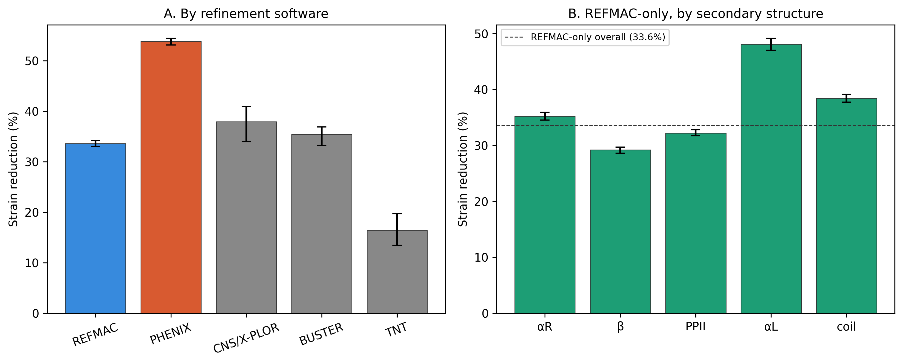
(A) Strain reduction by refinement software, parsed from each structure's REMARK 3 header. (B) REFMAC-only strain reduction by secondary-structure class; dashed line = REFMAC-only overall (33.6%). Error bars: bootstrap 95% CI, resampled by structure.

