Supplementary Information
Systematic Bond-Angle Deformation Across Conformational Space
Wei Chen and Xiaohong Lu
This supplement documents the structural dataset, use of observed coordinates, side-chain comparisons, resolution stratification and restrained relaxation analyses.

Supplementary Note S1 Use of observed coordinates
The analysis concerns variation in local covalent geometry measured in deposited crystallographic structures. Bond angles should therefore be calculated directly from the observed atomic coordinates. A coordinate reconstruction that fixes bond angles at prescribed targets replaces the variation being measured with those targets; reconstruction from torsions alone cannot recover observed deviations in those bond angles. The issue is the geometry supplied to a reconstruction, rather than the NeRF coordinate transformation itself.
We therefore calculate angles from the observed crystallographic coordinates, preserving the residue- and conformation-dependent geometry present in those coordinates. Reconstruction with fixed angle targets would remove the angle variation under study. This rationale does not imply that the NeRF transformation itself is intrinsically biased when supplied with the observed internal coordinates.
The PISCES acquisition list contains 9,162 chains from 8,887 PDB entries at ≤25% sequence identity, nominal X-ray resolution ≤2.0 Å and crystallographic R-factor ≤0.25. The final analysed set retains 7,836 exact PDB–chain matches (1,618,814 residues) and 102 alternatives with identical complete nonempty SEQRES sequences to selected chains in the same entries (17,508 residues): 7,938 chains and 1,636,322 residues. Sequence equivalence does not imply coordinate identity. The chain audit manifest and selection list are supplied as supporting data.
Quality filtering retains standard residues with defined φ/ψ, applies a Cα B-factor mean ≤30 Å² over ±3 retained rows in each PDB–chain group, and requires ≥10 retained residues per chain. Missing B-factors are assigned zero and windows are truncated at chain ends without an explicit reset at gaps. Chain breaks are detected from missing peptide-link atoms or C–N distance >2.5 Å. Highest atom occupancy determines alternate-coordinate selection, with ties preferring A then blank. Torque-cleaning steps mask selected torque values and do not remove the corresponding angle rows. The accompanying source archive contains the original scripts and a complete chain comparison.

Figure S1 Glycine and proline maps
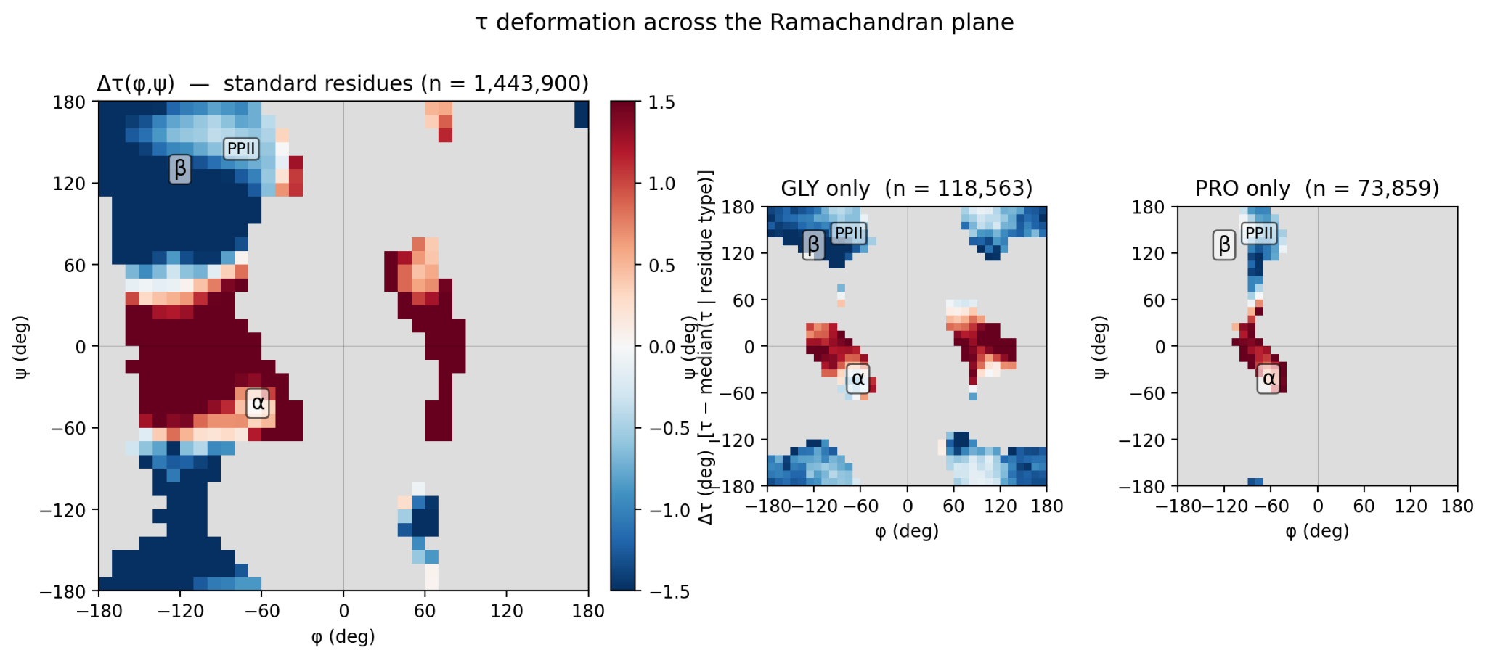
Figure S1. Residue-centered Δτ in 10° × 10° Ramachandran bins containing at least 30 residues. Left: 18 types excluding Gly and Pro (n = 1,443,900); middle: Gly (n = 118,563); right: Pro (n = 73,859). Positive and negative values are relative to residue-type medians. The main panel has limits ±1.5° and Gly/Pro ±2.25°; the visible color bar applies to the main panel.
Panel-specific display limits are given in the caption.

Figure S2 Side-chain mass comparison
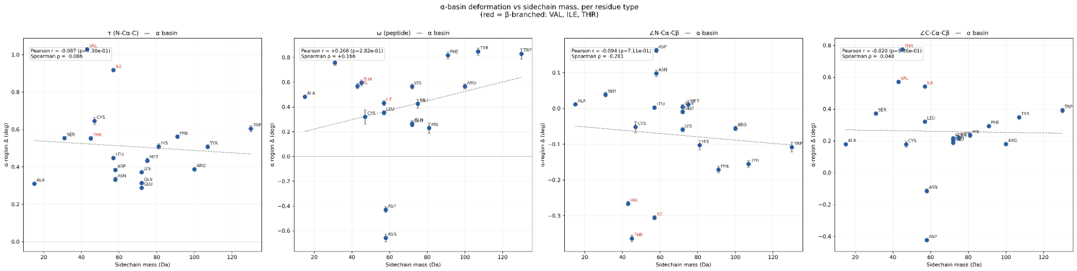
Figure S2. Side-chain mass descriptor versus α-basin mean residue-centered deviation for 18 residue types excluding Gly and Pro. Each point represents a residue type. Pearson r is −0.087 for τ, +0.268 for ω, −0.094 for ∠N–Cα–Cβ and −0.020 for ∠C–Cα–Cβ. These correlations use 18 residue-type means; the script labels its integer mass descriptor in Da.

Table S1 Angle residue and basin summaries
Table S1. Signed means and SEM in degrees for four observables, 18 residue types and four basins, transcribed from the four angle-specific rerun logs. Δ is measured relative to the global residue-type median; ω uses circular centering. Rotamer comparisons are separate.
The accompanying Table_S1.csv contains 288 combinations and approximate two-sided normal P-values from the rounded printed means and SEM; 269 have nominal P <0.01. Tests are unadjusted for multiple comparisons and within-structure dependence. These are approximate summary-data tests.
τ (N–Cα–C)
Residue | α | β | PPII | αL
ALA | +0.310 (0.005) | -1.776 (0.016) | -0.704 (0.017) | +0.987 (0.048)
ARG | +0.387 (0.008) | -1.840 (0.017) | -0.923 (0.024) | +1.056 (0.044)
ASN | +0.333 (0.012) | -2.381 (0.023) | -1.364 (0.031) | +0.966 (0.022)
ASP | +0.383 (0.009) | -2.491 (0.022) | -1.242 (0.023) | +0.973 (0.029)
CYS | +0.646 (0.019) | -1.352 (0.030) | -0.431 (0.046) | +1.452 (0.100)
GLN | +0.313 (0.009) | -1.824 (0.020) | -0.976 (0.028) | +0.890 (0.047)
GLU | +0.288 (0.006) | -1.990 (0.017) | -1.115 (0.021) | +1.005 (0.044)
HIS | +0.508 (0.014) | -1.778 (0.023) | -0.997 (0.034) | +1.234 (0.051)
ILE | +0.917 (0.007) | -1.444 (0.010) | -0.610 (0.023) | +1.491 (0.323)
LEU | +0.447 (0.005) | -1.876 (0.011) | -0.824 (0.017) | +1.075 (0.061)
LYS | +0.371 (0.008) | -1.856 (0.017) | -1.048 (0.023) | +0.861 (0.035)
MET | +0.434 (0.013) | -1.651 (0.026) | -0.726 (0.037) | +0.972 (0.096)
PHE | +0.561 (0.010) | -1.354 (0.015) | -0.645 (0.026) | +1.619 (0.066)
SER | +0.554 (0.009) | -1.525 (0.017) | -0.570 (0.019) | +1.174 (0.048)
THR | +0.552 (0.010) | -1.411 (0.013) | -0.715 (0.024) | +1.632 (0.159)
TRP | +0.604 (0.016) | -1.506 (0.028) | -0.713 (0.038) | +1.356 (0.115)
TYR | +0.507 (0.010) | -1.308 (0.016) | -0.647 (0.028) | +1.387 (0.068)
VAL | +1.028 (0.007) | -1.170 (0.009) | -0.442 (0.020) | +1.040 (0.194)

Table S1 continued
ω peptide torsion
Residue | α | β | PPII | αL
ALA | +0.482 (0.013) | -1.685 (0.105) | -2.645 (0.156) | -0.311 (0.157)
ARG | +0.566 (0.021) | -1.648 (0.104) | -1.291 (0.172) | -0.983 (0.226)
ASN | -0.658 (0.030) | -0.263 (0.187) | -0.944 (0.247) | -1.378 (0.107)
ASP | -0.430 (0.023) | +0.258 (0.144) | -1.523 (0.142) | -1.700 (0.099)
CYS | +0.320 (0.058) | -1.428 (0.203) | -1.563 (0.384) | -0.178 (0.352)
GLN | +0.266 (0.023) | -1.543 (0.151) | -1.247 (0.249) | -0.777 (0.190)
GLU | +0.257 (0.018) | -1.446 (0.144) | -1.182 (0.204) | -1.202 (0.238)
HIS | +0.230 (0.041) | -1.434 (0.152) | -0.654 (0.285) | -1.149 (0.218)
ILE | +0.431 (0.021) | -0.949 (0.052) | -0.419 (0.119) | -2.010 (0.983)
LEU | +0.353 (0.016) | -1.680 (0.067) | -1.844 (0.120) | -0.025 (0.218)
LYS | +0.565 (0.020) | -1.691 (0.113) | -1.488 (0.198) | -1.019 (0.141)
MET | +0.426 (0.037) | -1.897 (0.157) | -1.683 (0.226) | +0.337 (0.366)
PHE | +0.817 (0.027) | -2.055 (0.111) | -2.162 (0.225) | -1.059 (0.226)
SER | +0.757 (0.023) | -1.300 (0.130) | -2.130 (0.142) | +0.322 (0.162)
THR | +0.594 (0.025) | -1.320 (0.089) | -0.912 (0.152) | -0.594 (0.582)
TRP | +0.829 (0.042) | -2.328 (0.277) | -2.623 (0.362) | -1.391 (0.433)
TYR | +0.847 (0.030) | -2.358 (0.130) | -1.775 (0.301) | -1.059 (0.340)
VAL | +0.568 (0.022) | -1.118 (0.048) | -0.292 (0.096) | +0.365 (0.582)

Table S1 continued
∠N–Cα–Cβ
Residue | α | β | PPII | αL
ALA | +0.011 (0.003) | +0.338 (0.008) | -0.116 (0.008) | +0.508 (0.029)
ARG | -0.056 (0.006) | +0.264 (0.011) | -0.181 (0.016) | +0.588 (0.029)
ASN | +0.098 (0.009) | -0.073 (0.015) | -0.248 (0.022) | +0.345 (0.015)
ASP | +0.163 (0.007) | -0.338 (0.015) | -0.271 (0.017) | +0.288 (0.020)
CYS | -0.052 (0.016) | +0.017 (0.020) | -0.246 (0.034) | +0.476 (0.075)
GLN | +0.004 (0.007) | +0.214 (0.013) | -0.183 (0.020) | +0.524 (0.031)
GLU | -0.010 (0.005) | +0.242 (0.011) | -0.096 (0.014) | +0.472 (0.033)
HIS | -0.103 (0.013) | +0.134 (0.016) | -0.242 (0.025) | +0.623 (0.036)
ILE | -0.305 (0.006) | +0.276 (0.007) | -0.352 (0.015) | +1.275 (0.216)
LEU | +0.002 (0.004) | +0.084 (0.007) | -0.131 (0.010) | +0.762 (0.046)
LYS | -0.059 (0.006) | +0.231 (0.010) | -0.075 (0.014) | +0.597 (0.025)
MET | +0.011 (0.011) | +0.151 (0.018) | -0.172 (0.027) | +0.464 (0.069)
PHE | -0.171 (0.009) | +0.122 (0.010) | -0.073 (0.018) | +0.561 (0.045)
SER | +0.039 (0.007) | +0.132 (0.011) | -0.107 (0.013) | +0.484 (0.033)
THR | -0.363 (0.009) | +0.189 (0.009) | -0.248 (0.019) | +0.807 (0.131)
TRP | -0.108 (0.014) | +0.108 (0.018) | -0.130 (0.025) | +0.666 (0.078)
TYR | -0.155 (0.010) | +0.145 (0.010) | -0.110 (0.019) | +0.667 (0.048)
VAL | -0.266 (0.006) | +0.189 (0.006) | -0.403 (0.014) | +1.065 (0.129)

Table S1 continued
∠C–Cα–Cβ
Residue | α | β | PPII | αL
ALA | +0.179 (0.003) | -0.253 (0.008) | -0.409 (0.009) | +0.831 (0.027)
ARG | +0.180 (0.008) | -0.436 (0.013) | -0.328 (0.020) | +1.163 (0.039)
ASN | -0.115 (0.013) | -0.447 (0.019) | -0.664 (0.027) | +0.445 (0.017)
ASP | -0.424 (0.010) | +0.004 (0.017) | -0.696 (0.022) | +0.720 (0.024)
CYS | +0.178 (0.019) | -0.447 (0.025) | -0.458 (0.040) | +0.542 (0.083)
GLN | +0.203 (0.009) | -0.457 (0.017) | -0.344 (0.024) | +1.193 (0.044)
GLU | +0.188 (0.007) | -0.494 (0.014) | -0.330 (0.018) | +1.055 (0.040)
HIS | +0.235 (0.015) | -0.583 (0.021) | -0.346 (0.030) | +0.828 (0.042)
ILE | +0.542 (0.008) | -0.573 (0.009) | -0.170 (0.020) | +0.892 (0.255)
LEU | +0.321 (0.005) | -0.556 (0.008) | -0.502 (0.012) | +1.089 (0.045)
LYS | +0.216 (0.007) | -0.422 (0.013) | -0.295 (0.017) | +1.115 (0.031)
MET | +0.217 (0.013) | -0.518 (0.021) | -0.450 (0.033) | +1.075 (0.093)
PHE | +0.293 (0.010) | -0.674 (0.013) | -0.667 (0.023) | +1.133 (0.054)
SER | +0.372 (0.008) | -0.198 (0.013) | -0.411 (0.015) | +0.853 (0.037)
THR | +0.774 (0.010) | -0.023 (0.011) | -0.005 (0.021) | +1.770 (0.158)
TRP | +0.391 (0.015) | -0.792 (0.024) | -0.819 (0.033) | +1.131 (0.097)
TYR | +0.348 (0.010) | -0.685 (0.014) | -0.545 (0.024) | +1.075 (0.061)
VAL | +0.570 (0.007) | -0.458 (0.007) | -0.063 (0.015) | +1.564 (0.162)

Table S2 Resolution stratification
Table S2. Resolution-stratified mean deviations and SEM from paper2_08_angle_resolution_stratified.py using the final feature CSV and resolutions.csv. All 1,636,322 rows matched a resolution. Strict ≤2.0 Å and ≤1.0 Å subsets contain 7,935 and 324 structures. Counts refer to the angle-valid input subset, not per-basin residue counts.
All 16 angle–basin means preserve their signs between these cutoffs, while magnitudes vary. All eight cutoffs are supplied in Table_S2_all_cutoffs.csv. This diagnostic uses the same basin windows as the main analysis and includes all standard residue types where each angle is defined, including Gly and Pro. Its pooled means therefore differ from the 18-type main summaries.
Angle | Basin | ≤2.0 Å | ≤1.0 Å
tau (N-Ca-C) | α | +0.480 (0.002) | +0.506 (0.010)
tau (N-Ca-C) | β | -1.620 (0.004) | -1.797 (0.016)
tau (N-Ca-C) | PPII | -0.880 (0.005) | -0.895 (0.020)
tau (N-Ca-C) | αL | +1.009 (0.010) | +0.803 (0.040)
omega (peptide) | α | +0.365 (0.005) | +0.710 (0.032)
omega (peptide) | β | -1.417 (0.024) | -1.921 (0.137)
omega (peptide) | PPII | -1.630 (0.039) | -2.281 (0.202)
omega (peptide) | αL | -0.667 (0.041) | -0.680 (0.268)
angle N-Ca-Cb | α | -0.057 (0.002) | -0.305 (0.010)
angle N-Ca-Cb | β | +0.162 (0.002) | +0.221 (0.014)
angle N-Ca-Cb | PPII | -0.125 (0.003) | -0.417 (0.019)
angle N-Ca-Cb | αL | +0.466 (0.008) | +1.193 (0.047)
angle C-Ca-Cb | α | +0.266 (0.002) | +0.604 (0.012)
angle C-Ca-Cb | β | -0.447 (0.003) | -0.322 (0.016)
angle C-Ca-Cb | PPII | -0.380 (0.004) | -0.368 (0.022)
angle C-Ca-Cb | αL | +0.825 (0.009) | +1.271 (0.050)
Resolution medians are computed once per residue type across matched, angle-valid rows before applying cutoffs. The script uses inclusive basin boundaries and literal ≤ resolution comparisons. Three retained entries have metadata marginally above 2.0 Å: 6NSI (2.000063 Å), 7AOV (2.000016 Å) and 7M3P (2.000019 Å). The nominal ≤2.0 Å PISCES selection therefore has 7,938 entries, while this strict numerical cutoff retains 7,935. The ≤3.5 Å diagnostic is not an acquisition threshold. Persistence does not exclude refinement-restraint bias.

Table S3 Restrained relaxation comparison
Table S3. Of 778 saved relaxation results, 376 lie on retained analysed chains (374 exact PISCES matches and two sequence-identical alternatives). The 402 excluded results comprise 390 on PDB–chain pairs absent from the feature dataset and 12 on chains classified as diff_seq by the audit. This breakdown is established by joining the original saved results to the chain audit manifest; it does not establish the candidate-selection procedure. Ten residue types and four basins are represented. Gly lacks the 18-type crystal comparator. Sign comparisons require at least five results per group; 36 groups are evaluable, giving raw agreement 22/36 and adjusted agreement 30/36. Candidate residue-level membership in the quality-filtered feature file was not separately established; this comparison is restricted by chain membership.
Protocol from mm_local_relax.py: full deposited structures are loaded with PDBFixer; missing loops are not built, nonstandard residues are replaced, heterogens and water are removed, missing atoms are added, and hydrogens are added at pH 7. The base system uses amber14-all.xml, CutoffNonPeriodic nonbonded interactions with a 1.2 nm cutoff and no bond constraints. No explicit solvent box or implicit-solvent force is requested by the script. All atoms of the target residue are exempt from positional restraints. Other heavy atoms have harmonic positional restraints with k = 2000 kJ mol⁻¹ nm⁻² and other hydrogens k = 1000 kJ mol⁻¹ nm⁻²; the surrounding structure is strongly restrained, not mathematically fixed. Target φ/ψ are harmonically restrained to their initial coordinate values, when neighboring atoms are available, with the recorded final-run k = 800 kJ mol⁻¹ rad⁻². Each candidate starts from the same prepared structure coordinates. Energy minimization uses OpenMM Simulation.minimizeEnergy with a default cap of 200 iterations; tolerance is not explicitly passed. No dynamics steps are performed. These are crystallographic-environment models, not isolated Ace–X–Nme dipeptides.
The recorded final workflow is: python mm_local_relax.py candidates.csv pdb_cache/ --k_dih 800 --out relax_results_final.csv. It supplies no --mechlib option and no iteration-cap override; the script default cap is 200 iterations. This command is documented in the workflow notes, rather than a complete contemporaneous execution log. The original software versions, selected compute platform, omission reasons for 22 candidates and minimizer convergence diagnostics are not established by the saved CSV. No separate ff19SB result is provided.
An ordinary least-squares line is fitted across all 376 retained results: Δτ_pred = 0.420081(111.1° − τ_pre) + 0.604762°, with Pearson r = 0.482443. Residual = Δτ − Δτ_pred. SEM uses sample SD/√n. Group signs are compared with the updated 01b crystal means; their printed precision is 0.001°. Because an intercept is fitted, the reference angle does not change residuals. Agreement is descriptive and does not establish independent energetic validation.
Raw and residual changes and crystal deviations are in degrees; parenthesized values are SEM. All groups are supplied in Table_S3.csv and individual residuals in relaxation_residuals.csv.

Table S3 Numerical results
Residue | Basin | n | Raw Δτ | Residual | Crystal Δτ | Raw sign | Residual sign
ALA | PPII | 10 | +1.101 (0.405) | +0.092 (0.263) | -0.704 | MISS | MISS
ALA | alpha | 13 | +1.512 (0.342) | +0.950 (0.229) | +0.310 | match | match
ALA | alphaL | 8 | +1.075 (0.393) | +1.147 (0.317) | +0.987 | match | match
ALA | beta | 11 | +0.848 (0.303) | -0.182 (0.281) | -1.776 | MISS | match
GLY | PPII | 10 | +0.507 (0.645) | +0.174 (0.349) | n/a | n/a | n/a
GLY | alpha | 4 | +0.625 (0.268) | +0.994 (0.146) | n/a | n/a | n/a
GLY | alphaL | 15 | +0.005 (0.401) | +0.645 (0.246) | n/a | n/a | n/a
GLY | beta | 7 | +0.090 (0.662) | -0.201 (0.447) | n/a | n/a | n/a
HIS | PPII | 12 | +1.344 (0.472) | +0.011 (0.286) | -0.997 | MISS | MISS
HIS | alpha | 9 | +0.759 (0.235) | +0.537 (0.222) | +0.508 | match | match
HIS | alphaL | 7 | +1.391 (0.710) | +0.888 (0.479) | +1.234 | match | match
HIS | beta | 9 | +0.239 (0.354) | -1.156 (0.319) | -1.778 | MISS | match
ILE | PPII | 12 | +0.360 (0.290) | -1.203 (0.303) | -0.610 | MISS | match
ILE | alpha | 10 | +0.258 (0.272) | -0.400 (0.205) | +0.917 | match | MISS
ILE | alphaL | 9 | +0.638 (0.621) | +0.061 (0.407) | +1.491 | match | match
ILE | beta | 8 | +0.022 (0.431) | -1.072 (0.229) | -1.444 | MISS | match
LEU | PPII | 10 | +0.099 (0.465) | -0.962 (0.375) | -0.824 | MISS | match
LEU | alpha | 9 | +0.250 (0.268) | -0.045 (0.170) | +0.447 | match | MISS
LEU | alphaL | 11 | +1.096 (0.330) | +0.907 (0.212) | +1.075 | match | match
LEU | beta | 13 | -0.693 (0.854) | -1.659 (0.521) | -1.876 | match | match

Table S3 continued
Residue | Basin | n | Raw Δτ | Residual | Crystal Δτ | Raw sign | Residual sign
PHE | PPII | 7 | +0.889 (0.349) | -0.413 (0.312) | -0.645 | MISS | match
PHE | alpha | 11 | +0.772 (0.145) | +0.354 (0.116) | +0.561 | match | match
PHE | alphaL | 11 | +2.587 (0.754) | +1.613 (0.391) | +1.619 | match | match
PHE | beta | 11 | +2.775 (2.130) | +1.389 (2.152) | -1.354 | MISS | MISS
THR | PPII | 10 | -0.108 (0.226) | -1.011 (0.207) | -0.715 | match | match
THR | alpha | 7 | +0.219 (0.685) | -0.087 (0.348) | +0.552 | match | MISS
THR | alphaL | 8 | +0.289 (0.411) | +0.194 (0.310) | +1.632 | match | match
THR | beta | 5 | +1.216 (0.237) | -0.398 (0.397) | -1.411 | MISS | match
TRP | PPII | 8 | +0.425 (0.409) | -0.695 (0.276) | -0.713 | MISS | match
TRP | alpha | 9 | +1.337 (0.389) | +1.003 (0.271) | +0.604 | match | match
TRP | alphaL | 8 | +2.044 (0.427) | +1.472 (0.316) | +1.356 | match | match
TRP | beta | 11 | +0.571 (0.331) | -0.406 (0.264) | -1.506 | MISS | match
TYR | PPII | 11 | +0.429 (0.487) | -0.559 (0.325) | -0.647 | MISS | match
TYR | alpha | 5 | +2.734 (1.092) | +1.546 (0.801) | +0.507 | match | match
TYR | alphaL | 9 | +0.534 (0.809) | +0.724 (0.483) | +1.387 | match | match
TYR | beta | 11 | -0.516 (0.528) | -1.501 (0.332) | -1.308 | match | match
VAL | PPII | 8 | -0.130 (0.528) | -1.593 (0.374) | -0.442 | match | match
VAL | alpha | 8 | +0.858 (0.370) | +0.200 (0.353) | +1.028 | match | match
VAL | alphaL | 14 | +0.978 (0.439) | +0.161 (0.195) | +1.040 | match | match
VAL | beta | 7 | +1.167 (0.404) | -0.491 (0.435) | -1.170 | MISS | match
Groups with fewer than five saved results are reported numerically but excluded from the sign-agreement tally. Gly has no crystal sign comparator. Match and MISS denote agreement or disagreement with the comparator sign.

Figure S3 Valine torsion definition comparison
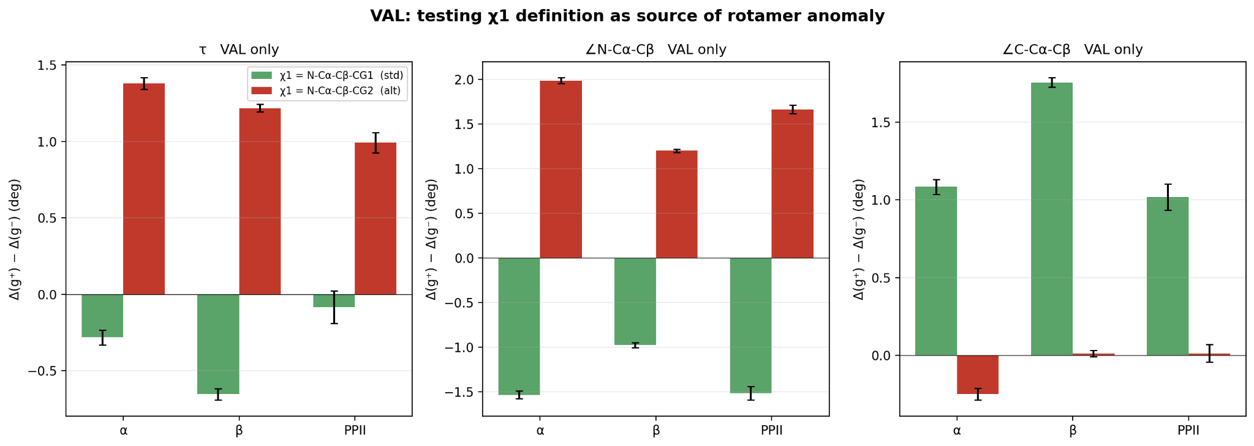
Figure S3. Val g⁺–g⁻ mean contrasts using N–Cα–Cβ–CG1 (standard) and N–Cα–Cβ–CG2 (alternative). Analysis is restricted to final-feature Val residue keys: 117,414 of 117,438 Val residues have the required atoms and geometry. Error bars are propagated residue-level SEM. Changing the terminal carbon changes rotamer group assignments; this comparison does not establish mislabeled atoms or a universal mechanism. The χ₁ difference is within 15° of ±120° for 99.9% of analysed residues.

