Systematic Bond-Angle Deformation Across Conformational Space
Running title: Context-dependent backbone geometry
Wei Chen¹,²,* and Xiaohong Lu²
¹ Department of Computer Science, Louisiana State University Shreveport, One University Place, Shreveport, LA 71115, USA
² Louisiana State University Health Sciences Center, Shreveport, LA 71103, USA
Present address: Wei Chen, Louisiana State University Health Sciences Center, Shreveport, LA 71103, USA
Correspondence: Wei Chen, wei.chen@lsuhs.edu
Co-author email: Xiaohong Lu, xiaohong.lu@lsuhs.edu
Article type: Research Article

Funding
This research received no specific grant from funding agencies in the public, commercial, or not-for-profit sectors.

Conflict of interest
The authors declare no conflicts of interest regarding the publication of this manuscript.

Data availability
Source coordinates are available from the Protein Data Bank. Supporting information includes the final PDB–chain manifest, the PISCES selection list and comparison, numerical source tables, saved relaxation results, and the supplied extraction and analysis scripts. The study code repository is https://github.com/wei09128/protein-backbone-mechanics.

Ethics statement
This study analyzes existing protein structure records and includes no new human-participant or animal experiments.

Abstract
Backbone bond angles in proteins are commonly represented by fixed geometric targets, although crystallographic structures show systematic context dependence. We analyze 1,636,322 residues from 7,938 X-ray structures to characterize associations of backbone geometry with conformation, side-chain identity, χ₁ rotamer state, and the surrounding environment. Residue-centered angular deviations exhibit distinct patterns across α, β, polyproline II, and left-handed α basins. Side-chain class and χ₁ rotamer state show observable-specific associations at the tetrahedral Cα center, with τ (the N–Cα–C valence angle) differing by up to approximately 1.5° between rotamer groups within a basin. Local-feature regression explains more variance for ∠N–Cα–Cβ (R² = 0.669) and τ (R² = 0.497) than for ∠C–Cα–Cβ (R² = 0.221) or the peptide torsion ω (R² = 0.115). Residual associations with hydrogen bonding, packing, and crystallographic B-factor differ among observables. Restrained molecular mechanics comparisons and resolution stratification provide complementary checks but do not exclude refinement bias or establish energetic mechanisms. The results describe a statistical hierarchy of protein backbone geometry and motivate direct validation of context-dependent geometry models in structural refinement and molecular simulation.
Keywords: Protein Conformation; Crystallography, X-Ray; Amino Acids; Molecular Conformation; Models, Molecular.

1. Introduction
The Ramachandran plot¹ records the preferred backbone dihedral conformations of proteins, but a complementary question is how local covalent geometry varies within this conformational space. Although these variations are typically only a few degrees, bond angles define the framework on which torsional energetics, side-chain placement, hydrogen bonding, and atomic packing depend. Here we ask how backbone conformation, side-chain identity, rotamer state, and the surrounding protein environment are associated with local backbone geometry.
The tetrahedral Cα atom provides the natural geometric link between the backbone and side chain. Because it connects N, C, Cβ, and H, changes in its bond angles are geometrically coupled. Among these substituents, Cβ is unique in varying size, topology, and rotamer state across amino acids, making it a candidate contributor to systematic geometric variation. We therefore asked whether Cβ substitution and χ₁ rotamer state are statistically associated with deformation of the Cα-centered bond angles and whether these changes covary with τ (∠N–Cα–C) and ω. Such relationships would be consistent with mechanical coupling through the tetrahedral Cα center, although the present observational analyses cannot establish the underlying physical mechanism.
Systematic deviations from ideal backbone geometry have long been recognized. The τ angle varies with secondary structure, and β-branched residues display characteristic conformational preferences commonly attributed to local steric effects.^{2,3,4} Conformation-dependent backbone geometry has also been quantified explicitly and used to develop a conformation-dependent geometry library.⁵ More broadly, small-molecule crystallography has established systematic relationships between substituent identity, torsion angle, and covalent geometry.^{6,7,8} Building on this literature, the present study jointly examines backbone conformation, residue identity, χ₁ rotamer state, and environmental associations in a large protein-structure dataset.
Here we analyze ~1.6 million residues from high-resolution crystal structures to characterize systematic deformation of τ, ω, ∠N–Cα–Cβ, and ∠C–Cα–Cβ. We test whether bond-angle variation is primarily determined by backbone conformation or whether residue identity, χ₁ rotamer state, and the surrounding protein environment provide additional explanatory power. Together, these analyses establish a hierarchical statistical framework linking backbone conformation, side-chain structure, and environmental context to local backbone geometry.

2. Materials and Methods

Structural dataset
The structural dataset comprises 1,636,322 residues from 7,938 protein chains in 7,938 PDB entries. Structures were selected using the Protein Data Bank (PDB)⁹ and the PISCES selection list cullpdb_pc25.0_res0.0-2.0_len40-10000_R0.25_Xray_d2026_05_14_chains9162¹⁰, which specifies ≤25% sequence identity, X-ray resolution ≤2.0 Å, crystallographic R-factor ≤0.25 and chain lengths of 40–10,000 residues. Following feature extraction and quality filtering, analysed chains were retained when their PDB–chain identifiers matched a PISCES-selected chain or the chain audit classified their amino-acid sequence as identical to a selected chain in the same PDB entry. The retained set contains 7,836 exact identifier matches (1,618,814 residues) and 102 sequence-identical alternatives (17,508 residues). The final feature input is chain_audit_features_pisces_consistent.csv. Glycine and proline are retained for analyses where the required geometric features are defined and excluded from Cβ-angle and χ₁ analyses as appropriate. The final chain manifest is supplied as supporting data.

Feature extraction
All geometric features were computed from observed crystallographic coordinates (pdb_loader.py), preserving the residue- and conformation-dependent bond-angle variation being measured. Coordinates reconstructed with fixed local geometry were avoided because fixed angle targets would replace that variation (Supplementary Note S1). Per residue: backbone dihedrals φ, ψ, ω by the signed-dihedral formula; bond angles τ (∠N–Cα–C), ∠N–Cα–Cβ, ∠C–Cα–Cβ as arc-cosines of normalised bond vectors; χ₁ and χ₂ where defined; sidechain mass, heavy-atom count, β-branching and aromaticity flags. Non-local features include per-atom steric density within 5 Å (N, Cα, C, O separately), backbone-local steric asymmetry vectors, Kabsch–Sander hydrogen-bond statistics¹¹ (threshold −0.5 kcal/mol; strong bonds < −2 kcal/mol), sidechain–backbone contact counts for residues i ± 1, and Cα B-factor. H-bond detection was validated against DSSP on 1UBQ and 1CRN (recall = 1.000, donor–acceptor Pearson r = 1.000). The loader reads ATOM records, excludes HETATM records, and selects the highest-occupancy alternative separately for each atom, breaking ties in favour of altloc A, then blank. Missing peptide-link atoms or a C(i)–N(i+1) distance >2.5 Å define chain breaks; undefined φ/ψ values are excluded by quality filtering. Only standard amino acids with defined φ and ψ are retained. Within each PDB–chain group, the mean Cα B-factor over the current row and up to three retained rows on either side must be ≤30 Å²; windows are truncated at chain ends and missing B-factors are assigned zero by the implementation. Windows follow retained row order and are not explicitly reset at gaps. At least 10 residues per chain must remain after filtering. This window criterion permits individual Cα B-factors above 30 Å². No separate R-free filter or blanket exclusion within ±3 positions of a chain break is applied by the supplied filter.

Ramachandran basins
Four (φ, ψ) windows isolate basin cores: α [−80°,−40°] × [−60°,−20°]; β [−150°,−90°] × [100°,160°]; PPII [−90°,−60°] × [120°,160°]; α_{L} [40°,80°] × [20°,80°]. Windows are intentionally narrow to minimise cross-basin contamination.

Per-residue deviation
To remove composition bias, deviations are defined as Δ = angle − median(angle | residue type), computed over the full dataset. For ω, median and difference use circular statistics (antipode method; shortest signed arc in [−180°,180°]).

Ramachandran heatmaps
Residues binned into 10° × 10° (φ, ψ) cells (minimum 30 residues); mean Δ per cell displayed with diverging colormap (display ranges as shown in Figure 2; τ approximately ±6°, ω ±18°, ∠N–Cα–Cβ ±4°, and ∠C–Cα–Cβ ±5°). Glycine and proline shown separately (Supplementary Fig. S1).

Sidechain class stratification
Residues assigned to five classes: G (glycine), A (alanine), U (unbranched: SER, CYS, LEU, MET, ASP, ASN, GLU, GLN, LYS, ARG), B (β-branched: VAL, ILE, THR), Ar (aromatic: PHE, TYR, TRP, HIS); proline excluded. Mean Δ and SEM computed per (angle × basin × class); pairwise Welch t-tests for B vs U and Ar vs U (32 comparisons; nominal P-values are reported in the source output). These residue-level tests and standard errors are descriptive; they do not account for dependence among residues within a protein structure.

χ₁ rotamer analysis
χ₁ wells: g⁻ (−150° to −30°), trans (|χ₁| ≥ 150°), g⁺ (30° to 150°); eclipsed residues (~5%) discarded. Rotamer shift reported as Δ(g⁺) − Δ(g⁻) with propagated SEM (cells with n < 30 in either well excluded).

Local vs non-local decomposition
Local contributions were modeled using gradient boosting regression (scikit-learn;¹² squared-error loss, 200 estimators, maximum depth 4, learning rate 0.05, random seed 42) trained on a random subset of 100,000 residues (70/30 train/test split). Predictors comprised φ, ψ, residue type (integer label encoded), χ₁, χ₂, mass, heavy-atom count, β-branching, aromaticity, and χ₁/χ₂ availability. Rows containing missing values were excluded. No hyperparameter optimization or cross-validation was performed because the models were used to estimate the relative explanatory power of local features rather than optimize prediction. Integer encoding permits threshold splits on an arbitrary ordering of residue labels and is not equivalent to native categorical treatment. The random split was performed at the residue level, so the reported test-set R² does not establish generalization to independent protein structures. Residual associations are descriptive and do not establish causal effects. For ω, the target is 180° − |ω| for trans peptides with |ω| >150°. Environmental effects are the range of predictor-bin mean residuals divided by residual SD; bootstrap errors use 200 residue-level resamples. Residuals are evaluated over the sampled training and test rows together. The 0.08 SD color threshold is a display threshold, not a significance test.

Sidechain lever arm
The side-chain lever arm was defined as the Euclidean distance between Cα and the center of the side-chain heavy atoms. Glycine was assigned a lever arm of zero. Bond lengths were joined to the final feature file using unique PDB identifier, chain and residue-index keys. This comparison contains 1,612,919 matched rows; 23,403 final-feature residues have no bond-file match.

Restrained molecular mechanics comparison
Restrained local molecular mechanics results were available for 376 residues in retained PISCES-consistent chains, spanning 10 residue types and four Ramachandran basins. The OpenMM runner prepares deposited structures with PDBFixer and AMBER ff14SB (amber14-all.xml), frees the target residue from positional restraints, and strongly restrains surrounding atoms. The recorded workflow specifies --k_dih 800, a target φ/ψ restraint strength of 800 kJ mol⁻¹ rad⁻², and no MechLib overlay. Each candidate starts from the same prepared coordinates; no dynamics steps are performed. Raw τ changes and residuals from a global linear adjustment for initial τ are compared with crystal deviation signs (Table S3).

Software and reproducibility
Python 3.11; NumPy 1.26, pandas 2.1, scikit-learn 1.4, SciPy 1.11, matplotlib 3.8. All p-values two-tailed; random seed 42 throughout.

3. Results

3.1 Systematic angular deviations across Ramachandran basins and residues
Protein backbones are commonly modeled using idealized geometries⁴, yet bond angles in folded structures show systematic deviations that depend on both Ramachandran basin and residue identity. To quantify these effects, we mapped mean angular deviations (Δ = θ_{observed} – θ_{median}) across the α, β, PPII, and α_{L} basins for 18 standard amino acids excluding glycine and proline (restricting to Cβ-containing and non-cyclic), within the full 1,636,322-residue dataset; observable-specific subsets exclude residues for which the required angles are undefined.
The backbone angles τ and ω (Fig. 2A,B) exhibit strong, basin-dependent deformations, indicating that local geometry is coupled to dihedral state: the relative orientation of successive peptide units modulates both peptide bond planarity and the Cα vertex. In contrast, ∠N–Cα–Cβ (φ-dependent) and ∠C–Cα–Cβ (ψ-dependent) show angle-specific patterns (Fig. 2C,D), consistent with geometric coupling around the Cα center.
Across the four observables, 270 of 288 residue–basin combinations agreed with the corresponding pooled basin sign. Approximate two-sided normal tests reconstructed from the printed mean deviations and SEM gave nominal P < 0.01 for 269 of 288 combinations (Table S1). These residue-level summaries do not account for dependence within protein structures or multiple testing.

3.2 Sidechain identity and χ₁ rotamer state are associated with systematic deformation of Cα-centered angles
We next asked whether the observed backbone deformations are systematically associated with side-chain identity and χ₁ rotamer state. Because Cβ is the only substituent whose size, branching, and rotameric state vary among amino acids, it provides a natural candidate for modulating local backbone geometry through the tetrahedral Cα center, which geometrically couples the backbone (N and C) to the side chain. Deformation amplitudes and signs differ among these classes, with the ordering dependent on the observable and Ramachandran basin (Fig. 3A).
Within the α basin, residue-type mean deviations are weakly linearly correlated with side-chain mass for τ (r = −0.087), ∠N–Cα–Cβ (r = −0.094), and ∠C–Cα–Cβ (r = −0.020); ω gives r = +0.268 (Fig. S2). Class contrasts depend on the observable and basin (Fig. 3A). For example, β-branched residues have a larger positive α-basin Δτ than unbranched residues (+0.867° versus +0.395°), but smaller-magnitude negative Δτ in β (−1.314° versus −1.889°) and PPII (−0.571° versus −0.937°). These patterns support observable-specific associations rather than a universal class ordering.
Glycine is not a neutral baseline for τ or ω. In the α basin its mean deviations are negative (τ: −0.384°; ω: −1.166°), whereas the other side-chain classes have positive means. In β its τ deviation is −2.424° and its ω deviation is −1.901°. Glycine should therefore be treated separately when interpreting residue-dependent geometry.
χ₁ rotamer state provides an additional axis of variation (Fig. 3B). For τ, the g⁺–g⁻ contrast is positive in 16 of 17 residue types in α and β and 15 of 17 in PPII; most αL estimates are unavailable because of sparse groups. In α, Ile gives +1.549 ± 0.056° and Val −0.281 ± 0.049°. A separate calculation using 117,414 retained Val residues with both terminal carbon atoms shows that defining the torsion with CG2 instead of standard CG1 changes the α, β and PPII τ contrasts to +1.379 ± 0.038°, +1.218 ± 0.025° and +0.993 ± 0.067°, respectively (Fig. S3). This demonstrates dependence on the torsion definition and group assignments, rather than establishing incorrect atom labeling.
The ω rotamer contrasts are more heterogeneous: positive contrasts occur for 12 of 17 residue types in α and 11 of 17 in β and PPII. Only one αL residue type satisfies the minimum group-size criterion. These patterns motivate further tests of local steric and electronic contributions.
Side-chain class and χ₁ rotamer state are associated with geometry in ways that depend on residue type, basin and observable. The results are compatible with geometric coupling at Cα, while the exceptions and sparse αL groups limit universal mechanistic interpretations.

3.3 Environmental associations differ among angular observables
We next asked whether the remaining variation reflects coupling to the surrounding protein environment. We therefore modeled the measured local predictors and analyzed the residuals for dependence on hydrogen bonding, steric packing and neighboring-residue contacts (Methods). The three backbone valence angles and the peptide torsion ω separated into distinct statistical regimes (Fig. 4).
Local features explain approximately half of τ variance (test R² = 0.4966). Its largest measured residual contrast is associated with strong hydrogen-bond count (0.100 ± 0.012 SD), followed by packing around C (0.093 ± 0.009 SD) and next-residue side-chain contacts (0.085 ± 0.013 SD; Fig. 4B,C). Strong hydrogen-bond count has negligible Pearson correlation with the residual (r = −0.003, P = 0.287); the binned contrast and linear correlation quantify different features of the association.
∠N–Cα–Cβ is best predicted by local features (test R² = 0.6689). Its largest measured environmental contrast is packing around C (0.100 ± 0.010 SD). These residual contrasts describe associations beyond the measured local predictors.
The ω model explains a smaller fraction of variance (test R² = 0.1151). The modeled target is unsigned trans-peptide non-planarity, 180° − |ω|, restricted to |ω| >150°. Its largest measured residual contrasts are packing around Cα (0.114 ± 0.009 SD), Cα B-factor (0.110 ± 0.009 SD), and next-residue side-chain contacts (0.109 ± 0.016 SD; Fig. 4B,D). The B-factor residual correlation is r = −0.040. B-factor reflects several sources of crystallographic variation and does not directly measure dynamical rigidity.
∠C–Cα–Cβ has test R² = 0.2210, with a largest measured environmental contrast of 0.085 ± 0.008 SD for packing around C. Low explanatory power does not itself identify weak energetic constraints.
Together, these results show that residual environmental associations differ among the angular observables. τ is associated with several measured environmental features; ω has low local-model R² and residual associations with B-factor and packing; and the two Cβ-coupled angles have smaller residual contrasts. These associations describe variation beyond the measured local predictors and do not identify equilibrium geometries or causal mechanisms.

3.4 Restrained relaxation and resolution stratification provide complementary comparisons
To compare the observed geometry with a fixed-angle molecular mechanics model, we examined local energy-relaxation results spanning 10 residue classes across the four Ramachandran basins (Table S3).
Among 376 saved relaxation results belonging to retained chains, raw sign agreement is 22 of 36 evaluable residue-type × basin groups (61%). A global fit gives Δτ_pred = 0.420081(111.1° − τ_pre) + 0.604762° (r = 0.482443). Subtracting this fitted component gives agreement in 30 of 36 groups (83%; Table S3). The remaining mismatches are Ala–PPII, His–PPII, Ile–α, Leu–α, Thr–α and Phe–β. This descriptive adjustment does not independently identify a force-field equilibrium or establish energetic validation.
The resolution diagnostic includes all standard residue types where each observable is defined, including Gly and Pro, and uses the same basin windows. All 16 angle–basin means retain their signs between strict ≤2.0 Å and ≤1.0 Å subsets (7,935 and 324 structures, respectively; Table S2). Magnitudes vary with resolution. Persistence of signs does not exclude refinement-restraint bias or establish force-field-independent energetic preferences.

3.5 Side-chain lever arm has different associations with angular and bond-length geometry
For 1,612,919 final-feature residues matched to the bond-length file, the squared Pearson correlation with side-chain lever arm is 0.0587 for τ and 0.0240 for Cα–C bond length (Figure 5). The mean Cα–C bond length differs by 0.0028 Å between the shortest- and longest-lever-arm quartiles (1.5225 versus 1.5253 Å). These statistics describe associations; they do not measure force constants, energetic stiffness or strain partitioning.

4. Discussion
Protein backbone bond angles are better described as context-dependent observed geometries than fixed ideal values. Rather than fluctuating randomly around canonical values, they vary systematically across nested structural scales. Backbone conformation is associated with the primary geometric pattern, side-chain substitution is associated with differences at the tetrahedral Cα center, χ₁ rotamer state shows further associations within residue classes, and the local environment shows angle-specific residual associations (Fig. 1). Together, these layers show that backbone geometry is an emergent property of coupled structural constraints.
The statistical framework separates basin-level patterns, residue-class differences, χ₁ rotamer contrasts, and residual environmental associations. These levels need not correspond to independent physical mechanisms, because the measured structural features covary and unmeasured interactions may contribute.
The tetrahedral Cα atom is the geometric hub of this hierarchy. As the only atom linking backbone and side chain, its bond-angle relationships impose geometric constraints. The coordinated behavior of τ, ∠N–Cα–Cβ, and ∠C–Cα–Cβ is consistent with a mechanically coupled tetrahedral network rather than independent angular fluctuations. Although observational, the widespread associations across residues, conformational basins, and rotamer states is consistent with geometric coupling through the tetrahedral Cα center.
The major Ramachandran basins show distinct patterns in τ and the Cβ-coupled angles. τ and ∠C–Cα–Cβ tend to increase in the α and α_{L} basins and decrease in the β and PPII basins. The ∠N–Cα–Cβ pattern is more dependent on residue class and does not follow a universal opposite-sign relationship (Figure 3A).
The peptide torsion has low local-model explanatory power and residual associations with packing and crystallographic B-factor. These observations complement previous reports of peptide non-planarity14 and motivate direct tests of proposed electronic mechanisms15–18; the present analysis does not identify their contributions.
These findings are relevant to models that use fixed bonded-equilibrium parameters. Such models omit explicit context-dependent shifts in their angle targets, although torsional and non-bonded terms can affect the realized geometry. Conformation-dependent geometry libraries already address part of this problem in structural modeling.⁵ The present comparisons motivate further evaluation of residue-, rotamer-, and environment-dependent extensions; they do not establish that all existing force fields or refinement protocols fail to represent the observed geometry.
By unifying conformation-dependent bond geometry, substituent effects, and peptide non-planarity within a single framework, this work provides a unified view of backbone mechanics. Rather than independent phenomena, conformation, side-chain substitution, rotamer state, and environmental interactions emerge as nested statistical associations acting through the same tetrahedral Cα center. This connects Ramachandran position with local covalent geometry while leaving the underlying energetics to be tested.
The relatively small Cα–C bond-length contrast is compatible with comparatively stable covalent bond lengths across the analyzed side-chain groups. The larger correlation for τ is a statistical observation; differences in stiffness or energy storage require independent energetic measurements or calculations.
These results have broad implications for structural modeling. Frameworks that assume fixed local geometry may omit some of the observed context dependence. Although individual deviations are modest (1–3°), their effects may influence energetic accuracy, structural refinement, and structure prediction. Whether incorporating these associations improves energetic accuracy, refinement, or structure prediction requires direct validation against those endpoints.
Several limitations remain. The analyses are observational and do not establish quantum mechanical mechanisms or causal effects. High crystallographic resolution does not remove refinement-restraint bias, and the restrained molecular mechanics comparisons do not constitute independent experimental validation. The residue-level train/test split, arbitrary integer encoding of residue type, and dependence among residues within structures limit the interpretation of model R² and nominal P-values. B-factors reflect multiple sources of variation and cannot be interpreted solely as backbone mobility. Explicit quantum chemistry calculations and validation of proposed geometry corrections in molecular dynamics or experimental observables were not performed. The analysis is restricted to X-ray structures selected through the PISCES acquisition list. Future studies should test structure-level generalization, refinement-software sensitivity, and independent experimental endpoints. The retained dataset includes 102 alternative chain identifiers classified as sequence-identical to PISCES-selected chains; equivalence of sequence does not imply identity of coordinates.

Conclusion
Protein backbone geometry shows systematic associations with Ramachandran basin, residue identity, χ₁ rotamer state, and measured environmental features. The patterns motivate context-dependent structural models, while their energetic interpretation and benefit for refinement or simulation require independent validation.

Acknowledgments
The authors thank the Louisiana State University Health Sciences Center Shreveport for logistical support.

Author contributions
Wei Chen: study design, data acquisition and curation, software, formal analysis, visualization, and manuscript drafting and revision. Xiaohong Lu: research supervision, conceptual guidance, scientific direction, and intellectual input on analyses and manuscript review.

Supporting information
Supplementary Note S1; Figures S1–S3; Table S1 (signed angle-, residue-, and basin-resolved deviations and approximate nominal tests); Table S2 (resolution-stratified angular deviations); Table S3 (restrained molecular mechanics relaxation comparison).

References
1. Ramachandran, G. N.; Ramakrishnan, C.; Sasisekharan, V. Stereochemistry of Polypeptide Chain Configurations. J. Mol. Biol. 1963, 7 (1), 95–99. https://doi.org/10.1016/S0022-2836(63)80023-6
2. Carey, J.; Benoff, B.; Harish, B.; Yuan, L.; Lawson, C. L. Environment-Dependent Long-Range Structural Distortion in a Temperature-Sensitive Point Mutant. Protein Sci. 2012, 21 (1), 63–74. https://doi.org/10.1002/pro.759
3. Towse, C.-L.; Vymetal, J.; Vondrasek, J.; Daggett, V. Insights into Unfolded Proteins from the Intrinsic φ/ψ Propensities of the AAXAA Host–Guest Series. Biophys. J. 2016, 110 (2), 348–361. https://doi.org/10.1016/j.bpj.2015.12.008
4. Engh, R. A.; Huber, R. Accurate Bond and Angle Parameters for X-ray Protein Structure Refinement. Acta Crystallogr., Sect. A: Found. Crystallogr. 1991, 47 (4), 392–400. https://doi.org/10.1107/S0108767391001071
5. Berkholz, D. S.; Shapovalov, M. V.; Dunbrack, R. L., Jr.; Karplus, P. A. Conformation Dependence of Backbone Geometry in Proteins. Structure 2009, 17 (10), 1316–1325. https://doi.org/10.1016/j.str.2009.08.012
6. Allen, F. H. The Geometry of Small Rings. I. Substituent-Induced Bond-Length Asymmetry in Cyclopropane. Acta Crystallogr., Sect. B: Struct. Sci. 1980, 36 (1), 81–96. https://doi.org/10.1107/S0567740880002711
7. Allen, F. H.; Kennard, O.; Taylor, R. Systematic Analysis of Structural Data as a Research Technique in Organic Chemistry. Acc. Chem. Res. 1983, 16 (5), 146–153. https://doi.org/10.1021/ar00089a001
8. Bürgi, H.-B.; Dunitz, J. D., Eds. Structure Correlation, Vols. 1–2; VCH: Weinheim, 1994.
9. Berman, H. M.; Westbrook, J.; Feng, Z.; Gilliland, G.; Bhat, T. N.; Weissig, H.; Shindyalov, I. N.; Bourne, P. E. The Protein Data Bank. Nucleic Acids Res. 2000, 28 (1), 235–242. https://doi.org/10.1093/nar/28.1.235
10. Wang, G.; Dunbrack, R. L., Jr. PISCES: A Protein Sequence Culling Server. Bioinformatics 2003, 19 (12), 1589–1591. https://doi.org/10.1093/bioinformatics/btg224
11. Kabsch, W.; Sander, C. Dictionary of Protein Secondary Structure: Pattern Recognition of Hydrogen-Bonded and Geometrical Features. Biopolymers 1983, 22 (12), 2577–2637. https://doi.org/10.1002/bip.360221211
12. Pedregosa, F.; Varoquaux, G.; Gramfort, A.; Michel, V.; Thirion, B.; Grisel, O.; Blondel, M.; Prettenhofer, P.; Weiss, R.; Dubourg, V.; Vanderplas, J.; Passos, A.; Cournapeau, D.; Brucher, M.; Perrot, M.; Duchesnay, É. Scikit-learn: Machine Learning in Python. J. Mach. Learn. Res. 2011, 12, 2825–2830. https://www.jmlr.org/papers/v12/pedregosa11a.html
13. Maier, J. A.; Martinez, C.; Kasavajhala, K.; Wickstrom, L.; Hauser, K. E.; Simmerling, C. ff14SB: Improving the Accuracy of Protein Side Chain and Backbone Parameters from ff99SB. J. Chem. Theory Comput. 2015, 11 (8), 3696–3713. https://doi.org/10.1021/acs.jctc.5b00255
14. MacArthur, M. W.; Thornton, J. M. Deviations from Planarity of the Peptide Bond in Peptides and Proteins. J. Mol. Biol. 1996, 264 (5), 1180–1195. https://doi.org/10.1006/jmbi.1996.0705
15. Choudhary, A.; Raines, R. T. Signature of n→π* Interactions in α-Helices. Protein Sci. 2011, 20 (6), 1077–1081. https://doi.org/10.1002/pro.627
16. Esposito, L.; Vitagliano, L.; Zagari, A.; Mazzarella, L. Pyramidalization of Backbone Carbonyl Carbon Atoms in Proteins. Protein Sci. 2000, 9 (10), 2038–2042. https://doi.org/10.1110/ps.9.10.2038
17. Newberry, R. W.; VanVeller, B.; Guzei, I. A.; Raines, R. T. n→π* Interactions of Amides and Thioamides: Implications for Protein Stability. J. Am. Chem. Soc. 2013, 135 (21), 7843–7846. https://doi.org/10.1021/ja4033583
18. Daniecki, N. J.; Yap, G. P. A.; Zondlo, N. J. Amide Nitrogen Pyramidalization via N–H•••N Interactions That Stabilize the δ/α Conformations in Turns, Loops, and 3(10)- and α-Helices. ACS Chem. Biol. 2025, 20 (11), 2617–2629. https://doi.org/10.1021/acschembio.5c00451

Table 1
Table 1. Per-residue backbone valence angle τ and basin-specific deviation. Median τ and mean Δτ ± SEM are reported in degrees. Δτ is the observed angle minus the global median for that residue type.
Residue | Median τ (°) | α Δτ (°), mean ± SEM | β Δτ (°), mean ± SEM | PPII Δτ (°), mean ± SEM | αₗ Δτ (°), mean ± SEM
ALA | 111.078 | +0.310 ± 0.005 | -1.776 ± 0.016 | -0.704 ± 0.017 | +0.987 ± 0.048
ARG | 111.010 | +0.387 ± 0.008 | -1.840 ± 0.017 | -0.923 ± 0.024 | +1.056 ± 0.044
ASN | 111.422 | +0.333 ± 0.012 | -2.381 ± 0.023 | -1.364 ± 0.031 | +0.966 ± 0.022
ASP | 111.079 | +0.383 ± 0.009 | -2.491 ± 0.022 | -1.242 ± 0.023 | +0.973 ± 0.029
CYS | 110.816 | +0.646 ± 0.019 | -1.352 ± 0.030 | -0.431 ± 0.046 | +1.452 ± 0.100
GLN | 111.093 | +0.313 ± 0.009 | -1.824 ± 0.020 | -0.976 ± 0.028 | +0.890 ± 0.047
GLU | 111.167 | +0.288 ± 0.006 | -1.990 ± 0.017 | -1.115 ± 0.021 | +1.005 ± 0.044
HIS | 111.011 | +0.508 ± 0.014 | -1.778 ± 0.023 | -0.997 ± 0.034 | +1.234 ± 0.051
ILE | 109.741 | +0.917 ± 0.007 | -1.444 ± 0.010 | -0.610 ± 0.023 | +1.491 ± 0.326
LEU | 110.923 | +0.447 ± 0.005 | -1.876 ± 0.011 | -0.824 ± 0.017 | +1.075 ± 0.061
LYS | 111.072 | +0.371 ± 0.008 | -1.856 ± 0.017 | -1.048 ± 0.023 | +0.861 ± 0.035
MET | 110.941 | +0.434 ± 0.013 | -1.651 ± 0.026 | -0.726 ± 0.037 | +0.972 ± 0.096
PHE | 110.706 | +0.561 ± 0.010 | -1.354 ± 0.015 | -0.645 ± 0.026 | +1.619 ± 0.066
SER | 111.187 | +0.554 ± 0.009 | -1.525 ± 0.017 | -0.570 ± 0.019 | +1.174 ± 0.048
THR | 110.645 | +0.552 ± 0.010 | -1.411 ± 0.013 | -0.715 ± 0.024 | +1.632 ± 0.159
TRP | 110.857 | +0.604 ± 0.016 | -1.506 ± 0.028 | -0.713 ± 0.038 | +1.356 ± 0.115
TYR | 110.803 | +0.507 ± 0.010 | -1.308 ± 0.016 | -0.647 ± 0.028 | +1.387 ± 0.068
VAL | 109.661 | +1.028 ± 0.007 | -1.170 ± 0.009 | -0.442 ± 0.020 | +1.040 ± 0.195
SEM, standard error of the mean; τ, N–Cα–C valence angle; Δτ, observed τ minus the residue-specific median. α, right-handed α; β, extended; PPII, polyproline II; α_{L}, left-handed α. Glycine and proline are excluded from this table. Standard errors are residue-level summaries.

Figure legends
Figure 1. Schematic framework for associations in local backbone geometry. Ramachandran position, side-chain class, and χ₁ rotamer state are considered alongside residual environmental associations. τ is the N–Cα–C valence angle; ω is the peptide torsion. The schematic illustrates the proposed interpretation and does not establish causal direction or energy transfer.
Figure 2. Residue-centered angular deviations across the Ramachandran plane. Eighteen standard residue types are pooled after subtracting each residue type’s global median; Δ is not a difference from Engh–Huber ideal geometry. Bins contain at least 30 residues; lower-occupancy bins are gray. (A) τ, the N–Cα–C valence angle. (B) Peptide torsion ω, with circular deviations as defined in Materials and Methods. (C) ∠N–Cα–Cβ. (D) ∠C–Cα–Cβ. Dashed boxes mark the α, β, polyproline II (PPII), and left-handed α (α_{L}) basin windows.
Figure 3. Side-chain class and χ₁ rotamer associations. (A) Mean residue-centered deviations by Ramachandran basin and side-chain class: G, glycine; A, alanine; U, unbranched; B, β-branched; Ar, aromatic. Bars show the standard error of the mean. Class order depends on the angle and basin; no universal amplification hierarchy is implied. Glycine has no Cβ, so Cβ-angle panels do not contain a meaningful glycine estimate. (B) Rotamer contrasts, Δ(g⁺) − Δ(g⁻), within residue types and basins. g⁻ and g⁺ designate the χ₁ groups defined in Materials and Methods; gray cells denote unavailable estimates. Basin stratification does not hold φ and ψ exactly fixed.
Figure 4. Local-model prediction and residual environmental associations. (A) Test-set R² from local-feature models, using a residue-level split. (B) Standardized residual contrasts for measured environmental predictors; error bars represent the bootstrap standard error reported in the source analysis. Red bars identify contrasts above the displayed effect threshold. (C) Mean τ residual by strong backbone hydrogen-bond count. (D) Mean ω residual by Cα B-factor. Shading in C and D shows bin-level 95% confidence intervals; gray bars show bin counts on the right axes. SD, standard deviation; hb_n_strong, number of strong backbone hydrogen bonds; sc_contact_np1_to_bb, next-residue side-chain contacts with backbone; steric_X_5A, steric density within 5 Å of atom X; steric_asym_x/z, components of steric asymmetry; hb_best_e/d_HO, hydrogen-bond energy and H···O distance descriptors. These are descriptive associations, not causal or dynamical measurements.
Figure 5. Associations of side-chain lever arm with backbone geometry for 1,612,919 residues matched by PDB identifier, chain and residue index to the final feature dataset; 23,403 feature residues lack bond-file rows. (A) τ relative to a fixed 111° baseline. (B) Cα–C length relative to 1.525 Å. These plotting baselines differ from the residue-specific medians used in Figures 2 and 3. (C) Squared Pearson correlations with geometric observables; these do not measure mechanical stiffness. φ and ψ are treated as numerical angular values in this exploratory comparison, so their correlations depend on the angular representation. (D) Cα–C bond-length distributions by lever-arm quartile; the Q4–Q1 mean difference is 0.0028 Å. μ, quartile mean; DOF, geometric degree of freedom.

Figure 1
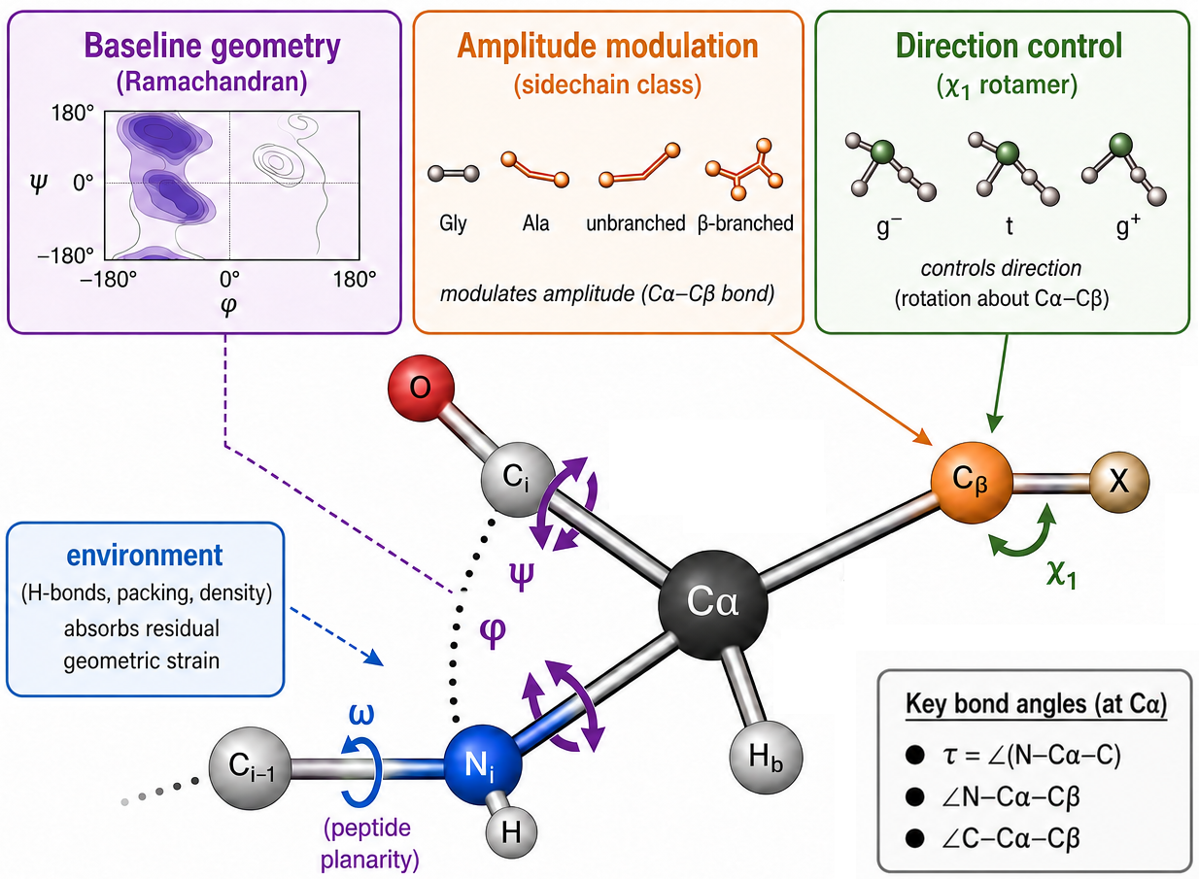
Figure 1. Schematic framework for associations in local backbone geometry. Ramachandran position, side-chain class, and χ₁ rotamer state are considered alongside residual environmental associations. τ is the N–Cα–C valence angle; ω is the peptide torsion. The schematic illustrates the proposed interpretation and does not establish causal direction or energy transfer.

Figure 2
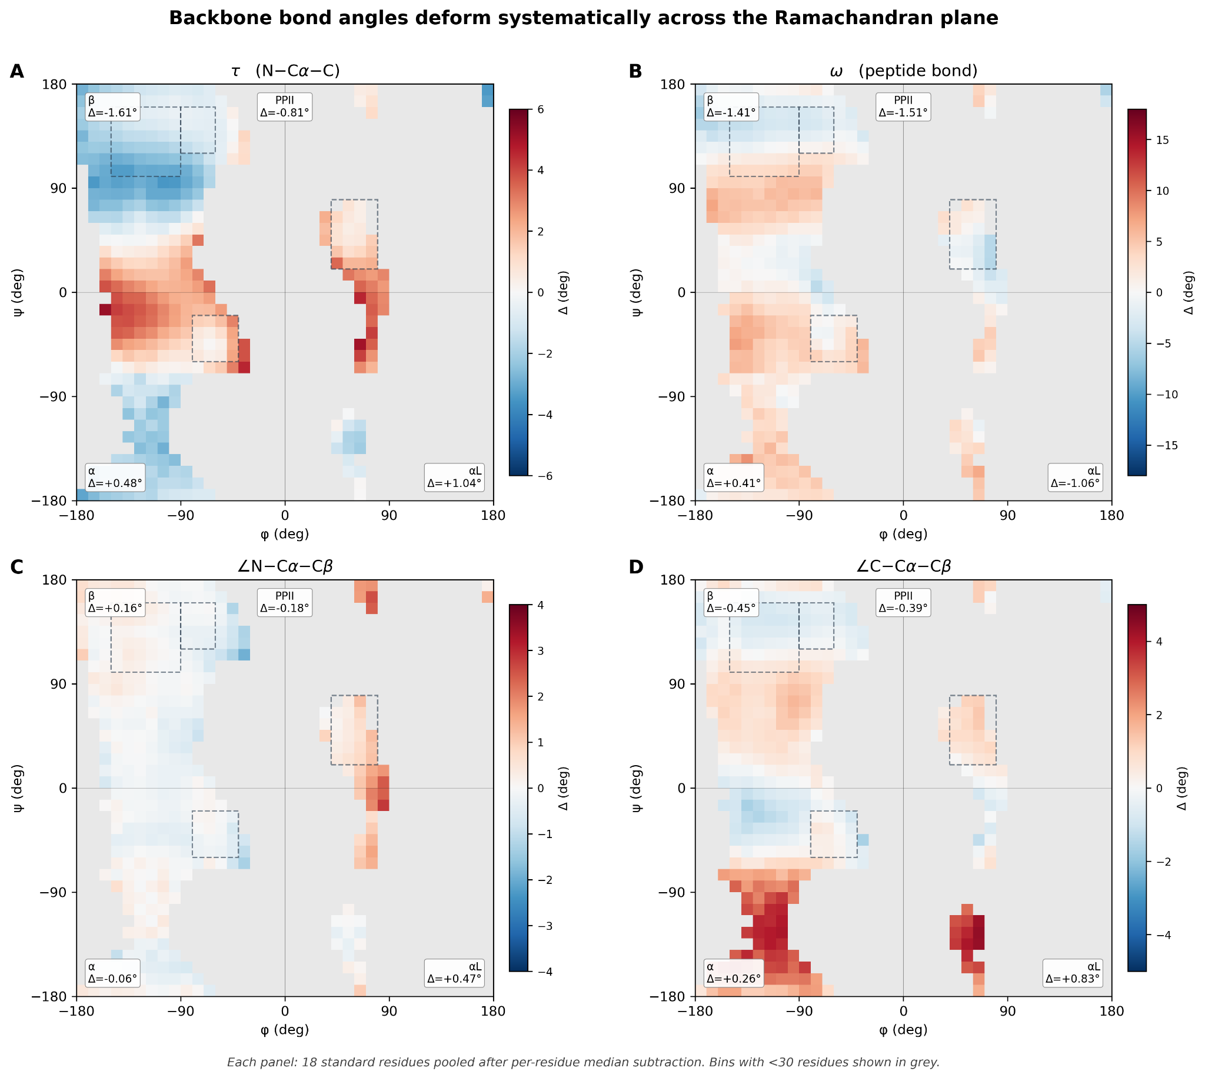
Figure 2. Residue-centered angular deviations across the Ramachandran plane. Eighteen standard residue types are pooled after subtracting each residue type’s global median; Δ is not a difference from Engh–Huber ideal geometry. Bins contain at least 30 residues; lower-occupancy bins are gray. (A) τ, the N–Cα–C valence angle. (B) Peptide torsion ω, with circular deviations as defined in Materials and Methods. (C) ∠N–Cα–Cβ. (D) ∠C–Cα–Cβ. Dashed boxes mark the α, β, polyproline II (PPII), and left-handed α (α_{L}) basin windows.

Figure 3
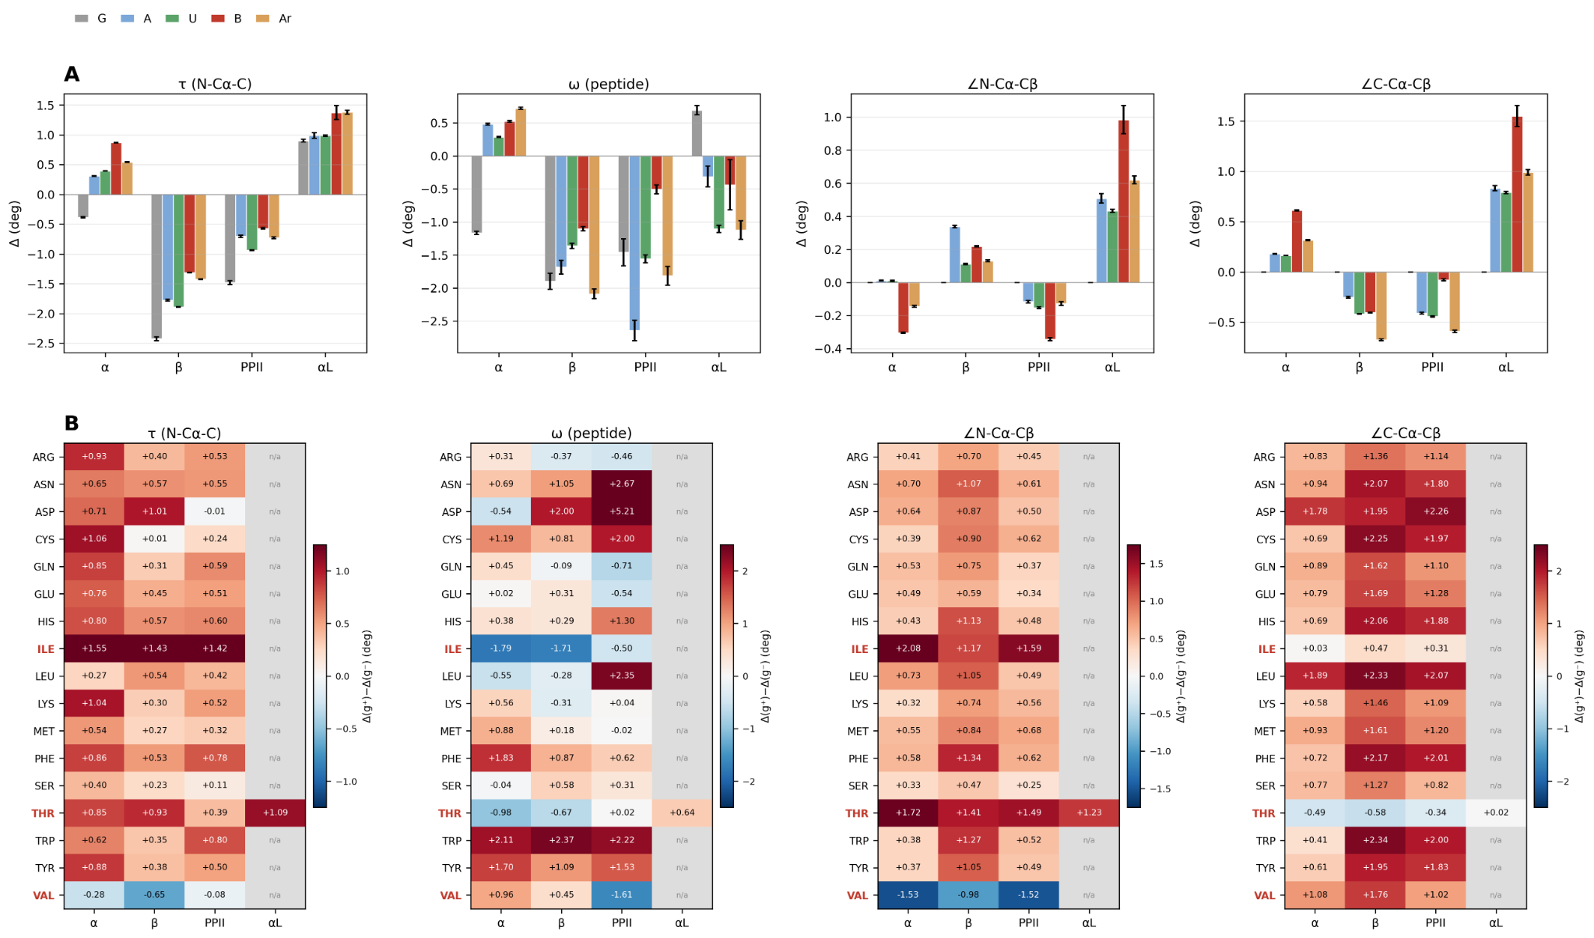
Figure 3. Side-chain class and χ₁ rotamer associations. (A) Mean residue-centered deviations by Ramachandran basin and side-chain class: G, glycine; A, alanine; U, unbranched; B, β-branched; Ar, aromatic. Bars show the standard error of the mean. Class order depends on the angle and basin; no universal amplification hierarchy is implied. Glycine has no Cβ, so Cβ-angle panels do not contain a meaningful glycine estimate. (B) Rotamer contrasts, Δ(g⁺) − Δ(g⁻), within residue types and basins. g⁻ and g⁺ designate the χ₁ groups defined in Materials and Methods; gray cells denote unavailable estimates. Basin stratification does not hold φ and ψ exactly fixed.

Figure 4
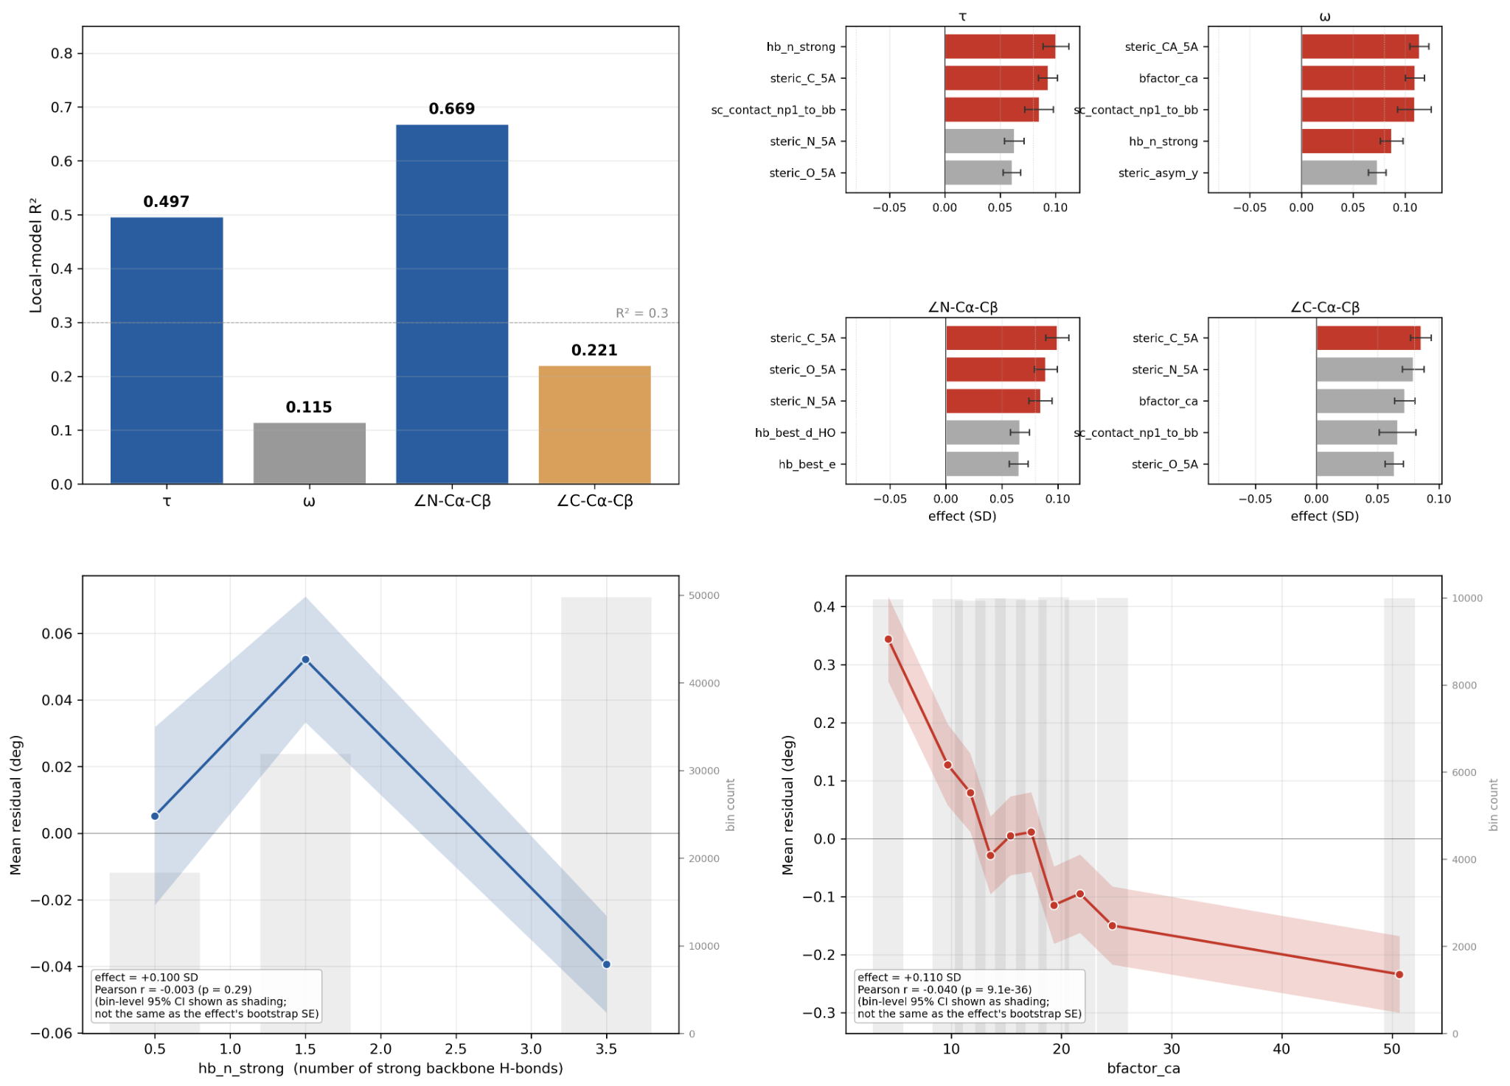
Figure 4. Local-model prediction and residual environmental associations. (A) Test-set R² from local-feature models, using a residue-level split. (B) Standardized residual contrasts for measured environmental predictors; error bars represent the bootstrap standard error reported in the source analysis. Red bars identify contrasts above the displayed effect threshold. (C) Mean τ residual by strong backbone hydrogen-bond count. (D) Mean ω residual by Cα B-factor. Shading in C and D shows bin-level 95% confidence intervals; gray bars show bin counts on the right axes. SD, standard deviation; hb_n_strong, number of strong backbone hydrogen bonds; sc_contact_np1_to_bb, next-residue side-chain contacts with backbone; steric_X_5A, steric density within 5 Å of atom X; steric_asym_x/z, components of steric asymmetry; hb_best_e/d_HO, hydrogen-bond energy and H···O distance descriptors. These are descriptive associations, not causal or dynamical measurements.

Figure 5
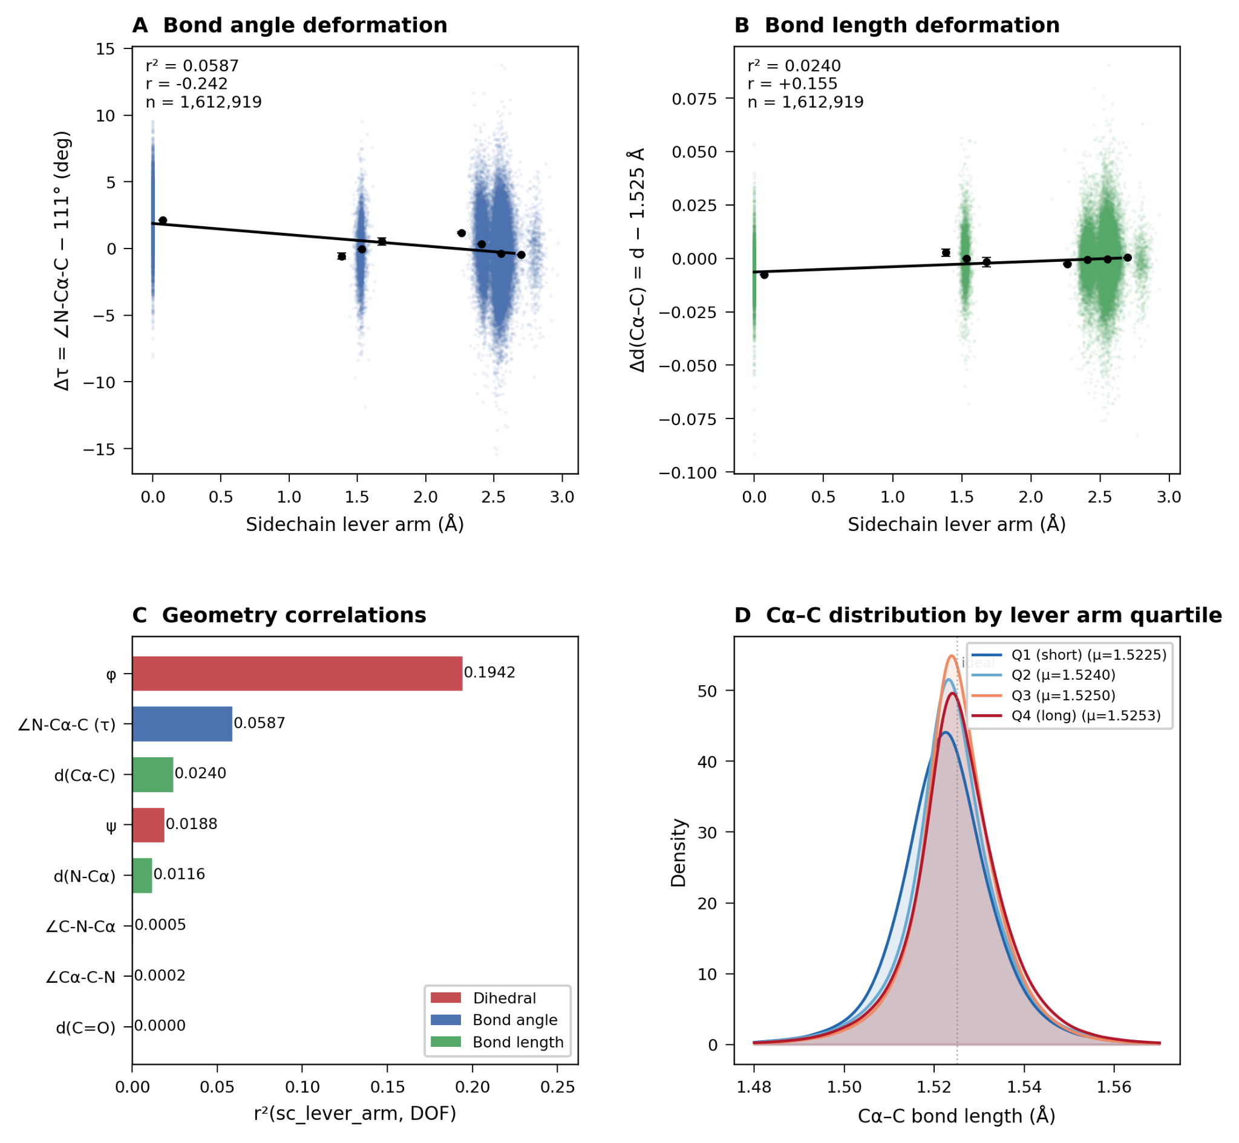
Figure 5. Associations of side-chain lever arm with backbone geometry for 1,612,919 residues matched by PDB identifier, chain and residue index to the final feature dataset; 23,403 feature residues lack bond-file rows. (A) τ relative to a fixed 111° baseline. (B) Cα–C length relative to 1.525 Å. These plotting baselines differ from the residue-specific medians used in Figures 2 and 3. (C) Squared Pearson correlations with geometric observables; these do not measure mechanical stiffness. φ and ψ are treated as numerical angular values in this exploratory comparison, so their correlations depend on the angular representation. (D) Cα–C bond-length distributions by lever-arm quartile; the Q4–Q1 mean difference is 0.0028 Å. μ, quartile mean; DOF, geometric degree of freedom.

