MechLib: A Conformation-Dependent Geometry Correction Library for Protein and DNA Backbones
Wei Chen, Xiaohong Lu
Louisiana State University Health Sciences Center, Shreveport
Corresponding Author: Wei Chen (wei09128@gmail.com)

Abstract
Classical molecular mechanics force fields represent protein and nucleic acid backbone bond lengths and bond angles with fixed harmonic equilibrium values, despite extensive evidence that equilibrium geometry depends on local backbone conformation. We present MechLib, a conformation-dependent equilibrium-geometry library built from 1.7 million residues in high-resolution crystal structures, and evaluate it primarily with tests whose outcome is not guaranteed by construction. In a static perturb–minimize–recover test on 300 temporally held-out structures, minimizing toward MechLib equilibria recovered the deposited backbone with 33.1% lower RMSD than minimizing toward fixed AMBER ff14SB equilibria (95% CI 32.0–34.1%), whereas a conformation-shuffled library performed worse than the fixed reference. In a prespecified benchmark of 80 ACE–X–NME peptides constrained at four backbone conformations and optimized at the ωB97X-D/def2-SVP level, the registered average weighted geometry error favored MechLib (mean Δ = 0.00933; residue-clustered 95% CI 0.00263–0.01666; 14 of 20 residue means positive), but the strict registered endpoint failed because three bond terms—N–Cα, C–O, and C–N(next)—were significantly worse after Holm correction. An exploratory 1 ns paired MD pilot on GB3 and ubiquitin favored MechLib in backbone ³J(HN,Hα) agreement in five of six seed pairs (equal-protein mean MSE difference 0.126 Hz²) but does not establish convergence. Descriptively, MechLib reduces backbone phantom strain against crystallographic geometry by 39.6% (34.4% in REFMAC-refined structures, which lack conformation-dependent refinement restraints), and an extension to the DNA sugar–phosphate backbone shows larger descriptive strain reduction and measurable sugar-pucker–glycosidic-torsion coupling. Together, the results support conformation-dependent equilibrium geometry as a useful but term-dependent correction layer and identify specific peptide-bond parameters that require revision before a uniform physical-improvement claim is justified.
Keywords: Conformation-dependent library (CDL), Empirical force fields, Backbone geometry relaxation, Rotamer-backbone interaction, Non-additive coupling, Constrained quantum-mechanical benchmark, DNA backbone
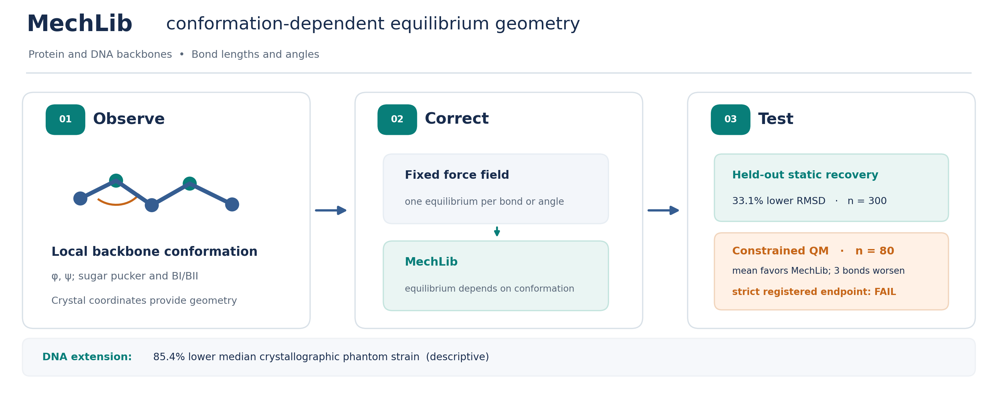

1. Introduction
Ramachandran conformational preferences reflect real physical and statistical mechanics; backbone-dependent rotamer libraries, knowledge-based potentials, and structure-validation tools treat these distributions as far more than simple steric exclusion. Local (ϕ, ψ) conformations represent dynamic equilibria among steric, electrostatic, and hydrogen-bonding forces, which we and others have proposed govern bond-angle hierarchies and non-additive ϕ/ψ coupling in equilibrium backbone geometry¹⁴,¹⁵. Independent of that broader framework, the present work demonstrates directly (Section 3.2) that correcting for conformation-dependent equilibrium geometry improves recovery of true backbone structure — establishing the practical claim on its own empirical footing rather than as a corollary of the coupling hypothesis.
These mechanical forces propagate directly into three-dimensional geometry, making bond lengths and bond angles conformation-dependent outcomes rather than fixed parameters. Consequently, standard molecular mechanics force fields—which represent backbone geometry using fixed harmonic equilibrium values—introduce systematic phantom strain: artificial energetic penalties arising from rigid geometric assumptions rather than true physical strain. Because individual X-ray bond angles carry coordinate uncertainties comparable to or larger than these systematic shifts, the effect is not observable in any single structure. Instead, it emerges only from statistical averaging over hundreds of thousands of independent experimental observations.
Because a library of bin-averaged equilibria necessarily fits the structures it was built from better than a single fixed value, agreement with crystallographic geometry cannot by itself establish that the correction is physically meaningful. We therefore organize the evaluation by evidentiary strength. We first characterize, descriptively, how much and where MechLib reduces phantom strain against crystallographic geometry, including a temporally blind holdout and controls for resolution and refinement-restraint confounding (Section 3.1). We then test MechLib out of sample and against observables it was not fit to: recovery of held-out structures after perturbation and energy minimization (Section 3.2), a prespecified constrained quantum-mechanical geometry benchmark (Section 3.3), and an exploratory molecular-dynamics comparison with NMR scalar couplings (Section 3.4). Finally, we extend the framework to the DNA sugar–phosphate backbone, including a separability test of equilibrium geometry across two torsional degrees of freedom analogous to the protein φ–ψ analysis (Section 3.5).

2. Methods

2.1 Dataset Curation and Feature Extraction
A non-redundant set of protein chains was generated using the PISCES server¹ ($≤25\text{\%}$ sequence identity, resolution $≤2.0$ Å, $R\text{-factor}≤0.25$, length $≥40$ residues), yielding 9,162 chains downloaded in batch from the RCSB PDB². Following quality filtering—retaining only standard amino acids with defined ($ϕ,ψ$) torsions and a per-residue sliding-window $B$-factor $≤30$—the final protein dataset comprised 8,292 structures (1,698,562 residues).
Structures were parsed directly from PDB coordinate records (model 1 only; HETATM records excluded). Where alternate locations were present, the highest-occupancy conformer was retained, with ties broken toward altloc 'A'. Amide hydrogens — absent from most X-ray depositions — were placed geometrically from each residue's own N and the preceding residue's C and O, following the Kabsch–Sander convention: H = N + 1.01 Å · (C(i−1) − O(i−1))/|C(i−1) − O(i−1)|; proline residues, lacking an amide hydrogen, were excluded from this step. Chain breaks were flagged wherever the sequential C(i)–N(i+1) distance exceeded 2.5 Å, and dihedral or geometry calculations spanning a flagged break were treated as undefined rather than computed across the discontinuity.
Backbone torsions were computed as φ(i) = dihedral(C(i−1), Nᵢ, Cαᵢ, Cᵢ), ψ(i) = dihedral(Nᵢ, Cαᵢ, Cᵢ, N(i+1)), and ω(i) = dihedral(Cαᵢ, Cᵢ, N(i+1), Cα(i+1)), all from directly observed atomic coordinates (no internal-coordinate reconstruction). Backbone bond lengths were computed as Euclidean distances between bonded atom pairs; bond angles as the arccosine of the normalized dot product between the two bond vectors meeting at the vertex atom. Side-chain χ1 and χ2 torsions were computed analogously from each residue's respective heavy-atom chains where applicable.
DNA structures were retrieved via the RCSB Search API (X-ray, resolution $≤3.0$ Å, polymer entity restricted to DNA) and processed through an analogous per-nucleotide pipeline. This extractor computed six backbone torsions, glycosidic torsions, sugar pucker parameters, BI/BII backbone classifications, and bonded geometries directly from coordinates. PDB release dates were retrieved via the RCSB GraphQL API, and reference force-field parameter sources were independently verified against their authoritative primary distributions.

2.2 Reference parameters
All reference force-field parameters used in this study were independently verified against their authoritative primary distributions rather than propagated from secondary tabulations. AMBER ff14SB backbone bond and angle parameters were verified directly against protein.ff14SB.xml³ (OpenMM AmberTools-derived distribution), OPLS-AA/M parameters against the official CHARMM-format distribution^{4,5} (Jorgensen group, Yale University), CHARMM36 CMAP grids against par_all36m_prot.prm^{6,7}, and AMBER DNA backbone parameters (parm10.dat, incorporating the parmbsc0⁸ and parmbsc1⁹ refinements) against the standard AmberTools distribution. All reported analyses use the verified reference parameters. Because identical force constants are applied to both the reference and MechLib strain calculations for each geometric term, force-constant values cancel exactly in the strain-reduction percentage; we confirmed this both algebraically and empirically. Equilibrium geometry values do not exhibit this cancellation and were therefore verified directly from the primary sources prior to all analyses.
In preparing the independent validation described in Section 2.7, we re-verified all eleven AMBER ff14SB parameters directly against the primary AmberTools distribution (parm10.dat), independently of the verification described above. This identified one additional force-constant error not caught in the original verification pass: the N-Cα-Cβ bond angle's force constant was k = 63.0 kcal·mol⁻¹·rad⁻² in our original analysis, where the verified value is k = 80.0 kcal·mol⁻¹·rad⁻² (parm10.dat, entry CT-CX-N). This has been corrected throughout, including in the strain-reduction statistics reported in Section 3.1 (revised from 38.7% to 39.6%; Fig. 1).

2.3 Data quality control
During protein feature extraction and the associated steric analysis, we checked three sources of systematic artifact. Disulfide-bonded cysteine pairs were detected independently of sequence position, via Cys Sγ–Sγ distance evaluated across the entire structure (≤2.5 Å, consistent with the ~2.05 Å covalent S–S bond length), and excluded from non-bonded steric calculations rather than being miscounted as clashes. Alternate-location and partial-occupancy atoms were handled by computing cross-residue non-bonded interactions only between atom pairs with occupancy ≥0.999 on both sides, rather than by attempting to match altLoc labels across residues — altLoc codes are assigned independently per residue and carry no guaranteed correspondence between residues, so occupancy-based filtering avoids pairing alternate conformers that are never simultaneously present in the physical structure. Solvent and heteroatom leakage into intrinsic backbone calculations was excluded by construction: only atoms belonging to one of the 20 standard amino acids were included in the non-bonded neighbor search, so waters, ligands, and other heteroatoms never contribute to backbone-intrinsic torque or strain calculations. After these corrections, direct atomic-distance inspection confirmed 91 residues across 43 structures (0.52% of the 8,292 structures; Table S1) as genuine local crystallographic modeling defects — predominantly involving Lys and Asn side chains (23 and 22 of 91 residues, respectively) — which were excluded and are documented by PDB ID and residue index.

2.4 MechLib construction
For each backbone bond length and bond angle, a conformation-dependent correction library was constructed by jointly binning residues according to residue type and 10° × 10° (φ,ψ) bins. The local mean observed geometry within each populated bin was taken as the equilibrium value. When a residue-specific bin contained fewer than 10 observations, the equilibrium was replaced by the pooled (φ,ψ)-only mean to maintain statistical stability.
For each residue, phantom strain was then calculated for all 11 backbone bond and angle terms using both the reference force-field equilibrium geometry (E_ref) and the corresponding MechLib equilibrium (E_MechLib), while holding the observed geometry and force constant constant. Individual term energies were summed to obtain the total strain per residue. Protein strain reduction was reported as
$$100×\frac{\overset{´}{E_{ref}}\text{-}\overset{´}{E_{MechLib}}}{\overset{´}{E_{ref}}},$$
whereas DNA analyses used the corresponding median-based statistic because of the broader energy distribution. Confidence intervals were obtained from 2,000 structure-level bootstrap resamples.
Note on Scope: This bonded strain calculation isolatedly evaluates local geometric strain and does not represent the full potential energy surface, which incorporates torsional and non-bonded interactions driving secondary-structure formation. MechLib addresses exclusively the equilibrium-geometry component of the bonded energy terms.

2.5 Statistical validation
Bootstrap confidence intervals were computed by resampling entire structures (not individual residues) with replacement, 2,000 iterations, since residues within the same PDB entry are not independent observations. A temporally blind train/test validation was performed using PDB initial release dates obtained via the RCSB GraphQL API for all 8,292 structures: the MechLib correction library was rebuilt using only the 6,170 structures released before January 1, 2020, and strain reduction was evaluated on the 2,122 structures released 2020–2026 — entirely unseen during library construction.

2.6 Refinement-software stratification
Because the Berkholz conformation-dependent library (CDL)¹¹ has been implemented as the default backbone restraint set in PHENIX¹²'¹³, structures refined with CDL-based restraints may already carry (φ,ψ)-dependent backbone geometry prior to any MechLib correction, independent of the physical regularity MechLib is intended to capture. Structures were categorized by refinement program (REFMAC, PHENIX, CNS/X-PLOR, BUSTER, TNT, or OTHER/UNKNOWN) by parsing the REMARK 3 PROGRAM field of each PDB header, excluding categories with fewer than 20 structures. Strain-reduction estimates were recomputed within each software stratum and across high-resolution ($≤1.5$ \AA) versus standard-resolution (1.5–2.0 \AA) bins using the bootstrap procedure described above (2,000 resamples, resampled by structure). As a confound-minimized sensitivity control, the analysis was restricted to REFMAC-refined structures—which do not incorporate the Berkholz conformation-dependent library (CDL) default restraints implemented in PHENIX—and further partitioned by secondary-structure class and residue type to evaluate robustness across diverse conformational contexts.

2.7 Independent Validation via Static Energy Minimization
The strain-reduction statistics reported above (Methods 2.4–2.6) quantify how well MechLib's conformation-dependent equilibrium geometry fits the crystallographic data from which it was constructed; because bin-averaged equilibrium values are guaranteed to fit their own training data at least as well as a single fixed value, this metric alone cannot demonstrate that the correction carries independent physical or predictive value. We therefore designed a complementary test whose outcome is not determined by construction: whether minimizing a perturbed structure toward MechLib's equilibrium geometry recovers the true, deposited structure more closely than minimizing toward a fixed-force-field equilibrium.
We used 300 structures drawn from the temporally-blind holdout population introduced in Methods 2.5, with one additional control: MechLib's correction tables for this analysis were rebuilt using exclusively the 6,170 pre-2020 structures, so that no holdout structure's own geometry could have contributed to the equilibrium bin average against which it was subsequently tested.
For each structure, we displaced all eleven backbone bond-length and bond-angle terms (Methods 2.4) from their deposited values by independent Gaussian noise (σ = 0.02 Å for bonds, 2.5° for angles), realized via a short energy minimization against noise-offset harmonic restraints, with all other atoms weakly positionally restrained, so that the resulting perturbed structure remains a valid, chain-connected conformation. The perturbed structure was then independently minimized toward three equilibrium targets using OpenMM's HarmonicBondForce and HarmonicAngleForce, with identical, independently verified AMBER ff14SB force constants (Methods 2.2) held fixed across all arms, so that any difference in outcome is attributable solely to the choice of equilibrium value: (1) the standard, fixed AMBER ff14SB reference geometry; (2) MechLib's conformation-dependent equilibria from the rebuilt, temporally-blind library; and (3) a shuffled-MechLib negative control, in which the same equilibrium value distribution was randomly permuted across bins, eliminating any correspondence to local conformation while preserving overall magnitude.
We additionally tested a fourth arm in which the two Cβ-adjacent bond angles (N-Cα-Cβ, C-Cα-Cβ) were further refined by sidechain χ1 rotamer state (classified by nearest-neighbor assignment to the standard g−/t/g+ rotamer wells at −60°/180°/+60°), using a χ1-stratified library rebuilt from the same pre-2020 population.
Backbone-atom RMSD was computed between each minimized structure and the true deposited structure. Uncertainty was estimated via structure-level bootstrap resampling (2,000 resamples), consistent with Methods 2.5.

2.8 Prespecified Independent Constrained-QM Benchmark
We evaluated MechLib against a quantum-mechanical geometry target that was independent of the crystallographic observations used to construct the library. Before confirmatory outcome access, we registered 80 capped peptides (ACE–X–NME; 20 standard residues at α, β, polyproline-II, and left-handed φ/ψ coordinates), fixed the central φ/ψ values, and froze model predictions, force constants, exclusions, quality-control rules, and the success criterion. Each peptide underwent GFN2-xTB preoptimization for construction only, followed by constrained ωB97X-D/def2-SVP optimization in Psi4; the converged geometry, not xTB, was the reference endpoint.
For registered term t in case i, angular differences were converted to radians and the model error was e(model,i,t) = √kₜ |q(model,i,t) − q(QM,i,t)|. The paired case effect Δᵢ was the mean over available registered terms of e(AMBER,i,t) − e(MechLib,i,t), so positive values favor MechLib. The primary estimand was the mean Δᵢ across cases. Its two-sided 95% interval used 10,000 deterministic bootstrap resamples with residue identity as the cluster (seed 20260915); an ordinary case bootstrap was prespecified as sensitivity. Success required: a clustered lower confidence limit above zero, at least 12 of 20 positive residue means, no Holm-significant materially worse registered term, and at least 68 of 80 quality-controlled cases. The four conditions formed a conjunction; secondary analyses could not rescue a failed primary endpoint.

2.9 Exploratory MD/NMR Scalar-Coupling Comparison
We analyzed paired fixed-AMBER and AMBER+MechLib v1 trajectories of GB3 (56 residues) and ubiquitin (76 residues), each with three registered seeds. Each 1 ns NPT lineage continued from its own verified M2-C final OpenMM state and its frozen, separately serialized molecular system; velocities were retained. The M2-D protocol used 298 K, 1 bar, a 2 fs time step, a Langevin middle integrator with friction 1 ps⁻¹, and a Monte Carlo barostat attempted every 25 steps. Ten successive 100 ps chunks (50,000 steps each) were produced per lineage, with 10 DCD frames saved per chunk (100 frames total). The fixed arm used the inherited fixed-AMBER system; the MechLib arm used its corresponding frozen AMBER+MechLib v1 system containing backbone equilibrium-geometry corrections, without the χ1 extension. The exact serialized systems, prepared PDB files, starting states, and upstream M2-C archive (SHA-256 7e22f95e45735144296ebe1d65341aee8048ef5f636014e2d29f0c2ee4a8f592) determine the atomistic setup. For each residue and saved frame, φ=C(i−1)–N(i)–Cα(i)–C(i) was converted to ³J(HN,Hα) using independently derived coefficients, J=6.7 cos²(φ−60°)−1.3 cos(φ−60°)+1.5 Hz. Frame-averaged predictions were compared with 113 non-glycine experimental couplings (50 GB3; 63 ubiquitin) by residue-level mean squared error (MSE). The frozen descriptive contrast was MSE(fixed AMBER)−MSE(MechLib), averaged over paired seeds within each protein and then equally over proteins. Input hashes, mappings and scoring rules were frozen before experimental scores were calculated; no significance claim or Gate M success criterion applies. Trajectory integrity and per-seed contrasts are detailed in the Supporting Information.

2.10 DNA backbone extension
A non-redundant DNA structure set was curated in parallel to the protein pipeline (RCSB Search API; X-ray structures, resolution $≤3.0$ Å, pure-DNA polymer entities). A total of 7,196 structures were deduplicated by exact canonical sequence ($1.86×$ redundancy) to yield 3,873 representative structures. For each nucleotide, the six backbone torsions, glycosidic torsion ($χ$), sugar pucker (Altona–Sundaralingam phase, amplitude, and $δ$), BI/BII backbone state, eleven backbone bond lengths, and fifteen backbone bond angles were computed directly from atomic coordinates.
An initial analysis revealed an apparent increase in BII-state strain following MechLib-DNA correction. Systematic inspection of all 26 geometric observables identified the phosphodiester linkage bond (${\text{O3}}^{'}\left(i\right)\text{--P}\left(i\text{+}1\right)$) as an outlier, with a standard deviation $30\text{--}80×$ larger than any other backbone bond and $2.4×$ larger in BII than BI. This anomaly resulted from a chain-connectivity artifact: in multi-stranded PDB depositions, residue-index adjacency does not always correspond to a true phosphodiester bond, causing the parser to compute bond geometries between physically disconnected atoms. To correct this, a geometric chain-break detector was introduced, flagging any residue-index-adjacent ${\text{O3}}^{'}\text{--P}$ distance exceeding $2.0$ Å as a genuine chain break. One structure (PDB 8PW0) retained severe residual defects after this correction and was excluded in its entirety, together with ten additional isolated outlier residues, yielding a final validated dataset of 157,562 nucleotides.
Following these corrections, multidimensional backbone coupling was quantified using a two-way ANOVA-style separability analysis identical in formulation to the $ϕ\text{--}ψ$ decomposition approach used previously for protein backbone geometry¹⁵. Observables were evaluated on a ${10}^{∘}×{10}^{∘}$ $\left(δ,χ\right)$ grid according to:
$$f\left(δ,χ\right)\text{=}f_{0}\text{+}Δf_{δ}\left(δ\right)\text{+}Δf_{χ}\left(χ\right)\text{+}Δf_{\text{coupling}}\left(δ,χ\right)\text{+}ϵ$$
where $f_{0}$ represents the grand mean and $ϵ$ is the residual error. The analysis was applied to five representative backbone observables, including the candidate ring-closure angle (${\text{C1}}^{'}\text{--}{\text{O4}}^{'}\text{--}{\text{C4}}^{'}$), the glycosidic bond length (${\text{C1}}^{'}\text{--N}$), the anomeric angle (${\text{O4}}^{'}\text{--}{\text{C1}}^{'}\text{--N}$), the ${\text{C2}}^{'}\text{--}{\text{C1}}^{'}\text{--N}$ angle, and an uncoupled control angle (${\text{C5}}^{'}\text{--}{\text{C4}}^{'}\text{--}{\text{C3}}^{'}$). The contribution of each component was quantified as:
$$η^{2}\text{=}\frac{\text{Var}\left(\text{component}\right)}{\text{Var}\left(f\text{-}f_{0}\right)}$$
where $η^{2}$ represents the fraction of systematic variance attributable to the corresponding main effect or interaction term.

3. Results

3.1 Descriptive Fit to Crystallographic Geometry
We first characterize how MechLib's bin-averaged equilibria fit crystallographic backbone geometry. Because a bin-averaged equilibrium fits its own training data at least as well as a single fixed value by construction, the strain-reduction statistic in this section is descriptive: it quantifies the size and location of the conformation-dependent departure from fixed equilibria, not physical validity, which is tested in Sections 3.2–3.4. Relative to independently verified AMBER ff14SB equilibria (Methods 2.2), MechLib reduced mean phantom strain by 39.6% (structure-bootstrap 95% CI 39.0–40.1%; Fig. 1). The reduction was present in every secondary-structure class (31–55%; Fig. 1A) and every bonded observable (Fig. 1B), was concentrated in τ(N–Cα–C), ∠N–Cα–Cβ, and the N–Cα bond, and was largest for Pro, Gly, Val, and Ile (Fig. 1C). Residual dispersion narrowed rather than merely re-centering: the standard deviation of observed-minus-equilibrium residuals fell by 9–40% for four representative terms (Fig. 1D). These figures describe static crystallographic geometry only and do not by themselves imply any change to simulated dynamics, thermodynamics, or kinetics.
The fit was not specific to the training structures or to data quality. A library rebuilt from only the 6,170 structures released before January 1, 2020 reduced strain by 40.6% on the 2,122 structures released 2020–2026, compared with 38.7% on its own training structures; this supports transfer across deposition time within the same curated X-ray population. Per-structure reduction was essentially independent of resolution (r = 0.066, n = 8,289; Fig. 1E), with the nominal significance (P = 1.62 × 10⁻⁹) attributable to sample size, and median reduction was stable across the 1.0–2.0 Å range. Because the Berkholz conformation-dependent library (CDL)¹¹ is the default backbone restraint set in PHENIX¹²,¹³, some deposited geometry may already carry (φ,ψ)-dependence from refinement. Stratifying by refinement program (Fig. 1F), PHENIX-refined structures showed the largest reduction (54.6%), whereas REFMAC-refined structures, which do not use CDL restraints, gave 34.4% (95% CI 33.8–35.0%), remaining positive in every secondary-structure class and residue type (Fig. S3). We take 34.4% as the confound-minimized estimate; the full-dataset 39.6% depends on refinement-software composition.
Cross-force-field comparisons provide context rather than independent evidence. Ten of the eleven backbone bond and angle parameters are numerically identical in AMBER ff14SB and OPLS-AA/M, reflecting OPLS-AA/M's inheritance of AMBER bonded parameters; baseline strain is therefore nearly identical (0.0342 versus 0.0333 kcal/mol/residue), and MechLib behaves alike against both references (Fig. S1). MechLib's geometric strain landscape correlated weakly and negatively with the CHARMM36 CMAP energy surface (r = −0.261, P = 5.43 × 10⁻¹³, n = 740 bins; Fig. S2), an association between a geometric and an energetic correction that does not validate either. The temporal holdout removes direct self-fitting, but every analysis in this section still scores agreement with crystallographic geometry. The following sections test MechLib against targets that were not used to build it.
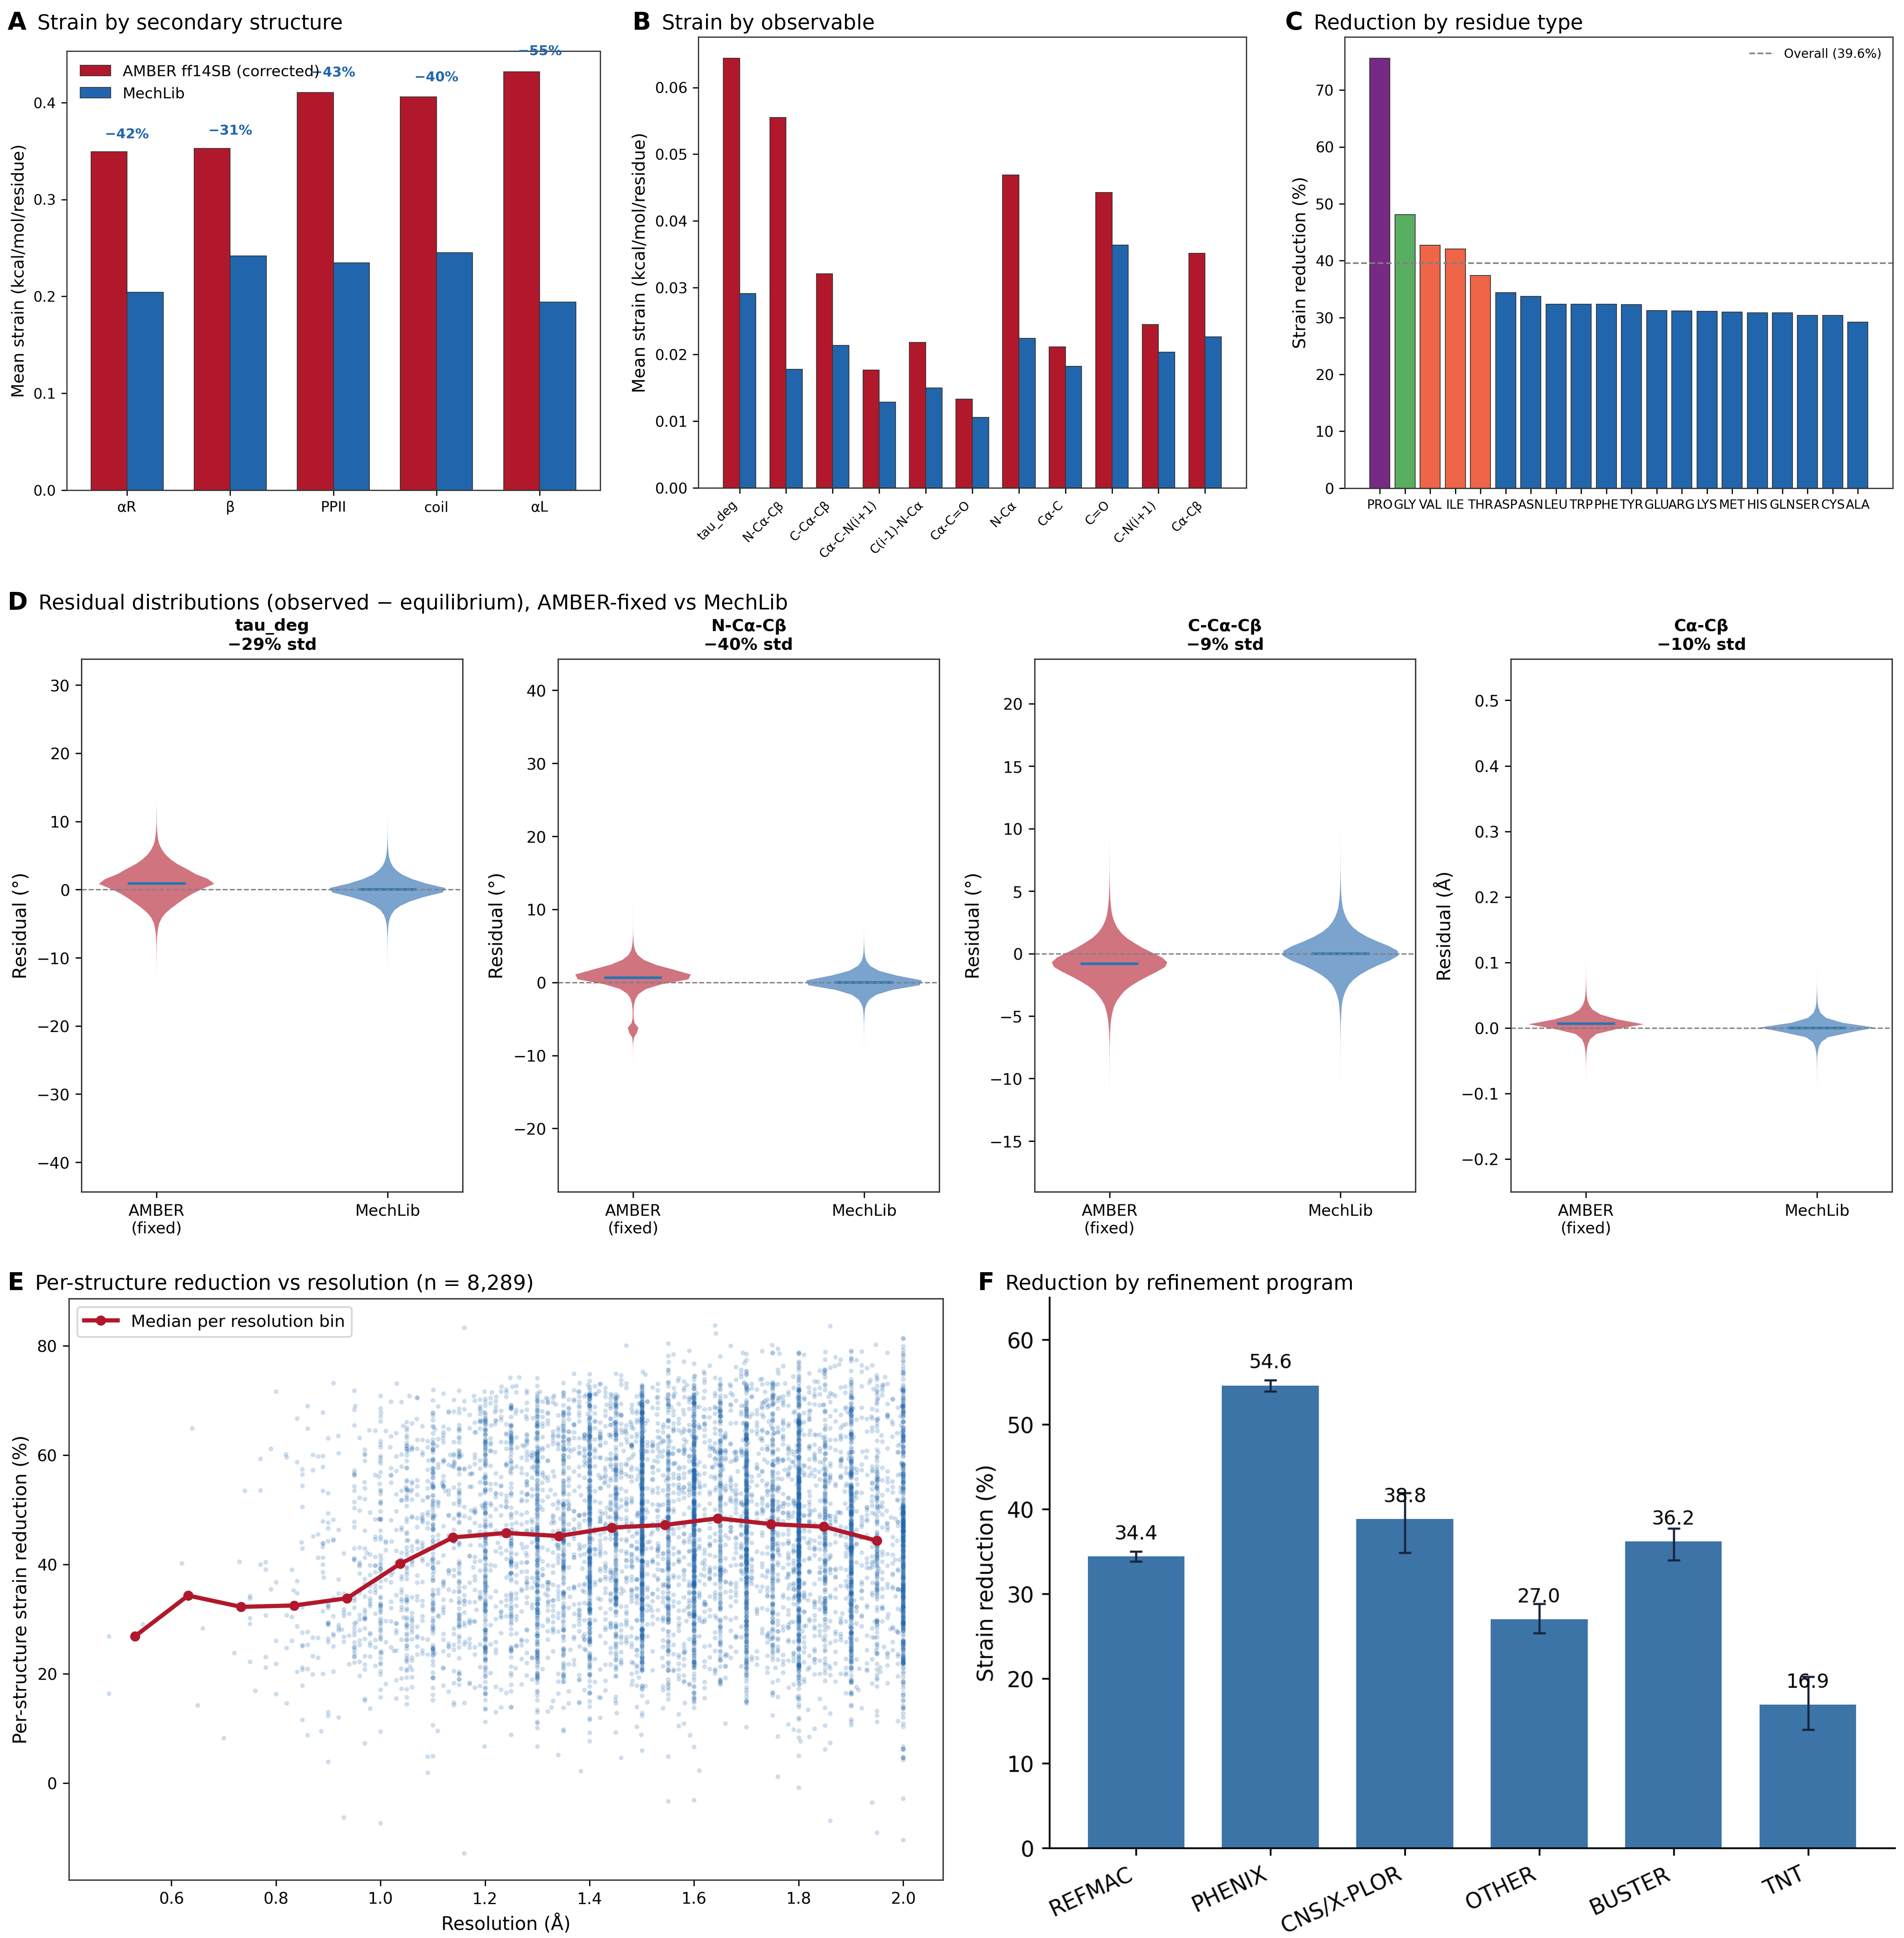
Figure 1. Descriptive fit of MechLib to crystallographic backbone geometry (see Section 3.1 for why these statistics are descriptive). (A) Mean phantom strain per residue, AMBER ff14SB (verified parameters) vs. MechLib, by secondary-structure class; labels give percent reduction. (B) Mean strain by bonded observable. (C) Percent strain reduction by residue type; dashed line, overall reduction of 39.6% (structure-bootstrap 95% CI 39.0–40.1%). (D) Observed-minus-equilibrium residual distributions for four representative terms; panel titles give the reduction in residual standard deviation. (E) Per-structure strain reduction versus resolution (n = 8,289; r = 0.066); red line, median per resolution bin. (F) Strain reduction by refinement program parsed from REMARK 3; error bars, 95% structure-bootstrap CIs. REFMAC-refined structures, which do not use conformation-dependent refinement restraints, give the confound-minimized estimate (34.4%).

3.2 Recovery of Held-Out Structures by Static Energy Minimization
Across the 300 temporally-blind holdout structures, minimizing toward MechLib's equilibria recovered the true structure substantially better than minimizing toward the fixed AMBER reference (33.1% lower RMSD-to-truth; 95% CI [32.0%, 34.1%]) and dramatically better than the shuffled negative control (86.9% lower RMSD-to-truth; 95% CI [86.6%, 87.2%]) (Fig. 2A,B). This improvement was consistent across the holdout set: not a single one of the 300 structures was recovered more closely by the fixed AMBER reference than by MechLib. Notably, the shuffled-table arm performed worse than the fixed-AMBER baseline rather than merely failing to improve on it, ruling out the possibility that any sufficiently granular correction table would outperform a single fixed equilibrium value, and isolating MechLib's specific conformation-dependent structure as the source of the improvement.
We additionally tested whether conditioning the two Cβ-adjacent bond angles on sidechain χ1 rotamer state, in addition to backbone (φ,ψ), further improves recovery. Using the same leakage-controlled design, we observed a small but statistically robust additional improvement of 1.2% (95% CI [1.0%, 1.4%]) beyond plain (φ,ψ)-only MechLib, with 90.0% of eligible terms drawing from a populated χ1-conditioned cell (Fig. 2C). This aggregate estimate is precise, but per-structure outcomes were more variable than the confidence interval alone conveys: individual structures ranged from approximately −4% to +9%, and a minority of structures showed a small negative effect from χ1-conditioning despite the significantly positive population-level mean. We report this as a modest, well-supported secondary finding — that sidechain rotamer state carries some independent information about backbone geometry beyond backbone torsion angles alone, on average — rather than as a reliable per-structure improvement or a central result of this validation.
This test is non-circular in the train/test sense, since no holdout structure contributed to the library against which it was minimized, and together with the temporal holdout (Section 3.1) it argues against training-set overfitting. It still scores agreement with crystallographic geometry, however, so it shows that MechLib predicts unseen crystal structures, not that its equilibria are physically correct. The constrained-QM and NMR comparisons below address the latter question with targets of a different kind.
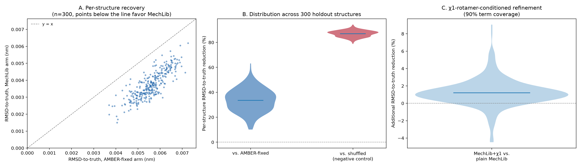
Figure 2. Static-minimization validation on 300 temporally-blind holdout structures. (A) Per-structure backbone RMSD-to-truth, AMBER-fixed arm vs. MechLib arm; points below the diagonal indicate MechLib recovered the true structure more closely, as was true for every structure in the holdout set. (B) Distribution of per-structure percent RMSD-to-truth reduction, MechLib vs. AMBER-fixed and MechLib vs. shuffled-table negative control. (C) Additional percent RMSD-to-truth reduction from χ1-rotamer-conditioned refinement of two Cβ-adjacent bond angles, beyond plain (φ,ψ)-only MechLib.

3.3 Independent Constrained-QM Benchmark Gives a Mixed Confirmatory Result
All 80 registered confirmatory optimizations passed the frozen convergence, constraint, connectivity, and finite-value checks. The mean paired weighted effect was positive (Δ = 0.00933099), with a residue-clustered 95% bootstrap interval of 0.00263134–0.01665963; the ordinary case-bootstrap sensitivity interval was 0.00201651–0.01678934. Fourteen of 20 residue-level means were positive. Thus the aggregate effect, residue-count rule, and completion rule each favored MechLib (Fig. 3A,B,D).
The strict registered endpoint nevertheless failed. Three bond terms were significantly worse for MechLib after Holm correction: N–Cα (mean absolute error 0.01224 Å versus 0.00561 Å for fixed AMBER), C–O (0.01632 versus 0.01206 Å), and C–N(next) (0.02512 versus 0.02081 Å). Other terms, especially N–Cα–C, N–Cα–Cβ, Cα–Cβ, and Cα–C, favored MechLib (Fig. 3C; Table S3). Because success required all four criteria, the confirmatory decision is FAIL despite the positive overall average. This outcome supports a narrower conclusion: conformation-dependent equilibria improve the registered term-average geometry, but the present library does not uniformly improve all bonded terms.
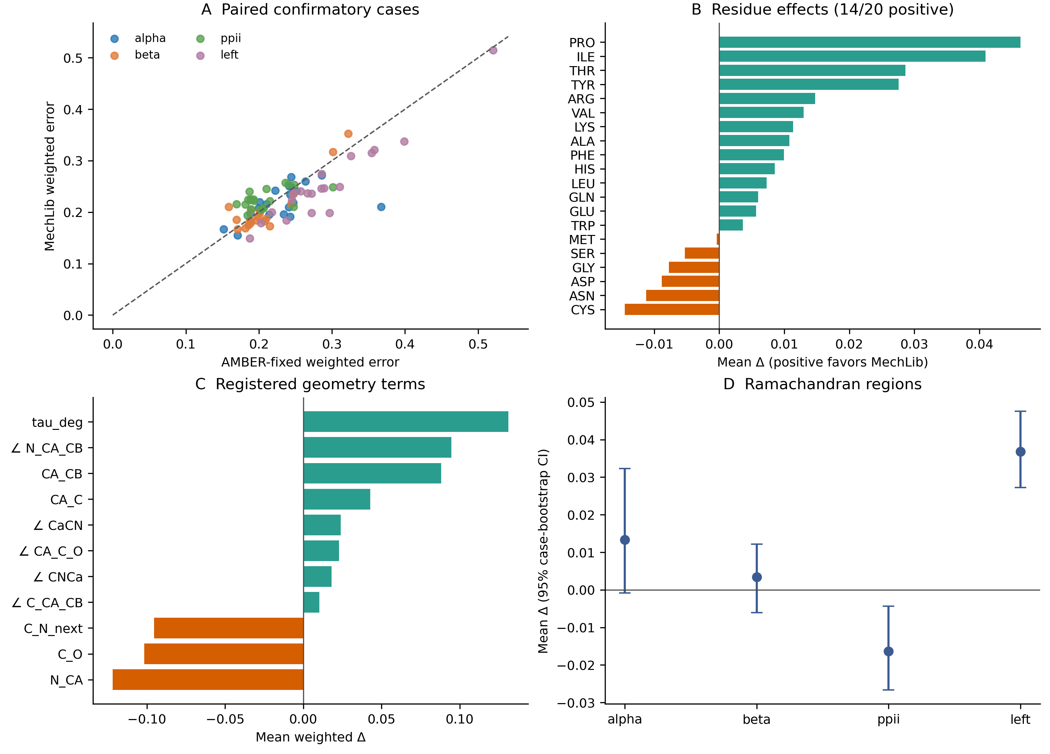
Figure 3. Prespecified independent constrained-QM benchmark. (A) Paired weighted case errors for fixed AMBER and MechLib; points below the diagonal favor MechLib. (B) Mean paired effect by residue. (C) Mean weighted effect by registered term; orange bars identify terms favoring fixed AMBER. (D) Mean paired effect by registered Ramachandran region with ordinary case-bootstrap 95% intervals. All 80 cases passed quality control, but the strict registered endpoint failed because N–Cα, C–O, and C–N(next) were Holm-significantly worse.

3.4 Exploratory Paired MD Comparison with NMR Scalar Couplings
We scored two proteins (GB3 and ubiquitin), three paired seeds per protein, and 100 frames per lineage after verifying 120 trajectory chunks and 1,200 readable frames. Six corrupted GB3 lineages were regenerated from frozen starting inputs; six intact ubiquitin lineages were copied with byte-verified identity. Before scoring, we froze the 259-file input inventory, 113 non-glycine experimental observations (50 GB3; 63 ubiquitin), the independent φ-to-³J(HN,Hα) Karplus coefficients, and the rule for calculating the equal-protein mean paired MSE difference. The input-hash and residue-mapping preflight passed.
The equal-protein mean difference, MSE(fixed AMBER) − MSE(MechLib), was +0.12597 Hz²; the mean differences were +0.22344 Hz² in GB3 and +0.02849 Hz² in ubiquitin. Five of six paired seeds favored MechLib; ubiquitin seed 2026092203 favored fixed AMBER (−0.09962 Hz²). GB3 seed 2026092203 gave the largest positive contrast (+0.57910 Hz²), so the aggregate is sensitive to a single pair. These are descriptive pilot results, without a significance test or a Gate M success rule.
The scalar-coupling comparison probes one phi-dependent experimental observable. One-nanosecond trajectories with three seeds per protein cannot establish convergence, and simulation and experimental conditions differ. The registered constrained-QM decision remains FAIL despite its positive aggregate, because three bond terms worsen; the exploratory NMR signal does not change that decision.

3.5 Extension to the DNA Sugar–Phosphate Backbone
We extended the framework to the DNA sugar–phosphate backbone using the same descriptive strain statistic, so the caveat of Section 3.1 applies; no minimization, QM, or solution-phase test has yet been performed for DNA. An initial analysis showed an apparent increase in BII-state strain after correction. Per-observable variance comparison traced this to the O3′(i)–P(i+1) term, whose distribution contained a non-physical tail of mis-linked strand boundaries in multi-stranded depositions (SD = 0.846 Å; Fig. 4D). After geometric chain-break detection (Methods 2.10), the distribution collapsed to SD = 0.014 Å, centered on the AMBER equilibrium (1.610 Å), with nearly identical BI and BII profiles (Fig. 4E), consistent with the connectivity artifact as the source of the earlier BII discrepancy. On the cleaned dataset (157,562 nucleotides), MechLib-DNA reduced median strain by 85.4% (bootstrap 95% CI 84.9–85.9%) relative to AMBER parm10 equilibria, consistently across bases (83.8–86.6%; Fig. 4A) and BI/BII states (85.4% and 85.8%; Fig. 4B). Per-nucleotide reductions were skewed toward near-complete elimination for every base (Fig. 4F), so the median reflects a broad distributional shift rather than a localized one. Because this is a median-based statistic, its magnitude is not directly comparable with the mean-based protein figure.
A two-way separability analysis on the (δ,χ) grid (Methods 2.10) showed that the ring-closure angle C1′–O4′–C4′ carries a non-separable δ×χ component (η²(coupling) = 0.073, compared with 0.026 for the control angle C5′–C4′–C3′; Fig. 4C) that was stable after removal of residual outlier contamination. Because δ sets the furanose conformation while χ positions the base over it, the ring-closure geometry must accommodate both torsions simultaneously. The coupling is smaller than the φ–ψ interactions reported for protein backbone bonded geometry (15–51%)¹⁵, consistent with the more constrained DNA backbone, and indicates that multidimensional equilibrium-geometry coupling is not unique to proteins.
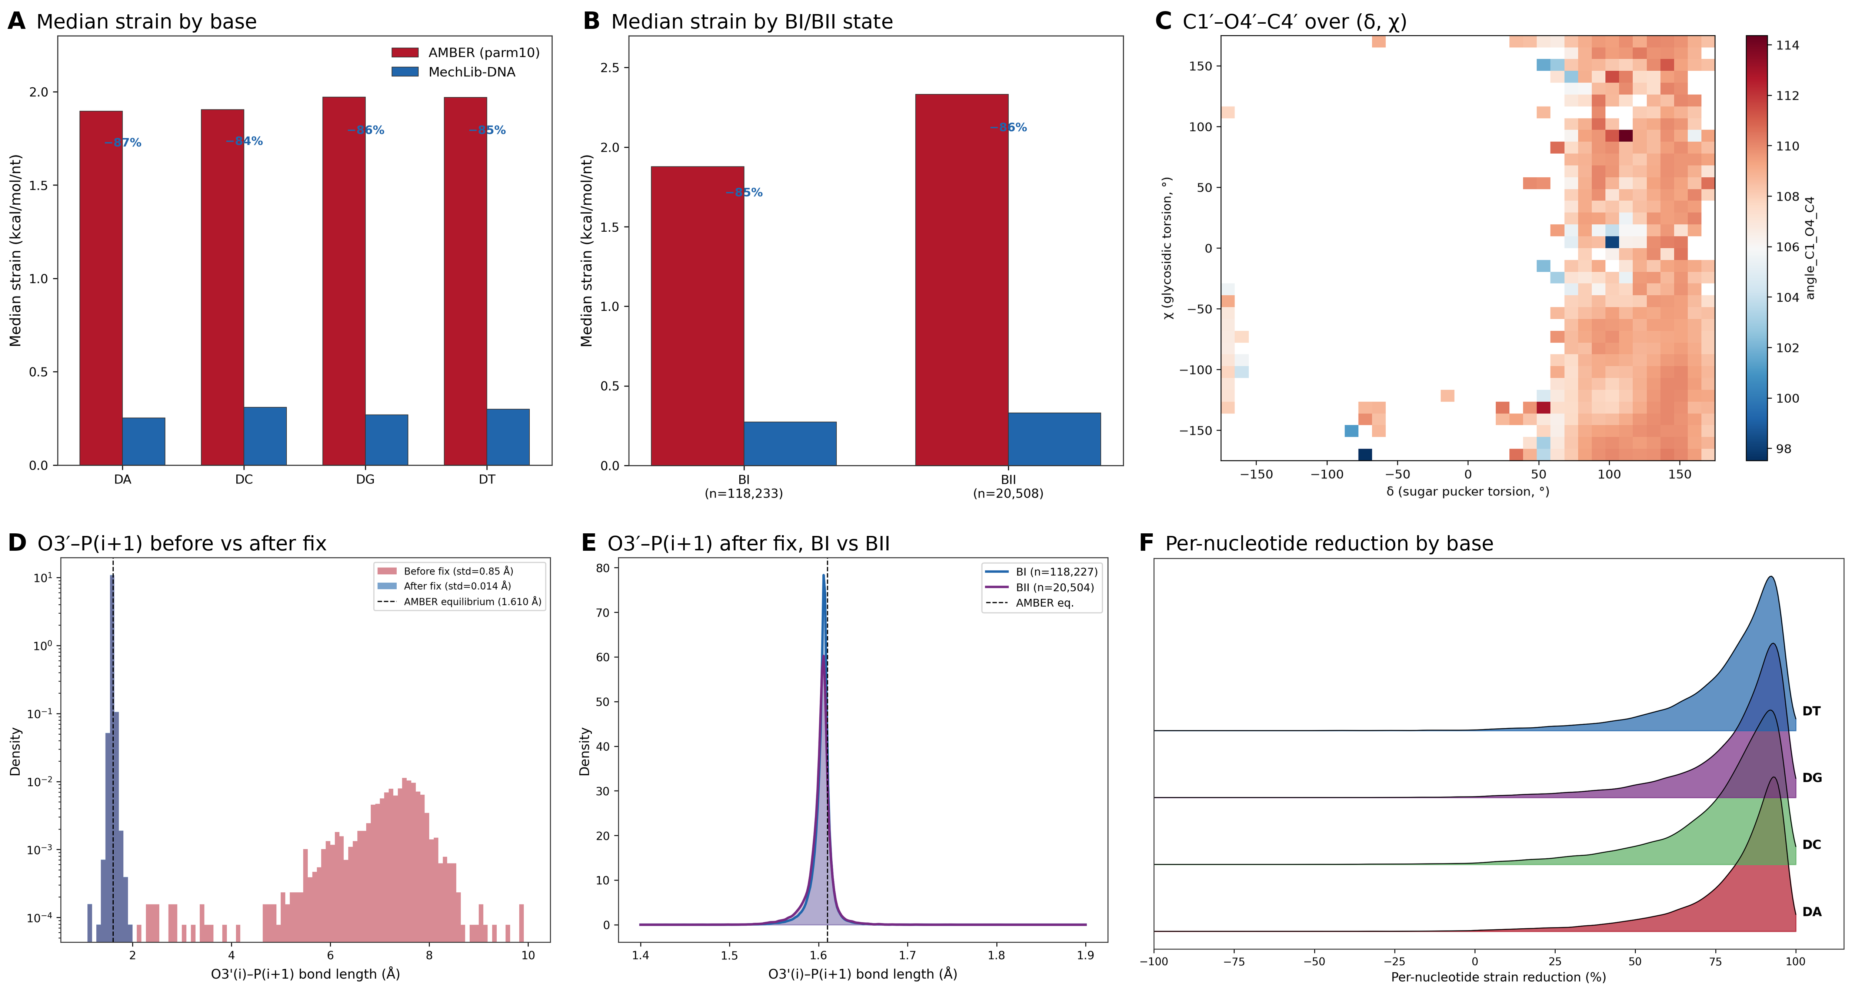
Figure 4. DNA backbone extension (descriptive; same caveat as Fig. 1). (A) Median phantom strain per nucleotide, AMBER parm10 vs. MechLib-DNA, by base (overall −85%). (B) By BI/BII backbone state. (C) Ring-closure angle C1′–O4′–C4′ over the (δ, χ) grid; η²(coupling) = 0.073, η²(δ) = 0.128, η²(χ) = 0.025. (D) O3′(i)–P(i+1) distance before and after the chain-connectivity fix (log density), showing the mis-linked tail removed by the fix. (E) After the fix, by BI/BII state; dashed line, AMBER equilibrium (1.610 Å). (F) Per-nucleotide strain reduction by base.

4. Discussion
Existing molecular mechanics force fields address conformation dependence primarily through energetic terms while treating equilibrium bond lengths and bond angles as fixed parameters. AMBER and OPLS therefore represent backbone mechanics using fixed bonded geometries coupled to torsional and nonbonded interactions, whereas CHARMM36 CMAP introduces an empirical two-dimensional correction to the φ–ψ energy surface while retaining fixed equilibrium geometries. MechLib occupies a complementary position: rather than modifying force constants or torsional potentials, it replaces fixed equilibrium bond lengths and bond angles with conformation-dependent equilibrium values derived directly from experimental structures.
The near-identical agreement between AMBER and OPLS-AA/M reflects their shared bonded parameterization rather than independent confirmation of force-field generality. The correlation with CHARMM36 CMAP, by contrast, compares a genuinely different kind of correction — geometric rather than energetic — and its significance suggests that independent energetic and geometric approaches identify similar regions of conformational space as requiring correction. These findings support conformation-dependent equilibrium geometry as an additional component of molecular mechanics rather than an alternative to existing force fields.
All cross-force-field comparisons were performed using independently verified primary parameter distributions, so the observed differences do not arise from transcription or implementation differences among reference parameter sets. The temporally blind holdout and the static-minimization recovery test (Section 3.2) address overfitting: a library built from structures deposited before 2020 fits later structures as well as its own training data, and recovers held-out structures better than both a fixed reference and a conformation-scrambled control. Both, however, are scored against crystallographic geometry. The constrained-QM benchmark (Section 3.3) is the most independent test in this work, and its mixed outcome, rather than the crystallographic statistics, sets the boundary of what can currently be claimed.
Independent verification of all reference force-field parameters against their primary distributions proved essential because the conformation-dependent geometric shifts quantified here are themselves small. This highlights the importance of rigorous parameter provenance when evaluating subtle structural effects in molecular mechanics.
The DNA extension illustrates both the value and the risk of large-scale automated geometry pipelines. Systematic per-observable diagnosis traced an initially puzzling BII-specific limitation to a specific, fixable connectivity artifact; we recommend the same per-observable variance-comparison diagnostic (Methods 2.10) as a general-purpose tool for this class of artifact in other large-scale structural bioinformatics pipelines. The δ–χ coupling result extends the equilibrium-geometry coupling observed previously for protein backbone φ/ψ¹⁵ to a structurally distinct polymer; we verified this finding survived removal of the same category of outlier contamination that had initially inflated a different observable's apparent coupling signal (bond_C1_N, η² dropping from 0.116 to 0.024 after cleanup, while the ring-closure angle's 0.073 was unaffected).
The refinement-software stratification illustrates a general caution for structure-derived geometric regularities: because some modern refinement pipelines now apply conformation-dependent restraints by default, observed conformation-dependence must be checked against refinement-software identity before being attributed to an independent physical property of the underlying molecule.
The constrained-QM result is deliberately interpreted as a mixed confirmatory outcome. It is more independent than the crystallographic fit and holdout analyses because the target geometries were generated electronically after model predictions were frozen. At the same time, its bond-level failures show why an average improvement cannot be treated as uniform force-field validation. The result points to a concrete revision path—retain the terms with reproducible conformation dependence, revisit the three worsening bond equilibria, and require new held-out evaluation before promotion—rather than supporting wholesale replacement of fixed bonded geometry. The disagreement is particularly informative for N–Cα and C–O: improvements in crystal-based residual fit coexist with significantly worse constrained-QM errors for these bonds. One testable explanation is that conformation-dependent crystallographic refinement restraints imprint some bond targets on the training structures; another is that the gas-phase, capped-peptide QM target differs systematically from a protein in a hydrated crystal. Neither mechanism has been isolated here. Stratifying the affected bonds by refinement software and testing new solution-phase or independently refined structures would distinguish these possibilities before any term-specific parameter revision is promoted.
We note explicitly what this paper does not address. The constrained-QM benchmark tests local equilibrium geometry at fixed central φ/ψ; it does not test molecular-dynamics trajectories, conformational populations, folding thermodynamics, NMR/RDC agreement or any dynamic property by itself. The static-minimization validation in Section 3.2 likewise concerns static crystallographic recovery, not dynamics. The exploratory MD/NMR pilot in Section 3.4 addresses only short-time scalar-coupling agreement; broader dynamics validation remains necessary.

5. Limitations
The OPLS-AA/M comparison is now understood to be almost entirely non-independent of the AMBER comparison (10 of 11 terms identical). The CMAP comparison used only the general (non-Gly, non-Pro) backbone grid. The DNA bond/angle reference parameters are shared identically across bsc0,8 bsc1,9 and OL15,10 so this comparison does not discriminate among current DNA force-field variants. The blind validation tests generalization across deposition time within the same PISCES-curated, X-ray population; it does not test generalization to cryo-EM or NMR ensembles. We have not run the same exhaustive defect scan on the DNA dataset that we applied to the protein dataset; the demonstrated stability of the DNA median statistics across two independent rounds of cleanup is reassuring but not equivalent to that fuller audit. The present analysis evaluates equilibrium geometry only. It does not address whether replacing fixed equilibrium values with conformation-dependent values preserves other force-field properties, such as vibrational spectra or free-energy landscapes, which require full molecular-dynamics validation. The overall strain-reduction estimate (39.6%) reflects a mixed population of refinement software, some of which can apply conformation-dependent restraints during refinement; a confound-minimized estimate restricted to REFMAC-refined structures (which do not implement such restraints) is lower but remains substantial and statistically robust (34.4%). The independent QM benchmark also has a deliberately narrow model scope (gas-phase ACE–X–NME with fixed central φ/ψ) and its registered conjunction failed because three bond terms worsened; it therefore cannot support a uniform physical-improvement claim.

6. Conclusion
MechLib complements rather than replaces existing molecular mechanics force fields. Temporal holdout and static recovery support the predictive utility of conformation-dependent equilibrium geometry, while the prespecified constrained-QM benchmark provides a sharper boundary: the registered average favored MechLib, but three bond terms worsened and the strict endpoint failed. MechLib should therefore be treated as a modular, term-specific geometry framework whose successful components can be incorporated into bonded-energy formulations while its unsuccessful components are revised and retested. Full MD and experimental validation remain necessary before claims about dynamics or solution observables.

7. Data and Software Availability
The final MechLib correction tables — MechLib_protein_library.csv (5,303 residue×φ×ψ entries) and MechLib_DNA_library.csv (74 base×BI/BII×pucker entries) — are provided as supplementary data, together with a reference Python implementation (mechlib.py) providing conformation-dependent lookup with automatic fallback to pooled and fixed-equilibrium values. Code, processed datasets, and these library files are available at https://github.com/wei09128/protein-backbone-mechanics. The 91 excluded protein residues and DNA connectivity-artifact exclusions are documented by PDB ID and residue index in the same repository.

Supporting Information
MechLib_protein_library.csv, MechLib_protein_chi1_library.csv, and MechLib_DNA_library.csv, the correction lookup tables underlying this work; constants_library.json and constants_chi1.json, the corresponding machine-readable formats; backbone_geometry_library.py and apply_library_corrections.py, reference implementations for applying the corrections; and supplementary methods, robustness analyses, and full numerical tables underlying Tables S1–S4 and Figures S1–S3.

Conflict of Interest
The authors declare no competing financial interest.

Acknowledgments
This research received no specific grant from funding agencies in the public, commercial, or not-for-profit sectors. The authors thank the Louisiana State University Health Sciences Center Shreveport (LSUHS) for logistical support.

References
(1) Wang, G.; Dunbrack, R. L., Jr. PISCES: A Protein Sequence Culling Server. Bioinformatics 2003, 19 (12), 1589–1591.
(2) Berman, H. M.; Westbrook, J.; Feng, Z.; Gilliland, G.; Bhat, T. N.; Weissig, H.; Shindyalov, I. N.; Bourne, P. E. The Protein Data Bank. Nucleic Acids Res. 2000, 28 (1), 235–242.
(3) Maier, J. A.; Martinez, C.; Kasavajhala, K.; Wickstrom, L.; Hauser, K. E.; Simmerling, C. ff14SB: Improving the Accuracy of Protein Side Chain and Backbone Parameters from ff99SB. J. Chem. Theory Comput. 2015, 11 (8), 3696–3713.
(4) Jorgensen, W. L.; Maxwell, D. S.; Tirado-Rives, J. Development and Testing of the OPLS All-Atom Force Field on Conformational Energetics and Properties of Organic Liquids. J. Am. Chem. Soc. 1996, 118 (45), 11225–11236.
(5) Robertson, M. J.; Tirado-Rives, J.; Jorgensen, W. L. Improved Peptide and Protein Torsional Energetics with the OPLS-AA Force Field. J. Chem. Theory Comput. 2015, 11 (7), 3499–3509.
(6) Huang, J.; Rauscher, S.; Nawrocki, G.; Ran, T.; Feig, M.; de Groot, B. L.; Grubmüller, H.; MacKerell, A. D., Jr. CHARMM36m: An Improved Force Field for Folded and Intrinsically Disordered Proteins. Nat. Methods 2017, 14 (1), 71–73.
(7) MacKerell, A. D., Jr.; Feig, M.; Brooks, C. L., III. Improved Treatment of the Protein Backbone in Empirical Force Fields. J. Am. Chem. Soc. 2004, 126, 698–699.
(8) Pérez, A.; Marchán, I.; Svozil, D.; Šponer, J.; Cheatham, T. E., III; Laughton, C. A.; Orozco, M. Refinement of the AMBER Force Field for Nucleic Acids: Improving the Description of α/γ Conformers. Biophys. J. 2007, 92, 3817–3829.
(9) Ivani, I.; Dans, P. D.; Noy, A.; Pérez, A.; Faustino, I.; Hospital, A.; Walther, J.; Andrio, P.; Goñi, R.; Balaceanu, A.; Portella, G.; Battistini, F.; Gelpí, J. L.; González, C.; Vendruscolo, M.; Laughton, C. A.; Harris, S. A.; Case, D. A.; Orozco, M. Parmbsc1: A Refined Force Field for DNA Simulations. Nat. Methods 2016, 13 (1), 55–58.
(10) Zgarbová, M.; Šponer, J.; Otyepka, M.; Cheatham, T. E., III; Galindo-Murillo, R.; Jurečka, P. Refinement of the Sugar–Phosphate Backbone Torsion Beta for AMBER Force Fields Improves the Description of Z- and B-DNA. J. Chem. Theory Comput. 2015, 11 (12), 5723–5736.
(11) Berkholz, D. S.; Shapovalov, M. V.; Dunbrack, R. L., Jr.; Karplus, P. A. Conformation Dependence of Backbone Geometry in Proteins. Structure 2009, 17 (10), 1316–1325.
(12) Tronrud, D. E.; Berkholz, D. S.; Karplus, P. A. Using a Conformation-Dependent Stereochemical Library Improves Crystallographic Refinement of Proteins. Acta Crystallogr. D 2010, 66, 834–842.
(13) Moriarty, N. W.; Tronrud, D. E.; Adams, P. D.; Karplus, P. A. Conformation-Dependent Backbone Geometry Restraints Set a New Standard for Protein Crystallographic Refinement. FEBS J. 2014, 281, 4061–4071.
(14) Chen, W.; Lu, X. Protein Backbone Mechanics II: Systematic Bond-Angle Deformation Across Conformational Space. Manuscript submitted for publication, 2026.
(15) Chen, W.; Lu, X. Non-Additive φ×ψ Coupling in Protein Backbone Bonded Geometry. Manuscript submitted for publication, 2026.

