Protein Backbone Geometry as Local Mechanical Equilibrium
Wei Chen, Marjan Trutschl, Urška Cvek
LSU Shreveport, One University Pl, Shreveport, LA 71115
Corresponding Author: Urška Cvek (ucvek@lsus.edu)

Abstract
For sixty years the Ramachandran plot has been read as a population census—a static map of where backbone dihedral angles are found. We show that it is, instead, a mechanical force field: each (φ, ψ) position is the deterministic outcome of a local balance among steric, electrostatic, and hydrogen-bond forces, and the plot’s topology encodes the direction and magnitude of the restoring or driving forces that hold every residue in place.
Analyzing 1,662,840 residues from quality-filtered high-resolution crystal structures, we decompose the torques acting on each backbone dihedral and establish three results. First, the net torque carries limited predictive signal (R² ≤ 0.20); it is the per-source force decomposition that determines conformation, raising explained variance to R² = 0.88 for φ and 0.65 for ψ. Second, steric torques dominate both dihedral axes, with strong cross-axis transmission: the steric torque computed along the φ rotation axis is the single best predictor of ψ position, indicating coupled mechanical control mediated by the sp³-hybridized Cα center. Third, the effective torsional resistance varies across Ramachandran space and depends on spatial position rather than amino-acid identity, giving rise to three distinct mechanical regimes—confinement in α-helices, persistence against a mechanical gradient in β-sheets, and chemistry-dependent driving in polyproline II—overlaid on a global geometric structure of orthogonal steric discontinuities whose intersection defines the αR minimum. Comparison with AMBER ff14SB reveals systematic ψ-dependent stiffness errors diagnostic of the separable one-dimensional parameterization, most pronounced in the α-helical corridor where φ stiffness varies with ψ context.
These findings recast the Ramachandran plot from a statistical summary into a causally interpretable mechanical landscape, providing a foundation for environment-aware force fields, backbone validation, and protein design.

1. Introduction
Protein backbone conformation is defined by the dihedral angles φ and ψ. The Ramachandran plot (Ramachandran et al., 1963) maps their allowed values, and its clustered regions—αR, β, PPII, 3₁₀, π, and αL—form the structural alphabet of protein architecture (Hollingsworth & Karplus, 2010; Sobolev et al., 2020). For six decades this plot has been interpreted as a population census: steric exclusion defines allowed and forbidden zones, and positions within allowed zones are treated as freely sampled statistical preferences shaped by sequence and thermal equilibrium.
Three contemporary approaches inherit this assumption. Statistical potentials and inference models such as AlphaFold (Jumper et al., 2021) treat (φ, ψ) distributions as evolutionary preferences—powerful for prediction but silent on physical causation. Molecular dynamics simulations capture forces explicitly but attribute non-canonical conformations to thermal noise (Frauenfelder et al., 1991). Empirical validation tools classify rare states as statistical outliers (Chen et al., 2010). All three assume, implicitly, that the Ramachandran restriction is binary and that positions within allowed regions are unconstrained.
This assumption is incorrect. We present a three-layer mechanical representation of backbone conformational space (Fig. 1), integrating steric constraints, torque fields, and effective torsional resistance. The Ramachandran plot is not a census but a force field. Each backbone (φ, ψ) position is the deterministic solution to a local mechanical equilibrium whose structure can be decomposed and measured. Using 1,662,840 residues from quality-filtered high-resolution crystal structures, we demonstrate that: (i) the net torque is weakly predictive—it is the per-source force decomposition that identifies conformation; (ii) steric torques dominate both dihedral axes, with cross-axis transmission through the Cα center providing the primary mechanical coupling; (iii) the effective torsional resistance varies across Ramachandran space, governed by position rather than residue identity; (iv) the stiffness landscape reveals two orthogonal, basin-independent steric discontinuities whose intersection defines the αR minimum as a mechanical attractor; and (v) comparison with AMBER ff14SB reveals systematic coupled-torsion errors diagnostic of the separable parameterization assumption.
These findings replace the binary Ramachandran model with a continuous, spatially structured mechanical landscape and provide a causal physical framework that complements inference-based prediction.
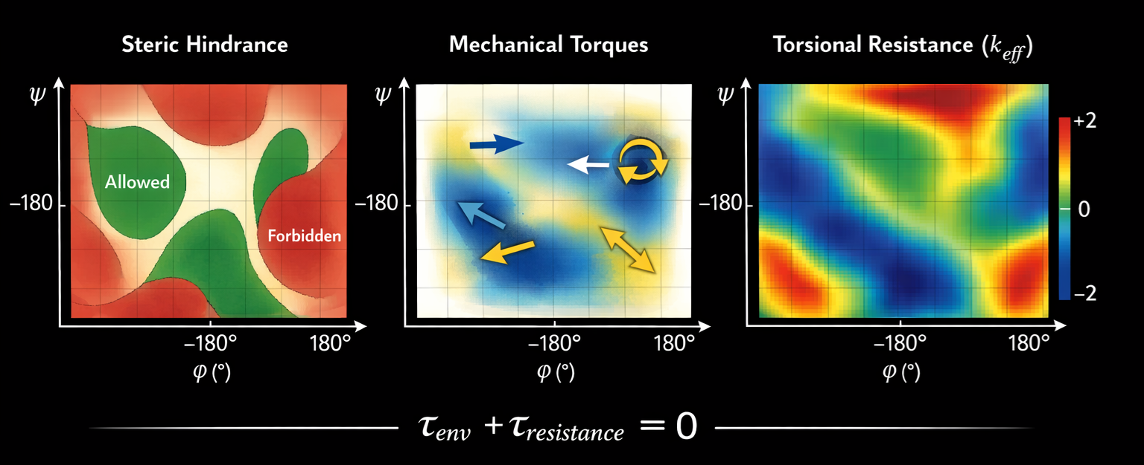

Fig. 1: A Three-Channel Hierarchy of Backbone Strain. Backbone conformation is governed by fundamental steric constraints, the underlying torque field, and a spatially varying effective torsional resistance across the Ramachandran plane.

2. Results

2.1 The Ramachandran Plot Encodes a Graded Mechanical Landscape
We analyzed 1,662,840 residues from quality-filtered high-resolution PDB structures (resolution < 2.0 Å, B-factor ≤ 30 Å², no chain gaps within ±3 residues; Methods 4.1). Using a normalized angular distance metric (d ≤ 1.5σ elliptical boundary; Methods 4.2), the six canonical Ramachandran states cover 79.6% of the (φ, ψ) plane. A greedy density-peak algorithm identifies eight additional clusters at basin peripheries, raising coverage to 92.2% (Fig. 2A–B). These satellite states are displaced 10–30° from canonical centers, confirming that Ramachandran basins are not rigid boundaries but elastic regions whose effective centers shift with the local mechanical environment.
The eight new states occupy characteristic positions: bridge conformations between αR and 3₁₀ (φ ≈ −78°, ψ ≈ −13°), type-II turn conformations at the αR–PPII boundary (φ ≈ −83°, ψ ≈ 113° and φ ≈ −48°, ψ ≈ 128°), extended loop conformations (φ ≈ −98° to −158°, ψ ≈ 8° to 163°), and an αL extension at positive φ (φ ≈ 78°, ψ ≈ 8°). Their locations at basin edges rather than between basins indicate continuous deformation from canonical geometry, not discrete intermediates.
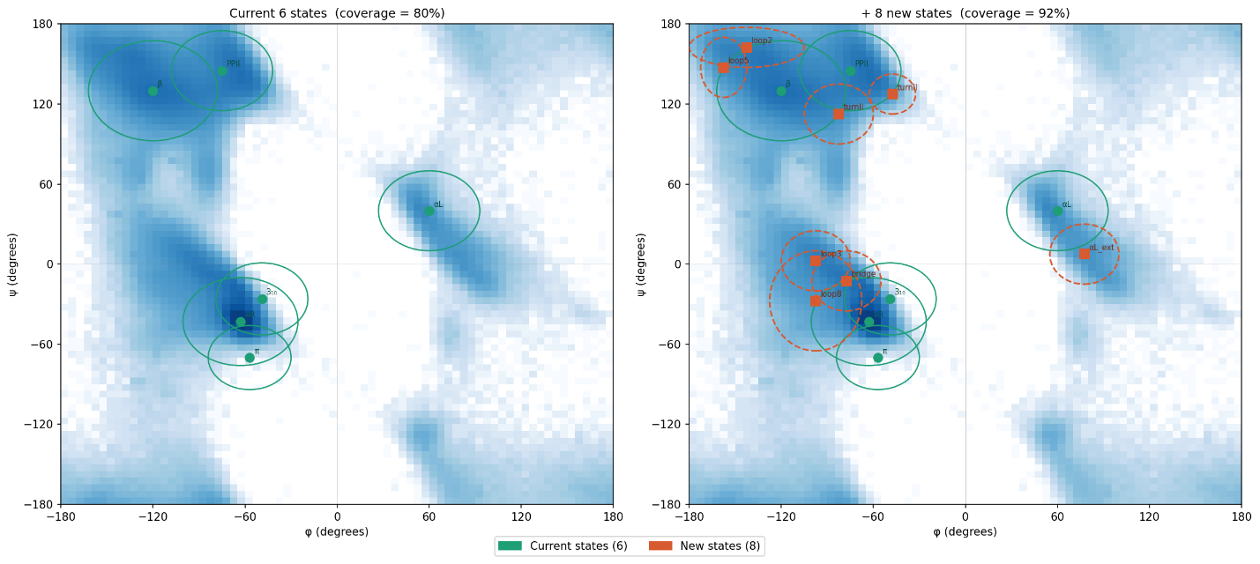
Fig. 2: Ramachandran coverage. (A) Six canonical states (green ellipses) cover 79.6% of the (φ, ψ) plane. (B) Adding eight data-driven states (orange squares) raises coverage to 92.2%. Background: log-density heatmap of 1,662,840 residues.

2.2 Force Decomposition, Not Total Environmental Torque, Determines Conformation
To identify what determines position within this landscape, we extracted 55 features per residue in three physically motivated groups (Methods 4.3–4.5): steric hindrance field (Group A, 21 features), mechanical torques (Group B, 14 features), and molecular context (Group C, 20 features). Backbone angles were predicted using both Δ-reference targets (deviation from the αR reference at −63°, −43°) and sin/cos encoding to handle circular topology (Methods 4.6).
Table 1. Model comparison: explained variance (R²) as model complexity increases. Environmental torque = 2 features (τ_φ, τ_ψ); Full = all 55 features. CV = 5-fold cross-validated R². Sin/cos Ridge uses reference-free circular encoding.
Model | R²_φ | CV_φ | R²_ψ | CV_ψ
Environmental torque only (2 features) | 0.199 | 0.199 | 0.011 | 0.011
Linear Ridge (55 features, Δ-ref) | 0.487 | 0.486 | 0.210 | 0.208
Linear Ridge (55 features, sin/cos) | 0.585 | — | 0.872 | —
Random Forest | 0.835 | 0.808 | 0.612 | 0.578
Gradient Boosting | 0.778 | 0.772 | 0.564 | 0.558
MLP (2-layer) | 0.912 | 0.884 | 0.682 | 0.655
The progression reveals a central insight (Table 1). A minimal environmental representation using two torque features explains 19.9% of φ variance but only 1.1% of ψ. Even the φ signal is modest: at equilibrium, environmental torques balance against intrinsic torsional resistance, leaving a near-zero sum that encodes position only coarsely. Expanding to a 55-feature decomposition increases performance to 48.7%/21.0% (linear, Δ-reference) and 88.4%/65.5% (MLP, cross-validated)—gains of ×4.4 for φ and ×59 for ψ. This paradox—weak net force yet fully determined structure—is the central insight: conformational information is encoded in force asymmetry (which sources act, their magnitudes and signs), not in force magnitude. This follows from mechanical equilibrium (τ_env + τ_res ≈ 0): the sum is constrained to vanish, so it carries no information; the components, coupled through geometry and balanced against intrinsic resistance, retain the full conformational signal. Statistical frameworks that aggregate force contributions necessarily discard it.
The reference-free sin/cos encoding dramatically improves the linear model for ψ (0.21 → 0.87), indicating that much of the apparent ψ prediction difficulty arises from the multi-basin topology rather than from missing physics: the circular encoding allows the linear model to separately resolve each basin without forcing all deviations through a single reference point.
The φ–ψ asymmetry persists across models. φ is more predictable because it is confined to a narrow sterically allowed corridor with a steep force gradient. In contrast, ψ spans multiple allowed basins (αR, β, PPII) with flatter, heterogeneous force landscapes. Per-basin accuracy reflects this: αR (96.7%) and αL (92.0%) are well resolved, whereas β (56.0%) and PPII (34.3%) remain poorly predicted, consistent with their mechanical neutrality and stronger dependence on chemical context (Section 2.4).

2.3 Steric Torques Dominate Both Axes with Cross-Axis Cα Transmission
Random Forest importance (Fig. 3) exposes the mechanics of backbone control. For φ, steric torques dominate: τ_φ,steric (0.19) and τ_ψ,steric (0.15) together exceed one-third of total importance. Next are Cα–Cα distance to i−2 (0.11), a proxy for local curvature, and corrected electrostatic torque along ψ (0.08). Smaller terms reflect molecular context—sidechain rigidity, mass, and heavy-atom count—capturing how residue identity shapes the steric field.
For ψ (given φ), a single term dominates: τ_φ,steric (0.44), over fourfold larger than any other feature. Thus, steric torque about φ best predicts ψ. Secondary terms are χ₁ rotamer (0.10), ∠N–Cα–C (0.08), and Cα–Cα distance to i+2 (0.07). Electrostatics are minor (τ_φ,elec = 0.03).
This cross-axis dominance has a clear structural origin. The sp³-hybridized Cα center connects the φ rotation axis (N–Cα bond) and the ψ rotation axis (Cα–C bond) at a fixed tetrahedral angle. Steric strain accumulated from φ rotation is not absorbed locally but transmitted across the junction and expressed as a displacement along ψ. The Cα center thus functions as a mechanical coupler: it converts steric pressure on one dihedral into a conformational response on the other. This transmission is directional—τ_φ,steric strongly predicts ψ, but τ_ψ,steric predicts ψ only modestly (importance 0.07)—consistent with the asymmetric lever geometry at the tetrahedral center.
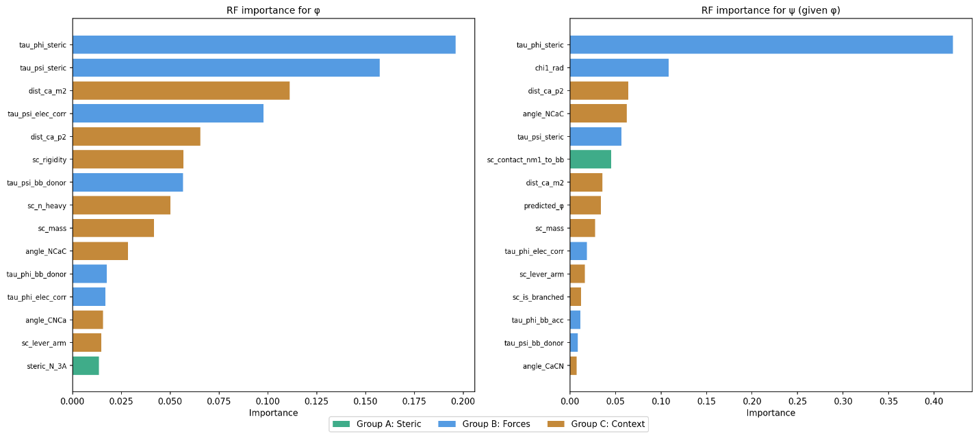
Fig. 3: Feature importance for φ and ψ prediction (Random Forest). Left: φ is governed by steric torques (τ_φ,steric, τ_ψ,steric), with secondary geometric support (Cα–Cα_i−2). Right: ψ (given φ) is dominated by cross-axis coupling—τ_φ,steric alone accounts for 44% of importance. Colors: green, steric geometry (Group A); blue, mechanical torques (Group B); amber, molecular context (Group C).

2.4 Three Mechanical Regimes Map onto Secondary Structure Function
The environmental torque field across Ramachandran space (Fig. 4A) is basin-specific in both magnitude and direction. While the αR basin exhibits ambivalent signals, others show strongly polarized torque distributions (Table 2), indicating regions of significant mechanical driving. Projection of the net torque toward the αR reference (−63°, −43°) and stratification by amino-acid chemistry (Fig. 4B) reveal three mechanically distinct regimes.
Table 2. Environmental torque and restoring projection per basin.
Basin | n | ⟨τ_proj⟩ | % Rest. | % Driv. | Regime
αR | 759,198 | −0.067 | 43.4 | 49.3 | Confined (stiff cage)
β | 453,980 | +1.232 | 84.5 | 8.1 | Persistent (against gradient)
PPII | 202,351 | +0.194 | 44.4 | 33.4 | Chemistry-dependent
loop | 180,975 | +0.639 | 67.4 | 17.8 | Funneled
αL | 66,322 | +0.069 | 37.8 | 46.1 | Chemistry-dependent
αR: confinement without restoring force. In αR, restoring and driving torques are balanced (43.4% vs 49.3%; Table 2), and the torque–displacement Pearson correlation is negligible (r = −0.004; Fig. 4E). αR is therefore not stabilized by convergent forces. Instead, it lies at the intersection of two orthogonal steric contacts—the C_{i−1}=O···Cβ collision along φ and the O···N_{i+1} collision along ψ (Section 2.5)—forming a steric cage from which displacement in either direction encounters an immediate barrier.
Chemistry refines but does not alter this picture. Proline alone shows strong restoring projection (+0.55; Fig. 4D), consistent with its ring constraint. All other classes show weak outward bias (−0.14 to −0.02; Fig. 4D), insufficient to escape the stiffness cage. Confinement is geometric, not chemical.
β: persistence against mechanical gradient. The β basin shows the strongest coherent restoring signal: 84.5% of residues experience torque toward αR, with uniformly positive projections across chemistries (+1.13 to +1.33), with the sole exception of Proline (+0.46), whose cyclic constraint reduces the local mechanical gradient. This near-universal ‘outward’ pressure provides a mechanical basis for the long-observed sequence tolerance and local instability of β-sheets (Overington et al., 1992).
Consistent with its role as a sheet breaker (Chou & Fasman, 1978), glycine shows the strongest restoring projection in the β basin (+1.33). Rather than entropy alone, the local torque field is intrinsically unfavorable, driving glycine out of β toward the αR sink.
PPII: chemistry-dependent driving. PPII shows mixed directionality overall (33.4% restoring, 44.4% driving) with strong chemical dependence. Proline is strongly driven into PPII (−0.51), with coherent driving (0.5% restoring, 48.2% driving), reflecting ring geometry. Polar and charged residues are moderately favored (≈ −0.18), whereas aromatic and aliphatic residues show weak restoring bias toward αR (+0.03 to +0.12). Glycine is neutral (+0.02, p = 0.08, n.s.). The torque–displacement relation is weakly spring-like (r = +0.015, k = +0.0020). PPII occupancy thus reflects coupling between residue identity and local mechanics, consistent with its solvent sensitivity (Shi et al., 2006): proline is mechanically locked into PPII, polar/charged residues are weakly held, and nonpolar residues are driven out toward αR.
Loops: mechanical funnels. Loops show coherent restoring (67.4%) and a positive torque–displacement correlation (r = +0.263, k = +0.0034; Fig. 4E): the farther from αR, the stronger the restoring torque. This defines a mechanical funnel, consistent with loops acting as deformable elements that return to canonical states after perturbation.
Summary. The regimes are distinguished by two independent conditions: directional coherence (do local forces point consistently?) and steric confinement (do stiffness walls prevent escape?). αR satisfies confinement without coherence—it is a stiff cage, not a force-driven funnel. β shows coherence without confinement—forces point toward αR, but no walls hold residues in place; persistence requires cooperative hydrogen bonding. PPII and αL show neither condition fully, relying on chemistry-dependent local forces. Loops alone combine coherence with displacement-dependent strengthening, defining a true mechanical funnel.
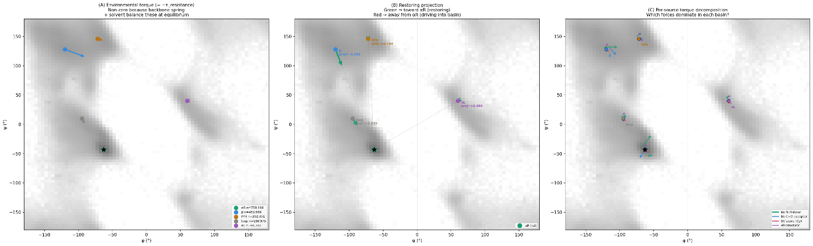

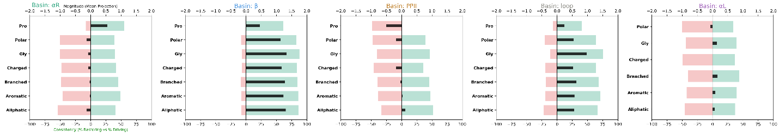
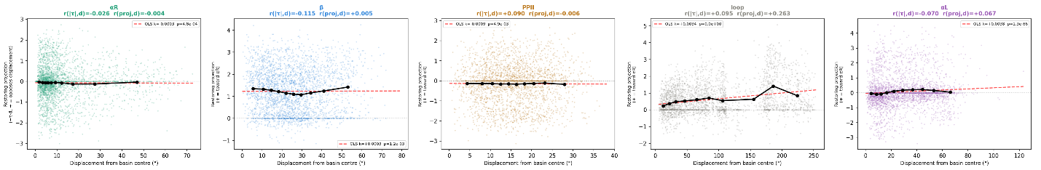

Fig. 4: Mechanical landscapes and basin-specific force environments. (A) Environmental torque vectors per basin overlaid on Ramachandran density. (B) Restoring projection toward αR (green = restoring, red = driving). (C) Per-source torque decomposition showing which forces dominate in each basin. (D) Directional coherence and mean projected torque (black) show that, although all chemistries are biased toward αR, basins separate by coherence and magnitude rather than sign. αR is near-balanced (confinement without bias), β shows uniformly strong restoring projections across chemistries, whereas PPII/αL are weaker and chemistry-dependent, and loops combine high coherence with effective restoring magnitude. (E) Torque–displacement profiles reveal that only loops exhibit positive coupling ($r>0.2,k>0$), consistent with Hooke-like funneling, whereas αR shows negligible coupling (a stiff cage) and β, PPII, and αL display weak slopes, indicating biased but non-elastic force fields.

2.5 Orthogonal Stiffness Walls and the αR Mechanical Trap
We map backbone resistance as effective stiffness k_eff = −τ_env / Δθ per residue (Methods 4.7). Because k_eff diverges as Δθ → 0, walls are identified from regions far from the reference where the ratio is well-behaved, and validated by known steric contacts rather than from intensity near the reference point (Fig. 5). Two orthogonal discontinuities organize the Ramachandran plane.
φ wall. A sharp vertical wall at φ ≈ −60° to −80° forms a high-stiffness ridge flanked by a compliant trough at more negative φ. Critically, this wall is visible in the β and PPII regions (ψ > 100°), where Δψ is large and the k_eff ratio is numerically stable. The wall therefore reflects genuine physics, not a small-denominator artifact. It arises from C_{i−1}=O···Cβ collision: rotation through φ ≈ −60° triggers steric clash and sharply resists further displacement.
ψ wall. A horizontal wall at ψ ≈ −40° to −60° shows the same behavior, validated by its visibility at φ < −120° (far from φ_ref = −63°) where the ratio is well-conditioned. It reflects O···N_{i+1} collision along ψ. Below this boundary (ψ < −60°), k_ψ reverses sign, indicating a compliant region where displacement is mechanically favored rather than resisted.
αR at the intersection. The αR minimum (−63°, −43°) sits at the crossing of these two steric barriers. This is not an inference from the k_eff map intensity at αR (which is inflated by the small denominator there) but a geometric consequence of the steric contacts themselves: the φ wall arises from the C_{i−1}=O···Cβ collision, which activates at φ ≈ −60° regardless of ψ, and the ψ wall arises from the O···N_{i+1} collision, which activates at ψ ≈ −40° regardless of φ. Their intersection necessarily occurs near (−60°, −40°), which is the αR position.
This explains α-helical behavior: (i) mutational robustness—α-helices tolerate sequence variation not because diverse residues all generate the same restoring forces but because the steric barriers prevent escape regardless of the force direction; (ii) narrow angular dispersion—the double-walled confinement produces the tightest (φ, ψ) distribution of any secondary structure; and (iii) no restoring field is needed—the αR basin does not require active force-driven funneling because the steric walls prevent escape.
Other basins lack this dual confinement. The β region lies in the compliant trough on both axes; stability requires non-local cooperativity (hydrogen bonding). PPII sits near the φ wall but above the ψ wall: partial confinement only, consistent with intermediate, environment-dependent stability.
Sidechain complexity sets stiffness by packing, not length. The magnitude of k_eff varies non-monotonically with sidechain rotatable-bond count (Fig. 6). Mean |k_φ| rises from 2.0 kcal·mol⁻¹·rad⁻² (0-χ: Gly/Ala/Pro) to 2.7 (3-χ: Met/Glu/Gln), then decreases to 2.6 (4-χ: Lys/Arg). Mean |k_ψ| follows the same pattern more sharply: 1.5 → 2.3 → 2.0. Longer sidechains might be expected to increase flexibility (more conformational degrees of freedom) or monotonically increase stiffness (more mass). Instead, stiffness peaks at intermediate chain length, reflecting a crowding optimum: three-χ sidechains are long enough to contact backbone atoms across the rotation axis but short enough to remain geometrically ordered; four-χ sidechains are sufficiently long that conformational averaging reduces the effective steric constraint. This identifies local packing geometry, rather than mass or flexibility, as the physical quantity that determines backbone mechanical response.
Position dominates over identity: the same amino acid exhibits different stiffness in different basins (e.g., Gly: ⟨k_φ⟩ = +1.60 in β vs. +0.03 in αL; Leu: +2.17 in β vs. +0.10 in αL), while different amino acids in the same basin show similar stiffness patterns. Chemistry rescales |k| without altering its spatial structure. Across chemistry groups, nonpolar residues are stiffest (⟨|k_φ|⟩ = 2.80), followed by charged (2.53–2.55), polar (2.27), and glycine (1.16), consistent with the crowding interpretation.
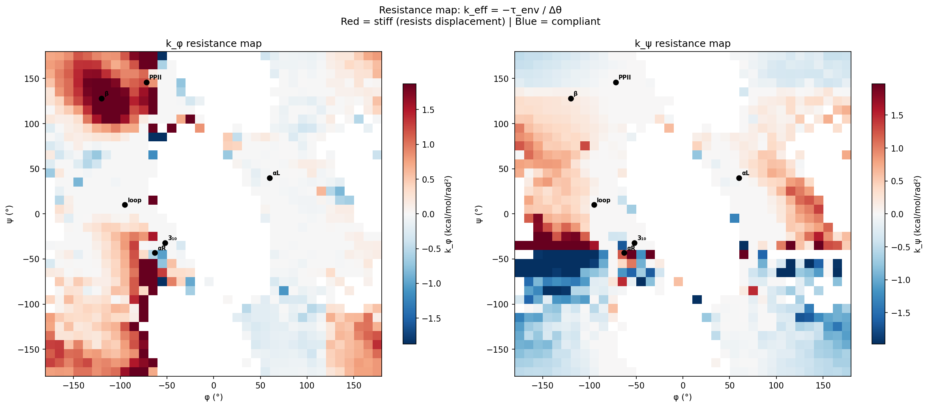
Fig. 5: Effective torsional resistance across Ramachandran space. Left: k_φ map showing a vertical stiffness wall near φ ≈ −60° to −80° (red = stiff, blue = compliant). Right: k_ψ map showing a horizontal wall near ψ ≈ −40° to −60°. Basin centers marked with black dots. Note: k_eff intensity near αR (−63°, −43°) is inflated by the small denominator (Δθ → 0); wall structures are validated by their persistence in regions far from the reference where the ratio is well-conditioned.
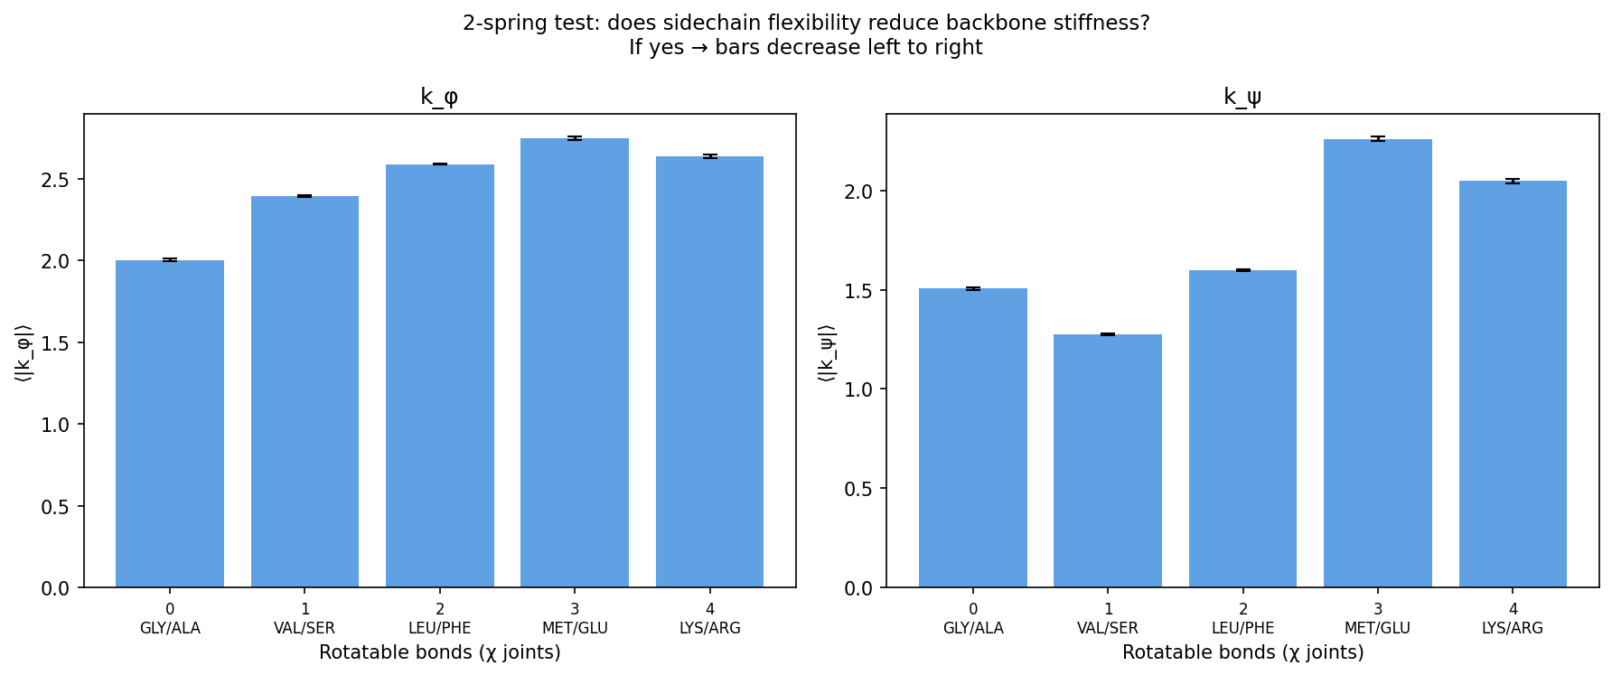
Fig. 6: Non-monotonic stiffness with sidechain complexity. Mean |k_φ| (left) and |k_ψ| (right) by number of rotatable χ bonds. Stiffness increases from 0-χ (Gly/Ala) to 3-χ (Met/Glu), then decreases at 4-χ (Lys/Arg), indicating crowding—not chain length—governs backbone resistance. Error bars: SEM.
2.6 Coupled torsional stiffness exposes breakdown of separability in AMBER
The stiffness landscape reveals systematic violations of the separability assumption underlying standard torsional force-field forms, in which backbone energetics are expressed as additive one-dimensional contributions $V(ϕ)+V(ψ)$. Under such a model, the local curvature $k_{ϕ}(ϕ,ψ)$ would be invariant with respect to ψ at fixed φ. In contrast, the empirical stiffness field exhibits strong ψ-dependent modulation of φ curvature.
The stiffness correction map $δk_{ϕ}(ϕ,ψ)=k_{eff}-k_{AMBER}$ (Fig. 7A) displays structured anisotropy across Ramachandran space, most notably in the form of vertical banding, indicating that φ-stiffness varies systematically with ψ at fixed φ. The magnitude of this modulation reaches approximately 10 kcal·mol⁻¹·rad⁻² in sparsely populated but physically relevant regions, particularly near the β/PPII boundary (φ ≈ −70°, ψ > 140°), where AMBER underestimates φ-restoring curvature relative to the empirical field.
A particularly pronounced breakdown of separability is observed in the α-helical corridor (Fig. 7B). At fixed φ = −65°, the empirical curvature $k_{ϕ}$spans a wide range (approximately −10 to +3 kcal·mol⁻¹·rad⁻²) as ψ varies, whereas AMBER assigns a single ψ-independent value (≈ −4 kcal·mol⁻¹·rad⁻²). This indicates that the local mechanical response of the backbone is not constant along ψ but instead undergoes sign changes and large amplitude variation within a single φ slice. A shift to φ = −55° yields a distinct ψ-dependent profile, confirming that the coupling structure is local in Ramachandran space rather than globally uniform.
Importantly, these differences reflect curvature-level discrepancies (second derivatives of the potential energy surface), rather than errors in equilibrium populations or basin locations. Thus, AMBER may reproduce correct low-energy regions while still misrepresenting the local restoring forces governing fluctuations within and between basins.
Resolving this limitation would require either explicit two-dimensional torsional coupling terms or a position-dependent correction to the effective stiffness field. The full discretized correction field (722 Ramachandran bins) is provided as a diagnostic reference for benchmarking separability violations.
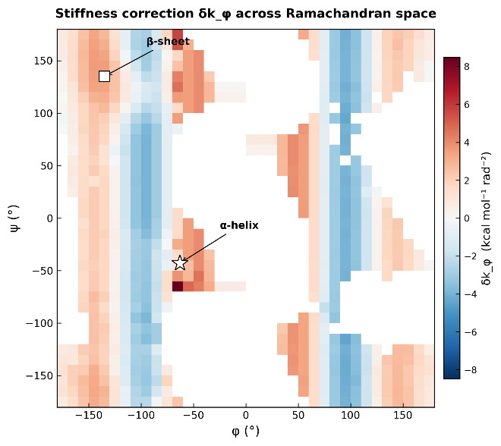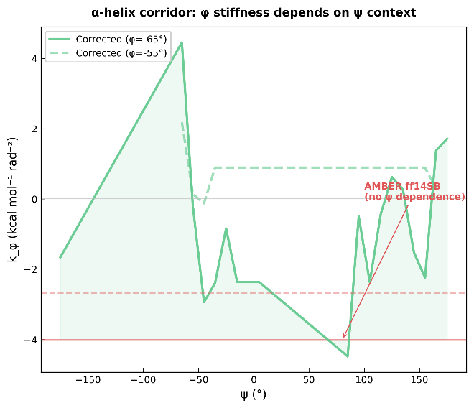
Fig. 7: Coupled-torsion stiffness errors in AMBER ff14SB. (A) Stiffness correction δk_φ across Ramachandran space showing systematic ψ-dependent modulation of φ resistance. Vertical banding reflects violation of separability in V(φ) + V(ψ)-type torsional parameterizations. (B) Within the α-helical corridor (φ = −65°, solid; φ = −55°, dashed), empirically derived k_φ varies by >13 kcal·mol⁻¹·rad⁻² as a function of ψ, whereas AMBER assigns a ψ-independent value (red lines). The strongest deviations occur near the intersection of steric constraints defining αR stability (Section 2.5).

3. Discussion
The Ramachandran restriction is usually treated as binary, with allowed regions as statistical preferences from sequence and thermal sampling. Here it resolves into a graded mechanical landscape, where each (φ, ψ) encodes a local force balance set by atomic geometry.
The central finding is that conformational information is distributed across local force contributions, rather than being recoverable from equilibrium populations alone. At equilibrium, net torques vanish by construction, and aggregation of forces removes the directional structure encoded in their decomposition. Force decomposition therefore provides access to the mechanical determinants of conformational preference that are not visible in population statistics alone.
A unified mechanical picture emerges in which steric interactions generate coupled constraints in (φ, ψ) space. The empirical stiffness field k_φ(φ, ψ) exhibits systematic ψ-dependence at fixed φ, indicating that backbone resistance is not separable into additive V(φ) + V(ψ) contributions. Instead, the effective stiffness reflects local geometric coupling mediated by the Cα junction. This manifests as curvature anisotropy that cannot be captured by independent one-dimensional torsional terms.
The force-field comparison confirms this curvature anisotropy. AMBER ff14SB parameterizes backbone torsions as separable one-dimensional potentials, and the resulting stiffness errors show the predicted signature: systematic ψ-dependent modulation of φ resistance, strongest in the α-helical corridor where the two steric walls intersect. This discrepancy concerns local curvature—the shape of the potential surface—rather than equilibrium populations, and would affect barrier heights, transition rates, and mechanical response even when basin locations are correctly reproduced. This discrepancy is fundamentally one of local curvature—the second-derivative ‘shape’ of the potential surface—rather than equilibrium population. Consequently, while AMBER may correctly locate the basins, the resulting errors in transition rates and mechanical response suggest that the underlying ‘spring constants’ of the protein backbone are misaligned with physical reality.
The three mechanical regimes map onto function. The αR basin is not stabilized by convergent restoring forces (as a harmonic-well model would predict) but by two orthogonal steric boundaries—the C_{i−1}=O···Cβ contact along φ and the O···N_{i+1} contact along ψ—whose intersection at (−60°, −40°) geometrically defines the αR position. This distinction matters for understanding mutational robustness: α-helices tolerate sequence variation not because diverse residues all generate the same restoring forces but because the steric barriers prevent escape regardless of the force direction. The β basin presents the complementary case: local forces coherently push residues toward αR, yet β-sheets persist through cooperative inter-strand hydrogen bonding that overcomes the mechanical gradient. This provides a mechanical explanation for the long-recognized sequence tolerance of β-sheets—any residue can occupy β because stability is cooperative, not local. PPII is intermediate, with partial confinement and strong chemistry dependence, consistent with its solvent sensitivity.
The non-monotonic relationship between sidechain complexity and backbone stiffness resolves an apparent paradox. Longer sidechains might be expected to increase flexibility (more conformational degrees of freedom) or monotonically increase stiffness (more mass). Instead, stiffness peaks at intermediate chain length (3-χ residues), reflecting a crowding optimum where sidechains are long enough to pack against backbone atoms but short enough to maintain geometric order. This identifies local packing geometry, rather than mass or flexibility, as the physical quantity that determines backbone mechanical response.
Limitations include reliance on static crystallographic snapshots, absence of explicit solvent, and the current treatment of sidechain contributions through geometric proxies rather than explicit Lennard-Jones gradients. The modest ψ prediction accuracy (R² = 0.65) indicates that additional determinants—likely non-local contacts and cooperative hydrogen-bonding networks—contribute to ψ selection beyond the local mechanical environment captured by our feature set. Extension to molecular dynamics trajectories and explicit solvent models would test whether the mechanical regimes identified here persist under thermal fluctuations.
The Ramachandran plot is therefore not a statistical summary but a mechanically structured landscape, globally organized by axis-separable steric discontinuities and locally by force balance. Conformation is not a statistical sample but the deterministic outcome of mechanical equilibrium.

4. Methods

4.1 Dataset
Non-redundant protein crystal structures were compiled from the RCSB Protein Data Bank (Burley et al., 2021), filtered to X-ray resolution ≤ 2.0 Å, crystallographic R-factor ≤ 0.25, and <30% maximum pairwise sequence identity. After chain-continuity validation (no peptide bonds >2.5 Å), backbone dihedral extraction, and exclusion of terminal residues, a quality filter was applied: residues with Cα B-factor > 30 Å² were excluded, and any residue within 3 positions of a chain gap (missing residue) was removed to ensure that all local geometric features reflect continuous, well-ordered backbone. 1,662,840 residues were retained.

4.2 Backbone Coverage Analysis
Each residue was assigned to the nearest canonical state using a normalized angular distance d = √[(Δφ/σ_φ)² + (Δψ/σ_ψ)²], where Δφ and Δψ are wrapped angular differences and σ_φ, σ_ψ are empirical basin widths. A residue was “covered” if d ≤ 1.5 for any state. New states were identified by greedy selection of the densest uncovered bin in a smoothed 2D histogram (5° bins, Gaussian kernel σ = 3 bins), with basin widths estimated from the half-width at half-maximum.

4.3 Feature Group A: Steric Hindrance Field (21 features)
Contact shells (12): For each backbone atom {N, Cα, C, O}, heavy atoms counted within 3, 4, and 5 Å radii, excluding self-residue atoms. Directional asymmetry (3): Weighted steric vector S = Σ(r_j − Cα)/|r_j − Cα|² for atoms within 5 Å, projected into the local backbone frame. Rotational clash (4): Backbone virtually rotated ±20° about φ and ψ axes (Rodrigues formula); sub-2.5 Å contacts counted. Neighbor sidechain proximity (2): Minimum distance from i±1 sidechain atoms to backbone.

4.4 Feature Group B: Mechanical Torques (14 features)
For each force source, torque along the φ and ψ rotation axes was computed as τ = (r × F) · â, where r is the lever arm from the rotation axis pivot, F the force vector, and â the bond axis unit vector. Torque values are in kcal·mol⁻¹·rad⁻¹, computed from AMBER ff14SB (Maier et al., 2015) partial charges and crystallographic coordinates. Sources: backbone N–H donor H-bonds (2); backbone C=O acceptor H-bonds (2); sidechain H-bonds (2); sidechain steric via Cβ/Cγ offset (2); corrected electrostatic from all atoms within 6 Å (2); net torques (2). χ₁ dihedral angle and presence flag (2).

4.5 Feature Group C: Molecular Context (20 features)
χ₂ dihedral and presence flag (2); sidechain mass, heavy atom count, rotatable bond count, rigidity ratio, branching flag, aromaticity flag, effective lever arm length (7); number of strong H-bonds and best H-bond energy (2); Cα B-factor (1); next-residue proline flag (1); backbone bond angles N–Cα–C, Cα–C–N, C–N–Cα (3); Cα–Cα distances to i±2 (2); neighbor sidechain masses (2, i±1).

4.6 Target Encoding and Models
Two target representations were used. (1) Δ-reference: Δφ = φ − (−63°) and Δψ = ψ − (−43°), wrapped to [−180°, 180°]. (2) Sin/cos encoding: y = [sin φ, cos φ, sin ψ, cos ψ], which avoids the discontinuity at ±180° and eliminates reference-dependence; angles are reconstructed via arctan2. Two-stage architecture (Δ-reference models): Stage 1 predicts Δφ from all features; Stage 2 predicts Δψ from all features plus the Stage 1 prediction. Models: Ridge regression (α = 1.0), Random Forest (200 trees, max depth 12, min samples leaf 5), Gradient Boosting (200 trees, max depth 5, learning rate 0.05), and MLP (128/64 hidden units, ReLU, early stopping). All features standardized to zero mean, unit variance. Evaluated by 5-fold cross-validation. Circular R² for sin/cos models computed from wrapped residuals of reconstructed angles.

4.7 Restoring Projection and Effective Stiffness
For each basin b centered at (φ_b, ψ_b), the restoring direction is the unit vector toward the αR reference (−63°, −43°). Mean net torque is projected onto this direction; positive = restoring (toward αR), negative = driving (away from αR). For αR itself, the convention is inverted: positive = forces oppose displacement from center (restoring within well). Effective stiffness k_eff = −τ_env / Δθ, where Δθ is the angular displacement from the αR reference in radians, computed per residue for |Δθ| > 5°. Sign consistency: fraction of residues with positive (restoring) vs. negative (driving) projections, tested by binomial test.

4.8 Force-field comparison and delta-stiffness mapping

Backbone torsional stiffness from AMBER ff14SB was calculated as the second derivative $\left(d^{2}V/dϕ^{2}\right)$of the backbone torsional potential at each $\left(ϕ , ψ\right)$bin center using the published Fourier coefficients (Maier et al., 2015). Empirical effective torsional stiffness, $k_{ϕ,empirical}(ϕ,ψ)$, was obtained from the local curvature of the PDB-derived potential of mean force (PMF). The stiffness difference map was defined as:

$$δk_{ϕ}(ϕ,ψ)=k_{ϕ,empirical}(ϕ,ψ)-k_{ϕ,AMBER}(ϕ)$$

and evaluated across 722 populated ${10}^{∘}×{10}^{∘}$Ramachandran bins. Because the ff14SB torsional potential depends only on $ϕ$, $k_{ϕ,AMBER}$ is constant along each $ψ$column.

4.9 Data Availability
The Python scripts and analysis framework are available at: https://github.com/wei09128/protein-backbone-mechanics

References
Chakravarty, D., & Porter, L. L. (2022). AlphaFold2 fails to predict protein fold switching. Protein Science, 31(6), e4353. https://doi.org/10.1002/pro.4353
Hollingsworth, S. A., & Karplus, P. A. (2010). A fresh look at the Ramachandran plot and the occurrence of standard structures in proteins. Biomolecular Concepts, 1(3–4), 271–283. https://doi.org/10.1515/BMC.2010.022
Jumper, J., Evans, R., Pritzel, A., Green, T., Figurnov, M., Ronneberger, O., Tunyasuvunakool, K., Bates, R., Žídek, A., Potapenko, A., Bridgland, A., Meyer, C., Kohl, S. A. A., Ballard, A. J., Cowie, A., Romera-Paredes, B., Nikolov, S., Jain, R., Adler, J., … Hassabis, D. (2021). Highly accurate protein structure prediction with AlphaFold. Nature, 596(7873), 583–589. https://doi.org/10.1038/s41586-021-03819-2
Pentelute, B. L., Gates, Z. P., Tereshko, V., Dashnau, J. L., Vanderkooi, J. M., Kossiakoff, A. A., & Kent, S. B. H. (2008). X-ray structure of snow flea antifreeze protein determined by racemic crystallization of synthetic protein enantiomers. Journal of the American Chemical Society, 130(30), 9695–9701. https://doi.org/10.1021/ja8013538
Perskie, L. L., & Rose, G. D. (2010). Physical-chemical determinants of coil conformations in globular proteins. Protein Science, 19(6), 1127–1136. https://doi.org/10.1002/pro.399
Porter, L. L., & Rose, G. D. (2011). Redrawing the Ramachandran plot after inclusion of hydrogen-bonding constraints. Proceedings of the National Academy of Sciences of the United States of America, 108(1), 109–113. https://doi.org/10.1073/pnas.1014674107
Ramachandran, G. N., Ramakrishnan, C., & Sasisekharan, V. (1963). Stereochemistry of polypeptide chain configurations. Journal of Molecular Biology, 7(1), 95–99. https://doi.org/10.1016/s0022-2836(63)80023-6
Sobolev, O. V., Afonine, P. V., Moriarty, N. W., Hekkelman, M. L., Joosten, R. P., Perrakis, A., & Adams, P. D. (2023). A global Ramachandran score identifies protein structures with unlikely stereochemistry. Acta Crystallographica. Section A, Foundations and Advances, 79(a2), C13–C13. https://doi.org/10.1107/s2053273323095955
Chen, V. B., Arendall, W. B., 3rd, Headd, J. J., Keedy, D. A., Immormino, R. M., Kapral, G. J., Murray, L. W., Richardson, J. S., & Richardson, D. C. (2010). MolProbity: all-atom structure validation for macromolecular crystallography. Acta Crystallographica. Section D, Biological Crystallography, 66(Pt 1), 12–21. https://doi.org/10.1107/S0907444909042073
Burley et al. (2021) Nucleic Acids Research 49:D437–D451
Harrison, H. R. (1999). Quaternions and rotation sequences: A primer with applications to orbits, aerospace and virtual reality, J. b. kuipers, Princeton university press, 41 William street, Princeton, NJ 08540, USA. 1999. 372pp. Illustrated. £35.00. ISBN 0-691-05872-5. The Aeronautical Journal, 103(1021), 175–175. https://doi.org/10.1017/s0001924000065039
Maier, J. A., Martinez, C., Kasavajhala, K., Wickstrom, L., Hauser, K. E., & Simmerling, C. (2015). Ff14SB: Improving the accuracy of protein side chain and backbone parameters from ff99SB. Journal of Chemical Theory and Computation, 11(8), 3696–3713. https://doi.org/10.1021/acs.jctc.5b00255
Engh, R. A., & Huber, R. (2012). Structure quality and target parameters. In International Tables for Crystallography (pp. 474–484). International Union of Crystallography.
Zhou, A. Q., O’Hern, C. S., & Regan, L. (2011). Revisiting the Ramachandran plot from a new angle. Protein Science, 20(7), 1166–1171. https://doi.org/10.1002/pro.644
Dunbrack, R. L., Jr. (2002). Rotamer libraries in the 21st century. Current Opinion in Structural Biology, 12(4), 431–440. https://doi.org/10.1016/s0959-440x(02)00344-5
Ho, B. K., Thomas, A., & Brasseur, R. (2003). Revisiting the Ramachandran plot: hard-sphere repulsion, electrostatics, and H-bonding in the alpha-helix. Protein Science, 12(11), 2508–2522. https://doi.org/10.1110/ps.03235203
Ravikumar, A., Ramakrishnan, C., & Srinivasan, N. (2019). Stereochemical assessment of (φ,ψ) outliers in protein structures using bond geometry-specific ramachandran steric-maps. Structure (London, England: 1993), 27(12), 1875-1884.e2. https://doi.org/10.1016/j.str.2019.09.009
Song, J., Tan, H., Wang, M., Webb, G. I., & Akutsu, T. (2012). TANGLE: two-level support vector regression approach for protein backbone torsion angle prediction from primary sequences. PloS One, 7(2), e30361. https://doi.org/10.1371/journal.pone.0030361
Gaines, J. C., Clark, A. H., Regan, L., & O’Hern, C. S. (2017). Packing in protein cores. Journal of Physics. Condensed Matter: An Institute of Physics Journal, 29(29), 293001. https://doi.org/10.1088/1361-648X/aa75c2
Kabir, M. W. U., Alawad, D. M., Mishra, A., & Hoque, M. T. (2023). TAFPred: Torsion angle fluctuations prediction from protein sequences. In Preprints. https://doi.org/10.20944/preprints202307.0012.v1
Stollar, E. J., & Smith, D. P. (2020). Uncovering protein structure. Essays in Biochemistry, 64(4), 649–680. https://doi.org/10.1042/ebc20190042
Ramachandran, G. N., & Sasisekharan, V. (1968). Conformation of polypeptides and proteins. Advances in protein chemistry, 23, 283–438. https://doi.org/10.1016/s0065-3233(08)60402-7
Hovmöller, S., Zhou, T., & Ohlson, T. (2002). Conformations of amino acids in proteins. Acta Crystallographica. Section D, Biological Crystallography, 58(Pt 5), 768–776. https://doi.org/10.1107/s0907444902003359
Gianni, S., Freiberger, M. I., Jemth, P., Ferreiro, D. U., Wolynes, P. G., & Fuxreiter, M. (2021). Fuzziness and Frustration in the Energy Landscape of Protein Folding, Function, and Assembly. Accounts of chemical research, 54(5), 1251–1259. https://doi.org/10.1021/acs.accounts.0c00813
Goldstein, H., Poole, C., & Safko, J. (2002). Classical mechanics (3rd ed.). Addison-Wesley.
Cornell, W. D., Cieplak, P., Bayly, C. I., Gould, I. R., Merz, K. M., Ferguson, D. M., Spellmeyer, D. C., Fox, T., Caldwell, J. W., & Kollman, P. A. (1996). A second generation force field for the simulation of proteins, nucleic acids, and organic molecules J. am. Chem. Soc. 1995, 117, 5179−5197. Journal of the American Chemical Society, 118(9), 2309–2309. https://doi.org/10.1021/ja955032e
Lovell, S. C., Davis, I. W., Arendall, W. B., 3rd, de Bakker, P. I. W., Word, J. M., Prisant, M. G., Richardson, J. S., & Richardson, D. C. (2003). Structure validation by Calpha geometry: phi,psi and Cbeta deviation. Proteins, 50(3), 437–450. https://doi.org/10.1002/prot.10286
Bartlett, G. J., Choudhary, A., Raines, R. T., & Woolfson, D. N. (2010). n-->pi* interactions in proteins. Nature chemical biology, 6(8), 615–620. https://doi.org/10.1038/nchembio.406
Kortemme, T., Morozov, A. V., & Baker, D. (2003). An orientation-dependent hydrogen bonding potential improves prediction of specificity and structure for proteins and protein-protein complexes. Journal of Molecular Biology, 326(4), 1239–1259. doi:10.1016/s0022-2836(03)00021-4
Hatcher, E., Guvench, O., & Mackerell, A. D. (2009). CHARMM additive all-atom force field for aldopentofuranoses, methyl-aldopentofuranosides, and fructofuranose. The Journal of Physical Chemistry. B, 113(37), 12466–12476. https://doi.org/10.1021/jp905496e
Lesk, A. (2021). Protein science. Oxford University Press.
Mackerell, A. D., Jr, Feig, M., & Brooks, C. L., 3rd. (2004). Extending the treatment of backbone energetics in protein force fields: limitations of gas-phase quantum mechanics in reproducing protein conformational distributions in molecular dynamics simulations. Journal of Computational Chemistry, 25(11), 1400–1415. https://doi.org/10.1002/jcc.20065
Overington J, Donnelly D, Clarke S, Bhikhabhai R, Blundell TL (1992) Environment-specific amino acid substitution tables: tertiary templates and prediction of protein folds. Protein Science 1:216–226.
Tian, C., Kasavajhala, K., Belfon, K. A. A., Raguette, L., Huang, H., Migues, A. N., Bickel, J., Wang, Y., Pincay, J., Wu, Q., & Simmerling, C. (2020). Ff19SB: Amino-acid-specific protein backbone parameters trained against quantum mechanics energy surfaces in solution. Journal of Chemical Theory and Computation, 16(1), 528–552. https://doi.org/10.1021/acs.jctc.9b00591
Ting, D., Wang, G., Shapovalov, M., Mitra, R., Jordan, M. I., & Dunbrack, R. L., Jr. (2010). Neighbor-dependent Ramachandran probability distributions of amino acids developed from a hierarchical Dirichlet process model. PLoS Computational Biology, 6(4), e1000763. https://doi.org/10.1371/journal.pcbi.1000763
Eastman, P., Swails, J., Chodera, J. D., McGibbon, R. T., Zhao, Y., Beauchamp, K. A., … Pande, V. S. (2017). OpenMM 7: Rapid development of high performance algorithms for molecular dynamics. PLoS Computational Biology, 13(7), e1005659. doi:10.1371/journal.pcbi.1005659
Chou, P. Y., & Fasman, G. D. (1978). Empirical predictions of protein conformation. Annual Review of Biochemistry, 47(1), 251–276. doi:10.1146/annurev.bi.47.070178.001343

