Protein Backbone Geometry Arises from Multi-Scale Mechanical Coupling
Wei Chen, Marjan Trutschl, Urska Cvek
¹ LSU Shreveport, One University Pl, Shreveport, LA 71115
Corresponding Author: Urska Cvek (ucvek@lsus.edu)

Abstract
Backbone bond angles in proteins are commonly treated as fixed geometric parameters, yet high-resolution structures show systematic deviations from ideal values. What determines these deviations, and how they relate to backbone conformation, remains unclear. Here we analyze 1.7 million residues from crystal structures to quantify how bond angles vary as a function of backbone dihedrals, sidechain properties, and the surrounding environment (Fig. 1). We show that bond-angle variation is not stochastic but highly structured across Ramachandran space, with distinct deformation patterns in α, β, PPII, and αL basins. These patterns follow a mechanical hierarchy. First, backbone dihedrals define a basin-specific strain field that sets baseline geometry. Second, sidechain identity and χ₁ rotamer state act through the tetrahedral Cα center to modulate deformation amplitude and direction, with β-branched residues producing the largest effects and χ₁ rotations shifting τ by up to ~1.7° within fixed (φ, ψ). Third, residual variance reflects coupling to the non-local environment: τ shows additional dependence on hydrogen bonding and steric density, whereas ω deviations from planarity are primarily determined by local packing rather than backbone or sidechain features. In contrast, ∠N–Cα–Cβ is fully specified by sidechain identity, and ∠C–Cα–Cβ remains largely uncoupled. These results establish backbone geometry as a multi-scale mechanical system linking dihedrals, sidechains, and environment. The peptide bond emerges as the most environmentally sensitive element, challenging its treatment as a rigid planar unit. Incorporating basin-, sidechain-, and environment-dependent bond-angle terms should improve the physical accuracy of force fields and structure prediction.

1. Introduction
The Ramachandran plot (Ramachandran et al., 1963) records where backbone dihedral angles are found, but a companion question has received less attention: once a residue occupies a given (φ, ψ) position, what determines the precise values of the bond angles that define its local geometry? In a preceding analysis (Chen et al., 2025; hereafter Paper I), we showed that the backbone dihedral landscape is a mechanically structured force field, with αR, β, and PPII occupying distinct regimes of torsional stiffness and restoring-force directionality. That analysis treated the sidechain as a passive context variable. Here we ask whether the sidechain is a mechanical participant: whether Cβ substitution and χ₁ rotamer state transmit force through Cα to deform backbone bond angles at fixed (φ, ψ).
Cα is an sp³ center linking N, C, Cβ, and H; its angles are geometrically coupled, so displacement of any substituent requires compensatory changes. Cβ is the only substituent whose mass, branching, and rotamer vary across residues, making it a candidate lever. If Cβ motion deforms ∠N–Cα–Cβ and ∠C–Cα–Cβ, and this propagates to τ (∠N–Cα–C) and ω, then the sidechain acts mechanically rather than passively.
Backbone angles deviate from ideal geometry (Roterman et al., 2022), with τ varying by secondary structure and α helices compressed relative to extended states, while β-branched residues preferentially occupy β conformations (Carey et al., 2012), typically attributed to Cγ sterics (Towseet al., 2016). Whether these preferences deform Cα-centered angles, and whether χ₁ modulates that distortions, remains unresolved.
We analyze 2.5 million residues from high-resolution crystal structures, extending Paper I to enable within-basin, within-class comparisons. We quantify τ, ω, ∠N–Cα–Cβ, and ∠C–Cα–Cβ, testing whether deviations are universal or substitution-specific, whether Cβ topology (Gly/Ala/unbranched/branched/aromatic) sets magnitude and sign within each basin, and whether χ₁ predicts residual deformation after controlling for (φ, ψ) and residue class. A χ₁ dependence of τ would indicate force transmission through Cα.
While β-branched residues drive the largest deformations in Cα bond angles, the mechanical landscape of ω and τ is more varied: Glycine and aromatic dominate deformations across most basins, and Ala alone dictates ω shift within the PPII basin. These results identify sidechain substitution as a site-specific, quantitative modulator of backbone geometry

2. Results
2.1 Bond angle deviations are universal across Ramachandran basins and residues.
Protein backbones are commonly modeled using idealized geometries (Engh & Huber, 1991), yet in folded structures bond angles systematically deviate to accommodate local mechanical strain. To quantify these effects, we mapped mean angular deviations (Δ) across the α, β, PPII, and αL basins for five residue classes (Gly, Ala, unbranched, β-branched, aromatic) using >1.7 million residues.
Primary per-residue, per-basin analyses excluded proline and glycine (Supplementary Table S1), restricting the dataset to non-cyclic, Cβ-containing amino acids with canonical sidechain stereochemical constraints. The backbone angles τ and ω (Fig. 2A,B) exhibit strong, basin-dependent deformations, indicating that local geometry is coupled to dihedral state: the relative orientation of successive peptide units modulates both peptide bond planarity and the Cα vertex. In contrast, ∠N–Cα–Cβ (φ-dependent) and ∠C–Cα–Cβ (ψ-dependent) deform in a complementary, antisymmetric manner (Fig. 2. C,D), consistent with coordinated redistribution of strain around the Cα center.
These geometries are never ideal. Instead, backbone bond angles vary in a highly structured, basin-dependent manner. This hierarchy is statistically robust: 265 of 288 angle–class–basin cells are significant (p < 10⁻²; Table 1), with non-significant cases largely confined to sparsely populated αL regions. The observed deviations are therefore not stochastic fluctuations but a near-universal, structurally encoded feature of protein backbone geometry.
Table 1: Statistical Universality of Backbone Deformations (p < 0.01; mostly < 10⁻¹⁰⁰)
Angle | α | β | PPII | αL | Total Consistency
Δτ (∠N–Cα–C) | 18/18 | 18/18 | 18/18 | 18/18 | 100%
Δ∠ω (peptide) | 16/18ª | 16/18^{b} | 18/18 | 10/18^{c} | 83%
Δ∠N–Cα–Cβ | 14/18^{d} | 17/18e | 13/18^{f} | 17/18^{g} | 85%
Δ∠C–Cα–Cβ | 18/18 | 18/18 | 18/18 | 18/18 | 100%
Expected signs follow the mechanical prediction: α and αL are expansion basins (Δ > 0 for τ, ∠C–Cα–Cβ; Δ < 0 for ∠N–Cα–Cβ); β and PPII are compression basins (signs reversed). 265 out of 288 cells are statistically significant at p < 10⁻²; primarily αL cells with relatively small n, where the per-residue distribution within the basin is sparse; exceptions are noted. Full per-residue Δ values are reported in Supplementary Table (S1).
ª GLN, HIS. ^{b} ASN, ASP. ^{c} ALA, CYS, ILE, LEU, MET, SER, THR, VAL. ^{d} ARG, CYS, HIS, LYS. ^{e} CYS. ^{f} GLN, GLU, LYS, PHE, SER. ^{g} ILE are non-significant.

2.2 A sidechain mechanical lever systematically deforms Cα-centered angles
The origin of these deviations lies in the tetrahedral geometry of Cα, which couples the backbone (N, C) to the side chain (Cβ). Because Cβ is the only substituent with variable size, branching, and rotameric state, it acts as a primary mechanical driver, converting backbone strain into coordinated angular reorientation rather than isotropic expansion.
This produces a clear hierarchy of deformation amplitudes—Gly < Ala < unbranched < β-branched < aromatic—with both magnitude and sign dependent on Ramachandran basin (Fig. 3A). These trends are not explained by side-chain mass (|r| < 0.13 for τ and ∠C–Cα–Cβ; Fig. S2) but instead reflect topology. β-branching is the dominant determinant, amplifying deviations by 2–5× relative to alanine or unbranched side chains. In the α basin, β-branched residues invert the sign of ∠N–Cα–Cβ, indicating a directional reorientation of Cβ away from the backbone nitrogen and toward the carbonyl. The complementary sign relationship between ∠N–Cα–Cβ and ∠C–Cα–Cβ confirms a lever-like rotation at Cα rather than uniform expansion.
Notably, glycine is not a neutral baseline: it exhibits a large negative deviation in β (Δ≈−2.6°) and is the only class with a negative shift in α basin. Instead, the unconstrained backbone adopts a deformed geometry, indicating that ‘ideal’ protein geometry is not intrinsic but emerges from sidechain-enforced packing constraints.
χ₁ rotation (Fig. 3B) provides an orthogonal control. Whereas residue class sets deformation magnitude, χ₁ determines direction. Across residues and basins, Δ(g⁺) − Δ(g⁻) is consistently positive for τ and ∠N–Cα–Cβ, indicating a coherent tilt of the Cα framework.
Aromatic residues follow the same amplitude hierarchy but diverge in extended conformations, where their planar geometry produces the largest negative deviations in ∠C–Cα–Cβ. By contrast, ω is mechanically distinct: its response does not scale with steric class and shows strong residue-specific behavior, with positive shifts in Asp/Asn and negative shifts in Ile/Thr/Ser, implicating electronic and hydrogen-bonding contributions.
Together, these results define a hierarchical mechanical coupling at Cα: side-chain class sets amplitude, χ₁ sets direction, and Cα-centered angles respond coherently with low variance. In contrast, ω falls outside this framework and requires residue-specific treatment.

2.3 Backbone bond angles couple to the non-local environment to different degrees
Sections 2.1 and 2.2 establish two local channels: backbone dihedrals (φ, ψ) and sidechain properties (class, χ₁) jointly produce systematic, quantitatively large bond-angle deformations. We next test whether residual variance reflects a third, non-local channel arising from the surrounding protein environment—steric packing, hydrogen bonding, and neighboring-residue contacts. Gradient boosting regressors were trained on a 100,000-residue subsample using 11 local features only (φ, ψ, χ₁, χ₂, sidechain mass, heavy-atom count, β-branching flag, and related sidechain descriptors). Residuals were then evaluated against 15 non-local environmental features to test whether variance unexplained by local geometry is captured by environment. Effect sizes are quantified as quartile-mean residual ranges in units of residual standard deviation, capturing monotonic but non-linear coupling invisible to Pearson correlation. The four backbone angles separate into distinct coupling regimes (Fig. 4A).
τ (N–Cα–C) is two-channel. Local features capture R² = 0.45, with ψ dominant (importance 0.79). Residuals couple to the i+1 sidechain–backbone contact distance (effect 0.112 SD, r = +0.029) and to steric density at backbone C and N atoms (0.075–0.092 SD). This coupling is non-linear: the Pearson correlation is negligible (r ≈ −0.03), yet the quartile-mean effect exceeds 0.1 SD, indicating that the environmental channel operates through threshold-like contacts rather than a smooth linear gradient (Fig. 4C). Hydrogen-bond count shows a large effect (0.104 SD) but does not reach statistical significance at the Bonferroni-corrected threshold (p = 0.31), suggesting that H-bond coupling is real but heterogeneous—averaging over diverse H-bond geometries dilutes the linear signal while preserving the quartile effect.
∠N–Cα–Cβ is one-channel. Local features capture R² = 0.67, dominated by sidechain mass (0.67) and heavy-atom count (0.22)—effectively encoding β-branching. The top non-local feature (steric_C_5A, 0.089 SD) is borderline, and all others fall below 0.08 SD. This geometry is largely determined by sidechain identity at the current resolution; environmental effects are secondary.
ω (peptide bond) is weakly coupled. Local features explain only R² = 0.10 (φ dominant at 0.56, ψ at 0.30), consistent with ω being governed primarily by electronic constraints of the partial double bond. Two environmental features reach the detection threshold: Cα steric density (steric_CA_5A, 0.090 SD) and i+1 sidechain contact (sc_contact_np1_to_bb, 0.091 SD). These indicate a limited, packing-driven modulation of peptide planarity—crowded environments slightly increase ω deviation—but the effect is small relative to the intrinsic electronic stiffness.
∠C–Cα–Cβ is weakly determined. Local R² = 0.21 (ψ at 0.35, χ₁ at 0.27). The top non-local effect (steric_C_5A, 0.081 SD) is marginal, insufficient to distinguish environmental coupling from refinement noise. This angle appears intrinsically flexible, with neither local nor environmental features providing strong constraint.
Together, these regimes reveal heterogeneous backbone mechanics. τ and ∠N–Cα–Cβ are largely determined by local geometry, though τ exhibits an additional non-local correction via steric contacts and hydrogen bonding. ω and ∠C–Cα–Cβ are weakly predicted by local models; ω shows marginal environmental coupling through packing density, while ∠C–Cα–Cβ remains effectively uncoupled. The ordering of environmental sensitivity—τ > ω > ∠N–Cα–Cβ ≈ ∠C–Cα–Cβ—indicates that non-local forces couple most strongly to the sp³ angle at Cα, moderately to peptide planarity, and minimally to the sidechain-coupled Cβ angles.

2.4 Mechanical stiffness hierarchy of the protein backbone
To quantify the relative compliance of the backbone, we calculated the stiffness hierarchy across all degrees of freedom. We find that bond angles respond to sidechain loading more strongly than bond lengths (r² ratio 2.6; Fig. 5C). Specifically, the Cα–C bond length is remarkably stable, shifting by a mean of only 2.7 mÅ across the entire range of sidechain lever arms (Fig. 5D). This suggests that the Cα center acts as a semi-rigid junction where sidechain-mediated forces are resolved primarily through angular bending (Fig. 5A) rather than covalent distension (Fig. 5B).

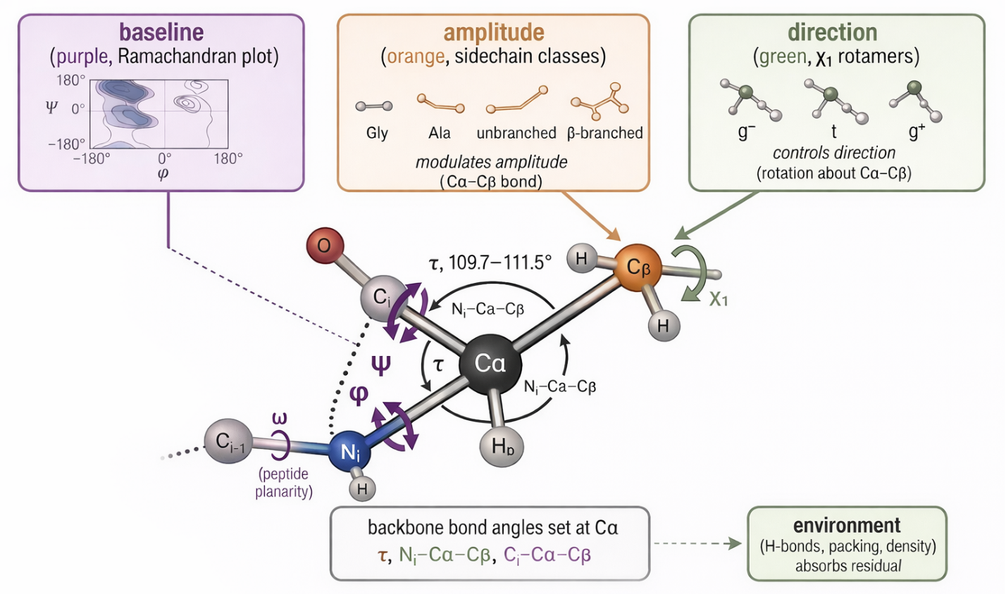
Figure 1 | Structural determinants of local backbone geometry at the $C_{α}$ center.
Three geometric channels jointly specify local backbone conformation. Baseline channel (purple): the primary conformational landscape of the polypeptide chain, determined by the backbone dihedral angles $ϕ, ψ$ and represented by the Ramachandran map. Amplitude channel (orange): sidechain steric and chemical identity modulate the local $C_{α}$–$C_{β}$ environment. Direction channel (green): sidechain orientation is specified by discrete $χ_{1}$rotamer states (gauche−, trans and gauche+), arising from rotation about the $C_{α}$–$C_{β}$ bond. The central $C_{α}$acts as a geometric junction at which bond angles are resolved. The valence angle $τ$($N_{i}$–$C_{α}$–$C_{i}$) has a median value of ~111° but varies systematically with local ($ϕ, ψ$) context. The sub-tetrahedral angles $N_{i}$–$C_{α}$–$C_{β}$ and $C_{i}$–$C_{α}$–$C_{β}$ further define sidechain trajectory. Residual geometric strain is accommodated by the surrounding environment, including hydrogen-bonding networks and atomic packing, yielding the final energy-minimized state.
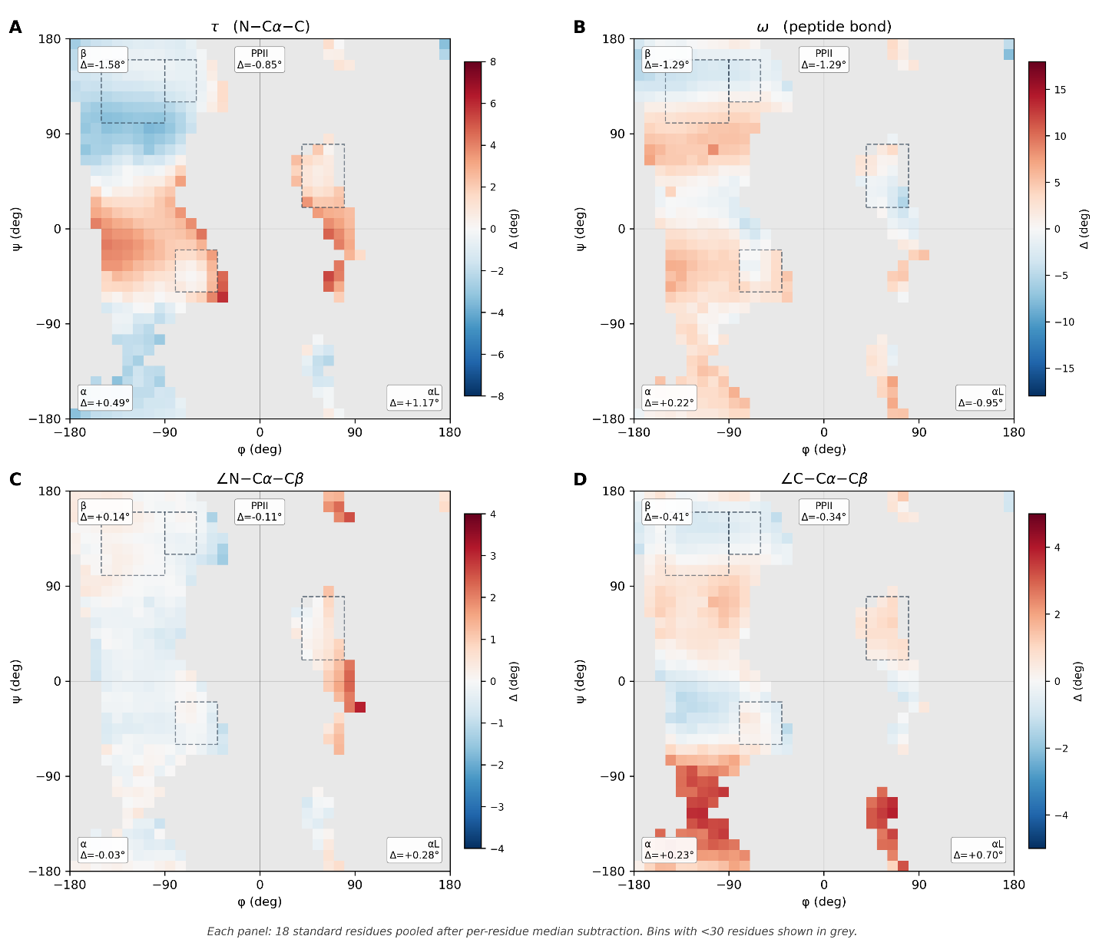
Fig. 2 | Backbone bond-angle deviations.
(Δ from ideal Engh–Huber geometry) mapped over the Ramachandran plane (φ, ψ) for 18 amino acids (low-occupancy bins masked; α, β, PPII, αL basins indicated). (A) τ varies strongly with ψ; (B) ω shows systematic non-planarity; (C) ∠N–Cα–Cβ is near-zero on average but bimodal; (D) ∠C–Cα–Cβ is complementary/antisymmetric to (C), consistent with tetrahedral constraints at Cα.
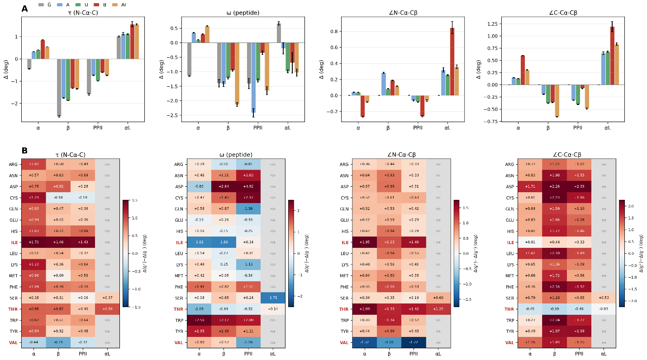
Fig. 3 | Sidechain substitution and χ₁ rotamer state modulate Cα-centered angles.
(A) Backbone angle deformations stratified by sidechain class (G, A, unbranched, β-branched, aromatic) across Ramachandran basins show systematic amplification with sidechain complexity. β-branching produces the largest shifts (2–5× relative to unbranched) in τ and ∠C–Cα–Cβ, along with a sign inversion in ∠N–Cα–Cβ. Glycine exhibits distinct behavior, including a large negative τ shift in β, consistent with a backbone-only response, whereas alanine and unbranched residues define the baseline sidechain contribution. The shared structure across all four angles indicates a common mechanical coupling at Cα.
(B) Stratification by χ₁ rotamer (g⁻, trans, g⁺) shows that sidechain rotation systematically modulates backbone geometry, producing ~1° shifts within the same residue and basin. This effect is strongest in τ and the Cβ-coupled angles, consistent with lever-like transmission through Cβ, whereas ω shows weaker and less consistent coupling.
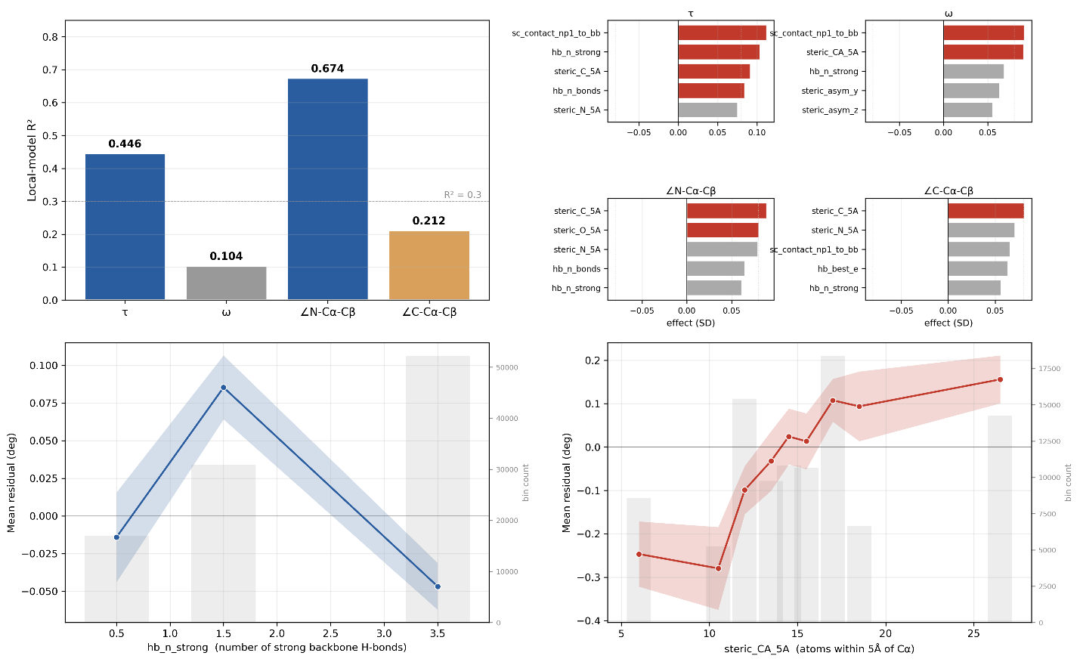
Figure 4 | Non-local channel.
(A) Local-feature models capture most variance for ∠N–Cα–Cβ (R² = 0.69) and τ (R² = 0.446), but perform poorly for ω and ∠C–Cα–Cβ (R² = 0.104 and 0.212), leaving substantial unexplained structure. (B) Residual analysis reveals angle-specific environmental coupling, with τ showing modest but consistent H-bonding and steric effects, ω exhibiting non-local contributions comparable to its weak local signal, and Cβ angles lacking structured non-local dependence. (C) τ residuals vary nonlinearly with backbone H-bonding, producing a small but reproducible shift (~0.13°) that is undetectable by linear correlation but captured by quartile-based effect size. (D) ω deviations from trans increase with local packing density around Cα, indicating that peptide-bond geometry is strongly modulated by the surrounding environment beyond backbone and sidechain constraints.
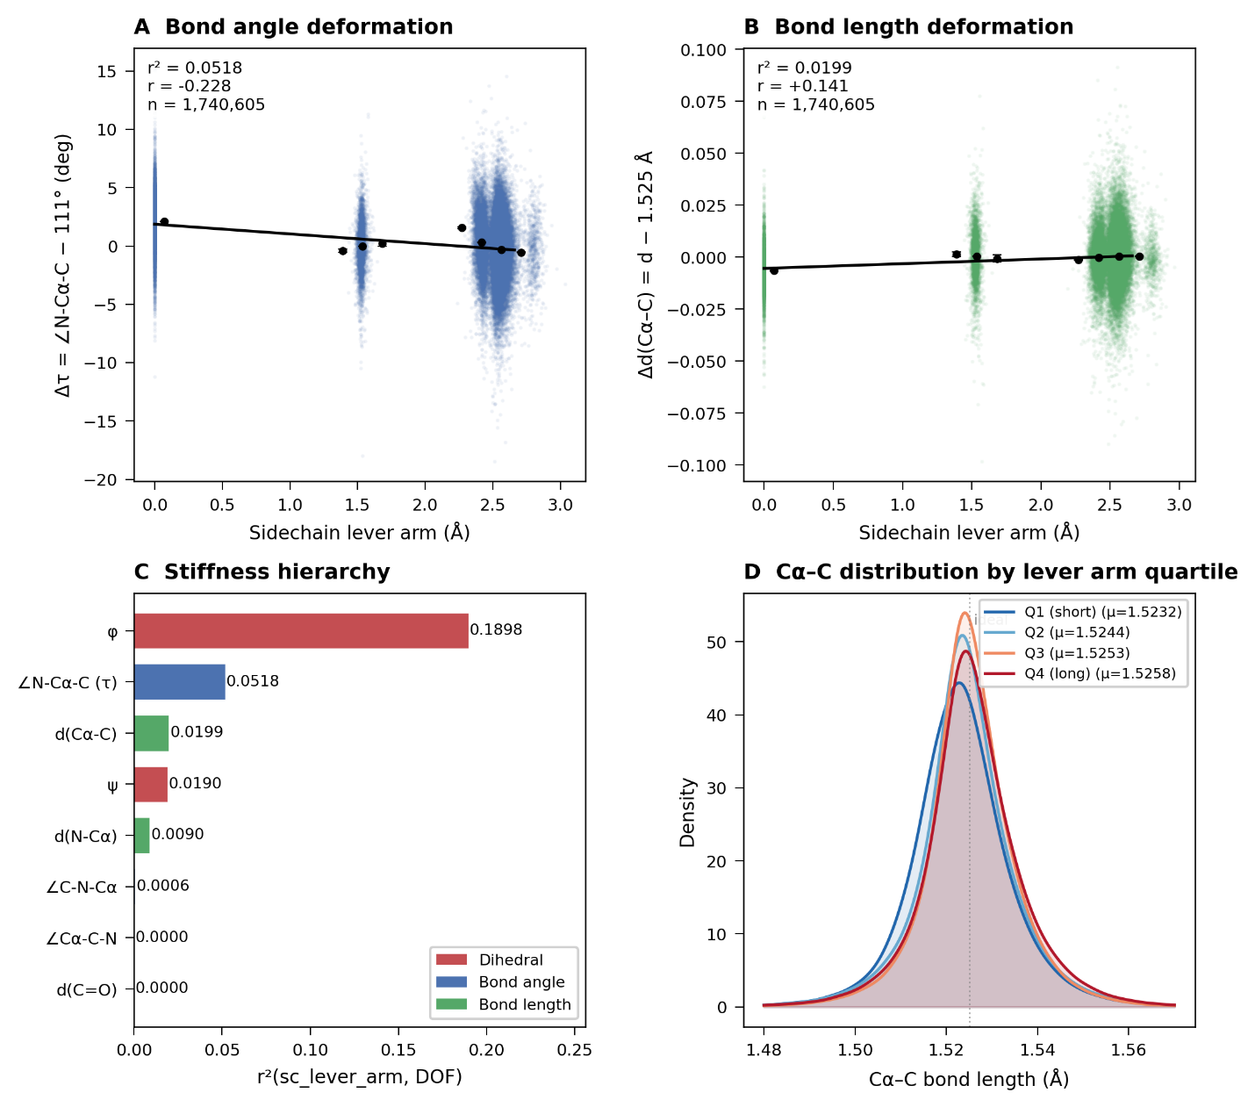
Figure 5 | Mechanical stiffness hierarchy of protein backbone.
Sidechain-induced strain is accommodated non-uniformly across backbone degrees of freedom. (A,B) Deformation of the bond angle τ (∠N–Cα–C) and bond length d(Cα–C) act as a function of sidechain lever arm (distance from Cα to the sidechain center of mass). (C) Variance (R²) reveals a mechanical hierarchy: the dihedral the dihedral φ and valence angle τ show principal sinks for sidechain-induced strain, whereas bond lengths and bond angle ∠Cα–C–N remain are largely invariant. (D) Cα–C bond-length distributions by lever-arm quartile. Higher loading shifts bonds longer, but the Q1–Q4 mean difference is only ~2.7 mÅ, indicating much greater stiffness in extension than bending.
3. Discussion
Backbone bond-angle variation is resolved into three coupled channels operating across length scales. Backbone dihedrals (φ, ψ) define a basin-specific strain field that sets the baseline geometry. Sidechain identity and χ₁ rotamer state modulate this field locally, with residue class setting deformation amplitude and χ₁ controlling direction through lever-like reorientation at Cα. Residual variance reflects a third, non-local channel: the surrounding protein environment, where steric packing and hydrogen bonding impose additional, angle-specific corrections. These channels are additive but not redundant, and together account for the majority of systematic bond-angle variation.
This framework extends the mechanical interpretation established in Paper I. There, the Ramachandran landscape emerged as a structured field of torsional stiffness and restoring forces. Here, that mechanical structure propagates beyond dihedrals into three-dimensional geometry: strain defined in (φ, ψ) space is transmitted through the tetrahedral Cα center, reweighted by sidechain topology, and coupled outward to non-local contacts. The backbone is therefore not a set of independent internal coordinates but a mechanically integrated system in which dihedrals, bond angles, and sidechain degrees of freedom form a continuous pathway for force transmission.
These results have direct implications for force-field design and structure prediction. Current frameworks such as AMBER, CHARMM, and Rosetta typically model backbone bond angles as harmonic wells around fixed equilibrium values. The present data show that these equilibria are not fixed: they shift systematically with Ramachandran basin, are amplified by β-branching and sidechain mass, and, for specific angles, respond to local packing and hydrogen bonding. Incorporating even basin-dependent equilibrium angles would reduce systematic errors in τ and Cβ-centered angles by ~1–3° per residue, which accumulates over chain length into substantial energetic discrepancies. More complete models will require coupling terms that explicitly encode sidechain topology and local environment.
Several limitations qualify these conclusions. Structural disorder, assessed via B-factor, does not account for the observed patterns, arguing against refinement artefacts; however, the analysis is restricted to high-resolution crystal structures and does not include cryo-EM data. Intrinsically disordered regions are underrepresented due to chain-continuity filtering, and the analysis is statistical rather than residue-specific, averaging over heterogeneous local environments. Future work should extend this framework to cryo-EM ensembles, incorporate explicit disorder models, and develop residue-resolved predictors that map local structural context to bond-angle geometry.

4. Methods
Structural dataset
11,475 PDB structures (resolution ≤ 2.0 Å, R-free ≤ 0.25, B-factor ≤ 30 Å², no chain gaps within ±3 residues) yielded 1,770,786 residues across all 20 standard amino acids after retaining highest-occupancy alternates (altloc 'A'; lexicographic tiebreak), discarding HETATM records, reducing NMR ensembles to model 1, and excluding residues flanking chain breaks (Cα–Cα > 4.5 Å or C–N > 1.8 Å). Per-type counts range from 24,730 (CYS) to 173,138 (LEU); glycine and proline are retained globally but excluded from Cβ-angle and χ1 analyses.
Feature extraction
All geometric features were computed from real crystallographic coordinates (pdb_loader.py); NeRF-reconstructed positions were explicitly avoided owing to systematic bias in the Ramachandran-dependent deformation signal (Supplementary Note S1). Per residue: backbone dihedrals φ, ψ, ω by the signed-dihedral formula; bond angles τ (∠N–Cα–C), ∠N–Cα–Cβ, ∠C–Cα–Cβ as arc-cosines of normalised bond vectors; χ1 and χ2 where defined; sidechain mass, heavy-atom count, β-branching and aromaticity flags. Non-local features include per-atom steric density within 5 Å (N, Cα, C, O separately), backbone-local steric asymmetry vectors, Kabsch–Sander hydrogen-bond statistics (threshold −0.5 kcal/mol; strong bonds < −2 kcal/mol), sidechain–backbone contact counts for residues i ± 1, and Cα B-factor. H-bond detection was validated against DSSP on 1UBQ and 1CRN (recall = 1.000, donor–acceptor Pearson r = 1.000).
Ramachandran basins
Four (φ, ψ) windows isolate basin cores: α [−80°,−40°] × [−60°,−20°]; β [−150°,−90°] × [100°,160°]; PPII [−90°,−60°] × [120°,160°]; αL [40°,80°] × [20°,80°]. Windows are intentionally narrow to minimise cross-basin contamination.
Per-residue deviation
To remove composition bias, deviations are defined as Δ = angle − median(angle | residue type), computed over the full dataset. For ω, median and difference use circular statistics (antipode method; shortest signed arc in [−180°,180°]).
Ramachandran heatmaps
Residues binned into 10° × 10° (φ, ψ) cells (minimum 30 residues); mean Δ per cell displayed with diverging colormap (limits: τ ±8°, ω ±18°, ∠N–Cα–Cβ ±4°, ∠C–Cα–Cβ ±5°, set at 99th percentile of |Δ|). Glycine and proline shown separately (Supplementary Fig. S1).
Sidechain class stratification
Residues assigned to five classes: G (glycine), A (alanine), U (unbranched: SER, CYS, LEU, MET, ASP, ASN, GLU, GLN, LYS, ARG), B (β-branched: VAL, ILE, THR), Ar (aromatic: PHE, TYR, TRP, HIS); proline excluded. Mean Δ and SEM computed per (angle × basin × class); pairwise Welch t-tests for B vs U and Ar vs U (32 comparisons, all p < 10⁻⁴ except where marked).
χ1 rotamer analysis
χ1 wells: g⁻ (−150° to −30°), trans (|χ1| ≥ 150°), g⁺ (30° to 150°); eclipsed residues (~5%) discarded. Rotamer shift reported as Δ(g⁺) − Δ(g⁻) with propagated SEM (cells with n < 30 in either well excluded). Valine CG1/CG2 labelling artefact confirmed and corrected (Supplementary Fig. S2); universal sidechain lever reported as 17/17 residues.
Local vs non-local decomposition
Local contributions were modeled using a gradient boosting regressor (scikit-learn; 200 estimators, max depth 4, learning rate 0.05, random seed 42) trained on 100,000 randomly sampled residues (70/30 split) with 11 features: φ, ψ, residue type, χ₁, χ₂, mass, heavy-atom count, β-branching, aromaticity, and χ₁/χ₂ availability. For ω, cis and highly twisted peptides (|ω| < 150°, ~0.3%) were excluded, and the target was transformed as ω_dev = 180° − |ω|.
Non-local effects were quantified as the quartile-mean residual range normalized by residual standard deviation; values exceeding 0.08 SD were considered significant. This analysis partitions angles into distinct regimes: ∠N–Cα–Cβ is predominantly local (R² = 0.69), τ reflects mixed local and non-local control (R² = 0.43), ω is environment-dominated (R² = 0.09), and ∠C–Cα–Cβ is largely noise-limited (R² = 0.18). Quartile-based effect sizes were used in place of Pearson correlation to capture non-monotonic environmental dependencies that are not reflected in global linear metrics.
Environmental dependence plots (Fig. 4C–D) were generated using occupancy-balanced binning. Discrete variables (e.g., hydrogen-bond counts) were grouped by integer value and plotted at bin midpoints, whereas continuous variables (e.g., steric density) were quantile-binned to ensure uniform sampling, with values plotted at bin centers. Corresponding histograms (light gray bars) are overlaid to indicate sampling density, confirming that observed residual shifts arise from well-populated regions of the environmental coordinate.
Sidechain lever arm
The sidechain lever arm was defined as the Euclidean distance between Cα and the geometric center of mass of all sidechain heavy atoms. Glycine was assigned to a lever arm of zero.
Software and reproducibility
Python 3.11; NumPy 1.26, pandas 2.1, scikit-learn 1.4, SciPy 1.11, matplotlib 3.8. All p-values two-tailed; random seed 42 throughout. Scripts and feature table (2,516,297 × 83, ~1.3 GB) deposited on Zenodo at publication.

Data Availability
The Python scripts and analysis framework are available at: https://github.com/wei09128/protein-backbone-mechanics

References
Ramachandran, G. N., Ramakrishnan, C., & Sasisekharan, V. (1963). Stereochemistry of polypeptide chain configurations. Journal of Molecular Biology, 7(1), 95–99. https://doi.org/10.1016/s0022-2836(63)80023-6
Carey, J., Benoff, B., Harish, B., Yuan, L., & Lawson, C. L. (2012). Environment-dependent long-range structural distortion in a temperature-sensitive point mutant: Long-Range Distortion Permitted by Point Mutation. Protein Science, 21(1), 63–74. doi:10.1002/pro.759
Roterman, I., Stapor, K., & Konieczny, L. (2022). Secondary structure in amyloids in relation to their wild type forms. International Journal of Molecular Sciences, 24(1), 154. doi:10.3390/ijms24010154
Towse, C.-L., Vymetal, J., Vondrasek, J., & Daggett, V. (2016). Insights into unfolded proteins from the intrinsic ϕ/ψ propensities of the AAXAA host-guest series. Biophysical Journal, 110(2), 348–361. doi:10.1016/j.bpj.2015.12.008
Engh, R. A., & Huber, R. (1991). Accurate bond and angle parameters for X-ray protein structure refinement. Acta Crystallographica. Section A, Foundations of Crystallography, 47(4), 392–400. doi:10.1107/s0108767391001071
Tian, C., Kasavajhala, K., Belfon, K. A. A., Raguette, L., Huang, H., Migues, A. N., Bickel, J., Wang, Y., Pincay, J., Wu, Q., & Simmerling, C. (2020). Ff19SB: Amino-acid-specific protein backbone parameters trained against quantum mechanics energy surfaces in solution. Journal of Chemical Theory and Computation, 16(1), 528–552. https://doi.org/10.1021/acs.jctc.9b00591
Maier, J. A., Martinez, C., Kasavajhala, K., Wickstrom, L., Hauser, K. E., & Simmerling, C. (2015). Ff14SB: Improving the accuracy of protein side chain and backbone parameters from ff99SB. Journal of Chemical Theory and Computation, 11(8), 3696–3713. https://doi.org/10.1021/acs.jctc.5b00255

