The Coupling Structure of Protein Backbone Geometry:
Separability Failure in Classical Force Fields

Wei Chen¹, Urska Cvek¹, Marjan Trutschl¹

¹ Department of Computer Science, Louisiana State University Shreveport, Shreveport, LA 71115, USA

Corresponding author: xxx
Email: xxx

Abstract
Classical molecular mechanics force fields decompose backbone conformational energy as a sum of independent torsional potentials: E(φ,ψ) = Eφ(φ) + Eψ(ψ) [2,3]. Here we test this separability assumption by decomposing seven backbone geometric observables across 1.77 million residues from 10,979 protein crystal structures using two complementary approaches: generalized additive models (GAMs) [7,8] with smooth spline bases and bootstrapped confidence intervals, and full-data cell-means ANOVA on a 10° Ramachandran grid. Both methods reveal significant φ×ψ coupling. The GAM analysis shows that the coupling term adds ΔR² = 2.13% [95% CI: 1.93–2.32%] beyond the additive model for the bond angle τ (N–Cα–C), 2.65% [2.43–3.00%] for the sidechain angle ∠N–Cα–Cβ, and 2.25% [2.05–2.43%] for peptide planarity ω. Coupling is strongest in coil regions (ΔR² = 2.29%) and weakest in β-sheets and PPII (0.54%), explaining why force fields perform well for regular secondary structure but fail for loops. A three-way decomposition reveals that χ¹ rotamer state adds a larger coupling channel for Cβ angles (ΔR² = +4.6%) than φ×ψ coupling itself. We further show that candidate quantum-mechanical corrections—n→π* orbital overlap and σ→σ* hyperconjugation—are geometrically redundant with the coupling term (ΔR² ≤ 0.02) (Figure 1) . The peak-to-peak coupling energy reaches 1.6 kcal/mol, comparable to a hydrogen bond. We provide complete coupling correction maps as supplementary lookup tables suitable for CMAP-style force-field corrections [4].

Keywords: protein backbone geometry, force field, separability, φψ coupling, Ramachandran, CMAP correction, generalized additive model

1. Introduction
The Ramachandran plot remains the cornerstone of protein structural analysis [1], yet most molecular mechanics force fields still approximate backbone energetics as separable one-dimensional torsions, E(φ,ψ) = Eφ(φ) + Eψ(ψ) [2]. Although grid-based corrections such as CMAP were introduced when this approximation failed for model peptides [4], the magnitude, structural scope, and physical origin of backbone φ×ψ coupling have never been quantified directly from experimental protein structures at scale.
In companion studies, we showed that the Ramachandran landscape behaves as a mechanical force field (Paper 1 [9]) with two orthogonal steric discontinuities at φ ≈ −60° and ψ ≈ −40°, and that local backbone geometry deforms systematically with conformation and residue identity (Paper 2 [10]), with the bond angle τ (N–Cα–C) varying by 8.4° peak-to-peak across the Ramachandran plane [7].
Here, analyzing 1.77 million residues from 10,979 structures, we decompose bond angles, bond lengths, peptide planarity, and sidechain-coupled geometry into additive and interaction terms. We employ generalized additive models (GAMs) with smooth spline bases to obtain properly calibrated coupling estimates with confidence intervals, avoiding the non-orthogonality artifacts inherent in unbalanced factorial designs. We find pervasive, residue-specific noncomparability that classical torsion models miss, and show that candidate quantum-mechanical corrections add negligible information beyond the geometric coupling surface (Figure 1) .

2. Results

2.1 Systematic Failure of the Separability Assumption
We decomposed seven backbone observables using two complementary methods: (1) a GAM approach [8] fitting y = s(φ) + s(ψ) (additive) versus y = te(φ,ψ) (full tensor product) on 50,000-residue subsamples with 20 bootstrap iterations, and (2) a cell-means ANOVA on the full 1.77 million rows using a 10° Ramachandran grid. The coupling is defined as ΔR² = R²_full − R²_additive, representing the unique variance explained by the φ×ψ interaction beyond what independent φ and ψ effects can capture.
The GAM results (Table 1) show that every observable statistically significant coupling (all 95% CIs exclude zero). The largest coupling occurs for ∠N–Cα–Cβ (ΔR² = 2.65% [2.43–3.00%]), followed by ω planarity (2.25% [2.05–2.43%]) and τ (2.13% [1.93–2.32%]). Bond lengths show smaller but significant coupling (0.28–0.30%). The additive model captures 39.8% of τ variance; adding the interaction raises this to 41.9%, a gain that is modest in absolute terms but statistically robust and physically meaningful given the 1.6 kcal/mol peak-to-peak energy involved.
The cell-means method on full data yields higher ΔR² values (e.g., 8.88% for τ) due to overfitting in sparsely populated Ramachandran bins. The GAM estimates, which use smooth spline bases with automatic penalization, provide more conservative and defensible numbers. The spatial pattern of coupling from both methods agrees: the coupling maps derived from cell-means residuals (Figure 2A) show coherent spatial structure that the GAM interaction surface reproduces.

2.2 Conformational and Residue-Specific Drivers of Coupling
Coupling strength varies markedly by secondary structure (Table 2). Coil regions exhibit the strongest τ coupling (ΔR² = 2.29% [2.05–2.50%]), while β-sheets and PPII show the weakest (both 0.54%). αR-helices are intermediate (1.35%). This hierarchy explains a long-standing observation in molecular dynamics: force fields reproduce helical and sheet geometry well but struggle with loop conformations [3]. The coupling that force fields neglect is precisely largest in the regions where they perform worst.
Residue identity further modulates the pattern (Table 3; Figure 2B). Among the four structural classes, non-branched residues show the strongest τ coupling (ΔR² = 2.35%), followed by glycine (2.12%), β-branched (1.67%), and proline (1.34%). Proline’s low coupling is mechanistically interpretable: its pyrrolidine ring constrains φ to a narrow range around −63°, effectively collapsing the two-dimensional coupling surface into a one-dimensional ψ-dependent profile. Among all 20 amino acids, per-residue τ coupling ranges from 5.8% (η², PRO) to 22.0% (GLY), a 3.8-fold range, with a weak positive correlation between coupling strength and sidechain rotameric flexibility (r = +0.47, p = 0.04 for ∠C–Cα–Cβ).

2.3 Sidechain Modulation via χ¹
Including χ¹ in a three-way decomposition reveals an additional interaction channel (Table 4). For ∠N–Cα–Cβ, the χ¹ coupling (ΔR² = +4.6%) exceeds the φ×ψ coupling (+2.8%), indicating that the sidechain rotamer modulates this angle more strongly than backbone dihedral interactions alone. For τ, the χ¹ coupling is negligible (+0.3%), confirming that τ is a backbone-intrinsic observable. This distinction—backbone angles coupled to (φ,ψ), sidechain angles coupled to (φ,ψ,χ¹)—defines the minimal coupling structure that a corrected force field must encode.

2.4 Spatial Structure of the Coupling Surface
The coupling residual Δτφψ is not randomly distributed across the Ramachandran plane but shows coherent spatial structure (Figure 3). The αR basin core exhibits the weakest coupling (⟨|Δτ|⟩ = 0.44°), while basin boundaries show the strongest (ψ ≈ −40° wall: 1.94°; φ ≈ −60° wall: 1.42°). The coupling changes sign between αR (sign bias = −0.44°) and β (+0.84°), confirming that the steric discontinuities identified in Paper 1 lie near the nodal lines of a structured coupling surface.
The αR basin is special not because it has strong coupling, but because it sits at a node where coupling from adjacent regions cancels. This explains why the separability approximation works best for α-helical conformations—the dominant secondary structure type in force-field parameterisation targets.
This spatial structure connects directly to the steric discontinuities identified in Paper 1 (Section 2.5). Paper 1 showed that two orthogonal steric contacts—the C_{i−1}=O···Cβ collision along φ and the O···N_{i+1} collision along ψ—create sharp stiffness walls at φ ≈ −60° and ψ ≈ −40°. The coupling analysis reveals that these walls coincide with the nodal lines of the coupling surface, where Δf_φψ passes through zero. Crucially, nodal lines are not energy barriers: they are sign-change boundaries where the coupling switches from positive (τ shifted upward in β, sign bias = +0.84°) to negative (τ shifted downward in αR, sign bias = −0.44°). Population density need not be depleted at a zero-crossing, just as the membrane of a vibrating drum is not absent at a nodal line. The steric walls and the coupling nodes are thus two representations of the same geometric boundary: Paper 1 detected them through stiffness discontinuities in k_eff, while the present work detects them through sign changes in the coupling residual. Their coincidence confirms that the separability failure originates in the same Cα-mediated steric transmission mechanism identified in Paper 1 (Section 2.3): steric pressure on one dihedral is transmitted across the tetrahedral Cα junction and expressed as a conformational response on the other, creating the φ×ψ cross-term that separable force fields cannot represent.

2.5 Geometric Redundancy of Electronic Effects
We tested whether two quantum-mechanical interactions—n→π* orbital overlap and σ→σ* hyperconjugation—provide predictive power beyond the classical coupling framework. The n→π* interaction shows the expected (φ,ψ)-dependence: αR has the shortest O···C distance (3.17 Å, 59% strong contacts) while β has the longest (3.55 Å, 27% strong). However, adding n→π* features to a basin + residue type baseline yields only ΔR² = +0.020 for τ prediction. Hyperconjugation geometry shows even weaker effects: all ΔR² < 0.004, including for β-branched residues specifically (Table 4).
Both quantum effects are real and physically present, but they are already encoded in the (φ,ψ) dependence of backbone geometry. Binning by (φ,ψ) implicitly stratifies these quantum descriptors, because both are geometrically determined by backbone and sidechain dihedral angles. The classical coupling term is a sufficient statistic for local quantum-mechanical interactions.

2.6 Energetic Significance and Robustness
Converting coupling magnitudes to approximate energies using AMBER ff14SB harmonic spring constants, the peak-to-peak coupling energy for τ is 1.59 kcal/mol and for ∠N–Cα–Cβ is 0.70 kcal/mol—both comparable to hydrogen-bond energies at basin boundaries. Sensitivity analyses confirm robustness: τ coupling is stable across B-factor strata (16.2% for B < 10 Å² vs. 14.5% for B = 25–30 Å²), and heavier i+1 neighbors increase coupling only modestly (13.8% to 16.7%).

3. Discussion

3.1 The Correct Energy Formula
Our results establish that the correct local backbone energy is:

E(φ,ψ) = Eφ(φ) + Eψ(ψ) + Eφψ(φ,ψ) + Eτ(τ|φ,ψ) + E_nonlocal

The interaction term Eφψ corresponds to the measured coupling surface, and Eτ(τ|φ,ψ) captures the conditional bond-angle dependence established in Paper 2. The coupling correction maps provided as supplementary data constitute a CMAP-style correction applicable to any separable backbone potential, with the advantage of being derived empirically from all 20 amino acids in crystallographic context rather than from quantum calculations on a single model compound.

3.2 Relationship to CMAP Corrections
The CHARMM CMAP correction addresses the same separability failure but differs from our approach in three respects. First, CMAP is derived from quantum calculations on Ac-Ala-NMe, whereas our maps are derived empirically from 10,979 structures spanning all amino acids. Second, CMAP corrects the total energy surface, while our decomposition isolates the coupling component, enabling diagnosis of which observables are most affected. Third, we provide residue-class-specific coupling maps (Gly, Pro, β-branched, other), whereas CMAP uses a single grid.

3.3 Understanding Force-Field Inaccuracies in Loop Regions
The systematic variation of coupling across conformational space—coil (2.29%) > αR (1.35%) > β (0.54%)—explains a long-standing problem in molecular dynamics. Because coupling peaks in coil regions, the omission of the interaction term leads to the greatest errors exactly where conformational flexibility is highest. Existing CMAP implementations, derived from single-residue quantum calculations, do not capture this residue- and environment-specific variation.
Paper 1 established that AMBER ff14SB assigns a ψ-independent stiffness value along the α-helical corridor, whereas the empirical curvature varies by more than 13 kcal·mol⁻¹·rad⁻² as ψ changes (Paper 1, Fig. 7B). The coupling decomposition quantifies the consequence: at the αR position, where coupling passes through zero, the separable approximation is accidentally adequate. But moving along ψ away from the αR node, the coupling term grows rapidly (reaching 1.94° at the ψ ≈ −40° wall and 1.42° at the φ ≈ −60° wall), and the separable model's error grows proportionally. This explains the paradox noted in Paper 1 that AMBER correctly reproduces αR basin locations while systematically misrepresenting local restoring forces: the basin sits at the coupling node where E_φψ ≈ 0, so the separable model happens to be correct there, but the curvature errors diagnosed in Paper 1 are the direct manifestation of the coupling term that the present work quantifies.

3.4 Geometric Encoding of Electronic Effects
The near-zero predictive gain from n→π* and hyperconjugation descriptors suggests that explicit quantum-mechanical terms are unnecessary for backbone geometry prediction. Both effects are determined by backbone atom positions, which are themselves functions of (φ,ψ). The geometric coupling term implicitly captures these quantum effects, providing a more parsimonious representation than explicit electronic models.

3.5 Statistical Methodology
We note that naive ANOVA decomposition on unbalanced Ramachandran grids yields inflated coupling estimates due to non-orthogonality of marginal effects under uneven cell occupancy. The cell-means method reports ΔR² = 8.88% for τ, versus 2.13% from the GAM analysis. We recommend the GAM approach as the primary metric because: (1) it uses smooth spline bases rather than step functions, (2) automatic penalization prevents overfitting in sparse regions, (3) bootstrap confidence intervals provide uncertainty quantification, and (4) the ΔR² = R²(te) − R²(s+s) formulation correctly isolates the unique coupling contribution regardless of marginal non-orthogonality. The cell-means coupling maps remain useful for visualizing the spatial pattern of coupling on the Ramachandran plane.

3.6 Limitations
Several limitations should be noted. First, the analysis uses crystallographic structures reflecting refined, ensemble-averaged geometry; coupling in solution may differ. Second, the harmonic energy conversion is approximate. Third, the dataset lacks explicit resolution metadata; future work should stratify by resolution. Fourth, the three-way decomposition uses coarse χ¹ bins; finer rotamer libraries may reveal additional structure. Fifth, the GAM analysis uses 50,000-residue subsamples; although bootstrap intervals are tight, systematic differences between subsamples and the full population cannot be excluded.

4. Methods

4.1 Dataset
Backbone geometry was extracted from 10,979 protein crystal structures using our previously described feature extraction pipeline (Papers 1–2). Quality filtering retained 1,770,786 residues with B-factor < 30 Å², complete backbone atoms, defined φ and ψ, and at least 3 residues from any chain break.

4.2 GAM Decomposition
For each backbone observable y, we fitted two models using pyGAM [11] with 15-knot cubic spline bases:
Model A (additive): y = s(φ, 15) + s(ψ, 15)
Model B (full): y = te(φ, ψ, 15×15)
where s() denotes a univariate penalized spline and te() a tensor-product spline. The coupling is ΔR² = R²_B − R²_A. Models were fitted on 50,000-residue random subsamples; 20 bootstrap iterations provided 95% percentile confidence intervals. The te() interaction surface is equivalent to s(φ) + s(ψ) + ti(φ,ψ), where ti() is the pure interaction orthogonal to marginals.

4.3 Cell-Means ANOVA
The Ramachandran plane was gridded into 10° × 10° bins (cells with < 5 observations excluded). R²_full was computed from cell-mean predictions; R²_additive from the sum of φ-marginal and ψ-marginal means minus the grand mean. Coupling maps (Δfφψ) were computed as cell mean minus additive prediction.

4.4 Three-Way Decomposition
For residues with defined χ¹ (excluding Gly and Ala; n = 1,488,353), we encoded φ, ψ as dummy variables (20° bins) and χ¹ as three rotamer classes (gauche+, trans, gauche−). R² was computed from linear models with all factors additive, then adding φ×ψ interactions, then all two-way interactions.

4.5 Quantum-Mechanical Geometry
n→π* geometry (Oᵢ···Cᵢ₊₁ distance, Bürgi–Dunitz angle) and hyperconjugation overlap (cos² of Cγ–Cβ–Cα–N dihedrals) were extracted from PDB coordinates. Predictive power was assessed via gradient boosting regressors with 5-fold cross-validation.

4.6 Energy Estimation
Coupling magnitudes in degrees were converted to energies using E = ½ k (Δθ)² with AMBER ff14SB spring constants: kτ = 63 kcal/mol/rad² [2].

4.7 Data Availability
The Python scripts and analysis framework are available at: https://github.com/wei09128/protein-backbone-mechanics

5. Conclusions
The separability approximation E(φ,ψ) ≈ Eφ(φ) + Eψ(ψ), which underlies all major molecular mechanics force fields, fails for every backbone geometric observable tested. The GAM-based coupling term adds ΔR² = 0.3–2.7% of total variance beyond the additive model, is strongest in loop regions (ΔR² = 2.3%), and reaches energies of 1.6 kcal/mol at basin boundaries. The χ¹ rotamer state provides a second, independent coupling channel for sidechain-linked angles. Quantum-mechanical corrections (n→π*, hyperconjugation) are geometrically redundant with the coupling surface. The coupling correction maps provided as supplementary data enable CMAP-style implementation in existing simulation packages.

Tables

Table 1. GAM-based coupling decomposition. ΔR²_coupling = R²(te(φ,ψ)) − R²(s(φ)+s(ψ)). 50,000-residue subsamples × 20 bootstrap iterations. All CIs exclude zero.
Observable | R²_add | R²_full | ΔR²_coup | p-p (°) | 95% CI
τ (N–Cα–C) | 39.82% | 41.94% | +2.13% | 12.86 | [1.93, 2.32]
∠N–Cα–Cβ | 10.60% | 13.25% | +2.65% | 8.51 | [2.43, 3.00]
ω (planarity) | 7.72% | 9.97% | +2.25% | 8.28 | [2.05, 2.43]
∠C–Cα–Cβ | 8.83% | 9.64% | +0.80% | 3.94 | [0.66, 0.98]
bond N–Cα | 3.49% | 3.79% | +0.30% | 0.09 | [0.21, 0.66]
bond Cα–C | 7.07% | 7.35% | +0.28% | 0.03 | [0.19, 0.36]
Table 2. τ coupling by secondary structure (GAM ΔR² with 95% CI).
SS type | ΔR²_coupling | 95% CI | R²_additive
Coil | +2.29% | [2.05, 2.50] | 40.3%
αL | +1.70% | [1.60, 1.84] | 29.7%
αR | +1.35% | [1.21, 1.50] | 25.5%
β | +0.54% | [0.45, 0.66] | 12.7%
PPII | +0.54% | [0.47, 0.64] | 5.3%
Table 3. τ coupling by residue class (GAM ΔR² with 95% CI).
Residue class | ΔR²_coupling | 95% CI | Mechanism
Non-branched other | +2.35% | [2.09, 2.56] | Full φψ access
Glycine | +2.12% | [1.95, 2.31] | No sidechain
β-branched | +1.67% | [1.47, 1.82] | Constrained χ¹
Proline | +1.34% | [1.21, 1.44] | φ locked
Table 4. Three-way decomposition (φ, ψ, χ¹). Δ(φψ) = R² gain from φ×ψ interactions; Δ(χ¹×) = additional gain from χ¹ interactions.
Observable | R²_add | +φψ | +all 2-way | Δ(φψ) | Δ(χ¹×)
τ (N–Cα–C) | 36.8% | 38.9% | 39.2% | +2.1% | +0.3%
∠N–Cα–Cβ | 10.5% | 13.3% | 17.9% | +2.8% | +4.6%
∠C–Cα–Cβ | 10.3% | 11.1% | 12.9% | +0.8% | +1.8%
ω | 7.2% | 9.0% | 9.2% | +1.8% | +0.1%
bond Cα–C | 6.5% | 6.6% | 6.7% | +0.1% | +0.1%
Table 5. Quantum-mechanical descriptors do not improve backbone geometry prediction beyond (φ,ψ) binning.
QM descriptor | ΔR² for τ | ΔR² for angles | Conclusion
n→π* (O···C distance) | +0.020 | +0.020 | Marginal
σ→σ* hyperconjugation | <0.004 | <0.004 | Negligible
Both combined | ≤0.02 | ≤0.02 | Redundant

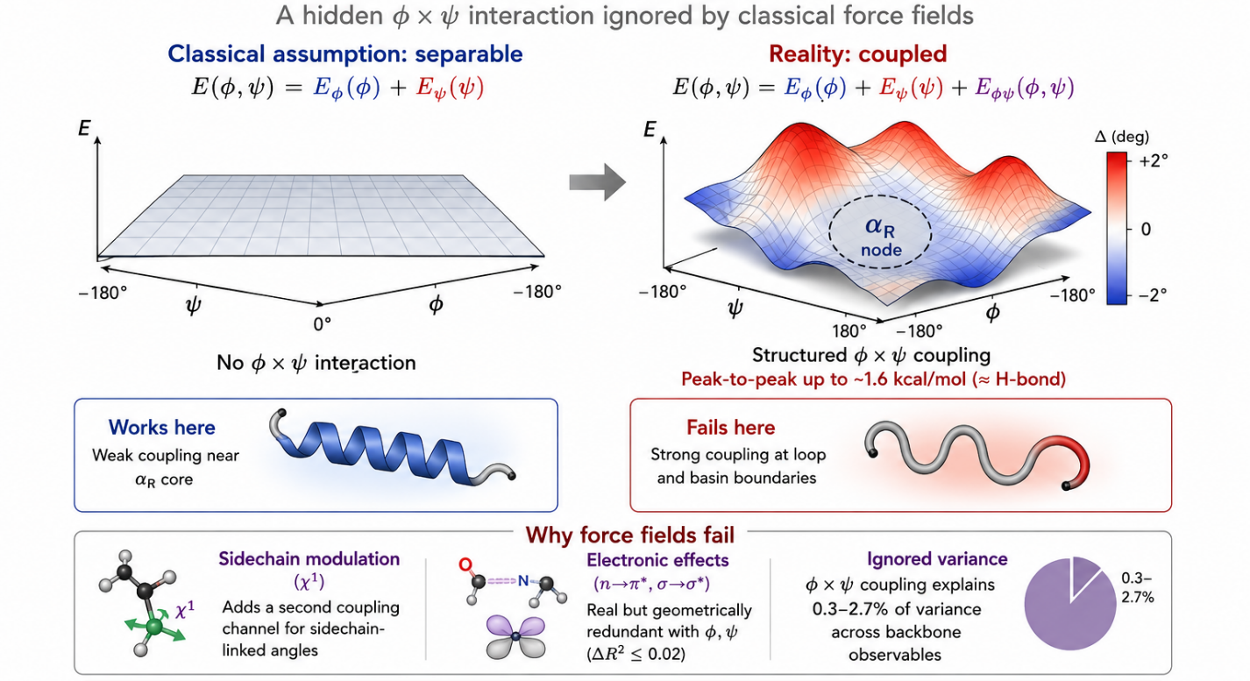
Figure 1 | Protein backbone geometry is not separable.
Classical force fields model backbone energetics as independent φ and ψ torsions. Δτ, φ×ψ coupling surface that is weakest near the α-helical basin but strongest in loop and basin-boundary regions. The neglected interaction reaches ~1.6 kcal/mol, explaining why separable force fields reproduce regular secondary structure yet systematically fail for flexible conformations.
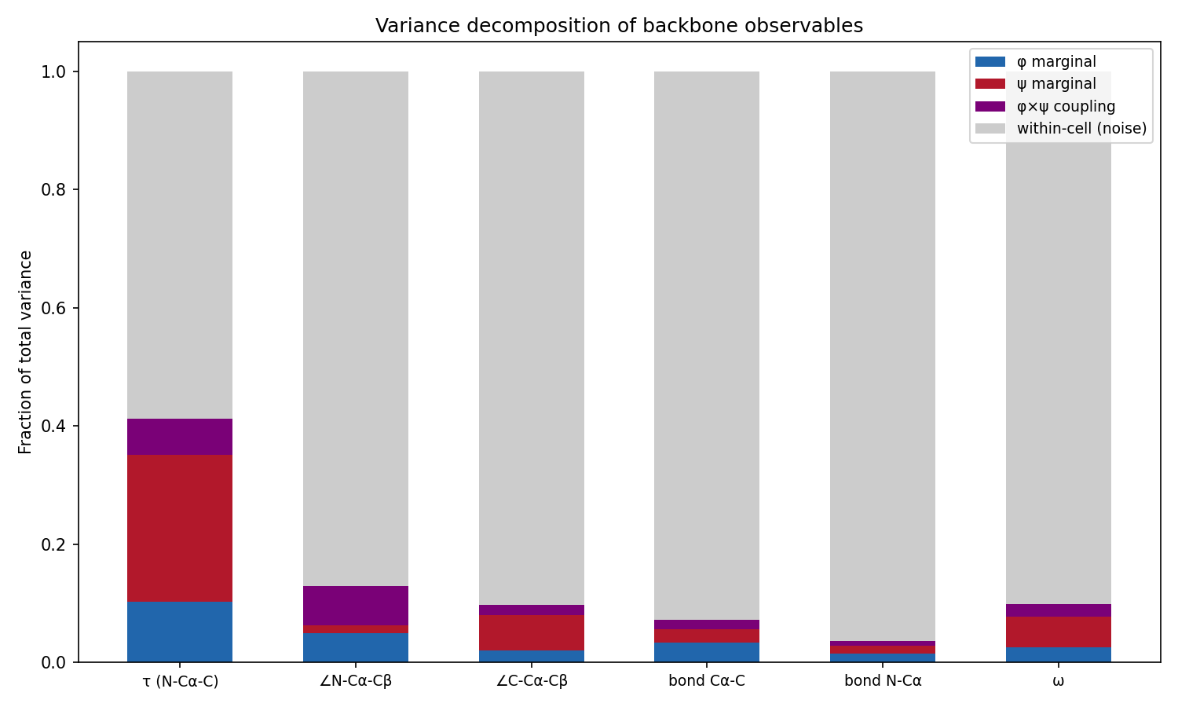
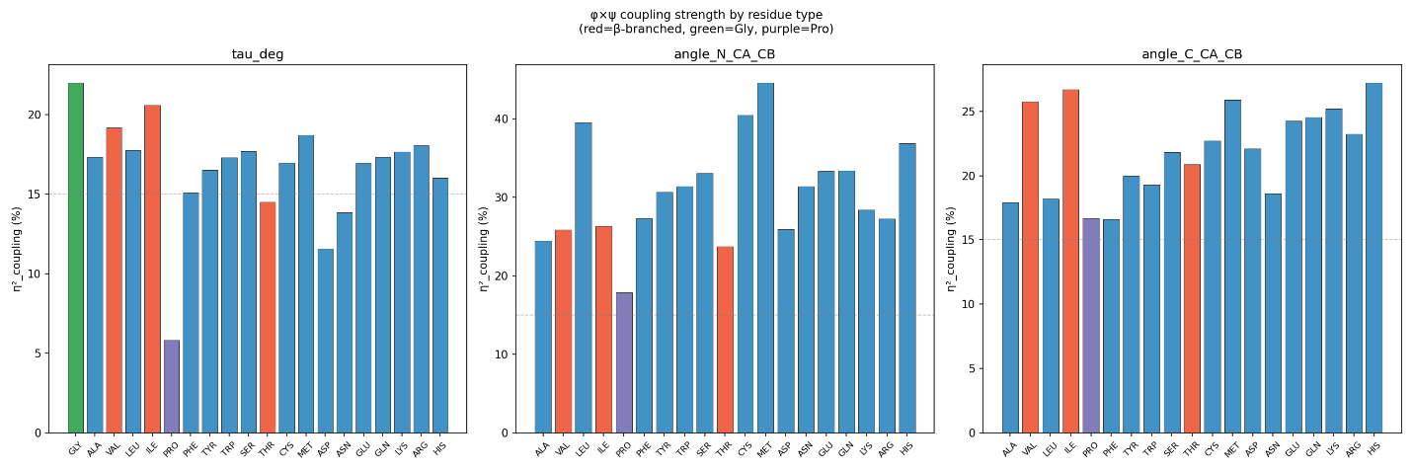
Figure 2 | Variance decomposition and residue-specific coupling of backbone geometry.
(A) Total variance for seven backbone observables partitioned into φ (blue) and ψ (red) marginal contributions, φ×ψ interaction (purple), and within-cell variance (gray). (B) Coupling strength (η²_coupling) across the 20 amino acids, showing higher values for glycine and lower values for proline.
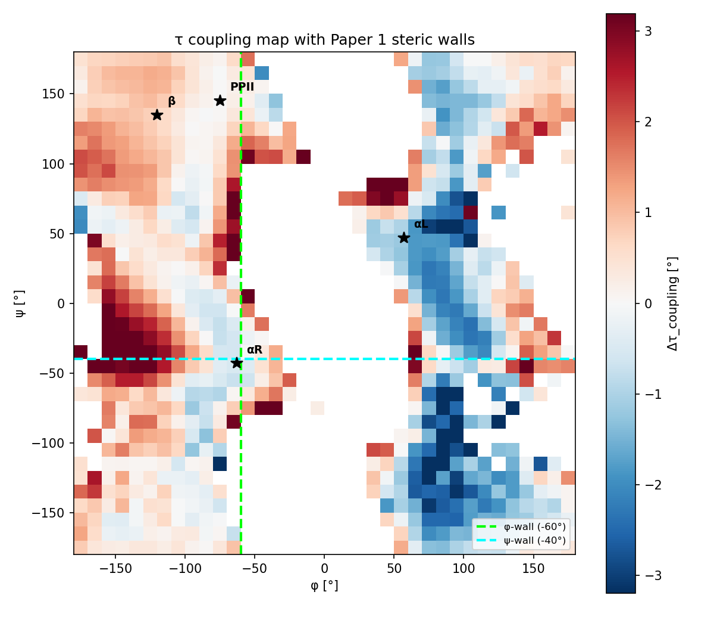
Figure 3. Coupling map of τ on the Ramachandran plane. Colour indicates Δτ_coupling in degrees (red positive, blue negative). Dashed lines mark the Paper 1 steric discontinuities. The αR core sits at the coupling node; basin boundaries show the strongest coupling.

References
[1] Bartlett, G. J., Newberry, R. W., VanVeller, B., Raines, R. T., & Woolfson, D. N. (2013). Interplay of hydrogen bonds and n→π* interactions in proteins. Journal of the American Chemical Society, 135(49), 18682–18688. https://doi/10.1021/ja4106122
[2] Huang, J., Rauscher, S., Nawrocki, G., Ran, T., Feig, M., de Groot, B. L., ... & MacKerell, A. D., Jr. (2017). CHARMM36m: An improved force field for folded and intrinsically disordered proteins. Nature Methods, 14(1), 71–73. https://doi.org/10.1038/nmeth.4067
[3] MacKerell, A. D., Jr., Feig, M., & Brooks, C. L., 3rd. (2004). Extending the treatment of backbone energetics in protein force fields: limitations of gas-phase quantum mechanics in reproducing protein conformational distributions in molecular dynamics simulations. Journal of Computational Chemistry, 25(11), 1400–1415. https://doi.org/10.1002/jcc.20065
[4] Maier, J. A., Martinez, C., Kasavajhala, K., Wickstrom, L., Hauser, K. E., & Simmerling, C. (2015). ff14SB: Improving the accuracy of protein side chain and backbone parameters from ff99SB. Journal of Chemical Theory and Computation, 11(8), 3696–3713. https://doi.org/10.1021/acs.jctc.5b00255
[5] Ramachandran, G. N., Ramakrishnan, C., & Sasisekharan, V. (1963). Stereochemistry of polypeptide chain configurations. Journal of Molecular Biology, 7(1), 95–109. https://doi.org/10.1016/s0022-2836(63)80023-6
[6] Newberry, R. W., & Raines, R. T. (2017). The n→π* Interaction. Accounts of Chemical Research, 50(8), 1838–1846. https://doi.org/10.1021/acs.accounts.7b00121
[7] Wood, S. N. (2017). Generalized Additive Models: An Introduction with R. (2nd ed.). Chapman and Hall/CRC. https://doi.org/10.1201/9781315370279
[8] Hastie, T., & Tibshirani, R. (1986). Generalized Additive Models. Statistical Science, 1(3), 297–318. https://doi.org/10.1214/ss/1177013604
[9] Chen, W., Cvek, U., & Trutschl, M. (2026). Protein backbone geometry as local mechanical equilibrium. Manuscript submitted for publication.
[10] Chen, W., Cvek, U., & Trutschl, M. (2026). Backbone bond angles deform systematically with (φ,ψ). Manuscript submitted for publication.
[11] Servén, D., & Brummitt, C. (2018). pyGAM: Generalized Additive Models in Python. Zenodo. https://doi.org/10.5281/zenodo.1208723
[12] Efron, B., & Tibshirani, R. J. (1994). An Introduction to the Bootstrap. Chapman and Hall/CRC. https://doi.org/10.1201/9780429246593

