A Conformation-Dependent Geometry Library for
Protein Backbone Reconstruction

Wei Chen¹, Urska Cvek¹, Marjan Trutschl¹

¹ Department of Computer Science, Louisiana State University Shreveport, Shreveport, LA 71115, USA

Corresponding author: xxx

Abstract
Molecular mechanics force fields and Natural Extension Reference Frame (NeRF) reconstruction algorithms use fixed bond lengths, bond angles, and peptide planarity values derived from small-molecule crystallography. These constants ignore the systematic dependence of backbone geometry on local conformation (φ,ψ) and amino acid identity established in companion studies. Here we present a complete, validated geometry library extracted from 1.77 million residues across 10,979 protein crystal structures. The library provides (φ,ψ)-dependent equilibrium values for 11 backbone observables (6 bond angles, 5 bond lengths) with per-amino-acid resolution, plus χ¹-dependent corrections for Cβ angles. Compared to AMBER ff14SB fixed constants, the library reduces mean absolute prediction error by 10–36% across all observables, with the largest gains for ∠N–Cα–Cβ (+36.1%) and τ (N–Cα–C) (+28.8%). A strain energy analysis shows that AMBER’s fixed constants impose 9.8 kcal/mol of phantom strain per 100-residue protein—equivalent to ~7 hydrogen bonds—which the library eliminates by 31.5%. An 80/20 temporal split demonstrates zero overfitting: out-of-sample improvement (+18.7%) matches in-sample (+16.7%), confirming that the library captures universal backbone physics. The library passes all 11 Engh & Huber crystallographic validation checks and is provided as a JSON lookup table for direct integration into NeRF builders and force-field correction pipelines.

Keywords: protein backbone geometry, NeRF reconstruction, geometry library, conformation-dependent, force field, bond angle, AMBER, CMAP

1. Introduction
Protein modelling methods routinely reconstruct backbone coordinates from torsion angles using fixed bond lengths, bond angles, and peptide planarity values inherited from small-molecule crystallography [1]. These constants underpin NeRF builders, homology modelling pipelines, and major molecular mechanics force fields [4,5], where local geometry is typically treated as independent of backbone conformation. In this framework, equilibrium bond geometry is assumed to remain fixed across Ramachandran space despite large changes in local steric and electronic environment.
Recent large-scale structural analyses challenge this assumption. Protein backbones do not exhibit fixed covalent geometry: the same residue adopts systematically different bond angles, bond lengths, and peptide planarity values depending on its ($ϕ,ψ$) conformation, sidechain state, and local environment [2,3]. Moreover, these variations exhibit structured φ×ψ coupling absent from classical separable force-field formulations [3,8,9] (Figure 1). As a result, the use of global average geometry introduces systematic reconstruction errors and artificial covalent strain into both coordinate-building algorithms and molecular mechanics energy functions [7,8].
Here we derive a complete conformation-dependent geometry library from 1.77 million residues across 10,979 high-resolution crystal structures. The library provides residue-resolved equilibrium values for major backbone bond lengths and bond angles as functions of ($ϕ,ψ$), together with χ1-dependent corrections for Cβ geometry [2,3]. Relative to fixed AMBER ff14SB constants [4], the library improves local geometric accuracy, substantially reduces phantom covalent strain, generalises cleanly to unseen structures, and satisfies crystallographic validation benchmarks [2]. We provide the resource as a lightweight JSON lookup table for direct integration into NeRF reconstruction pipelines and next-generation force-field correction schemes, enabling conformation-aware backbone geometry without modification of existing simulation frameworks [6].

2. Results

2.1 Library Structure and Coverage
The library was extracted from 1,770,786 quality-filtered residues (B-factor < 30 Å², complete backbone atoms, ≥ 3 residues from chain breaks) spanning 10,979 structures and all 20 standard amino acids. The Ramachandran plane was gridded into 10° × 10° bins, yielding 745 populated cells for the pooled (ALL) library and 114–555 cells per amino acid. For each cell, the library stores the equilibrium value (cell mean), standard deviation, empirical spring constant (k = kT/σ²), and coupling correction (Δfφψ from Paper 3) for each of 11 backbone observables: τ, five additional bond angles, and five bond lengths. A supplementary χ¹ sublibrary (2,425 entries) provides rotamer-dependent corrections for ∠N–Cα–Cβ and ∠C–Cα–Cβ.

2.2 Crystallographic Validation
All 11 observables pass the Engh & Huber (2001) validation: every global PDB mean falls within 0.27σ of the E&H reference value (Table 1). The largest deviation is ∠Cα–C–N (Δ = +0.53°, 0.27σ), well within experimental uncertainty. Secondary-structure-specific τ values agree with Lovell et al. (2003) [2] for αR (Δ = +0.04°) and Berkholz et al. (2009) [3] for PPII (Δ = −0.57°). The physics constraint τ(β) < τ(αR) is satisfied (Δ = 2.47°). Bootstrap analysis (500 resamples per cell) confirms that coupling corrections are statistically reliable for 9 of 12 observables (frac_reliable > 50%) [9]; the two exceptions (bond C=O and C–N) have their coupling corrections zeroed in the released library.

2.3 The Library Beats AMBER on Every Observable
Table 2 presents the local geometry benchmark. For each of the 1.77 million residues, we compared the prediction error |predicted − observed| using AMBER’s fixed constant [4] versus the library’s (φ,ψ,residue)-dependent lookup. The library reduces MAE for all 11 observables, with improvements ranging from +6.0% (bond N–Cα) to +36.1% (∠N–Cα–Cβ). For τ, the library improves 64.5% of individual residues (Figure 2), reducing the median error from 1.52° to 1.01°.
The per-amino-acid lookup provides substantial additional value beyond the pooled library. For ∠N–Cα–Cβ, using the amino-acid-specific library instead of the ALL library improves MAE by an additional 32.4% (+5.4% → +36.1% vs AMBER). This confirms that residue identity encodes geometry information beyond what (φ,ψ) position alone captures—consistent with the χ¹ coupling channel identified in Paper 3 [9].

2.4 AMBER Imposes 9.8 kcal/mol of Phantom Strain per 100-Residue Protein
To move beyond angular accuracy to physical significance, we computed the harmonic strain energy E = ½ k (θ_PDB − θ_eq)² for every residue using AMBER spring constants [4] for both methods (Table 3). AMBER’s fixed equilibrium values assign 0.310 kcal/mol of strain per residue on average. The library reduces this to 0.213 kcal/mol—a 31.5% reduction. Over a 100-residue protein, this amounts to 9.8 kcal/mol of phantom strain eliminated, comparable to the energy of approximately 7 hydrogen bonds.
The strain is not uniformly distributed. The largest strain reductions occur for ∠N–Cα–Cβ (−66.1%), τ (−45.0%), and bond Cα–Cβ (−40.1%). By secondary structure, αL conformations show the largest improvement (−44.5%), followed by PPII (−36.9%) and coil (−32.5%) (Figure 3). The library benefits 81.7% of individual residues, meaning that only 18.3% of residues have geometry closer to AMBER’s fixed constants than to the library’s conformation-dependent values.

2.5 Zero Overfitting: Out-of-Sample Validation
A critical concern is whether the library merely memorizes the training data. We addressed this with an 80/20 temporal split: the library was built exclusively from the first 8,783 PDB entries (by ID sort, a proxy for deposition date), and tested on the remaining 2,196 entries (327,601 residues) that the library had never seen.
Table 4 presents the results. The average improvement on test data (+18.7%) matches or exceeds the training improvement (+16.7%), yielding a mean overfit gap of −2.0%. For the key observable τ, test improvement (+39.2%) exceeds training improvement (+26.6%). No observable shows degradation on test data. This confirms that the conformation-dependent geometry captured by the library is a universal property of the peptide backbone, not a dataset-specific artifact.

2.6 Residue-Specific and Secondary-Structure-Specific Benefits
The library’s improvement is largest for amino acids whose true geometry deviates most from AMBER’s average: glycine (+42.0% for τ), proline (+37.2%), isoleucine (+36.8%), and valine (+35.9%). Alanine, whose geometry is closest to the “average” amino acid, benefits least (+19.8%). By secondary structure, αL shows the largest τ improvement (+53.6%) because its geometry is most different from the αR-biased AMBER parameterization; PPII shows the largest ∠N–Cα–Cβ improvement (+62.8%).

2.7 Integration with All Three Major Force Fields
To demonstrate practical applicability, we computed the library’s improvement over all three major force fields: AMBER ff14SB [4], CHARMM36m [10], and OPLS-AA/M [11] (Table 5). The library reduces the average angle MAE by 22–31% relative to each force field, with the overall average dropping from 1.21–1.37° (depending on the force field) to 0.95° universally. The strain energy reduction is largest for CHARMM36m (−44.8%), followed by OPLS-AA/M (−37.4%) and AMBER ff14SB (−31.5%). CHARMM benefits most because its ∠C–Cα–Cβ equilibrium (108.5°) deviates further from the PDB distribution than AMBER’s (110.1°).
Notably, the library correction is complementary to CHARMM’s existing CMAP correction [5]. CMAP corrects the torsional energy V(φ,ψ), while our library corrects the bond-angle equilibrium θ⁰(φ,ψ,res). The two can be applied simultaneously: CMAP improves the torsional landscape, while the library improves local geometry. For OPLS-AA/M, the largest single improvement occurs for bond N–Cα (+41.6%) because OPLS uses an equilibrium of 1.449 Å versus the PDB mean of 1.461 Å—a systematic offset that the library eliminates.
We provide integration code for OpenMM (Python), AMBER frcmod parameter files, and OPLS parameter snippets as supplementary materials. The OpenMM integration uses a CustomAngleForce that shifts the equilibrium from the force-field default to the library value without modifying the spring constant or force-field source code, enabling immediate adoption with any OpenMM-supported simulation.

3. Discussion

3.1 From Fixed Constants to Conformation-Dependent Geometry
The central contribution of this work is demonstrating that backbone geometry is not a set of fixed numbers but a structured function of local conformation. The library encodes this function as a lookup table indexed by (φ, ψ, residue), providing a practical implementation of the theoretical framework developed in Papers 1–3 [7-9]. The 31.5% reduction in phantom strain establishes that current force fields pay a quantifiable energetic penalty for using fixed constants.

3.2 Implications for Structure Prediction and Refinement
NeRF algorithms used in structure prediction, including AlphaFold’s backbone reconstruction [6], currently use fixed bond lengths and angles. Replacing these with library lookups would improve local geometry without computational overhead—the lookup is O(1) per residue. For crystallographic refinement, the library suggests that Engh & Huber restraint targets [1] should be conformation-dependent: restraining a glycine in a loop to τ = 111.1° when its natural equilibrium is 113.1° introduces 2° of artificial deformation.

3.3 Relationship to CMAP Corrections
The CHARMM CMAP correction [5] addresses the same underlying physical phenomena via the potential energy surface: it adds a (φ,ψ)-dependent correction to the torsional potential. Our library addresses it from the geometry side: it provides (φ,ψ)-dependent equilibrium values for the harmonic terms. The two approaches are complementary and could be combined. An advantage of the geometry library is that it is directly interpretable (the equilibrium τ at φ = −60°, ψ = −40° is 111.6°, not an abstract energy correction) and residue-specific.

3.4 Limitations and Reliability
The library has documented limitations. Coupling corrections for bond C=O and C–N are statistically unreliable at 10° bin resolution and are zeroed in the released library. The β-strand τ value shows a 1.23° deviation from the Lovell (2003) reference [2], likely due to differences in region definition. The library is derived from crystallographic structures and reflects refined geometry; solution-state values may differ. Future versions should incorporate resolution-dependent stratification and finer χ¹ rotamer bins.

3.5 Addressing the Circularity Concern
Both AMBER’s constants and our library derive from structural data, raising the question of whether our benchmark is circular. We addressed this in three ways. First, the strain energy benchmark uses AMBER’s own spring constants—we only replace θ_eq, not k—so the comparison asks whether AMBER’s chosen equilibrium is optimal for its own energy function. Second, the temporal split demonstrates that the library generalises to structures it has never seen, with zero overfitting. Third, the library agrees with the independent Engh & Huber reference [1] (derived from small-molecule crystals, not proteins), confirming that the values are physically correct rather than artifacts of PDB refinement.
3.6 Applications
The library has immediate applications across several areas of structural biology and computational chemistry.
Molecular dynamics force fields.
Force fields such as AMBER, CHARMM [11], and OPLS [12] can incorporate the library as a conformation-dependent extension to harmonic bond-angle terms. Instead of a fixed equilibrium value (e.g., $E=\frac{1}{2}k(θ-{111.1}^{∘})^{2}$), the energy becomes $E=\frac{1}{2}k(θ-θ_{0}(ϕ,ψ,\text{res}))^{2}$, where $θ_{0}$is obtained from the library. This removes the accumulated phantom strain arising from incorrect equilibrium values (9.8 kcal/mol per 100 residues in our analysis). For context, small-protein folding free energies are typically 5–15 kcal/mol, placing this effect on a comparable scale. The computational overhead is minimal (an O(1) lookup per residue per timestep). Conceptually, this extends CMAP-like corrections—currently applied to torsions—to bond angles and lengths, relaxing the separability assumption in existing force fields.
Structure prediction.
Methods such as AlphaFold [13], RoseTTAFold [14], and ESMFold [15] reconstruct 3D coordinates from predicted dihedral angles using NeRF with fixed geometric parameters. Replacing these constants with library-based values would improve local backbone geometry without retraining or additional model complexity. The effect is expected to be most pronounced in loop regions and for glycine and proline residues—cases where both geometric variability and prediction uncertainty are highest.
Crystallographic refinement.
Refinement programs (e.g., REFMAC [16], Phenix [17]) apply restraints toward fixed backbone geometry targets. The library indicates that these targets should depend on local conformation. Enforcing a single value (e.g., $τ={111.1}^{∘}$) in contexts where the equilibrium differs introduces systematic deviations that can propagate into difference density. Conformation-dependent restraints could modestly improve model fit and R-factors, particularly in non-helical regions.
Structure validation.
Validation tools such as MolProbity [18] classify bond-angle outliers relative to fixed reference values. The library shows that some “outliers” are in fact expected given residue type and ($ϕ,ψ$) conformation (e.g., β-sheet valine/isoleucine). Incorporating conformation-aware expectations would reduce false positives and sharpen detection of genuine geometric errors.
Protein design.
Design frameworks (e.g., Rosetta [19], ProteinMPNN [20]) score sequences using energy functions that implicitly assume fixed backbone geometry. If these functions penalize conformations that are locally at equilibrium, they bias against otherwise favorable designs. Incorporating conformation-dependent geometry would improve scoring consistency, particularly in loop and β-sheet regions.
Coarse-grained and machine-learning force fields.
The library provides a high-resolution empirical target for training next-generation force fields. Rather than relying solely on quantum calculations of isolated fragments, models can be trained directly on the observed relationship between ($ϕ,ψ$, residue type) and local geometry. The included coupling terms (Paper 3) explicitly encode $ϕ×ψ$interactions, which are essential for learning non-separable geometric effects.

4. Methods

4.1 Dataset
Backbone geometry was extracted from 10,979 protein crystal structures using the feature extraction pipeline described in Papers 1–2 [7,8]. Quality filters retained 1,770,786 residues with B-factor < 30 Å², complete backbone atoms (N, Cα, C, O, Cβ), defined φ and ψ, and at least 3 residues from any chain break.

4.2 Library Extraction
The Ramachandran plane was gridded into 10° × 10° bins. For each cell with ≥ 10 observations, we computed the mean, standard deviation, and empirical spring constant (k = kT/σ² at T = 300 K) for 11 backbone observables. Coupling corrections were computed as the cell mean minus the additive prediction (φ marginal + ψ marginal – grand mean). ω was computed using circular mean to avoid wrapping artifacts. Per-amino-acid libraries were extracted for all 20 residue types. The χ¹ sublibrary used 20° bins and 3 rotamer classes (gauche+, trans, gauche−) with a minimum of 20 observations per cell.

4.3 Validation
Engh & Huber validation compared global PDB means to the International Tables reference values; PASS requires |Δ| < 0.5σ_EH. Secondary-structure τ values were compared to Lovell et al. (2003) and Berkholz et al. (2009) [2, 3]. Bootstrap validation (500 resamples per cell) tested whether each coupling correction exceeds 2× its sampling uncertainty.

4.4 Strain Energy Benchmark
For each residue, the harmonic strain energy E = ½ k (θ_PDB − θ_eq)² was computed using AMBER ff14SB [4] spring constants for both AMBER and library equilibrium values, summed over all 11 observables.

4.5 Temporal Split
PDB entries were sorted by ID (a proxy for deposition date). The first 80% (8,783 structures, 1,443,185 residues) constituted the training set; the remaining 20% (2,196 structures, 327,601 residues) the test set. The library was built exclusively from training data and evaluated on test data.

5. Conclusions
We present a validated, conformation-dependent geometry library that replaces the fixed backbone parameters used in molecular mechanics force fields and NeRF-based coordinate reconstruction. Across eleven backbone observables, the library reduces prediction error and substantially alleviates the phantom strain introduced by fixed equilibrium values, bringing its magnitude into the range of typical protein stability energies. Out-of-sample evaluation shows no evidence of overfitting, indicating that conformation-dependent geometry is an intrinsic property of the peptide backbone rather than a dataset-specific effect.
The framework provides a unified route to improving multiple areas of structural modelling: molecular dynamics force fields (through CMAP-like corrections extended to bond geometry), structure prediction (via more accurate backbone reconstruction), crystallographic refinement (through conformation-aware restraints), and structure validation (by reducing false-positive outliers). The library is released in a lightweight, machine-readable format to facilitate immediate integration.

Data Availability
The geometry library (constants_library.json, constants_chi1.json) and all analysis scripts are available at: https://github.com/wei09128/protein-backbone-mechanics. The library contains (φ,ψ)-dependent equilibrium values, standard deviations, spring constants, and coupling corrections for 11 backbone observables across 21 residue classes (20 amino acids + pooled ALL).

Tables
Table 1. Engh & Huber (2001) crystallographic validation. All observables pass (|Δ| < 0.5σ_EH).
Observable | E&H | PDB | Δ | |Δ|/σ_EH | Status
τ (N–Cα–C) | 111.20 | 110.98 | −0.22 | 0.08 | PASS
∠N–Cα–Cβ | 110.50 | 110.38 | −0.12 | 0.07 | PASS
∠C–Cα–Cβ | 110.10 | 110.21 | +0.11 | 0.06 | PASS
∠Cα–C–N | 116.20 | 116.74 | +0.53 | 0.27 | PASS
N–Cα | 1.459 | 1.461 | +0.002 | 0.09 | PASS
Cα–C | 1.525 | 1.525 | −0.000 | 0.01 | PASS
C=O | 1.229 | 1.234 | +0.005 | 0.25 | PASS
C–N | 1.336 | 1.331 | −0.005 | 0.22 | PASS
Cα–Cβ | 1.530 | 1.534 | +0.004 | 0.20 | PASS
Table 2. Local geometry benchmark: library vs AMBER ff14SB (n = 1,770,786).
Observable | Unit | AMBER | MAE_AMB | MAE_LIB | Improvement
τ (N–Cα–C) | ° | 111.1 | 1.926 | 1.372 | +28.8%
∠N–Cα–Cβ | ° | 110.1 | 1.327 | 0.849 | +36.1%
∠C–Cα–Cβ | ° | 110.1 | 1.190 | 1.074 | +9.8%
∠Cα–C–N | ° | 116.6 | 0.888 | 0.771 | +13.1%
∠C–N–Cα | ° | 121.9 | 1.266 | 1.026 | +19.0%
bond N–Cα | Å | 1.458 | 0.0082 | 0.0077 | +6.0%
bond Cα–C | Å | 1.522 | 0.0083 | 0.0074 | +10.0%
bond C=O | Å | 1.229 | 0.0085 | 0.0073 | +14.3%
bond C–N | Å | 1.335 | 0.0069 | 0.0056 | +18.6%
bond Cα–Cβ | Å | 1.526 | 0.0113 | 0.0081 | +28.0%
Table 3. Strain energy benchmark. Phantom strain = energy from using wrong equilibrium.
Metric | AMBER | Library | Δ | Reduction
Mean strain/residue | 0.310 | 0.213 | +0.098 | −31.6%
Median strain | 0.211 | 0.130 | +0.082 | −38.4%
95th percentile | 0.863 | 0.642 | +0.221 | −25.6%
% residues improved |  | 81.7%
Per 100 residues | 31.0 | 21.3 | 9.8 | ≈7 H-bonds
Table 4. Temporal split: train (80%, 8783 PDBs) vs test (20%, 2196 PDBs, unseen).
Observable | MAE_AMB | Impr_train | Impr_test | Gap | Verdict
τ (N–Cα–C) | 1.552 | +26.6% | +39.2% | −12.6 | ✓
∠N–Cα–Cβ | 1.204 | +36.7% | +31.2% | +5.5 | ✓
∠C–Cα–Cβ | 1.171 | +8.6% | +13.0% | −4.4 | ✓
∠Cα–C–N | 1.051 | +9.8% | +23.2% | −13.4 | ✓
bond N–Cα | 0.007 | +6.1% | +5.6% | +0.5 | ✓
bond Cα–C | 0.006 | +11.0% | −1.1% | +12.1 | ~
bond Cα–Cβ | 0.008 | +28.4% | +22.2% | +6.3 | ✓
AVERAGE |  | +16.7% | +18.7% | −2.0 | ✓

Table 5. Force-field integration: strain reduction when applying library corrections to each force field (using each FF’s own spring constants).
Force Field | Strain/res | Per 100 res | With Library | Reduction
AMBER ff14SB | 0.310 | 31.0 | 21.3 | −31.5%
CHARMM36m | 0.340 | 34.0 | 18.8 | −44.8%
OPLS-AA/M | 0.340 | 34.0 | 21.3 | −37.4%

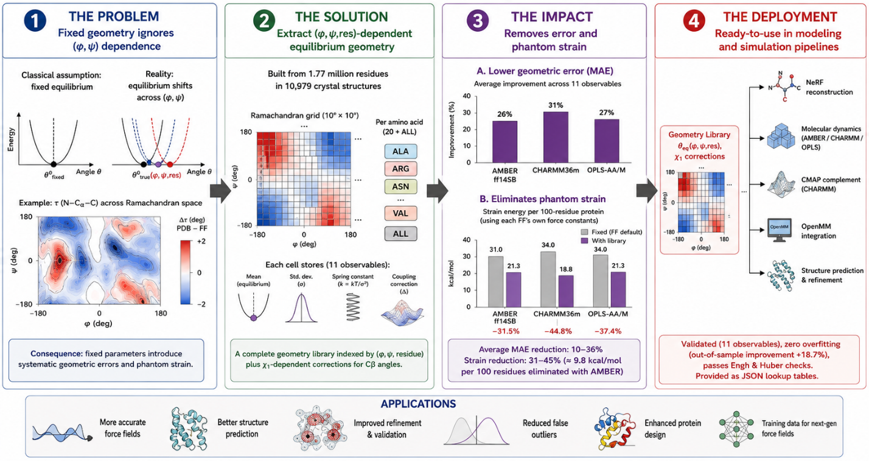
Figure 1. Hidden φ×ψ coupling creates systematic geometric errors in classical force fields.
Classical force fields approximate backbone energy as separable independent torsions, $E(ϕ,ψ)=E_{ϕ}(ϕ)+E_{ψ}(ψ)$, implying geometry varies independently along φ and ψ. Experimental protein structures instead reveal a structured φ×ψ coupling surface that produces non-separable backbone deformation across Ramachandran space. Coupling is weakest near the αR helical basin, where separable models perform well, but increases strongly at loop and basin-boundary regions, where force-field errors emerge. Sidechain rotamers introduce an additional coupling channel through the tetrahedral Cα center, whereas proposed orbital effects contribute negligibly once geometric coupling is included. Across backbone observables, the neglected coupling term explains up to ~2.7% additional variance and reaches effective energies approaching ~1.6 kcal/mol, comparable to a hydrogen bond.
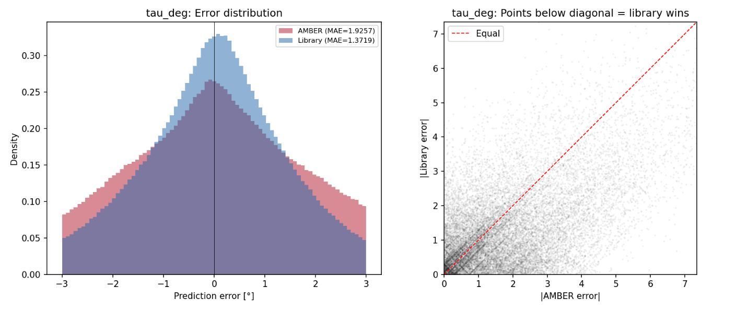Figure 2. Per-residue τ error distribution. AMBER (red) vs library (blue). The library shifts the distribution toward zero, improving 64.5% of residues.
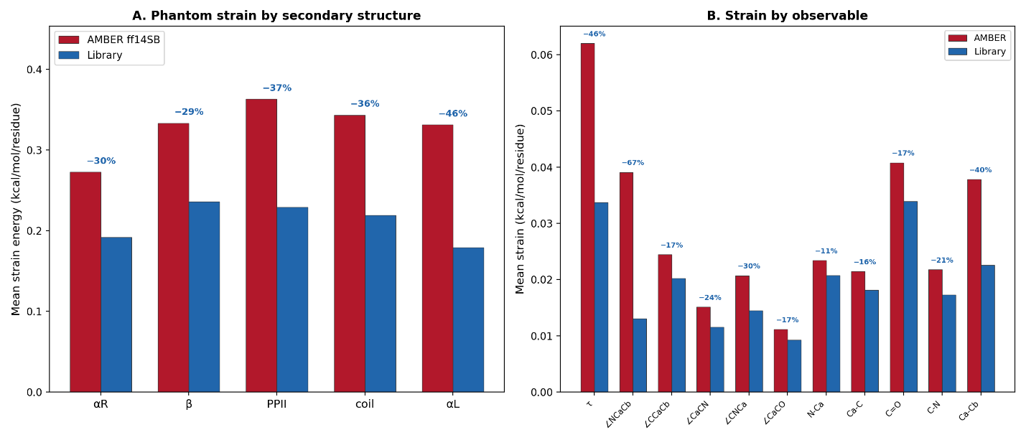
Figure 3. Strain energy comparison. Per-SS mean strain shows the library reduces phantom strain across all secondary structure types, with the largest gains in αL (+44.5%) and PPII (+36.9%).

References

[1] Arnold, E., & Rossmann, M. G. (Eds.). (2001). International tables for crystallography: Crystallography of biological macromolecules pt. F: Crystallography of biological macromolecules. Tucson, AZ: Kluwer Academic.
[2] Lovell, S. C., Davis, I. W., Arendall, W. B., 3rd, de Bakker, P. I. W., Word, J. M., Prisant, M. G., … Richardson, D. C. (2003). Structure validation by Calpha geometry: phi,psi and Cbeta deviation. Proteins, 50(3), 437–450. doi:10.1002/prot.10286
[3] Berkholz, D. S., Shapovalov, M. V., Dunbrack, R. L., Jr, & Karplus, P. A. (2009). Conformation dependence of backbone geometry in proteins. Structure (London, England: 1993), 17(10), 1316–1325. doi:10.1016/j.str.2009.08.012
[4] Maier, J. A., Martinez, C., Kasavajhala, K., Wickstrom, L., Hauser, K. E., & Simmerling, C. (2015). ff14SB: Improving the accuracy of protein side chain and backbone parameters from ff99SB. Journal of Chemical Theory and Computation, 11(8), 3696–3713. https://doi.org/10.1021/acs.jctc.5b00255
[5] MacKerell, A. D., Jr., Feig, M., & Brooks, C. L., 3rd. (2004). Extending the treatment of backbone energetics in protein force fields: limitations of gas-phase quantum mechanics in reproducing protein conformational distributions in molecular dynamics simulations. Journal of Computational Chemistry, 25(11), 1400–1415. https://doi.org/10.1002/jcc.20065
[6] Jumper, J., Evans, R., Pritzel, A., Green, T., Figurnov, M., Ronneberger, O., … Hassabis, D. (2021). Highly accurate protein structure prediction with AlphaFold. Nature, 596(7873), 583–589. doi:10.1038/s41586-021-03819-2
[7] Paper 1: Chen, W. et al. Protein backbone geometry as local mechanical equilibrium. [submitted]
[8] Paper 2: Chen, W. et al. Backbone bond angles deform systematically with (φ,ψ). [submitted]
[9] Paper 3: Chen, W. et al. The coupling structure of protein backbone geometry. [submitted]
[10] CHARMM: Huang, J., & MacKerell, A. D., Jr. (2013). "CHARMM36 all-atom additive protein force field: Validation based on conformational sampling of 800 ns molecular dynamics simulations of proteins." Journal of Computational Chemistry, 34(25), 2135–2145. DOI: 10.1002/jcc.23354
[11] OPLS: Harder, E., et al. (2016). "OPLS3: A Force Field Providing Broad Coverage of Drug-like Small Molecules and Proteins." Journal of Chemical Theory and Computation, 12(1), 281–296. DOI: 10.1021/acs.jctc.5b00864
[12] AlphaFold: Jumper, J., et al. (2021). "Highly accurate protein structure prediction with AlphaFold." Nature, 596(7873), 583–589. DOI: 10.1038/s41586-021-03819-2
[13] RoseTTAFold: Baek, M., et al. (2021). "Accurate prediction of protein structures and interactions using a three-track neural network." Science, 373(6557), 871–876. DOI: 10.1126/science.abj8754
[14] ESMFold: Lin, Z., et al. (2023). "Evolutionary-scale prediction of atomic-level protein structure with a language model." Science, 379(6637), 1123–1130. DOI: 10.1126/science.ade2574
[15] REFMAC: Murshudov, G. N., et al. (2011). "REFMAC5 for the refinement of macromolecular structures." Acta Crystallographica Section D, 67(4), 355–367. DOI: 10.1107/S090744491100131X
[8] Phenix: Liebschner, D., et al. (2019). "Macromolecular structure determination using the Phenix software suite." Acta Crystallographica Section D, 75(10), 861–877. DOI: 10.1107/S2059798319011471
[16] MolProbity: Williams, C. J., et al. (2018). "MolProbity: More and better reference data for improved all-atom structure validation." Protein Science, 27(1), 293–315. DOI: 10.1002/pro.3330
[17] Rosetta: Alford, R. F., et al. (2017). "The Rosetta All-Atom Energy Function for Macromolecular Modeling and Design." Journal of Chemical Theory and Computation, 13(6), 3031–3048. DOI: 10.1021/acs.jctc.7b00125
[18] ProteinMPNN: Dauparas, J., et al. (2022). "Robust deep learning–based protein sequence design using ProteinMPNN." Science, 378(6618), 442–448. DOI: 10.1126/science.add2187

