

ADFP Cell-based Training Course
ICLAB 特別課程實作：
16奈米 FinFET 技術下的異步 FIFO 設計

Report

2025.12.24

Advisor Lecturer
李鎮宜教授 蕭邦原、王鈺翔
Student
Iclab103 林佳葦

目錄
Overview 3
Data Preparation 4
Design Description 4
I/O Description 6
Front-End Design Steps 7
A. 01_RTL 7
B. 02_SYN 7
C. 02_SYN with cg 9
D. 03_GATE 10
E. 07_PX 11
F. 08_JG 11
Back-End Design Steps 12
G. 05_APR 12
Data Preparation 12
Import Design 13
Configuration 13
Floorplan 14
Powerplan 16
Placement 18
CCOPT 19
Nano-Route 19
Finish Design 20
H. 06_POST 23
I. 09_RVE 24

Overview
In this lab, students will follow a comprehensive IC design flow to gain hands-on experience with advanced FinFET technology. Each step in the process builds on the previous one, ensuring a clear relationship that enhances both understanding and skill development.
- RTL Design (01_RTL): Students begin by designing the RTL code for a simple FIFO structure, learning how to describe hardware behavior using Verilog.
- Logic Synthesis (02_SYN): The RTL design is synthesized into gate-level netlists using Design Compiler, helping students understand how high-level designs are translated into actual hardware.
- Gate-Level Simulation (03_GATE): Students simulate the synthesized design to verify its functional correctness, ensuring that the gate-level implementation matches the intended RTL behavior.
- Hard Macro SRAM (04_MEM): The lab introduces the integration of hard macro SRAMs into the design, teaching students how to use pre-built memory blocks to improve performance and area efficiency.
- Physical Design (05_APR): Through Auto Placement and Routing (APR), students learn how to map the netlist into a physical layout, addressing challenges such as cell placement, routing, and the integration of boundary cells and tap cells.
- Post Layout Simulation (06_POST): Students simulate the post-layout design to verify its timing and functional correctness, learning the importance of layout impact on performance.
- Power Analysis (07_PX): Using PrimeTime, students perform dynamic and leakage power analysis, comparing results to understand the effect of optimizations like clock gating.
- CDC Formal Verification (08_JG): The lab covers Clock Domain Crossing (CDC) verification using JasperGold, teaching students how to ensure proper data transfer between asynchronous domains.
- Sign-off Checks (09_RVE): The flow concludes with Design Rule Check (DRC) and Layout Versus Schematic (LVS) verification, emphasizing the critical final steps for ensuring design manufacturability and correctness.
By completing this flow, students will gain a practical understanding of each phase in the IC design process, from RTL to sign-off, and develop the skills necessary to tackle real-world challenges in advanced FinFET technology.

ADFP lab – TSMC ADFP IC Design
NYCU-EE ICLAB – Fall 2025

Design: Pseudo Random Number Generator (PRNG)

Data Preparation
- Extract LAB data from TA’s directory:
% tar -xvf ~ba25iclabTA01/Lab_adfp_2025F.tar
- The extracted LAB directory contains:
  - UMC018/
  - N16ADFP/
  - N16ADFP_cg/
  - N16ADFP_cg_chip/
  - src/

Design Description
A Pseudo-Random Number Generator (PRNG) is a deterministic algorithm capable of producing a sequence of numbers that approximates the properties of random numbers. Unlike True Random Number Generators (TRNG), which rely on physical entropy, PRNGs expand a small initial value, known as the Seed, into a much longer sequence.
The generation of random sequences in this design is implemented using the Xorshift family of Pseudo-Random Number Generators (PRNGs). While numerous algorithms exist for random number generation, Xorshift variants are specifically selected due to their renowned simplicity and execution speed, particularly on modern hardware architectures.
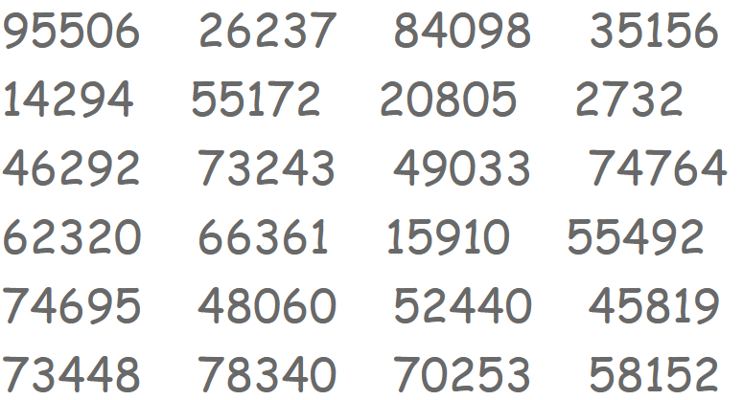
Figure 1. Random Number example
In this lab, you are asked to build a design to perform Pseudo Random Number Generator (PRNG) to calculate 256 random numbers by the given seed for each pattern.
- Block diagram
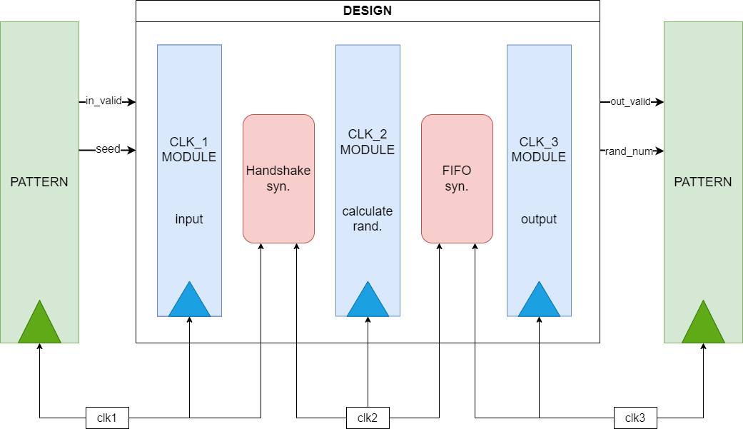
Figure 2. The block diagram of this design in this lab
- The seed is given in clk1 domain. (Serial in: 1-bit for 32 cycles)
- Use Handshake synchronizer to transfer the seed into clk2 domain.
- Calculate the random number in clk2 domain.
- Store the result into FIFO synchronizer and get the random number in clk3 domain.
- Output the random number in the clk3 domain (Serial out: 1-bit for 32 cycles)
- Algorithm of PRNG: Xorshift algorithm
- Initialization: start with a non-zero 32-bit seed X0 (1-bit serial in)
- Generation: for each desired random number
  - $X_{n+1}=X_{n}$
  - $X_{n+1}=X_{n+1} ⊕ \left(X_{n+1} ≪a\right) (left shift and XOR)$
  - $X_{n+1}=X_{n+1} ⊕ \left(X_{n+1} ≫b\right) (right shift and XOR)$
  - $X_{n+1}=X_{n+1} ⊕ \left(X_{n+1} ≪c\right) (left shift and XOR)$
  - Return $X_{n+1}$
where a, b, c are constants.
In this lab, we use 32-bit version, that is, a = 13, b = 17 and c = 5

- CDC problem
  - The Handshake synchronizer is used to cross clk1 to clk2.
  - The FIFO synchronizer is used to cross clk2 to clk3.
- Cycle time
 | CYCLE_1 | CYCLE_2 | CYCLE_3
UMC018 | 14.1 ns | 3.9 ns | 20.7 ns
N16ADFP | 1.41 ns | 0.49 ns | 2.13 ns

I/O Description
Input | Bits | Definition and Description
clk1 | 1 | Positive edge trigger clock by clock 1  clock period: UMC018=14.1, N16ADFP=1.41 (ns)
clk2 | 1 | Positive edge trigger clock by clock 2  clock period: UMC018=3.9, N16ADFP=0.49 (ns)
clk3 | 1 | Positive edge trigger clock by clock 3  clock period: UMC018=20.7, N16ADFP=2.07 (ns)
rst_n | 1 | Asynchronous reset active low reset
in_valid | 1 | seed are valid when in_valid is high This signal is trigger by clk1 for 32 cycles to serial in for a 32-bit value (MSB to LSB)
seed | 1 | The seed for Xorshift algorithm. A positive number $X_{0}$
Output | Bits | Definition and Description
out_valid | 1 | should be set to low after reset and not be raised when invalid is high. Should set to high when your rand_num is ready. Should be pulled up for 256 cycles, not required to be continuous.
rand_num | 1 | The generated number $X_{1}$, $X_{2}$, …, $X_{256}$ should be output for 256 cycles, not required to be continuous. Each 32-bit X will be serial out for 32 cycles (MSB to LSB)

Front-End Design Steps

01_RTL
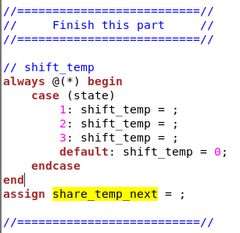
  - Finish “DESIGN_module.v” in src/01_RTL
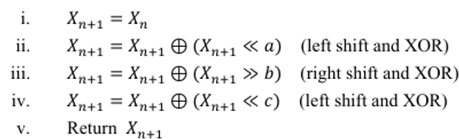

  - Open “FIFO_syn.v” in src/01_RTL/synchronizer
    - For design, what kind of SRAM we use? ☐ Dual-Port / ■ Two-Port
    - Can we read & write to the same address at the same time? ☐ Yes / ■ No
  - Open “PRNG_TOP.v” in src/01_RTL and “PATTERN.v” in src/00_TESTBED
    - If we use synchronous reset, we have to pass the setup/hold time check.
    - If we use asynchronous reset, we should pass the recovery/removal time check
    - In this lab,■ Asynchronous / ☐Synchronous reset technique is adopted.
    - In real case, do we usually force clk = 1’b0 when rst_n = 0? ☐ Yes / ■ No
Therefore, reset synchronizers are used to solve the metastability issue between clk & rst
  - Run “./01_run_vcs_rtl” to do RTL-level simulation and pass all pattern

02_SYN
- Standard cell library comparison for different manufacturing processes
    - For corner case, S, T and F means slow, typical and fast, respectively, which is used to represent the speed of MOS. For example, FF, SS, TT, FS and SF corners are used for simulation. The first one is for NMOS, the second one is for PMOS.
    - For UMC018 process, the library files are placed in the following path:
/RAID2/PROCESS/U18/UMC018_CBDK/CIC/SynopsysDC/lib/
Check the three files listed below to observe different PVT situation
- fsa0m_a_generic_core_ff1p98vm40c.lib (FF corner, 1.98V, -40℃)
- fsa0m_a_generic_core_tt1p8v25c.lib (TT corner, 1.80V, 25℃)
- fsa0m_a_generic_core_ss1p62v125c.lib (SS corner, 1.62V, 125℃)
    - You can see the definition of index & variable of the top of each .lib
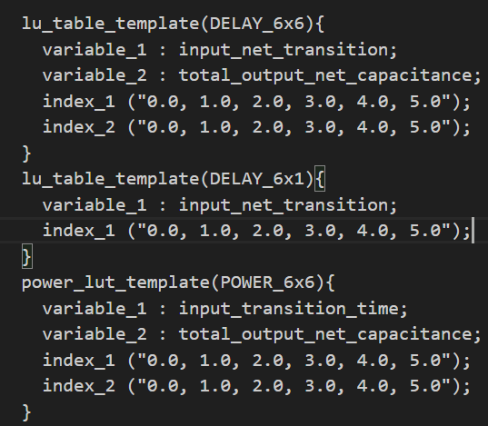
    - Find the NAND2 cell specified below and observe power & timing information
- NAND2 cell: ND2
- pin(O), related pin: “I1”, (index1, index2) = (0,0)
- Lookup table for power information (internal power)
- Lookup table for timing information (rising time)
- Finish the table below and answer the question
Corner | Voltage | Temperature | Power | Delay
FF | 1.98V | 40℃ | 0.010103 | 0.021058
TT | 1.80V | 25℃ | 0.008827 | 0.030047
SS | 1.62V | 125℃ | 0.007664 | 0.047627
Question: Which cell should be used for worse case analysis?
☐ ff / ☐ tt / ■ ss, why: 電壓低、溫度高、delay高，所以是最壞情況
    - For N16ADFP process, the library files are placed in the following path:
/RAID2/PROCESS/ADFP/Executable_Package/Collaterals/IP/stdcell/N16ADFP_StdCell/CCS/
Check the five files listed below to observe different PVT situation
- N16ADFP_StdCellff0p88v125c_ccs.lib (FF corner, 0.88V, 125℃)
- N16ADFP_StdCellff0p88vm40c_ccs.lib (FF corner, 0.88V, -40℃)
- N16ADFP_StdCelltt0p8v25c_ccs.lib (TT corner, 0.80V, 25℃)
- N16ADFP_StdCellss0p72v125c_ccs.lib (SS corner, 0.72V, 125℃)
- N16ADFP_StdCellss0p72vm40c_ccs.lib (SS corner, 0.72V, -40℃)
In ADFP process, standard threshold voltage (SVT) cells and low threshold voltage (LVT) cells are provided for tool to synthesize and optimize circuit.
    - Find the NAND2 cell specified below and observe power & timing information
- SVT NAND2: ND2D12BWP16P90
- LVT NAND2: ND2D12BWP16P90LVT
- Power information (leakage power)
- Timing information (rising time)
- Finish the table below and answer the question
Corner | Voltage | Temperature | Power | Delay
FF (lvt) | 0.88V | 40℃ | 3.63197 | 0.00211245
FF (lvt) | 0.88V | 125℃ | 782.776 | 0.00219008
FF (svt) | 0.88V | 40℃ | 0.179304 | 0.00249980
FF (svt) | 0.88V | 125℃ | 107.562 | 0.00250904
TT (lvt) | 0.80V | 25℃ | 23.216 | 0.00230
TT (svt) | 0.80V | 25℃ | 1.368 | 0.00282
SS (lvt) | 0.72V | 40℃ | 0.556901 | 0.00256213
SS (lvt) | 0.72V | 125℃ | 232.433 | 0.00256762
SS (svt) | 0.72V | 40℃ | 0.02017 | 0.00348809
SS (svt) | 0.72V | 125℃ | 23.1403 | 0.00328336
Question: Which cell have higher leakage power?
■lvt / ☐ svt, why: Vth小，漏電流為指數上升
- Run “./01_run_dc_shell” to synthesize the circuit (in UMC018 & N16ADFP)
- Area comparison
 | UMC018 | N16ADFP
Area | 224589.013951 | 3687.690846
The design area in UMC018 is 60.9 times larger than that in N16ADFP
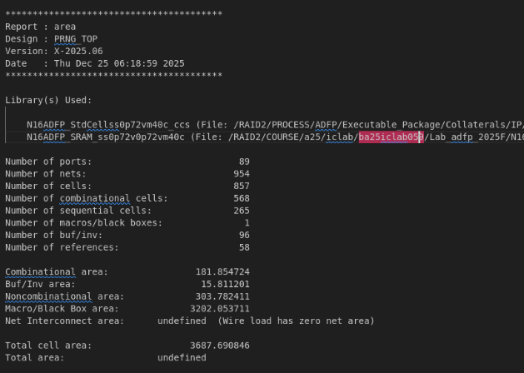
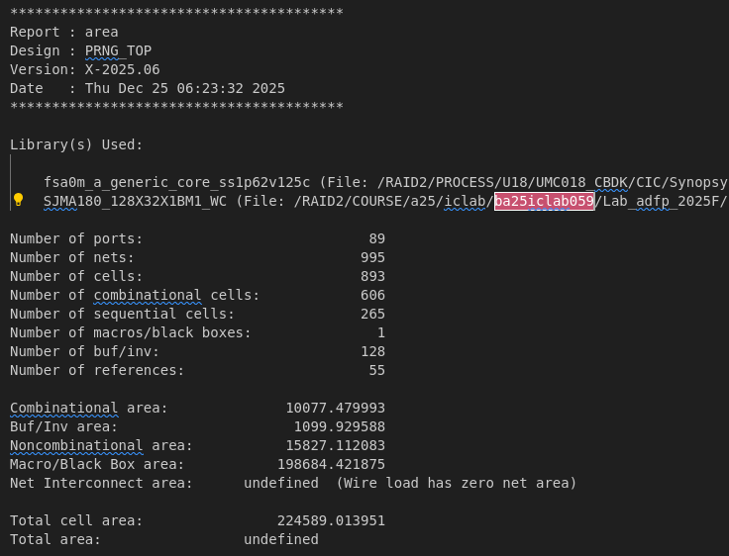
- Paste your synthesis area report here

- Run “./02_run_pt” to disable setup & hold time check for synchronizers

02_SYN with cg
- Observe commands we set in N16ADFP_cg/02_SYN/syn.tcl about clock gating, and as the gating result we get
- What is the clock gating cells? CKLNQD1BWP20P90
- We gate 73.03 % of registers?
- How do you think about this gating method? 可避免glitch的產生，也可以降低dynamic power

- There are many gating techniques, refer to the table and match each technique:
Clock Gating: (1) Multi-Threshold Gating: (4)
Power Gating: (2) Data Gating: (3)
Gating  Technique | Time  Overhead | Power  Savings | Complexity | Use Case
(1) | Low | Moderate | Low | Frequently used for reducing dynamic power in digital circuits.
(2) | Moderate  to High | High | High | Used in low-power design for shutting down idle blocks.
(3) | Low | Moderate | Moderate | Efficient in reducing unnecessary data toggling
(4) | Moderate | High | High | Common in designs requiring fine-grained power control.
- Run “./01_run_dc_shell” in N16ADFP_cg directory and observe the result in N16ADFP_cg/02_SYN/Report/PRNG_TOP.cg.
Paste your result in the box below
Example | Your Result
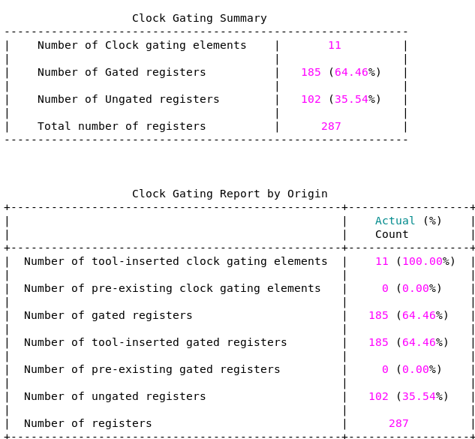 | 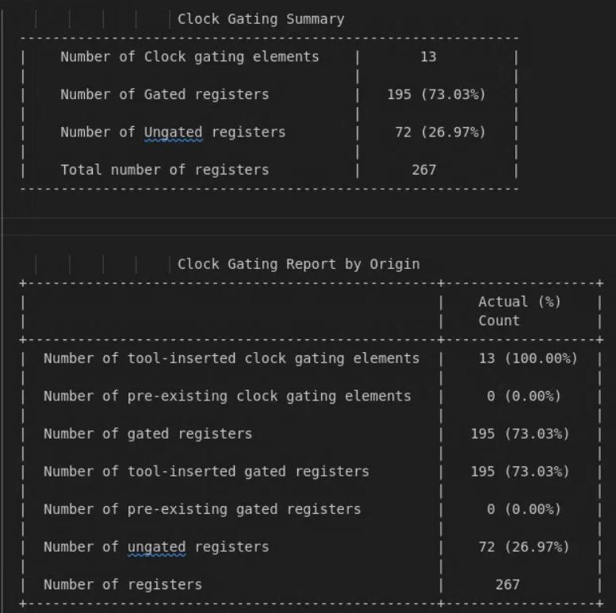

03_GATE
- Run “./01_run_vcs_gate” in each directory (UMC018 / N16ADFP / N16ADFP_cg / N16ADFP_cg_chip)
- Do you think it is necessary to do hold time check in gate-level?
■ Yes / ☐ No, why: 需要驗證STA無法完全覆蓋的狀況
- After the gate-level simulation, we can use its waveform to do the power analysis

07_PX
- Prime Time Power Analysis
- Run “./01_run_ptpx” (what we use in Lab08)
- Finish the table below
 | UMC018 | N16ADFP | N16ADFP_cg
Leakage Power | 8.924e-06 | 4.8251e-07 | 4.795e-07
Total Power | 0.0306 | 8.296e-04 | 3.955e-04
- Design Compiler Power Analysis
- Run ./02_run_dcpx to convert fsdb file to saif file to know the switch activity information, read DDC file to know the current circuit and generate power report
- Finish the table below
 | UMC018 | N16ADFP | N16ADFP_cg
Leakage Power | 8.9307mW | 483.47nW | 480.5443nW
Total Power | 30.57mW | 0.8293mW | 0.3962mW
- Notice that in ADFP, we have about 10 times faster clock speed than UMC018. Please observe the power tables above and briefly summarize the result.
N16ADFP 的時脈頻率高出 10 倍，其 Total Power (約 0.83mW) 僅為 UMC018 (30.57mW) 的 2.7%。這展現了 FinFET 製程在低電壓下的極高能效。此外，引入 Clock Gating (cg) 後，N16ADFP 的總功耗進一步下降約 52%，證明在高速設計中，動態功耗的管理也是相當重要

08_JG
- Run “./01_run_jg” (What we use in Lab07)
- Paste your result of the CDC report
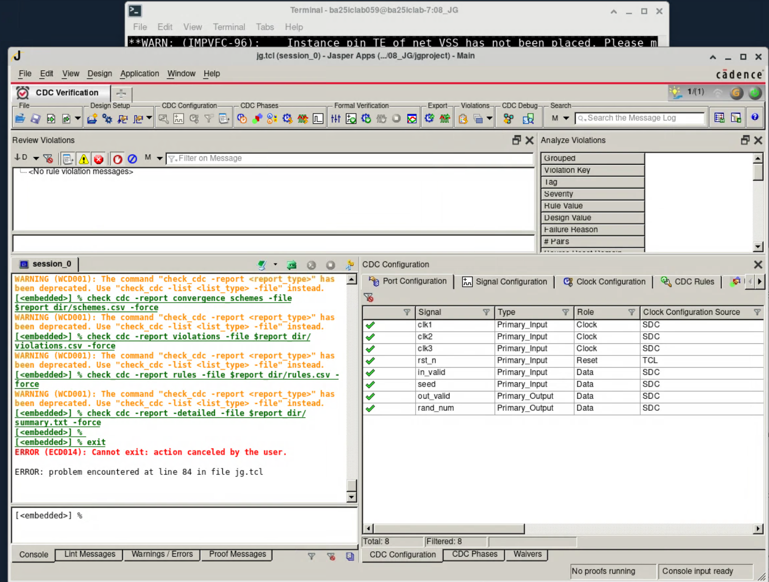

Back-End Design Steps

05_APR
Please answer the following questions during this lab.

Data Preparation
- Open CHIP_SHELL.v in 05_APR and find:
  - What is pad module name for input and output signals? PDCDG_V、PDCDG_H
  - What is pad module name for core power and ground? PVDD1CDGM_V、PVDD1CDGM_H
  - What is pad module name for I/O power and ground? PVDD2CDGM_V 、PVDD1CDGM_H
  - Why “_H” or “_V” is as the suffix of pad module name?
Poly的方向，FinFET製程的Poly不能像.18製程一樣任一方向
  - How to set the pads to avoid violation? (Hint: You can check CHIP.io to know the relationship between pad type and its placed location)
上下擺Vertical 的PAD 左右擺Horizontal 的PAD
- Open CHIP_mmmc.view in 05_APR and find:
  - What is qrc file used in RC_MAX? Tech/RC/N16ADFP_QRC/worst/qrcTechFile
  - What is qrc file used in RC_MIN? Tech/RC/N16ADFP_QRC/best/qrcTechFile
  - What is PVT condition for worst case timing analysis?
    - Process corner: __ss____, Voltage: __0.72V____, Temperature: __-40ﾟC_ _
  - What is PVT condition for best case timing analysis?
    - Process corner: _ff_____, Voltage: ___0.88V___, Temperature: _125ﾟC __
  - What is the sdc file used? _CHIP.sdc________________________
  - How many are the setup time analysis views? ________1_________________
  - How many are the hold time analysis views? ________1_________________

Import Design
- Open the 00_import_design.cmd in 05_APR/cmd and find:
  - The command “set init_design_uniquify 1” will make the name of every instance different so that tool can implement clock tree synthesis.
  - What is the design process node? _______16nm___________________________
  - What are the lef files used?
    - Technology lef file: __N16ADFP_APR_Innovus_11M.10a.tlef __
    - Standard cell lef file: __N16ADFP_StdCell.lef、 N16ADFP_StdIO.lef__
    - Memory lef file: ________N16ADFP_SRAM_100.lef____________
  - What are the power names used for init_pwr_net? ____VDD 、VDDPST___

Configuration
- Open the 01_config.cmd file in 05_APR/cmd and find:
  - What is the metal layer setup for topRoutingLayer? ________M9____________
  - What is the metal layer setup for bottomRoutingLayer? _______M2__________
  - What is the mode for timing analysis? ____onChipVariation_______
  - What are the parameters for adding extra margin to accommodate variation in timing analysis?
    - Early / late path for setup time analysis: ___-early 0.8 -late 1.0___
    - Early / late path for hold time analysis: ____-early 1.0 -late 1.1_______
  - What is the purpose of “Clock Path Pessimism Removal”? __移除不可能發生的路徑_
  - What are nondefault rules (NDR)?
    - Trunk: M8 width = ___0.124____, M4 spacing = __0.04_____
    - Leaf: M8 width = ___0.062____, M4 spacing = ___0.08____
  - What is route type for clock tree routing?
    - ClkTrunkNDR: top preferred layer = ___7____, NDR rule = TrunkNDR_
    - ClkLeafNDR: top preferred layer = __5_____, NDR rule =LeafNDR_
  - What are clock max transition time?
    - (Top, Trunk, Leaf) = (__0.15____, __0.1____, __0.1____)
  - Early clock flow has been activated. Typically, CTS is performed after placement, a stage where numerous clock buffer cells are inserted. Consequently, enabling early clock flow before placement becomes beneficial. This ensures that congestion measurements during the placement process consider the presence of clock trees.

Floorplan
- What are parameters about your floorplan?
  - Specify core size:
    - Aspect Ratio (H/W): _________1.0_______________________________
    - Core Utilization: _____________0.5______________________________
  - Specify core margins:
    - Core to Left/Right/Top/Bottom IO Boundary: _______100_____________
- What are parameters about placement halo and routing halo for all macros
  - Placement halo:
    - Add/Update Halo for Top, Bottom, Left, Right: _____2um______________
  - Routing halo:
    - Add/Update Halo for Halo Value: _________1um_____________________
    - Add/Update Halo for Bottom Layer / Top Layer: _____M1/M9_________
- Open add_IOFiller.cmd in 05_APR/cmd and find:
  - What types of pad fillers we use? __PFILLER10080、 PFILLER01008、 PFILLER00048、PFILLER00001__
  - Why we need “-fitGap true” in the command? _不用的話會DRC /LVS Violation_
- Please show the result after executing “checkFPlan” on Innovus terminal
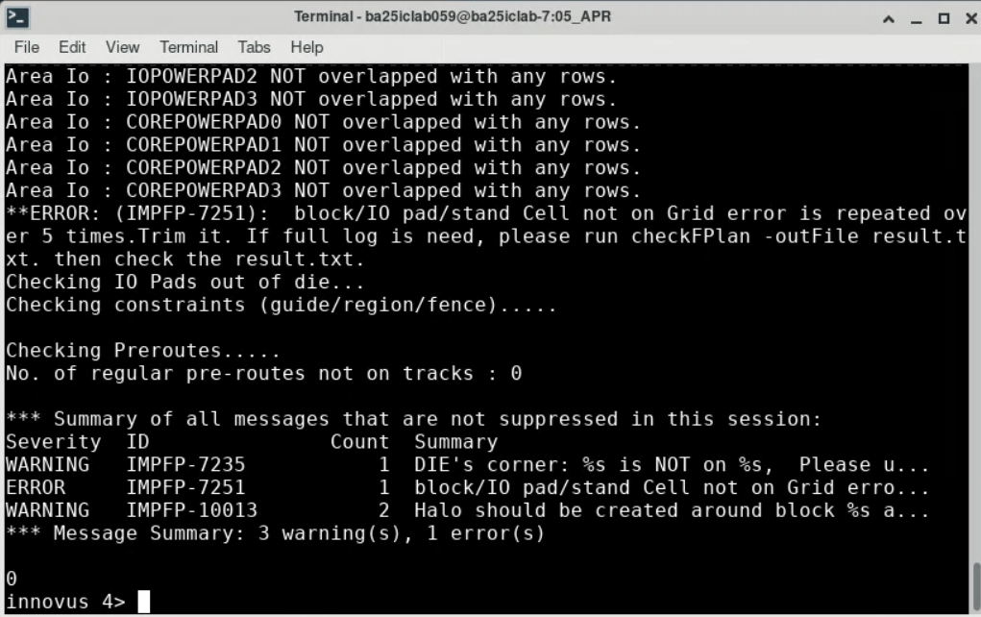
- What are parameters about your flip chip setting
  - What is the bump type we use? _____PAD80APB_LF_BU_____
  - How many bumps you use for VDD? _________4__________________
  - How many bumps you use for VDDPST? _________2_______________
  - How many bumps you use for VSS? ______________2______________
  - What width is AP layer used for RDL routing? ________8____________
- Please show your floorplan result including the bumps (Picture): 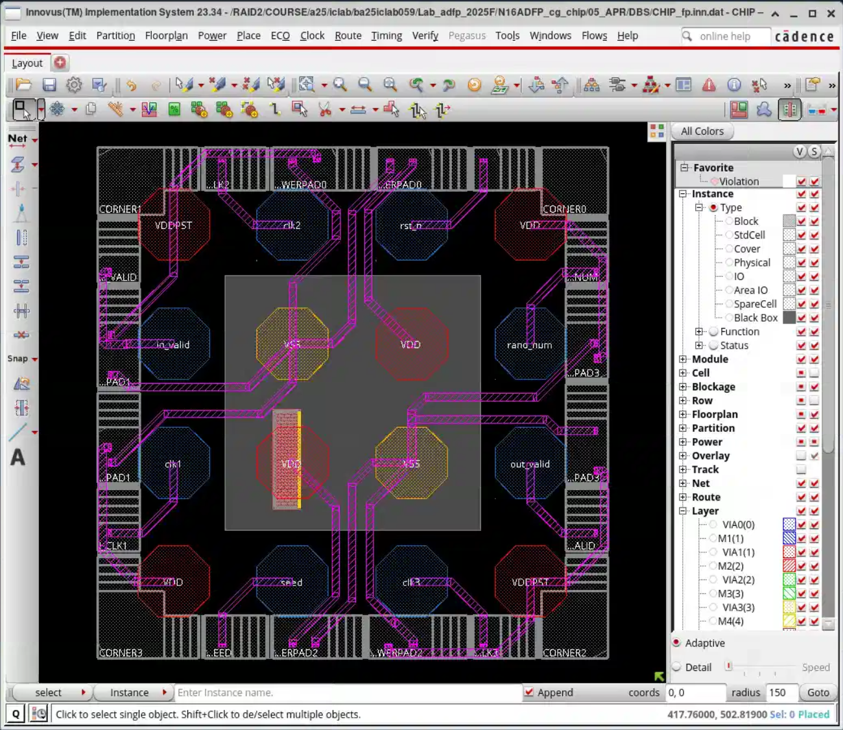

Powerplan
- Please list all the parameter for core power ring (You can add new sheet row)
Nets | Metal Layer | Direction (H/V) | Width | Spacing | Interleaving | Wire group bits
VDD | M10 | H | 2 | 1 | O | 5
VSS | M10 | H | 2 | 1 | O | 5
VDD | M9 | V | 2 | 1 | O | 5
VSS | M9 | V | 2 | 1 | O | 5
VDD | M8 | H | 2 | 1 | O | 5
VSS | M8 | H | 2 | 1 | O | 5
VDD | M7 | V | 2 | 1 | O | 5
VSS | M7 | V | 2 | 1 | O | 5
VDD | M6 | H | 2 | 1 | O | 5
VSS | M6 | H | 2 | 1 | O | 5
VDD | M5 | V | 2 | 1 | O | 5
VSS | M5 | V | 2 | 1 | O | 5
VDD | M4 | H | 2 | 1 | O | 5
VSS | M4 | H | 2 | 1 | O | 5
VDD | M3 | V | 2 | 1 | O | 5
VSS | M3 | V | 2 | 1 | O | 5

- Please list all the parameter for block power ring (You can add new sheet row)
Nets | Metal Layer | Direction (H/V) | Width | Spacing | Interleaving | Wire group bits
VDD | M5 | V | 0.5 | 0.5 | X | X
VSS | M5 | V | 0.5 | 0.5 | X | X
VDD | M4 | H | 0.5 | 0.5 | X | X
VSS | M4 | H | 0.5 | 0.5 | X | X
VDD | M3 | V | 0.5 | 0.5 | X | X
VSS | M3 | V | 0.5 | 0.5 | X | X
- Please list all the parameter for core power stripe (You can add new sheet row)
Nets | Metal Layer | Direction (H/V) | Width | Spacing | Set-to-set | Offset | Snap
VDD | M10 | H | 1.8 | 1.8 | 7.2 | 1.8 | none
VSS | M10 | H | 1.8 | 1.8 | 7.2 | 1.8 | none
VDD | M9 | V | 1.8 | 1.8 | 7.2 | 1.8 | none
VSS | M9 | V | 1.8 | 1.8 | 7.2 | 1.8 | none
VDD | M8 | H | 0.864 | 0 | 2.88 | 0 | half_grid
VSS | M8 | H | 0.864 | 0 | 2.88 | 1.44 | half_grid
VDD | M7 | V | 0.24 | 0 | 7.2 | 7.2 | grid
VSS | M7 | V | 0.24 | 0 | 7.2 | 3.6 | grid
VDD | M6 | H | 0.24 | 0 | 7.2 | 0 | grid
VSS | M6 | H | 0.24 | 0 | 7.2 | 3.6 | grid
VDD | M5 | V | 0.24 | 0 | 7.2 | 0 | grid
VSS | M5 | V | 0.24 | 0 | 7.2 | 3.6 | grid
- Please list the parameter for block power stripe (You can add new sheet row)
Nets | Metal Layer | Direction (H/V) | Width | Spacing | Set-to-set | Offset | Snap
VDD | M6 | H | 0.24 | 0 | 7.2 | 2.4 | grid
VSS | M6 | H | 0.24 | 0 | 7.2 | 1.2 | grid
VDD | M5 | V | 0.24 | 0 | 7.2 | 0 | grid
VSS | M5 | V | 0.24 | 0 | 7.2 | 3.6 | grid
- Please show the DRC result about your power plan (Picture)
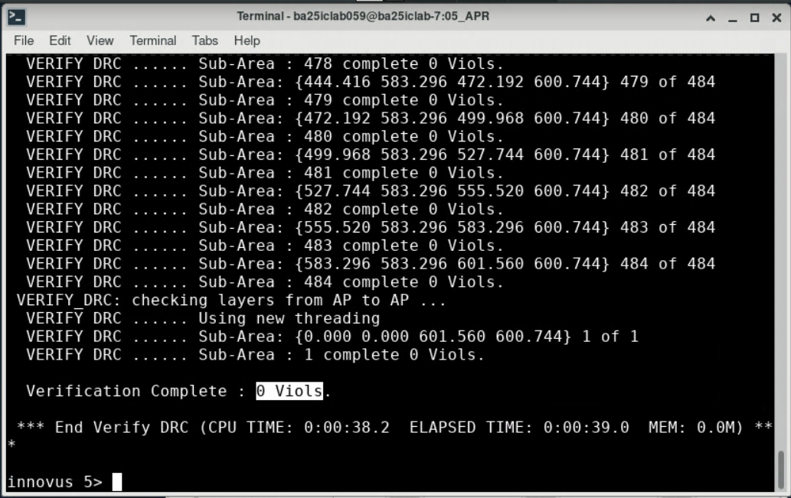
- Please show the LVS (Connectivity) result about your power plan (Picture)
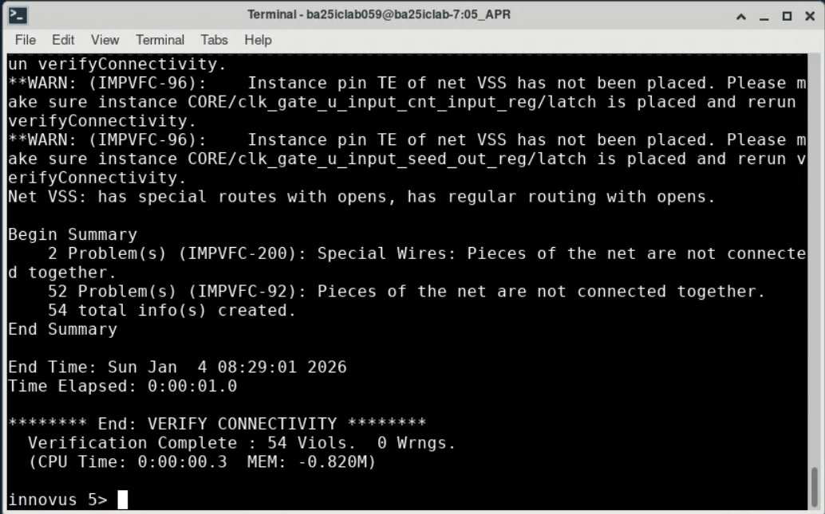
- How many are violations of maximum metal density? _____194_________________
- Please show your power plan (Picture): 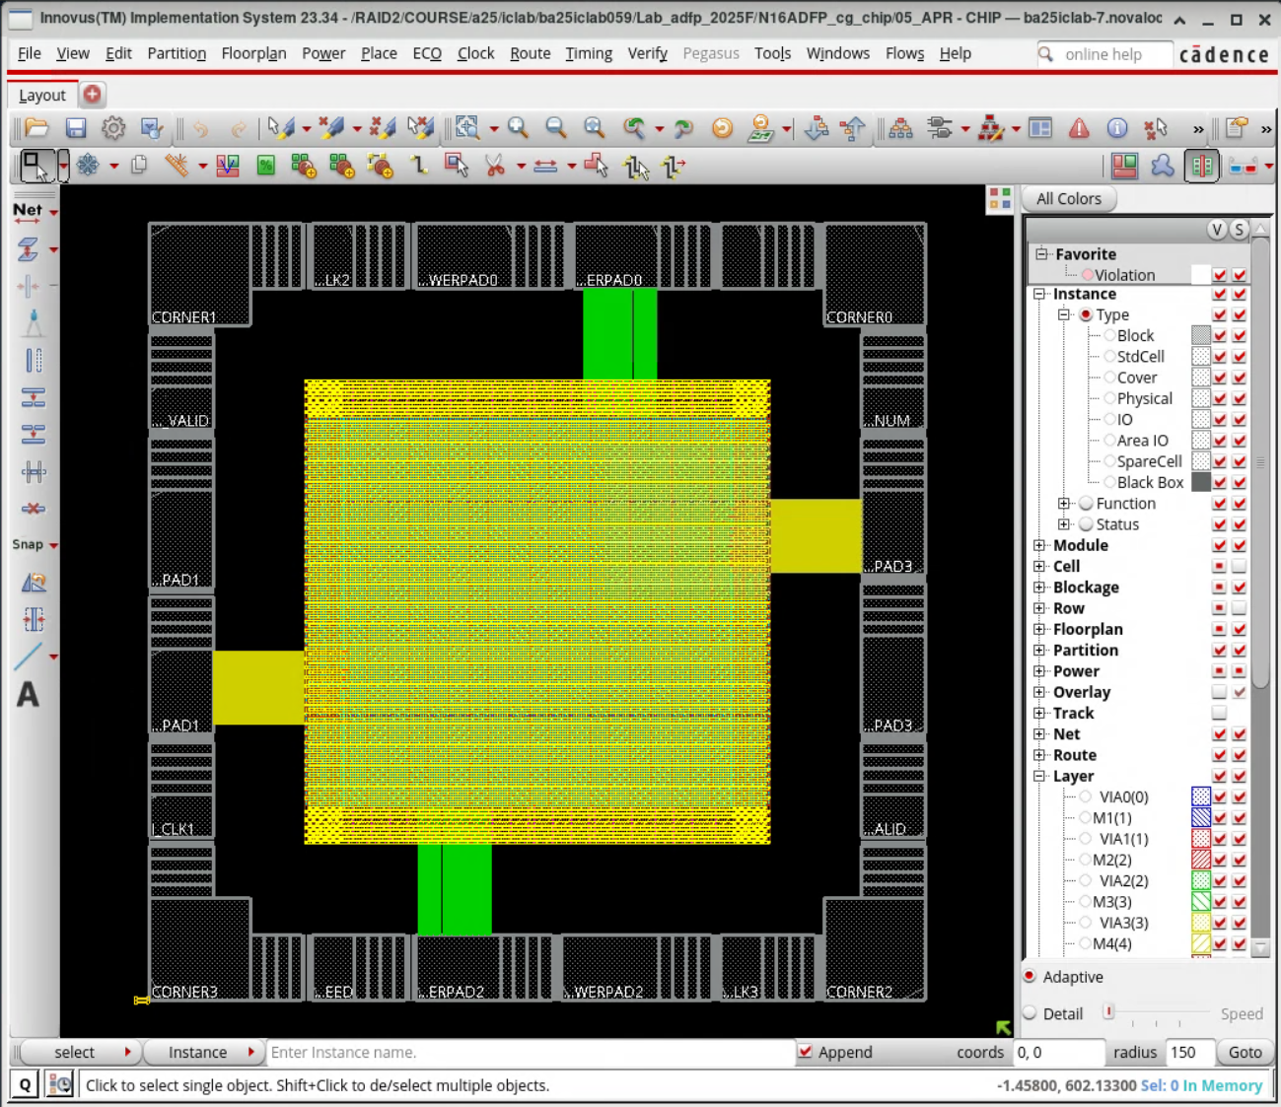

Placement
- Open add_Endcap_WellTap.cmd file in 05_APR/cmd and find and find:
  - What is the endcap cell used at right edge? BOUNDARY_LEFTBWP20P90LVT
  - What is the rule (or spacing) of well tap cell? _
_______TAPCELLBWP20P90LVT rule 40.00___
- What is the placement density? _______________0.518%___________________
- Setup time analysis in pre-CTS stage after optimization
  - What are the worst negative slack (WNS) and the total negative slack (TNS)?
    - WNS=___-0.001_____, TNS=___-0.001_____
  - How many real design rule violations (DRVs) are there?
    - DRVs (max_cap, max_tran, max_fanout) = ( ____0__, ___0___, ___0___ )

CCOPT
- Please show the clock tree with Clock Tree Debugger (Picture)
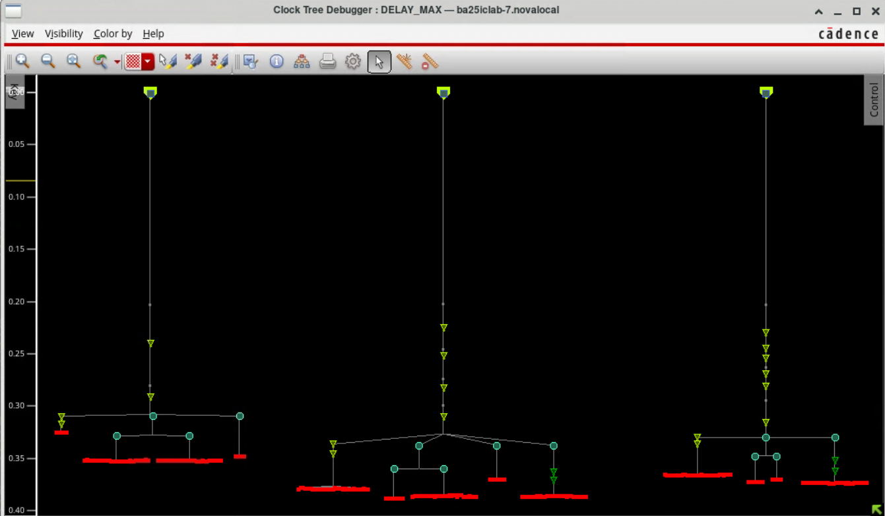
What is the maximum clock skew of the design after CTS?
__0.388_(PostCTS 後:0.3725)__ 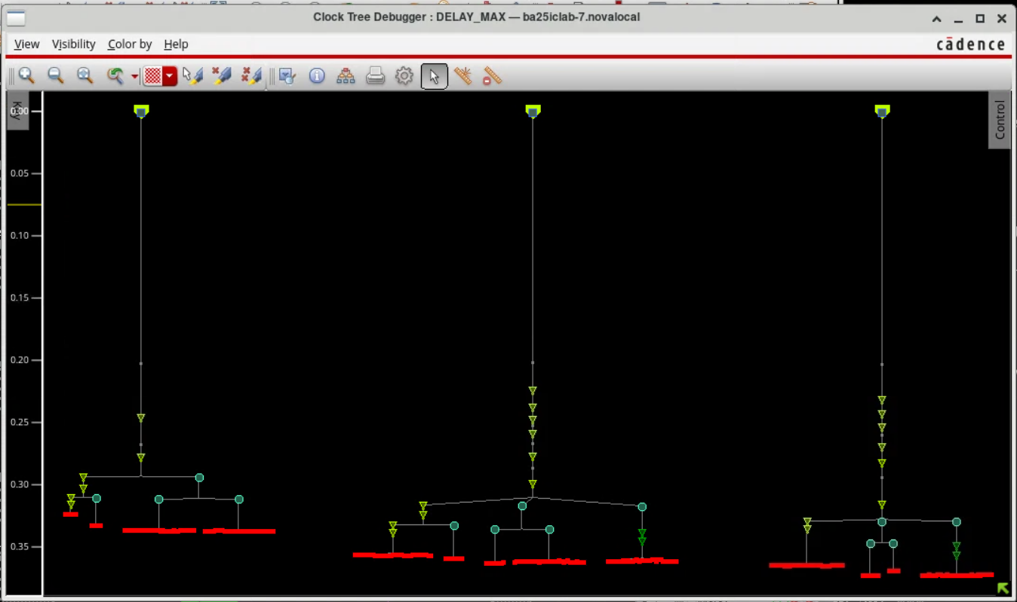
- Setup time analysis in post-CTS stage after optimization
  - What is the worst negative slack (WNS) and the total negative slack (TNS)?
    - WNS=__-0.009______, TNS=____-0.009____
  - How many real design rule violations (DRVs) are there?
    - DRVs (max_cap, max_tran, max_fanout) = ( ___0___, __0____, ___0___ )
- Hold time analysis in post-CTS stage after optimization
  - What is the worst negative slack (WNS) and the total negative slack (TNS)?
    - WNS=____0.001____, TNS=__0.000______
  - How many real design rule violations (DRVs) are there?
    - DRVs (max_cap, max_tran, max_fanout) = ( ___0___, ____0__, ____0__ )
- Open add_ TieHiLo.cmd file in 05_APR/cmd and find and find:
  - What are cells for tie high / low? __TIEHBWP20P90/ TIELBWP20P90______
  - What is max distance between each cell? ______100______________________

Nano-Route
- Please show the LVS (Connectivity) result about your design (Picture)
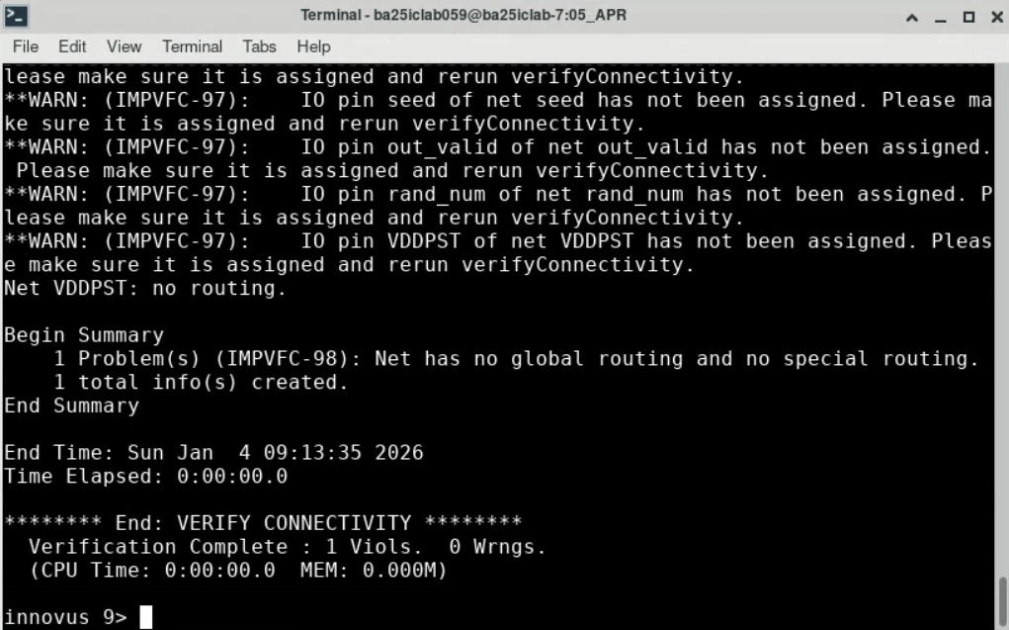
- Please show the DRC result about your design (Picture)
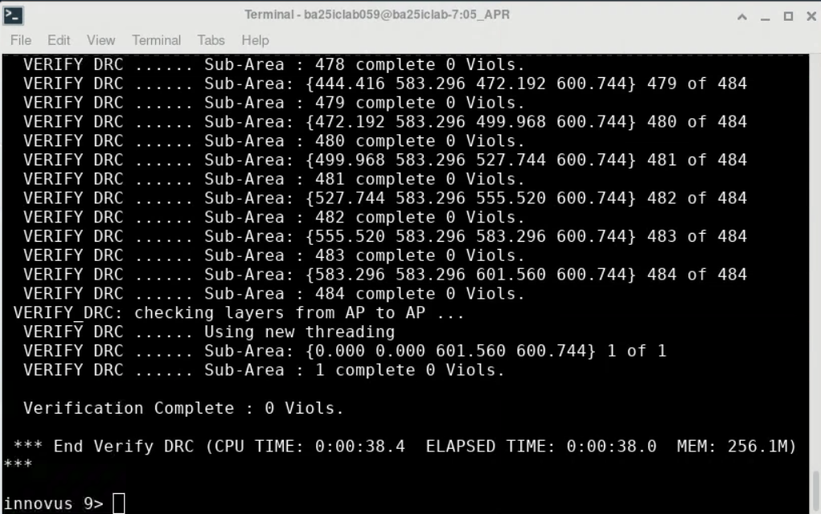
- Setup timing analysis at post-route stage after optimization
  - What are the worst negative slack (WNS) and the total negative slack (TNS)?
    - WNS=___0.009_____, TNS=____0.000____
  - How many real design rule violations (DRVs) are there?
    - DRVs (max_cap, max_tran, max_fanout) = ( ___0___, __0____, __0____ )
- Hold timing analysis at postRoute stage after optimization
  - What are the worst negative slack (WNS) and the total negative slack (TNS)?
    - WNS=___0.001_____, TNS=__0.000______
  - How many real design rule violations (DRVs) are there?
    - DRVs (max_cap, max_tran, max_fanout) = ( __0____, __0____, ___0___ )

Finish Design
- Open add_CoreFiller.cmd in 05_APR/cmd and find:
  - What characteristic does the core filler cell “FILL32BWP20P90LVT” have?
    - Size / Well Tap / poly length / VT = ___32 / Non-Tap/90/LVT_____
  - Why we need “-fitGap true” in the command? __填滿所有空隙，避免DRC__
- Please show the DRC result about your design (Picture)
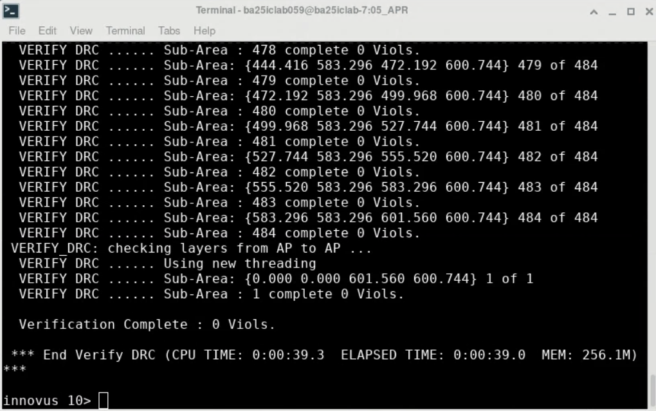
- Please show the LVS (Connectivity) result about your design (Picture)
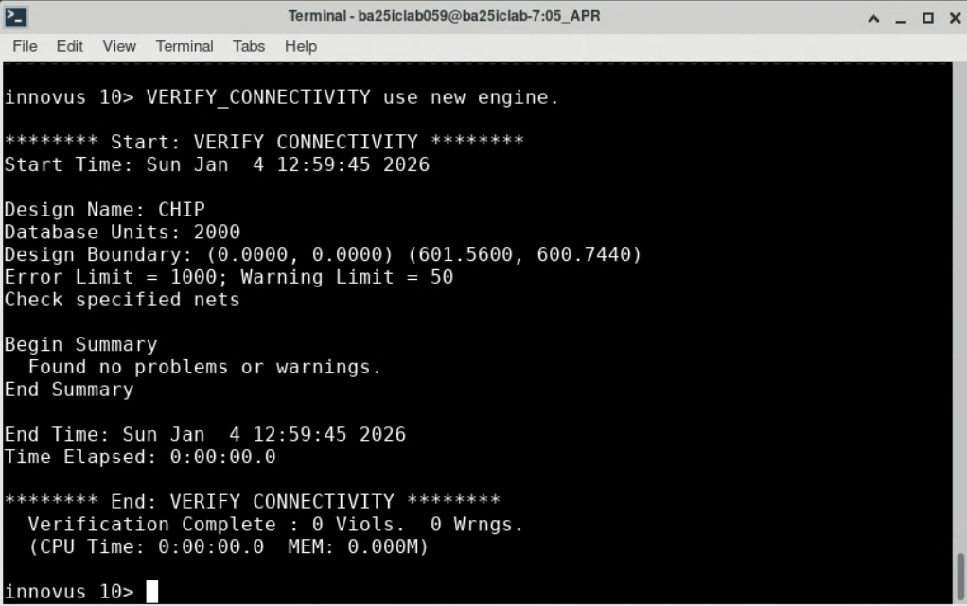
- Information after executing “verify_antenna” on Innovus terminal
  - Antenna violations: ______0___________________________________
- Information after executing “CheckPlace” on Innovus terminal
  - Placed = ___36656_____ (Fixed = ___5436___ ), Unplaced = __0____
  - Placement Density: __100%_____
- Information after executing “checkFiller” on Innovus terminal
  - Padded cell violations: _______0___________________________________
  - Gaps found: _________0__________________________________________
- Information after executing “VerifyMetalDensity” on Innovus terminal
  - Max. Density violations: ____194_____________________________________
- Setup timing analysis at postRoute stage of your chip
  - What is the worst negative slack (WNS) and the total negative slack (TNS)?
    - WNS=____0.001____, TNS=____0____
  - How many real design rule violations (DRVs) are there?
    - DRVs (max_cap, max_tran, max_fanout) = ( ___0___, ___0___, ___0___ )
- Hold timing analysis at postRoute stage of your chip
  - What is the worst negative slack (WNS) and the total negative slack (TNS)?
    - WNS=__0.001______, TNS=____0____
  - How many real design rule violations (DRVs) are there?
    - DRVs (max_cap, max_tran, max_fanout) = ( ___0___, __0____, _____0_ )
- Open streamOut.cmd file in 05_APR/cmd and find:
  - What is the map file for layout stream out?
___N16ADFP_APR_Innovus_Gdsout_11M.10a.map _____________
  - What should .gds files be merged for layout stream out?
______ N16ADFP_StdCell.gds,N16ADFP_StdIO.gds, N16ADFP_BondPad.gds , N16ADFP_SRAM_100a.gds _______
  - Please explain the content and the purpose of CHIP.v and CHIP_pg.v.
___CHIP.v是 APR 完成後的 Gate-level Netlist，不包含 VDD、VSS 的。用於gate-level simulation。
CHIP_pg.v 為Power/Ground Netlist，包含了所有元件的VDD、VSS。用於LVS驗證。_
- Please show your APR result (Picture)
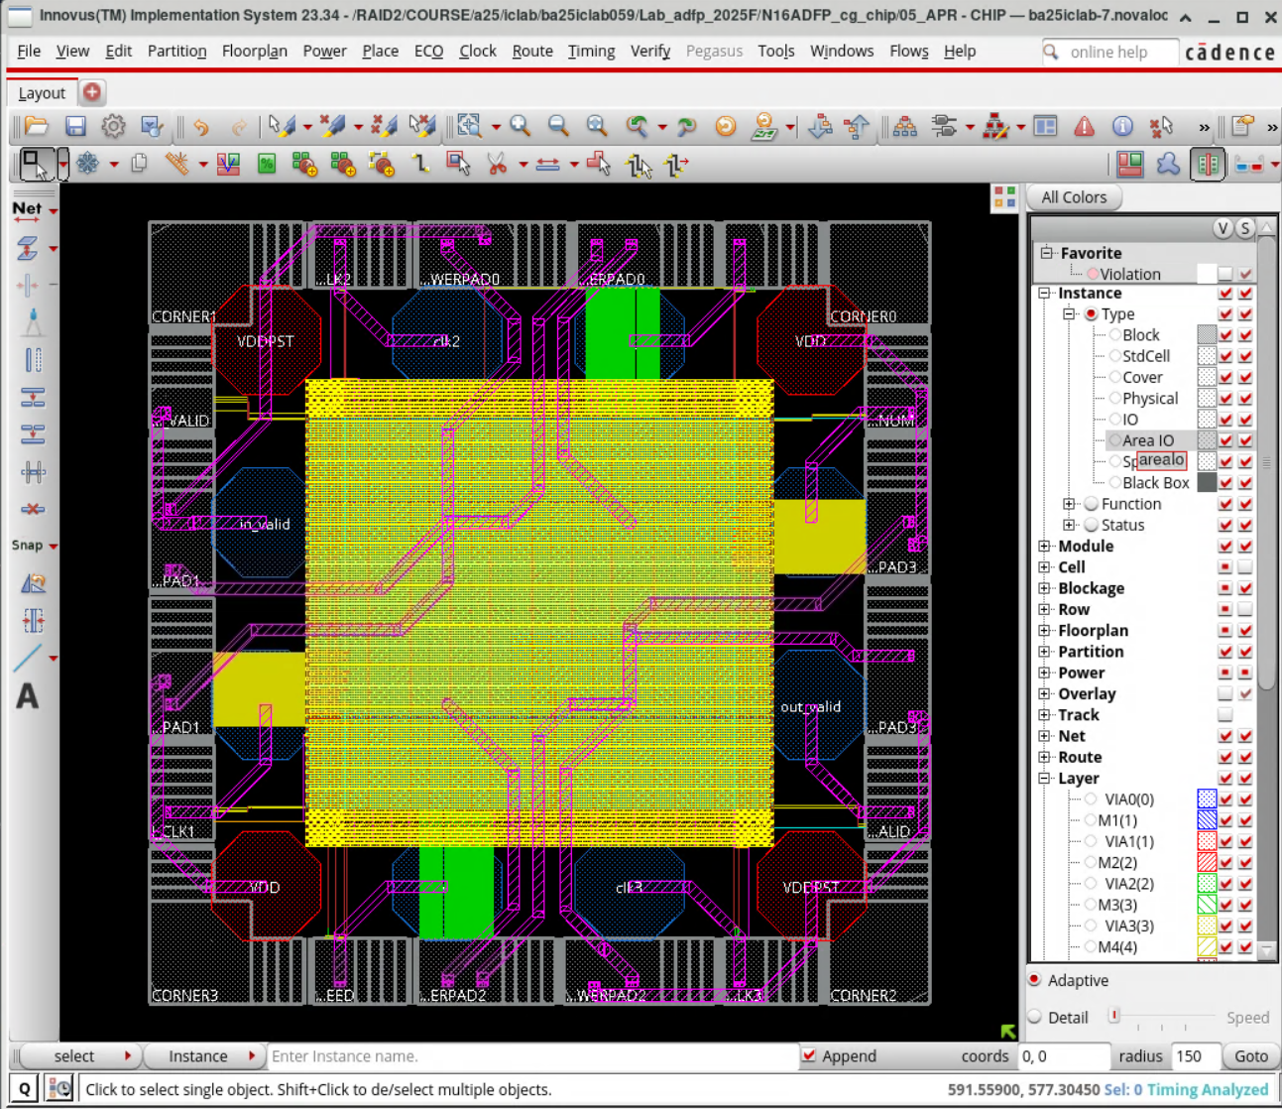

06_POST
- Change the directory to N16ADFP_cg_chip/06_POST
- Execute the command to disable synchronizer path timing check with Prime Time
$ ./00_run_pt
And you will get CHIP_pt.sdf
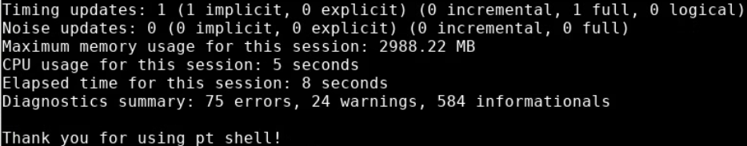
These errors are about pad cells and can be ignored in this lab
- Execute the command to do post-layout gate-level simulation of CHIP.v
$ ./01_run_vcs_post

09_RVE
- Please show your FEOL.gds in Calibre DESIGNrev window (Picture)
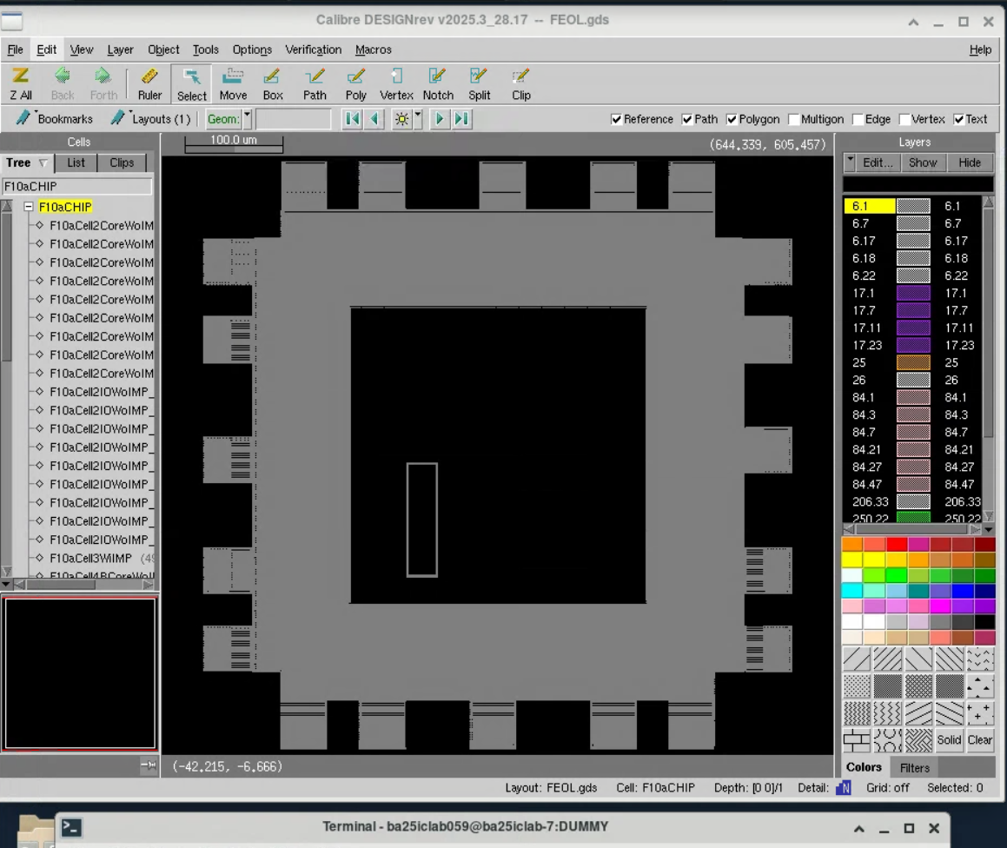
- Please show your BEOL.gds in Calibre DESIGNrev window (Picture)
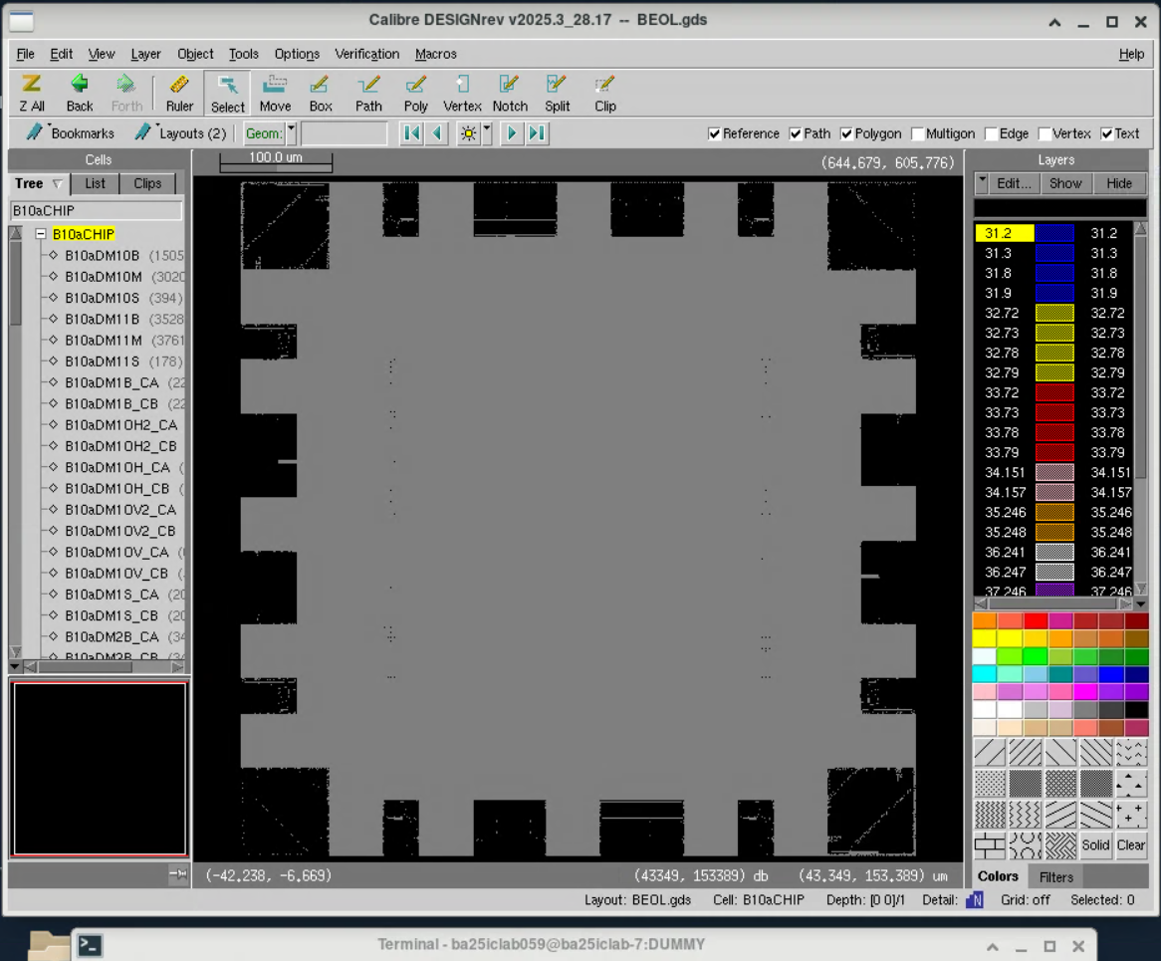
- Please show your summary information in DRC.rep (Picture)
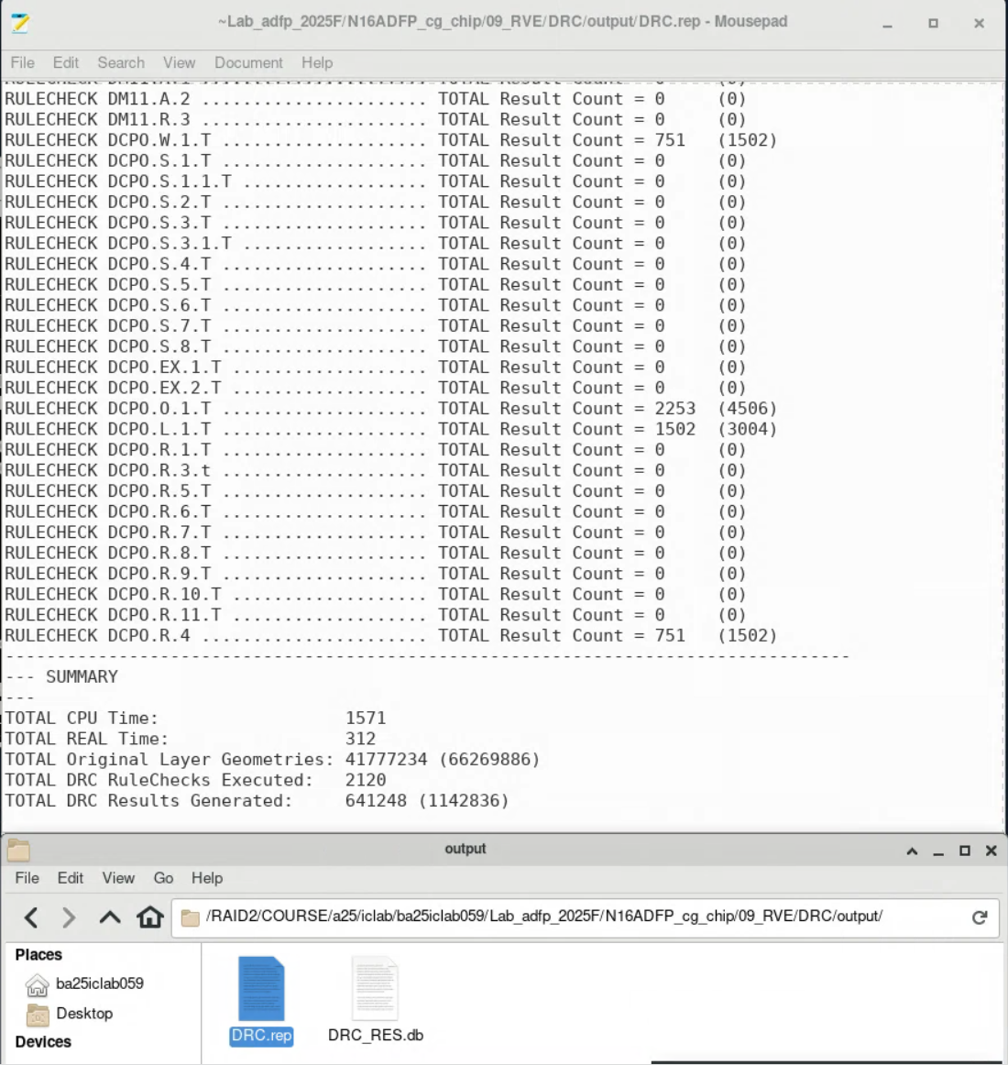
- Please show your summary information in ANTENNA.rep (Picture)
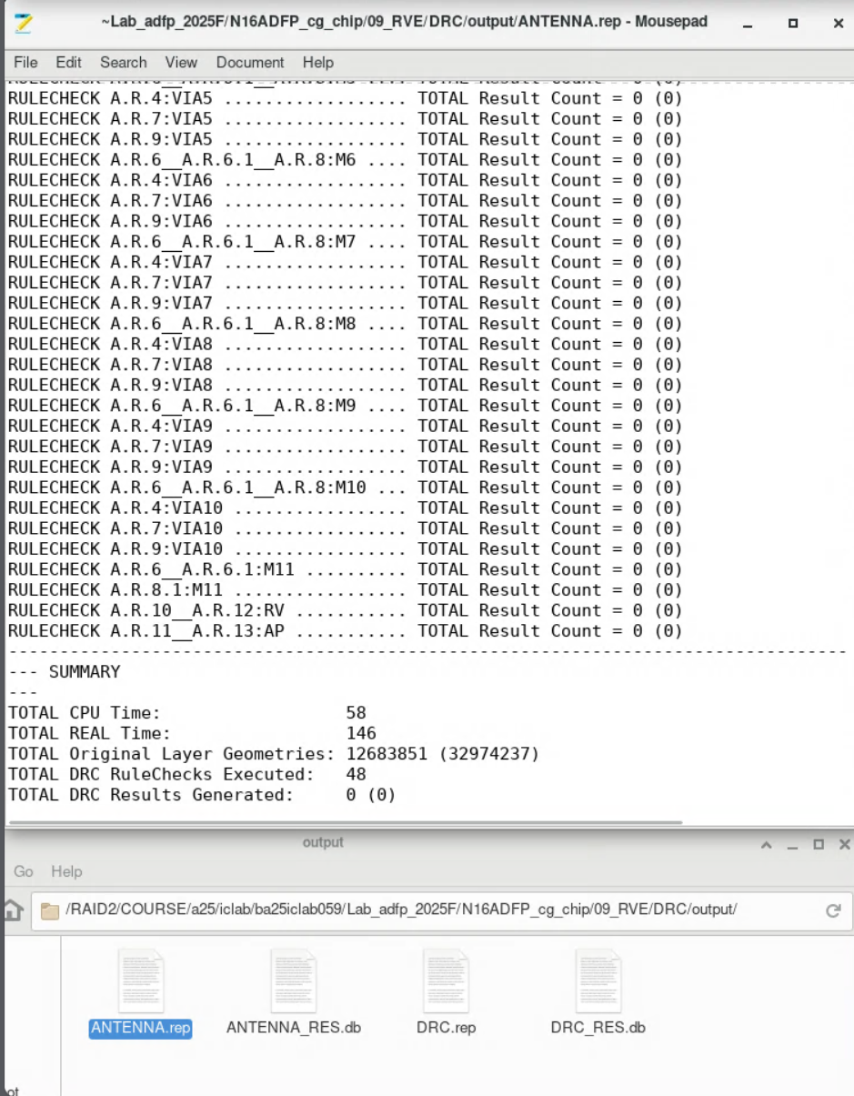
- Open 01_run_v2lvs file in 09_RVE/LVS and find:
  - What Verilog files do we need? __ N16ADFP_StdCell_pwr.v_、_ N16ADFP_StdIO_pwr.v _、_ N16ADFP_SRAM_100a.v _____
  - What spice files do we need? __ N16ADFP_StdCell_100b.spi__、_ N16ADFP_StdIO.spi __、_ N16ADFP_SRAM_100a.spi __
- Please show your Calibre LVS result in lvs.rep (Picture)
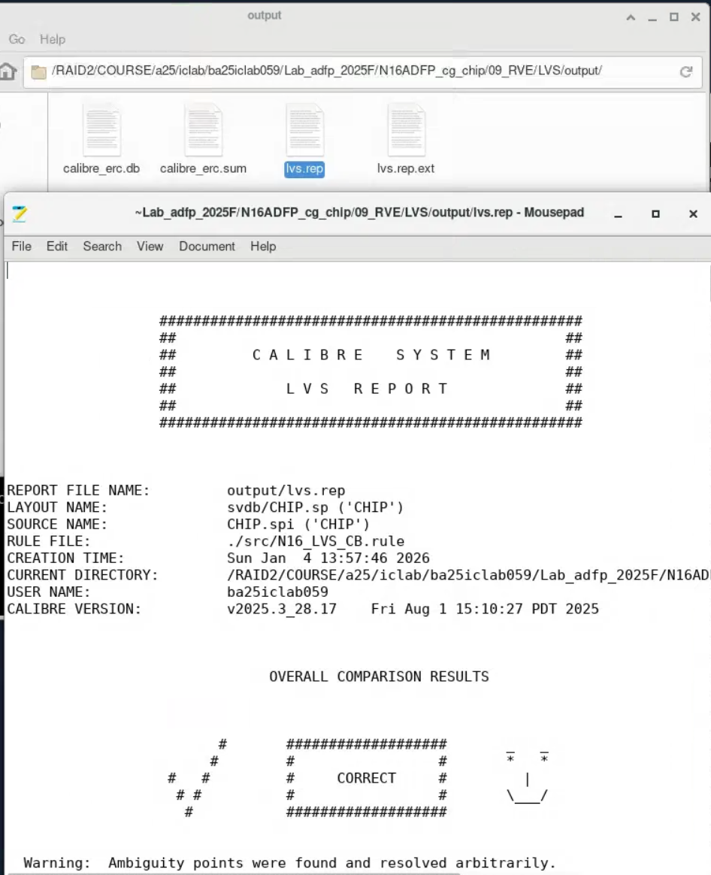
- Please show your layout (CHIP_addDummy.gds) in Virtuoso (Picture)
